**Module 5 Assignment(ACCESS)**

Data Source 1: Access table

Load Access File is loaded First.

1. Check Fields Null or not (Filter Rows)
2. Check If it has proper data types (DataValidator)
3. Check Foreign Key References (Doing Sort and Merge at each step)(Transformation Image)

Filter Rows

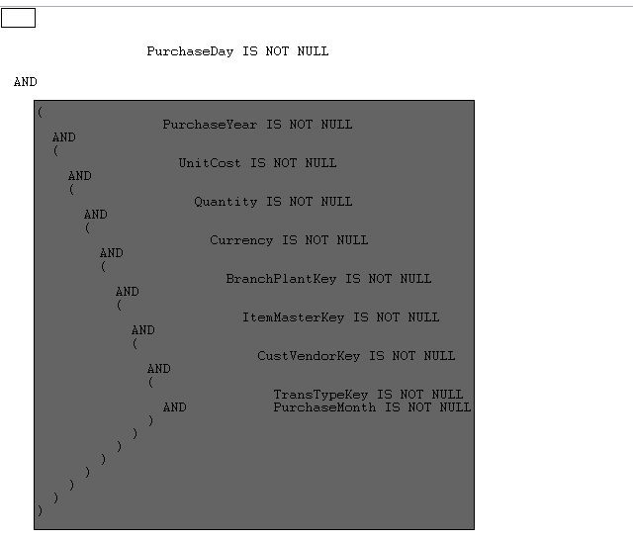

**DataValidator (Check Data Type)**

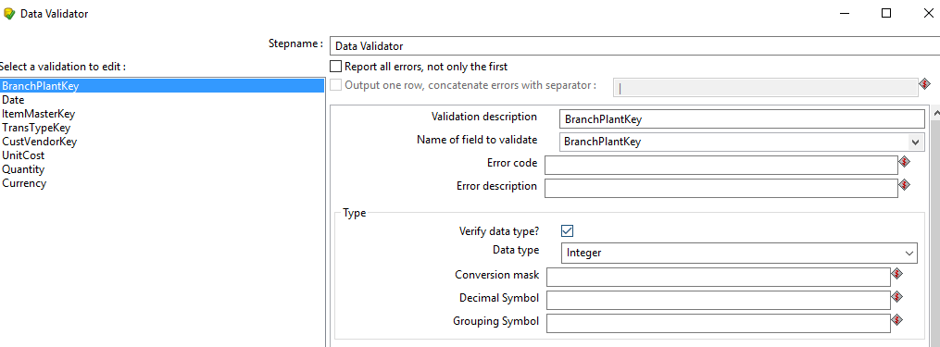

**Transformation:**

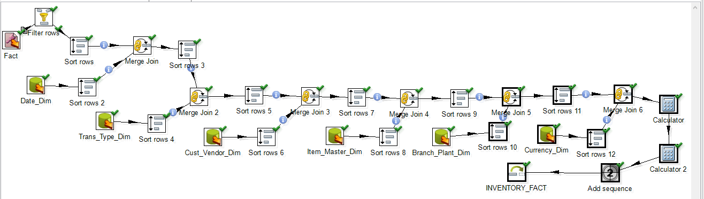

Here Calculator1, Does Unit_Cost(To be inserted) = Unit_Cost in Data Source * Exchange_Rate

Here, Calculator2, Does EXT_COST = Unit_Cost(New one calculated in Calculator1) * Quantity

After running the above, Transformation, 11 rows were inserted.

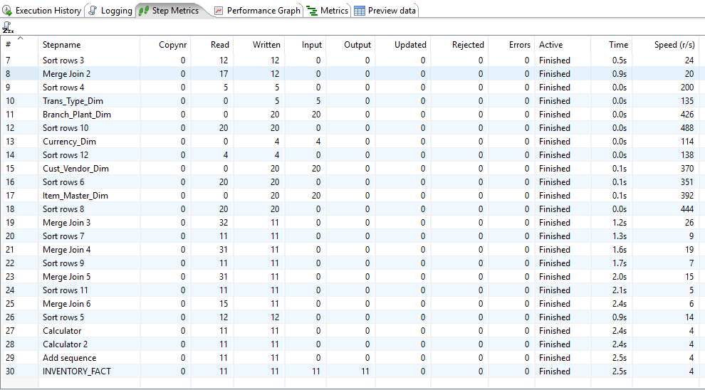

**Check Last INVETORY_FACT , Here 11 rows are written or inserted into the database. I checked the rows in sql developer.**

