The problem describes the use of I have used Pentaho Data Integration Software and Oracle Database.

First of all Excel File was loaded n following things were checked:

1. Check Fields Null or not (Filter Rows)
2. Check If it has proper data types (DataValidator)
3. Check Foreign Key References (Doing Sort and Merge at each step)(Transformation Image)

**Filter Rows**

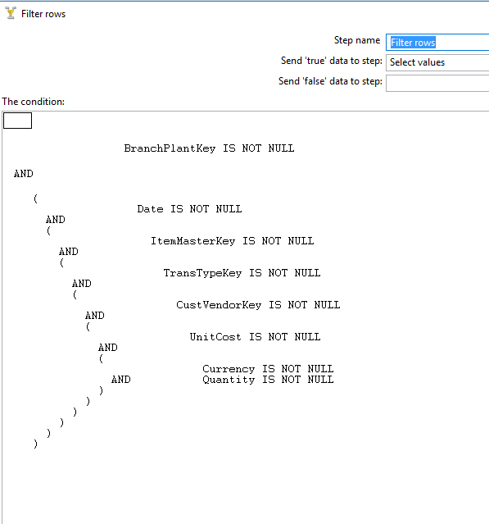

**DataValidator (Check Data Type)**

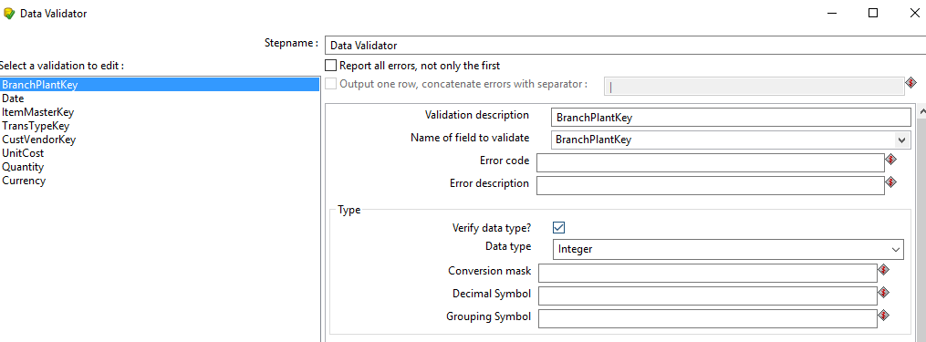

**Transformation:**

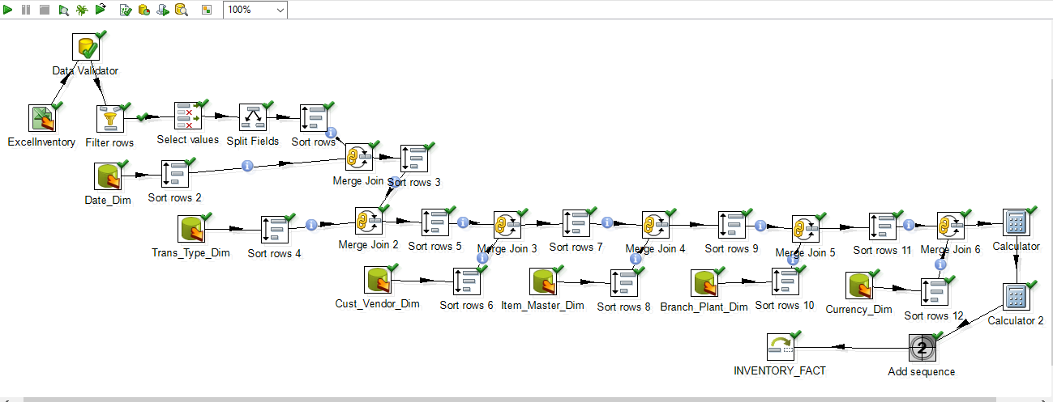

Here Calculator1, Does Unit_Cost(To be inserted) = Unit_Cost in Data Source * Exchange_Rate

Here, Calculator2, Does EXT_COST = Unit_Cost(New one calculated in Calculator1) * Quantity

After running the above, Transformation, 10 rows were inserted.

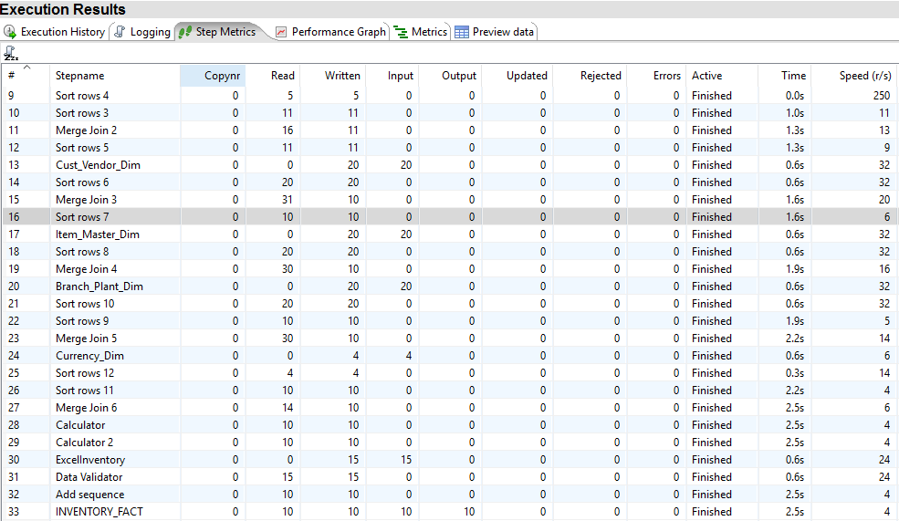

Check Last INVETORY_FACT , Here 10 rows are written or inserted into the database. I checked the rows in sql developer.

