24CY764
SECURE SYSTEM ENGINEERING
LAB - 2
Web Application Security Testing Report on OWASP Juice Shop

NAME: Krishna Vejahash KR
ROLL NO: CB.SC.P2CYS25012

1. Session Hijacking :
Session hijacking occurs when an attacker steals a user's session token and uses it to impersonate the victim without needing their password or credentials.
Logged in using admin credentials (email: admin@juice-sh.op, password: admin123)

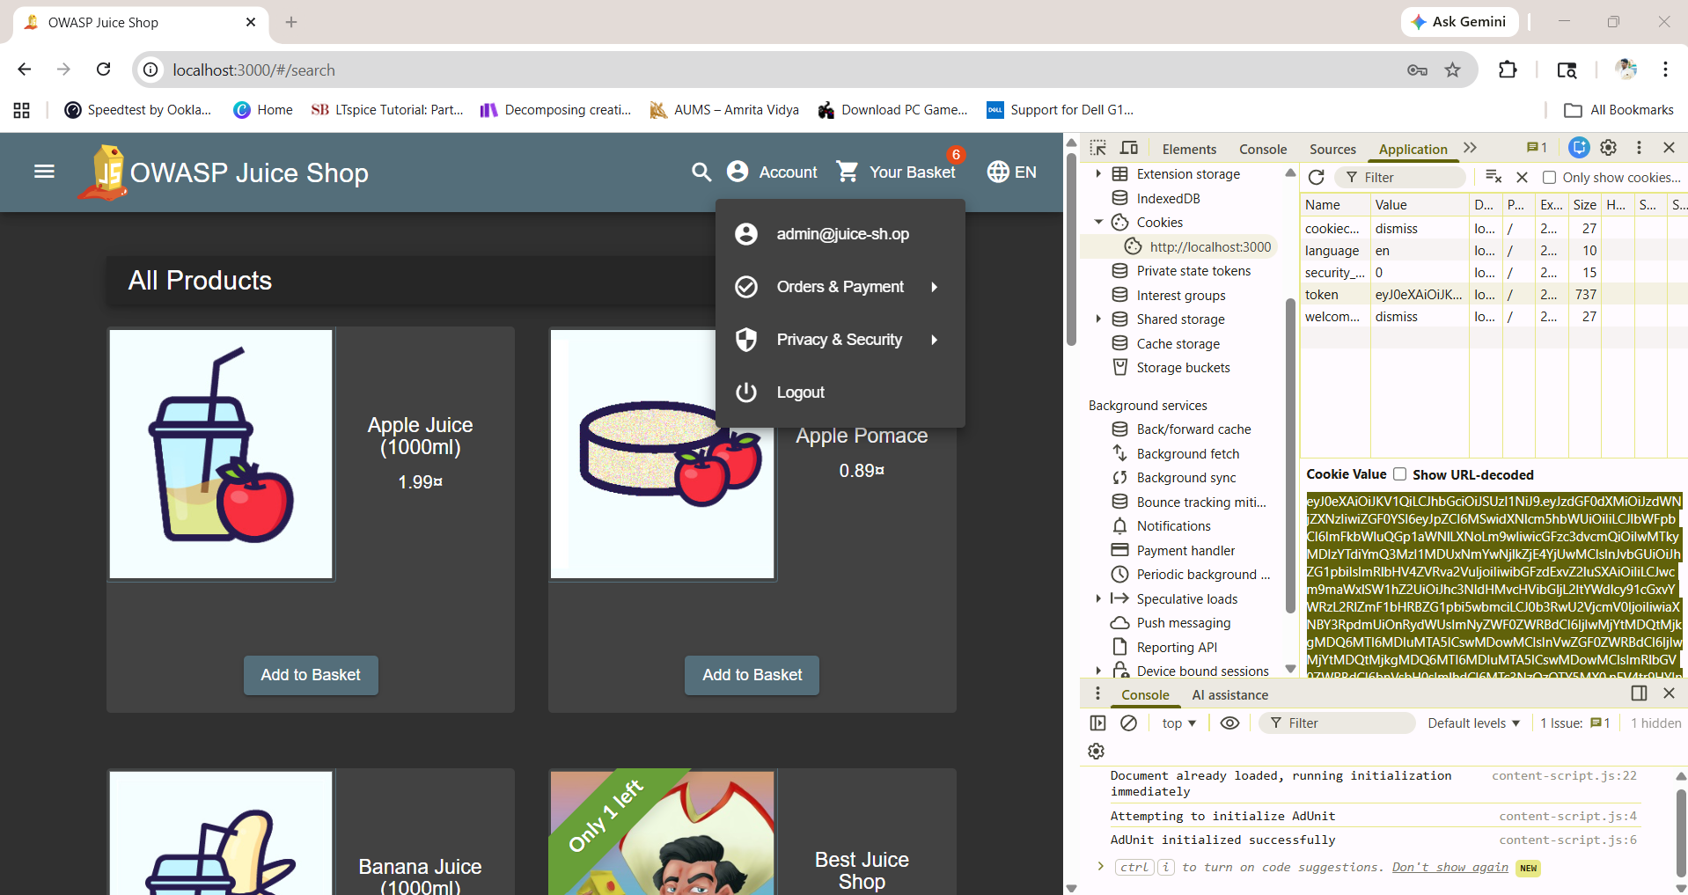

Steps Performed:
- Opened Developer Tools → Storage tab → Local Storage
- Located and copied the JWT token value
- Opened a new Private Browsing window
- In the private window, opened DevTools → Local Storage
- Created a new key named token and pasted the copied value
- Refreshed the page
Result:
The private window automatically logged in as the admin user without asking for any credentials. This confirms that session hijacking is possible if an attacker can obtain a valid session token.
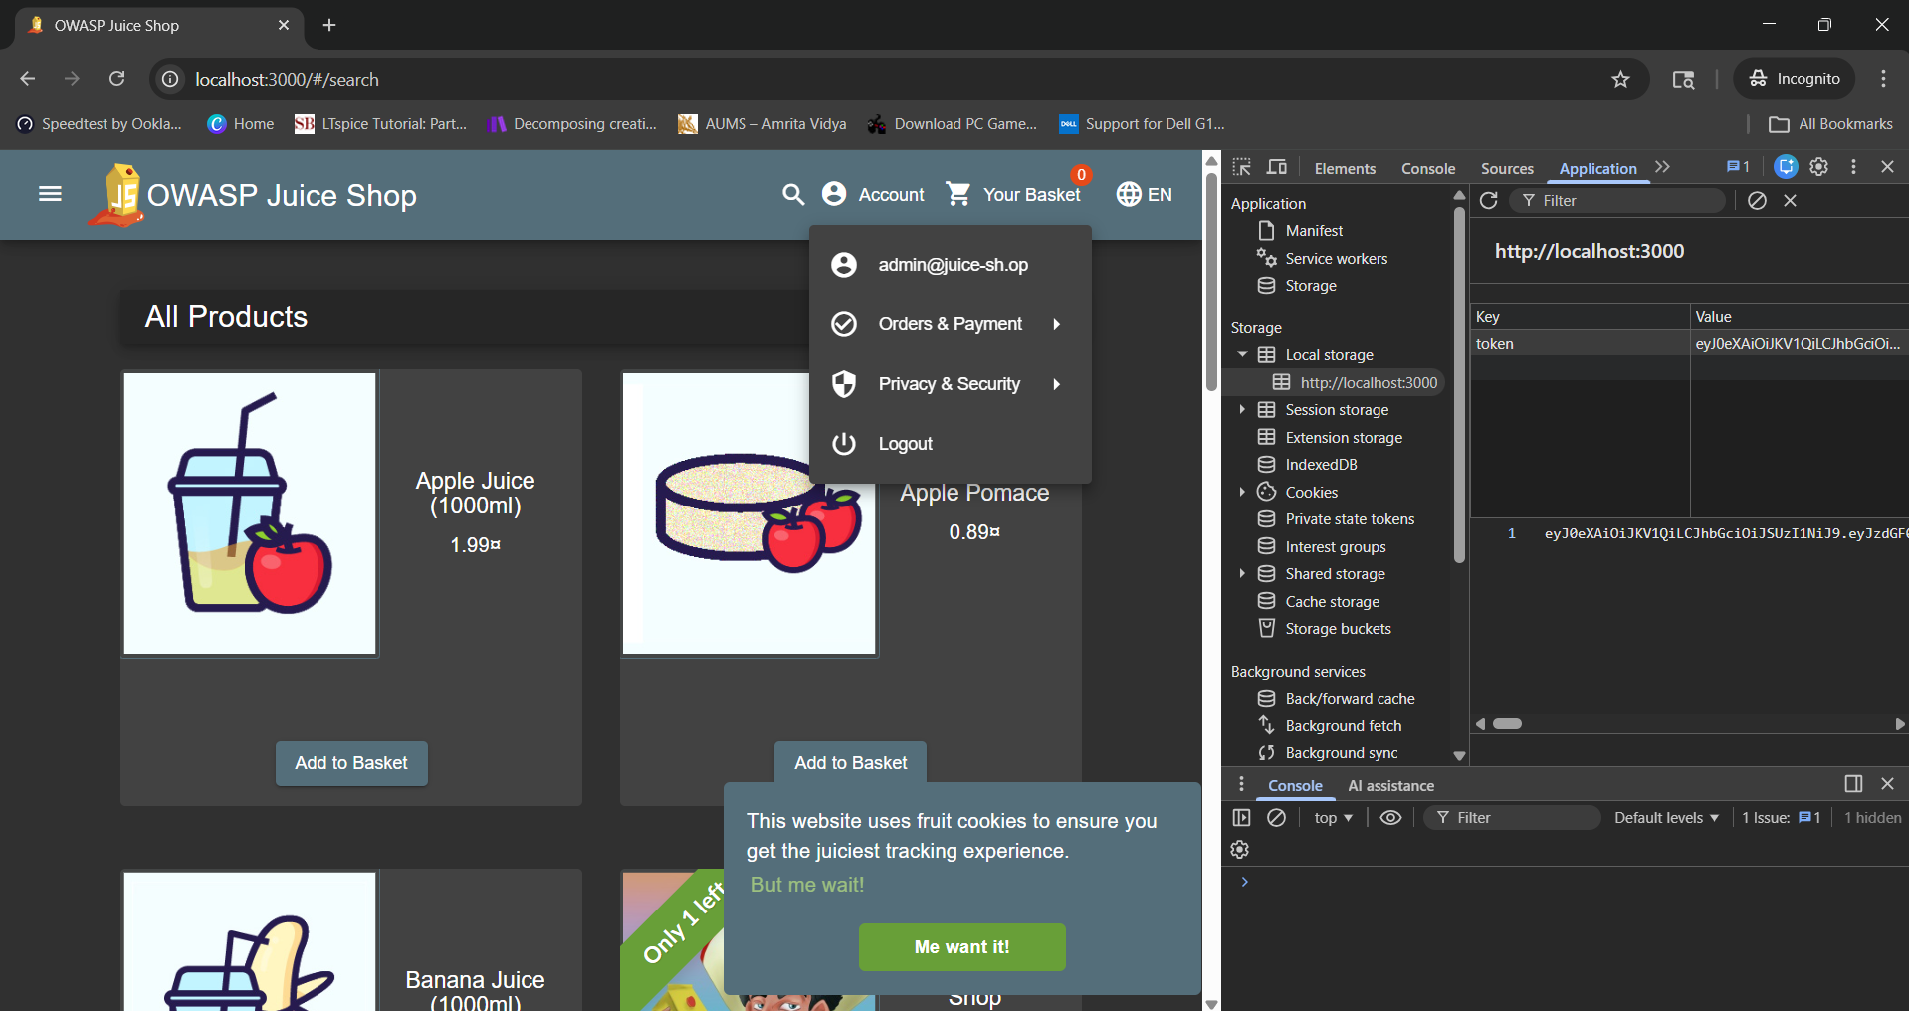

2. IDOR Attack (Insecure Direct Object Reference)
IDOR is a vulnerability that occurs when an application uses direct object IDs (like basket numbers) to access data but fails to verify if the user is authorized to view that data.
Steps Performed:
- Opened Developer Tools and went to the Console tab
- Sent a request to access basket 1: /rest/basket/1
- Modified the request to access basket 2: /rest/basket/2
- Added the Authorization header with the JWT token
- Executed the modified request
Result:
The application returned data from another user's basket. This shows that the application does not properly validate whether the user has permission to access the requested basket ID.
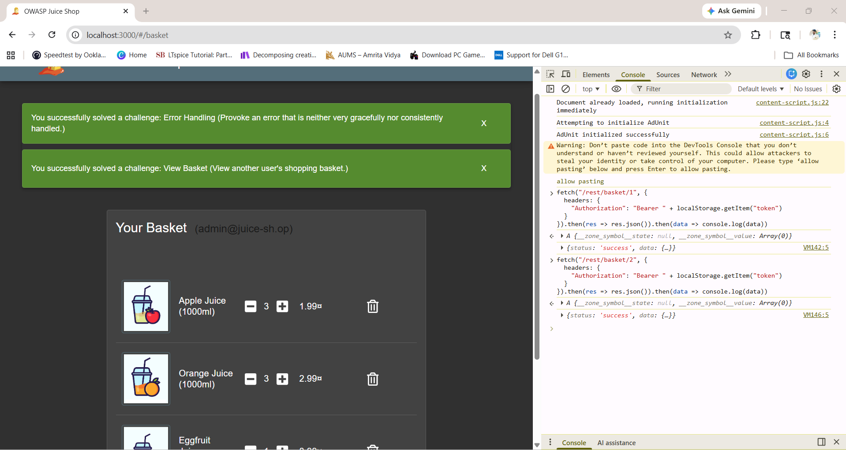

3. Missing Access Control
This vulnerability occurs when users can access restricted administrative functions without proper authorization checks.
Steps Performed:
- Attempted to access the admin panel at /#/administration without logging in
- Observed the server response
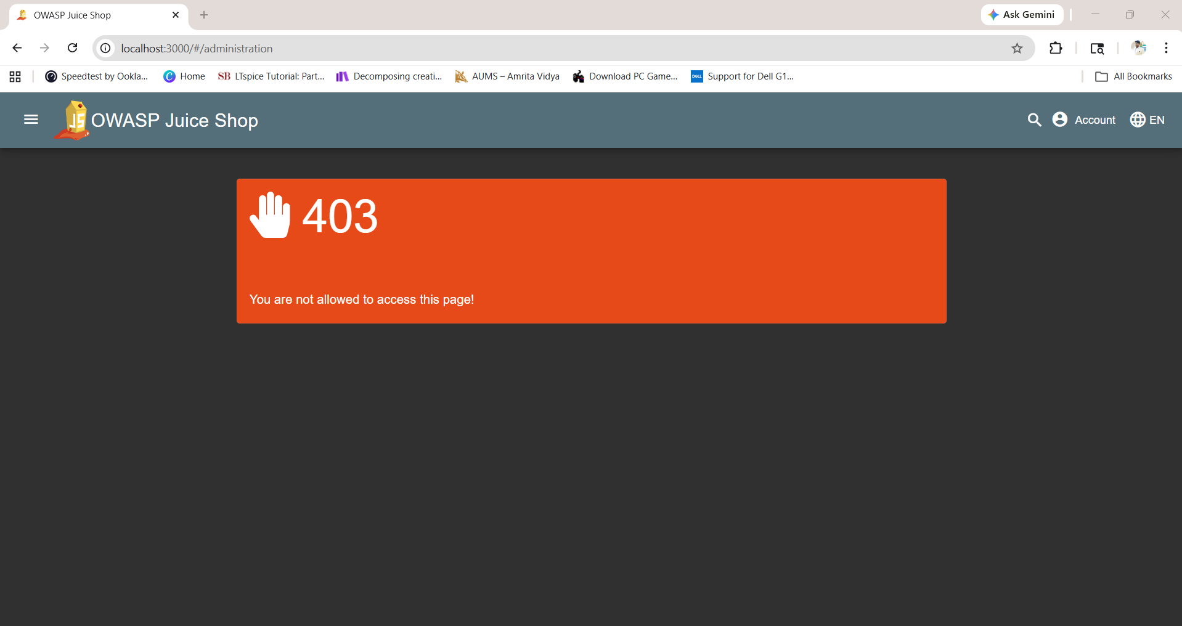
Observation:
- Server returned 403 Forbidden error
- Unauthorized users cannot access admin functionality
Conclusion:
Proper access control is implemented for admin routes. The application correctly blocks unauthorized access attempts.
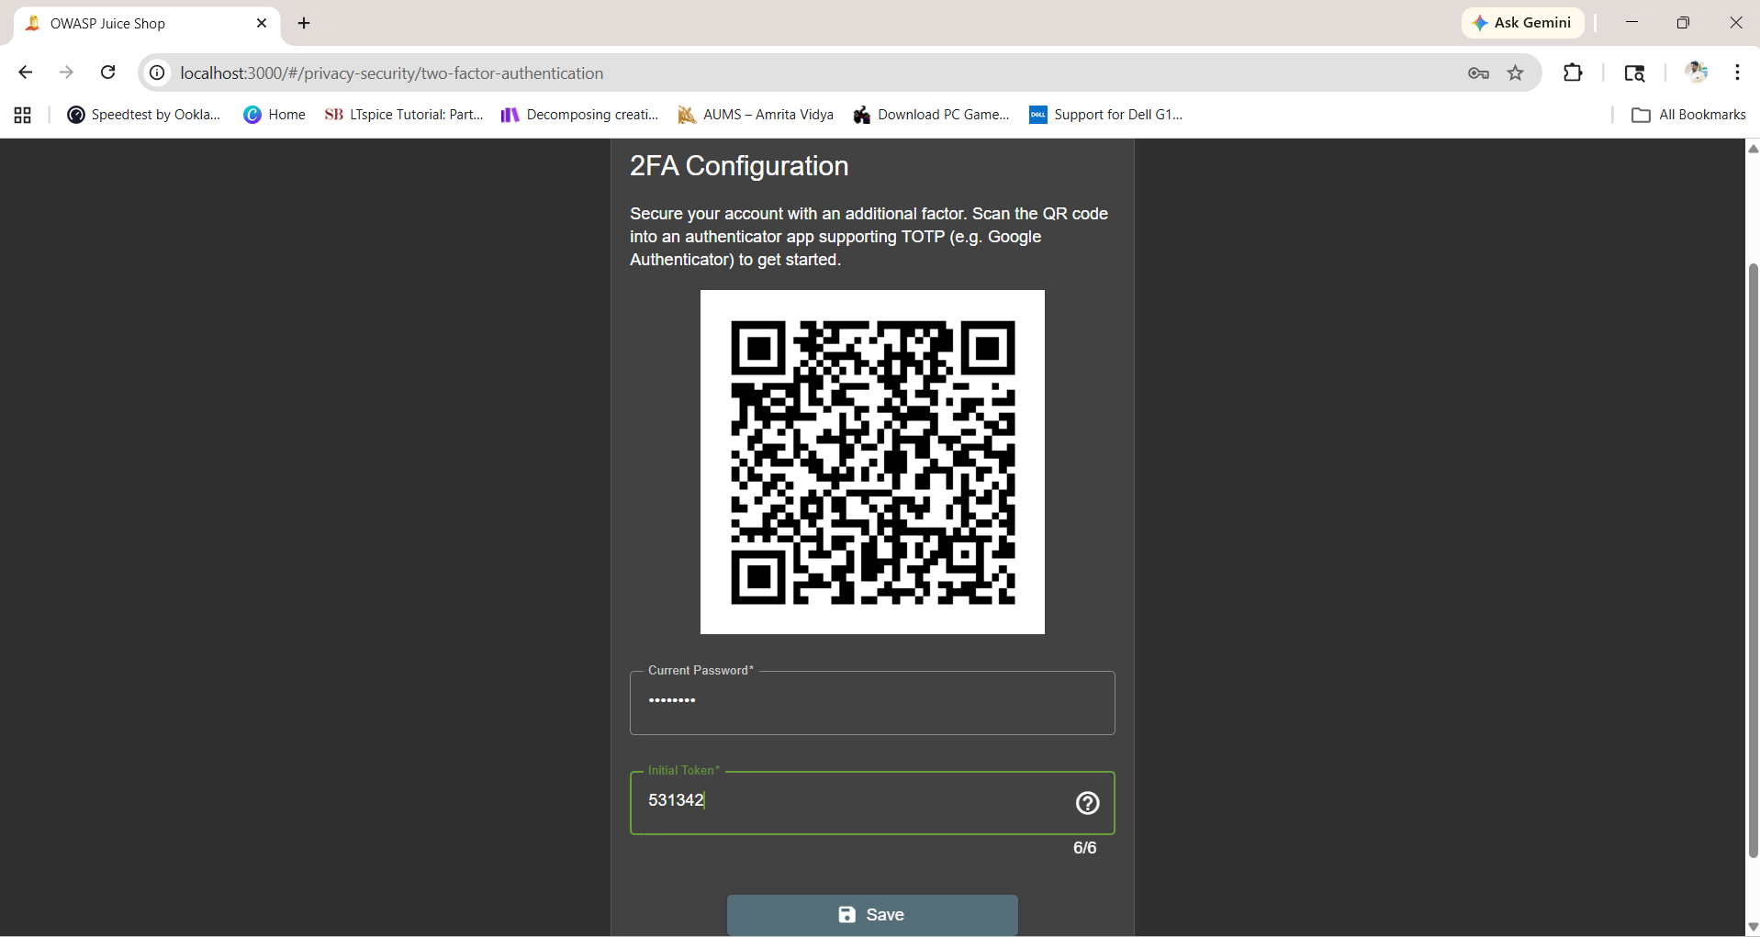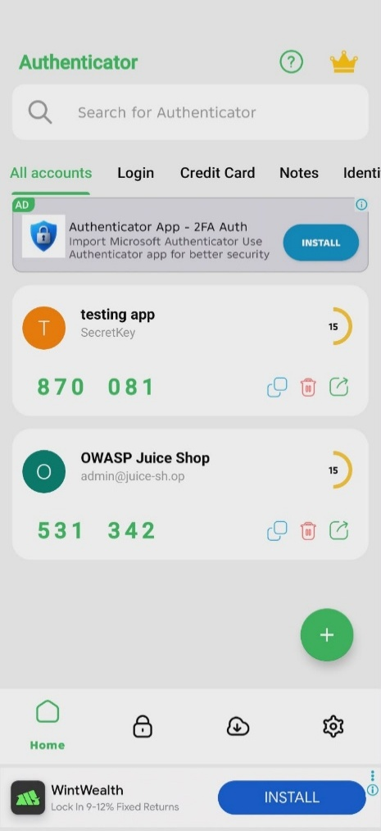

Logging in using the 2FA using correct otp:

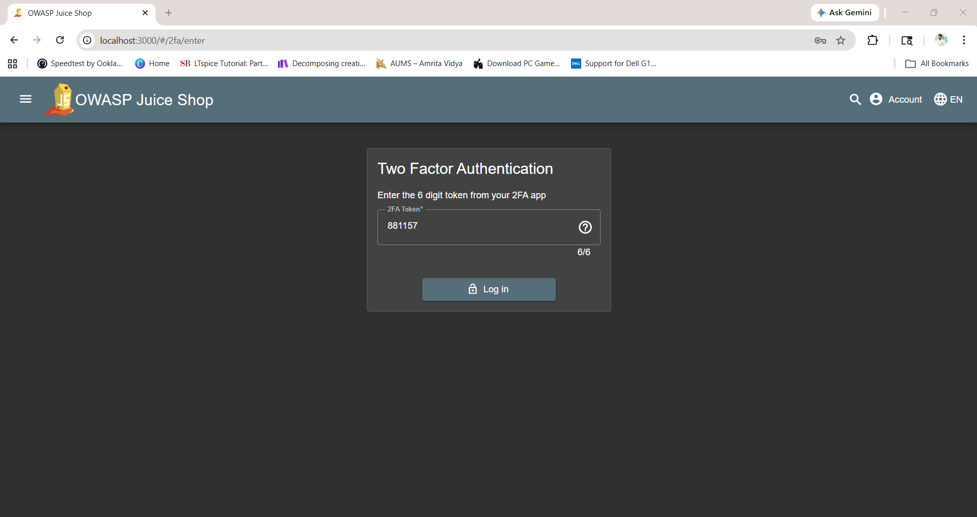
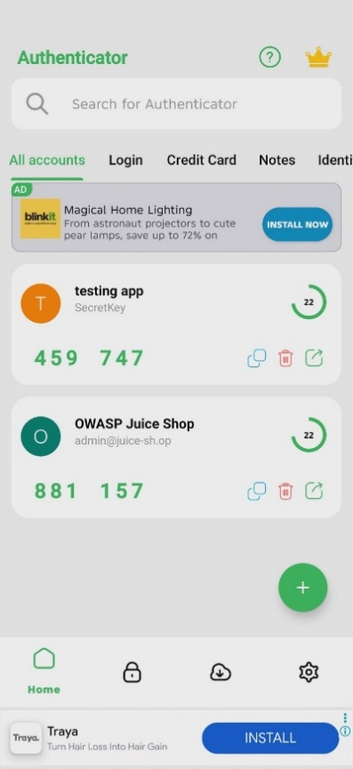
Attack:

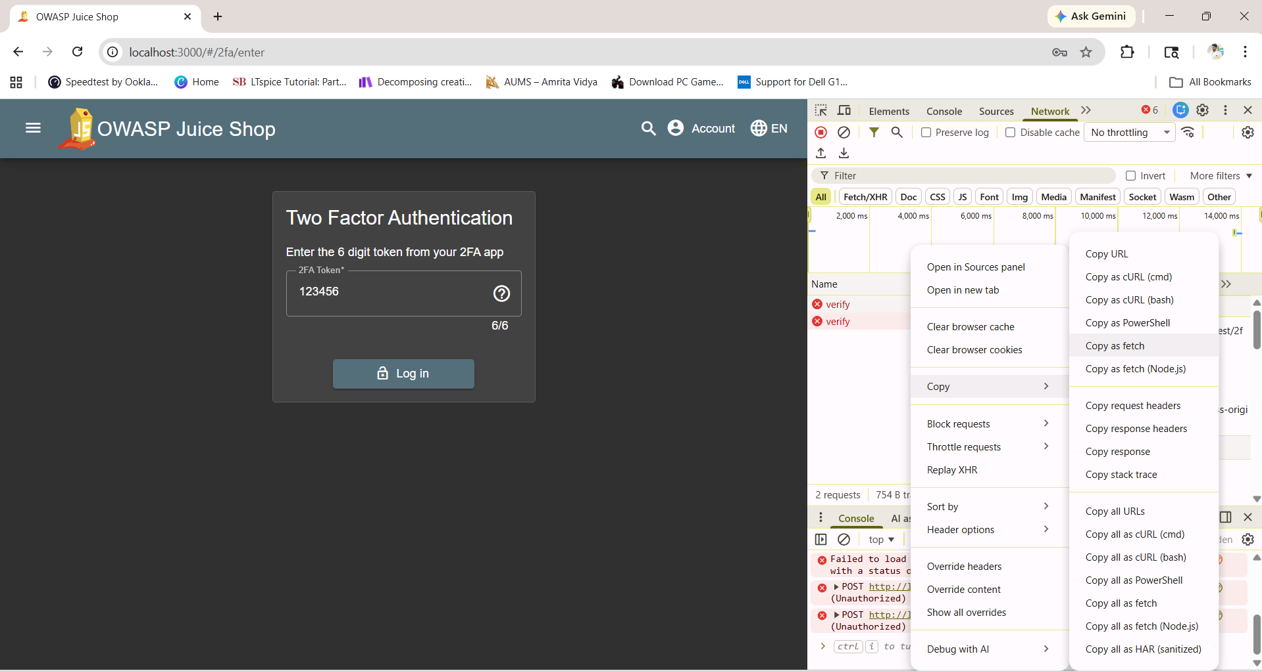

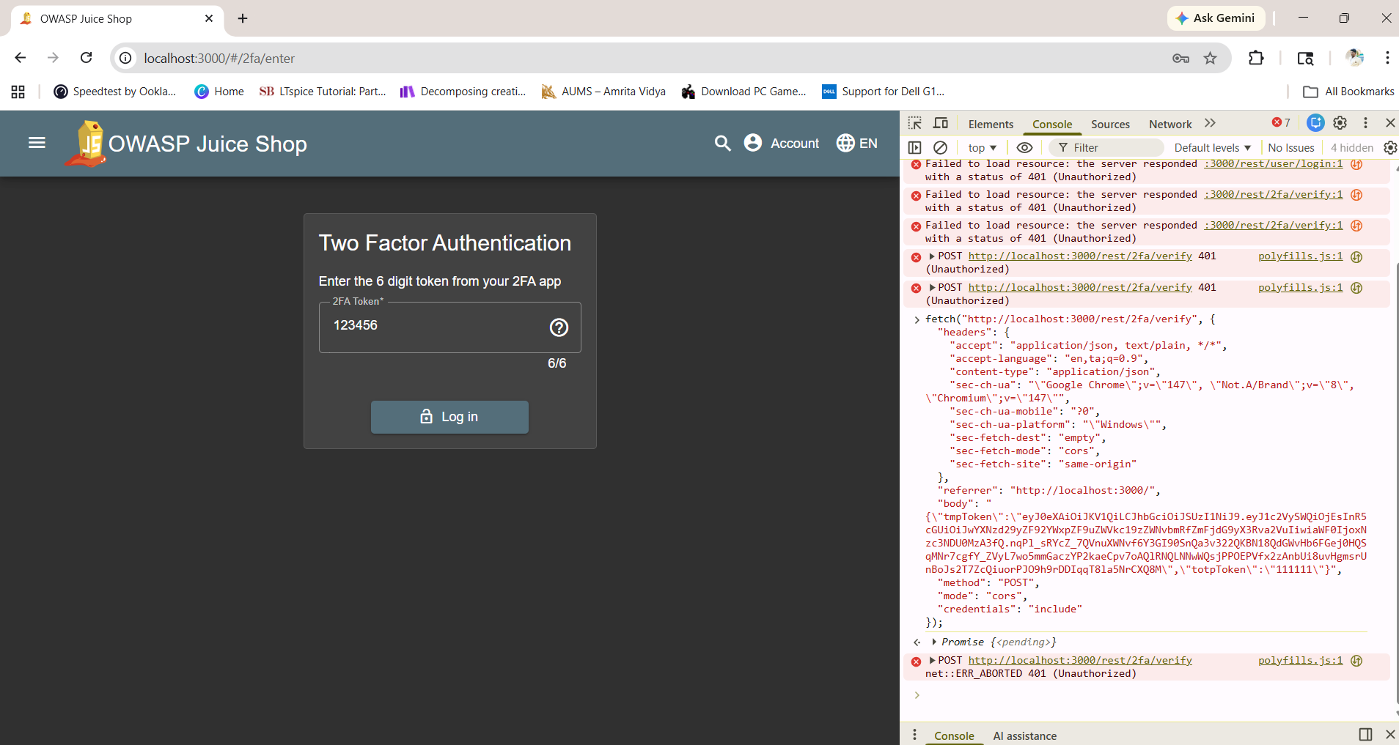

Steps:
- Enabled 2FA in application
- Entered incorrect OTP
- Captured request /rest/2fa/verify using DevTools
- Copied request using Copy as fetch
- Modified totpToken values manually
- Sent modified request
Observation:
- Server returned 401 Unauthorized
- Invalid OTP values were rejected
OTP BYPASS = NOT POSSIBLE here
Because:
- Server strictly validates totpToken
- Random values like:
  - 123456
  - 000000
  - 111111
are rejected
4. CSRF Attack (Cross-Site Request Forgery)
CSRF is a vulnerability where an attacker tricks a logged-in user into performing unintended actions by sending forged requests from the user's browser.

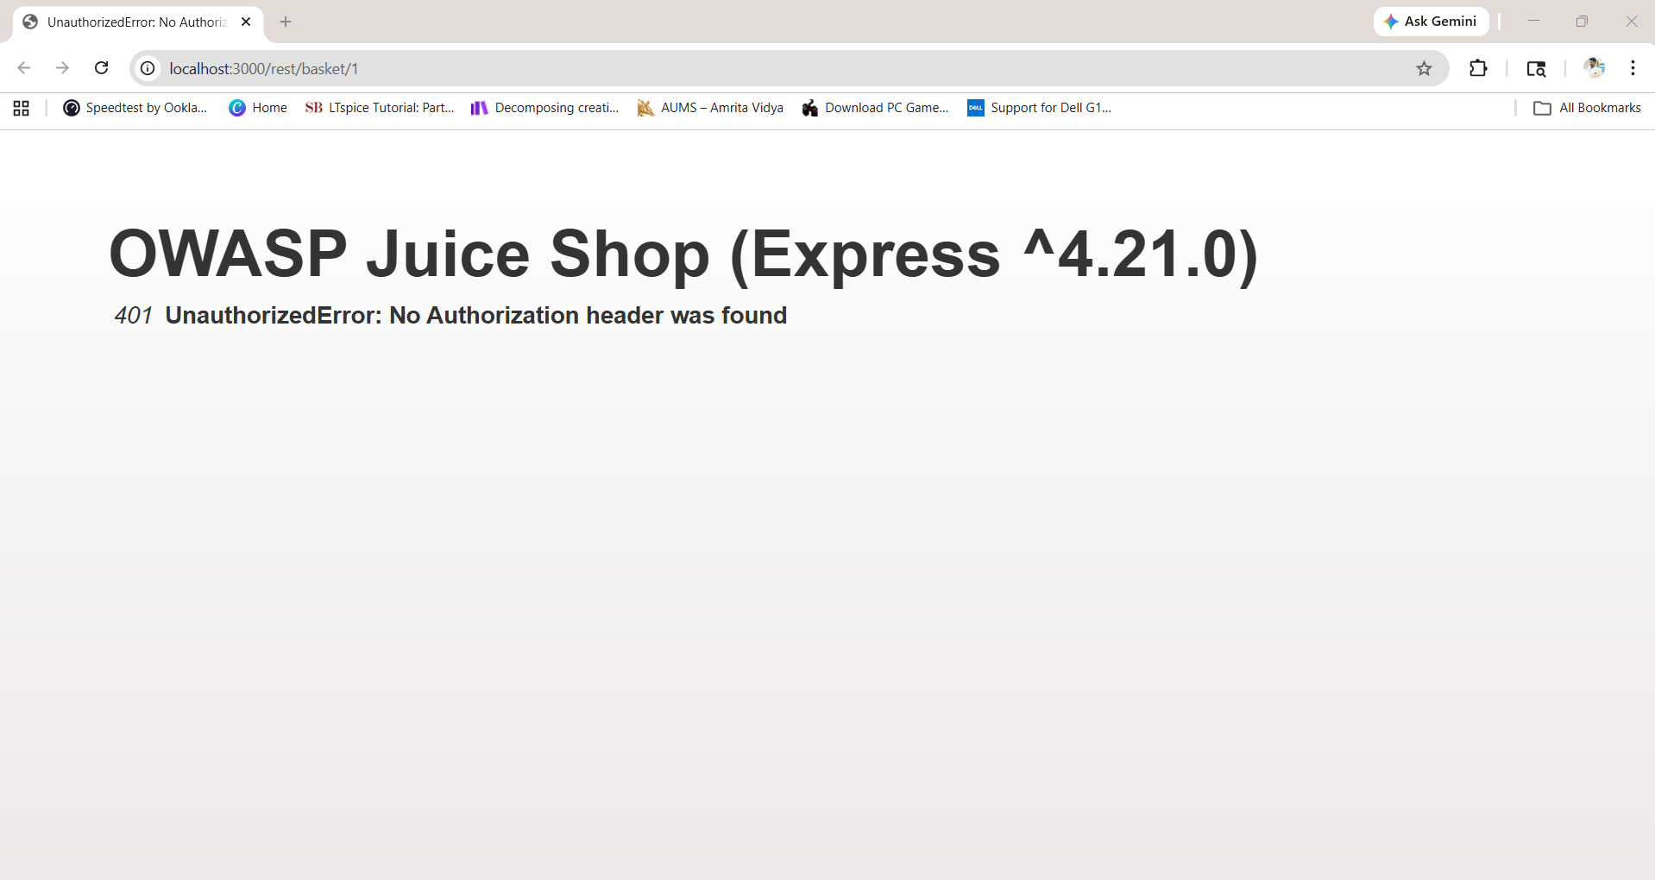
Steps Performed:
- Created a malicious HTML file (attack.html) with a hidden form
- The form was designed to send a POST request to /rest/basket/1
- Attempted to execute the form while the user was logged into Juice Shop
Attack.html Code:
<html>
<body>
<h2>CSRF Attack</h2>
<form action="http://localhost:3000/rest/basket/1" method="POST">
<input type="hidden" name="quantity" value="10">
</form>
<script>
document.forms[0].submit();
</script>
</body>
</html>
Observation:
- Server returned 401 Unauthorized
- Request failed due to missing Authorization header
Reason:
The application uses JWT-based authentication. Unlike cookie-based sessions, JWT tokens are not automatically sent by browsers with every request, providing built-in CSRF protection.

5. XSS Attack (Cross-Site Scripting)
XSS is a vulnerability where an attacker injects malicious scripts into a web application. When the application fails to properly validate or sanitize user input, the script gets executed in the victim's browser.
Steps Performed:
- Navigated to the search functionality in Juice Shop
- Entered a malicious script payload: <script>alert('XSS')</script>
- Submitted the search query

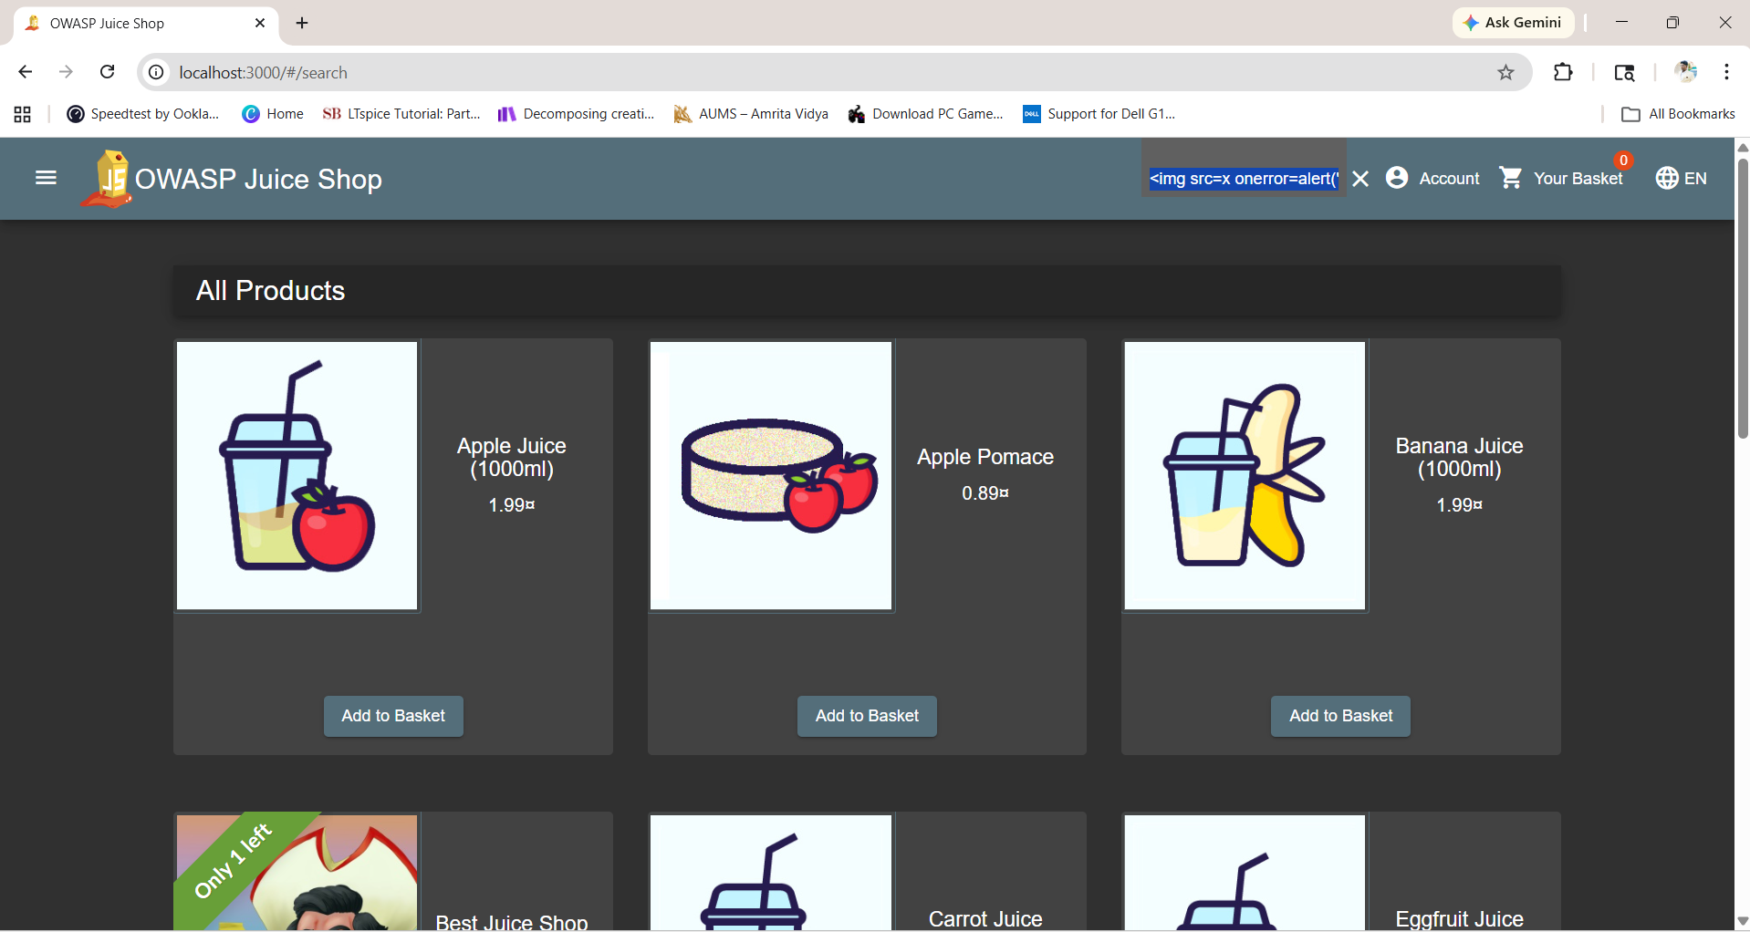
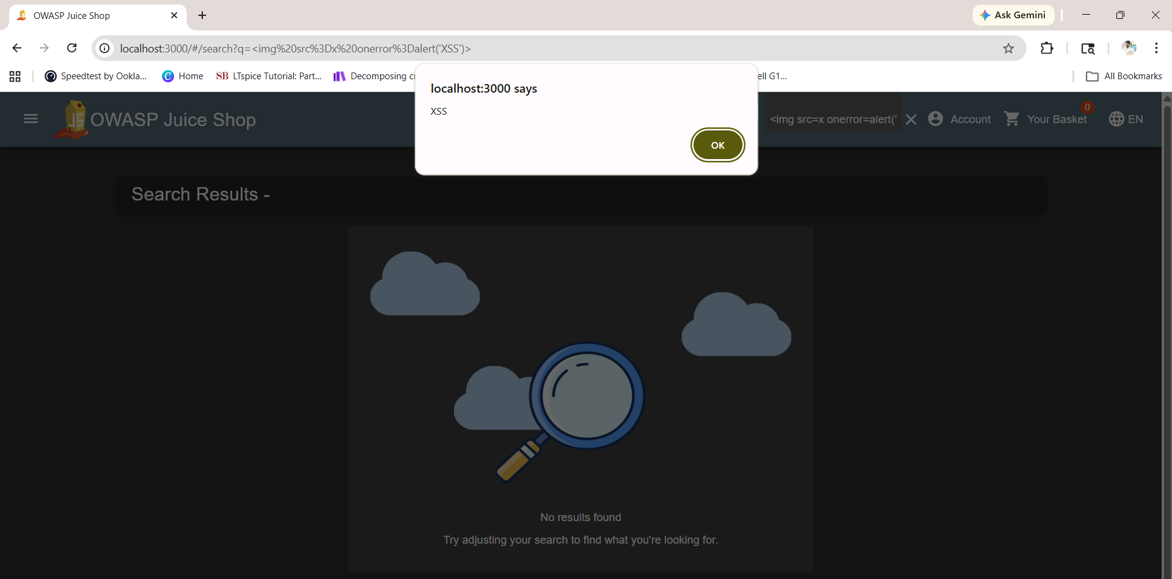
Result:
A popup alert appeared in the browser, confirming that the script was executed. This demonstrates that the application is vulnerable to XSS attacks due to insufficient input sanitization.

6. SQL Injection (Authentication Bypass)
SQL Injection is a vulnerability where an attacker injects malicious SQL queries into input fields. If the application fails to validate input properly, the attacker can manipulate database queries to bypass authentication.
Steps Performed:
- Navigated to the login page
- In the Email field, entered: ' OR 1=1 --
- Entered any random password (e.g., 123)
- Clicked the Login button

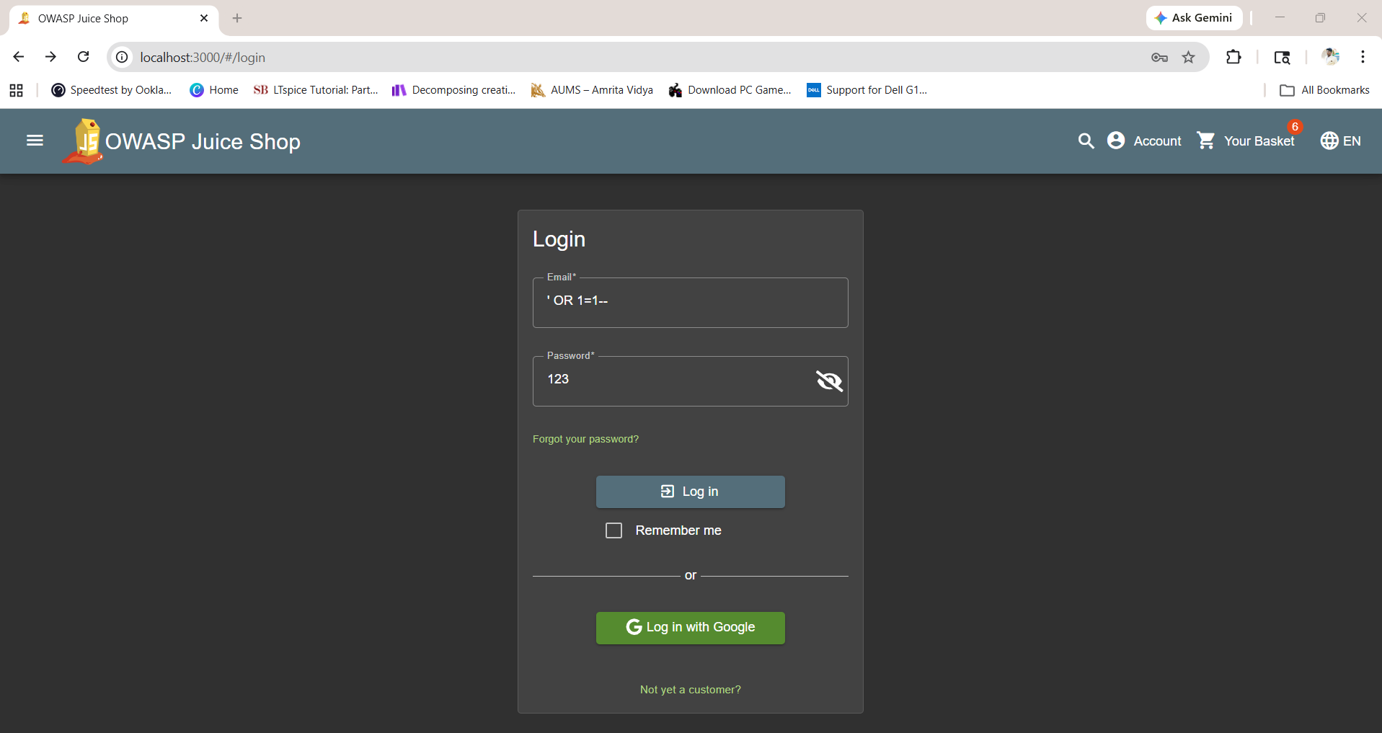
It login as admin@juice-sh.op
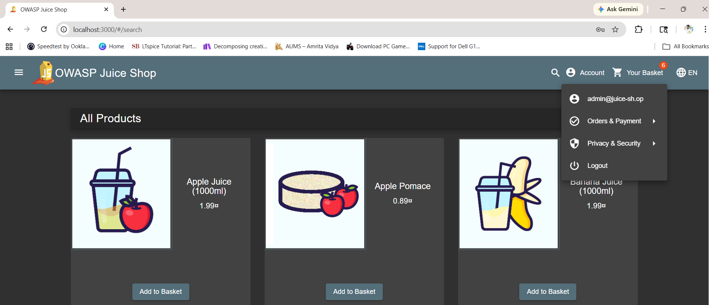
Result:
Successfully logged in as the administrator (admin@juice-sh.op). The SQL injection bypassed the password check by commenting out the rest of the SQL query.

7. JWT Token Tampering
JWT Token Tampering occurs when an attacker modifies the contents of a JSON Web Token (such as changing the user role). If the application does not properly verify the token signature, the modified token may be accepted.
Steps Performed:
- Logged into the application as admin
- Retrieved the JWT token from browser Local Storage
- Decoded the token using jwt.io
- Analyzed the token payload structure including user role information
Observation:
- The decoded token clearly showed "role": "admin" in the payload
- Admin panel access is properly restricted to users with admin role
- The application enforces proper access control based on JWT claims
- Token signature verification appears to be correctly implemented

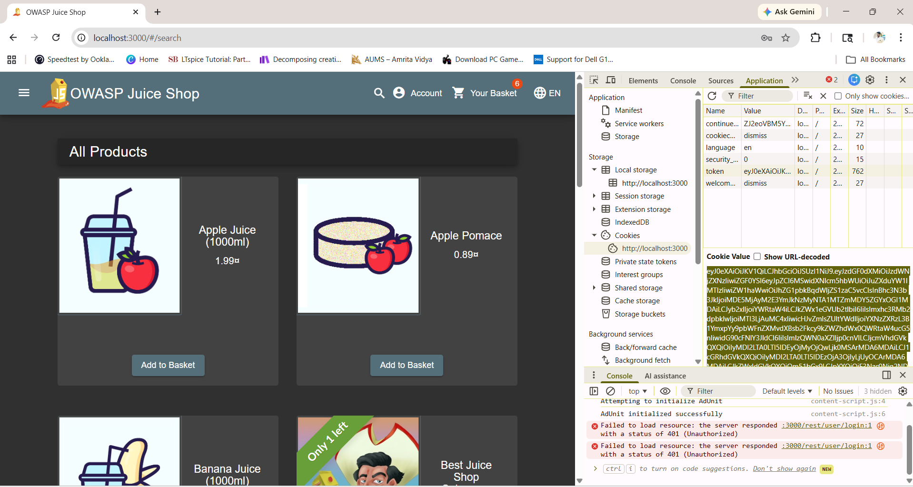

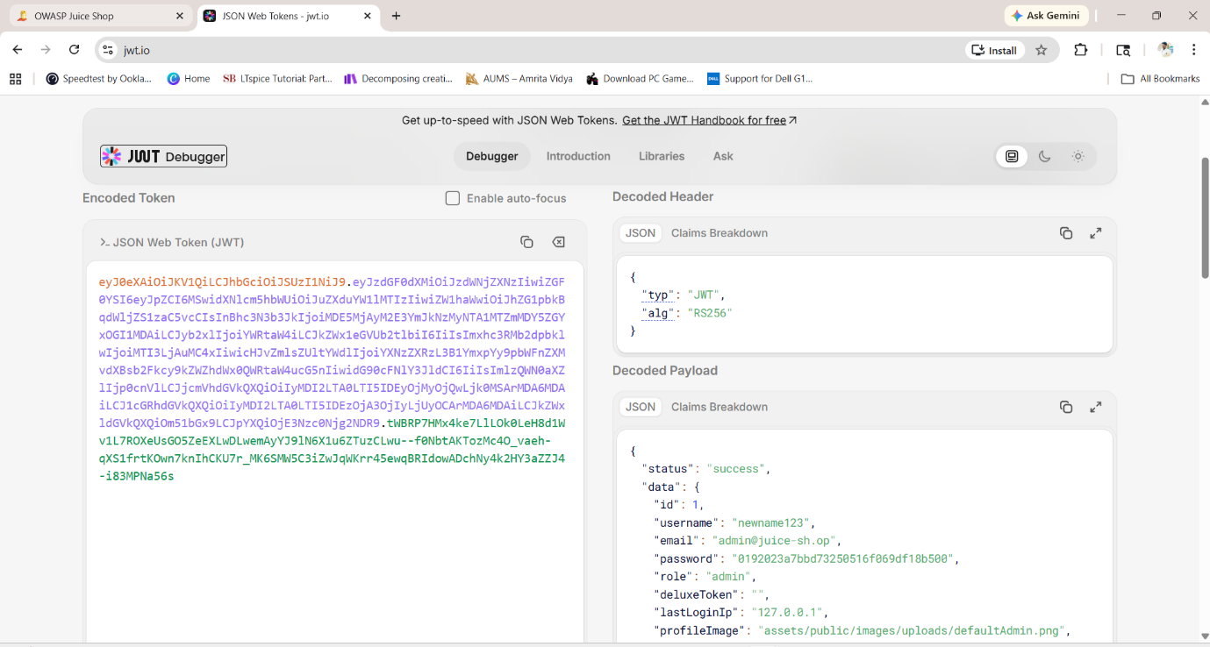
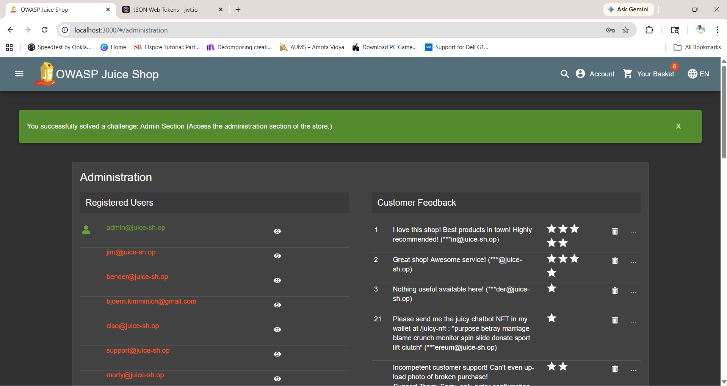

8. Password Reset Flaw
Password Reset Flaw occurs when the password recovery mechanism is weak. This application uses simple security questions that can be easily guessed or discovered.
Steps Performed:
- Clicked "Forgot your password?" on the login page
- Entered the admin email address
- Observed the security question prompt
Observation:
- The reset process only requires an email and security answer
- No additional verification (like OTP or email confirmation link) is required
- Unlimited reset attempts can be made
- Security questions like "Your eldest sibling's middle name" can be easily guessed or found through social engineering

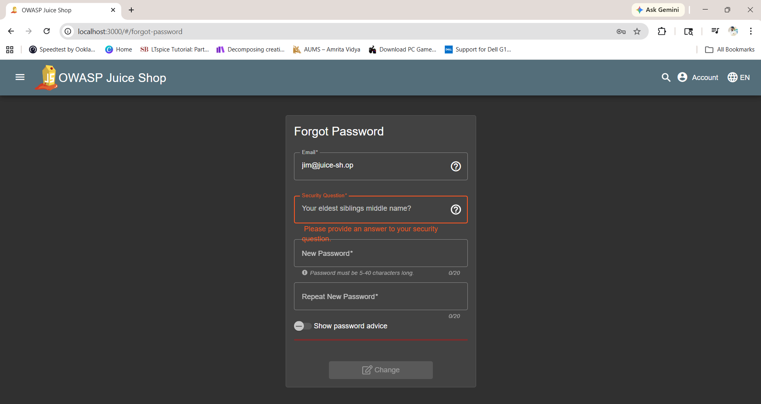

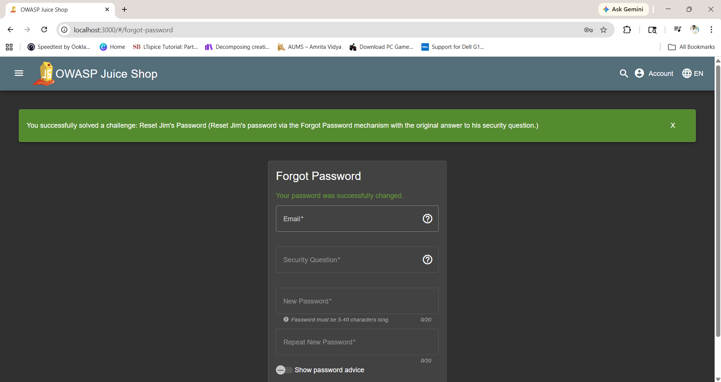

Risk:
This weakness allows attackers to reset any user's password if they can guess or obtain the answer to the security question.

Secure Password Practices
Based on the observations from this lab, the following secure password practices should be implemented:
- Use strong passwords: Minimum 12 characters with a mix of uppercase, lowercase, numbers, and symbols
- Hash passwords: Store passwords using secure algorithms like bcrypt, never in plain text
- Enable MFA: Add an extra layer of security using OTP or biometric verification
- Rate limiting: Restrict repeated login attempts to prevent brute-force attacks
- No plain storage: Never store or transmit passwords in plain text over the network

Conclusion
In this lab, multiple web application vulnerabilities were tested using the OWASP Juice Shop environment. Attacks such as Session Hijacking, IDOR, SQL Injection, XSS, and Password Reset Flaws were successfully demonstrated, showing how weak input validation and improper security mechanisms can lead to serious risks including:
- Data leakage through IDOR vulnerabilities
- Account takeover via session hijacking and SQL injection
- Unauthorized access through missing access controls
- Client-side attacks using XSS payloads
At the same time, some protections were observed to be effectively implemented:
- Proper access control for admin routes (403 Forbidden response)
- Strong OTP validation preventing 2FA bypass
- JWT signature verification preventing token tampering
This experiment highlights the importance of secure coding practices, proper authentication mechanisms, and strong input validation to protect web applications from common security threats.

