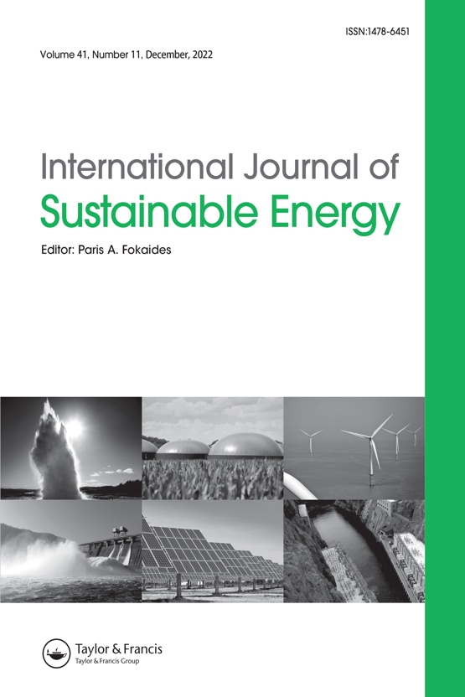
International Journal of Sustainable Energy

Publisher: Taylor & Francis
Impact Factor: 4.2
SI Title: Recent Innovations in Waste Valorization for Sustainable Energy: Technological Advances, Circularity, and Life-Cycle Perspectives
Scope: Waste-to-Energy Technologies, Bioenergy and Biofuel, Energy Recovery from Wastewater, Life-Cycle Assessment, Environmental Sustainability
Website: https://think.taylorandfrancis.com/article_collections/international-journal-of-sustainable-energy-recent-innovations-in-waste-valorization-for-sustainable-energy-technological-advances-circularity-and-life-cycle-perspectives/

Submission dates: Special issue closes on July 31, 2027

