FareCompass
Introduction
FareCompass estimates based on services available within short to medium regular basis distance on both source and destination sides. We consider integrated mobility options with auto-rickshaw, bus, and trains on both sides. Fares are estimated for autorickshaw (manual rickshaw) and ride-sharing services.

Motivation of the project
The motivation behind the project was to build a system to estimate and compare travel fares of different transportation services for a particular distance, thus providing a better and more convenient way for users to decide on their mode of transport based on estimated time and cost.

Problem statement
-Bring Your Own Project (BYOP)
As part of this course, you are required to complete a Bring Your Own Project — a capstone activity designed to push you beyond exercises and into real problem-solving.

-What is BYOP?
BYOP challenges you to identify a real-world problem that genuinely interests you and solve it using the concepts, tools, and techniques covered in this course. There is no predefined problem statement — the problem is yours to find, and the solution is yours to build.

-What to Submit
You must submit all three of the following on the VITyarthi platform:
- GitHub Repository — Your complete project code, version-controlled and publicly accessible. The repository should reflect your actual development process, not a one-time upload.
- Project Report — A structured document covering the problem you chose, why it matters, your approach to solving it, key decisions you made, challenges you faced, and what you learned. There is no strict page limit, but it should be thorough enough to communicate your thinking clearly.
- README File — A well-written README inside your GitHub repository that explains what the project does, how to set it up, and how to use it. Someone who has never seen your project should be able to understand and run it from your README alone.
-What Makes a Good Project?
- The problem should be real — something observed in your environment, community, workplace, or daily life
- The solution should meaningfully apply what you learned in this course
- It does not need to be complex or large in scale; it needs to be purposeful and well-executed
- There is no single right answer — originality, effort, and clarity of thought matter more than technical complexity
-Evaluation Criteria
Your submission will be evaluated on:
- Relevance of the problem to course concepts
- Quality and clarity of your solution
- Code organization and documentation
- Depth of reflection in the project report
- Usability of the README

OBJECTIVE OF THE PROJECT
Provide fare comparison in one place. Estimate travel cost based on distance and time and Identify the cheapest available option.
Offer a simple API and exportable results.

EXISTING METHODS
1.Manual comparison using multiple apps.
2.Google Maps fare estimates.
3.Individual ride service apps.

PROS AND CONS OF EXISTING METHODS
- Pros:
- Real-time pricing.
- Accurate ETAs.
- Cons:
- Time-consuming.
- No unified comparison.
- Requires multiple apps.

HARDWARE AND SOFTWARE REQUIREMENTS
- Hardware:
-Basic computer or laptop.
-Internet connection.
- Software:
-Python 3.
-Flask.
-Requests library.
-Web browser.

METHODOLOGY AND GOAL
The system converts location names into coordinates. It calculates distance using routing APIs, estimates time, and applies fare formulas for each platform. The goal is to provide quick and useful fare comparisons.

FUNCTIONAL MODULES DESIGN AND ANALYSIS
-Geocoding Module: Converts location names to coordinates.
-Distance Module: Calculates route distance and duration.
-Fare Calculation Module: Computes fares for each service.
-API Module: Handles user requests.
-Export Module: Generates CSV output.

ALGORITHM DEVELOPMENT
-Input origin and destination.
-Convert locations to coordinates.
-Calculate distance and time.
-Apply fare formulas.
-Sort by lowest fare.
-Return results.

SOFTWARE ARCHITECTURAL DIAGRAM
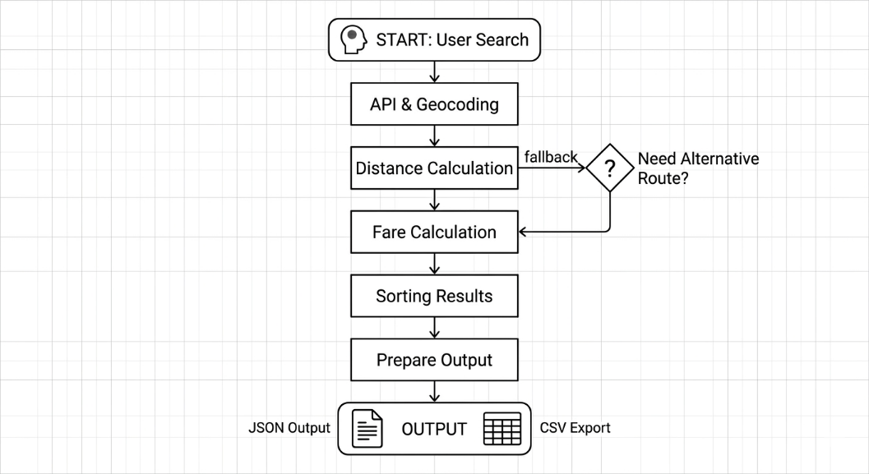

CODING
The system is implemented in Python using Flask. It integrates external APIs, OpenStreetMap and OSRM, and uses modular functions for geocoding, routing, and fare computation.

OUTPUT
-JSON response with fare comparison.
-Cheapest option highlighted.
-CSV file for download.

KEY IMPLEMENTATIONS OUTLINE OF THE SYSTEM
-API-based architecture.
-Multi-platform fare simulation.
-Fallback distance calculation.
-Data export functionality.

SIGNIFICANT PROJECT OUTCOMES
-Reduced time for fare comparison.
-Centralized travel cost estimation.
-Simple and extensible backend system.

TESTING AND REFINEMENT
-Tested with multiple city pairs.
-Handled API failures with fallback logic.
-Improved accuracy through tuning fare formulas.

PROJECT APPLICABILITY ON REAL-WORLD APPLICATIONS
-Travel planning tools.
-Budget estimation apps.
-Logistics and delivery planning.
-Ride aggregation platforms.

CONTRIBUTION / FINDINGS OF THE PROJECT
-Demonstrates the feasibility of fare aggregation without official APIs.
-Shows how approximate models can still provide useful insights.

LIMITATIONS / CONSTRAINTS OF THE SYSTEM
-No real-time pricing.
-Surge pricing is estimated.
-Depends on external APIs.
-Limited accuracy in rural areas.

CONCLUSIONS
FareCompass successfully provides a simple and effective way to compare travel costs across multiple platforms. While not perfectly accurate, it is practical for quick decision-making and demonstrates the potential of aggregated transport systems.

FUTURE ENHANCEMENTS
-Integration with real APIs.
-Better UI/UX.
-Traffic-aware pricing.
-More transport options.
-Mobile support.

REFERENCES
-OpenStreetMap Nominatim API.
-OSRM Routing API.
-Flask Documentation.
-Python Requests Library.

