Inheritance in java:
one class allow features access another class is called inheritance.
Super class:
the class whole features inherited
sub class:
super features are access and create own features.
Re usability:
inheritance support re-usability of existing class data can used new classes.
Syntax:
class derived-class extends base-class

multilevel inheritance:
a derived class inherited from base class and same way intermediary class.
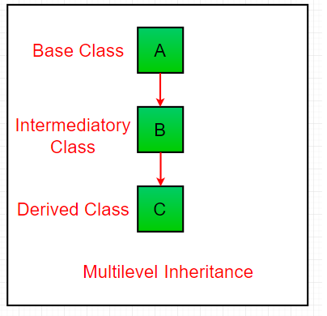

Hierarchical Inheritance:

one super class serve the remains sub classes .
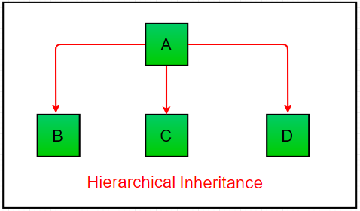

multiple inheritance (Through Interfaces):
in multiple inheritance one class can have more than one subclass and inherit features from all parent classes. We can achieve multiple inheritance only through interfaces.
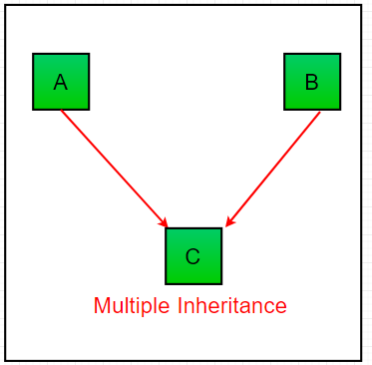

Java 8 support default methods where interfaces can provide default implementation of methods.

Java object creation of inherited class:
when a subclass object is created a separate object of super class object will not be created. only subclass object created is created that has super class variables.
Using final with Inheritance in java:
final is a keyword in java used for restricting some functionality can declare variables methods and classes with final keyword.

