Testcase-1: To retrieve order items from OrderService microservice

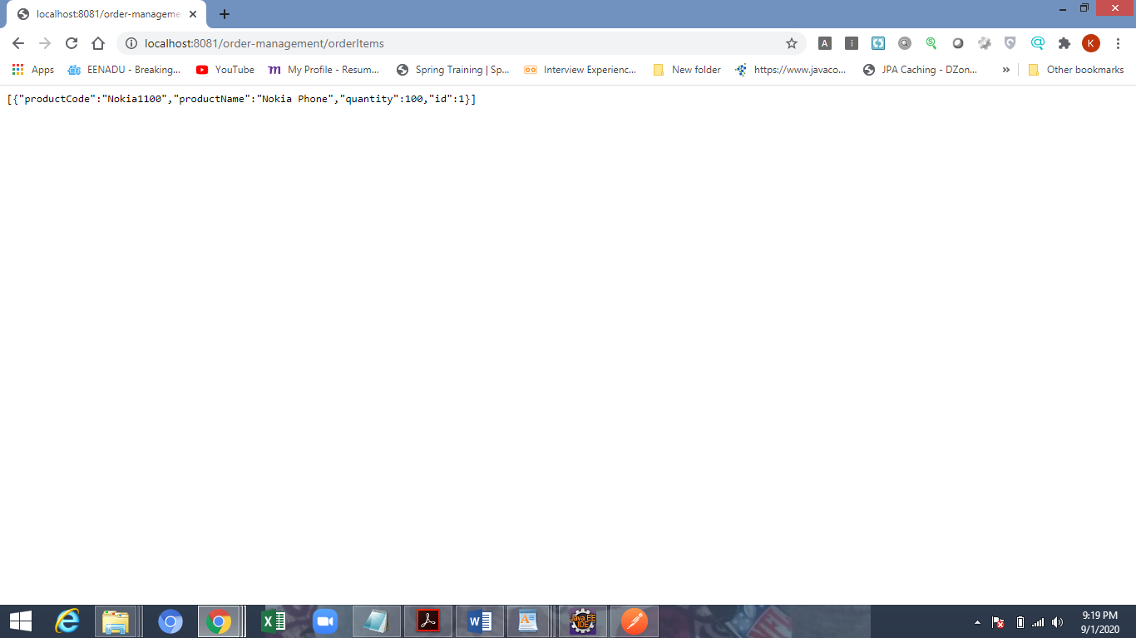

Testcase-2: To retrieve order items from OrderService microservice for a paerticular Order Item Id

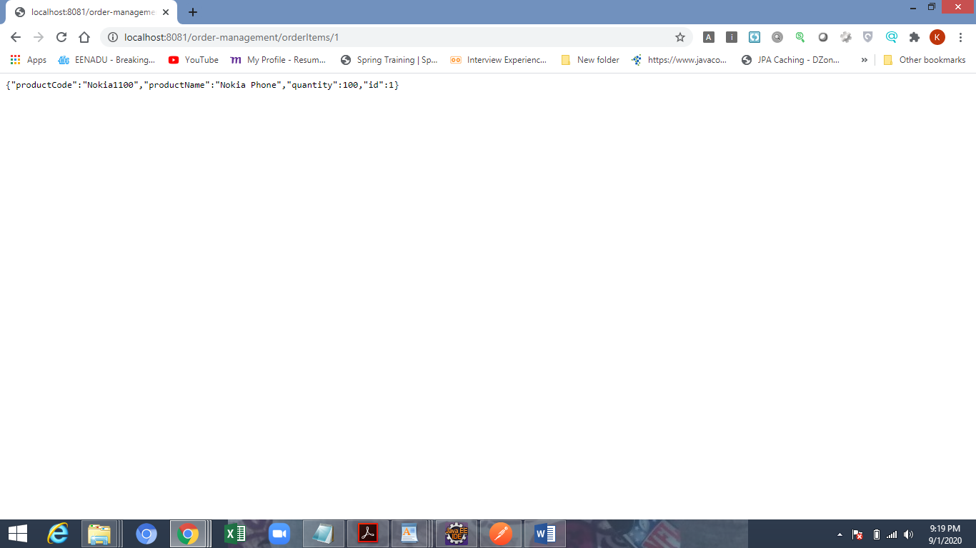

Testcase-3: To check validation for invalid Order Item Id from OrderService

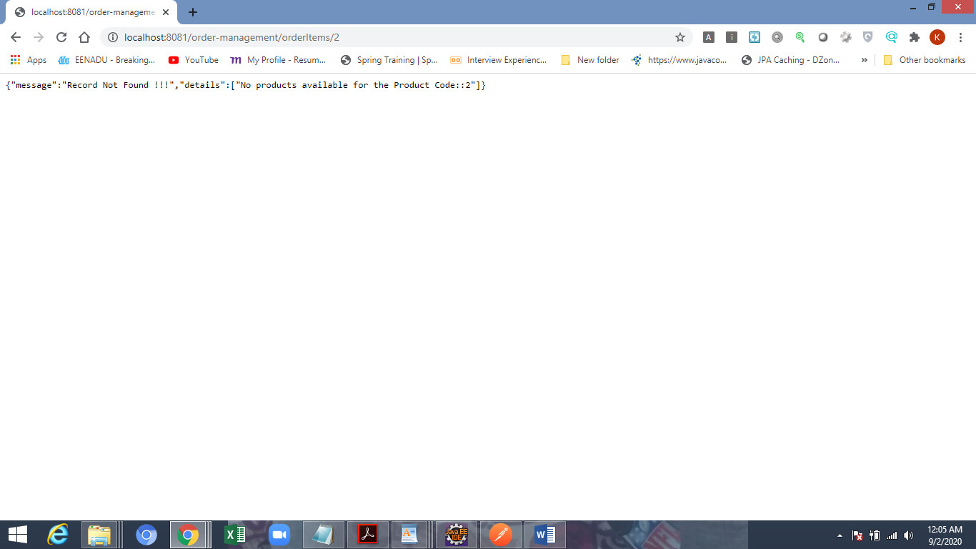

Testcase-4: To check validation for input missing for OrderService

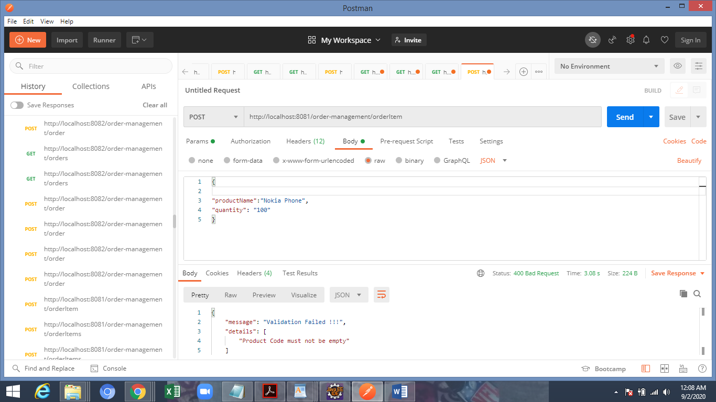

Testcase-5: To create Order from Order microservice

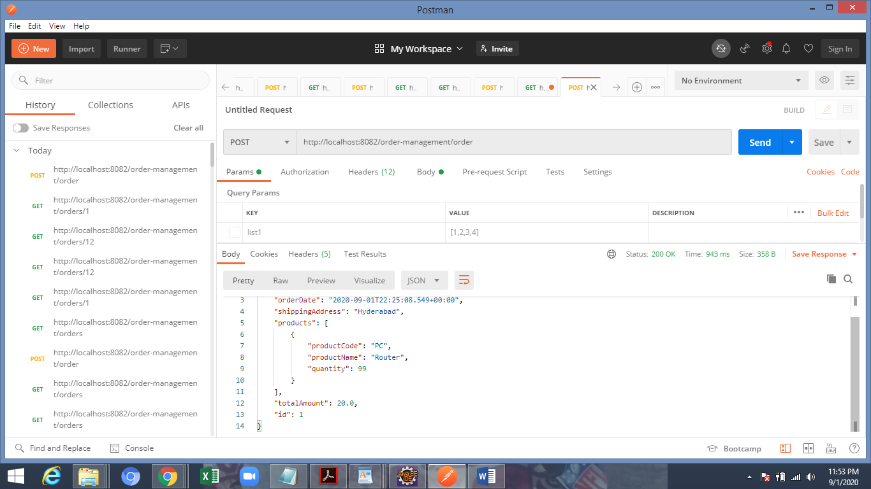

Testcase-6: To retrieve Order from Order microservice for a given Order Id

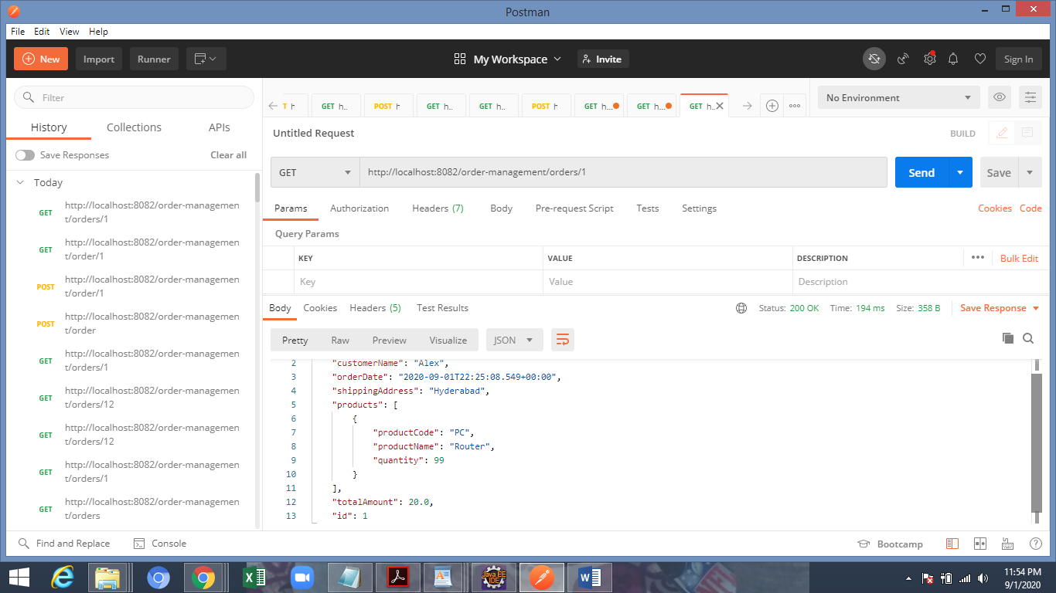

Testcase-7: To check vaidation for invalid order Id for an Order from Order microservice

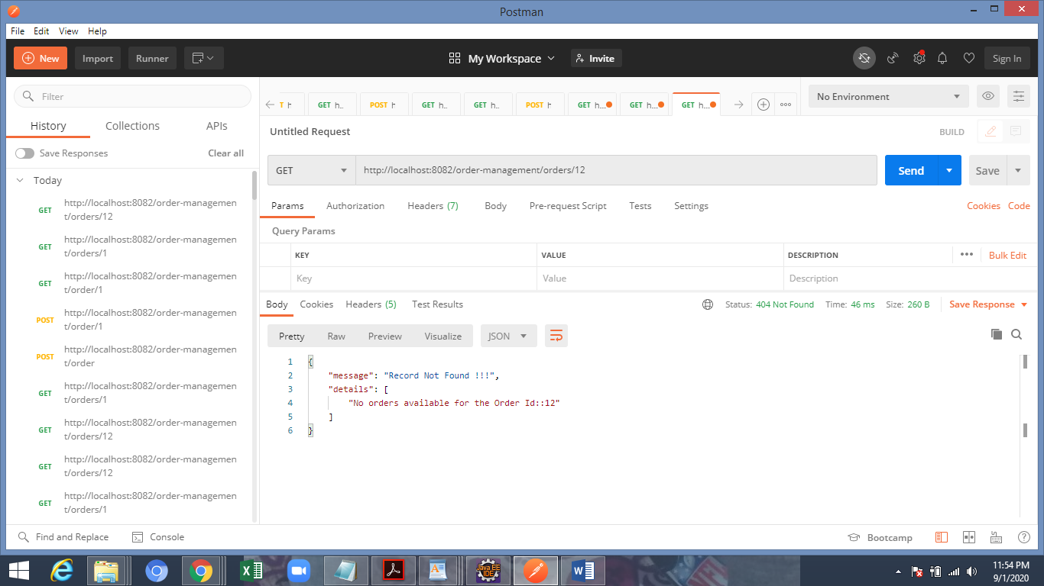

Test case- 8: Feign Client testing, getting output from OrderItem service invoked a client communication from Order service, can refer the URL for cross check

