💰 EXPENSE TRACKER
PROJECT REPORT

SUBMITTED BY: KRISHNA MISHRA
PROJECT TITLE: EXPENSE TRACKER

TECHNOLOGY USED:
-PYTHON
-PROJECT TYPE
-COMMAND-LINE BASED APPLICATION

1. ABSTRACT
The Expense Tracker is a Python-based command-line application designed to help users record and manage their daily expenses.
The application provides basic features such as adding expenses, viewing all expenses, calculating total spending, searching expenses by category or date, viewing monthly summaries, setting a monthly budget, checking the budget status, and deleting expenses.
The project uses file handling to store expense information so that the saved expenses can be loaded when the program starts.
The program is divided into different Python files such as main.py, expense.py, category.py, and budget.py. This modular structure makes the program easier to understand, maintain, and modify.

2. INTRODUCTION
Managing daily expenses is important for understanding personal spending habits. When expenses are recorded manually, it can become difficult to calculate total spending, identify spending categories, and keep track of a monthly budget.
The Expense Tracker was developed as a simple solution to this problem.
The application provides a menu-driven interface where the user can select different operations related to their expenses. The project focuses on implementing the basic concepts of Python such as functions, lists, dictionaries, loops, conditional statements, exception handling, file handling, and modules.

3. PROBLEM STATEMENT
People often record their daily expenses manually without having a proper way to organize or summarize them.
This can make it difficult to:
- Keep track of daily expenses
- Calculate total spending
- Understand spending by category
- Find a particular expense
- Check monthly spending
- Compare spending with a monthly budget
The purpose of this project is to provide a simple application that can perform these tasks in one place.

4. OBJECTIVES
The main objectives of the Expense Tracker are:
- To provide a simple way to record expenses.
- To store expense information for future use.
- To calculate total expenses.
- To organize expenses by category.
- To search expenses by category and date.
- To calculate monthly expenses.
- To allow users to set a monthly budget.
- To show the remaining budget.
- To allow users to delete unwanted expenses.
- To practice modular programming using Python.

5. SCOPE OF THE PROJECT
The project is mainly designed for individual users who want to maintain a simple record of their expenses.
The current system supports:
- Expense recording
- Expense viewing
- Expense searching
- Category-wise analysis
- Monthly analysis
- Budget management
- File-based data storage
The project can later be expanded into a graphical or web-based application with database support and additional financial features.

6. TECHNOLOGIES USED
Python
Python is used as the main programming language for developing the application.
File Handling
File handling is used to save and load expense information.
The project uses a file named expenses.
Lists
A list is used to store multiple expense records.
expenses = []
Dictionaries
Each expense is stored as a dictionary containing:
{
"date": "01-09-2026",
"category": "Food",
"amount": 500,
"description": "Lunch"
}
Functions
Functions are used to divide the program into smaller and manageable sections.
Modules
The program is divided into different Python files and imported into the main program.

7. SYSTEM ARCHITECTURE
The Expense Tracker follows a simple modular architecture.
The main program acts as the central part of the application and communicates with the different modules.

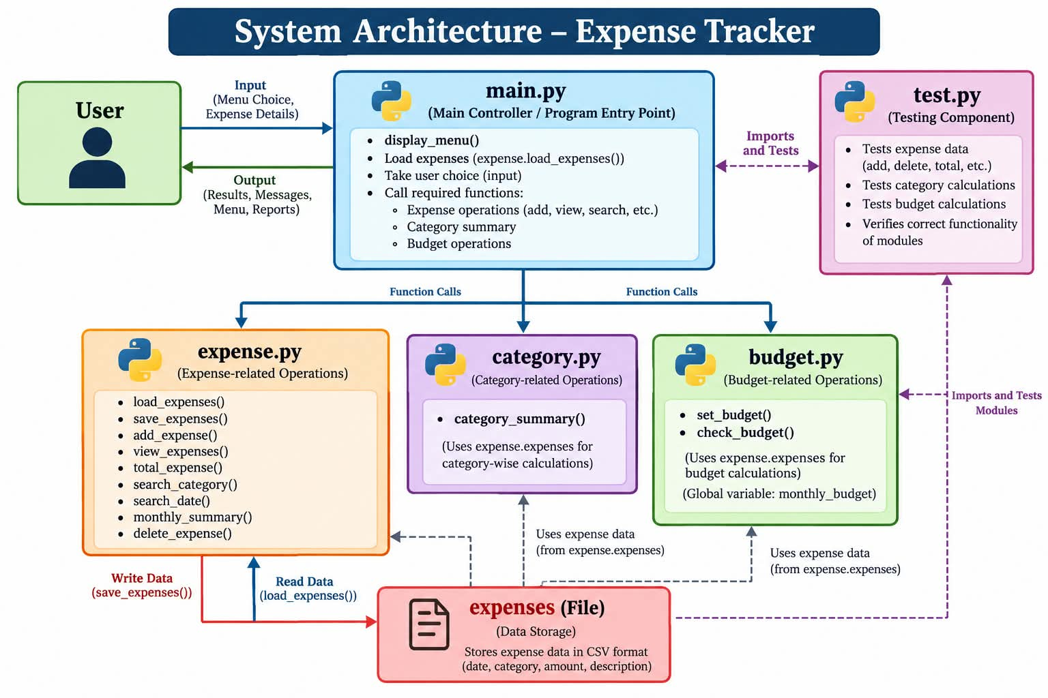

Architecture Components
main.py
Controls the menu and overall program flow.
expense.py
Handles adding, viewing, searching, saving, loading, and deleting expenses.
category.py
Handles category-wise expense summaries.
budget.py
Handles monthly budget operations.
expenses
Stores the expense information.

8. FLOWCHART
The overall working of the program can be represented as follows:

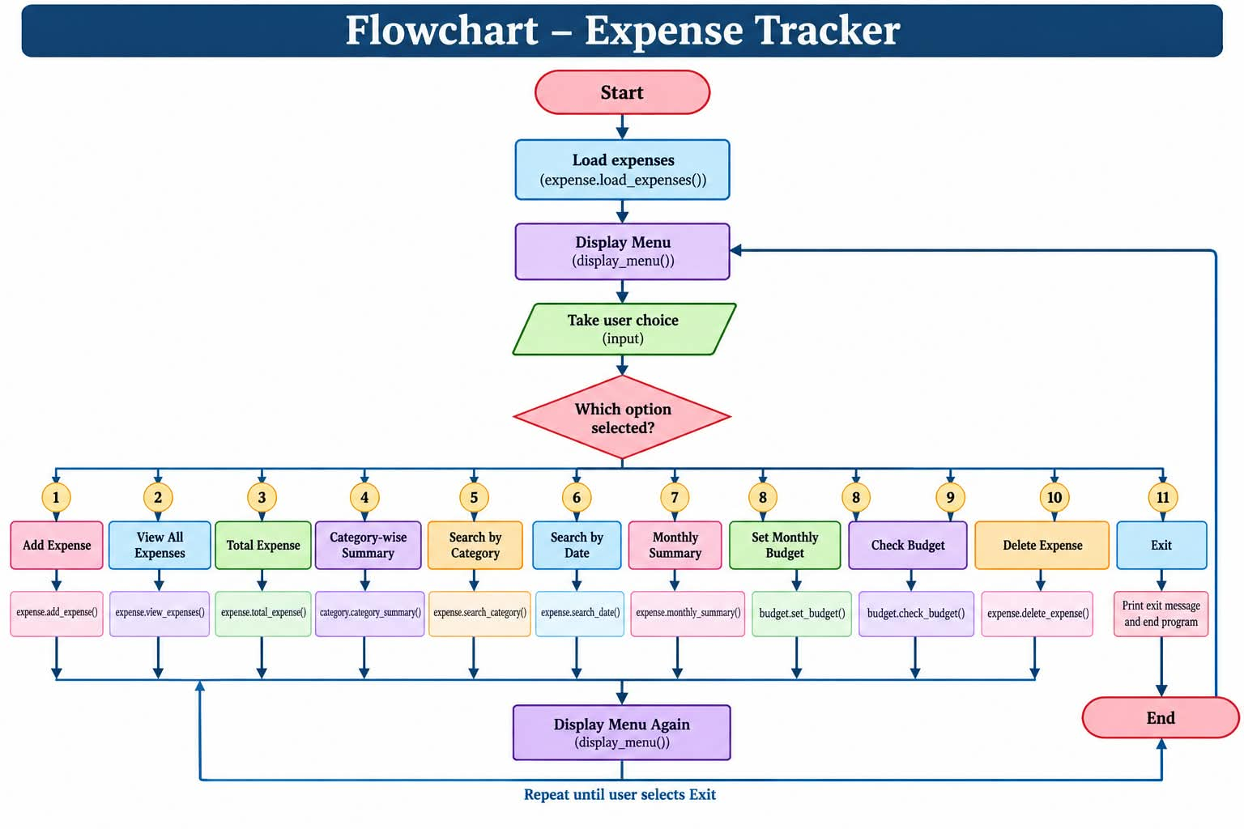

9. USE CASE DIAGRAM
The main actor in the system is the User.
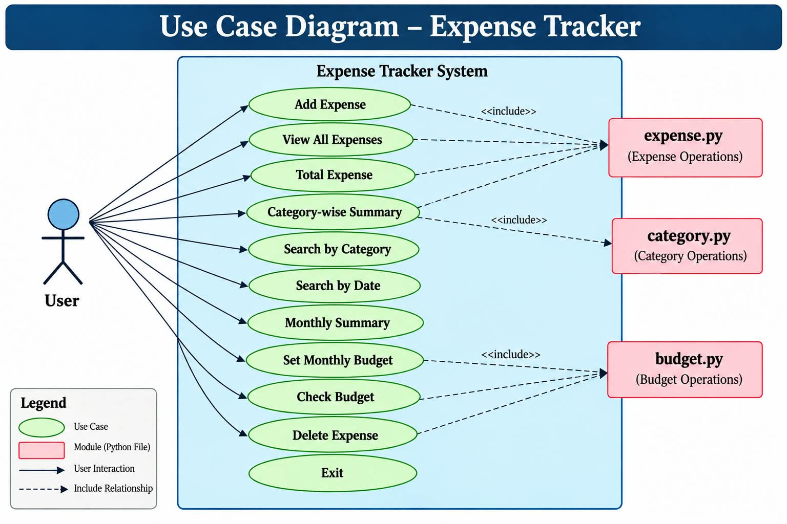
The user interacts with the application through the command-line menu.

10. SEQUENCE DIAGRAM
The sequence below shows how the system handles adding an expense.
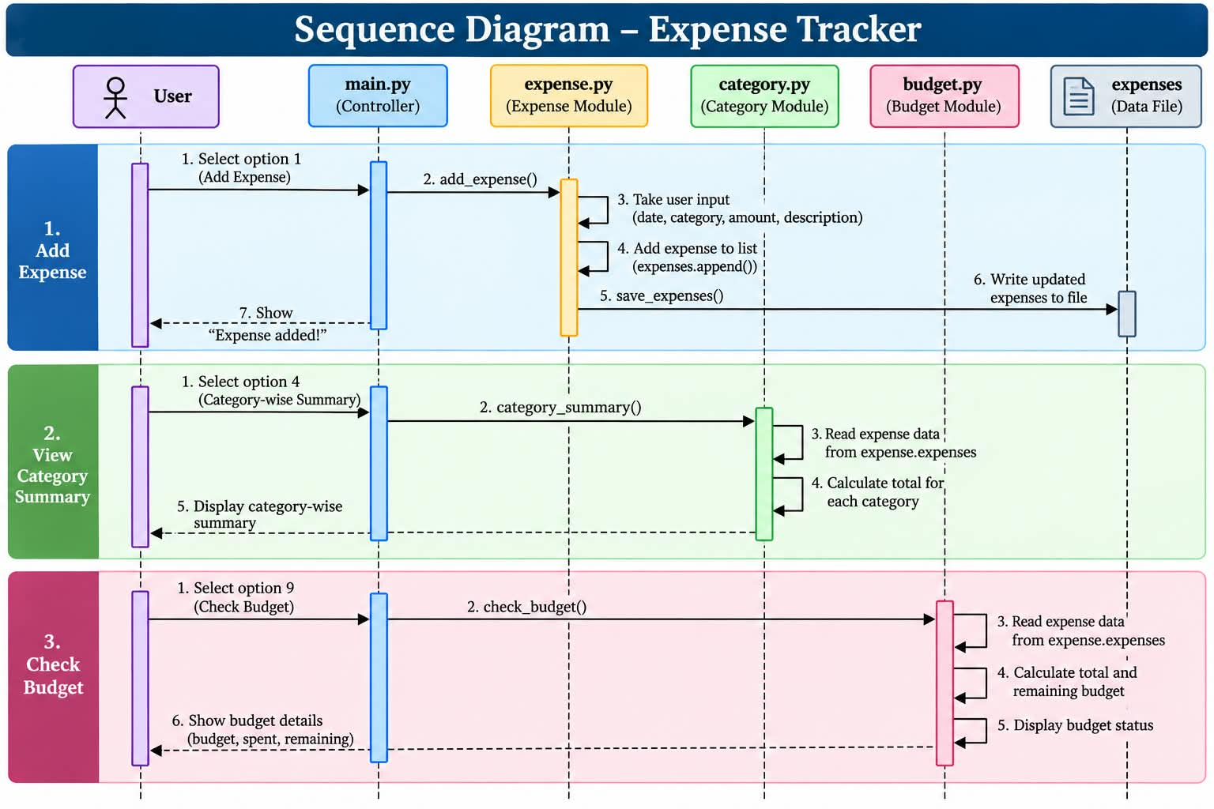

11. COMPONENT DIAGRAM
The main components of the project are:
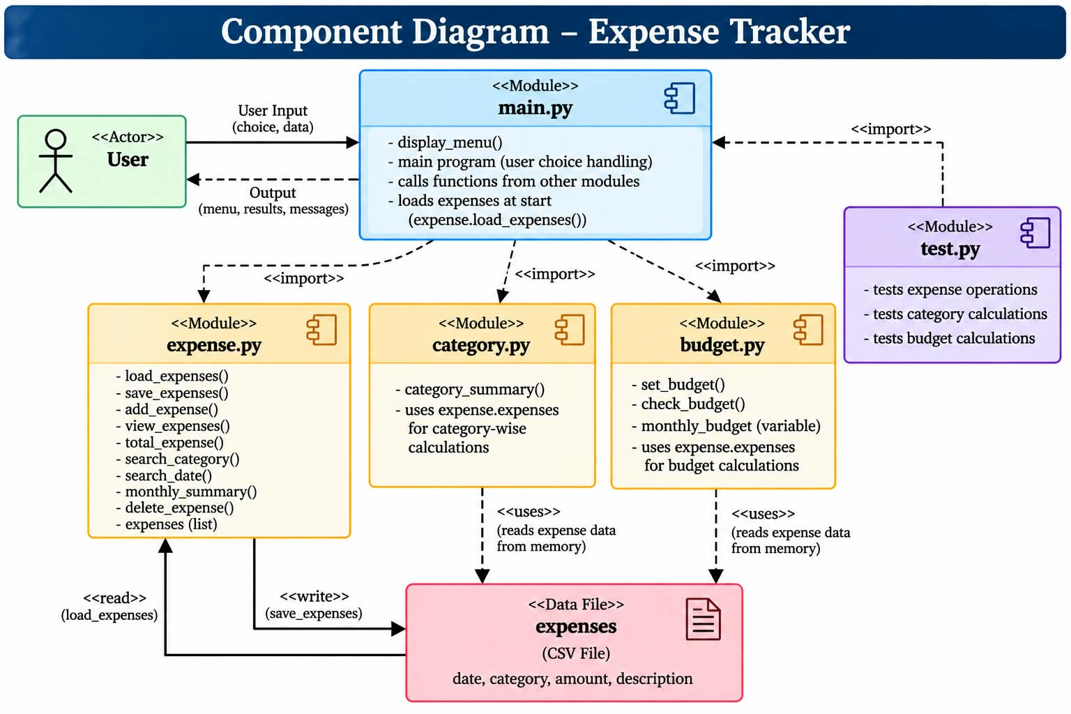

12. DESIGN DECISIONS AND RELATIONSHIPS
The project was divided into separate files instead of keeping all functions in one file.
This was done to make the code easier to understand and maintain.
main.py and expense.py
main.py imports the expense module and uses its functions when the user selects an expense-related option.
main.py and category.py
main.py uses the category module when the user wants to see a category-wise summary.
main.py and budget.py
main.py uses the budget module for setting and checking the monthly budget.
expense.py and expenses file
The expense.py module is responsible for loading and saving expense information.
Lists and Dictionaries
The expenses list contains individual expense dictionaries.
This structure makes it possible to store multiple records while keeping the details of each expense together.

13. IMPLEMENTATION
The application is implemented using basic Python programming concepts.
Adding Expenses
The add_expense() function takes the date, category, amount, and description from the user.
The amount is checked to make sure it is greater than zero.
The expense is then added to the list and saved.
Viewing Expenses
The view_expenses() function loops through the expense list and displays each expense.
Total Calculation
The total expense is calculated by adding the amount of every expense.
Category Summary
The category_summary() function identifies categories and calculates the total amount spent in each category.
Searching
The project provides two search functions:
search_category()
search_date()
The category search is case-insensitive.
Monthly Summary
The monthly_summary() function checks the month and year from the expense date and calculates the total spending for that month.
Budget
The set_budget() function allows the user to enter a monthly budget.
The check_budget() function compares the total spending with the budget and displays the remaining amount.
Delete Expense
The delete_expense() function allows the user to select an expense number and remove that expense from the list.

14. SCREENSHOTS
Screenshots of the running application can be added in this section.

Main Menu
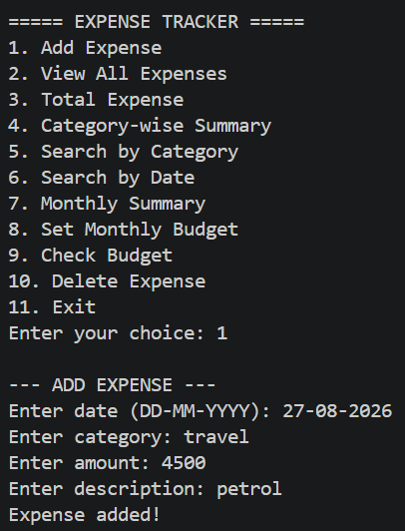

Adding an Expense

Viewing Expenses
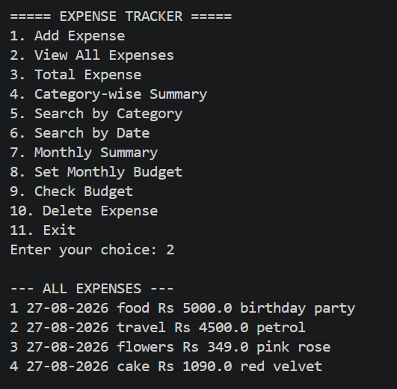

Total expenses
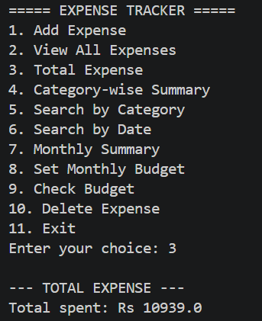

Category Summary
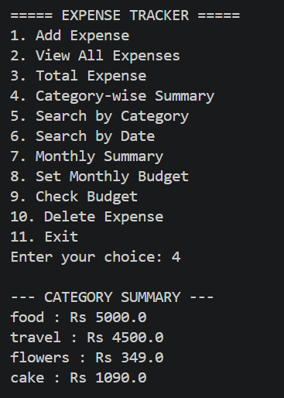

Search by category
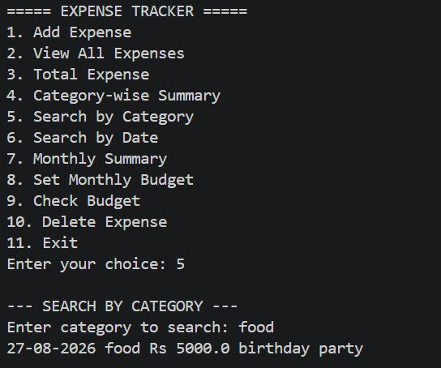

Search by date
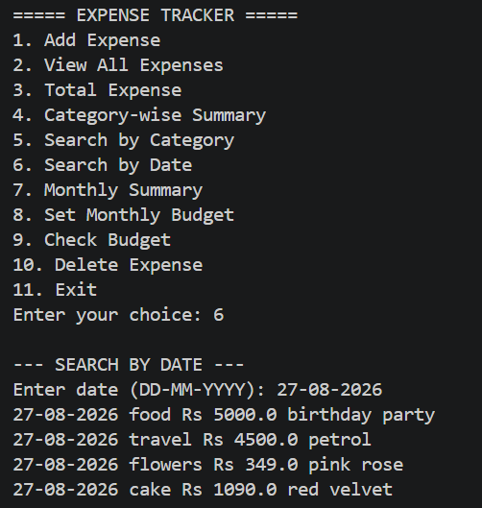

Monthly summary
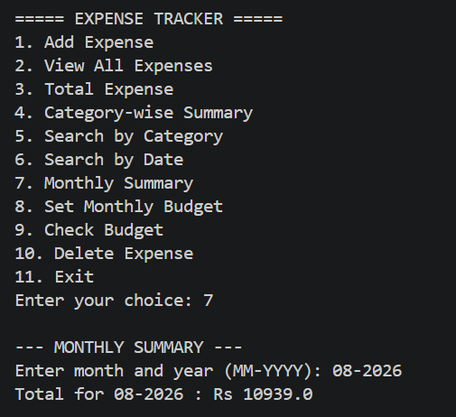

Budget Status
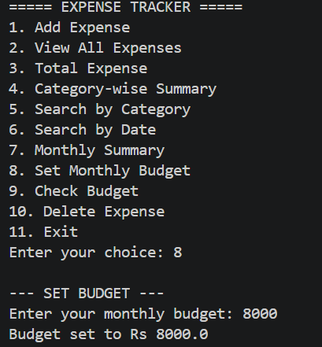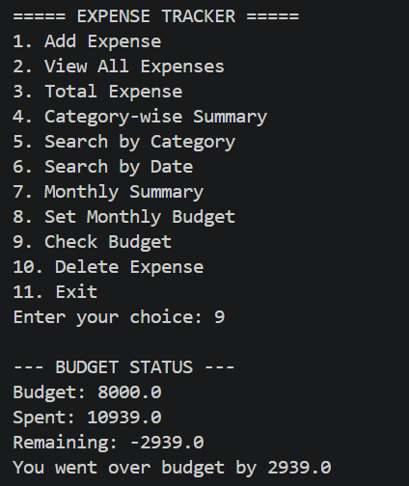

Delete Expense
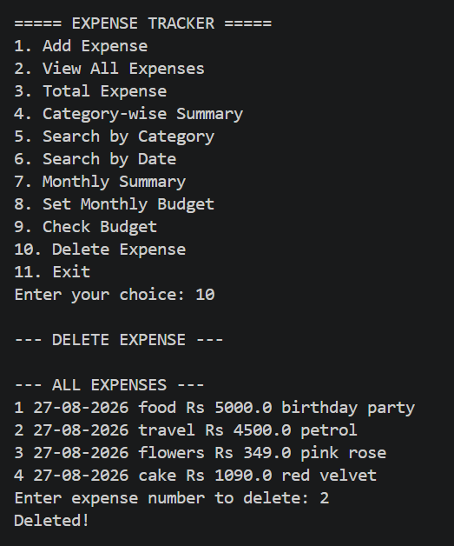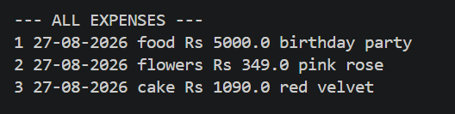

15. TESTING APPROACH
A separate test.py file is included in the project for basic testing.
The testing file uses Python's built-in assert statement.
The main areas tested are:
- Expense data storage
- Total expense calculation
- Category total calculation
- Budget calculation
- Expense deletion
Example:
assert total == 800
This checks whether the calculated total matches the expected value.
The test file can be run using:
python test.py
The testing approach is mainly focused on checking whether the basic calculations and operations produce the expected results.

16. CHALLENGES FACED
During the development of this project, some challenges were faced.
Dividing the Program
The original program contained all functions in one file. Dividing it into separate modules required deciding which functions belonged to expenses, categories, and budgets.
File Handling
Reading and writing the expense data to the file required proper handling of the stored information.
Input Validation
The program needs to handle incorrect amounts and invalid expense numbers without crashing.
Sharing Data Between Modules
Since different modules use the expense information, the project needed to maintain access to the expense list between the different parts of the program.
Testing Interactive Functions
Testing functions that normally require user input can be more difficult, so the basic test file focuses mainly on calculations and data operations.

17. LEARNING AND KEY TAKEAWAYS
This project helped me understand several important Python concepts.
I learned how to:
- Create and use functions.
- Work with lists and dictionaries.
- Use loops and conditional statements.
- Handle invalid input using exception handling.
- Read and write files.
- Divide a program into multiple modules.
- Import functions and modules.
- Build a menu-driven application.
- Store structured data using dictionaries.
- Perform basic testing using assert.
One of the main things I learned from this project was that dividing a larger program into smaller modules makes the code easier to understand and maintain.

18. FUTURE ENHANCEMENTS
The project can be improved in several ways in the future.
- Add a graphical user interface.
- Use SQLite or another database for data storage.
- Add an option to edit existing expenses.
- Add income tracking.
- Add graphs and charts.
- Save the monthly budget permanently.
- Improve date validation.
- Add CSV or Excel report export.
- Add user accounts.
- Add password protection.
- Add more detailed financial reports.

19. REFERENCES
Python Documentation
https://docs.python.org/
Python File Handling Documentation
https://docs.python.org/3/tutorial/inputoutput.html
Python Data Structures
https://docs.python.org/3/tutorial/datastructures.html
Python Functions
https://docs.python.org/3/tutorial/controlflow.html#defining-functions

20. CONCLUSION
The Expense Tracker is a simple Python-based application developed to manage and organize daily expenses.
The application provides useful features such as adding, viewing, searching, calculating, and deleting expenses. It also provides category-wise summaries, monthly summaries, and monthly budget management.
The project uses file handling for storing expense data and is divided into multiple Python modules to keep the program organized.
Overall, this project provided practical experience with Python programming, file handling, modular programming, data structures, exception handling, and basic software testing.
The current application provides the basic functionality required for an expense management system and can be further developed into a more advanced application with a database, graphical interface, charts, and additional financial features.

