

Maze Generator & Pathfinder
A DSA-Based Maze Generation and Pathfinding Visualization Project
NAME-Krishna Agarwal
REGISTRATION NUMBER- 26BAI10200
COURSE NAME- CSE SPECIALIZATION IN ARTIFICIAL INTELLIGENCE AND MACHINE LEARNING
VITyarthi — Build Your Own Project
September 2026

2. Introduction
A maze is one of the simplest structures that still captures the core ideas of graph theory: a set of locations (nodes) connected by passages (edges), with the interesting question being how to move through them efficiently. This project treats maze generation and maze solving as two separate, well-defined problems on the same underlying graph structure.
Studying this problem is directly relevant to Data Structures and Algorithms because it requires stacks and recursion (for generating the maze), queues (for Breadth-First Search), and, in later stages of this project, priority queues and heuristics (for Dijkstra's algorithm and A*). The same underlying problem — finding an efficient route through a network of connected points — appears in GPS route planning, robot and drone navigation, network packet routing, and game AI, which makes it a genuinely practical demonstration of these algorithms rather than a purely academic exercise.

3. Problem Statement
Manually solving a maze, or brute-forcing a route through one, doesn't scale and doesn't demonstrate why one algorithm might be preferable to another. This project treats a maze as a graph — each cell is a node, and each open passage between cells is an edge — so that classical graph-search algorithms can be applied to it directly and their behavior compared on identical ground.
The generation side of the project (building a random, guaranteed-solvable maze) and the solving side (finding a route through it) are deliberately built as independent components: the solver has no knowledge of how the maze was constructed, and only reads the finished wall layout. This mirrors how a real pathfinding system (e.g. GPS routing) has no control over the road network it's given — it can only work with the map as it exists.

4. Functional Requirements
The project is organized into three major functional modules, each with a clearly defined input and output.

Module 1 — Maze Generation Engine (maze_generator.py) — Implemented
- Input: grid dimensions (columns, rows)
- Output: a fully connected, solvable maze — a grid of Cell objects with walls carved out using Randomized DFS (the recursive backtracker algorithm)

Module 2 — Pathfinding Solver Engine (maze_solver.py) — Partially Implemented
- Input: the finished maze, a start cell, and an end cell
- Output: the shortest path between them, as an ordered list of cells, plus a status (found / searching / no path)
Currently implements Breadth-First Search (BFS), which is guaranteed to find the shortest path on an unweighted maze. DFS, Dijkstra, and A* are planned additions using the same input/output contract (see Section 14, Future Enhancements).

Module 3 — Visualization & Analytics Dashboard (visualizer.py) — Partially Implemented
- Input: live state from Modules 1 and 2, updated every frame
- Output: an animated Pygame window showing the maze being built, then solved, then the final path highlighted
Currently implements the visualization half of this module. The analytics half — a side-by-side comparison of multiple algorithms on the same maze — is planned (see Section 14).

5. Non-functional Requirements
NFR | How it applies to this project
Performance | BFS on the current 16×16 grid completes in well under a second; verified by timing headless test runs during development.
Usability | The program runs generation and solving automatically with no setup required; a future UI will let the user choose start/end cells and algorithm.
Scalability | Grid size is a single parameter (COLS, ROWS in visualizer.py) with no hardcoded assumptions elsewhere in the codebase, so larger mazes require no code changes.
Reliability | The solver returns an explicit "no_path" status instead of crashing if a maze has no solution, rather than assuming a path always exists.
Maintainability | maze_solver.py has zero import dependency on maze_generator.py — proven by a standalone self-test (Section 11) — so either module can be modified independently.
Resource efficiency | The maze is stored as a flat list of lightweight Cell objects rather than a nested structure, keeping memory use predictable as grid size grows.

6. System Architecture
The system is organized as three modules with a strict one-directional data contract: Module 1 produces a maze structure; Module 2 consumes that structure and produces a path; Module 3 orchestrates both and renders the result. Module 3 is the only file that imports pygame, and Module 2 never imports Module 1 — it only operates on whatever Cell objects it's handed, which is what makes it independently testable (see Section 11).
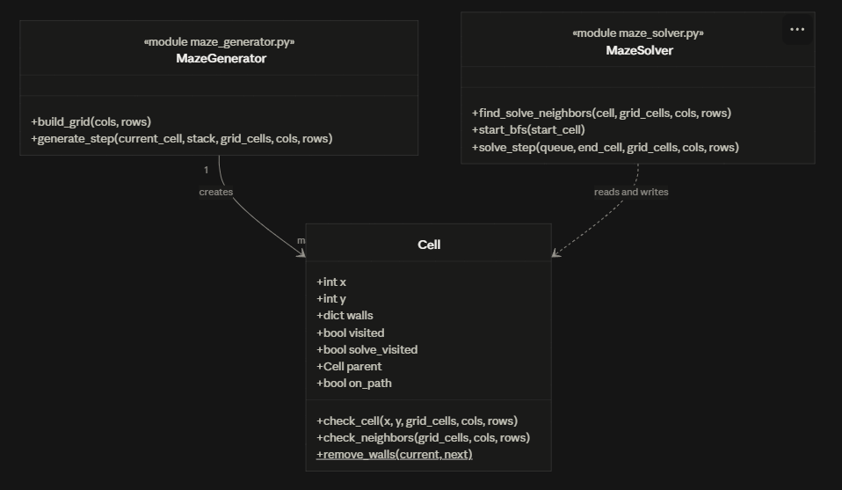.

7. Design Diagrams

7.1 Use Case Diagram
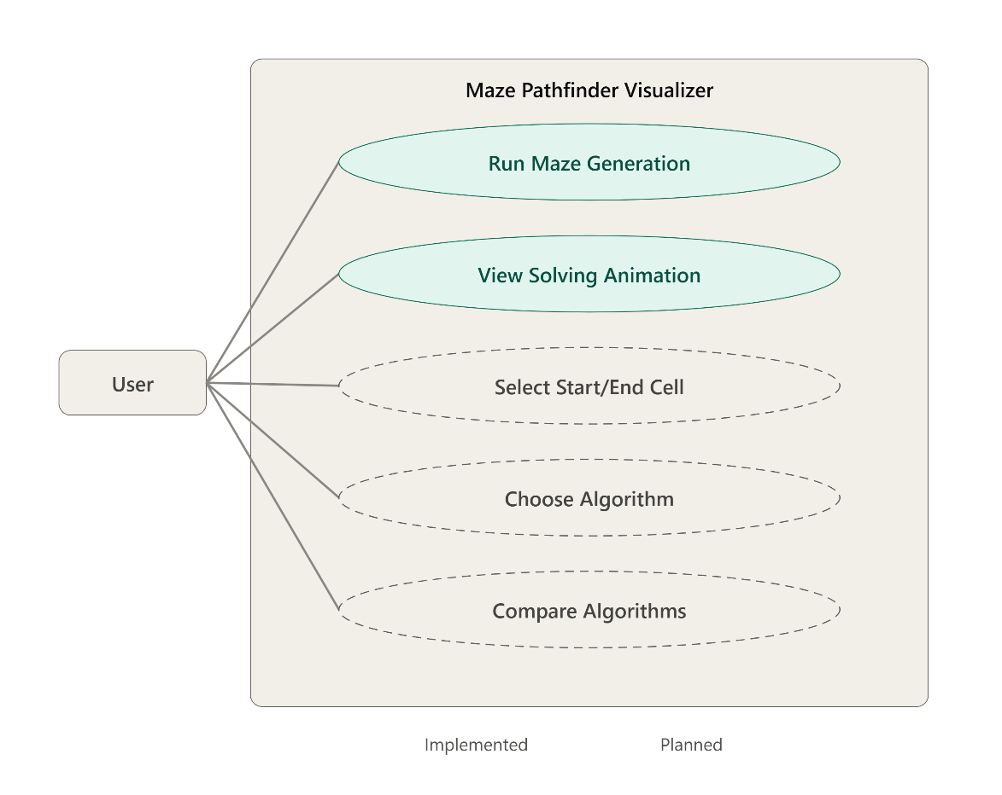

7.2 Workflow / Process Flow
Start → Build empty grid → Generate maze using Randomized DFS (animated) → Generation complete → Run BFS from start cell to end cell (animated) → Path found → Reveal path → Done.

7.3 Sequence Diagram
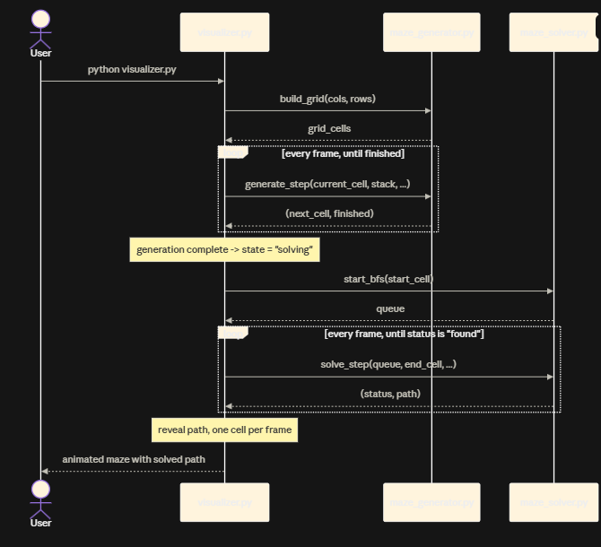.

7.4 Class / Component Diagram
Cell (in maze_generator.py) holds the shared grid data: position, walls, and separate visited flags for generation (visited) versus solving (solve_visited), plus a parent pointer used to reconstruct the path. maze_generator.py additionally defines build_grid() and generate_step(). maze_solver.py defines find_solve_neighbors(), start_bfs(), and solve_step(), and depends on Cell's fields only — never on maze_generator.py's functions.
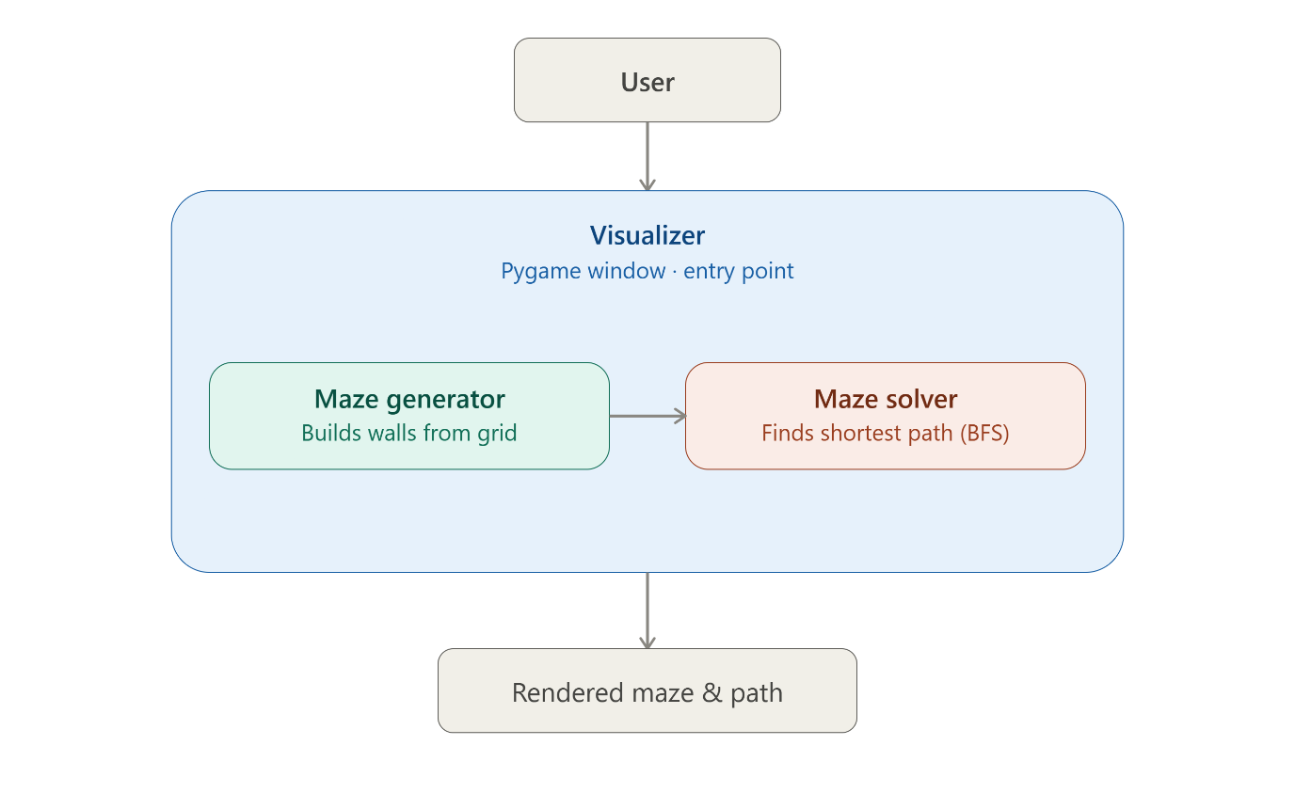

7.5 ER Diagram / Schema
Not applicable. This project does not use a database or persistent file storage — all maze and solver state exists only in memory during a single run.

8. Design Decisions & Rationale
- Randomized DFS for generation — chosen as the starting algorithm because it always produces a "perfect maze" (exactly one path between any two cells, no loops), which made it straightforward to verify correctness: every generated maze was checked to confirm all cells are reachable from the start.
- BFS as the first solver — chosen because it guarantees the shortest path on an unweighted graph and is simple to verify correctness against by hand on a small maze, making it a solid baseline before adding algorithms like Dijkstra and A* that trade simplicity for handling weighted edges or heuristic speed-ups.
- Explicit step functions instead of recursion or threads — generate_step() and solve_step() each perform exactly one unit of work and return control immediately. This was chosen over a truly recursive or multi-threaded implementation because Pygame requires the main loop to keep running (to stay responsive and keep redrawing); a step function called once per frame achieves animation without blocking the window or risking Python's recursion limit on a large maze.
- Strict module separation — maze_solver.py never imports maze_generator.py. This was a deliberate design choice, not an accident of file organization: it means the solver's correctness does not depend on any assumption about how the maze was built, and it can be tested completely on its own (Section 11).

9. Implementation Details

maze_generator.py
Defines the Cell class (position, walls dictionary, and the visited/solve_visited/parent/on_path fields shared across all three modules). check_neighbors() implements the generation-side neighbour rule: it ignores walls entirely (since none have been decided yet) and returns a random neighbour that hasn't been visited. remove_walls() is a static method that uses simple coordinate delta math (dx, dy between two adjacent cells) to knock down the shared wall on both sides. generate_step() ties this together as the module's public entry point: given the algorithm's current position and backtracking stack, it performs exactly one step — move into a new cell, backtrack, or signal that generation is complete.

maze_solver.py
Implements Breadth-First Search using Python's collections.deque as a FIFO queue. find_solve_neighbors() is the solving-side mirror of check_neighbors(): it checks the actual wall data (not ignoring it) and filters on a separate solve_visited flag so solving state never interferes with generation state. start_bfs() initializes the queue with the start cell. solve_step() performs one BFS step per call: pop the next cell, check if it's the goal (and if so, reconstruct the path by walking the parent chain backwards), otherwise enqueue any newly-reachable neighbours.

visualizer.py
The only module that imports pygame. Maintains a simple state machine ("generating" → "solving" → "revealing_path" → "done") in its main loop, calling into Module 1 or Module 2 depending on the current state, and redrawing the full grid every frame based on each cell's visited / solve_visited / on_path flags.

10. Screenshots / Results
Screenshots below were captured from a real run of the program (16×16 grid) at three key stages.
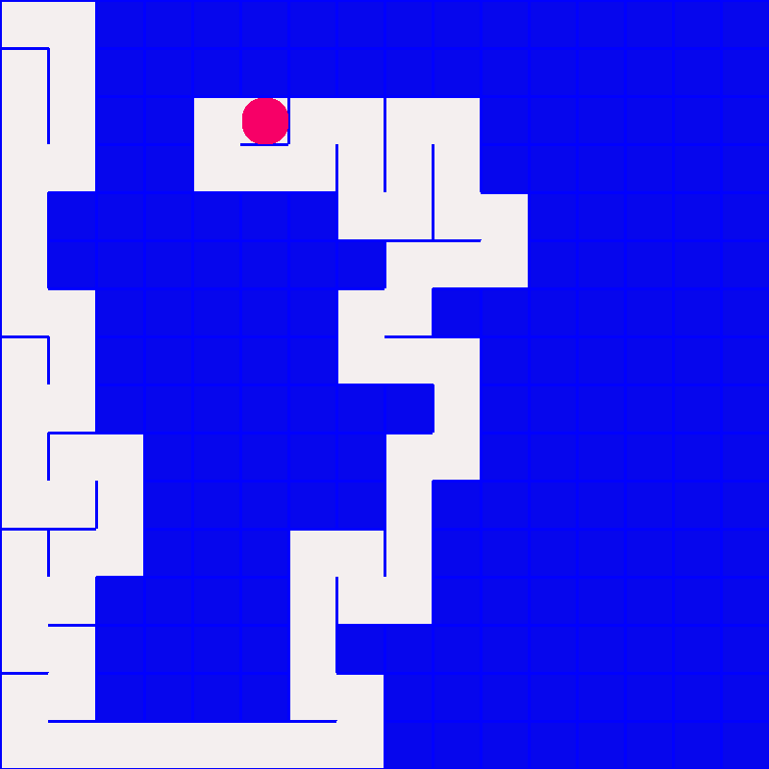
Figure 1: Maze generation in progress (Randomized DFS). The pink cell is the algorithm's current position; light cells have been visited.
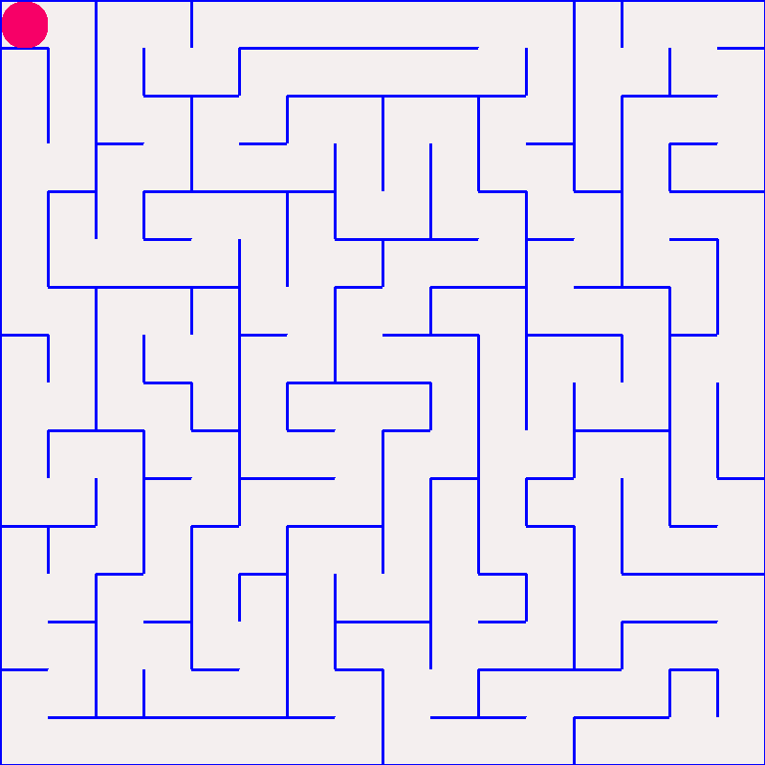
Figure 2: BFS exploring the completed maze. Blue-marked cells have been explored by the solver so far.
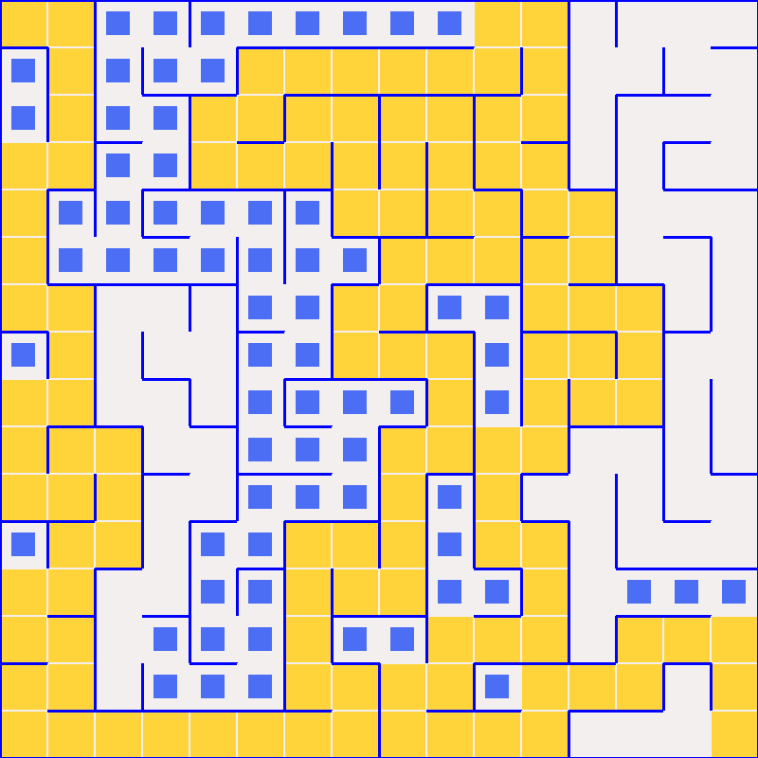
Figure 3: The final shortest path (yellow) revealed after BFS reaches the end cell.

11. Testing Approach
- Standalone solver self-test — maze_solver.py has a built-in `if __name__ == "__main__":` block that builds a maze, solves it with BFS, and asserts the path starts at the start cell and ends at the end cell, with no Pygame window opened at all. This directly demonstrates that Module 2 works correctly independent of Module 1 and Module 3.
- Full-pipeline headless test — the complete generation → solving → path-reveal pipeline was run using Pygame's dummy video driver (no visible window), confirming it runs to completion without errors across multiple runs of varying maze sizes.
- Maze connectivity check — after generation, every cell was confirmed to have been visited (visited = True), proving the maze has no unreachable, isolated pockets.
- Path validity check — every consecutive pair of cells in the returned BFS path was checked to differ by exactly one grid step (never “jumping” through a wall), confirming the reconstructed path is actually walkable.

12. Challenges Faced
- Reusing one “visited” flag for two purposes — an early version of the solver reused the same visited flag that generation had already set on every cell (since generation must visit every cell to finish). This made the solver think the entire maze was already explored before it started. The fix was introducing a separate solve_visited flag, kept completely independent of generation's visited flag.
- Animating an algorithm without freezing the window — the natural way to write DFS/BFS by hand runs the whole algorithm in one uninterrupted block, which would freeze the Pygame window until it finished. This was solved by restructuring both algorithms as step functions (generate_step(), solve_step()) that perform one unit of work per call, letting the main Pygame loop stay in control of pacing and redraw every frame.
- Project file setup on Windows — an early run of the program failed with a ModuleNotFoundError even though all files appeared to be in the same folder. The cause turned out to be running the script directly from inside an unextracted .zip archive rather than an actual folder on disk — resolved by extracting the archive first.

13. Learnings & Key Takeaways
- Separating algorithm logic from rendering code makes both easier to reason about and, critically, makes the algorithm code testable on its own without opening a window.
- The practical difference between BFS and DFS, once neighbour-checking and parent-tracking are correctly built, is a single line: a queue's popleft() versus a stack's pop(). The conceptual difference (shortest path vs. arbitrary path) comes entirely from that one change.
- A perfect maze (one built by a spanning-tree algorithm like randomized DFS) has exactly one path between any two cells — which means a real pathfinding comparison only becomes meaningful once weighted edges or multiple valid routes exist, motivating the planned move to Dijkstra and A* with weighted cells.
- Small, frequent Git commits made it far easier to track which change introduced which behavior, especially once bugs like the visited-flag conflict above appeared.

14. Future Enhancements
- Implement DFS as a second solver, reusing the same input/output contract as solve_step()
- Implement Dijkstra's algorithm with optional weighted “terrain” cells, using a priority queue (heapq)
- Implement A* search with a Manhattan-distance heuristic
- Add an interactive UI: click to set start/end cells, key press to switch active algorithm
- Add the analytics/comparison dashboard: run all implemented algorithms on the same maze and display path length, cells explored, and time taken side by side
- Support larger, user-configurable grid sizes without code changes

15. References
- Python 3 official documentation — docs.python.org
- Pygame official documentation — pygame.org/docs
- Youtube Videos for learning Graphs , dfs ,bfs algorithms
- Wikipedia for the logic behind pathfinder algorithm

