cp /home/hadoop/app_labels_new.txt /home/hadoop/capstonetelcom/stage/app_labels.txt

cp /home/hadoop/label_categories.csv /home/hadoop/capstonetelcom/stage/label_categories.csv

sqoop import --connect jdbc:mysql://mlc-testcapstone.cyaielc9bmnf.us-east-1.rds.amazonaws.com:3306/mlctest --table app_events --columns "event_id,app_id,is_installed,is_active" --target-dir /home/hadoop/capstonetelcom/stage/app_events2 --driver org.mariadb.jdbc.Driver --username student -P -m 1

sqoop import --connect jdbc:mysql://mlc-testcapstone.cyaielc9bmnf.us-east-1.rds.amazonaws.com:3306/mlctest --table brand_device --columns "device_id,phone_brand,device_model" --target-dir /home/hadoop/capstonetelcom/stage/brand_device --driver org.mariadb.jdbc.Driver --username student -P -m 1

sqoop import --connect jdbc:mysql://mlc-testcapstone.cyaielc9bmnf.us-east-1.rds.amazonaws.com:3306/mlctest --table events --columns "event_id,device_id,timestamp,longitude,latitude" --target-dir /home/hadoop/capstonetelcom/stage/events --driver org.mariadb.jdbc.Driver --username student -P -m 1

sqoop import --connect jdbc:mysql://mlc-testcapstone.cyaielc9bmnf.us-east-1.rds.amazonaws.com:3306/mlctest --table train --columns "device_id,gender,age,group_train" --target-dir /home/hadoop/capstonetelcom/stage/train --driver org.mariadb.jdbc.Driver --username student -P -m 1

hadoop fs -ls /home/hadoop/capstonetelcom/stage/app_events2



hadoop fs -ls /home/hadoop/capstonetelcom/stage/brand_device



hadoop fs -ls /home/hadoop/capstonetelcom/stage/events



hadoop fs -ls /home/hadoop/capstonetelcom/stage/train



hadoop fs -cat /home/hadoop/capstonetelcom/stage/app_events/part-m-00000 | head

hadoop fs -cat /home/hadoop/capstonetelcom/stage/brand_device/part-m-00000 | head

hadoop fs -cat /home/hadoop/capstonetelcom/stage/events/part-m-00000 | head

hadoop fs -cat /home/hadoop/capstonetelcom/stage/train/part-m-00000 | head

create table app_events_stg2(

event_id bigint,

app_id bigint,

is_installed int,

is_active int

)

ROW FORMAT DELIMITED

FIELDS TERMINATED BY ','

LINES TERMINATED BY '\n';

load data inpath ‘/home/hadoop/capstonetelcom/stage/app_events2’ into table app_events_stg2

create table app_events

stored as parquet

as

select event_id,app_id,is_installed,is_active from app_events_stg2;

create table brand_device_stg(

device_id bigint,

phone_brand string,

device_model string

)

ROW FORMAT DELIMITED

FIELDS TERMINATED BY ','

LINES TERMINATED BY '\n';

load data inpath ‘/home/hadoop/capstonetelcom/stage/brand_device’ into table brand_device_stg

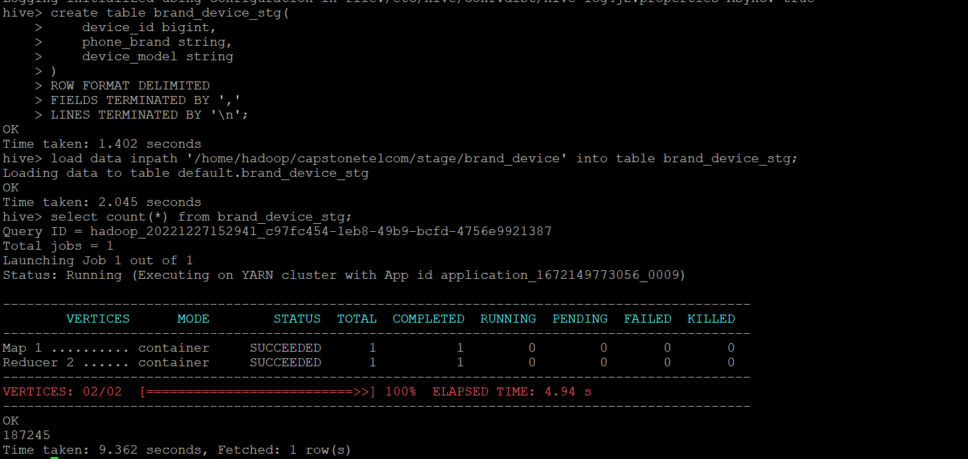

create table brand_device

stored as parquet

as

select device_id,phone_brand,device_model from brand_device_stg;

create table events_stg (

event_id bigint,

device_id bigint,

event_timestamp timestamp,

longitude decimal(10,2),

latitude decimal(10,2)

)

ROW FORMAT DELIMITED

FIELDS TERMINATED BY ','

LINES TERMINATED BY '\n';

load data inpath ‘/home/hadoop/capstonetelcom/stage/events’ into table events_stg;

create table events

stored as parquet

as

select event_id, device_id, event_timestamp, longitude, latitude from events_stg;

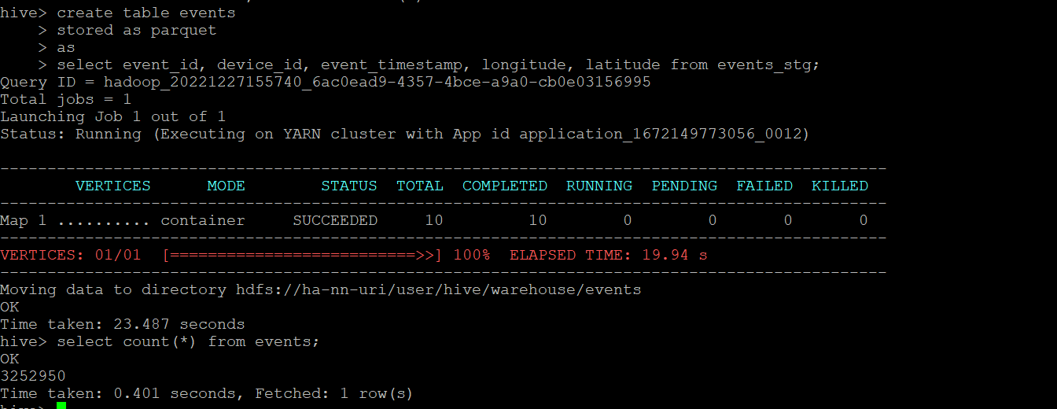

create table train_stg (

device_id bigint,

gender string,

age int,

group_name string

)

ROW FORMAT DELIMITED

FIELDS TERMINATED BY ','

LINES TERMINATED BY '\n';

load data inpath ‘/home/hadoop/capstonetelcom/stage/train’ into table train_stg;

create table train

stored as parquet

as

select device_id, gender, age, group_name from train_stg;

