**Data Preparation for Modelling**

**Creating table app_data**

create table app_data

stored as parquet

as

select

a.event_id, a.app_id, a.is_installed, a.is_active,

b.label_id, c.category

from

app_events3 a,

app_labels3 b,

label_categories3 c

where

a.app_id = b.app_id and

b.label_id = c.label_id;

**Shape of the app_data**

**Dump the app_data into S3**

set mapred.reduce.tasks = 1;

insert overwrite directory 's3://upgradcapstone2022bucket/capstonedata/app_data.csv'

row format delimited fields terminated by ','

select

event_id, app_id, is_installed, is_active,

label_id, category

from

app_data

order by event_id;

set mapred.reduce.tasks = -1;

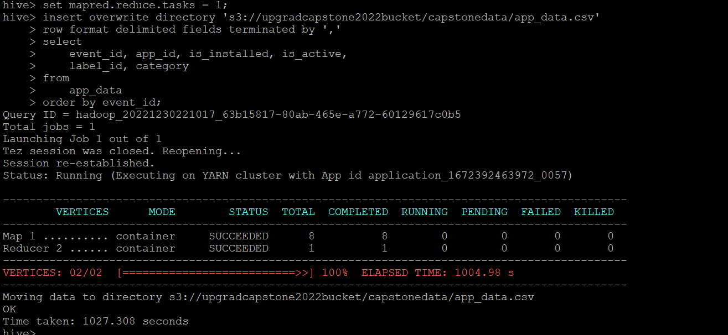

**Creating event_data**

create table event_data1

stored as parquet

as

select

a.event_id, a.device_id, a.event_timestamp,a.longitude,a.latitude,

b.gender,b.age,b.group_name

from

events3 a left join train3 b on a.device_id=b.device_id;

**Shape of the data**

**Dump event_data1 into S3**

set mapred.reduce.tasks = 1;

insert overwrite directory 's3://upgradcapstone2022bucket/capstonedata/event_data.csv'

row format delimited fields terminated by ','

select

event_id, device_id, event_timestamp,longitude,latitude,

gender,age, group_name

from

event_data1

order by device_id;

set mapred.reduce.tasks = -1;

**Creating non_event_data**

create table non_event_data1

stored as parquet

as

select

a.device_id, a.phone_brand, a.device_model,

b.gender,b.age, b.group_name

from

brand_device3 a left join train3 b on a.device_id=b.device_id;

**Shape of the data**

**Dump non_event_data to S3**

set mapred.reduce.tasks = 1;

insert overwrite directory 's3://upgradcapstone2022bucket/capstonedata/non_event_data.csv'

row format delimited fields terminated by ','

select

device_id, phone_brand, device_model,

gender,age, group_name

from

non_event_data1

order by device_id;

set mapred.reduce.tasks = -1;

