**Hive analysis**

**Created external tables and data is stored in parquet format which is faster in accessing**

create external table app_events_stg2(

event_id bigint,

app_id bigint,

is_installed int,

is_active int

)

ROW FORMAT DELIMITED

FIELDS TERMINATED BY ','

LINES TERMINATED BY '\n';

load data inpath ‘/home/hadoop/capstonetelcom/stage/app_events2’ into table app_events_stg2

create table app_events

stored as parquet

as

select event_id,app_id,is_installed,is_active from app_events_stg2;

create external table brand_device_stg(

device_id bigint,

phone_brand string,

device_model string

)

ROW FORMAT DELIMITED

FIELDS TERMINATED BY ','

LINES TERMINATED BY '\n';

load data inpath ‘/home/hadoop/capstonetelcom/stage/brand_device’ into table brand_device_stg

create table brand_device

stored as parquet

as

select device_id,phone_brand,device_model from brand_device_stg;

create external table events_stg (

event_id bigint,

device_id bigint,

event_timestamp timestamp,

longitude decimal(10,2),

latitude decimal(10,2)

)

ROW FORMAT DELIMITED

FIELDS TERMINATED BY ','

LINES TERMINATED BY '\n';

load data inpath ‘/home/hadoop/capstonetelcom/stage/events’ into table events_stg;

create table events

stored as parquet

as

select event_id, device_id, event_timestamp, longitude, latitude from events_stg;

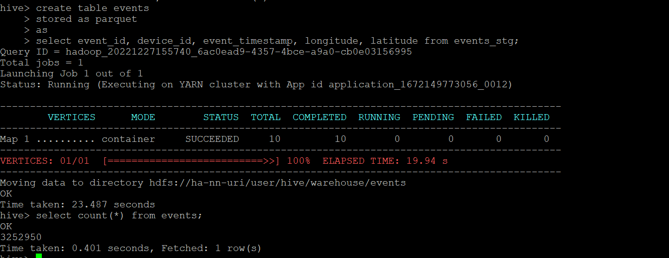

create external table train_stg (

device_id bigint,

gender string,

age int,

group_name string

)

ROW FORMAT DELIMITED

FIELDS TERMINATED BY ','

LINES TERMINATED BY '\n';

load data inpath ‘/home/hadoop/capstonetelcom/stage/train’ into table train_stg;

create table train

stored as parquet

as

select device_id, gender, age, group_name from train_stg;

create external table label_categories_stg3(

label_id bigint,

category string

)

ROW FORMAT DELIMITED

FIELDS TERMINATED BY ','

LINES TERMINATED BY '\n'

stored as textfile

location '/home/hadoop/capstonetelcom/stage/labelcategories/'

tblproperties ('skip.header.line.count'='1');

create table label_categories

stored as parquet

as

select label_id,category from label_categories_stg3;

create external table app_labels_stg3(

app_id bigint,

label_id bigint

)

ROW FORMAT DELIMITED

FIELDS TERMINATED BY ','

LINES TERMINATED BY '\n'

stored as textfile

location '/home/hadoop/capstonetelcom/stage/applabels'

tblproperties ('skip.header.line.count'='1');

create table app_labels

stored as parquet

as

select app_id,label_id from app_labels_stg3;

**Analytics report**

The 10 most popular brands and the percentage of the respective Male and Female owners of these brands [Handle the device id duplicates from brand_device table.]

The 10 most popular brands for Male and Female? [Handle the device id duplicates from the brand_device data set.]

The count and percentage analysis of the Gender in the train data set

The top mobile phone brands offering the highest number of models [Provide details about the top three brands.]

The average number of events per device id [Applicable to the device_id column from the train table, which has at least one associated event in the event table]

Whether the count and percentage of the device_id column in the train table have corresponding events data available