**Hive analysis**

**Created external tables and data is stored in parquet format which is faster in accessing**

create external table app_events_stg3(

event_id bigint,

app_id bigint,

is_installed int,

is_active int

)

ROW FORMAT DELIMITED

FIELDS TERMINATED BY ','

LINES TERMINATED BY '\n';

load data inpath ‘/home/hadoop/capstonetelcom/stage/app_events2’ into table app_events_stg3;

create table app_events3

stored as parquet

as

select event_id,app_id,is_installed,is_active from app_events_stg3;

--------------------------------------------------------------------------------------------------------------------------------------

create external table brand_device_stg3(

device_id bigint,

phone_brand string,

device_model string

)

ROW FORMAT DELIMITED

FIELDS TERMINATED BY ','

LINES TERMINATED BY '\n';

load data inpath ‘/home/hadoop/capstonetelcom/stage/brand_device’ into table brand_device_stg3;

create table brand_device3

stored as parquet

as

select device_id,phone_brand,device_model from brand_device_stg3;

--------------------------------------------------------------------------------------------------------------------------------------

create external table events_stg3 (

event_id bigint,

device_id bigint,

event_timestamp timestamp,

longitude decimal(10,2),

latitude decimal(10,2)

)

ROW FORMAT DELIMITED

FIELDS TERMINATED BY ','

LINES TERMINATED BY '\n';

load data inpath ‘/home/hadoop/capstonetelcom/stage/events’ into table events_stg3;

create table events3

stored as parquet

as

select event_id, device_id, event_timestamp, longitude, latitude from events_stg3;

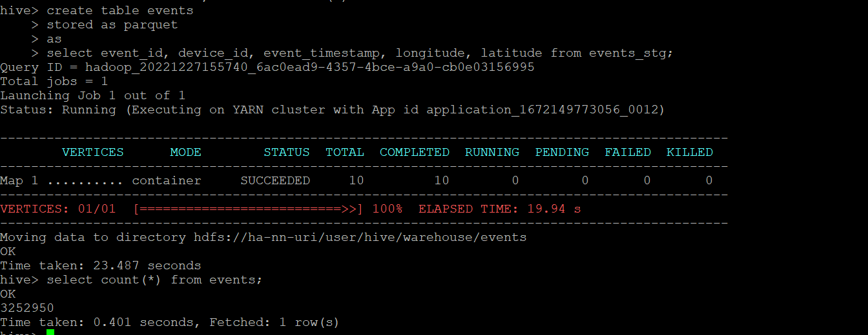

--------------------------------------------------------------------------------------------------------------------------------------

create external table train_stg3 (

device_id bigint,

gender string,

age int,

group_name string

)

ROW FORMAT DELIMITED

FIELDS TERMINATED BY ','

LINES TERMINATED BY '\n';

load data inpath ‘/home/hadoop/capstonetelcom/stage/train’ into table train_stg3;

create table train3

stored as parquet

as

select device_id, gender, age, group_name from train_stg3;

--------------------------------------------------------------------------------------------------------------------------------------

create external table label_categories_stg3(

label_id bigint,

category string

)

ROW FORMAT DELIMITED

FIELDS TERMINATED BY ','

LINES TERMINATED BY '\n';

load data local inpath '/home/hadoop/capstonetelcom/stage/labelcategories/label_categories.csv' into table label_categories_stg3;

create table label_categories3

stored as parquet

as

select label_id,category from label_categories_stg3;

--------------------------------------------------------------------------------------------------------------------------------------

create external table app_labels_stg3(

app_id bigint,

label_id bigint

)

ROW FORMAT DELIMITED

FIELDS TERMINATED BY ','

LINES TERMINATED BY '\n';

load data local inpath '/home/hadoop/capstonetelcom/stage/applables/app_labels_new.txt' into table app_labels_stg3;

create table app_labels3

stored as parquet

as

select app_id,label_id from app_labels_stg3;

**Analytics report**

**1. The 10 most popular brands and the percentage of the respective Male and Female owners of these brands [Handle the device id duplicates from brand_device table.]**

select phone_brand, ((malecount/totalcount)*100) as male_owner_percentage,

((femalecount/totalcount)*100) as female_owner_percentage

from

(select count(a.device_id) as cnt1, a.phone_brand, count(case when gender=='M' then 1 end) as malecount, count(case when gender=='F' then 1 end) as femalecount, count(gender) as totalcount

from

(Select device_id, count(1) cnt from brand_device3 group by device_id having cnt=1) c,

brand_device3 a,

train3 b

where

a.device_id=b.device_id and

a.device_id=c.device_id

group by a.phone_brand

order by cnt1 desc

limit 10) n;

**2. The 10 most popular brands for Male and Female? [Handle the device id duplicates from the brand_device data set.]**

with cte as (

select

b.gender,

a.phone_brand,

count(a.device_id) as c,

dense_rank() over (partition by b.gender order by count(a.device_id) desc) as dr

from

(Select device_id, count(1) cnt from brand_device3 group by device_id having cnt=1) c,

brand_device3 a,

train3 b

where

a.device_id=b.device_id and

a.device_id=c.device_id

group by b.gender, a.phone_brand

)

select *

from cte

where dr <= 10

order by gender, c desc;

**3. The count and percentage analysis of the Gender in the train data set**

select male as male_count, female as female_count, (male/total)*100 as male_percentage, (female/total)*100 as female_percentage

from(

select COUNT(case when gender=='M' then 1 end) as male,

COUNT(case when gender=='F' then 1 end) as female,

COUNT(gender) as total

from train3) n;

**4. The top mobile phone brands offering the highest number of models [Provide details about the top three brands.]**

select count(a.device_id) as device_count, a.phone_brand, count(device_model) as model_count

from

(Select device_id, count(1) cnt from brand_device3 group by device_id having cnt=1) c,

brand_device3 a,

train3 b

where

a.device_id=b.device_id and

a.device_id=c.device_id

group by a.phone_brand

order by device_count desc

limit 3;

**5. The average number of events per device id [Applicable to the device_id column from the train table, which has at least one associated event in the event table]**

select (sum(event_count)/count(device_id)) as avg_events_per_device

from

(select

a.device_id, count(a.event_id) as event_count

from

events3 a,

train3 b

where

a.device_id = b.device_id

group by a.device_id) as n;

**6. Whether the count and percentage of the device_id column in the train table have corresponding events data available**

select count(device_id) from train3;

Yes the count and percentage of device id column in train table have events data. Below is the query and screenshot

select

count(b.device_id) as device_count, ((count(b.device_id) * 100.0)/74645) as device_percentage

from

events3 a,

train3 b

where

a.device_id = b.device_id

having count(a.event_id) >0;

