**Basic SQL analysis**

**Count of unique device ids in the train table**

Select count(distinct(device_id)) from train;

Identified 74645 unique device ids



**Check whether there are any duplicate device ids present in the brand_device table. If yes, how many duplicates?**

Select device_id, count(1) cnt from brand_device group by device_id having cnt>1;

There are duplicates

Select count(device_id) from (Select device_id, count(1) cnt from brand_device group by device_id having cnt>1) a;

Identified 532 duplicates

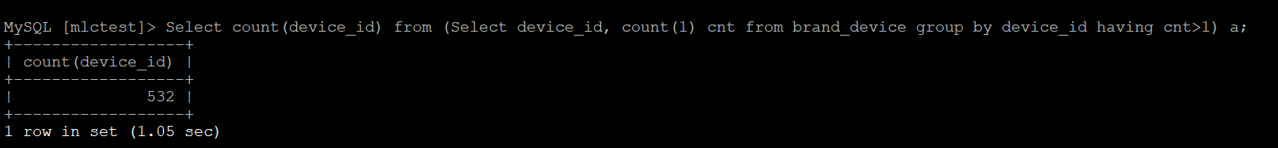

**Number of unique phone brands from the brand_device table**

Select count(distinct(phone_brand)) from brand_device;

There are distinct 97 phone brands

**Count of device ids where the latitude and longitude detail are zero, from the events table**

Select count(device_id) from events where latitude>0 and longitude=0;

There are 24 rows with lat and long =0

