**SOP for Tableau Licenses and Troubleshooting**

**Date: 03/01/2023**

**Document Revision History**

|  |  |  |  |  |
| --- | --- | --- | --- | --- |
| **Version** | **Date** | **Author** | **Status** | **Notes** |
| 1.0 | 03/01/2023 | Sumeet | Draft |  |
|  |  |  |  |  |
|  |  |  |  |  |

​​Contents

​

​

​

​​

Introduction

This document details on the process followed to Validate and Apply Tableau licenses. This covers entire process of how we are applying licenses and various Troubleshooting steps in case of any issues with the same.

Tableau server details:

|  |  |  |  |  |
| --- | --- | --- | --- | --- |
| **#** | **Environment** | **Account** | **Tableau server name** | **IP address** |
| 1 | dev | non-prod | Tableau-Init | 10.130.86.84 [CORE] |
| 4 | pre-prod | prod | CalHEERs-Production-clpreprdtblu01 | 10.131.149.192 [CORE] |
| 6 | prod | prod | CalHEERs-Production-clprdtblu01 | 10.131.149.14 [CORE] |
| 7 | prod | prod | CalHEERs-Production-clprdtblu02 | 10.131.150.172 |
| 8 | prod | prod | CalHEERs-Production-clprdtblu03 | 10.131.151.161 |

Admin Console Links for all the 3 environments.

Non-Prod - [https://10.130.86.84:8850](https://10.130.86.84:8850/)

Pre-Prod - [https://10.131.149.192:8850](https://10.131.149.192:8850/)

Production - [https://10.131.149.14:8850](https://10.131.149.14:8850/)

These are accessible with tabsvcnonprod and tabsvcprod user credentials are stored in OPAM

License Details

1. To fetch license details for tableau login to the customer portal using the below link.

<https://customer-portal.tableau.com/s/my-keys>

2. once you are under the portal navigate to the licenses.\

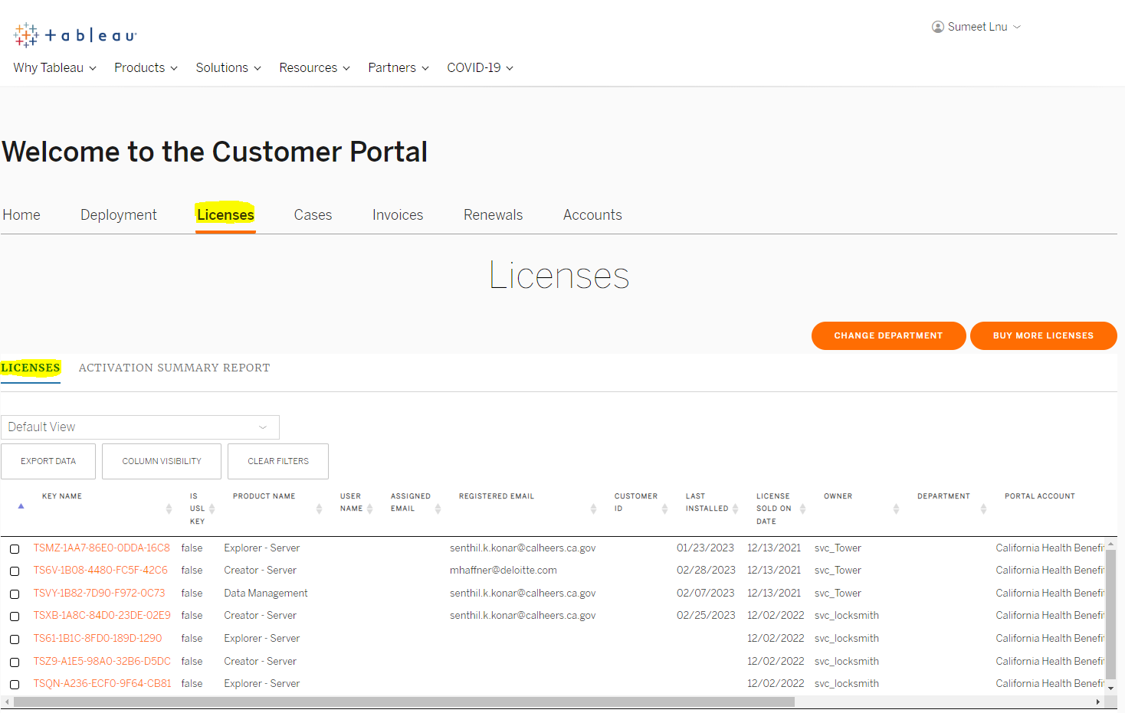

3. All the licenses will be listed under the licenses Tab. Below are details of all the licenses with brief details.

TS6V-1B08-4480-FC5F-42C6 - Creator license

TSMZ-1AA7-86E0-0DDA-16C8 - Explorer License

TSVY-1B82-7D90-F972-0C73 - Data Management (To enable Data Management)

TSIP-1BCA-F840-D4F0-EC32 - Advanced Management (To enable Advance Management)

Details on each license can be found here –

<https://help.tableau.com/current/blueprint/en-us/bp_license_types.htm>

<https://help.tableau.com/current/server/en-us/dm_license.htm>

<https://help.tableau.com/current/blueprint/en-us/bp_advanced_management.htm>

Note : Each license is associated with a fullfillment ID and Each license can accommodate/serve 5 fulfilment ID.    
To Get the fulfillment ID for each environment we can login to the tableau primary node and run the below command.

1. Open a command prompt and run the following:

    serveractutil -view > $(hostname)\_LicResults.txt

1. Locate the LicResults.txt file in the directory where the command was executed and Cat the file to view the License details and fulfilment ID associated with it for that environment.

License Validations and License Apply

1. Application should be Up and running.
2. Log to this URL[**https://<<server-ip-core>>:8850**](https://localhost:8850/)and check status – it would be similar to that shown below

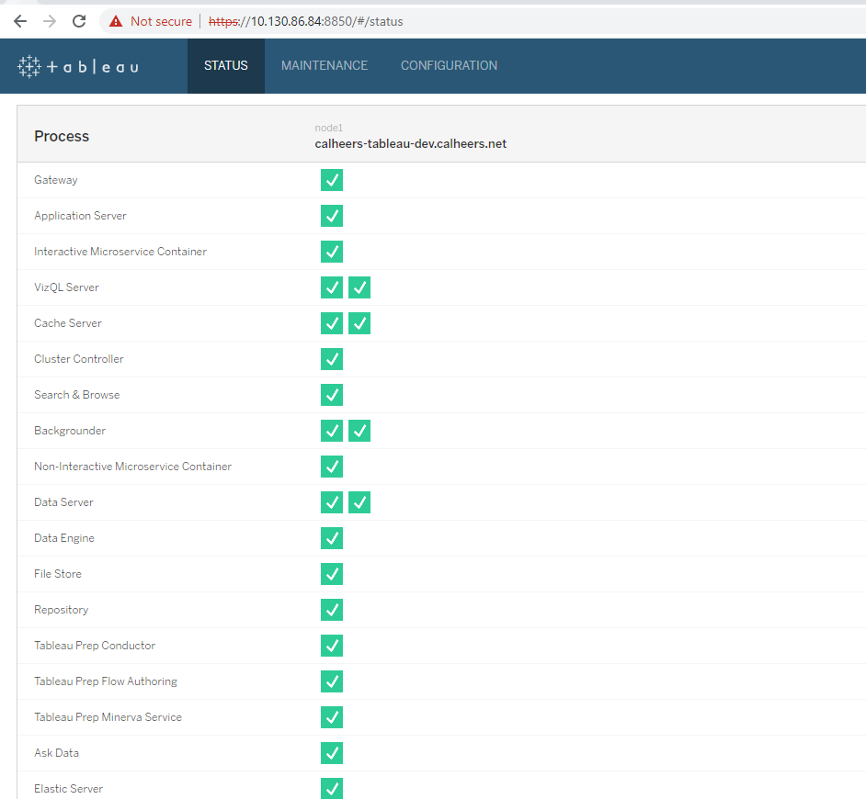

1. Click on Configuration tab on the top and navigate to Licenses on the Left panel.

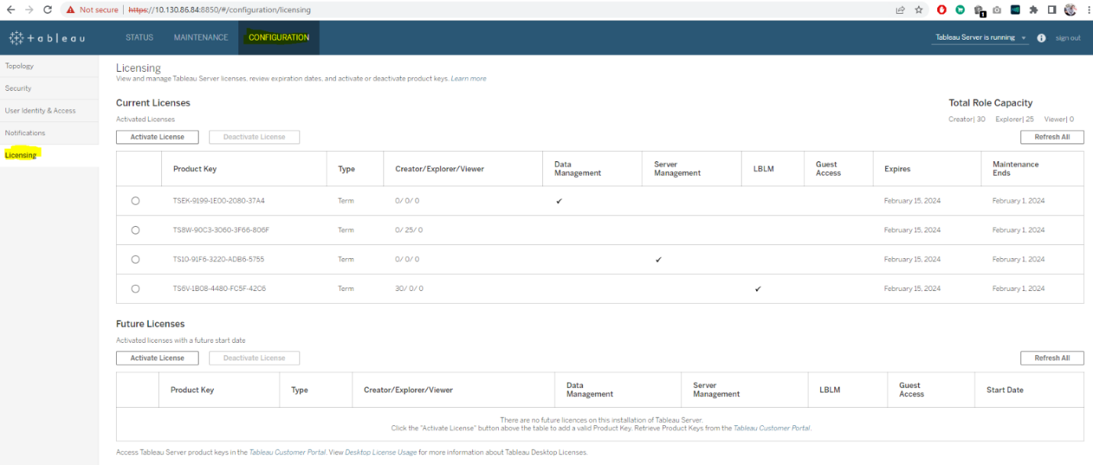

1. Once you are there you will be able to view all the licenses applied.

1. Currently there are 30 creator licenses and 25 explorer licenses applied in the tableau environment. Just in prod we have additional 3 creator licenses and 11 explorer licenses applied in Production alone.

1. To Apply licenses, you just need to Click on activate licenses on the licenses page and paste the licenses you need to apply and click on activate.

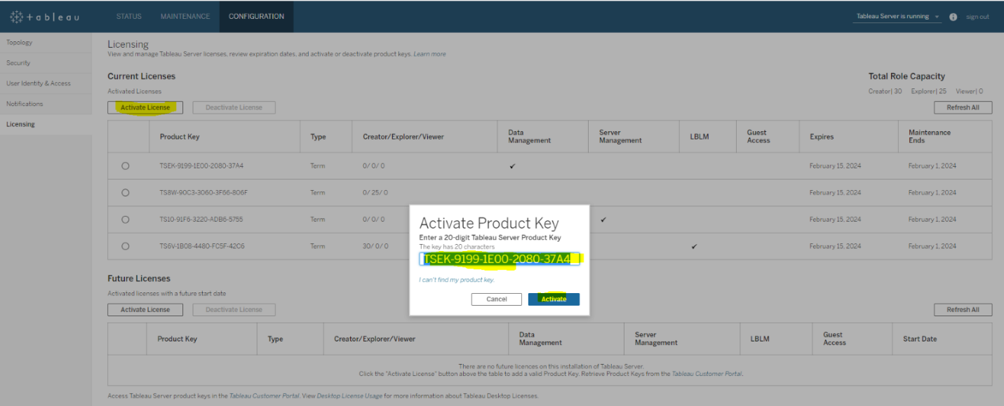

1. Click on Refresh All button to see if the licenses are applied.
2. Once licenses are activated. Please restart the Tableau application.

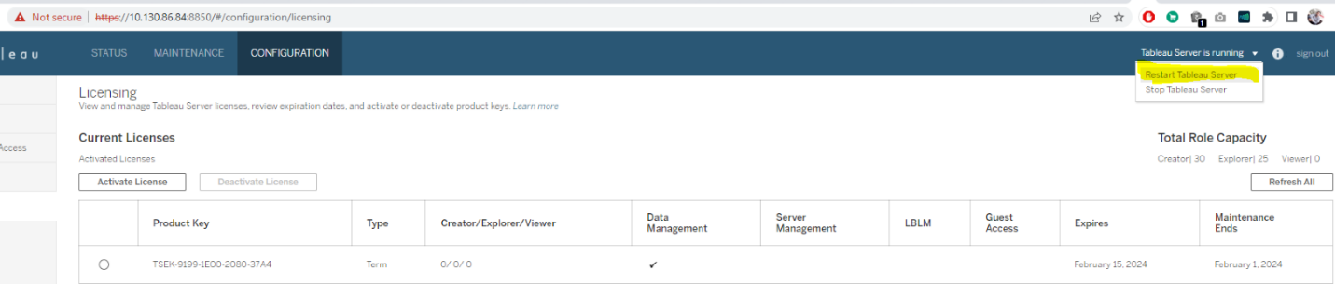

1. Validate all the services are running post restart.



License Troubleshooting

1. If the Licenses went missing from the console. All the users will become unlicensed.
2. To fix we need to manually activate the licenses.
3. To activate the licenses, follow the same process as above
4. Also, we noticed few issues after licenses application. We are not able to grant users licenses post activating the licenses and even not able to view the reports. This is known issue and the fix is available in the below document.

<https://kb.tableau.com/articles/issue/unable-to-log-in-as-server-administrator-after-activating-creator-license>

1. To fix those we need run TSM Reset commands and TSM initaluser commands

tsm reset

tabcmd initialuser --username "<username>" --password "<password>" --server [http://localhost](http://localhost/)

**Note:** Username should be site administrator and password should be the users AD password

1. Once the command is run please start and stop All the nodes for tableau cluster.
2. Post this we will be able to grant roles and assign licenses to the user.

**Tableau Installation**

**Date: 04/08/2022**

**Document Revision History**

|  |  |  |  |  |
| --- | --- | --- | --- | --- |
| **Version** | **Date** | **Author** | **Status** | **Notes** |
| 1.0 | 04/08/2022 | Prathap Gangadhar | Draft |  |
| 2.0 | 05/02/2022 | Prathap Gangadhar | Draft |  |
| 3.0 | 05/02/2022 | Krishna Muthagouni | Final |  |

​​Contents

​

​

​

​

​

​**​**

Introduction

This document details on the process followed to perform tableau Installation on AWS cloud (EC2). The entire process of Installation is carried out on Linux command line interface on the new servers. It also captures how to convert the standalone installation into HA (High Available).

Tableau server details

|  |  |  |  |  |  |  |
| --- | --- | --- | --- | --- | --- | --- |
| **#** | **Environment** | **Account** | **Tableau servername** | **IP address** | **Instance Type** | **Security Group** |
| 1 | dev | non-prod | Tableau-Init | 10.130.86.84 [core] | m5.4xlarge | sg-07bafe5d181d4421f (CalHEERs-Non-Production-ForgeRock-SG)  sg-0d08cb2366dc0840e (CalHEERs-NonProd-VPN-SG)  sg-00b95986f78476eb1 (calheers-openshift-buildserver-sg) |
| 2 | dev | non-prod | Tableau-Node1 | 10.130.86.114 | m5.4xlarge |  |
| 3 | dev | non-prod | Tableau-Node2 | 10.130.64.139 | m5.4xlarge |  |
| 4 | pre-prod | prod | CalHEERs-Production-clpreprdtblu01 | 10.131.149.192 [core] | m5.4xlarge |  |
| 5 | pre-prod | prod | CalHEERs-Production-clpreprdtblu02 | 10.131.150.163 | m5.4xlarge |  |
| 6 | prod | prod | CalHEERs-Production-clprdtblu01 | 10.131.149.14 [core] | m5.4xlarge |  |
| 7 | prod | prod | CalHEERs-Production-clprdtblu02 | 10.131.150.172 | m5.4xlarge |  |
| 8 | prod | prod | CalHEERs-Production-clprdtblu03 | 10.131.151.161 | m5.4xlarge |  |

Prerequisites

1. Please create required number of EC2 instances from gdot pipeline with the required AMI ID available, post instance creation integrated the instances with AD, also whitelist the internet connectivity to the initial node as per the **CHG0032453**.
2. Please follow proper naming standards for the instances created for hostname cl<env>.calheers.net, ex: clprdtblu01.calheers.net
3. Create a service account in AD XXXXX.calheers.net associated case task CTASK0014356, ex: tabsvcprod.calheers.local
4. Add the Service user in sudoers file vi /etc/sudoers, ex: add tabsvcprod it will be an service account we need to be added in the file, this is required for the installation of tableau to initialize the tableau server manager (TSM).

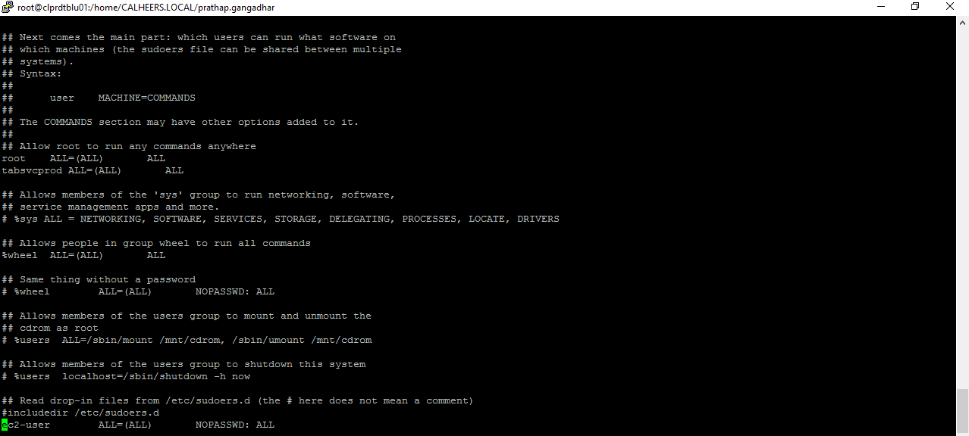

Download Tableau binaries to the installation location on the initial server

1. Download the required rpm packages from tableau from [link](https://www.tableau.com/support/releases/server/2021.3.6#esdalt) based on the version required ex: 2021.3.6 which used for current installation. And copy these to the Jenkins build server at ‘/opt/openshift/util/tableau’
2. Download other required packages for supporting tableau integrations following packages are required to be downloaded and available at ‘/opt/openshift/util/tableau/’ snowflake-odbc-2.24.4.x86\_64.rpm , simbaspark-2.6.19.1033-1.x86\_64.rpm, ojdbc10-full.tar.gz
3. Log in to Jenkins build servers using AD creds and navigate to following job <http://ocp-buildsrv1.calheers.net/job/Data-Warehouse/job/Tableau-Installation/>
4. Please initiate build with below parameters for the Jenkins to run the installation.

TARGET\_INSTANCE: EC2 instance IP

USER\_NAME: AD Username Service account

USER\_PASSWORD: AD password XXXXX

1. Post successful run of the job, Log in to the EC2 instance and check files are copied and installation is completed, check below location for the installation.

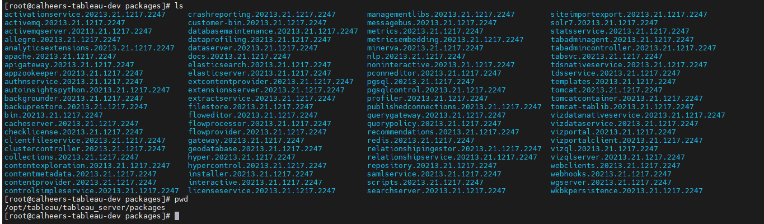

1. Post validation lets run the initialization command, login to the server with AD and perform a switch user to root and from root to service account (tabsvcprd).
2. Change directory to the tsm initialization directory in scripts location /opt/tableau/tableau\_server/packages/scripts.<**version**>/initialize-tsm --accepteula
3. Validate the successful initializations from logs at ‘/var/opt/tableau/tableau\_server/data/tabsvc/logs/’
4. [Sign in to Tableau Services Manager Web UI(Link opens in a new window)](https://help.tableau.com/current/server-linux/en-us/sign_in_tsm.htm) to activate and register Tableau Server: [**https://<<server-ip-core>>:8850**](https://localhost:8850/) the user login should be the svc AD account.
5. On the **Activate** page, Enter or paste your product key and click **Activate License**.

**Note :- all the license related information will be with DW manager and one license will allow only for 3 environments max if we are creating any new then we need to get new set of licenses**

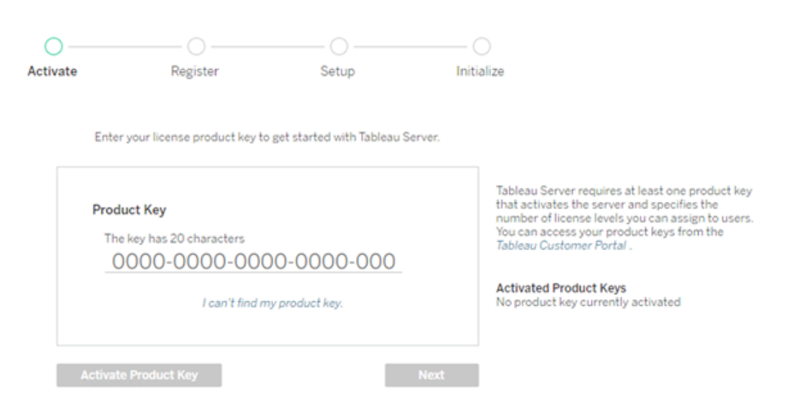

1. [On the Register page, enter your information into the fields and click **Register**.](https://autosys.np.calheers.net/wcc/ui/Launcher.html)

         Below Contact details

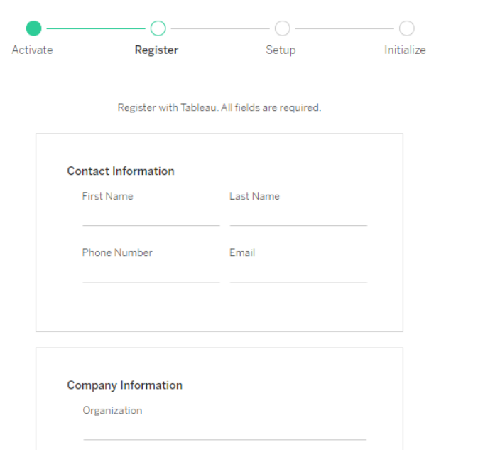

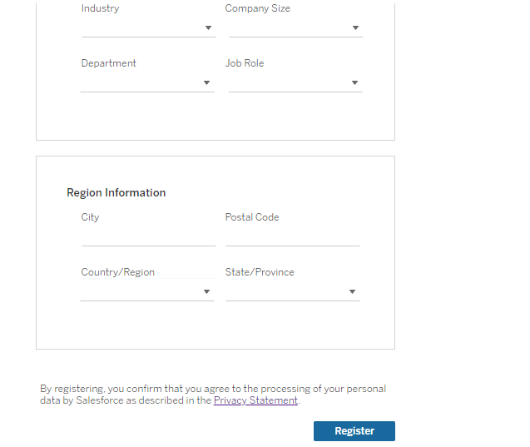

1. Dcd Step 3: Configure general server settings

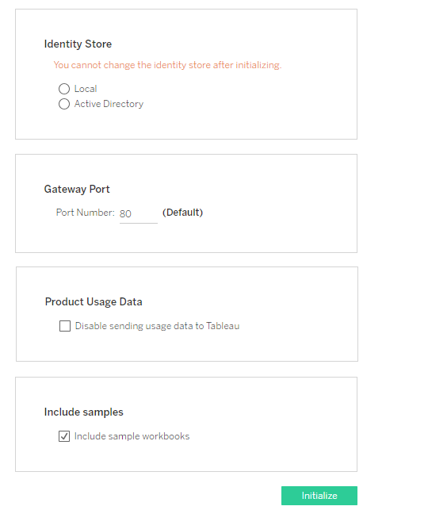

1. Tableau Server requires read access to Active Directory. You can use simple bind or GSSAPI bind to authenticate Tableau Server with Active Directory.

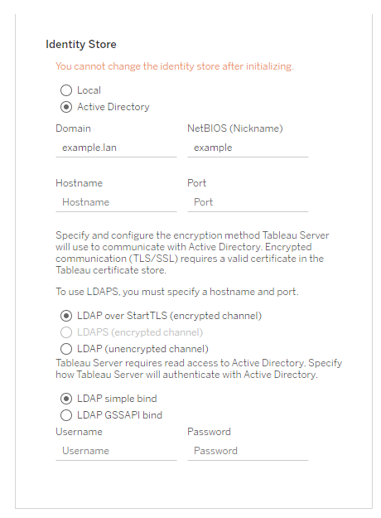

1. After you have configured the options on this page, click **Initialize**.

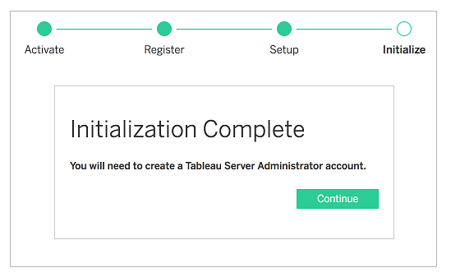

1. Log to this URL [**https://<<server-ip-core>>:8850**](https://localhost:8850/) and check status

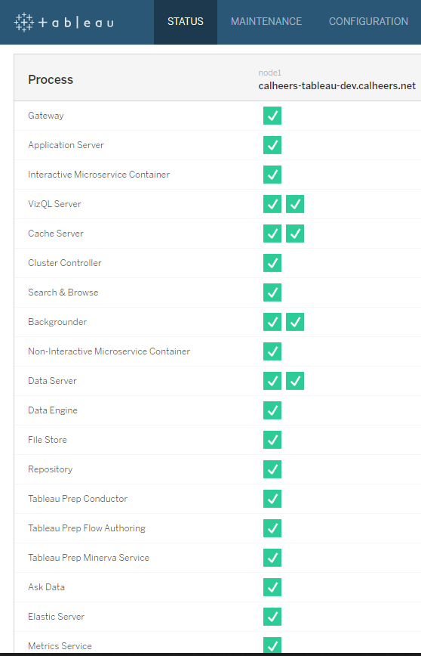

1. Run The below command on the initial Node

tabcmd initialuser --server '10.131.149.14:80' --username 'tabsvcprod' --password 'XXXXX'

1. create a Load balancing routing 443 traffic to 80 of tableau server group.

Add CNAME record in Route 53.

1. Login to this URL [**https://<<server-ip-core>>:8850**](https://localhost:8850/) and check the status

Setting SMTP

1. Log to this URL [https://LOCALHOST:8850](https://localhost:8850/) and check Configuration and navigate to USER IDENTITY & ACCESS and provide the below details based on Environment

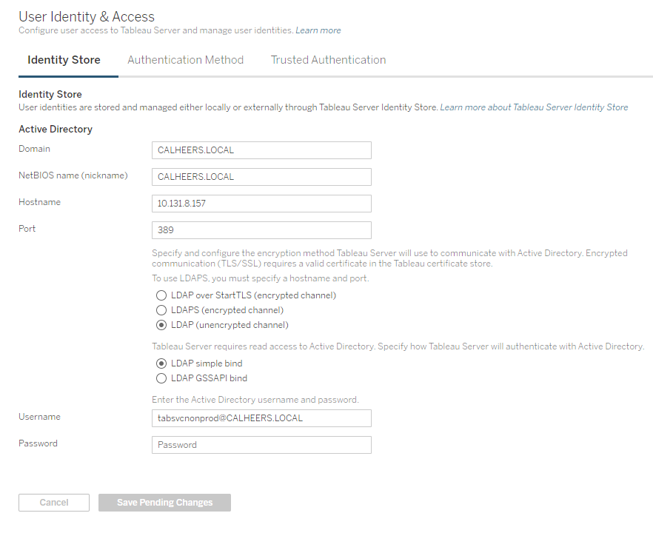

1. Navigate to Configuration click on Licensing

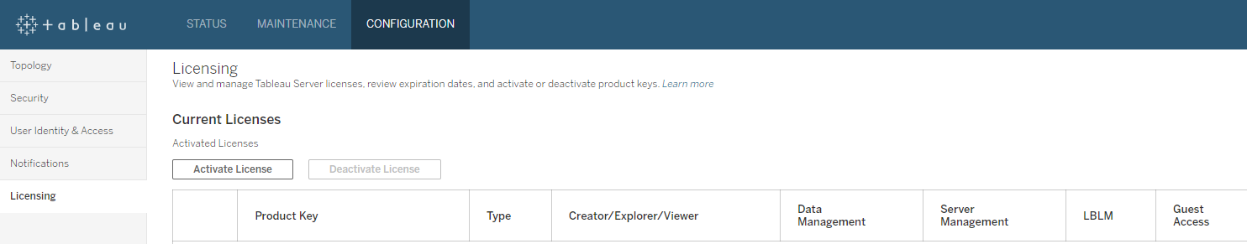

1. Click and activate license under current Licenses

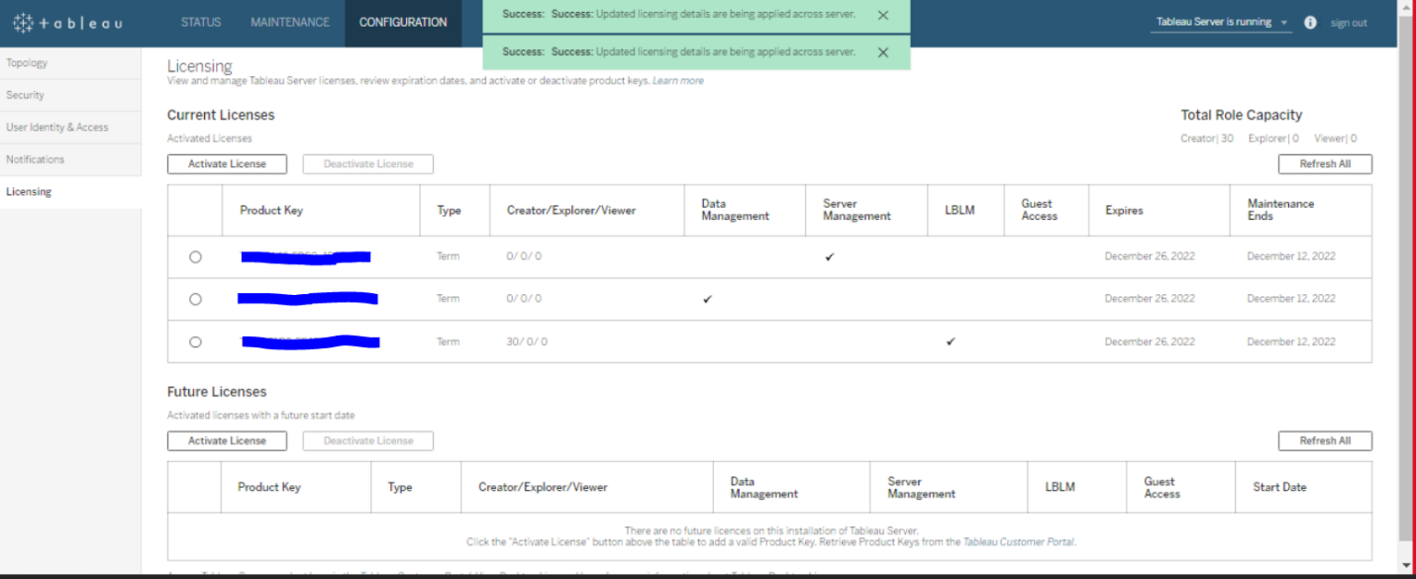

1. Log in to server EC2 instance and as a root user Run yum install postfix
2. Navigate to /etc/postfix and update main.cf



1. Restart the service postfix
2. Copy Jar File form /opt/tableau/downloads to /opt/tableau/tableau\_driver/jdbc



1. Yum install simbaspark-2.6.19.1033-1.x86\_64.rpm
2. Yum install snowflake-odbc-2.24.4.x86\_64.rpm

Setting Second Node

1. Open TSM in a browser: https://<tsm-computer-name>:8850
2. Click the Configuration tab, and in the Add a Node box, click Download Bootstrap File.

1. Copy the original installer you used on the first computer along with the bootstrap file you generated and put them in a location accessible from the new computer you are adding Tableau Server to. This could be a mounted network share, or directly on the new computer.
2. Copy the bootstrap.json file to this location  /opt/tableau/tableau\_server/packages/scripts.20213.21.1217.2247/
3. Run the command sudo ./initialize-tsm -b /opt/tableau/tableau\_server/packages/scripts.20213.21.1217.2247/bootstrap.json tabsvcnonprod –accepteula
4. Log in to https://<tsm-computer-name>:8850
5. In TSM, click Configuration.

A message displays, telling you the node was added:

1. Click Continue.
2. Click Pending Changes at the top of the page:

1. Click Apply Changes and Restart and Confirm to confirm a restart of Tableau Server.
2. On the initial node, open a command prompt as administrator.
3. Stop Tableau Server: tsm stop
4. Configure Client File Services (CFS) on additional nodes
5. On the initial node, open a command prompt as administrator.
6. Find the node ID for the node you are adding CFS to:
7. tsm topology list-nodes -v
8. tsm topology set-process -n node2 -pr clientfileservice -c 1
9. Apply the changes:
10. tsm pending-changes apply
11. Configure processes for the second node
12. Open TSM in a browser:
13. https://<tsm-computer-name>:8850
14. For more information, see [Sign in to Tableau Services Manager Web UI](https://help.tableau.com/current/server/en-us/sign_in_tsm.htm).
15. Click the Configuration tab.
16. Specify the processes and number of instances that should run on the first additional node.
17. In this example:
18. Select Gateway.
19. Set the Application Server (vizportal) count to 2.
20. Set the VizQL Server count to 2.
21. Set the Cache Server count to 2.
22. Select Search & Browse.
23. Set the Backgrounder count to 2.
24. Adding Backgrounder to a node will also add an instance of Data Engine if one is not already on the node.
25. Set the Data Server count to 2.
26. Select File Store.
27. Select Repository (pgsql).
28. The specific processes and process counts you set will depend on your organizational environment and needs. Some processes are added automatically when you add another process. For more information, see [Configure Nodes](https://help.tableau.com/current/server/en-us/config_nodes.htm) and [Tableau Server Processes](https://help.tableau.com/current/server/en-us/processes.htm).
29. **Note:** The TSM Web UI limits you to a maximum of 8 instances of processes that allow you to select the number of instances. To configure more instances than this, use the command line and the TSM topology set-process command. For more information, see [tsm topology set-process](https://help.tableau.com/current/server/en-us/cli_topology_tsm.htm" \l "TSMSetProcess" \t "_blank).
30. Step 8: Configure processes for third node
31. In TSM, on the Configuration tab, specify the processes and number of instances that should run on the second additional node.
32. In this example:
33. Select Gateway.
34. Set the Application Server (vizportal) count to 2.
35. Set the VizQL Server count to 2.
36. Set the Cache Server count to 2.
37. Select Search & Browse.
38. Set the Backgrounder count to 2.
39. Adding Backgrounder to a node will also add an instance of Data Engine if one is not already on the node.
40. Set the Data Server count to 2.
41. Select File Store.
42. Click Pending Changes at the top of the page:
43. 
44. The Pending Changes list displays.
45. Click Apply Changes and Restart and Confirm to confirm a restart of Tableau Server.