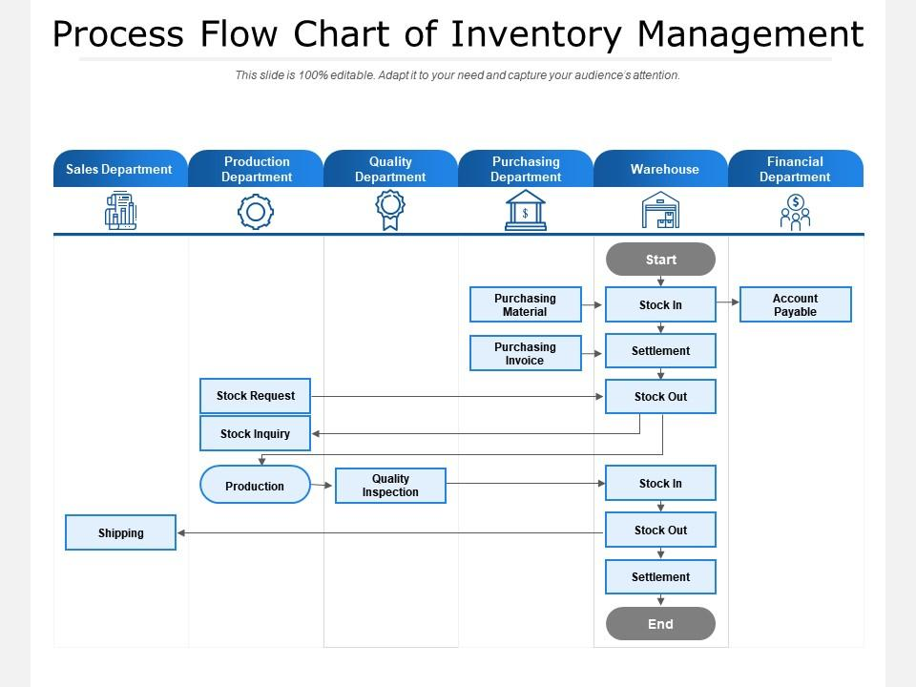

ACCOUNT PAYABLE

PURCHASING MATERIAL

STOCK IN

START