ASSIGNMENT-1

Challenge

1. The calculator should have 5 rows,4 cloumns,and one display row

<html>

<head>

<style>

table {

margin-left: auto;

margin-right: auto;

background-color: #810000; <!-- background colour--!>

}

</style>

<!-- javascript -->

<script>

function f(d) {

if (d == 'c') {

document.getElementById('res').value = "";

return;

}

res = document.getElementById('res').value;

if (res == 0 && d == 0)

return;

if (d == '+' || d == '-' || d == '\*' || d == '/') {

opr = d;

num = parseFloat(res);

document.getElementById('res').value = d;

return;

}

if (d == '=') {

num1 = parseFloat(res);

<!--case -->

switch (opr) {

case '+':

ans = num + num1;

break;

case '-':

ans = num - num1;

break;

case '\*':

ans = num \* num1;

break;

case '/':

ans = parseInt(num / num1);

break;

}

document.getElementById('res').value = ans;

return;

}

if (d == '--') {

document.getElementById('res').value \*= -1;

return;

}

if (!isNaN(document.getElementById('res').value))

document.getElementById('res').value += d;

else

document.getElementById('res').value = d;

}

</script>

</head>

<body>

<h1>

<center>A SIMPLE CALCULATOR</center>

</h1>

<table border="5px solid white">

<tbody>

<tr>

<td colspan="4"><input type="text" id="res" size="16" onfocus="this.blur();"></td>

</tr>

<tr>

<td><input type="button" id="b1" value="1" size="2" onclick="f('1')"></td>

<td><input type="button" id="b2" value="2" size="2" onclick="f('2')"></td>

<td><input type="button" id="b3" value="3" size="2" onclick="f('3')"></td>

<td><input type="button" id="b4" value="+" size="2" onclick="f('+')"></td>

</tr>

<tr>

<td><input type="button" id="b5" value="4" size="2" onclick="f('4')"></td>

<td><input type="button" id="b6" value="5" size="2" onclick="f('5')"></td>

<td><input type="button" id="b7" value="6" size="2" onclick="f('6')"></td>

<td><input type="button" id="b8" value="-" size="2" onclick="f('-')"></td>

</tr>

<tr>

<td><input type="button" id="b9" value="7" size="2" onclick="f('7')"></td>

<td><input type="button" id="b10" value="8" size="2" onclick="f('8')"></td>

<td><input type="button" id="b11" value="9" size="2" onclick="f('9')"></td>

<td><input type="button" id="b12" value="\*" size="2" onclick="f('\*')"></td>

</tr>

<tr>

<td><input type="button" id="b13" value="C" size="2" onclick="f('c')"></td>

<td><input type="button" id="b14" value="0" size="2" onclick="f('0')"></td>

<td><input type="button" id="b15" value="=" size="2" onclick="f('=')"></td>

<td><input type="button" id="b16" value="/" size="2" onclick="f('/')"></td>

</tr>

</tbody>

</table>

</body>

</html>

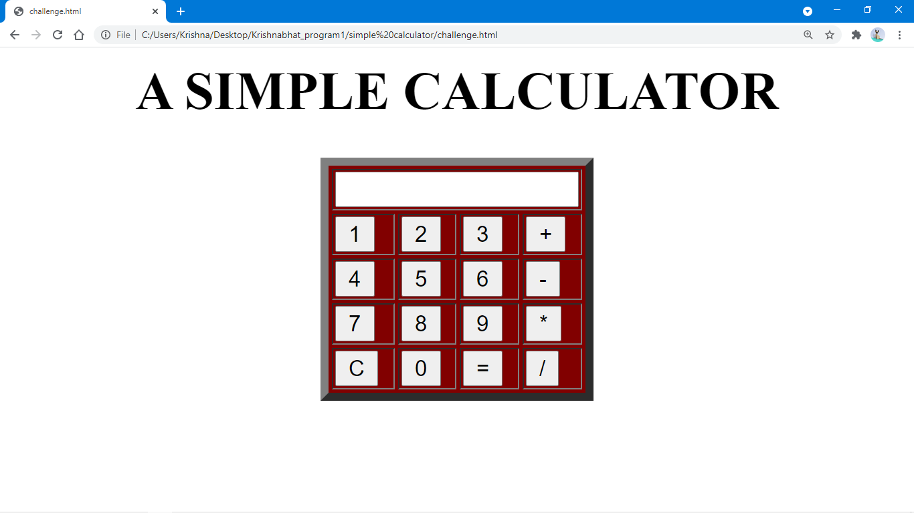

1. ADDITION :

888+999 =1887

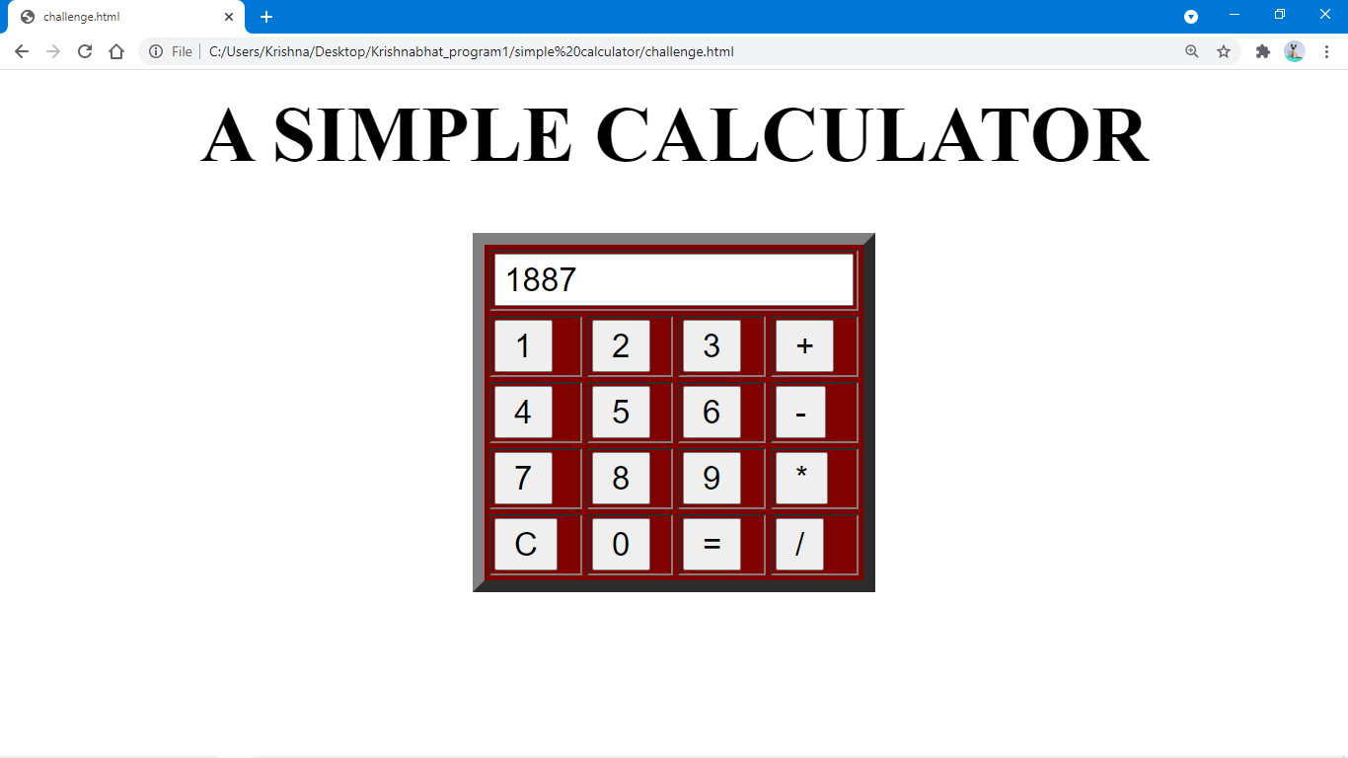

1. SUBSTRACTION:

777-999= -222

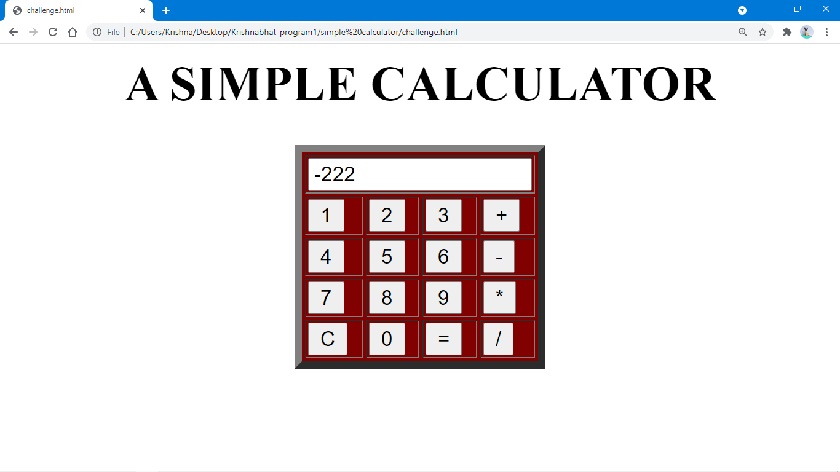

3) MULTIPLICATION:

78\*56=4368

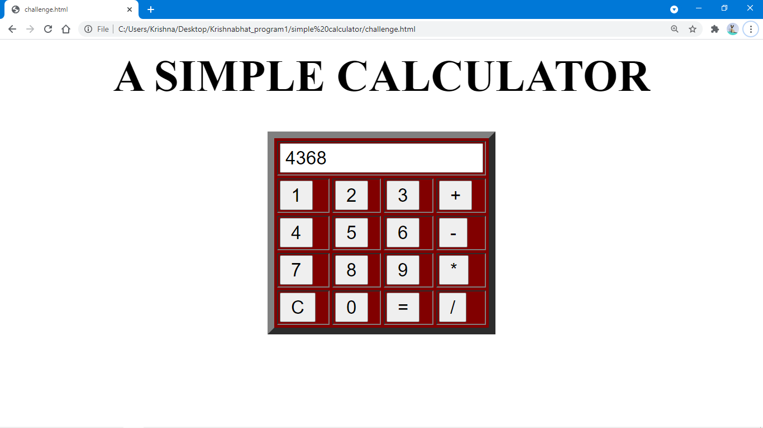

4) DIVISION:

99/0=NAN

