AWS Deployment – DevOps Assignment
Flask Backend + Express Frontend on EC2, ECR, ECS and VPC

Name: krishna bhatt
GitHub repository: [https://github.com/krishnabhatt-028/AWS_krishna-.git]

Project Overview
- backend/ – Flask API on port 5000 (/api, /submit, /submissions).
- frontend/ – Express app on port 3000 with a form; it forwards submissions to Flask using the BACKEND_URL environment variable.
- Dockerfile in each folder, docker-compose.yml for local testing, ecs/task-definition.json for Fargate.

Task 1: Flask + Express on a Single EC2 Instance

Step 1: Launch the EC2 instance
EC2 → Launch instance → Ubuntu Server 22.04, t2.micro (free tier), create key pair, security group inbound rules: SSH 22, Custom TCP 3000, Custom TCP 5000.

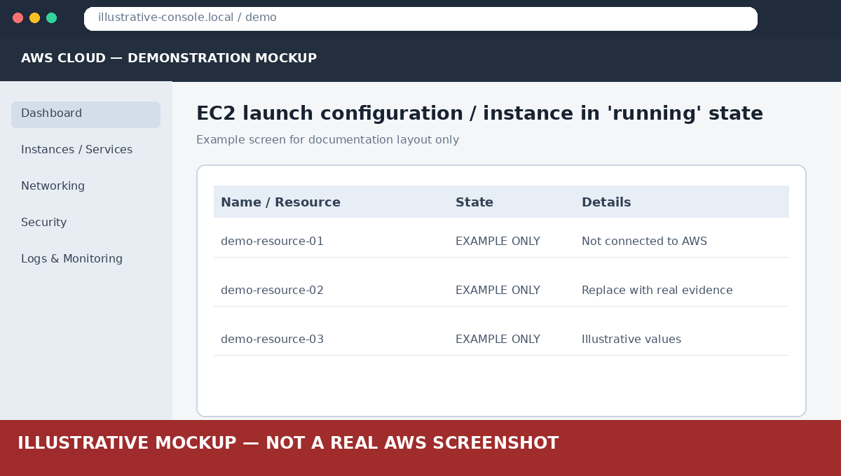
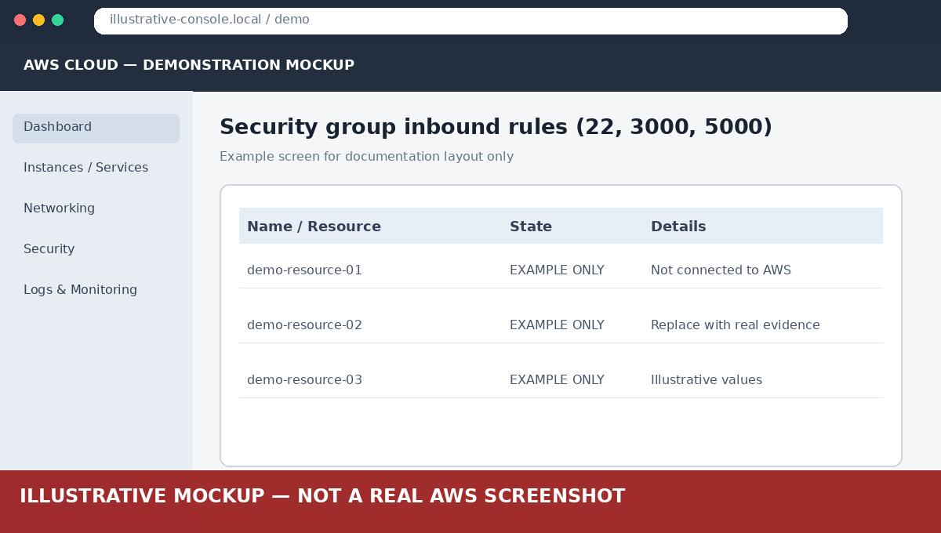
Explanation: A t2.micro Ubuntu instance is free-tier eligible. The security group works as a virtual firewall, so ports 3000 (frontend) and 5000 (backend) must be opened for the app to be reachable.

Step 2: Connect over SSH and install prerequisites
chmod 400 key.pem
ssh -i key.pem ubuntu@<EC2_PUBLIC_IP>
git clone <GITHUB_REPO_URL> && cd <repo>
bash scripts/install-prereqs.sh

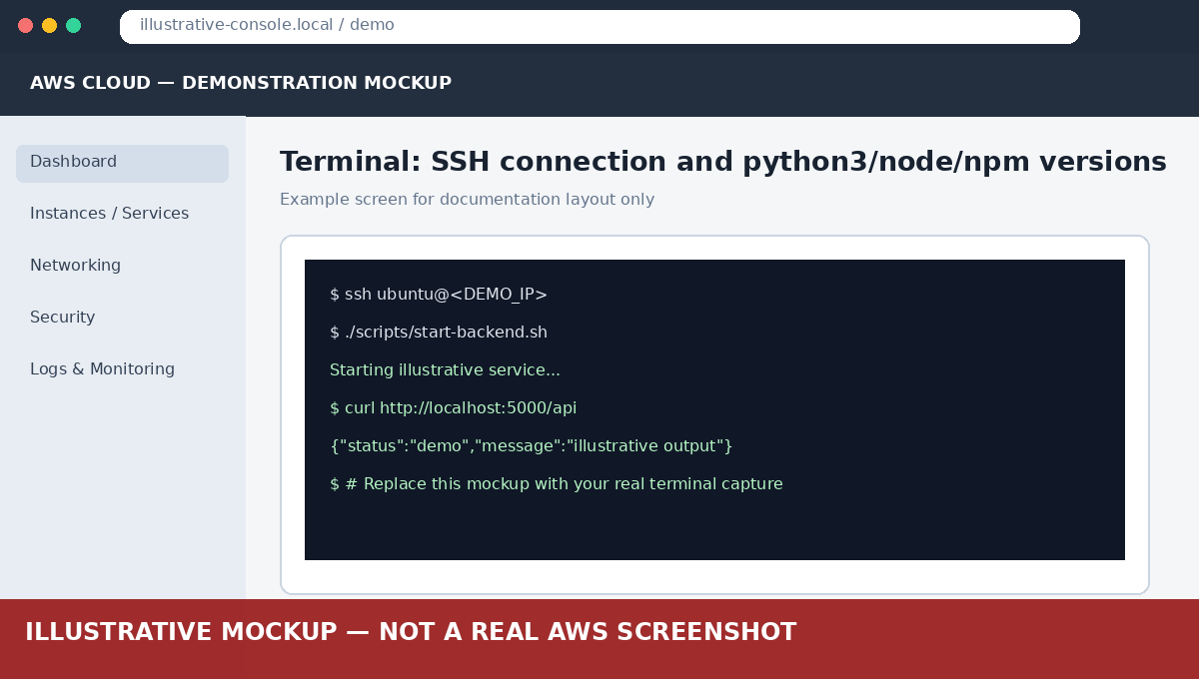
Explanation: SSH gives a remote shell on the server. The script installs Python 3, pip, Node.js 20 and git, which are needed to run both applications.

Step 3: Start the Flask backend
bash scripts/start-backend.sh
curl http://localhost:5000/api

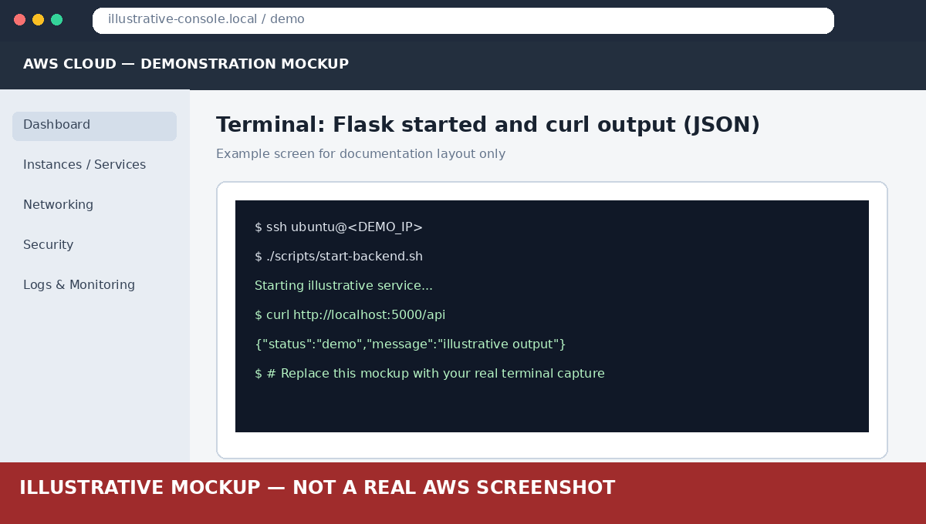
Explanation: A virtual environment isolates dependencies. nohup keeps Flask running after the SSH session closes. Flask binds to 0.0.0.0 so it accepts external connections.

Step 4: Start the Express frontend
bash scripts/start-frontend.sh http://localhost:5000
ps aux | grep -E 'python|node'
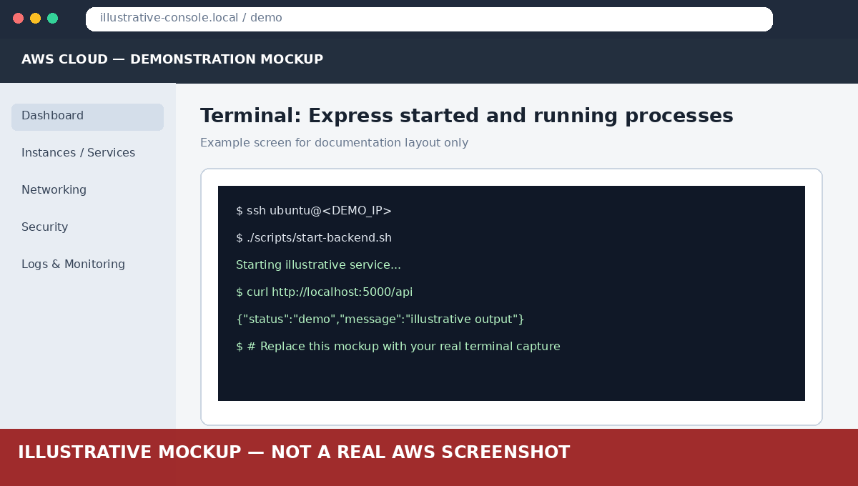
Explanation: Both services run on the same machine, so the frontend reaches Flask through localhost:5000 using the BACKEND_URL variable.

Step 5: Test in the browser
Open http://<EC2_PUBLIC_IP>:3000, fill the form and submit.
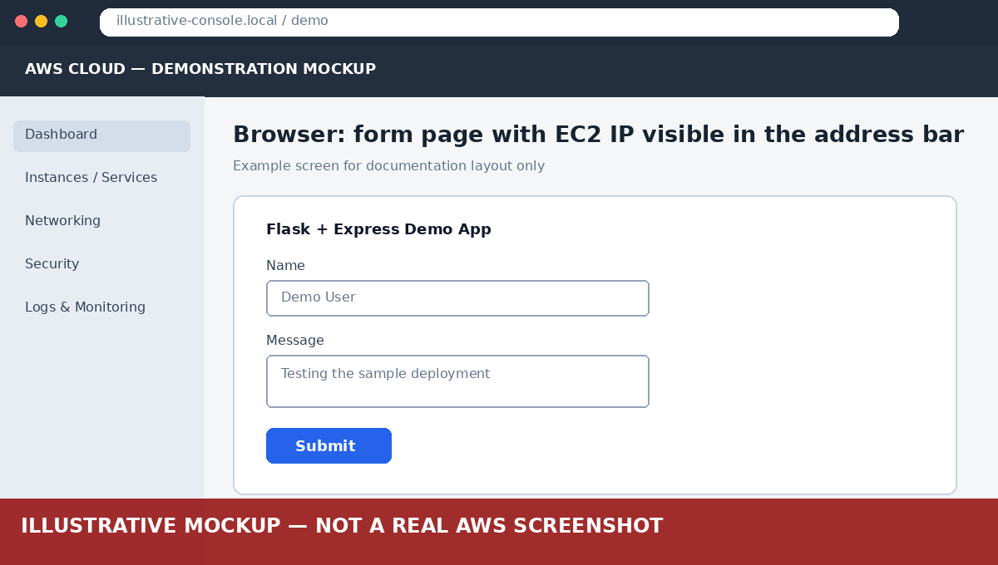
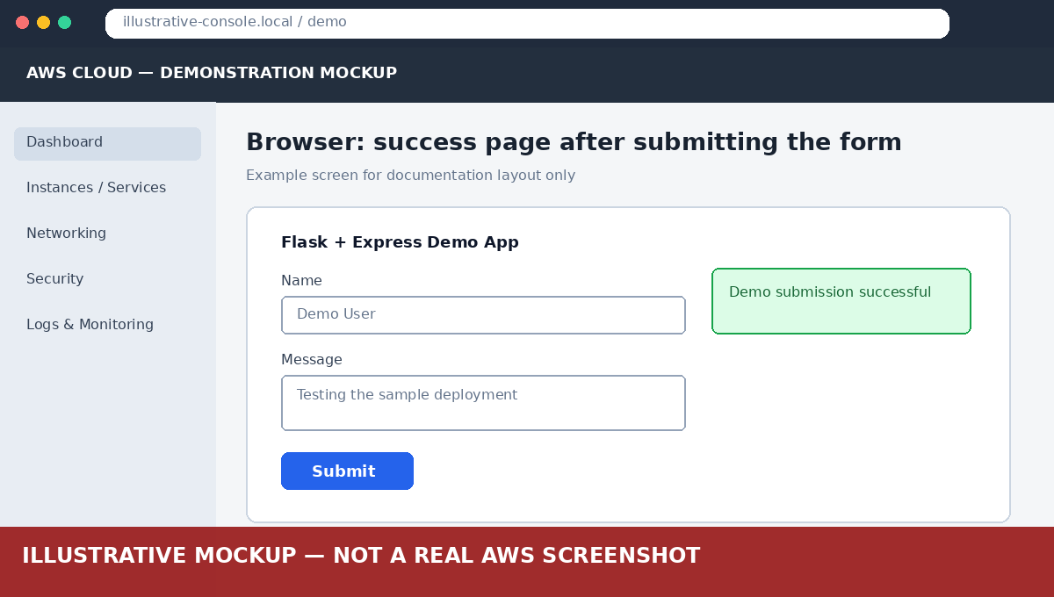
Explanation: The success page proves the full request path: Browser → Express (3000) → Flask (5000) → response back to the browser.

Task 2: Flask and Express on Separate EC2 Instances

Step 1: Launch two instances
Launch backend-ec2 and frontend-ec2 (Ubuntu 22.04, t2.micro) in the same VPC. Backend security group: SSH 22, TCP 5000 (source: frontend security group or the frontend IP). Frontend security group: SSH 22, TCP 3000 (source: anywhere).
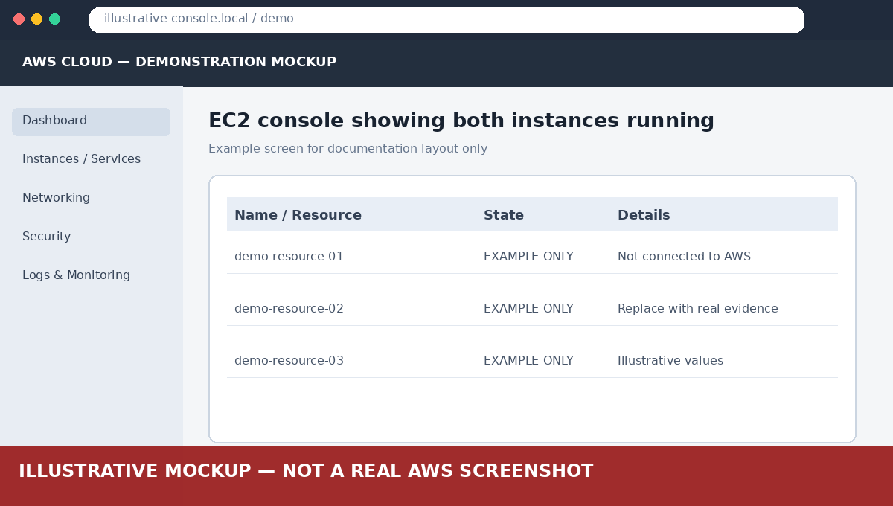
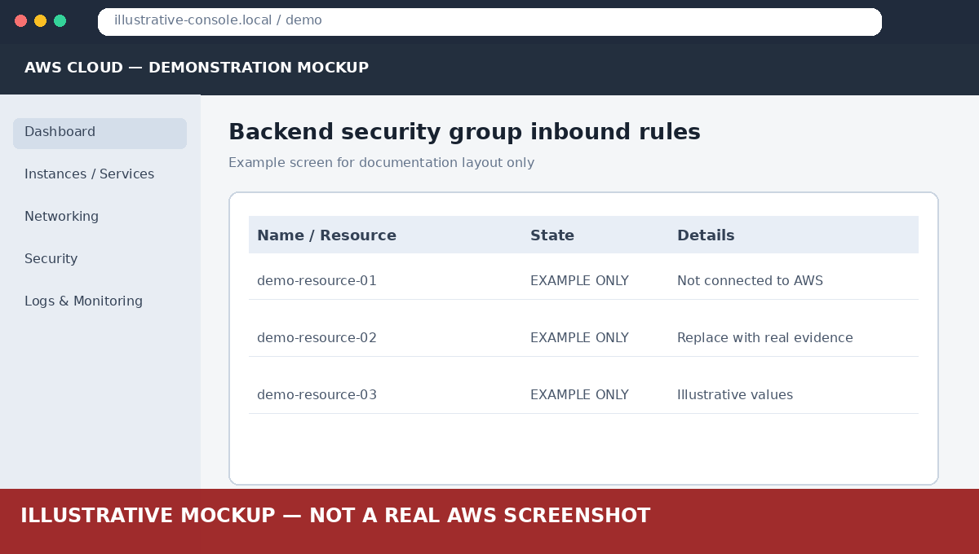
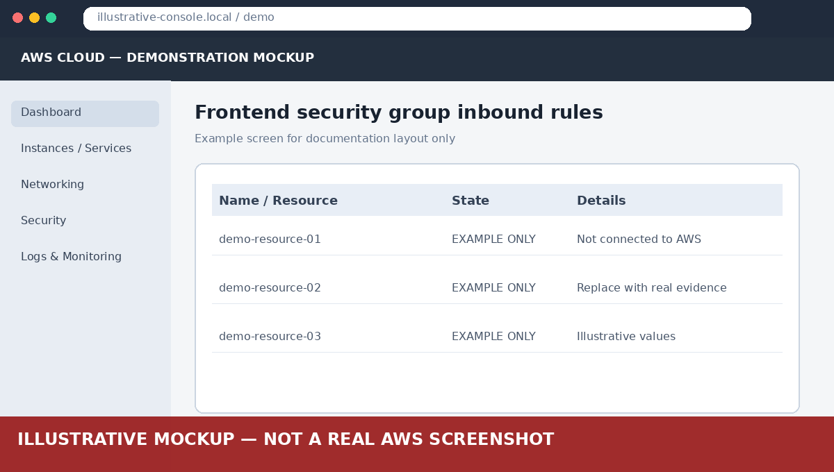
Explanation: Separating tiers is closer to a real architecture. Only the frontend is public; the backend port is restricted to the frontend, improving security.

Step 2: Set up the backend instance
ssh -i key.pem ubuntu@<BACKEND_PUBLIC_IP>
git clone <GITHUB_REPO_URL> && cd <repo>
bash scripts/install-prereqs.sh
bash scripts/start-backend.sh
curl http://localhost:5000/api
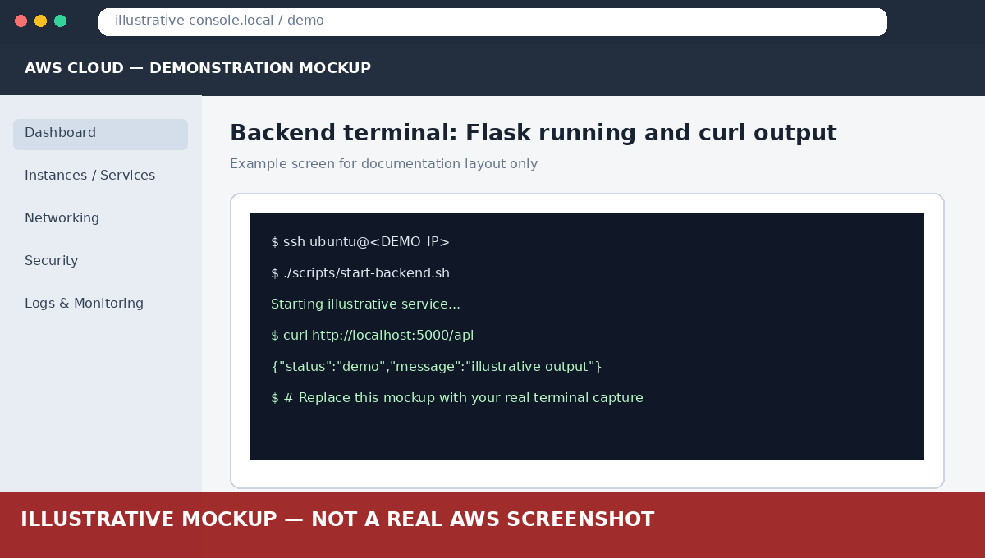
Explanation: Only Flask runs on this machine and it listens on port 5000.

Step 3: Set up the frontend instance
ssh -i key.pem ubuntu@<FRONTEND_PUBLIC_IP>
git clone <GITHUB_REPO_URL> && cd <repo>
bash scripts/install-prereqs.sh
bash scripts/start-frontend.sh http://<BACKEND_IP>:5000
curl http://<BACKEND_IP>:5000/api

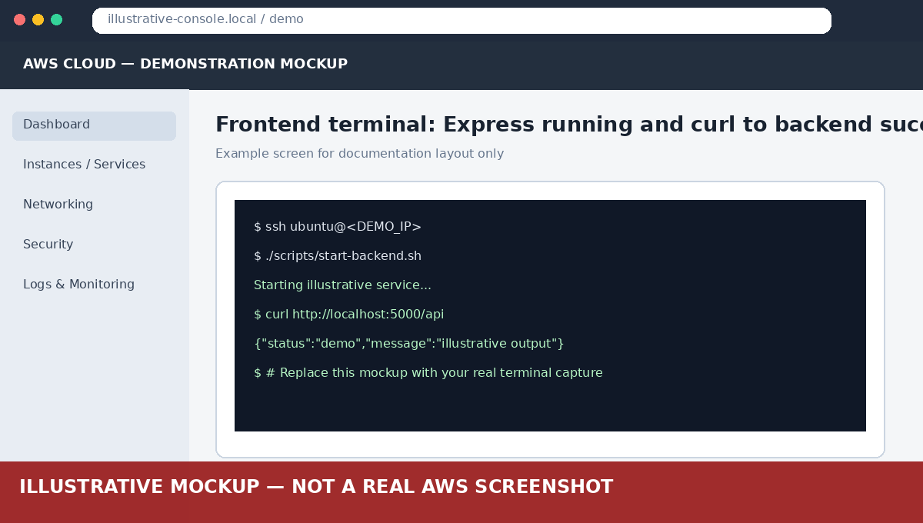
Explanation: BACKEND_URL now points to the other instance's IP, so the frontend communicates with Flask over the network.

Step 4: Test
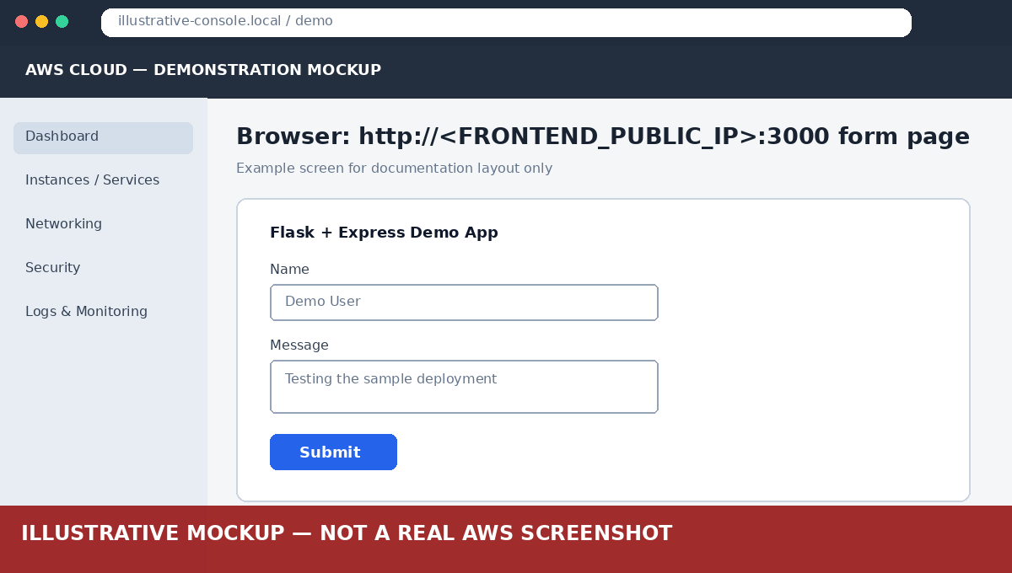
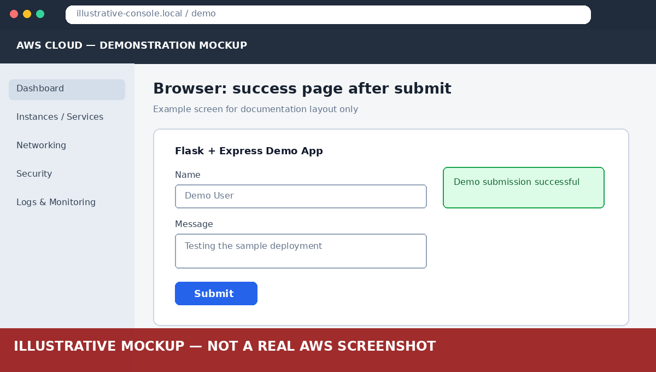
Explanation: Working submission confirms cross-instance communication between the frontend and backend servers.

Task 3: Docker Containers with ECR, ECS and VPC

Step 1: Test the containers locally
docker compose up --build
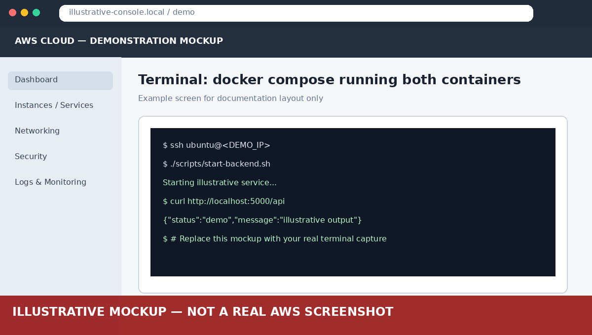
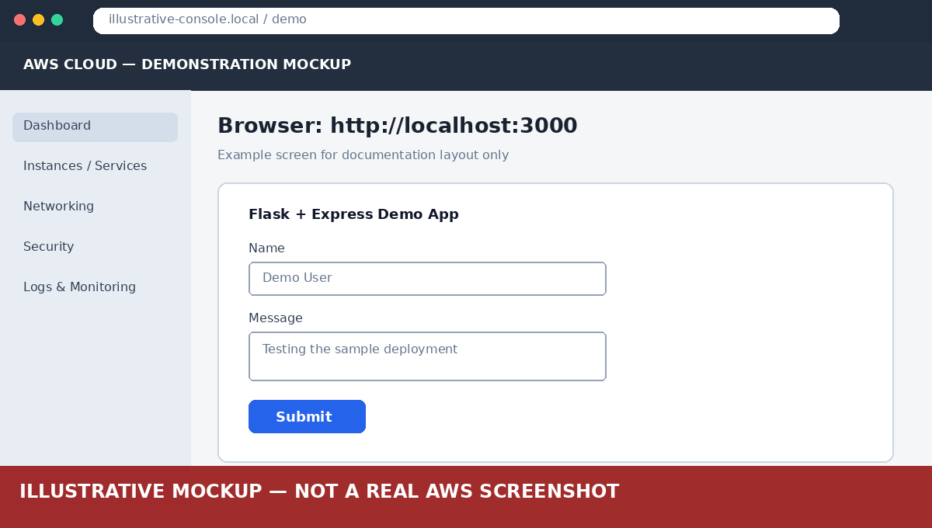
Explanation: Verifying locally first avoids debugging in the cloud. docker-compose connects the containers by service name (backend).

Step 2: Create ECR repositories
ECR → Create repository: flask-backend and express-frontend (private).
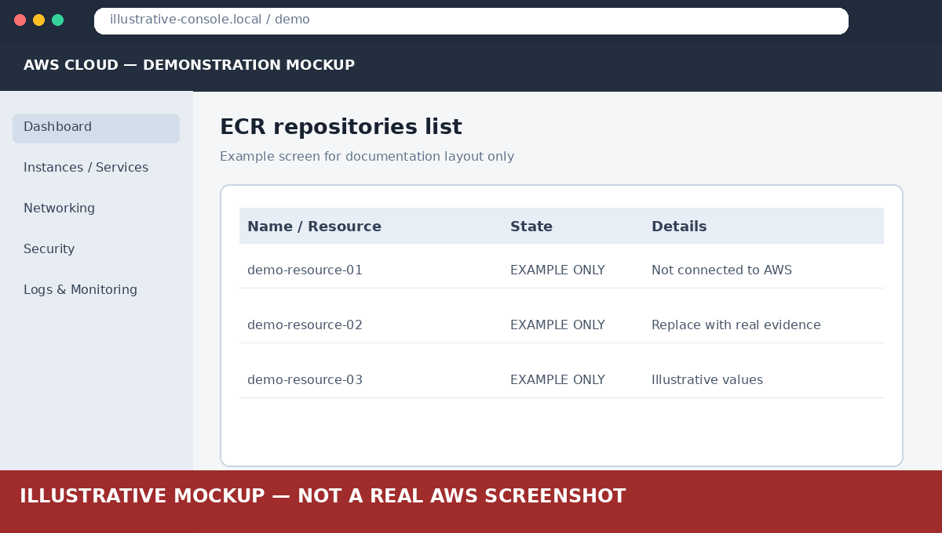
Explanation: ECR (Elastic Container Registry) is AWS's private Docker registry where ECS pulls images from.

Step 3: Build and push images to ECR
aws configure
bash scripts/push-to-ecr.sh <ACCOUNT_ID> <REGION>
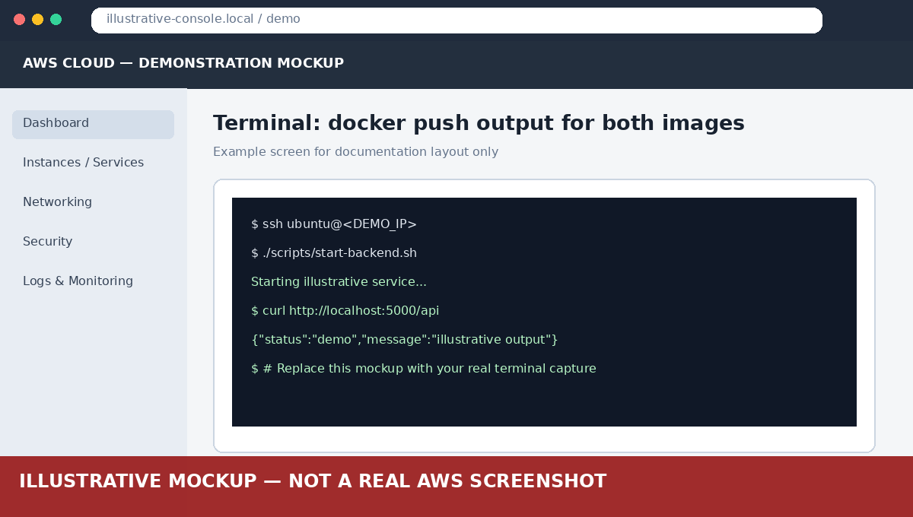
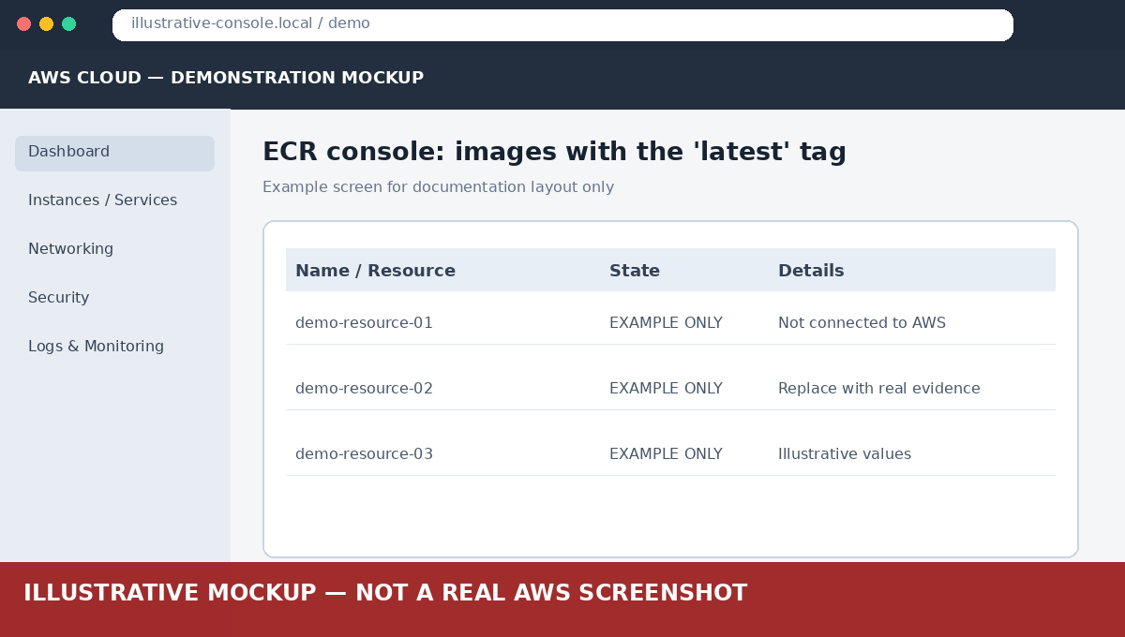
Explanation: The script logs Docker in to ECR, builds each image, tags it with the ECR URI and pushes it.

Step 4: VPC and networking
Use the default VPC with its public subnets. Create a security group (e.g. ecs-sg) allowing inbound TCP 3000 (and 5000 if needed for testing).
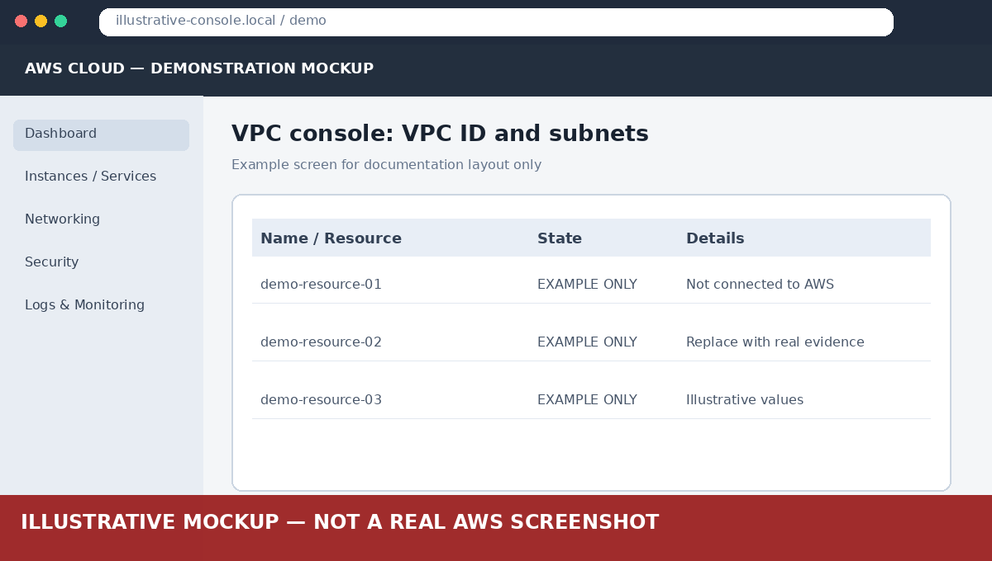
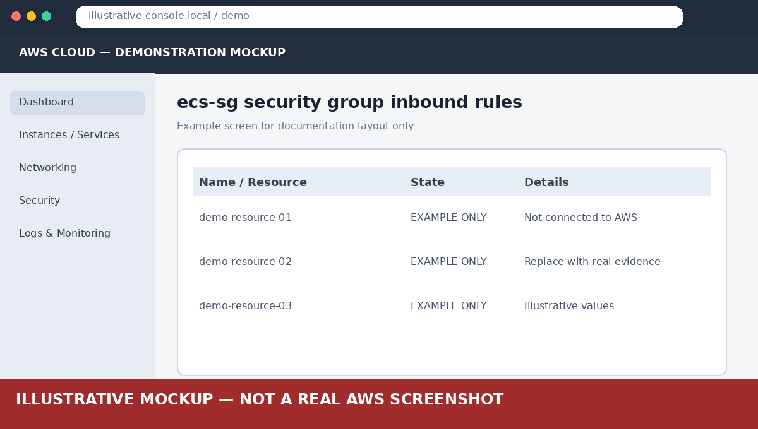
Explanation: The VPC is the isolated network the containers run in. Public subnets with an internet gateway let the task receive a public IP.

Step 5: ECS cluster, task definition and service
ECS → Create cluster (AWS Fargate). Create a Task Definition (Fargate, awsvpc) with two containers: flask-backend (port 5000) and express-frontend (port 3000, BACKEND_URL=http://localhost:5000). See ecs/task-definition.json. Then create a Service (1 task, public subnets, ecs-sg, public IP enabled).
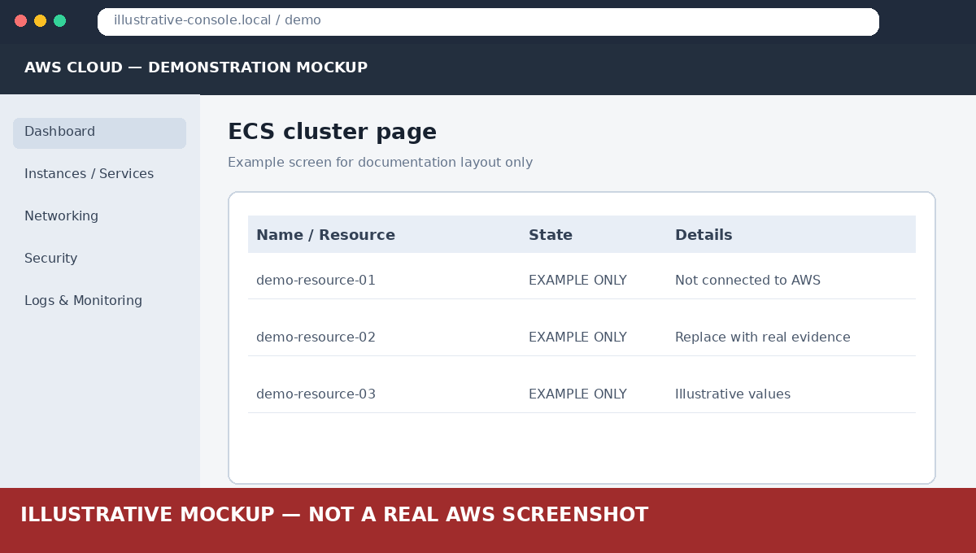

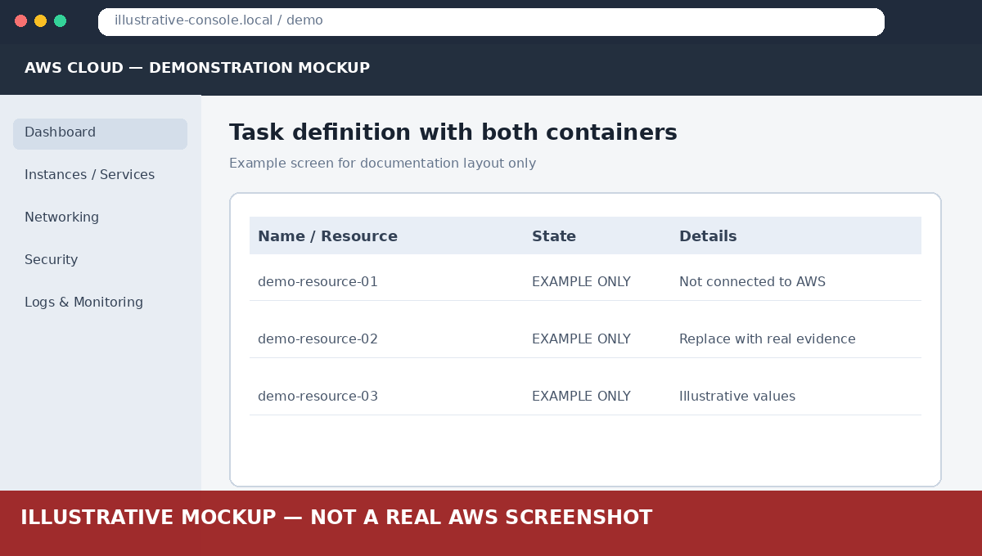
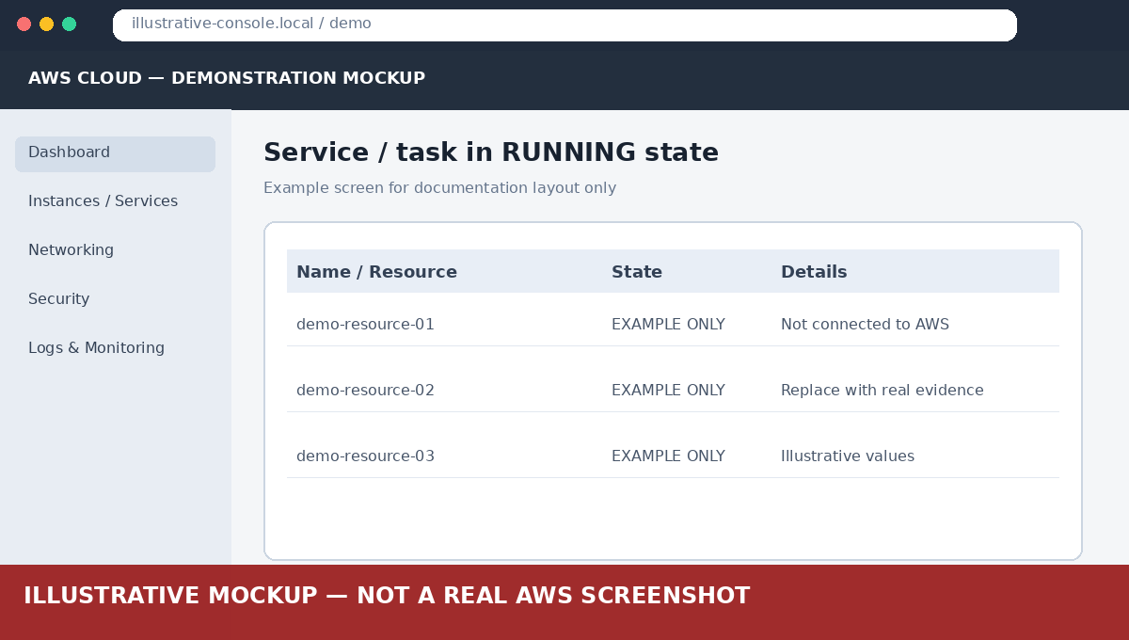
Explanation: Fargate runs containers without managing servers. Both containers share the task's network namespace, so the frontend reaches Flask at localhost:5000.

Step 6: Test the deployed app
Open the task's public IP: http://<ECS_TASK_PUBLIC_IP>:3000

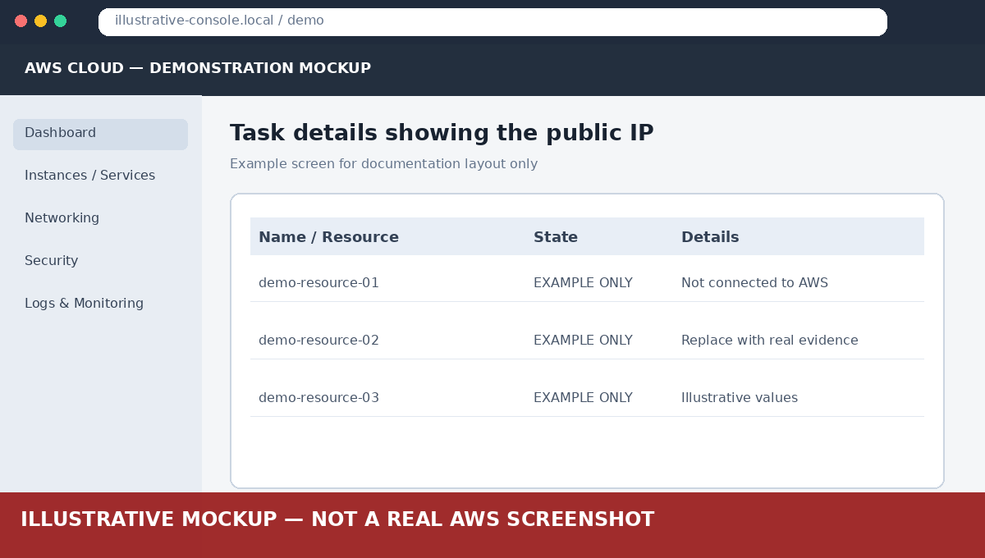

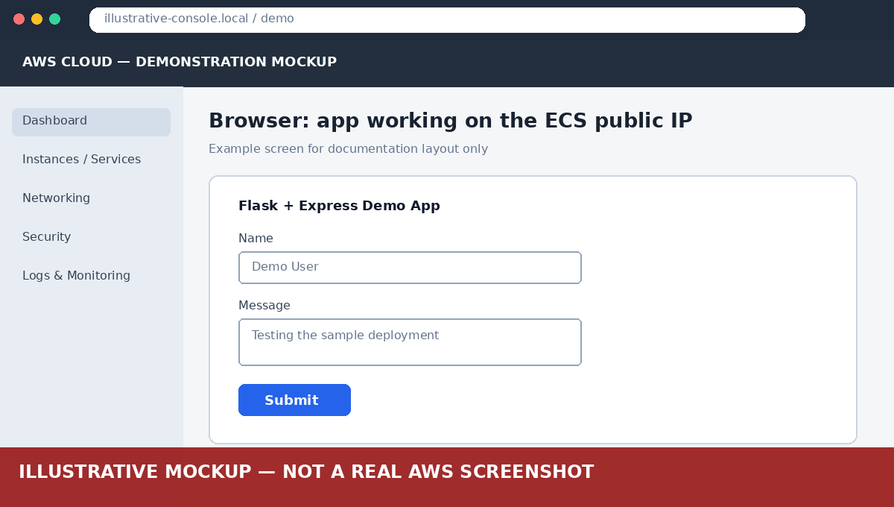
Explanation: A successful form submission confirms the containerised deployment works end to end.

