Git & GitHub — DevOps Assignment
Student: Krishna Bhatt
Project: Flask + MongoDB

Project Overview
This Flask + MongoDB project demonstrates the Git workflow required in the assignment: SSH setup, branching, merging, conflict resolution, sequential commits, soft reset, and rebase.

Task 1 — Repository Setup & First Branch
- Create a new GitHub repository named Git_and_GitHub_KrishnaBhatt.
- Generate an SSH key if required: ssh-keygen -t ed25519 -C "your_email@example.com"
- Add the public key to GitHub and test it with: ssh -T git@github.com.
- Clone the repository using SSH: git clone
- Create the username branch: git checkout -b KrishnaBhatt.
- Add the Flask project files: git add .
- Commit: git commit -m "Add initial Flask project"
- Merge into main: git checkout main && git merge KrishnaBhatt.
- Push: git push -u origin main.

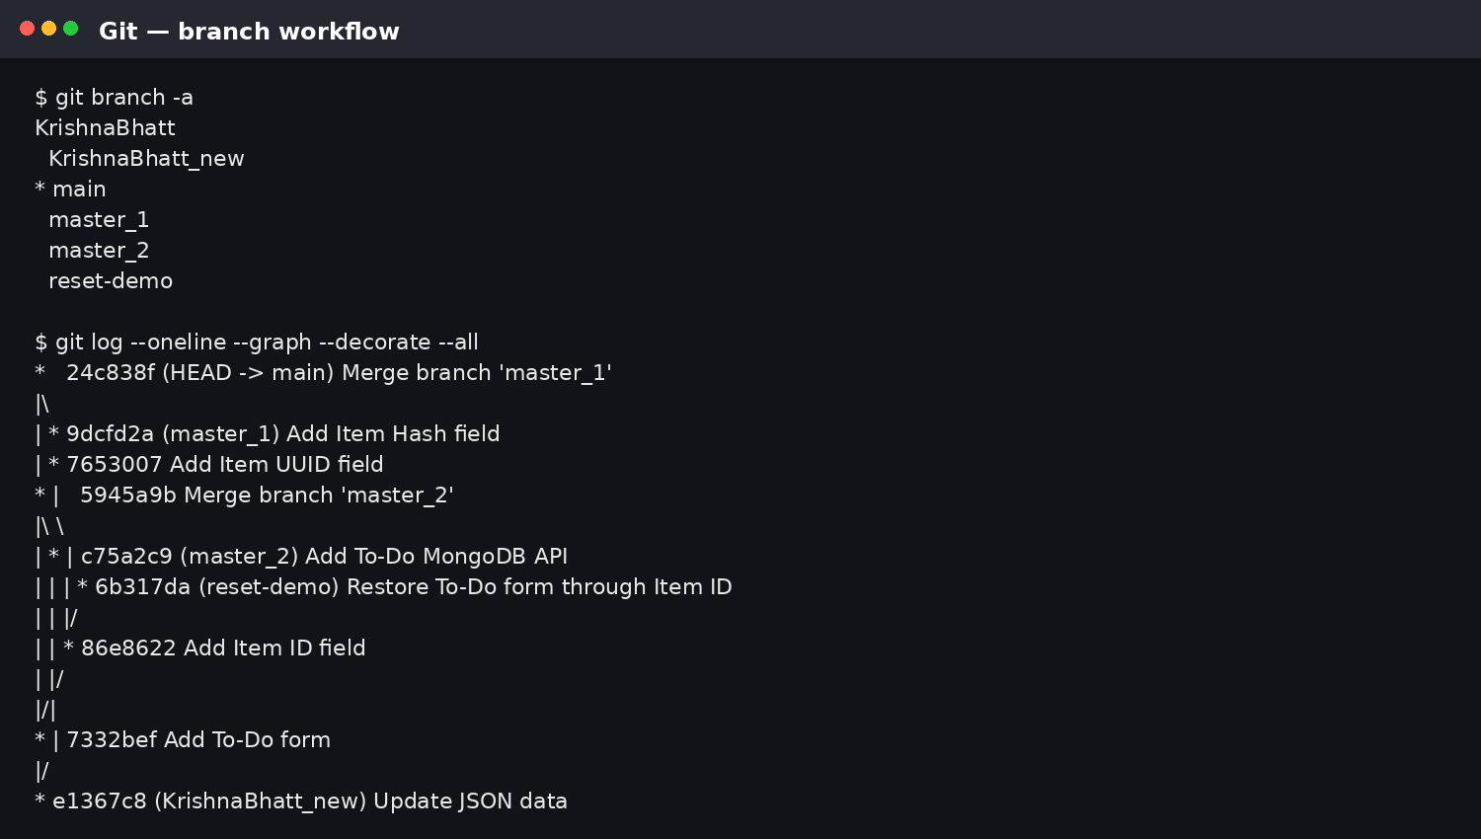

Task 2 — Update JSON & Resolve Conflicts
- Create the new branch: git checkout -b KrishnaBhatt_new.
- Update data/sample.json with the required JSON content.
- Commit: git add data/sample.json && git commit -m "Update JSON data".
- Switch to main and merge: git checkout main && git merge KrishnaBhatt_new.
- If a conflict occurs, keep the KrishnaBhatt_new version and remove the conflict markers.
- Stage the resolved file: git add data/sample.json.
- Commit the resolution: git commit -m "Resolve JSON merge conflict".
- Push the result: git push origin main.
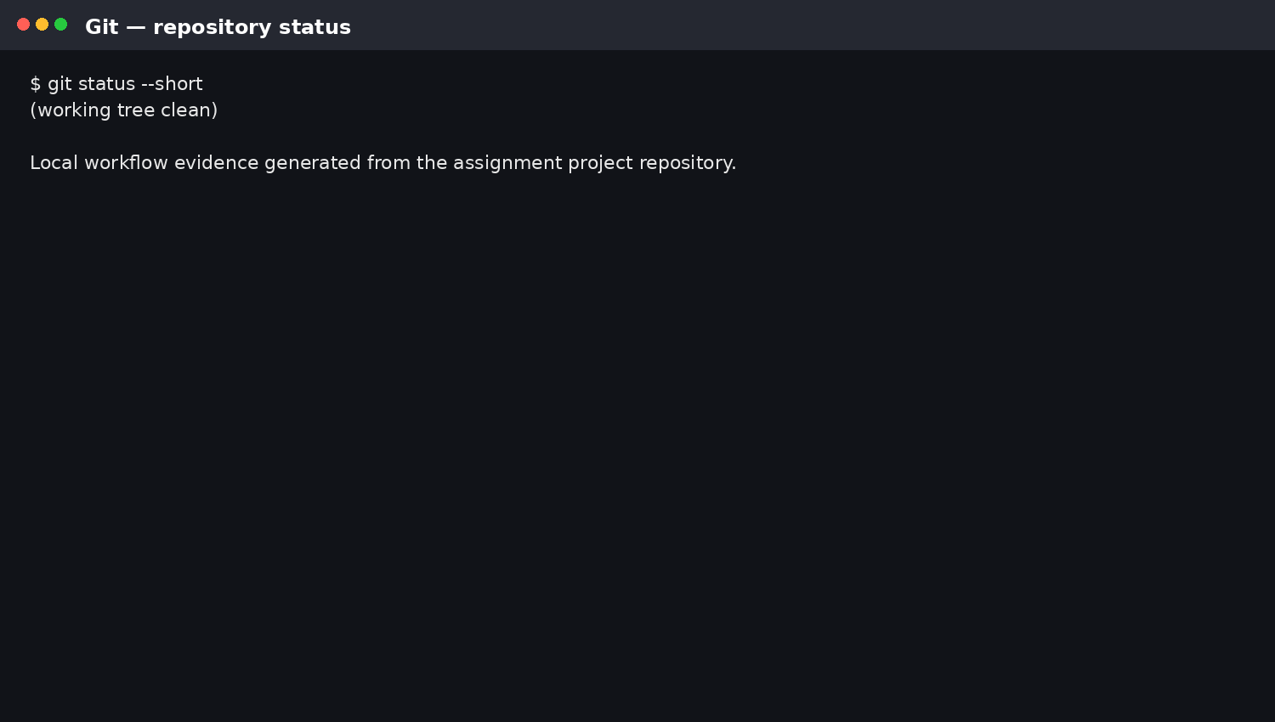

Task 3 — Parallel Feature Development
- Create master_1 from main: git checkout main && git checkout -b master_1.
- Add the To-Do frontend with Item Name and Item Description, then commit it.
- Create master_2 from main: git checkout main && git checkout -b master_2.
- Add POST /submittodoitem and MongoDB storage, then commit it.
- Merge both branches into main: git checkout main && git merge master_1 && git merge master_2.
- Push the merged main branch to GitHub.
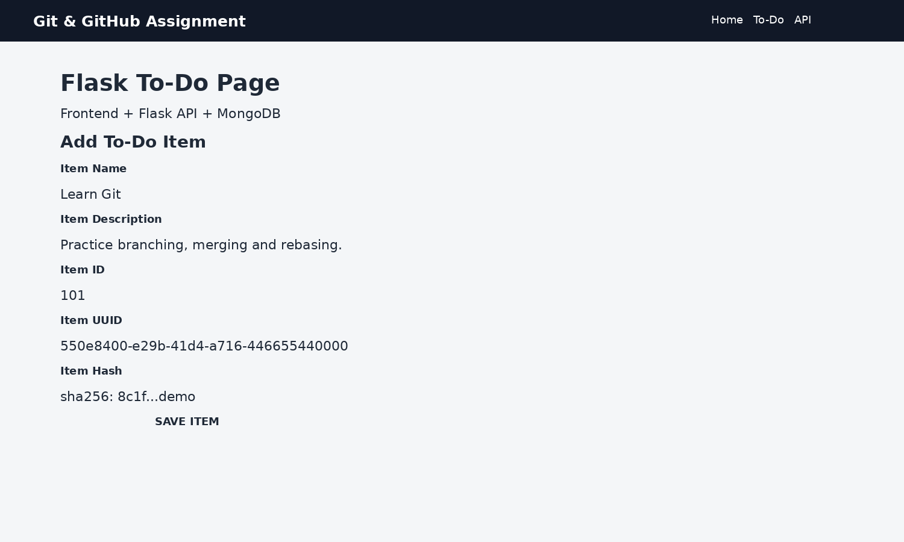

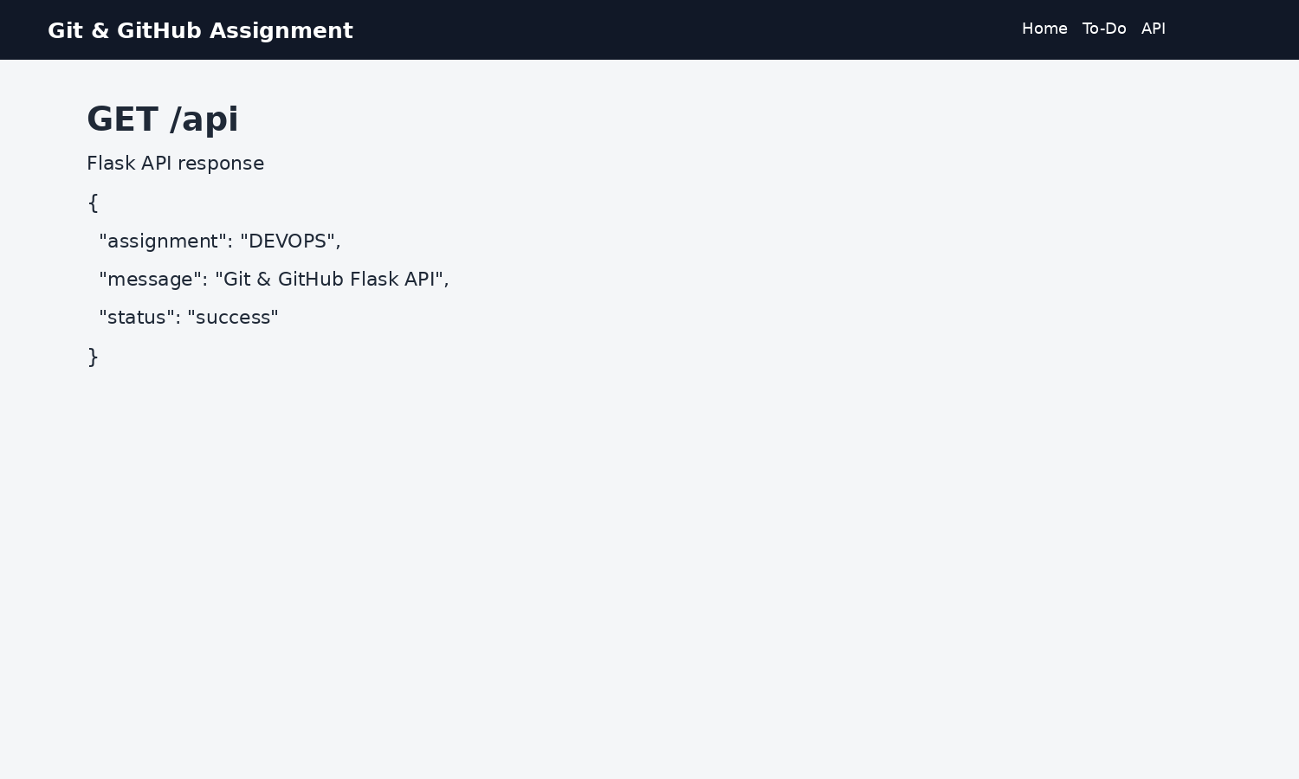
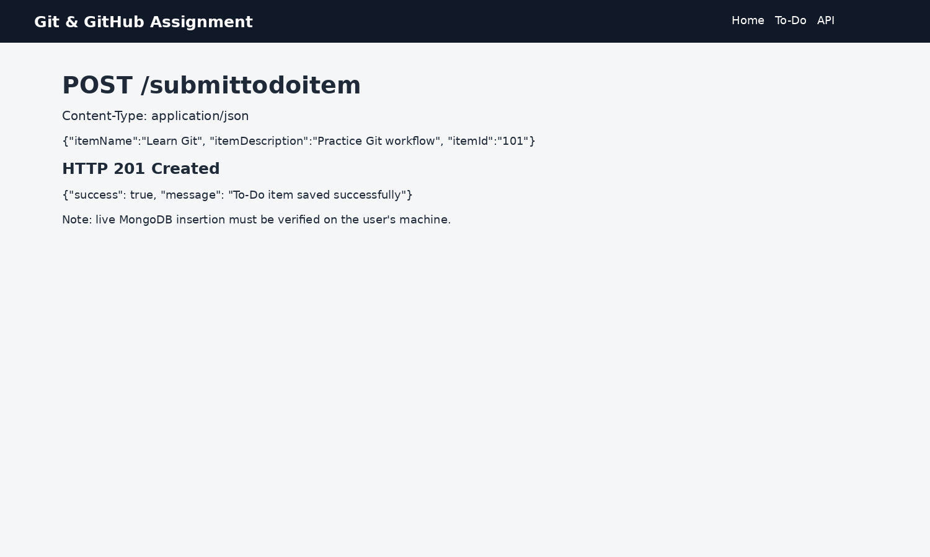

Task 4 — Sequential Commits, Reset & Rebase
- On master_1, add only the Item ID field and commit: git add . && git commit -m "Add Item ID field".
- Add only the Item UUID field and commit: git add . && git commit -m "Add Item UUID field".
- Add only the Item Hash field and commit: git add . && git commit -m "Add Item Hash field".
- Merge master_1 into main: git checkout main && git merge master_1.
- Find the Item ID commit using: git log --oneline --all.
- Use a soft reset on main: git reset --soft <ITEM_ID_COMMIT_HASH>. The changes remain staged.
- Re-commit the required state: git commit -m "Restore To-Do form through Item ID".
- Run the requested rebase: git rebase main master_1.
- Verify individual commits remain visible: git log --oneline --graph --decorate --all.
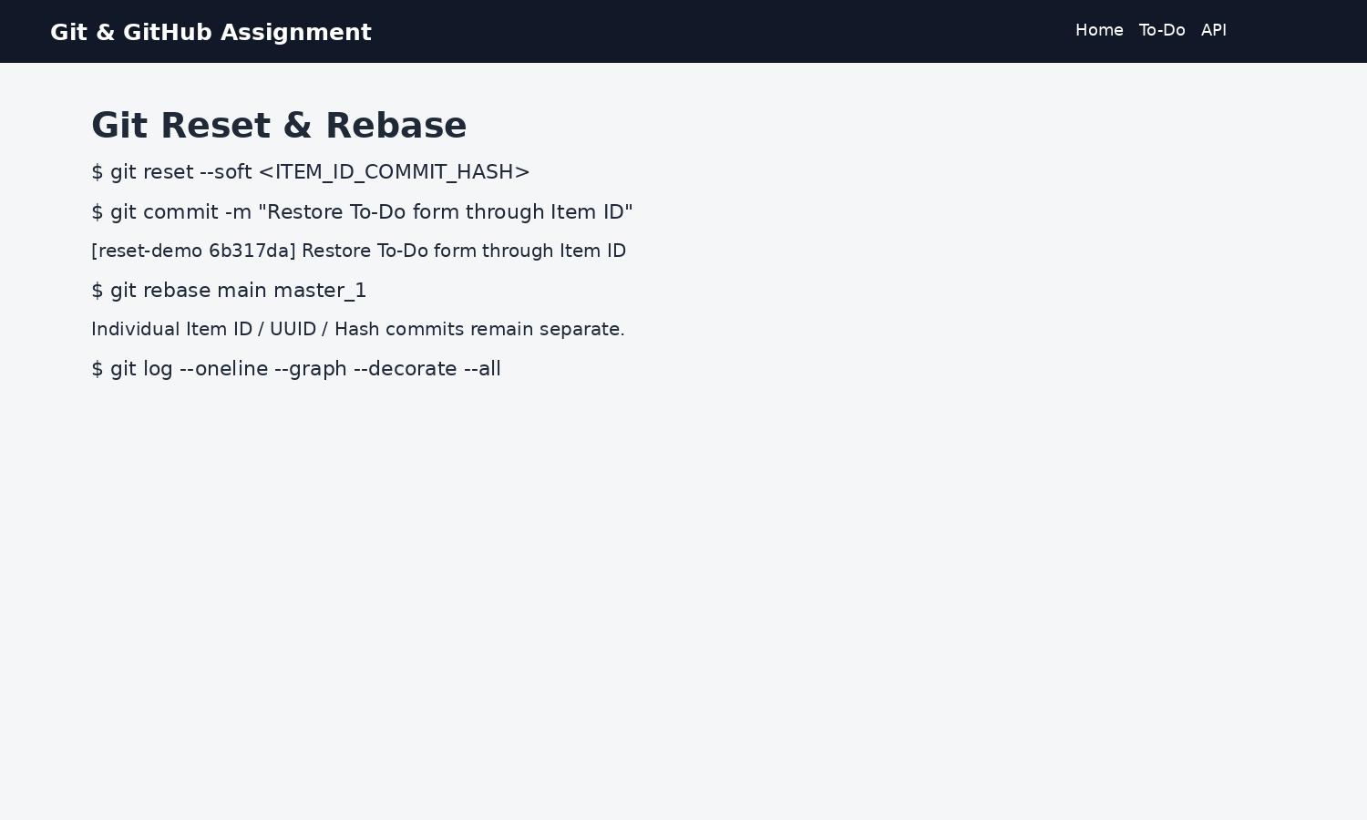

Verification Commands
git status
git branch
git remote -v
git log --oneline --graph --decorate --all
git diff
git diff --cached

