Python & Bash - DevOps Assignment
Name: Krishna Bhatt
Objective: Practise core Python programming - conditionals, dictionaries, and file handling (reading and writing files).
GitHub repository: <add your GitHub repository link here>

Task 1: Grade Checker
The program takes a score as input and prints a grade using if / elif / else: 90+ is A, 80-89 is B, 70-79 is C, 60-69 is D and below 60 is F.

Code (1_grade_checker.py)
# Task 1: Grade Checker
# Takes a score as input and prints the grade using if / elif / else.

score = float(input("Enter the score: "))

if score >= 90:
grade = "A"
elif score >= 80:
grade = "B"
elif score >= 70:
grade = "C"
elif score >= 60:
grade = "D"
else:
grade = "F"

print("Grade:", grade)

Command
python3 1_grade_checker.py

Output
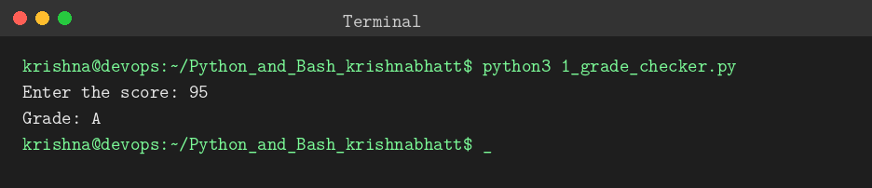
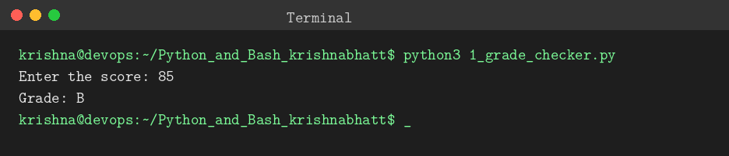
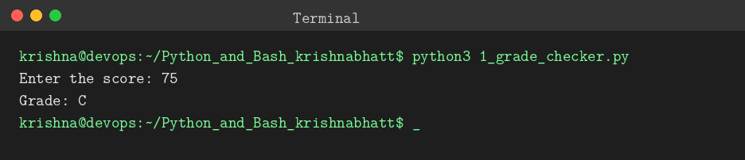
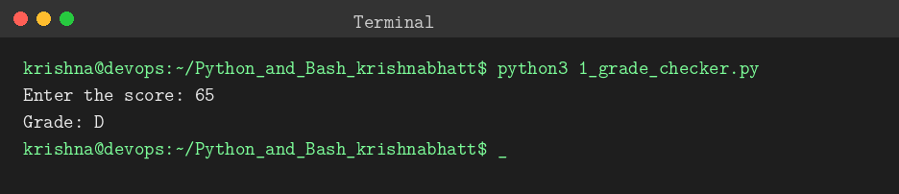
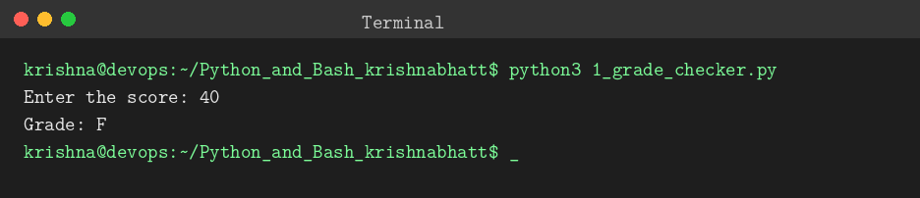
Explanation: input() reads the score and float() converts it to a number. The conditions are checked from the highest grade down, so the first true condition sets the grade and the else branch handles every score below 60.

Task 2: Student Grades
A dictionary stores student names as keys and grades as values. A menu lets the user add a student, update a grade, print all grades, or exit.

Code (2_student_grades.py)
# Task 2: Student Grades
# A dictionary stores student names (keys) and their grades (values).

students = {
"Amit": "A",
"Neha": "B",
}

while True:
print("\n--- Student Grades Menu ---")
print("1. Add a new student and grade")
print("2. Update an existing student's grade")
print("3. Print all student grades")
print("4. Exit")
choice = input("Enter your choice (1-4): ")

if choice == "1":
name = input("Enter student name: ")
if name in students:
print(name, "already exists. Use option 2 to update the grade.")
else:
grade = input("Enter grade: ")
students[name] = grade
print(name, "added with grade", grade)

elif choice == "2":
name = input("Enter student name: ")
if name in students:
grade = input("Enter new grade: ")
students[name] = grade
print("Updated", name, "to grade", grade)
else:
print(name, "not found. Use option 1 to add the student.")

elif choice == "3":
if len(students) == 0:
print("No students yet.")
else:
print("\nStudent Grades:")
for name, grade in students.items():
print(name, "->", grade)

elif choice == "4":
print("Goodbye!")
break

else:
print("Invalid choice. Please enter 1, 2, 3 or 4.")

Command
python3 2_student_grades.py

Output
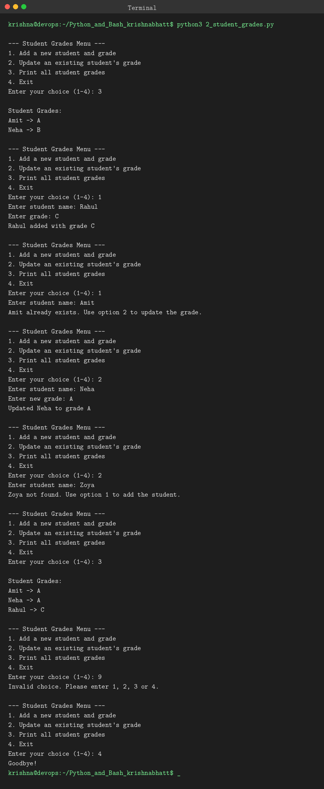
Explanation: "name in students" checks whether a key exists. Adding a new student and updating an existing one both use students[name] = grade, but the if / else decides which is allowed, so a duplicate is not added and an unknown student is not updated. The for loop with .items() prints every name and grade.

Task 3: Write to a File
The program creates notes.txt and writes content to it with open() in "w" mode and write().

Code (3_write_file.py)
# Task 3: Write to a File
# Creates a text file and writes some content to it using open() and write().

file = open("notes.txt", "w")
file.write("Hello, this is my DevOps assignment.\n")
file.write("I am learning Python and Bash.\n")
file.write("This file was created using Python file handling.\n")
file.close()

print("File 'notes.txt' created and content written successfully.")

Command
python3 3_write_file.py

Output
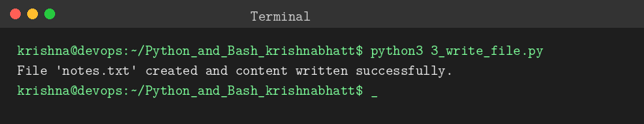
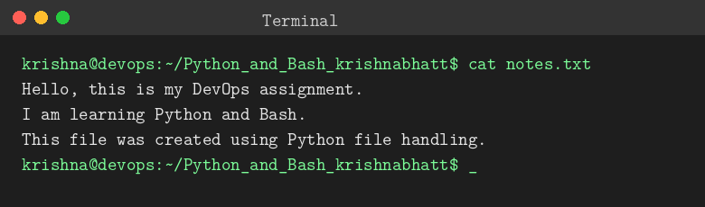
Explanation: open("notes.txt", "w") creates the file (or overwrites it if it exists). Each write() call adds text, \n starts a new line, and close() saves the file.

Task 4: Read from a File
The program opens notes.txt in read mode and displays its content using file.read().

Code (4_read_file.py)
# Task 4: Read from a File
# Opens the file in read mode and displays its content using file.read().

file = open("notes.txt", "r")
content = file.read()
file.close()

print("Content of notes.txt:\n")
print(content)

Command
python3 4_read_file.py

Output
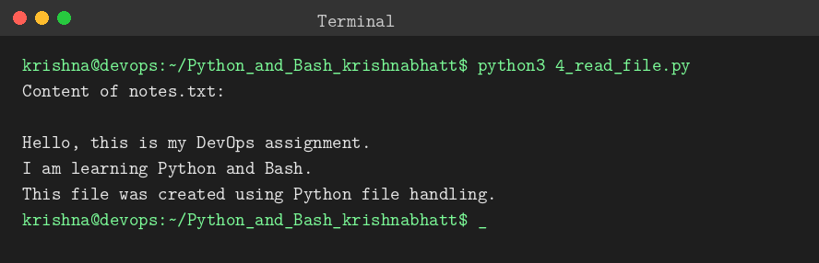
Explanation: open("notes.txt", "r") opens the file for reading and file.read() returns the whole content as one string, which is then printed. Run Task 3 first so that notes.txt exists.

