Python & Bash - DevOps Assignment
Core Python: Conditionals, Dictionaries and File Handling
Name: krishnabhatt

Project Structure
$ ls Python_and_Bash_YourName
- task1_grade_checker.py
- task2_student_grades.py
- task3_write_file.py
- task4_read_file.py
- sample.txt (created by Task 3)
- Python_and_Bash_YourName_Documentation.docx
All programs were written in Python 3 and run from the terminal with python3 .

Task 1: Grade Checker

Aim
Take a score as input and print the grade: 90+ = A, 80-89 = B, 70-79 = C, 60-69 = D, below 60 = F.

Code (task1_grade_checker.py)
# Task 1: Grade Checker
# Takes a score as input and prints the grade using if / elif / else.

score = float(input("Enter the score (0-100): "))

if score >= 90:
grade = "A"
elif score >= 80:
grade = "B"
elif score >= 70:
grade = "C"
elif score >= 60:
grade = "D"
else:
grade = "F"

print("Grade:", grade)

Explanation
- input() reads the score as text, and float() converts it into a number so it can be compared.
- The if / elif / else chain checks conditions from the highest grade down. The first true condition sets the grade, so a score like 95 stops at "A".
- The final else catches everything below 60 and gives "F".

Output
$ python3 task1_grade_checker.py
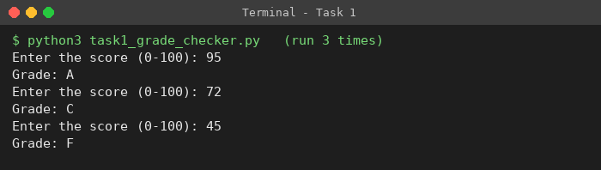
Test values: 95 gives A, 72 gives C, 45 gives F.

Task 2: Student Grades

Aim
Store student names and grades in a dictionary, and let the user add a student, update a grade, and print all grades.

Code (task2_student_grades.py)
# Task 2: Student Grades
# A dictionary stores student names (keys) and grades (values).
# The user can add a student, update a grade, or print all grades.

students = {
"Amit": "A",
"Neha": "B",
}

while True:
print("\n--- Student Grades Menu ---")
print("1. Add a new student and grade")
print("2. Update an existing student's grade")
print("3. Print all student grades")
print("4. Exit")
choice = input("Enter your choice (1-4): ")

if choice == "1":
name = input("Enter student name: ")
if name in students:
print(name, "already exists. Use option 2 to update the grade.")
else:
grade = input("Enter grade: ")
students[name] = grade
print("Added", name, "with grade", grade)

elif choice == "2":
name = input("Enter student name: ")
if name in students:
new_grade = input("Enter new grade: ")
students[name] = new_grade
print("Updated", name, "to grade", new_grade)
else:
print(name, "not found. Use option 1 to add the student first.")

elif choice == "3":
if len(students) == 0:
print("No students yet.")
else:
print("\nStudent Grades:")
for name, grade in students.items():
print(name, ":", grade)

elif choice == "4":
print("Goodbye!")
break

else:
print("Invalid choice. Please enter 1, 2, 3 or 4.")

Explanation
- students is a dictionary: the key is the student name and the value is the grade.
- Option 1 (add): if name in students checks whether the name already exists. If not, students[name] = grade adds it; otherwise the program tells the user to use the update option.
- Option 2 (update): if the name exists, students[name] = new_grade overwrites the old grade; otherwise it says the student is not found.
- Option 3 (print): students.items() is looped over to print every name and grade.
- A while True loop keeps showing the menu until the user chooses 4 (Exit), which uses break. Any other input prints an "Invalid choice" message.

Output
$ python3 task2_student_grades.py
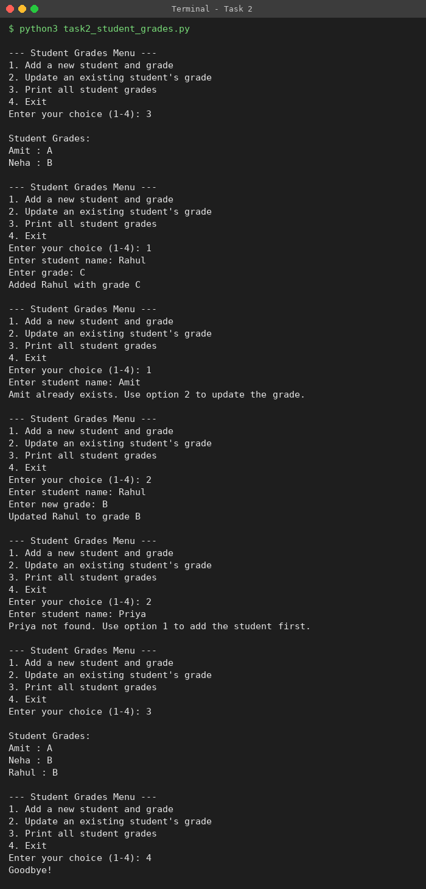
The run shows: printing the starting data, adding Rahul, rejecting a duplicate (Amit), updating Rahul to B, rejecting an unknown student (Priya), printing the final list, and exiting.

Task 3: Write to a File

Aim
Create a text file and write content to it using open() and write().

Code (task3_write_file.py)
# Task 3: Write to a File
# Creates a text file and writes some content to it using open() and write().

file = open("sample.txt", "w") # "w" mode creates the file (or overwrites it)
file.write("Hello, this is my DevOps assignment.\n")
file.write("I am learning Python file handling.\n")
file.write("This file was created using open() and write().\n")
file.close()

print("File 'sample.txt' created and content written successfully.")

Explanation
- open("sample.txt", "w") opens the file in write mode. If the file does not exist it is created; if it exists its old content is replaced.
- file.write() writes a string to the file. \n at the end of each string starts a new line.
- file.close() saves and closes the file so the data is safely stored.

Output
$ python3 task3_write_file.py && cat sample.txt
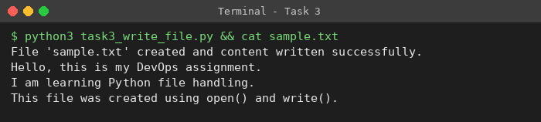

Task 4: Read from a File

Aim
Open the file in read mode and display its content using file.read().

Code (task4_read_file.py)
# Task 4: Read from a File
# Opens the file in read mode and displays its content using file.read().

file = open("sample.txt", "r") # "r" mode opens the file for reading
content = file.read()
file.close()

print("Content of sample.txt:")
print("-----------------------")
print(content)

Explanation
- open("sample.txt", "r") opens the file created in Task 3 in read mode.
- file.read() returns the whole content of the file as one string, which is stored in content and printed.
- Task 3 must be run first, otherwise Python raises FileNotFoundError because sample.txt does not exist yet.

Output
$ python3 task4_read_file.py
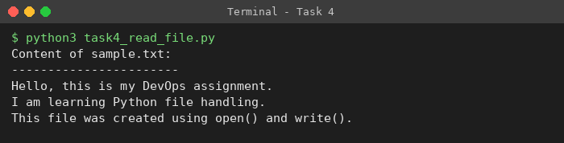

Conclusion
This assignment practised conditionals (if / elif / else), dictionaries (add, update, iterate), and file handling (open, write, read, close) in Python.

