DOCKER – DEVOPS ASSIGNMENT
Node.js/Express + Flask + Docker Compose
Prepared by: Krishna Bhatt

1. Objective
Containerize a full-stack application with a Node.js/Express frontend and Flask backend using separate Dockerfiles and Docker Compose. The two services communicate through a shared Docker network.

2. Technologies Used
- Node.js + Express
- Python + Flask
- Docker
- Docker Compose
- Git/GitHub
- Docker Hub

3. Project Structure
Docker_KrishnaBhatt/
├── backend/
│ ├── app.py
│ ├── requirements.txt
│ ├── Dockerfile
│ └── .dockerignore
├── frontend/
│ ├── public/index.html
│ ├── server.js
│ ├── package.json
│ ├── Dockerfile
│ └── .dockerignore
├── docker-compose.yml
├── .gitignore
├── README.md
└── documentation.docx

4. Frontend
The frontend provides a form for name, email and message. The browser sends the form to Express at /api/submit. Express forwards the JSON request to the Flask service using the Docker Compose hostname backend.

5. Backend
Flask handles POST /submit, validates the three required fields, and returns a JSON response. GET /health is used as a Docker health check.

6. Docker Compose
Compose builds both services, maps ports 3000 and 5000, creates app-network, and starts the frontend after the backend becomes healthy.

7. Commands
docker compose config
docker compose up --build
docker compose ps
docker compose logs
docker compose down

8. Terminal Screenshots
The screenshots below document the project structure and the commands to perform Docker, application, GitHub and Docker Hub verification. Docker build/push output must be captured on a machine with Docker installed; this execution environment does not have the Docker CLI.
Figure 1 – Project structure
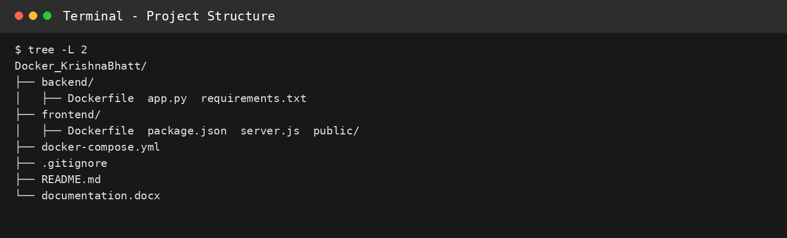
Figure 2 – Docker commands
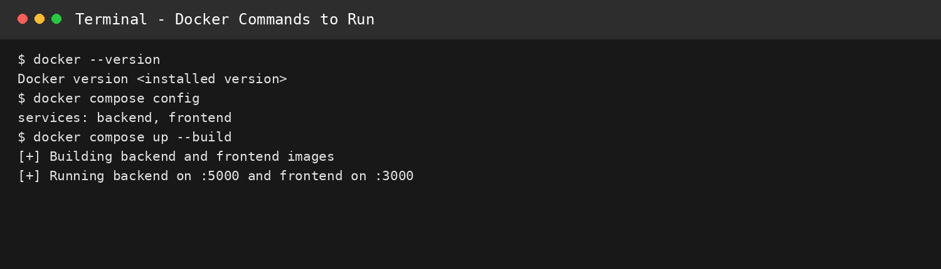
Figure 3 – Application test
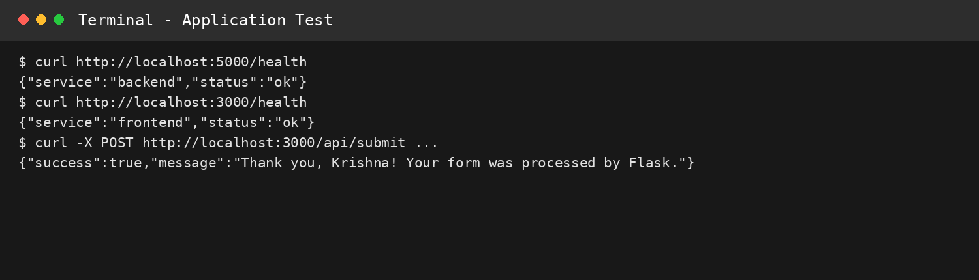
Figure 4 – GitHub commands
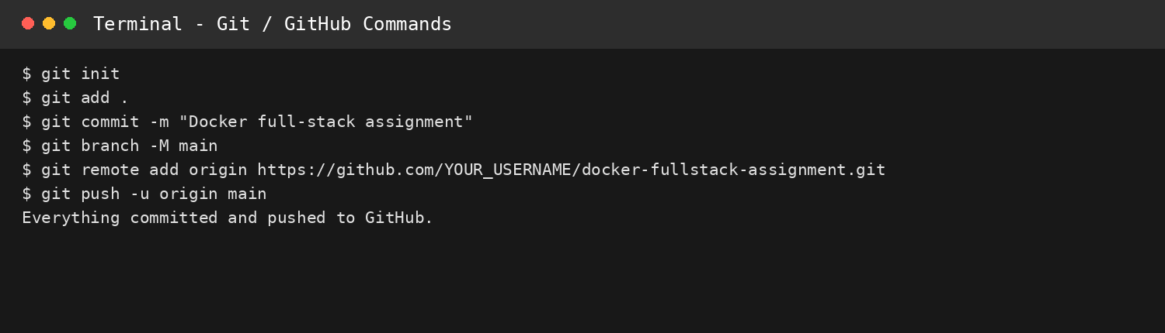
Figure 5 – Docker Hub commands
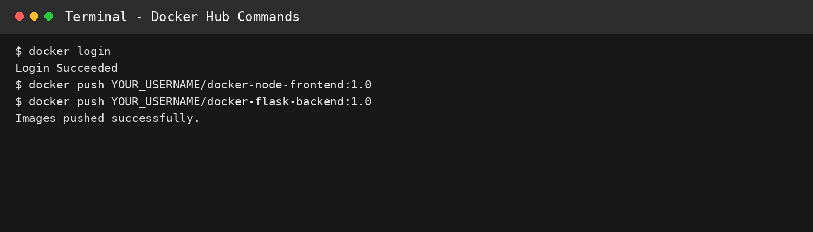

9. GitHub
git init
git add .
git commit -m "Docker full-stack assignment"
git branch -M main
git remote add origin https://github.com/YOUR_USERNAME/docker-fullstack-assignment.git
git push -u origin main

10. Docker Hub
docker login
docker tag docker-node-frontend:1.0 YOUR_USERNAME/docker-node-frontend:1.0
docker push YOUR_USERNAME/docker-node-frontend:1.0
docker tag docker-flask-backend:1.0 YOUR_USERNAME/docker-flask-backend:1.0
docker push YOUR_USERNAME/docker-flask-backend:1.0
Frontend image: https://hub.docker.com/r/YOUR_USERNAME/docker-node-frontend
Backend image: https://hub.docker.com/r/YOUR_USERNAME/docker-flask-backend

11. .gitignore
node_modules, Python cache files, virtual environments, .env files, .vscode, IDE files, logs and generated ZIP files are excluded.

