Flask & MongoDB Atlas — Assignment Documentation
DEVOPS Assignment | Prepared for submission
Objective: Build a Flask application with a JSON API route and a frontend form that stores submitted data in MongoDB Atlas, with success and error handling.

1. Project Structure
Flask_and_MongoDB_KrishnaBhatt/
├── app.py
├── backend/data.json
├── templates/index.html
├── templates/success.html
├── static/style.css
├── requirements.txt
├── .env.example
├── .gitignore
├── README.md
├── GITHUB_LINK.txt
└── screenshots/
The .env file is intentionally not included. It must contain the private MongoDB Atlas connection string and should never be committed to GitHub.

2. Task 1 — JSON API Route
The /api route reads backend/data.json on each request and returns the contents using Flask jsonify(). This satisfies the requirement that the data is stored in a backend file, read from that file, and sent as a JSON response.
GET /api
→ load_api_data()
→ backend/data.json
→ jsonify(data)
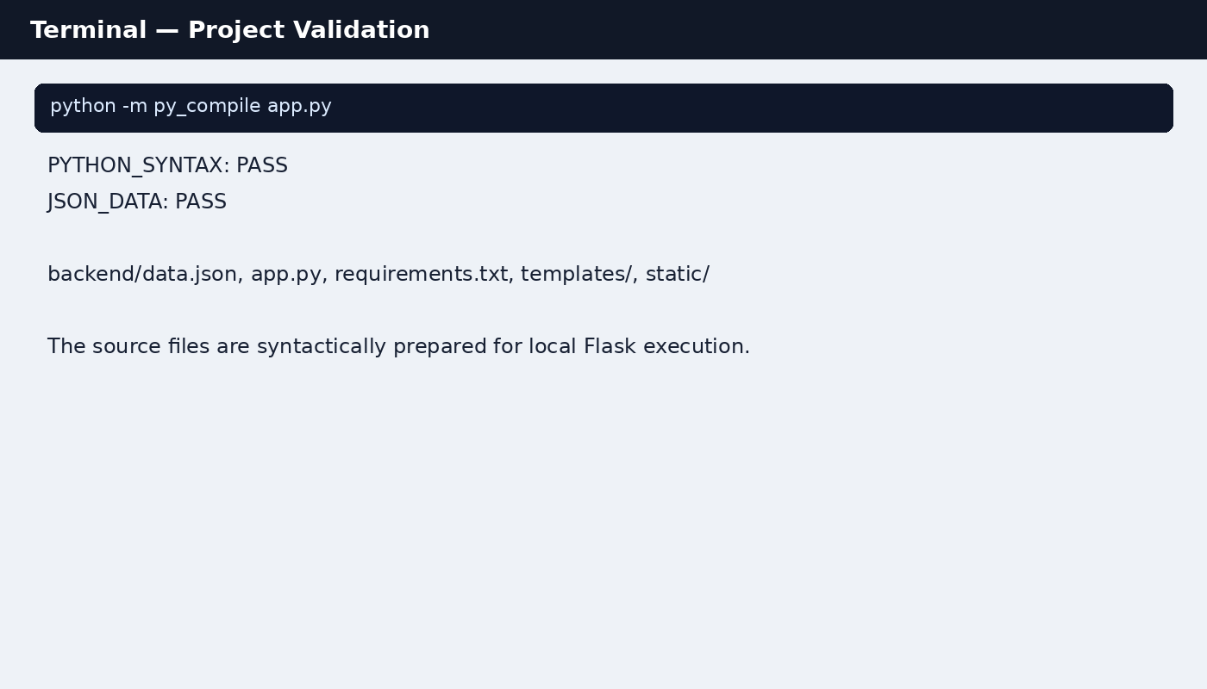
Figure 1: Local source/syntax validation.
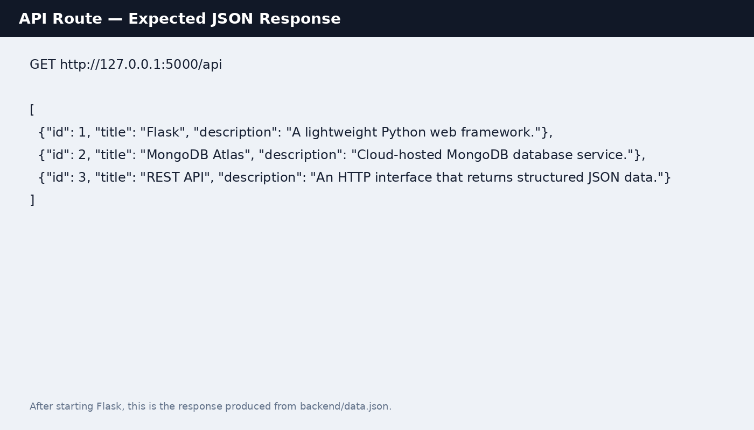
Figure 2: Expected /api JSON response from backend/data.json.

3. Task 2 — Frontend Form + MongoDB Atlas
The home page contains a form with name, email and message fields. POST /submit validates the fields, connects to MongoDB Atlas using MONGO_URI, and inserts one document into the configured submissions collection.
{
"name": "Krishna Bhatt",
"email": "krishna@example.com",
"message": "Assignment submission test"
}
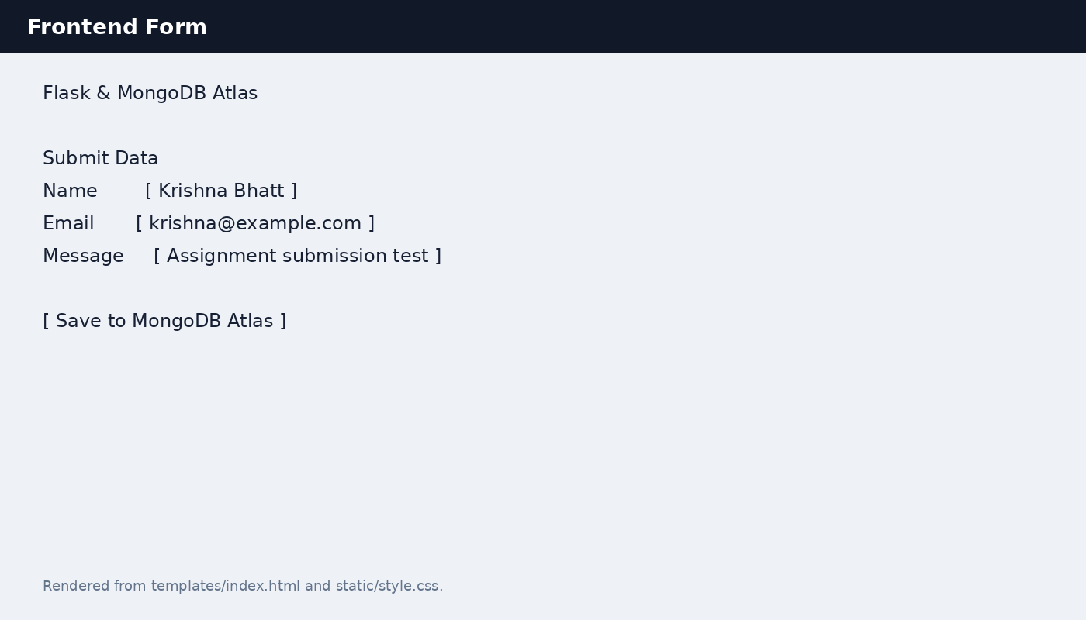
Figure 3: Frontend form UI.

Success handling
After insert_one() succeeds, Flask redirects to /success. The success page displays exactly: “Data submitted successfully”.
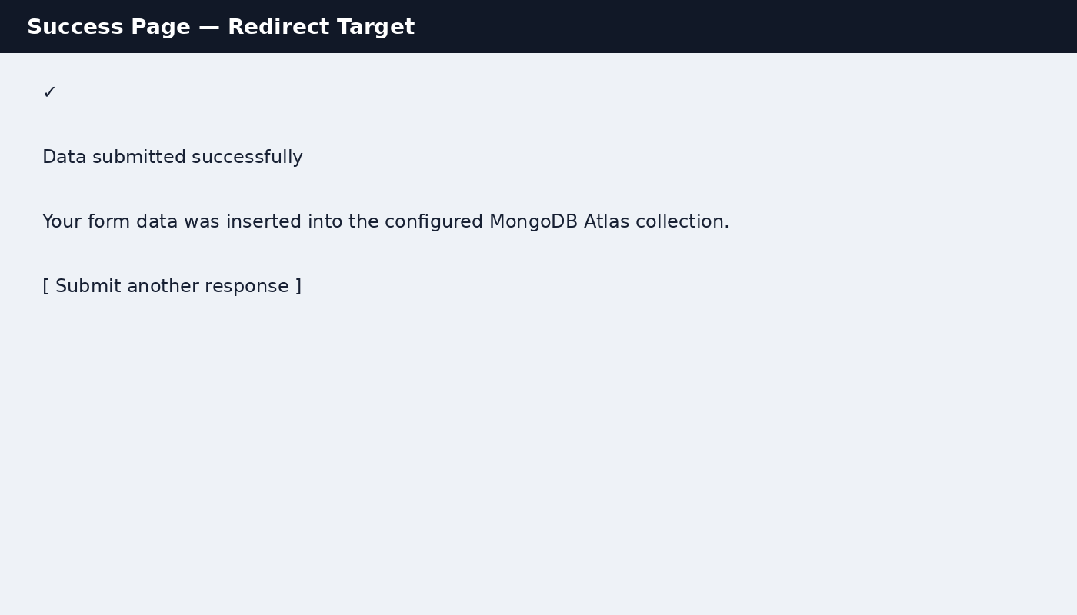
Figure 4: Success page and redirect target.

Error handling
If required fields are missing, or MongoDB raises a connection/database error, the application renders index.html again with an error message. It does not redirect.
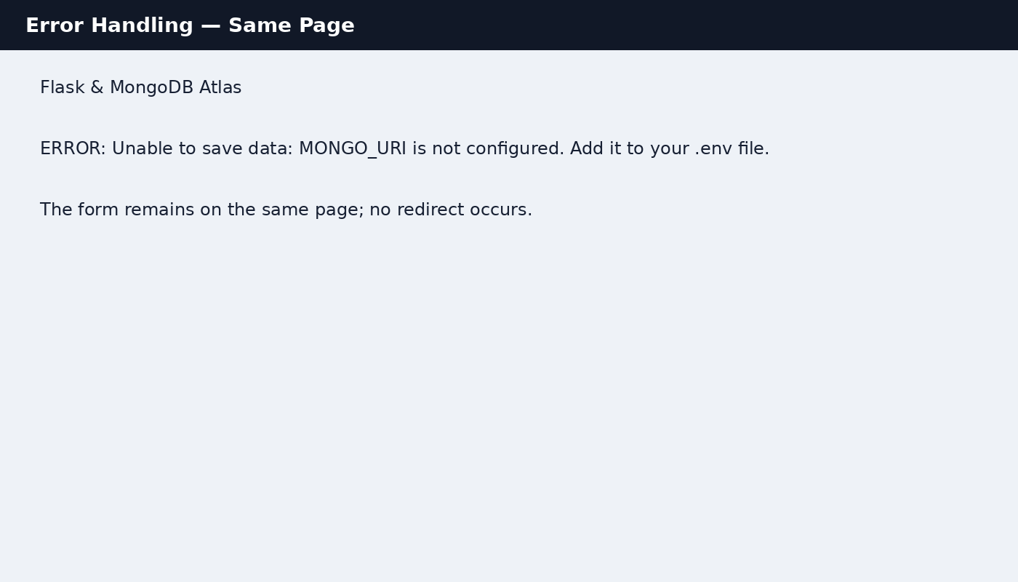
Figure 5: Same-page error handling example.

4. MongoDB Atlas Configuration
- Create a MongoDB Atlas cluster and database user.
- Under Network Access, allow the IP address from which you will run the application.
- Copy .env.example to .env.
- Replace MONGO_URI with your Atlas connection string.
- Keep MONGO_DB_NAME=flask_assignment and MONGO_COLLECTION_NAME=submissions unless you want different names.
- Do not upload .env to GitHub or the submission ZIP if it contains real credentials.
MONGO_URI=mongodb+srv://<username>:<password>@<cluster-url>/?retryWrites=true&w=majority
MONGO_DB_NAME=flask_assignment
MONGO_COLLECTION_NAME=submissions
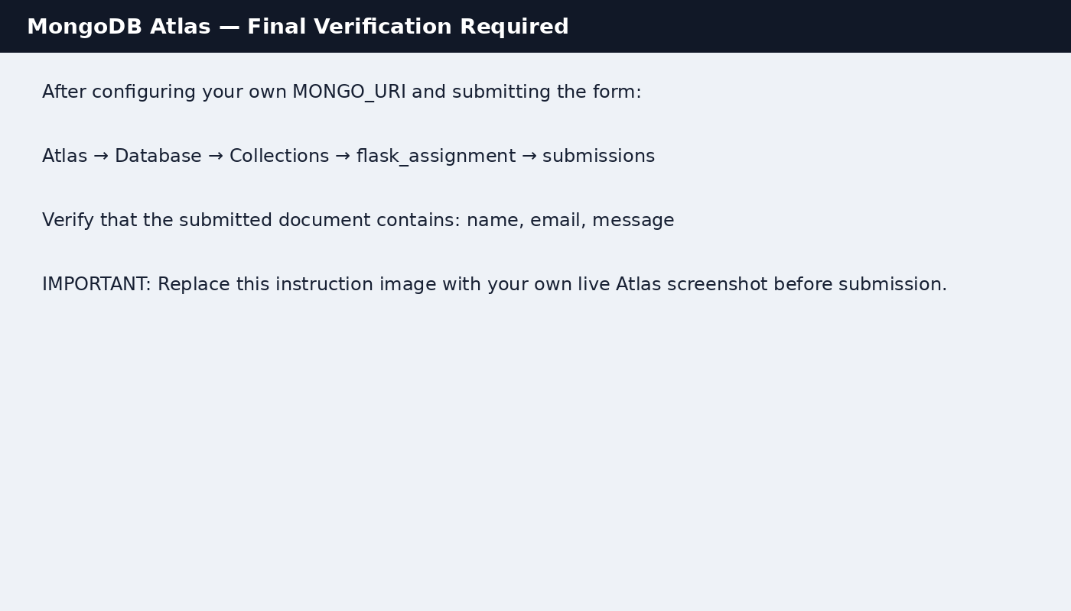
Figure 6: Required live Atlas verification. Replace this instruction image with a real screenshot after your own successful insert.

5. How to Run
python -m venv .venv
# Windows
.venv\Scripts\activate
# macOS/Linux
source .venv/bin/activate
pip install -r requirements.txt
copy .env.example .env # Windows
# or: cp .env.example .env
python app.py
Open http://127.0.0.1:5000/ for the form and http://127.0.0.1:5000/api for the JSON API.

