

**Analyzing Swiggy**



Wireframe Documentation

Krishnachaitanya Pabbu

Gangireddy Madhava Reddy

Analysis:

According to the given issue description, we have outlined various scenarios for conducting an examination. This approach aids not only in comprehending significant connections among attributes but also facilitates independent exploration and the formulation of our own discoveries.

Basic Information:

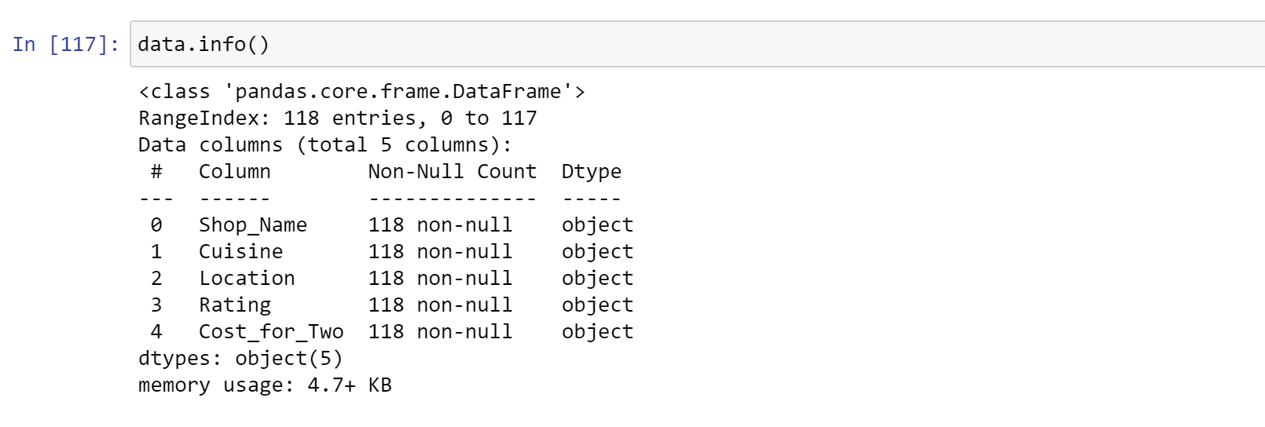

The study examined information from Swiggy, a food delivery company, focusing on its Bangalore operations. The dataset utilized was sourced from Google Drive and encompassed details regarding eateries in Bangalore, encompassing their culinary offerings, ratings, and pricing.

FIRST FIVE ENTRIES IN THE DATASET:

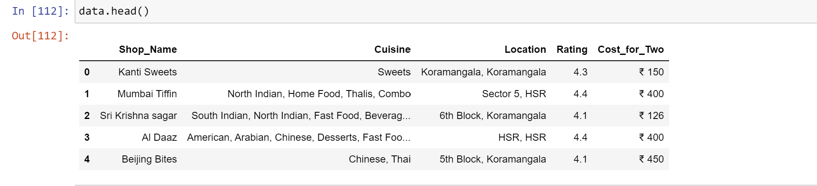

The initial five rows of the dataset were exhibited utilizing the head() method. This presented the names of the columns and a few example records from the data collection, encompassing details such as the eatery's name, its location, rating, types of cuisines offered, and the mean expense for a pair of diners.

COUNT OF DISTINCT VALUES PER ATTRIBUTE:

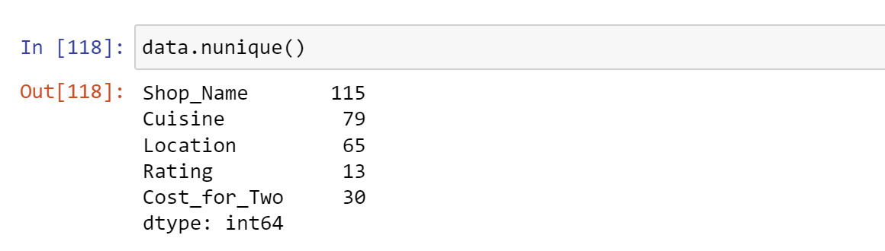

The distinct values of every attribute were identified utilizing the nunique() function. This displayed the count of distinct values for each attribute within the dataset, encompassing distinct restaurant names, different geographical positions, varied culinary styles, and distinct evaluations.

|  |  |  |
| --- | --- | --- |
|  |  |  |

Mean Ratings for Different Types of Food:

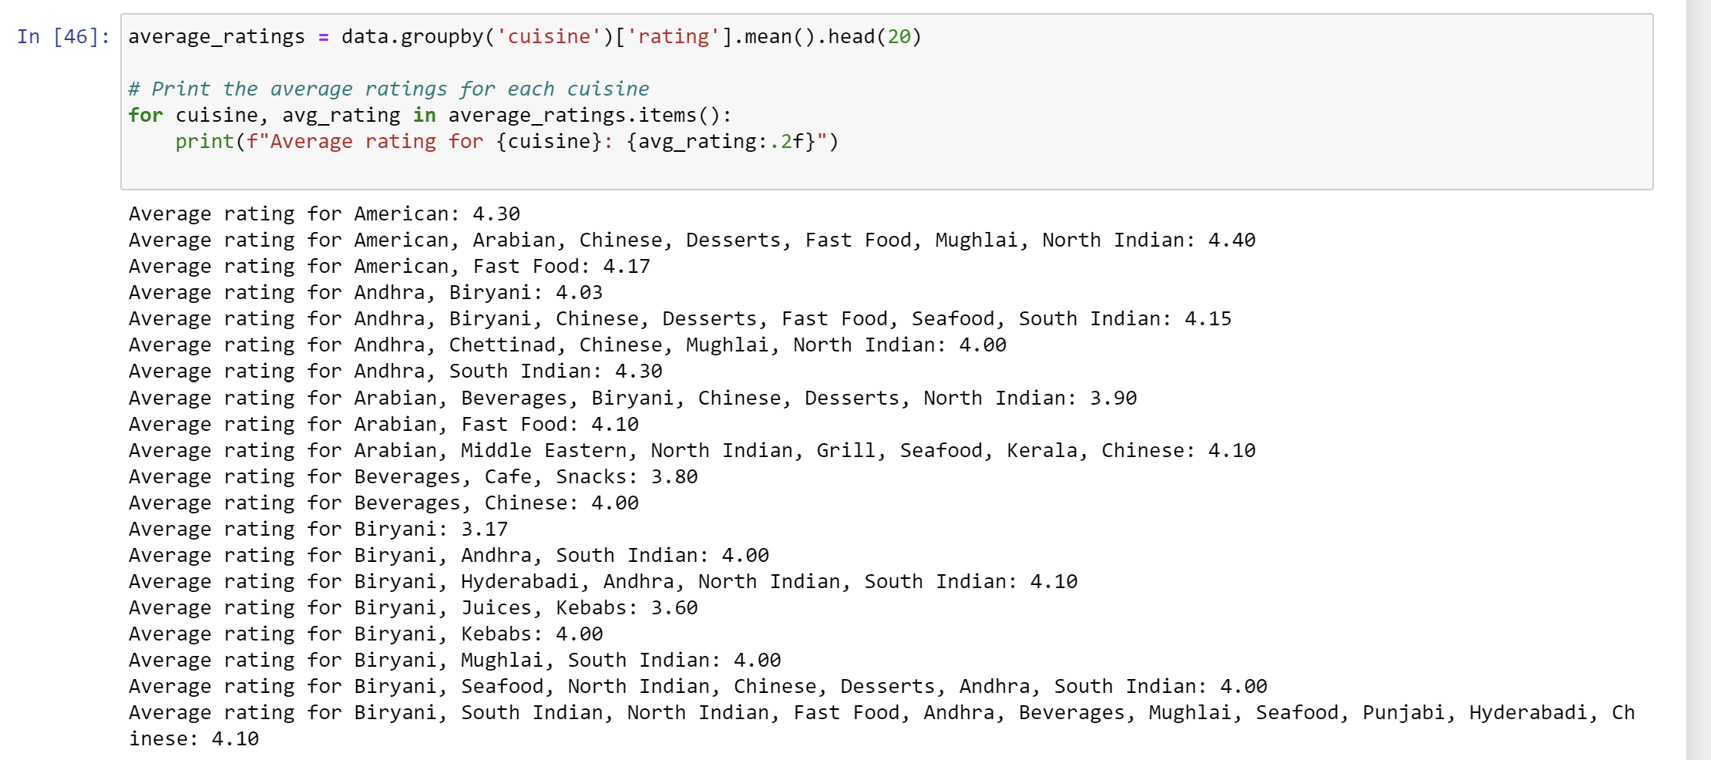

The groupby() function was employed to compute the mean rating for different cuisines. By grouping the data according to cuisine, the mean rating for each cuisine was derived. The outcome presented the cuisine's mean rating in a descending sequence, with the top-rated cuisine displayed at the forefront.

Culinary and Expense Classification's Mean Rating:

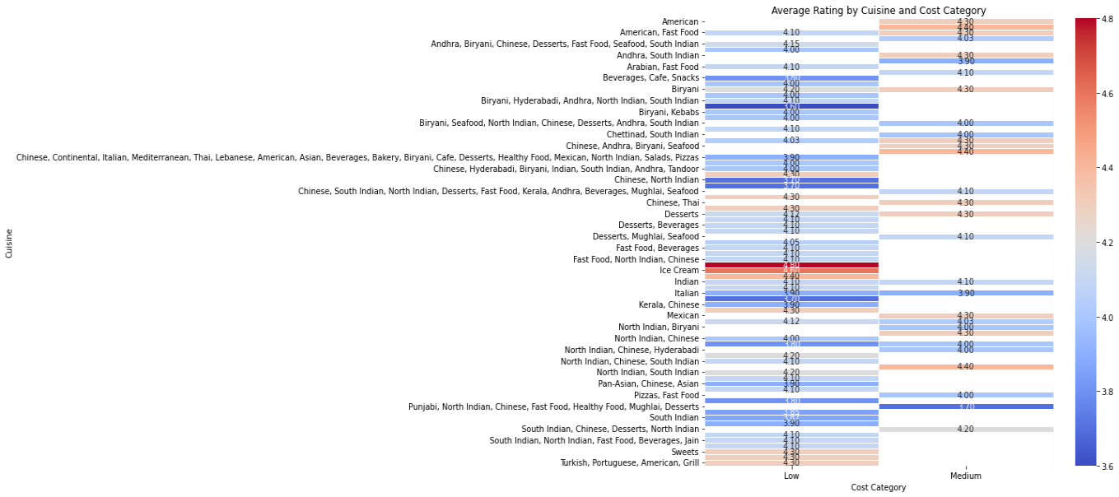

The heatmap illustrates the mean expenses and ratings associated with various culinary styles in Bangalore. This examination aids in recognizing the cuisines that exhibit the greatest mean expenditure and rating. This data enables patrons to make well-informed decisions while selecting their preferred cuisine for ordering.

Distribution of restaurants categorized by cost displayed in a pie chart:

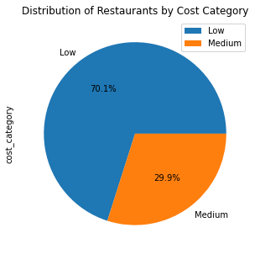

The distribution of restaurants according to their cost classification is presented through a pie chart. This examination assists in recognizing the proportion of dining establishments situated within each expense bracket. Such data can guide patrons in selecting eateries in accordance with their financial plan.

Graph illustrating the rating distribution:

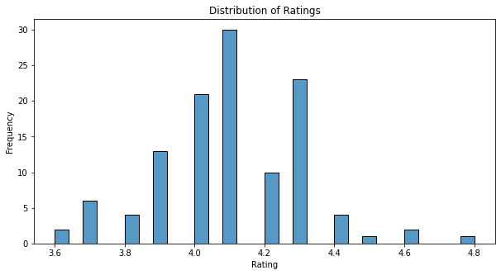

The histogram illustrates how ratings are spread across all dining establishments in Bangalore. This analysis aids in recognizing the rating distribution and the prevalent score that customers frequently assign.

Distribution of dining establishments based on their geographical locations:

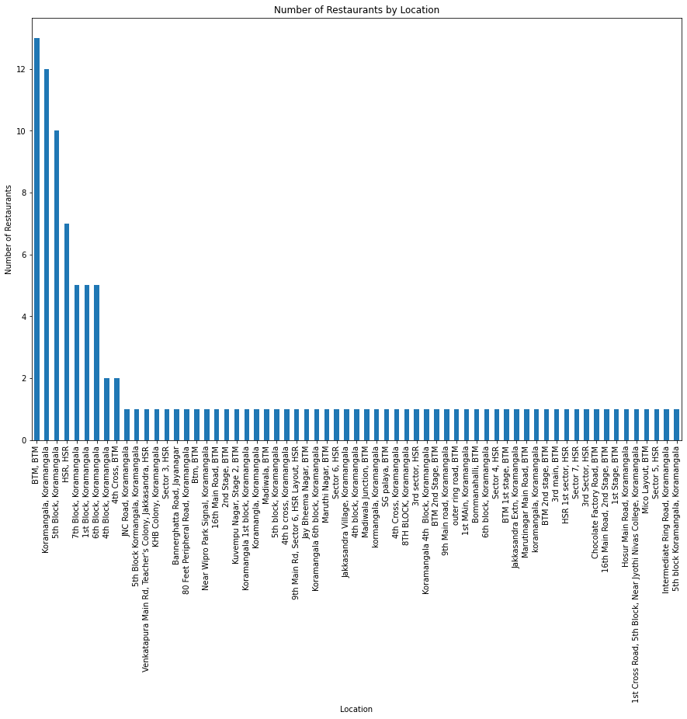

The examination presents the count of dining establishments based on their locations. This data aids patrons in recognizing regions with the most significant concentration of eateries, enabling them to make well-informed decisions about where to place their orders.

Vertical bar chart depicting the mean expense per individual according to different places:

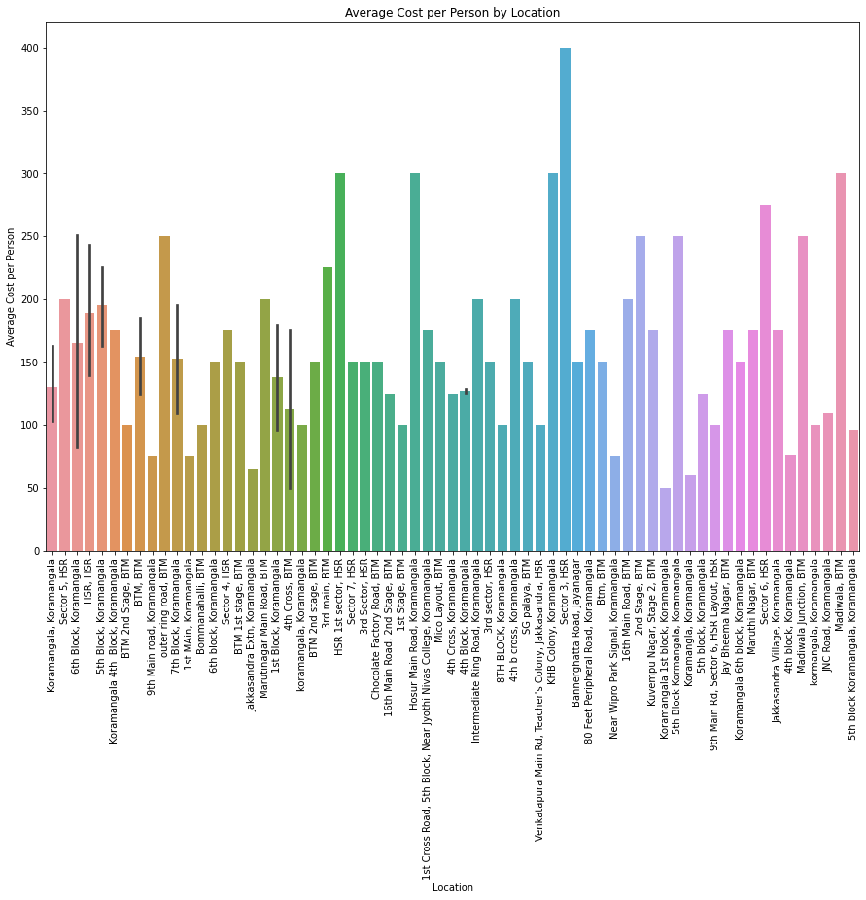

The bar chart illustrates the mean expense per individual according to different places. This examination aids in pinpointing regions with the most and least expensive average expenditure per individual. Such data can assist patrons in selecting eateries based on their financial plan.

Box plot depicting the mean rating according to expense grouping:

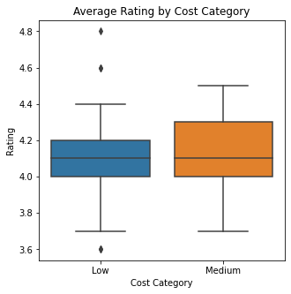

The plot illustrates the mean rating according to different expense brackets. This examination assists in pinpointing the cost category with the most elevated mean rating and the one with the most minimal. Such insights empower diners to make restaurant selections aligned with their financial plans while also relishing favorable ratings.

In general, the examination conducted during the project offers valuable perspectives for Swiggy users in Bangalore who rely on its food delivery offerings. This data can enable customers to make knowledgeable decisions about their culinary selections, dining establishments, and delivery areas, all taking into account their financial plan, preferred ratings, and geographical preference.