TECHNOZIS WEBSITE
AUTOMATION PROJECT
Technical Documentation
Powered by n8n • Firecrawl • Google Gemini • Groq • GitHub • Vercel
Version 2.0 | March 2026
All 5 Pages Complete | Deployed on Vercel

1. Project Overview
This document describes the end-to-end automated website generation pipeline built to recreate a premium, content-accurate version of the Technozis website (technozis.com). The project uses n8n as the workflow orchestration engine, Firecrawl for web scraping, and dual AI models (Google Gemini and Groq) chained together to generate production-quality HTML pages.

Project Name | Technozis Website Automation
Orchestration Tool | n8n (self-hosted, localhost:5678)
Scraping Tool | Firecrawl API (api.firecrawl.dev)
AI Model 1 | Google Gemini Chat Model (content analysis & HTML generation)
AI Model 2 | Mistral Cloud Chat Model / Groq (code generation & merge)
Output Format | Static HTML files with Tailwind CSS
Pages Completed | Home, Careers, Business, About Us, Contact Us (all 5 complete)
Deployment | Vercel (via GitHub repository)
Status | COMPLETE — All pages live on Vercel

2. System Architecture
The automation pipeline follows a structured flow: trigger → scrape → split → analyse + generate → clean → download → GitHub push → Vercel deploy. Two pages are processed simultaneously per run thanks to the parallel chain architecture.

Architecture Highlights
Two parallel LLM chains run simultaneously — one for HTML structure (Google Gemini) and one for content accuracy (Groq/Mistral).
Two pages can be downloaded and processed in a single workflow execution.
The final HTML files are pushed to GitHub and automatically deployed to Vercel.
All 5 pages — Home, Careers, Business, About Us, and Contact Us — are now complete and live.

3. n8n Workflow — Node-by-Node Breakdown
The workflow is named 'wedsite' and runs on n8n at localhost:5678. The diagram below shows the full workflow as it ran during production. Each node serves a specific role in the pipeline.

3.1 Workflow Diagram
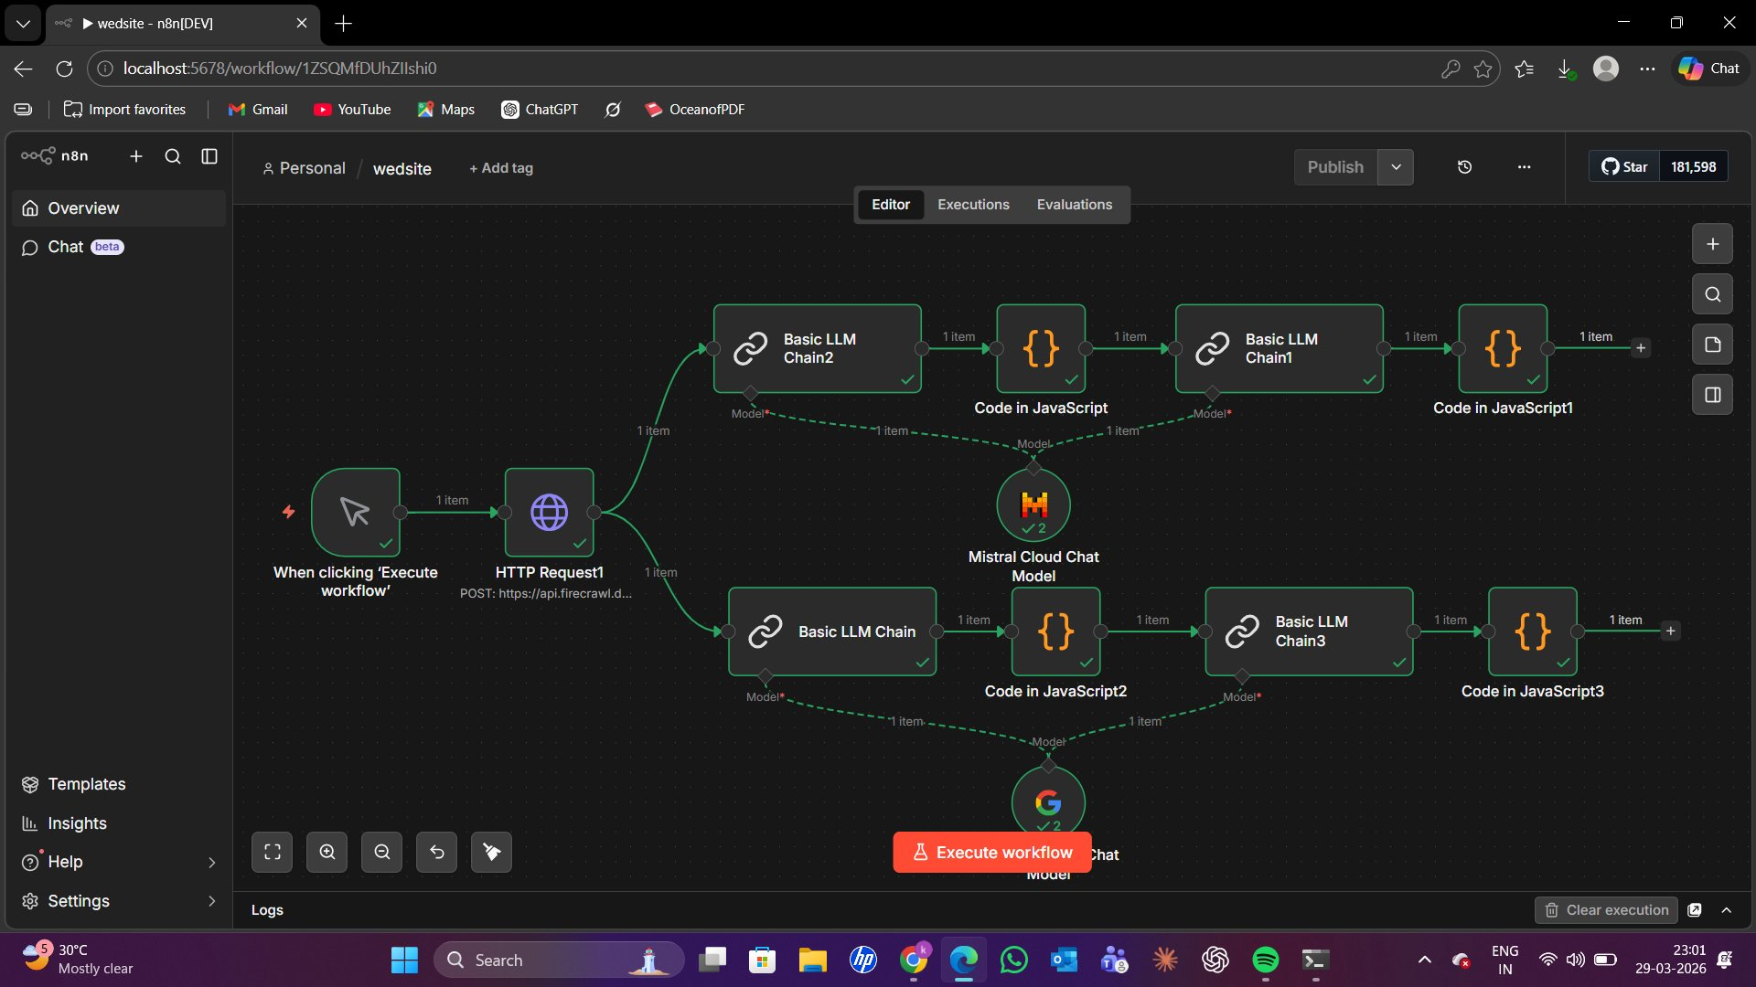
Figure 1: Full n8n workflow — Trigger → Firecrawl → Dual LLM Chains → JavaScript → Download

3.2 Node Reference Table
Node Name | Type | Purpose
When clicking 'Execute workflow' | Trigger | Manual trigger that starts the entire automation pipeline on demand.
HTTP Request1 | HTTP Request | POST request to Firecrawl API to scrape the target Technozis webpage and return raw content in markdown + HTML format.
Basic LLM Chain2 (upper) | LLM Chain | First AI chain — takes scraped content and generates the visual HTML structure, layout, and Tailwind CSS styling.
Basic LLM Chain (lower) | LLM Chain | Parallel content analysis chain — extracts headings, descriptions, job roles, addresses, stats, and all factual content as structured JSON.
Mistral Cloud Chat Model | AI Model | Powers both parallel LLM chains. Used for HTML generation and content analysis tasks.
Code in JavaScript (upper) | Code | Parses and cleans HTML output from Chain2. Strips markdown fences, extracts pure HTML.
Basic LLM Chain1 | LLM Chain | Takes the cleaned HTML and content analysis output to refine accuracy and align with real Technozis content.
Code in JavaScript1 | Code | Final cleanup pass on Chain1 output before download.
Code in JavaScript2 | Code | Parses and structures the content analysis JSON output from the lower chain.
Basic LLM Chain3 | LLM Chain | Final merge chain — combines HTML structure with accurate content to produce the finished page.
Code in JavaScript3 | Code | Final processing node — extracts the complete HTML, strips LLM artifacts, and prepares for download.

4. Pages Completed
All five pages of the Technozis website have been successfully generated, verified, and deployed. Each page was produced by running the workflow with the corresponding Technozis URL.

Page | Key Sections | Filename | Status
Home Page | Navbar, Hero (Run a Marathon or do a Sprint), animated logo slider, certifications, Enterprise Capabilities, Statistics, Footer | index.html | Complete
Careers Page | Hero, GPTW + DUNS certifications, Why Join (4 cards), Open Roles (5 real roles), Community, CTA, Footer | careers_page.html | Complete
Business Page | Hero, Platform logos, 3 Service Lines, Build & Deploy process, Managed IT Services, Develop & Operate, Footer | business_page.html | Complete
About Us Page | Company story, leadership section, values, team culture, global presence, certifications, Footer | About_page.html | Complete
Contact Us Page | Contact form, office address, email, social links, map reference, Footer | contact_page.html | Complete

5. Deployment — GitHub & Vercel
Once all five HTML pages were generated, verified, and integrated with a consistent navbar and footer, the website was deployed to the public internet using GitHub and Vercel.

5.1 GitHub — Version Control & Source Repository
All completed HTML files were pushed to a GitHub repository. GitHub served as the version control system and the deployment source for Vercel.

GitHub Deployment Steps
1. All HTML files (index.html, careers_page.html, business_page.html, About_page.html, contact_page.html) were saved locally.
2. A new GitHub repository was created for the Technozis website project.
3. The HTML files were pushed to the repository via Git commit.
4. The repository was set to public so Vercel could access it.
5. Any manual fixes or updates were committed and pushed, automatically triggering a Vercel redeploy.

5.2 Vercel — Cloud Deployment Platform
Vercel is a cloud platform for deploying static and dynamic websites. It was chosen for its seamless GitHub integration, zero-configuration deployment, and free hosting for static sites.

What is Vercel?
Vercel is a cloud deployment platform built for frontend frameworks and static sites. It connects directly to GitHub repositories, monitors for new commits, and automatically builds and deploys the latest version of the site whenever code is pushed.

Key features used in this project:
• Zero-configuration deployment — no server setup required
• Automatic redeploy on every GitHub push
• Free SSL certificate (HTTPS) provided automatically
• Global CDN — the site loads fast from anywhere in the world
• Preview deployments for every commit

5.3 Vercel Deployment Steps
- Logged into vercel.com and connected the GitHub account.
- Selected the Technozis website repository from the GitHub projects list.
- Vercel automatically detected the project as a static site (no build step required).
- Clicked Deploy — Vercel built and published the site in under 30 seconds.
- The live Vercel URL was confirmed and tested across all 5 pages.
- All inter-page navigation links (navbar and footer) were verified to work on the live deployment.

Deployment Result
All 5 pages are live and publicly accessible via Vercel.
The site auto-redeploys whenever new HTML files are pushed to the GitHub repository.
No manual server management required — Vercel handles everything.

6. Challenges & How They Were Overcome
Building a production-quality website using LLM automation introduced several significant technical and quality challenges. Below are the key challenges encountered and the solutions applied.

6.1 Model Hallucination (Primary Challenge)
Challenge
The AI models — particularly during HTML generation — frequently hallucinated content. This meant the models invented job roles, service names, addresses, statistics, and certifications that do not exist on the real Technozis website.

Examples of hallucinated content:
• Fabricated job titles (e.g. 'AI Research Lead', 'Blockchain Architect') that are not real Technozis openings.
• Invented service names that do not match the real Technozis offering.
• Made-up statistics and achievement numbers.
• Incorrect addresses and email addresses.

Solution Applied
The dual-chain architecture was specifically designed to combat hallucination.
The lower LLM chain runs a dedicated content analyst that extracts only verified, real content from the Firecrawl-scraped page.
The merge chain (Chain3) was instructed to replace any invented content in the HTML with the verified content from the analysis JSON.
Manual post-generation review was performed on every page to catch any remaining hallucinations before deployment.

6.2 Content Analysis Accuracy
Challenge
Even the content analysis chain (lower chain) sometimes misinterpreted or incompletely extracted the scraped content. Complex sections like the Open Roles listing, certifications, and multi-column layouts were particularly difficult for the models to parse correctly from raw Firecrawl markdown.

Solution Applied
Prompt engineering was used to give the content analyst chain highly specific instructions — listing exactly which data types to extract (headings, job roles, addresses, certifications, stats, nav labels, footer links).
Structured JSON output was requested to make the extraction machine-readable and easy to inject into the merge chain.
Multiple re-runs were performed for problematic pages, with prompt adjustments each time.

6.3 HTML Conversion & JavaScript Processing
Challenge
LLM outputs often included markdown code fences (```html), explanatory text, partial HTML, or invalid characters that broke the HTML files when downloaded and opened in a browser.

Solution Applied
Dedicated JavaScript code nodes (Code in JavaScript 1, 2, and 3) were added after each LLM chain specifically to strip markdown artifacts, extract only the content inside <html>...</html> tags, and validate that the output was a complete, self-contained HTML file before download.

6.4 Design Consistency Across Pages
Challenge
Each page was generated in a separate workflow run. Without tight prompt constraints, the models produced pages with inconsistent colour schemes, different font choices, and varying component styles — making the site look disjointed.

Solution Applied
A shared design system was defined and enforced in every LLM chain prompt — specifying the exact background gradient, blue accent colour (#3B82F6), card styles, navbar structure, and footer layout.
Post-generation, the navbar and footer HTML were manually standardised across all pages to ensure pixel-perfect consistency.

7. Technology Stack
Tool | Category | Role in Project
n8n | Workflow Automation | Orchestrates the entire pipeline. Hosts all nodes, triggers, LLM chains, and HTTP requests.
Firecrawl | Web Scraping | Scrapes live Technozis pages — handles JS rendering, returns clean markdown + HTML.
Google Gemini | AI / LLM | HTML generation and content analysis. Strong at structured code and content output.
Mistral Cloud | AI / LLM | Powers parallel LLM chains for generation and content analysis tasks.
JavaScript (n8n nodes) | Processing | Parses LLM outputs, strips artifacts, extracts clean HTML, prepares files for download.
Tailwind CSS | Frontend Styling | All page styling via CDN. Provides the complete dark premium design system.
GitHub | Version Control | Hosts all HTML files. Serves as the deployment source connected to Vercel.
Vercel | Cloud Deployment | Hosts the live website. Auto-deploys on every GitHub push. Provides HTTPS and global CDN.
technozis.com CDN | Assets | All logos, icons, certifications, and carousel images load from the real Technozis CDN.

Technozis Website Automation Project
Technical Documentation — Version 2.0 — March 2026
careers@technozis.com | www.technozis.com

