Implementation and Simulation of Forward and Inverse Kinematics
for a Differential Drive Robot and a Planar Manipulator Arm

A PROJECT REPORT

Submitted by

NAME OF THE CANDIDATE(S)
Ashwin Subramaniam
Krishna H Chandawar
Nandhesh H
Aditya Jayram
Mounesh
as part of the Continuous Internal Evaluation

for the course

Introduction in Robotics
Course Code: CS2210

Offered in
Semester III
of
B.Tech (Hons)



School of Computer Science and Engineering
RV University
RV Vidyaniketan,8th Mile, Mysuru Road, Bengaluru, Karnataka, India - 562112

NOVEMBER 2026-27

DECLARATION

We, Ashwin Subramaniam (1RUA25CSE0092), Krishna H Chandawar (1RUA25BCA0052), Nandhesh H (1RUA25CSE0281), Aditya Jayram (1RUA25CSE0029), and Mounesh (1RUA25CSE0276), students of the third semester B.Tech at the School of Computer Science and Engineering, RV University, hereby declare that the project work titled “Implementation and Simulation of Forward and Inverse Kinematics for a Differential Drive Robot and a Planar Manipulator Arm” has been carried out by us and submitted for the CIE requirements of Introduction in Robotics (CS2210) during the academic year 2026-27.

Names: Ashwin Subramaniam; Krishna H Chandawar; Nandhesh H; Aditya Jayram; Mounesh Signatures
USNs: 1RUA25CSE0092; 1RUA25BCA0052; 1RUA25CSE0281; 1RUA25CSE0029; 1RUA25CSE0276

Place:

Date: November 2026



School of Computer Science and Engineering
RV University
RV Vidyaniketan,8th Mile, Mysuru Road, Bengaluru, Karnataka, India – 562112

CERTIFICATE

This is to certify that the project work titled “Implementation and Simulation of Forward and Inverse Kinematics for a Differential Drive Robot and a Planar Manipulator Arm” is performed by Ashwin Subramaniam (1RUA25CSE0092), Krishna H Chandawar (1RUA25BCA0052), Nandhesh H (1RUA25CSE0281), Aditya Jayram (1RUA25CSE0029), and Mounesh (1RUA25CSE0276), bonafide students of Bachelor of Technology at the School of Computer Science and Engineering, RV University, as part of CIE-3 for Introduction in Robotics (CS2210), offered in Semester III during the academic year 2026-27.

Name of Course Faculty: Thoterethiem Hongray

Signature with date of Faculty

TABLE OF CONTENTS

 | TITLE
 | LIST OF FIGURES | i
 | LIST OF SYMBOLS AND ABBREVIATIONS | ii
1.0 | INTRODUCTION | 1
 | 1.1 Background and motivation | 1
 | 1.2 Objectives and scope | 1
2.0 | THE MODEL | 2
 | 2.1 Differential-drive robot | 2
 | 2.2 Planar 2R manipulator | 3
3.0 | METHOD OF SOLUTIONS | 4
 | 3.1 Implementation and simulation workflow | 4
 | 3.2 Validation and experiments | 5
4.0 | RESULTS AND DISCUSSION | 7
 | 4.1 Differential-drive results | 7
 | 4.2 Manipulator results | 9
5.0 | ANALYSIS AND EVALUATION | 11
 | 5.1 Required evaluation questions | 11
 | 5.2 Limitations and design decisions | 13
6.0 | CONCLUSION | 14
7.0 | FUTURE SCOPE | 15

LIST OF FIGURES
Figure 1. Differential-drive reference trajectories.
Figure 2. Planar 2R end-effector paths.
Figure 3. Sampled reachable workspace.

LIST OF SYMBOLS AND ABBREVIATIONS
Symbol | Meaning
r | Wheel radius
L | Wheel base
wL, wR | Wheel angular speeds
v, omega | Body linear and angular velocity
x, y, theta | Mobile-robot pose
q1, q2 | Arm joint angles
FK / IK | Forward / inverse kinematics
DT | Simulation time step

1.0 INTRODUCTION

1.1 Background and motivation
This project implements and simulates two representative robotic systems: a differential-drive mobile robot and a planar two-link (2R) manipulator. The mobile robot demonstrates nonholonomic motion, wheel-to-body mapping, dead reckoning, and go-to-goal control. The arm demonstrates forward kinematics, analytic inverse kinematics, workspace boundaries, singularities, and end-effector trajectory generation.
The repository uses Python and Pygame, metres, radians, seconds, a 60 Hz simulation loop, and 100 pixels per metre. The report analyses the supplied implementation and provides reproducible analytical and numerical checks.

1.2 Objectives and scope
• Implement FK and IK for both robots.
• Display state, commands, markers, and trajectories.
• Compare joint-space and Cartesian arm motion.
• Evaluate constraints, integration, controller behaviour, workspace, and singularities.
• Prepare results that can be defended in the viva.

2.0 THE MODEL

2.1 Differential-drive robot
The parameters are r = 0.05 m, L = 0.30 m, maximum wheel speed 12 rad/s, and initial pose (-3, -2, 0). The model is v = r(wR + wL)/2, omega = r(wR - wL)/L, xdot = v cos(theta), ydot = v sin(theta), and thetadot = omega. Inverse kinematics is wL = (2v - omega L)/(2r), wR = (2v + omega L)/(2r), with saturation.
The simulator uses forward Euler in Robot.step(dt). The go-to-goal controller computes rho and alpha, then uses v = min(K_RHO rho, 1.0), omega = K_ALPHA alpha, with K_RHO = 1 and K_ALPHA = 3. The constraint xdot sin(theta) - ydot cos(theta) = 0 prevents instantaneous lateral motion.

2.2 Planar 2R manipulator
The arm uses L1 = 1.5 m and L2 = 1.0 m. Its forward kinematics are x = L1 cos(q1) + L2 cos(q1 + q2) and y = L1 sin(q1) + L2 sin(q1 + q2). Analytic IK computes cos(q2) = (x^2 + y^2 - L1^2 - L2^2)/(2 L1 L2), then q1 from atan2. Both elbow branches are supported and unreachable targets are detected. The Jacobian determinant is L1 L2 sin(q2).

3.0 METHOD OF SOLUTIONS

3.1 Implementation and simulation workflow
Each program reads commands, computes kinematics, updates state, logs a trail, draws the robot and markers, displays live state, and maintains the frame rate. The implementation points are:
Feature | Function | Line
Mobile FK | forward_kinematics | diffdrive_starter.py:64
Mobile IK | inverse_kinematics | diffdrive_starter.py:71
Euler update | Robot.step | diffdrive_starter.py:102
Go-to-goal | go_to_goal | diffdrive_starter.py:120
Arm FK | fk | arm_starter.py:49
Arm IK | ik | arm_starter.py:58
Jacobian | jacobian_det | arm_starter.py:76
Time scaling | time_scaling | arm_starter.py:84
Arm paths | joint_space_q / cartesian_line_q | arm_starter.py:104-112

3.2 Validation and experiments
Reference calculations use the same constants as the code. Differential-drive tests use 10 s and DT = 0.01 s for numerical comparison. Arm motion uses T = 3 s and the cubic profile s(u) = 3u^2 - 2u^3. The figures and tables below provide repeatable expected behaviour.
Test | Parameters | Expected result
Straight | wL = wR = 4 | 2 m translation in 10 s
In-place turn | wL = 4, wR = -4 | Zero translation; pure rotation
One wheel stopped | wL = 0, wR = 4 | Arc with |R| = 0.15 m
Arm joint path | qA to qB | Curved Cartesian trail
Arm Cartesian path | A to B with IK | Straight end-effector chord

4.0 RESULTS AND DISCUSSION

4.1 Differential-drive results
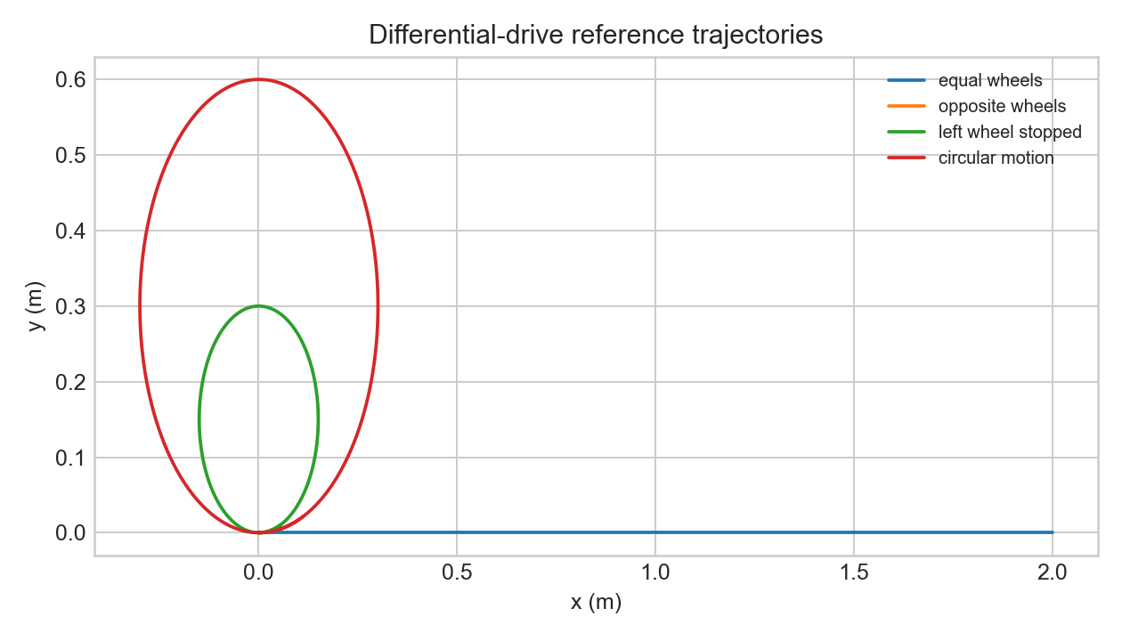
Figure 1. Reference trajectories generated from the repository model.
Case | v (m/s) | omega (rad/s) | Pose after 10 s | R (m)
Equal wheels | 0.200 | 0.000 | (2.000, 0.000, 0.00 deg) | --
Opposite wheels | 0.000 | -1.333 | (0.000, 0.000, -763.94 deg) | -0.000
Left stopped | 0.100 | 0.667 | (0.056, 0.011, 381.97 deg) | 0.150
Circle | 0.200 | 0.667 | (0.112, 0.021, 381.97 deg) | 0.300
Equal wheel speeds produce 2.0 m of straight travel. Opposite speeds produce pure rotation. With one wheel stopped, the instantaneous centre is 0.15 m from the axle midpoint. A circular path closes approximately in the ideal model; closure error is reduced by decreasing DT because Euler integration approximates an arc with short tangent segments.

4.2 Planar manipulator results
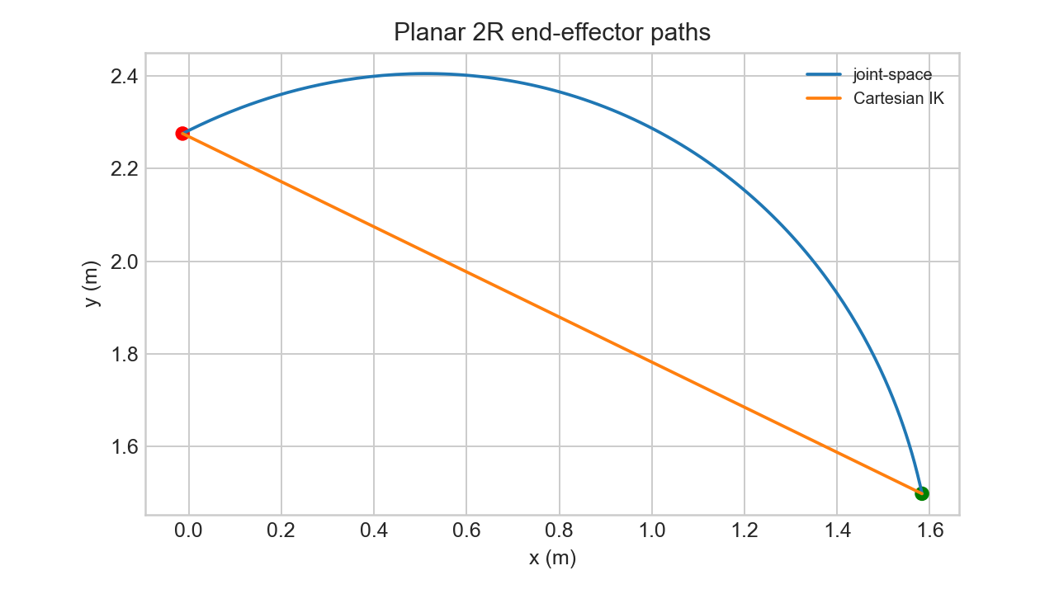
Figure 2. End-effector paths for joint-space and Cartesian interpolation.
Configuration | q1 (deg) | q2 (deg) | x (m) | y (m)
A | 20 | 60 | 1.5832 | 1.4978
B | 110 | -50 | -0.0130 | 2.2756
Mid test | 65 | 5 | 0.9759 | 2.2992
Motion | Path length (m) | Maximum deviation (m)
Joint-space cubic | 2.0669 | 0.4544
Cartesian IK | 1.7756 | 0.0000
The A endpoint is (1.5832, 1.4978) m and B is (-0.0130, 2.2756) m. Joint-space interpolation gives a curved path of length 2.0669 m and maximum deviation 0.4544 m from the chord. Cartesian IK gives a path of length 1.7756 m with negligible deviation, demonstrating its suitability for straight tool paths.
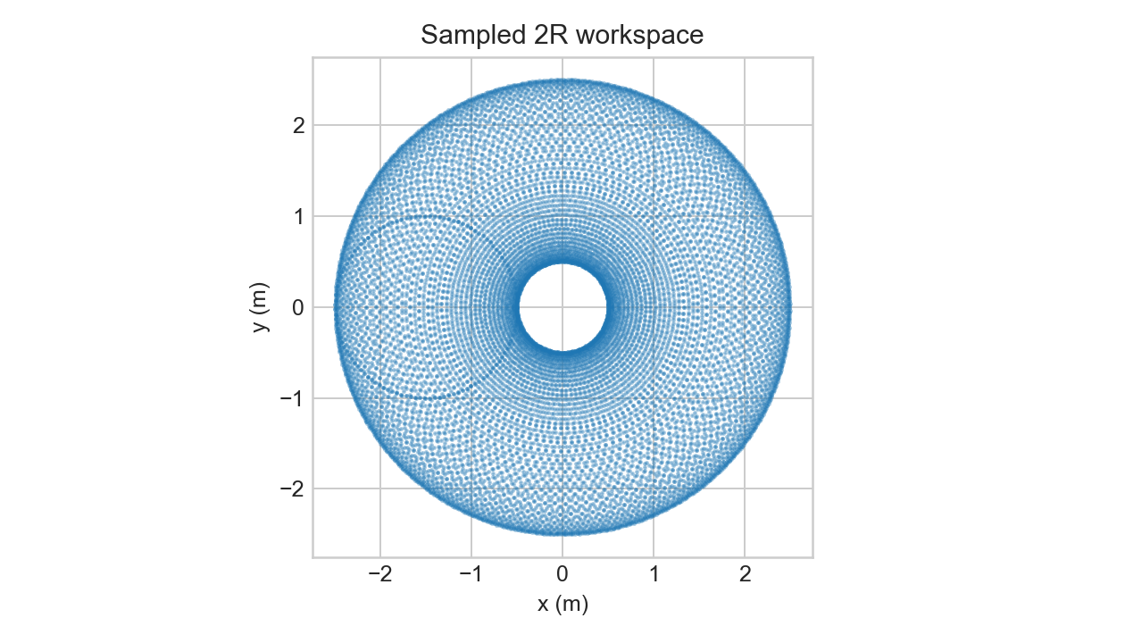
Figure 3. Sampled workspace for -pi <= q1, q2 <= pi.
The workspace is an annulus bounded by |L1 - L2| = 0.5 m and L1 + L2 = 2.5 m. At q2 = 0 or +/-pi, det(J) = 0; near these configurations a modest Cartesian speed can require very large joint rates.

5.0 ANALYSIS AND EVALUATION

5.1 Required evaluation questions

5.1.1 Dead reckoning
Real robots drift because wheel radius, wheel-base calibration, encoder counts, timing, slip, backlash, motor mismatch, and floor contact are imperfect. The simulation omits these effects. Larger DT increases Euler discretisation error; smaller DT reduces numerical error but not physical modelling error.

5.1.2 Euler versus exact arc
For nonzero omega, the exact update is x1 = x0 + (v/omega)[sin(theta0 + omega DT) - sin(theta0)] and y1 = y0 - (v/omega)[cos(theta0 + omega DT) - cos(theta0)]. Euler uses the beginning-of-step heading. The difference matters when |omega DT| is not small, especially during fast turns, large steps, or long runs.

5.1.3 No sideways motion
The constraint xdot sin(theta) - ydot cos(theta) = 0 removes lateral velocity. The pose has three coordinates but the robot has two instantaneous controls, v and omega, plus one nonholonomic constraint. It can reach general positions through combined translation and rotation, but not move sideways instantaneously.

5.1.4 Instantaneous centre
R = v/omega = (L/2)(wR + wL)/(wR - wL). Equal wheels put the centre at infinity and produce straight motion. Opposite wheels make v = 0 and R = 0, so the robot turns in place. Other ratios produce arcs whose side depends on the signed wheel-speed difference.

5.1.5 Go-to-goal
K_RHO = 1 and K_ALPHA = 3 are a reasonable speed/smoothness compromise. When alpha is near +/-pi, the target is behind the robot and the angular command is large; saturation can distort the requested velocity. A useful improvement is v = max(0, K_RHO rho cos(alpha)), which suppresses strong forward motion until the heading is corrected.

5.1.6 Joint versus Cartesian
Joint-space interpolation is simple and suitable for pick-and-place when only endpoints matter, but the tool path is curved. Cartesian interpolation with IK is better for welding, cutting, or painting because it preserves a straight tool path, but it costs more computation and can encounter branch changes or unreachable points.

5.1.7 Singularities
Near q2 = 0 or +/-pi, det(J) approaches zero and the inverse Jacobian becomes ill-conditioned. Joint speeds can spike, exceed actuator limits, or become impossible to track. Damped least-squares IK, speed limits, slowing near low |det(J)|, and path re-planning are suitable responses.

5.1.8 Comparison of the two robots
Property | Differential drive | Planar 2R arm
Configuration | (x, y, theta) | (q1, q2)
Constraints | No instantaneous lateral velocity | Link and workspace limits
FK | Wheels to body velocity and pose | Joints to end-effector position
IK | Unique wheel map for specified v, omega | Analytic elbow-up/down solutions
Uniqueness | Velocity mapping is unique | Reachable target may have two, one, or no solutions

5.2 Limitations and design decisions
• The simulator is kinematic and omits motor dynamics, friction, slip, encoder noise, and obstacles.
• Wheel saturation can make realised body velocity differ from the requested controller output.
• Cartesian arm motion uses the elbow-up branch; production software should report unreachable samples and re-plan.
• The supplied repository contains no hardware measurements, so results are analytical/numerical rather than experimental.

6.0 CONCLUSION
The project connects closed-form kinematics to executable simulations. The differential-drive model demonstrates wheel-to-body mapping, nonholonomic motion, Euler dead reckoning, inverse wheel kinematics, circular motion, and go-to-goal control. The planar arm demonstrates forward and inverse kinematics, elbow branches, cubic joint motion, Cartesian straight-line motion, workspace boundaries, and singularity behaviour. The numerical results show why joint-space motion is convenient for endpoint tasks while Cartesian IK is necessary when the tool path is itself a requirement.

7.0 FUTURE SCOPE
• Use exact constant-twist integration and quantify error versus DT.
• Add wheel slip, encoder noise, motor limits, and parameter uncertainty.
• Log trajectories and automatically plot distance, velocity, wheel speed, and joint rate.
• Add damped IK, joint limits, collision checking, and branch-continuity logic.
• Add waypoints, obstacle avoidance, final-heading control, and hardware validation.
• Add unit tests for FK/IK round trips, reachability, saturation, and stopping tolerance.

