EXPERIMENT 1

Aim:
Getting started with linux basic commands for directory operations.

1.1 Command 1 : touch

Purpose:
Used to make a new file in the current directory.

Usage:
touch filename

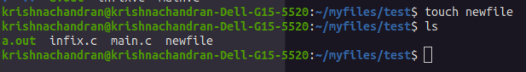

1.2 Command 2 : mkdir

Purpose:
Creates a new directory in the current directory.

Usage:
mkdir directoryname

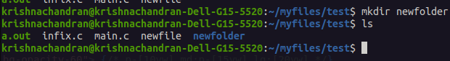

1.3 Command 3 : ls

Purpose:
Lists files and directories in the current directory.

Usage:
ls

1.4 Command 4 : cd

Purpose:
Changes the current directory.

Usage:
cd directoryname

1.5 Command 5 : pwd

Purpose:
Displays the current working directory.

Usage:
pwd

1.6 Command 6 : cp

Purpose:
Copies files or directories.

Usage:
cp sourcefile destination

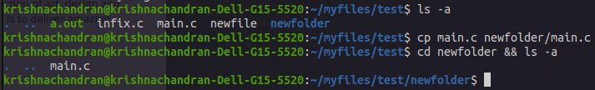

1.7 Command 7 : mv

Purpose:
Moves or renames files and directories.

Usage:
mv source destination

1.8 Command 8 : rm

Purpose:
Renames (deletes) files or directories.

Usage:
rm filename



1.9 Command 9 : cat

Purpose:
Displays the contents of a file.

Usage:
cat filename



1.10 Command 10 : less

Purpose:
Displays the contents of a file one page at a time.

Usage:
less filename



1.11 Command 11 : grep

Purpose:
Searches for patterns in files.

Usage:
grep pattern filename

1.12 Command 12 : chmod

Purpose:
Changes file permissions.

Usage:
chmod permissions filename

1.13 Command 13 : chown

Purpose:
Changes file owner and group.

Usage:
chown user:group filename

1.14 Command 14 : head

Purpose:
Displays the first part of a file.

Usage:
head filename

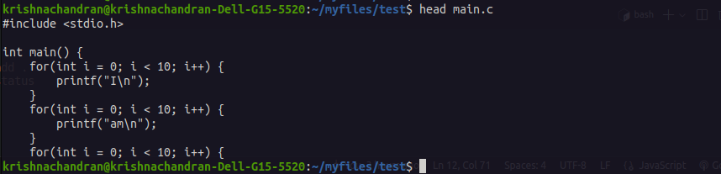

1.15 Command 15 : tail

Purpose:
Displays the last part of a file.

Usage:
tail filename

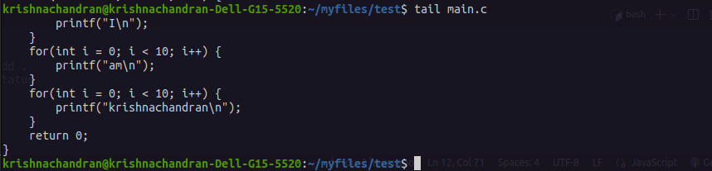

1.16 Command 16 : wc

Purpose:
Counts lines, words, and characters in a file.

Usage:
wc filename

1.17 Command 17 : sort

Purpose:
Sorts lines of text files.

Usage:
sort filename

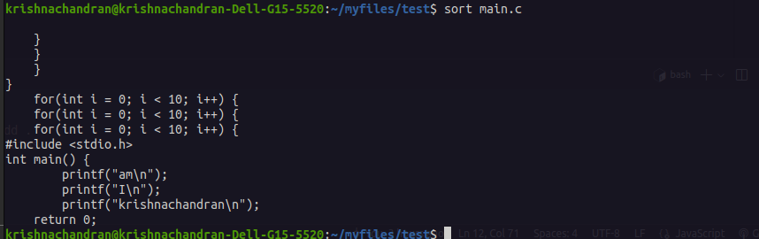

1.18 Command 18 : uniq

Purpose:
Filters out repeated lines in a text file.

Usage:
uniq filename

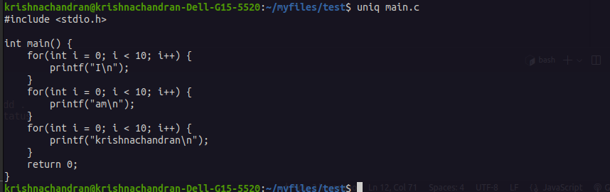

1.19 Command 19 : tar

Purpose:
Archives files and directories into a single file.

Usage:
tar options filename

1.20 Command 20 : gzip

Purpose:
Compresses files.

Usage:
gzip filename

1.21 Command 21 : gunzip

Purpose:
Decompresses files compressed with gzip.

Usage:
gunzip filename

1.22 Command 22 : du

Purpose:
Displays the disk usage of files and directories.

Usage:
du options filename

1.23 Command 23 : df

Purpose:
Displays disk space usage for filesystems.

Usage:
df options filename

1.24 Command 24 : find

Purpose:
Searches for files and directories within a directory hierarchy.

Usage:
find directory options



1.25 Command 25 : echo

Purpose:
Displays a line of a text.

Usage:
echo "text”

