A PROJECT REPORT ON
Build Adviser
Submitted in fulfilment for the award of the degree of

BACHELOR OF COMPUTER APPLICATIONS

To

KP HUMAN SARVAJANIK COLLEGE OF COMMERCE
AND COMPUTER APPLICATIONS

Submitted by

Mr. Krishna Daruwala (SC24BCCA019)
Mr. Haasil Dumsiya (SC24BCCA026)
Mr. Huzaifa Bangdiwala (SC24BCCA006)

Under the Guidance of
Ms. Falguni Dhabi

SARVAJANIK UNIVERSITY


Academic year
(2026-2027)

KP HUMAN SARVAJANIK COLLEGE OF COMMERCE
AND COMPUTER APPLICATIONS

October- 2026

CERTIFICATE

This is to certify that the project entitled “Build Adviser” has been carried out by
Mr. Krishna Daruwala (SC24BCCA019), Mr. Haasil Dumsiya (SC24BCCA026),
Mr. Huzaifa Bangdiwala (SC24BCCA006) under my guidance in fulfilment of the degree of Bachelor of Computer Applications in the 5th Semester of Sarvajanik University, Surat during the academic year 2026-27.

DATE: __________

Internal Guide Program Coordinator

_____________ ___________________

DECLARATION

We, the undersigned, hereby declare that the project report entitled Build Adviser, with special reference to KP HUMAN SARVAJANIK COLLEGE OF COMMERCE AND COMPUTER APPLICATIONS, written and submitted by us in partial fulfilment of the requirements for the award of Bachelor of Computer Applications under the guidance of Falguni Dhabi, is our original work and the interpretations drawn therein are based on material collected by ourselves.

Signature:
Name: Krishna Daruwala
Enrollment: (SC24BCCA019)

Signature:
Name: Haasil Dumsiya
Enrollment: (SC24BCCA026)

Signature:
Name: Huzaifa Bangdiwala
Enrollment: ( SC24BCCA006)

ACKNOWLEDGEMENT

We are pleased to present this project on “Build Adviser”. First, we would like to thank the respected Head of the Department of Bachelor of Computer Applications, who provided us with more details about the project.
We are also thankful to our guide, and many more things are guided to our project. And finally, our sincere thanks to my batch-mate, who provided us with innumerable discussions on many technicalities and friendly tips. Without his cordial and friendly support, this activity might be much tougher.
We are also thankful to our Parents, friends, and Others for their opinions and support in the system.

Your Faithfully,
Krishna Daruwala
Haasil Dumsiya
Huzaifa Bangdiwala

ABSTRACT

Choosing parts for a gaming PC is hard for most first-time buyers. A gamer has to match a processor to a motherboard socket, pick memory the board supports, size the power supply for the graphics card, and check that every part fits the case, all while staying within a fixed budget and still getting playable frame rates in the games they care about. Mistakes are common and expensive: a wrong socket, an undersized power supply or an unbalanced CPU/GPU pairing can waste a large part of the budget.
Build Adviser (BuildAdvisor) is an AI-powered PC build recommender for gamers that solves this problem. The user enters a budget in Indian Rupees, a target game and a target resolution (1080p, 1440p or 4K). The system then generates a complete seven-part build (CPU, GPU, motherboard, RAM, storage, PSU and case) from its component database, validates it against socket, memory-type, power-headroom and form-factor rules, repairs any conflict by substituting compatible parts, compares prices across retailers, and estimates the frame rate the build should deliver in the chosen game.
Every recommendation is accompanied by a plain-language explanation generated by the Google Gemini API (gemini-2.5-flash), so that non-technical users understand why each part was chosen. If the AI service is unavailable, the system falls back to a locally generated explanation, so the user is never left without an answer. Beyond new builds, an Upgrade Advisor identifies the biggest bottleneck in an existing PC and suggests the most cost-effective upgrade for an extra budget, and a Community module lets users save, share and rate builds.
The application follows a three-tier client/server architecture: a Streamlit frontend, a Flask REST backend and an SQLite database containing seven related tables (User, Component, Build, BuildComponent, Game, Benchmark and Rating). The database is populated with 35 components and 13 popular games through JSON bulk import. Business rules such as minimum budget, budget tiers, resolution multipliers and retailer names are not hard-coded; they are read from environment variables, which makes the system easy to reconfigure. An administrator dashboard protected by login supports component and game management, bulk JSON import and rating moderation.
The project shows how rule-based compatibility logic combined with generative AI can turn a complex technical purchase into a simple, guided and trustworthy experience for gamers.

Table Of Contents

No. | Content | Page No.
1. | Introduction of Project
 | 1.1 Project Overview
 | 1.1.1. Project Definition
 | 1.1.2. User-wise Functionality Description
 | 1.1.3. Tools and Technology
2. | Project Planning
 | 2.1 Project Development Approach
 | 2.2 Hardware Requirement
 | 2.3 Software Requirement
3. | Project Design
 | 3.1 DFD
 | 3.2 E-R Diagram
 | 3.3 Data Dictionary
4. | Test Strategies & Cases
 | 4.1Testing
 | 4.1.1.Purpose of Testing
 | 4.1.2.Testing Strategy
5. | Project User Interface
6. | Advantages & Limitations
 | 6.1. Advantages
 | 6.2. Limitations
7. | Conclusion
 | 7.1. Future Planning
 | 7.2. References
8. | Bibliography

CHAPTER 1
INTRODUCTION OF PROJECT
1.1 Project Overview
India's PC gaming community has grown rapidly, but building a gaming computer is still a task that needs real hardware knowledge. Component names are confusing, prices change across retailers every week and compatibility rules are rarely explained to the buyer. Most buyers rely on forum posts, YouTube videos or shop salespeople, which can be inconsistent or biased.
Build Adviser is a web-based decision-support system that acts as a knowledgeable friend for the gamer. It takes three simple inputs (budget, game and resolution) and returns a complete, compatible and priced build together with an estimated frame rate and an AI-written explanation. The system is built in Python using Streamlit for the user interface, Flask for the REST API and SQLite for persistent storage, with the Google Gemini API providing natural-language explanations.
1.1.1. Project Definition
Build Adviser is an AI-powered PC build recommender for gamers which, given a budget in Indian Rupees, a target game and a target resolution, automatically selects a compatible set of seven PC components from a database, validates and repairs the build against hardware compatibility rules, compares prices across multiple retailers, estimates in-game FPS and explains the recommendation in plain language using generative AI.
The main objectives of the project are:
• To generate a complete gaming PC build within the user's budget for a chosen game and resolution.
• To guarantee compatibility (CPU socket, RAM type, PSU wattage headroom and case form factor) before a build is shown.
• To show the best available price for each part across retailers such as Amazon, MDComputers, PrimeABGB and Vedant Computers.
• To estimate the expected frame rate (FPS) of the build in the selected game.
• To explain every recommendation in simple language using the Google Gemini API, with a local fallback.
• To help users of existing PCs find their biggest bottleneck and the best upgrade for an extra budget.
• To let users save, share and rate builds, and to give administrators control over the catalogue.
1.1.2. User-wise Functionality Description
The system has two types of users: the Gamer (End User) and the Administrator.
Table 1.1: User-wise Functionality
User | Module | Functionality
Gamer | Build Advisor | Select budget (slider), target game and resolution; generate a compatible build; view list total, best live total and estimated FPS; see per-part best price, retailer and freshness; read the AI explanation.
Gamer | Upgrade Advisor | Enter current CPU, GPU, RAM and extra budget; find the biggest bottleneck and the most cost-effective upgrade.
Gamer | Save & Share | Name a generated build and save it; receive a unique share ID for the build.
Gamer | Community | Browse saved builds with cost and average rating; view components; submit a 1–5 rating.
Admin | Login | Sign in with admin credentials to access the dashboard; sign out.
Admin | Component database | View all components with type, name, price and tier; add new components with specifications.
Admin | Add game | Add a game with its performance weight and CPU-bound flag.
Admin | Bulk import (JSON) | Import many components and games at once from a JSON file.
Admin | Ratings moderation | Remove inappropriate or spam ratings from a build.

1.1.3. Tools and Technology
Table 1.2: Tools and Technology Used
Category | Tool / Technology | Purpose
Programming language | Python 3.13 | Core language for frontend, backend and logic
Frontend | Streamlit (≥ 1.32) | Interactive web UI with a custom dark violet theme
Backend | Flask (≥ 3.0) | REST API for build generation, upgrades, community and admin
Database | SQLite 3 | Lightweight relational database (buildadvisor.db)
Artificial Intelligence | Google Gemini API (gemini-2.5-flash) | Plain-language build explanations
HTTP client | Requests (≥ 2.31) | Frontend-to-backend calls and Gemini REST calls
Web scraping | BeautifulSoup4 (≥ 4.12) | Optional live retailer price scraping
Configuration | python-dotenv (≥ 1.0) | Load API key and business rules from .env
IDE | Visual Studio Code | Code editing, debugging and terminal
Database tool | DB Browser for SQLite | Inspecting and verifying database tables
Browser | Google Chrome | Running and testing the web application

CHAPTER 2
PROJECT PLANNING
2.1 Project Development Approach
The project was developed using the Iterative and Incremental Model. Instead of building the full system in one pass, it was delivered in small, working increments. Each increment went through requirement analysis, design, coding and testing, and the feedback from one increment was used to improve the next. This approach suited the project because requirements such as AI explanations, live pricing and UI polish became clearer only after a working core was available.
Table 2.1: Development Iterations
Iteration | Work Completed
1. Requirement analysis | Studied the problem, prepared the Software Requirements Specification (SRS v2.0) and identified modules, users and data.
2. Core logic | Implemented build generation, compatibility checking, substitution (repair) loop and FPS estimation in logic.py.
3. Database | Designed the ER model and created seven SQLite tables in db.py; added JSON bulk import (bootstrap.py).
4. Backend API | Exposed REST endpoints in backend.py (/generate-build, /upgrade, /builds, /admin/*, /health, /config).
5. Frontend | Built the Streamlit UI (app.py) with Build Advisor, Upgrade Advisor, Community and Admin pages.
6. AI & pricing | Integrated the Gemini API (ai.py) with a fallback explanation, and multi-retailer pricing (pricing.py).
7. Configuration | Moved business rules to BUILDADVISOR_* environment variables (config.py) instead of hard-coding them.
8. UI polish & testing | Added the dark violet theme, ui.py (hero headers, chips, cards, metrics) and carried out system testing.

2.2 Hardware Requirement
Table 2.2: Hardware Requirements
Component | Minimum Requirement | Recommended
Processor | Intel Core i3 / AMD Ryzen 3, 2.0 GHz | Intel Core i5 / AMD Ryzen 5 or better
RAM | 4 GB | 8 GB or more
Storage | 500 MB free space | 1 GB free space (SSD)
Display | 1366 × 768 | 1920 × 1080
Network | Internet connection for Gemini API | Broadband connection
Input devices | Keyboard and mouse | Keyboard and mouse

2.3 Software Requirement
Table 2.3: Software Requirements
Software | Specification
Operating system | Windows 10/11, Linux or macOS
Language runtime | Python 3.10 or above (developed on Python 3.13)
Python libraries | streamlit, flask, requests, beautifulsoup4, python-dotenv
Database | SQLite 3 (bundled with Python)
AI service | Google AI Studio account with a Gemini API key
Web browser | Google Chrome, Microsoft Edge or Mozilla Firefox
Development tools | Visual Studio Code, DB Browser for SQLite

CHAPTER 3
PROJECT DESIGN
The system follows a three-tier client/server architecture. The Streamlit frontend (app.py) sends HTTP requests through api.py to the Flask backend (backend.py). The backend applies the business logic in logic.py, reads and writes the SQLite database through db.py, gets prices from pricing.py and AI explanations from ai.py, and returns JSON responses to the frontend.
3.1 DFD
A Data Flow Diagram (DFD) shows how data moves between external entities, processes and data stores.
Level 0 DFD (Context Diagram)
At Level 0 the whole system is a single process, 0.0 Build Adviser System, with three external entities:
• Gamer → sends budget, game, resolution, current parts, saved build name and ratings; ← receives recommended build, prices, FPS estimate, explanation, upgrade advice and community builds.
• Administrator → sends login credentials, new components, new games, JSON import files and moderation actions; ← receives the component list and status messages.
• Google Gemini API ← receives a build prompt; → returns the explanation text.
Level 0 DFD (Context Diagram)
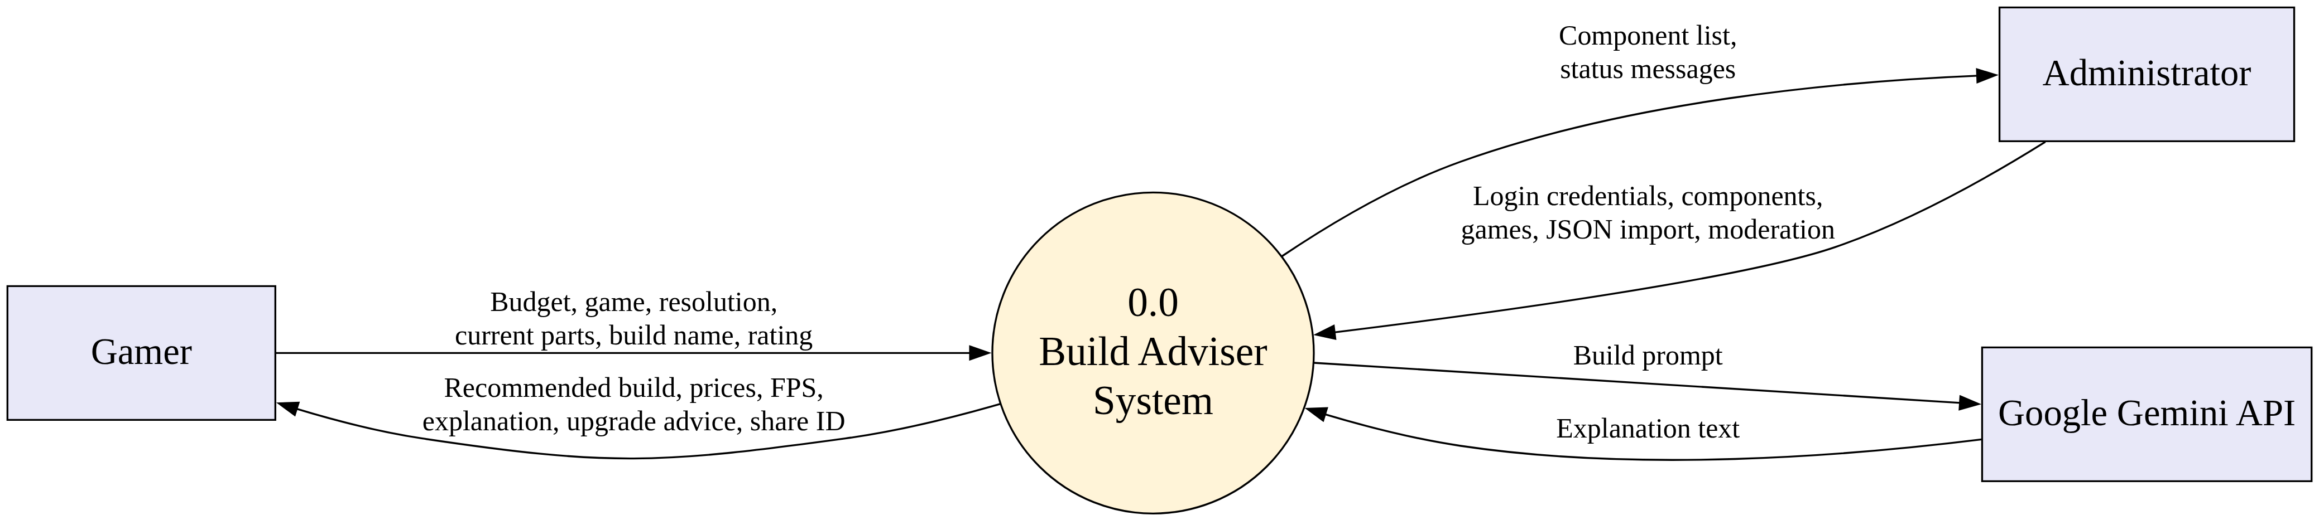
Figure 3.1: Level 0 DFD (Context Diagram)
Description: The context diagram shows the whole Build Adviser system as one process (0.0) and its data flows with the three external entities: Gamer, Administrator and the Google Gemini API.
Level 1 DFD
Table 3.1: Level 1 DFD Processes
Process | Input | Output | Data Store
1.0 Generate Build | Budget, game, resolution | Compatible 7-part build | D1 Component, D2 Game
2.0 Check Compatibility & Repair | Draft build | Validated build / substitutions | D1 Component
3.0 Price Build | Validated build | Best price per part, retailer, totals | D1 Component
4.0 Estimate FPS | Build, game, resolution | Estimated FPS | D2 Game, D6 Benchmark
5.0 Explain Build | Build, budget, game, FPS | Plain-language explanation | — (Gemini API)
6.0 Upgrade Advice | Current CPU, GPU, RAM, extra budget | Bottleneck and best upgrade | D1 Component
7.0 Save & Rate Build | Build name, rating | Share ID, average rating | D3 Build, D4 BuildComponent, D7 Rating
8.0 Admin Management | Credentials, components, games, JSON | Updated catalogue | D1 Component, D2 Game, D5 User, D7 Rating

Level 1 DFD
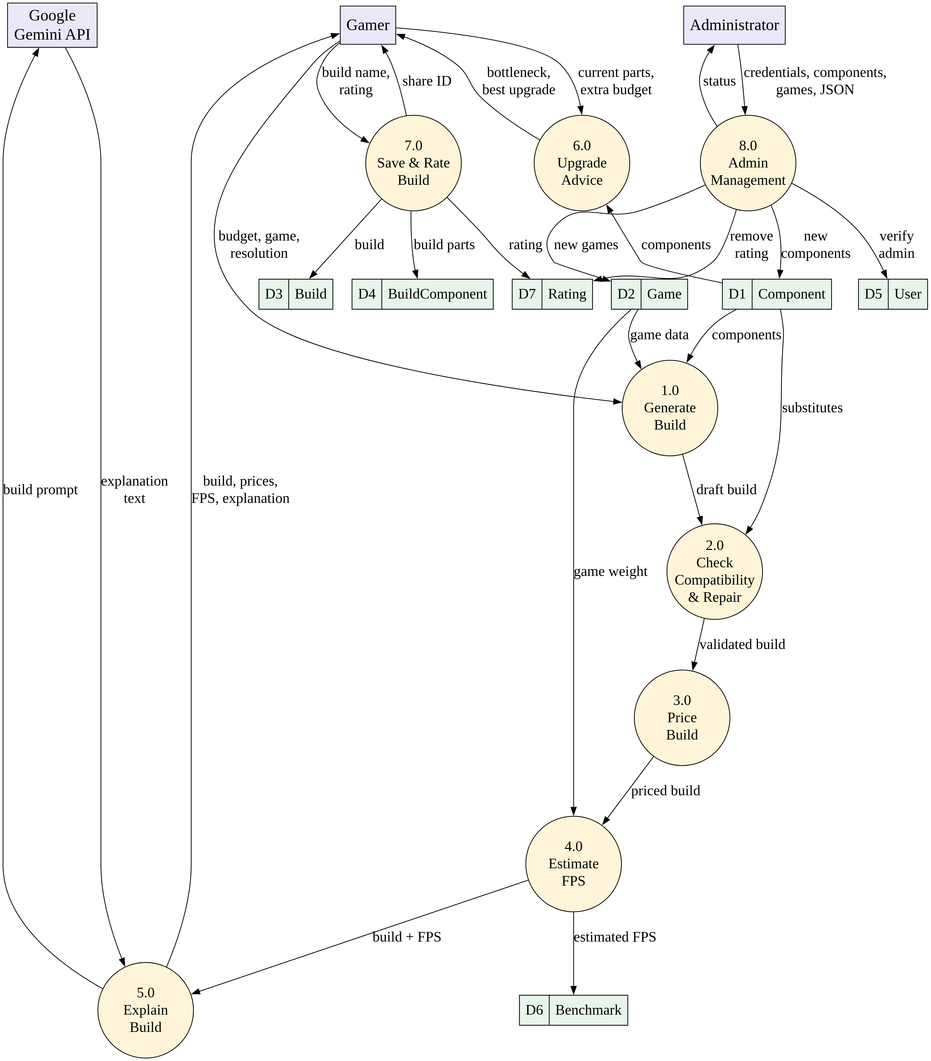
Figure 3.2: Level 1 DFD
Description: The Level 1 DFD breaks the system into eight processes (1.0 to 8.0). It shows how a build request moves through generation, compatibility checking, pricing, FPS estimation and explanation, and how the processes read and write the seven data stores (D1 to D7).
3.2 E-R Diagram
The Entity-Relationship model consists of seven entities. Build is the central entity; it is linked to its components through the associative entity BuildComponent, to frame-rate estimates through Benchmark and to user feedback through Rating.
E-R Diagram
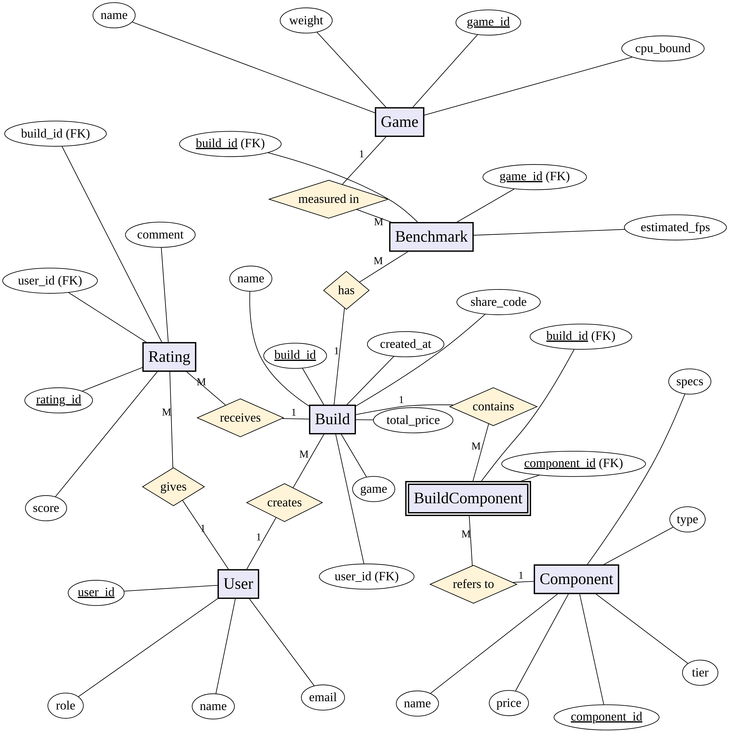
Figure 3.3: E-R Diagram of Build Adviser
Description: The E-R diagram uses Chen notation: rectangles are entities, diamonds are relationships, ellipses are attributes and primary keys are underlined. BuildComponent is the associative entity that resolves the many-to-many relationship between Build and Component.
Table 3.2: Entities and Relationships
Relationship | Cardinality | Description
User — creates — Build | 1 : M | A user can save many builds; each build belongs to at most one user.
Build — contains — Component (via BuildComponent) | M : N | A build has many components and a component can appear in many builds.
Build — has — Benchmark | 1 : M | A build can have an FPS estimate for many games.
Game — measured in — Benchmark | 1 : M | A game can have benchmarks for many builds.
Build — receives — Rating | 1 : M | A build can receive many ratings.
User — gives — Rating | 1 : M | A user can rate many builds.

3.3 Data Dictionary
Table 3.3: User
Field Name | Data Type | Constraint | Description
user_id | INTEGER | Primary Key, Auto Increment | Unique user identifier
name | TEXT | Not Null | Name of the user
email | TEXT | — | E-mail address
role | TEXT | Not Null, Default 'Gamer' | Gamer or Admin

Table 3.4: Component
Field Name | Data Type | Constraint | Description
component_id | TEXT | Primary Key | Unique component code
type | TEXT | Not Null, Indexed | CPU, GPU, Motherboard, RAM, Storage, PSU or Case
name | TEXT | Not Null | Product name
price | INTEGER | Not Null | List price in ₹
tier | TEXT | — | entry / mid / high / ultra
specs | TEXT (JSON) | — | Socket, TDP, RAM type, wattage, form factor, score etc.

Table 3.5: Game
Field Name | Data Type | Constraint | Description
game_id | TEXT | Primary Key | Unique game code
name | TEXT | Not Null | Game title
weight | REAL | Not Null | Performance weight (0.5 light – 2.1 very heavy)
cpu_bound | INTEGER | Not Null, Default 0 | 1 if the game depends heavily on the CPU

Table 3.6: Build
Field Name | Data Type | Constraint | Description
build_id | INTEGER | Primary Key, Auto Increment | Unique build identifier
share_code | TEXT | Unique, Not Null | Public share ID
user_id | INTEGER | Foreign Key → User | Owner of the build
name | TEXT | — | Build name given by user
game | TEXT | — | Target game
total_price | INTEGER | Not Null | Total build cost in ₹
created_at | TEXT | Not Null | Date and time of saving

Table 3.7: BuildComponent
Field Name | Data Type | Constraint | Description
build_id | INTEGER | Primary Key (composite), Foreign Key → Build, On Delete Cascade | Build reference
component_id | TEXT | Primary Key (composite), Foreign Key → Component | Component reference

Table 3.8: Benchmark
Field Name | Data Type | Constraint | Description
build_id | INTEGER | Primary Key (composite), Foreign Key → Build | Build reference
game_id | TEXT | Primary Key (composite) | Game reference
estimated_fps | INTEGER | Not Null | Estimated frames per second

Table 3.9: Rating
Field Name | Data Type | Constraint | Description
rating_id | INTEGER | Primary Key, Auto Increment | Unique rating identifier
build_id | INTEGER | Not Null, Foreign Key → Build | Rated build
user_id | INTEGER | — | User who rated
score | INTEGER | Not Null | Rating from 1 to 5
comment | TEXT | — | Optional comment

CHAPTER 4
TEST STRATEGIES & CASES
4.1 Testing
Testing is the process of running the system with the intention of finding errors and confirming that it behaves as specified in the SRS. Build Adviser was tested module by module and then as a complete system running the Streamlit frontend, Flask backend and SQLite database together.
4.1.1. Purpose of Testing
• To verify that every generated build is within budget and fully compatible.
• To make sure that invalid or missing input is rejected with a clear message.
• To confirm that the system degrades gracefully when the Gemini API or live pricing is unavailable.
• To check that data is saved and read correctly from the SQLite database.
• To confirm that admin features are only available after a successful login.
4.1.2. Testing Strategy
• Unit testing: individual functions such as check_compatibility(), tier_for_budget(), estimate_fps(), upgrade_advice() and sanitize() were tested with known inputs.
• Integration testing: the frontend-to-backend flow was tested through the REST endpoints (/generate-build, /upgrade, /builds, /admin/*); the backend log showed HTTP 200 responses.
• Gemini API testing: a separate script (test_gemini.py) was used to check the API key and model, and the request count was confirmed in Google AI Studio.
• Black-box / system testing: the complete application was used through the browser with different budgets, games and resolutions.
• Fault-tolerance testing: the 'Simulate service state' switches were used to turn off live pricing and the Gemini API and check the fallback behaviour.
4.2 Test Cases
The following test cases were carried out on the running application (Streamlit frontend, Flask backend and SQLite database). Each test case is explained below with its objective, input, expected result, actual result and a screenshot.
Test Case 1 (TC01): Generate a build for a mid-range budget
Objective: To check that the Build Advisor creates a complete and compatible seven-part build that stays within the selected budget.
Input / Steps: Budget = ₹80,000, Target game = Starfield, Resolution = 1080p, then click Generate Build.
Expected Result: A compatible build within ₹80,000 with prices, retailers, estimated FPS and an AI explanation.
Actual Result: The system recommended an AMD Ryzen 5 5600 with an AMD RX 6600, MSI A520M-A PRO motherboard, Corsair Vengeance 16GB DDR4 RAM, Crucial P3 500GB NVMe SSD, Antec CSK 550W PSU and Ant Esports ICE-120AG case. The list total was ₹49,000 and the best live total was ₹47,856, both well within the budget. Estimated FPS was about 131, and the Why this build panel showed the explanation written by Gemini.
Status: Pass
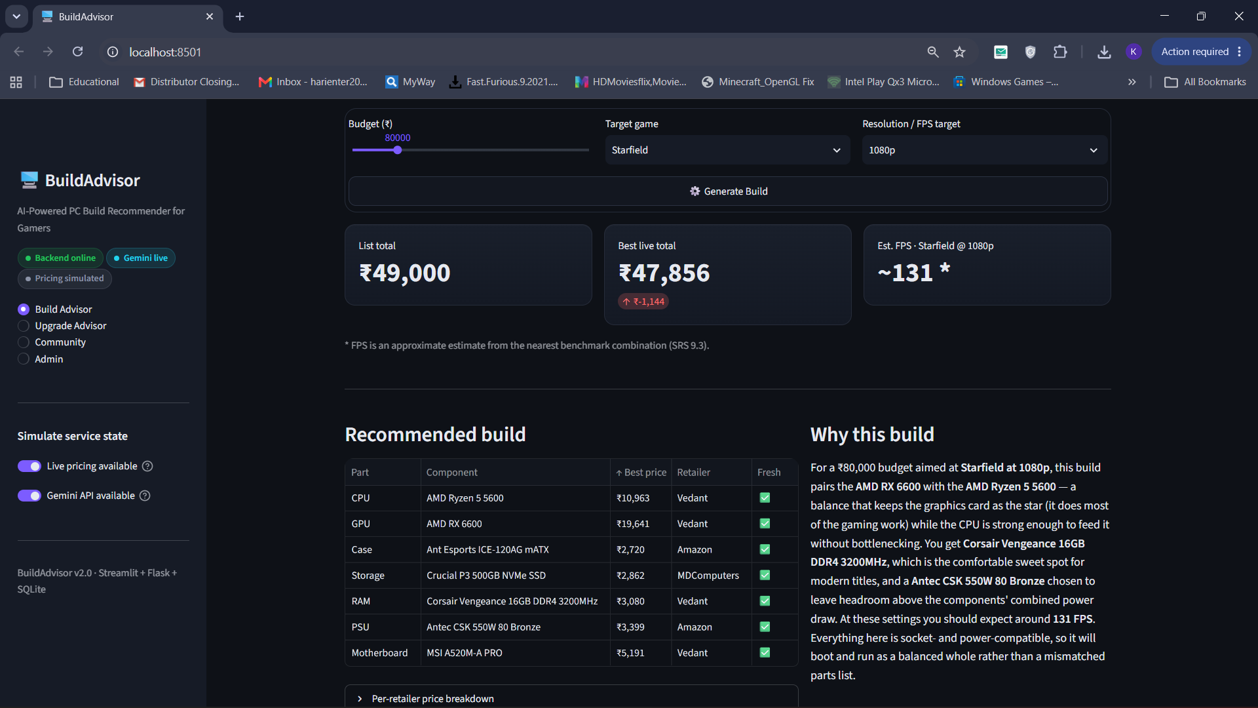
Figure 4.1: TC01 – Generate a build for a mid-range budget
Test Case 2 (TC02): Generate a build for a 4K resolution target
Objective: To check that a higher resolution produces a stronger build and a lower, realistic FPS estimate.
Input / Steps: Budget = ₹90,000, Target game = Elden Ring, Resolution = 4K, then click Generate Build.
Expected Result: A stronger GPU should be chosen, and the FPS estimate should be lower than at 1080p because of the 4K resolution multiplier (2.6).
Actual Result: The system chose an NVIDIA RTX 4060 Ti with an AMD Ryzen 5 7600, ASUS PRIME B650M-A motherboard and G.Skill Flare X5 16GB DDR5 RAM. The AM5 socket and DDR5 memory match. The list total was ₹86,600 and the best live total was ₹86,759. Estimated FPS at 4K was about 81, and the explanation mentioned Elden Ring at 4K.
Status: Pass
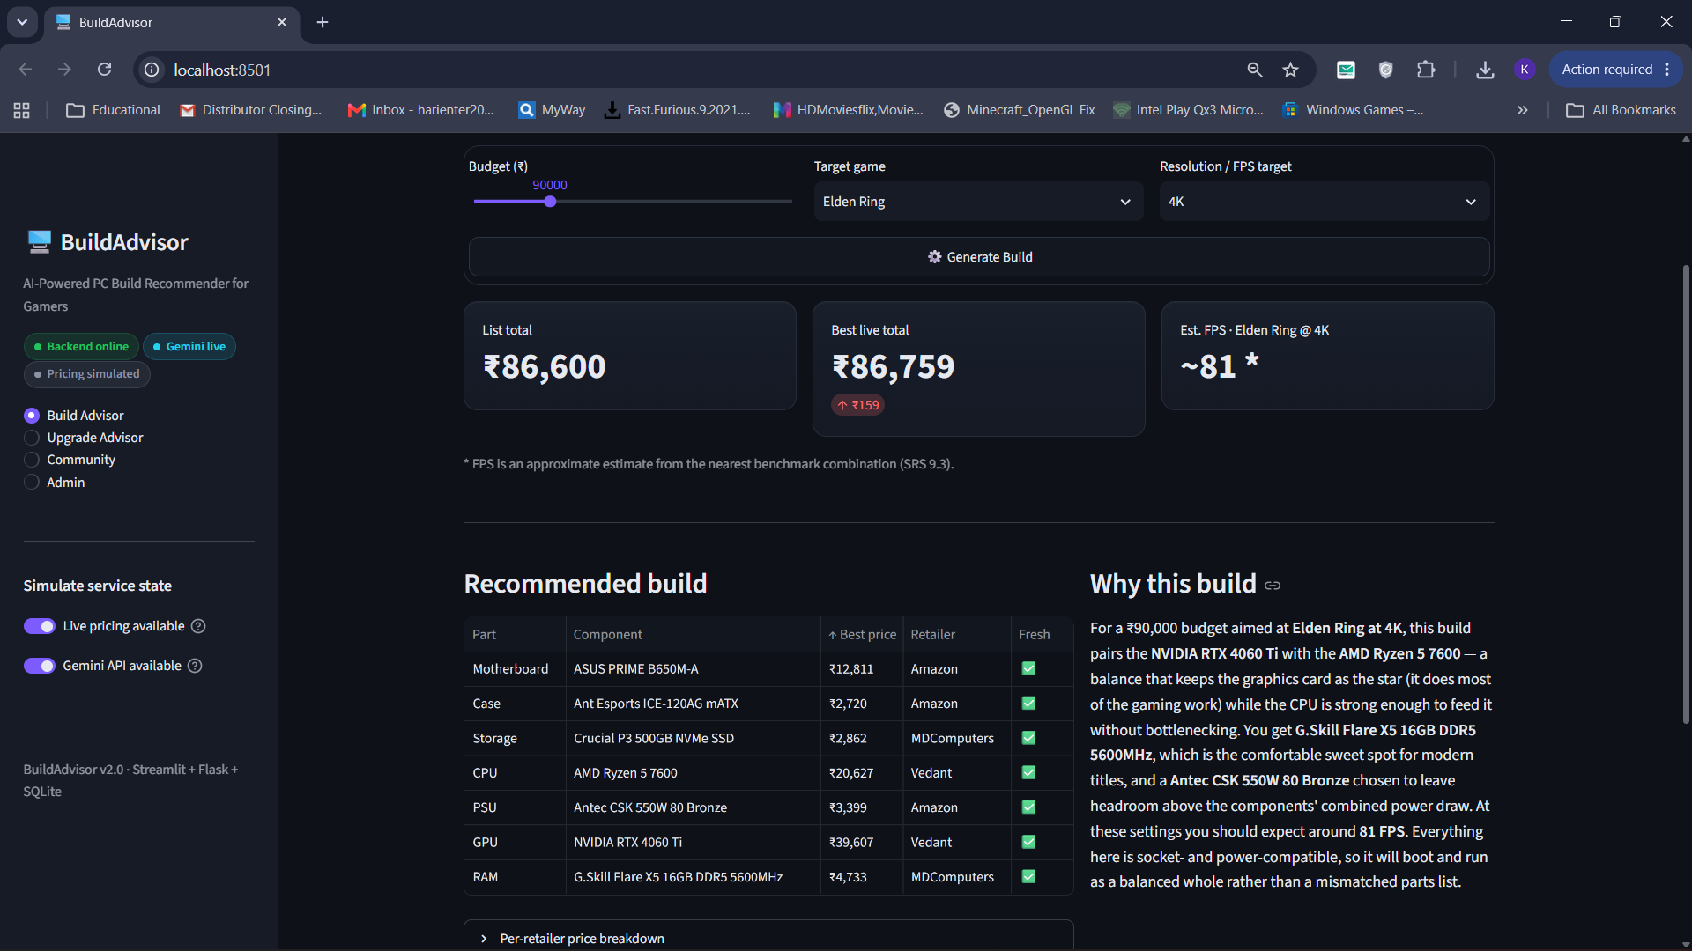
Figure 4.2: TC02 – Generate a build for a 4K resolution target
Test Case 3 (TC07): Gemini API unavailable (graceful fallback)
Objective: To check that the application keeps working when the AI explanation service is not available.
Input / Steps: Turn off the Gemini API available switch in the sidebar. Budget = ₹90,000, Target game = Valorant, Resolution = 1080p, then click Generate Build.
Expected Result: The build, prices and FPS should still be generated, with a friendly message in place of the AI explanation.
Actual Result: The full build and prices were shown as normal, and estimated FPS for Valorant was about 534 because it is a light, CPU-bound game. In place of the explanation the system showed the message "AI explanation is temporarily unavailable. Your build is still complete and usable." along with a Retry explanation button. The application did not crash.
Status: Pass
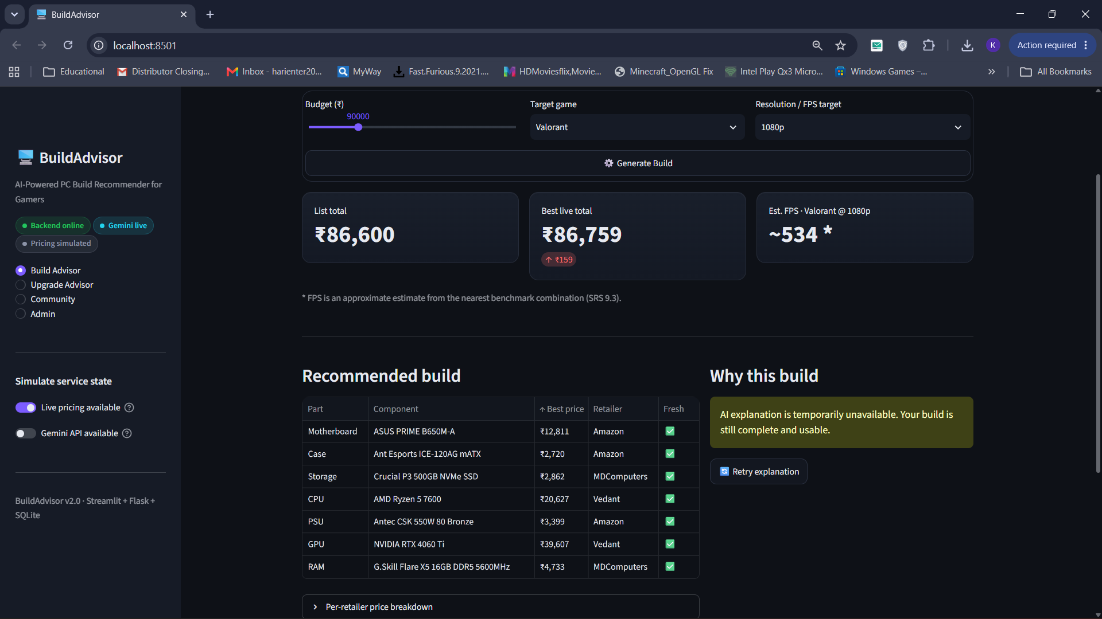
Figure 4.3: TC07 – Gemini API unavailable (graceful fallback)
Test Case 4 (TC08): Live pricing unavailable (last-known prices)
Objective: To check that the system falls back to last-known prices when live retailer prices cannot be fetched.
Input / Steps: Turn off the Live pricing available switch. Budget = ₹90,000, Target game = GTA V, Resolution = 1440p, then click Generate Build.
Expected Result: The build should use last-known prices and clearly tell the user that live pricing is unavailable.
Actual Result: An information note "Live pricing unavailable — showing last-known prices with a note." appeared above the table. Every part showed last-known in the Retailer column with a clock icon in the Fresh column. The best live total was the same as the list total (₹86,600, change ₹0). The FPS estimate (about 183) and the AI explanation were still shown.
Status: Pass
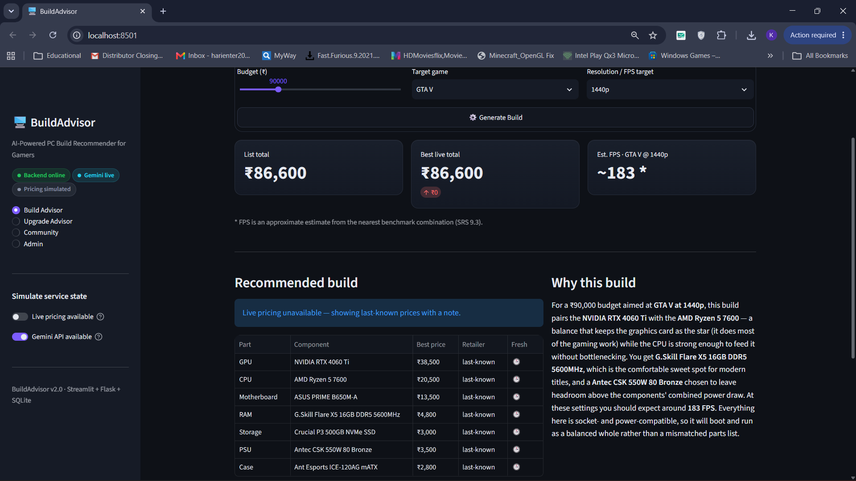
Figure 4.4: TC08 – Live pricing unavailable (last-known prices)
Test Case 5 (TC09): Upgrade Advisor finds the bottleneck
Objective: To check that the Upgrade Advisor finds the weakest part of an existing PC and suggests the best upgrade within the extra budget.
Input / Steps: Open Upgrade Advisor. Current CPU = Intel Core i3-12100F, Current GPU = NVIDIA GTX 1650, RAM = 16 GB, Extra budget = ₹30,000, then click Find best upgrade.
Expected Result: The GPU should be found as the biggest bottleneck, and a GPU costing no more than ₹30,000 should be recommended.
Actual Result: The system displayed "Biggest bottleneck: GPU" and recommended the NVIDIA RTX 4060 at ₹29,000, which is within the ₹30,000 budget. The Other options in your budget section also listed the AMD RX 6600 at ₹19,500 as a cheaper choice.
Status: Pass
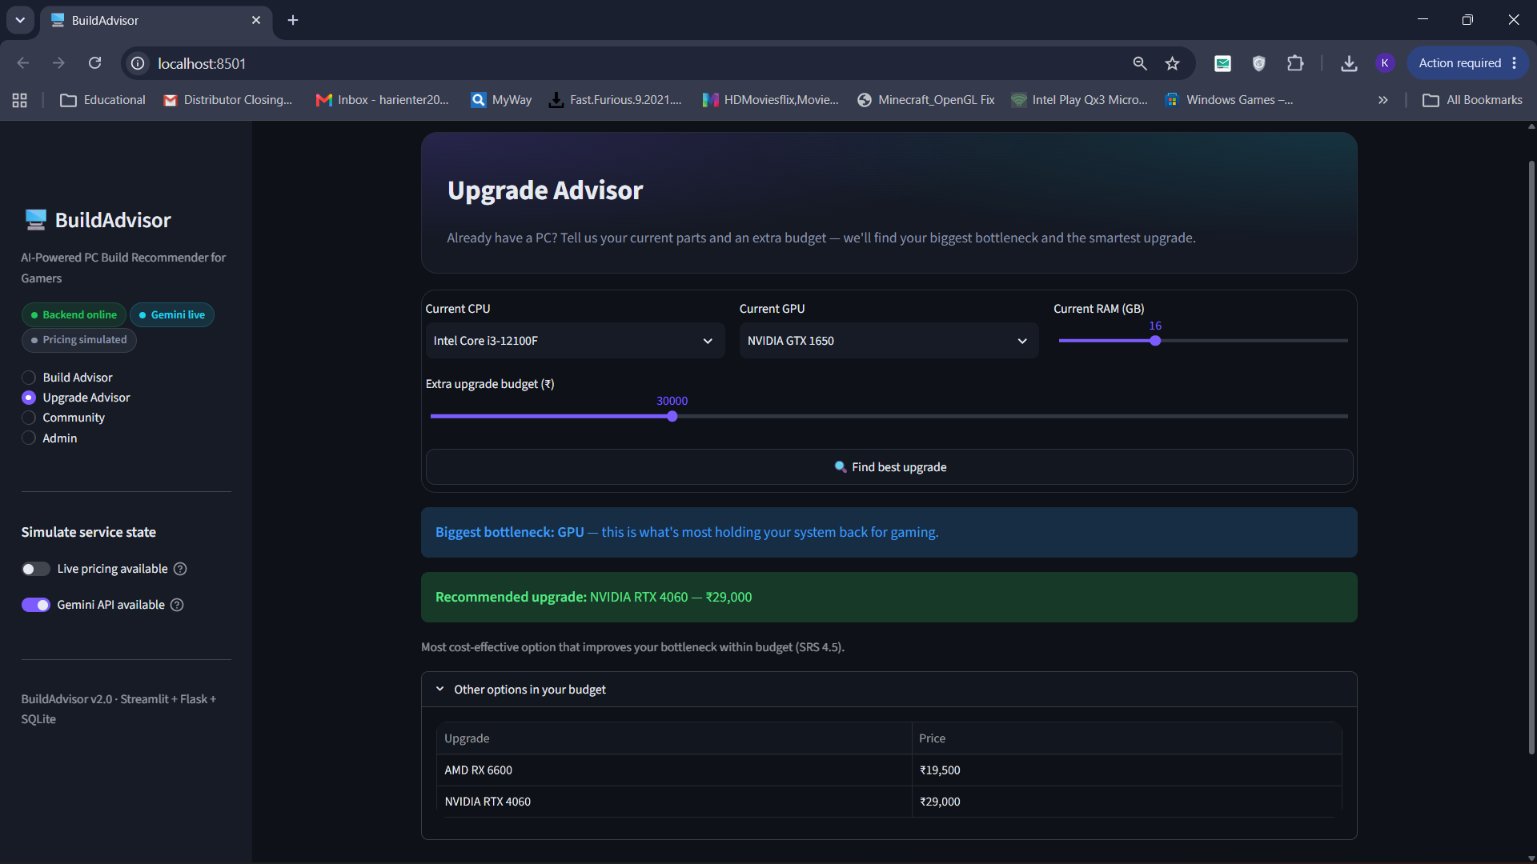
Figure 4.5: TC09 – Upgrade Advisor finds the bottleneck
Test Case 6 (TC10): Save and share a build
Objective: To check that a generated build can be saved to the database and a unique share link is created.
Input / Steps: After generating the GTA V build, enter GTA V in Name this build and click Save & get share link.
Expected Result: The build should be stored in the Build and BuildComponent tables and a unique share link should be shown.
Actual Result: The success message "Saved! Share link: buildadvisor.app/b/1e6192e9c9" was shown. The build then appeared on the Community page, which confirms that it was saved in the SQLite database.
Status: Pass
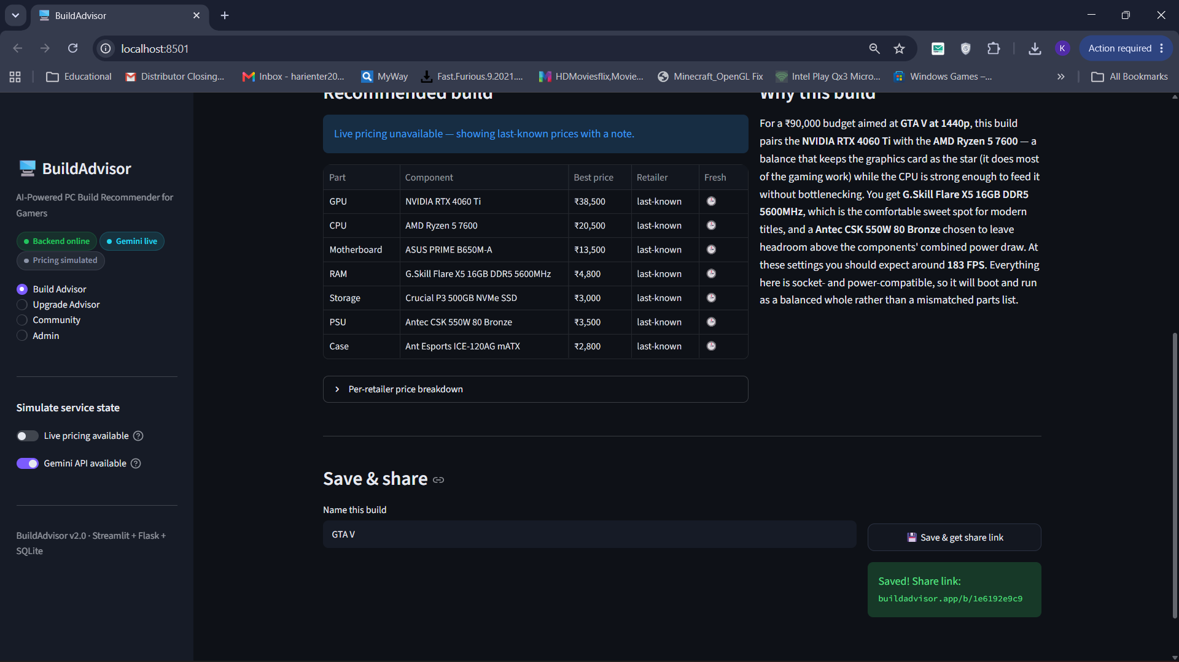
Figure 4.6: TC10 – Save and share a build
Test Case 7 (TC12): Admin login with an incorrect password
Objective: To check that the Admin Dashboard is protected and cannot be opened with wrong credentials.
Input / Steps: Open the Admin page, enter a wrong password in Admin password and click Sign in.
Expected Result: Access should be denied with an error message, and the admin tabs should not be shown.
Actual Result: The system displayed the error "Incorrect password." and stayed on the Admin sign in card. The component database, add component, add game, bulk import and ratings moderation tabs were not shown, so admin functions are protected.
Status: Pass
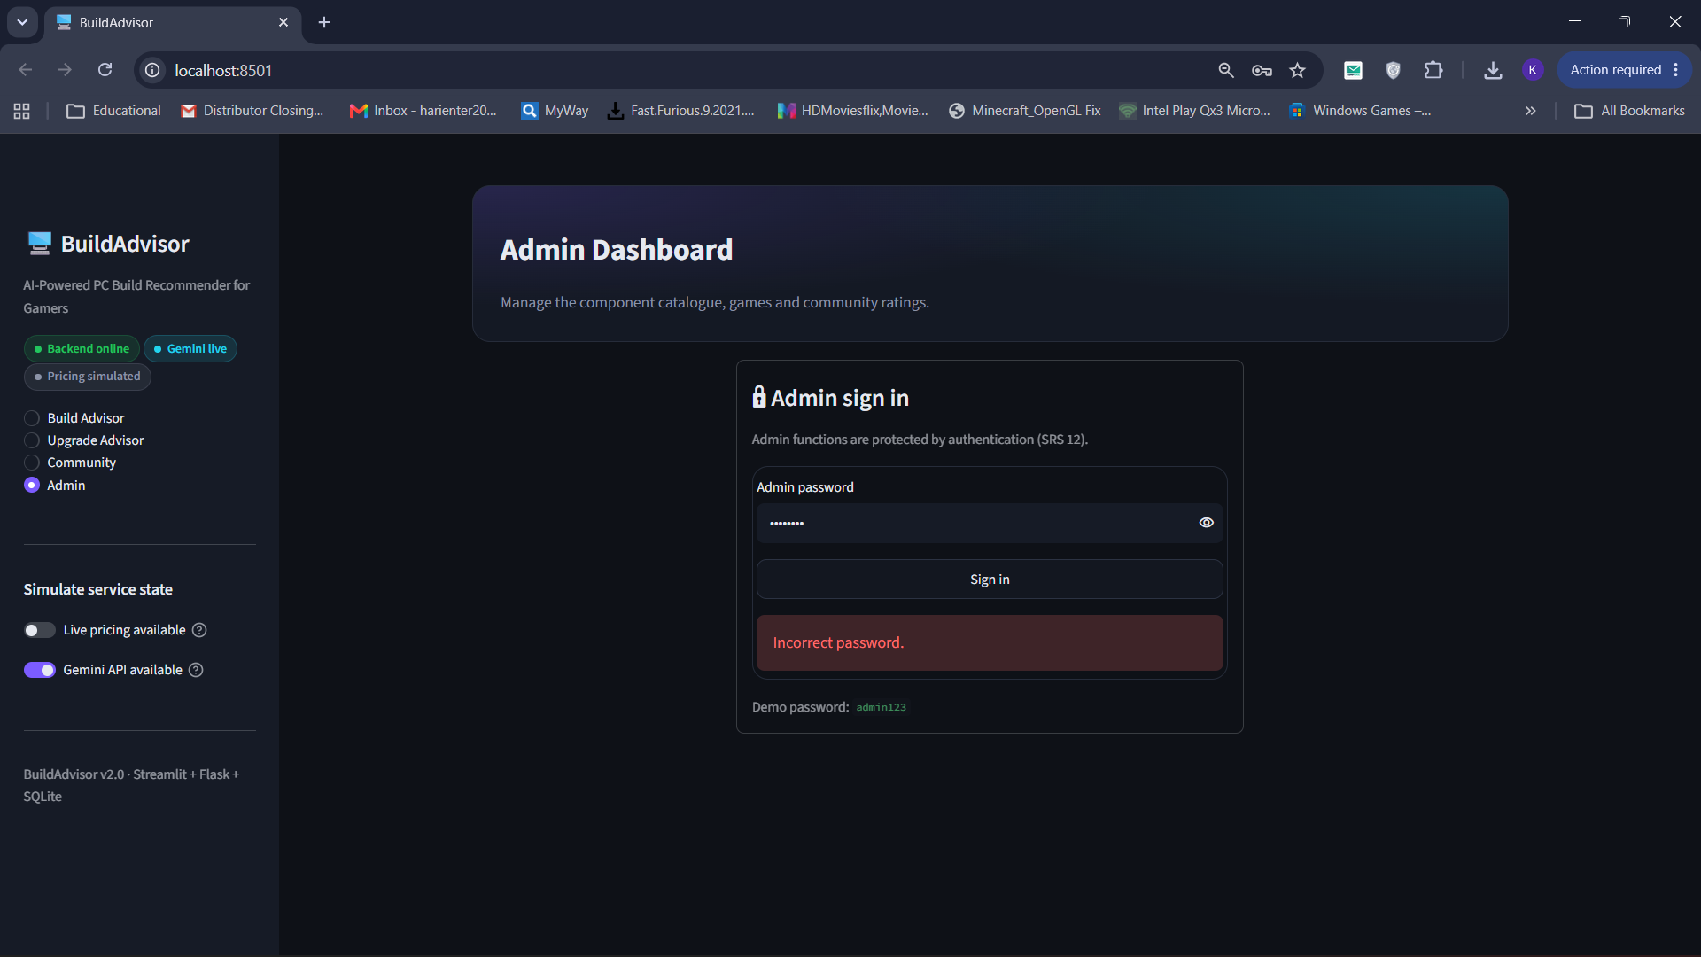
Figure 4.7: TC12 – Admin login with an incorrect password
Test Case 8 (TC14): Backend server offline
Objective: To check that the frontend handles the situation when the Flask backend is not running.
Input / Steps: Stop the Flask server (backend.py) and open or refresh the Streamlit application.
Expected Result: The user should see a clear message that the backend cannot be reached, and the application should not crash.
Actual Result: The sidebar status chip changed to a red Backend offline chip with the hint "Run python backend.py to connect." The main area showed the error "Cannot reach the backend at http://localhost:8000. Start it with python backend.py and try again." The application stayed stable and worked normally again once the backend was restarted.
Status: Pass
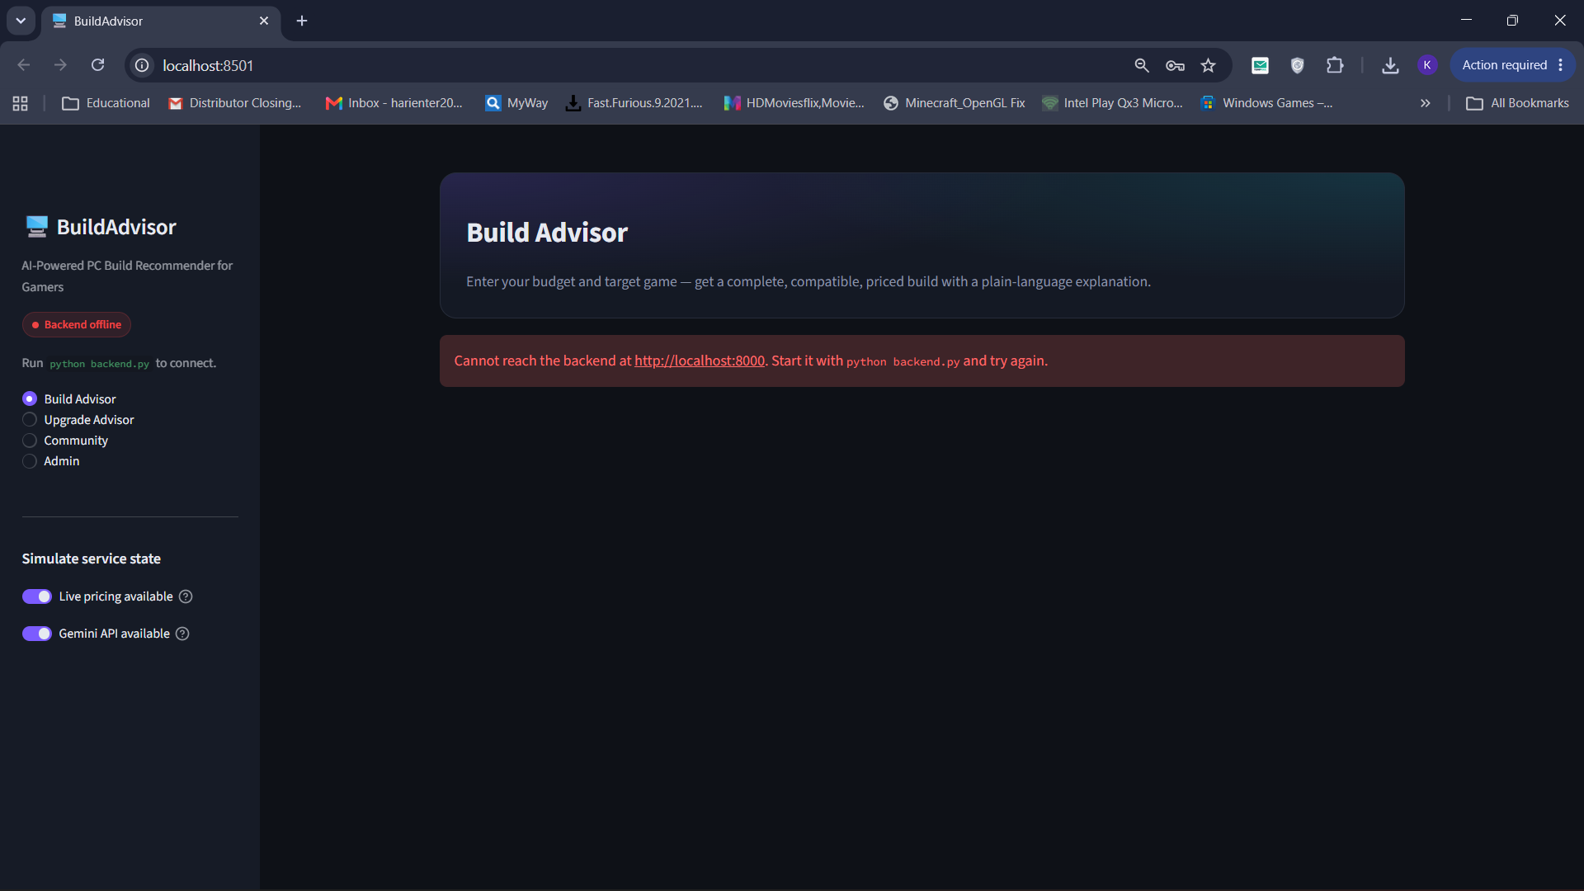
Figure 4.8: TC14 – Backend server offline
4.3 Other Testing Evidence
Validation when business rules are not configured
Description: This screen was captured during testing (validation of missing business rules and empty database). When the BUILDADVISOR_* variables are missing from the .env file, the sidebar lists the missing variables, an information box reports that the component database is empty, and clicking Generate Build shows a clear error instead of crashing.
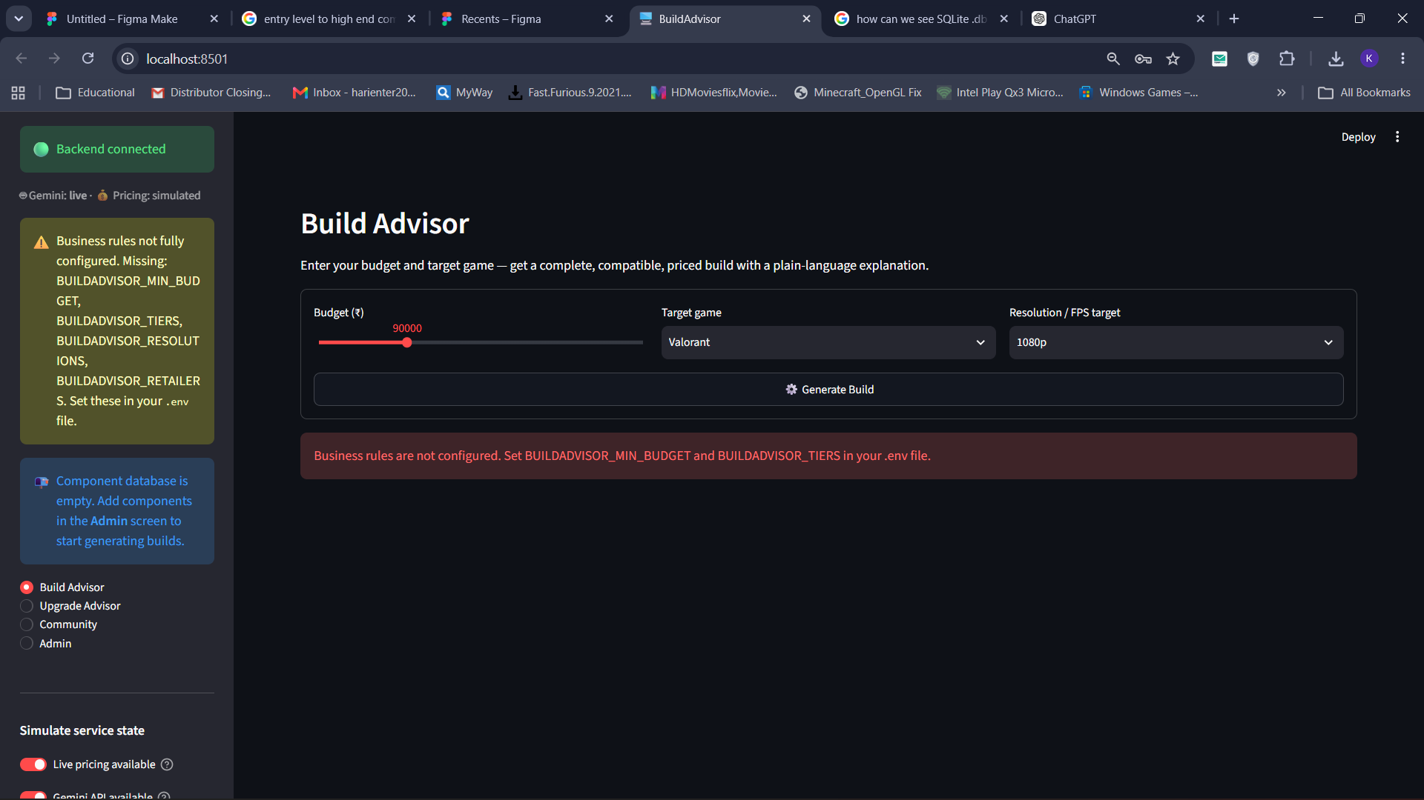
Figure 4.9: Validation when business rules are not configured
Gemini explanation function with graceful fallback (ai.py)
Description: The explain() function sends the build prompt to the Gemini generateContent endpoint with a 20-second timeout. Any network error, rate limit, timeout or unexpected response returns None, so the caller can fall back to a locally generated explanation.
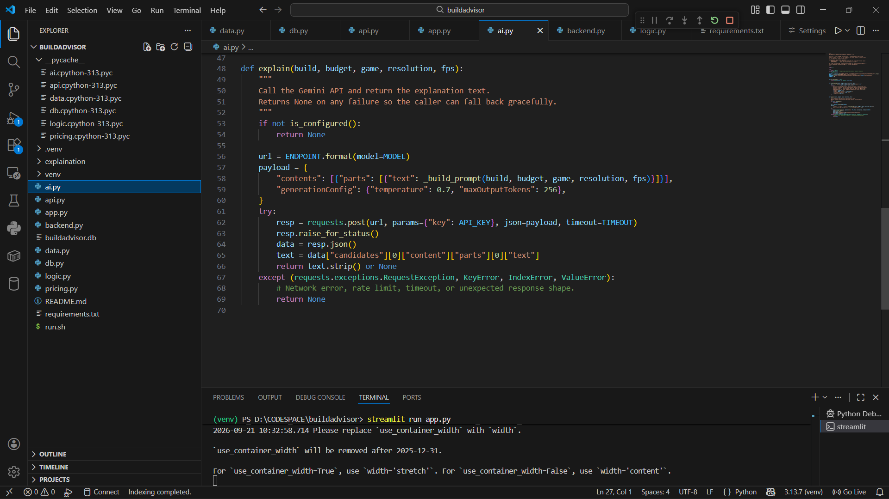
Figure 4.10: Gemini explanation function with graceful fallback (ai.py)
Gemini API usage in Google AI Studio
Description: The Google AI Studio usage page for the BuildAdviser project confirms that the requests sent by the application reach the Gemini API. It was used while testing the API key and model configuration.
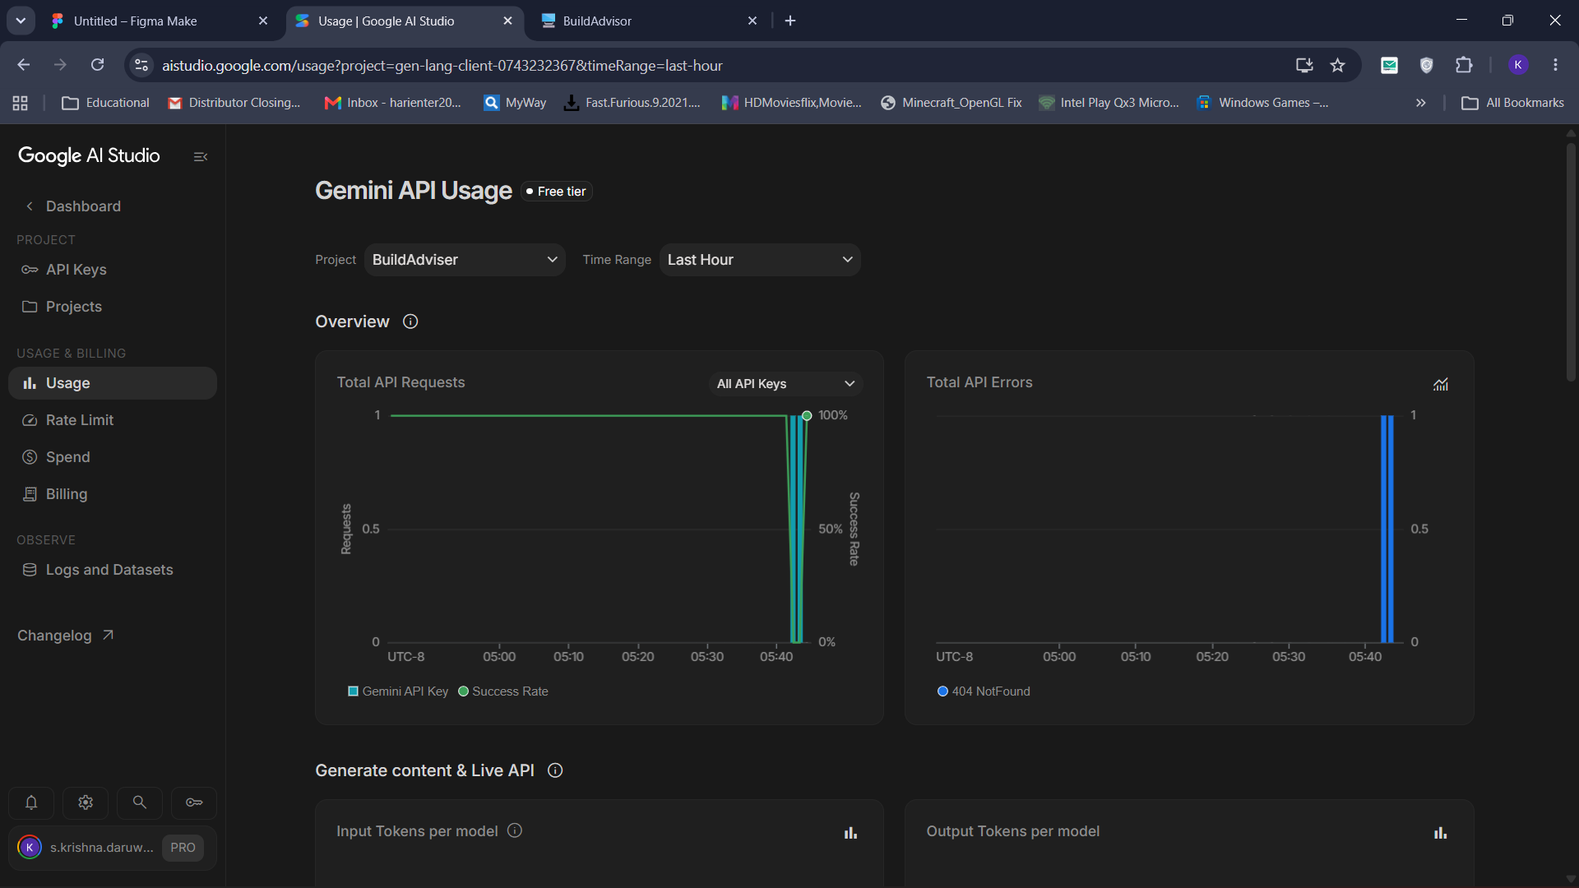
Figure 4.11: Gemini API usage in Google AI Studio

CHAPTER 5
PROJECT USER INTERFACE
The user interface is built with Streamlit using a custom dark violet theme defined in .streamlit/config.toml and a helper module ui.py that adds gradient hero headers, status chips, metric cards and bordered cards. A sidebar on every page shows the application name, live status chips (Backend online, Gemini live, Pricing simulated), page navigation and the service-state switches.
Build Advisor – home screen
Description: The main Build Advisor page. The user chooses a budget with the slider (₹80,000 here), selects a target game (Alan Wake 2 Full RT) and a resolution (1080p), and clicks Generate Build. The sidebar shows that the backend and Gemini are online.
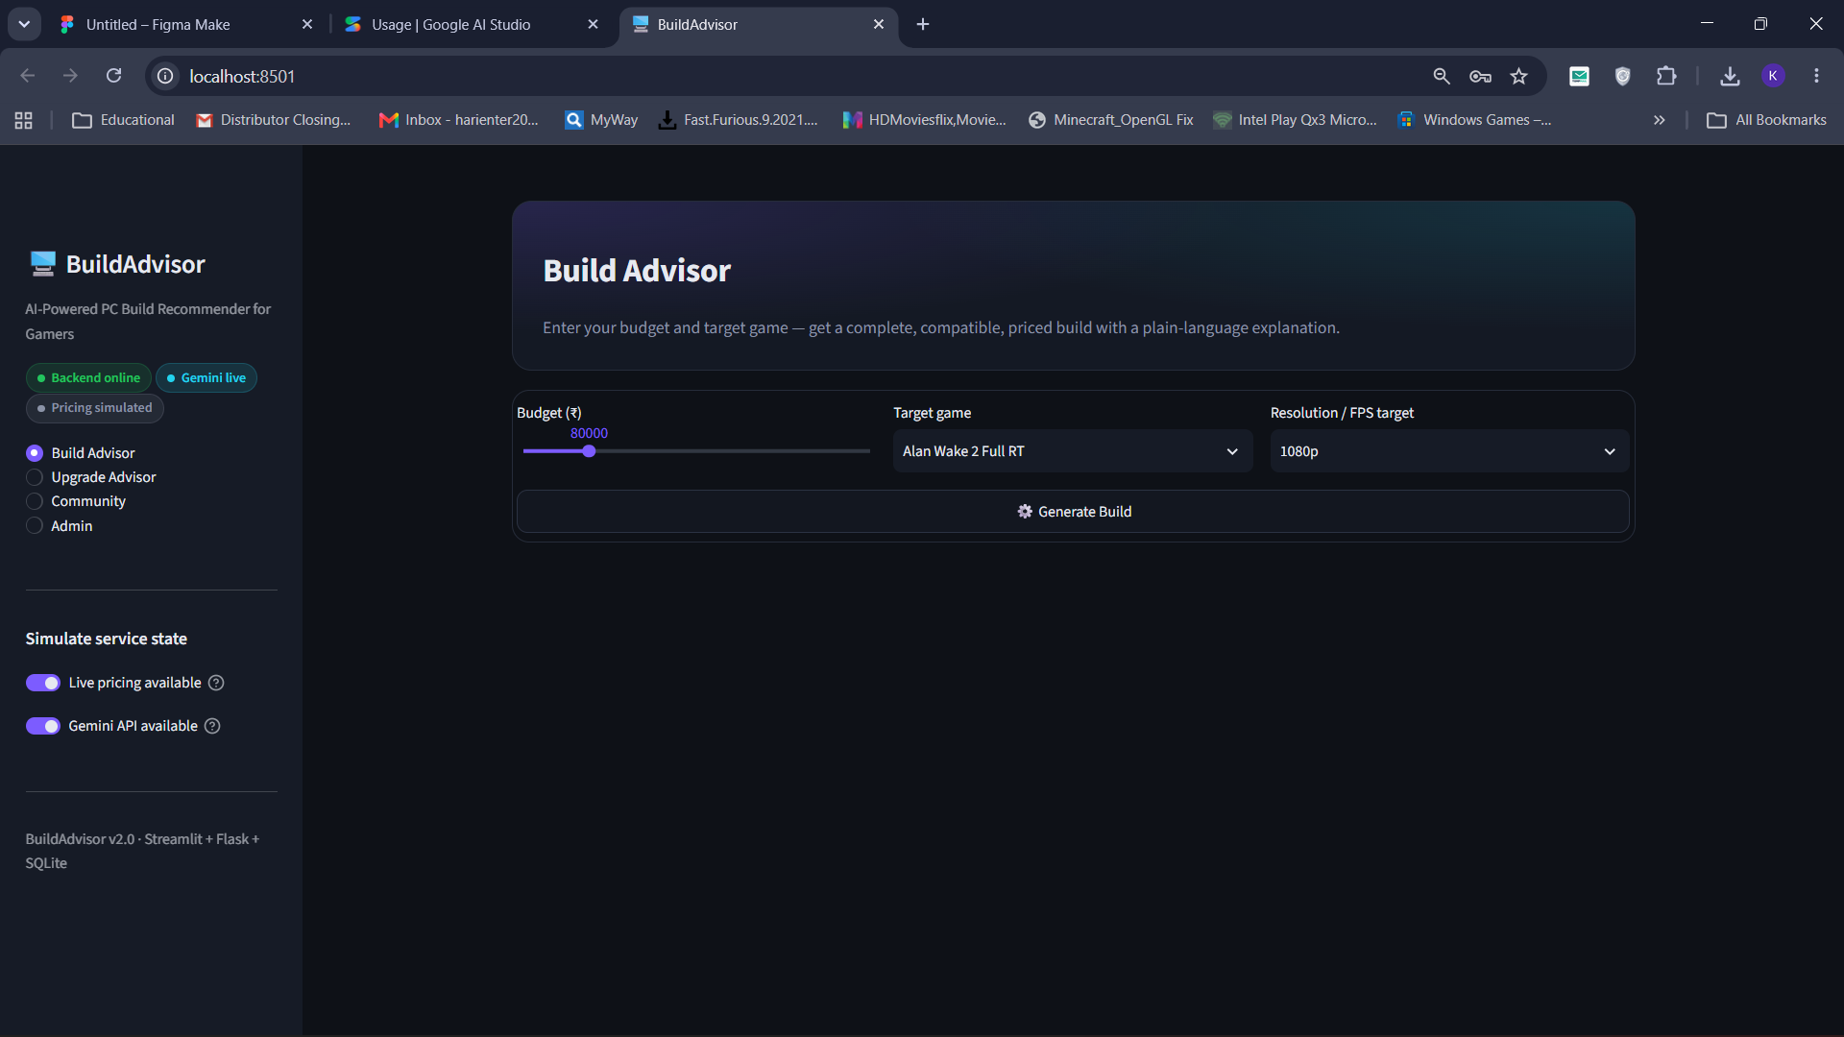
Figure 5.1: Build Advisor – home screen
Recommended build with AI explanation
Description: Result for a Starfield build at 1080p. Metric cards show the list total (₹49,000), the best live total (₹47,856) and the estimated FPS (~131). The Recommended build table lists each part with its best price, retailer and freshness, and the Why this build panel shows the explanation written by Gemini. Below it is the Save & share section.
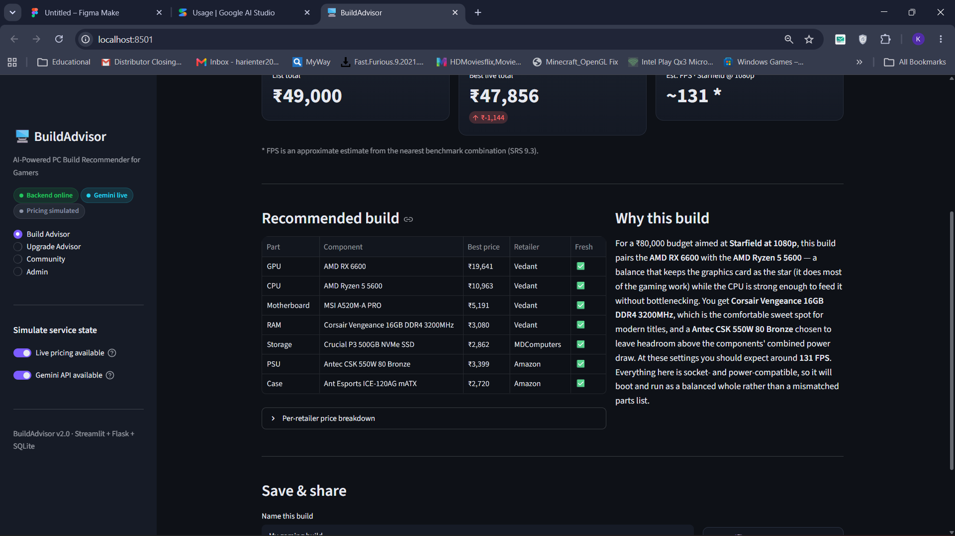
Figure 5.2: Recommended build with AI explanation
Build result for a 4K target
Description: A build for Elden Ring at 4K with a ₹90,000 budget. Because 4K uses a higher resolution multiplier, the estimated FPS is lower (~62). The price change badge shows the saving between list price and best live price.
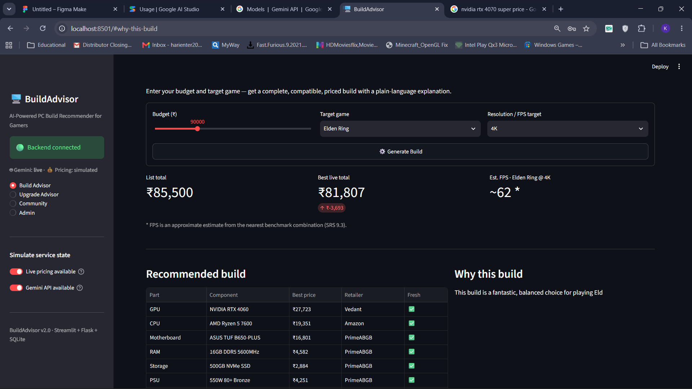
Figure 5.3: Build result for a 4K target
Upgrade Advisor
Description: The Upgrade Advisor page for users who already own a PC. The user selects the current CPU and GPU, the RAM size and an extra upgrade budget, and clicks Find best upgrade to get the biggest bottleneck and the most cost-effective replacement part.
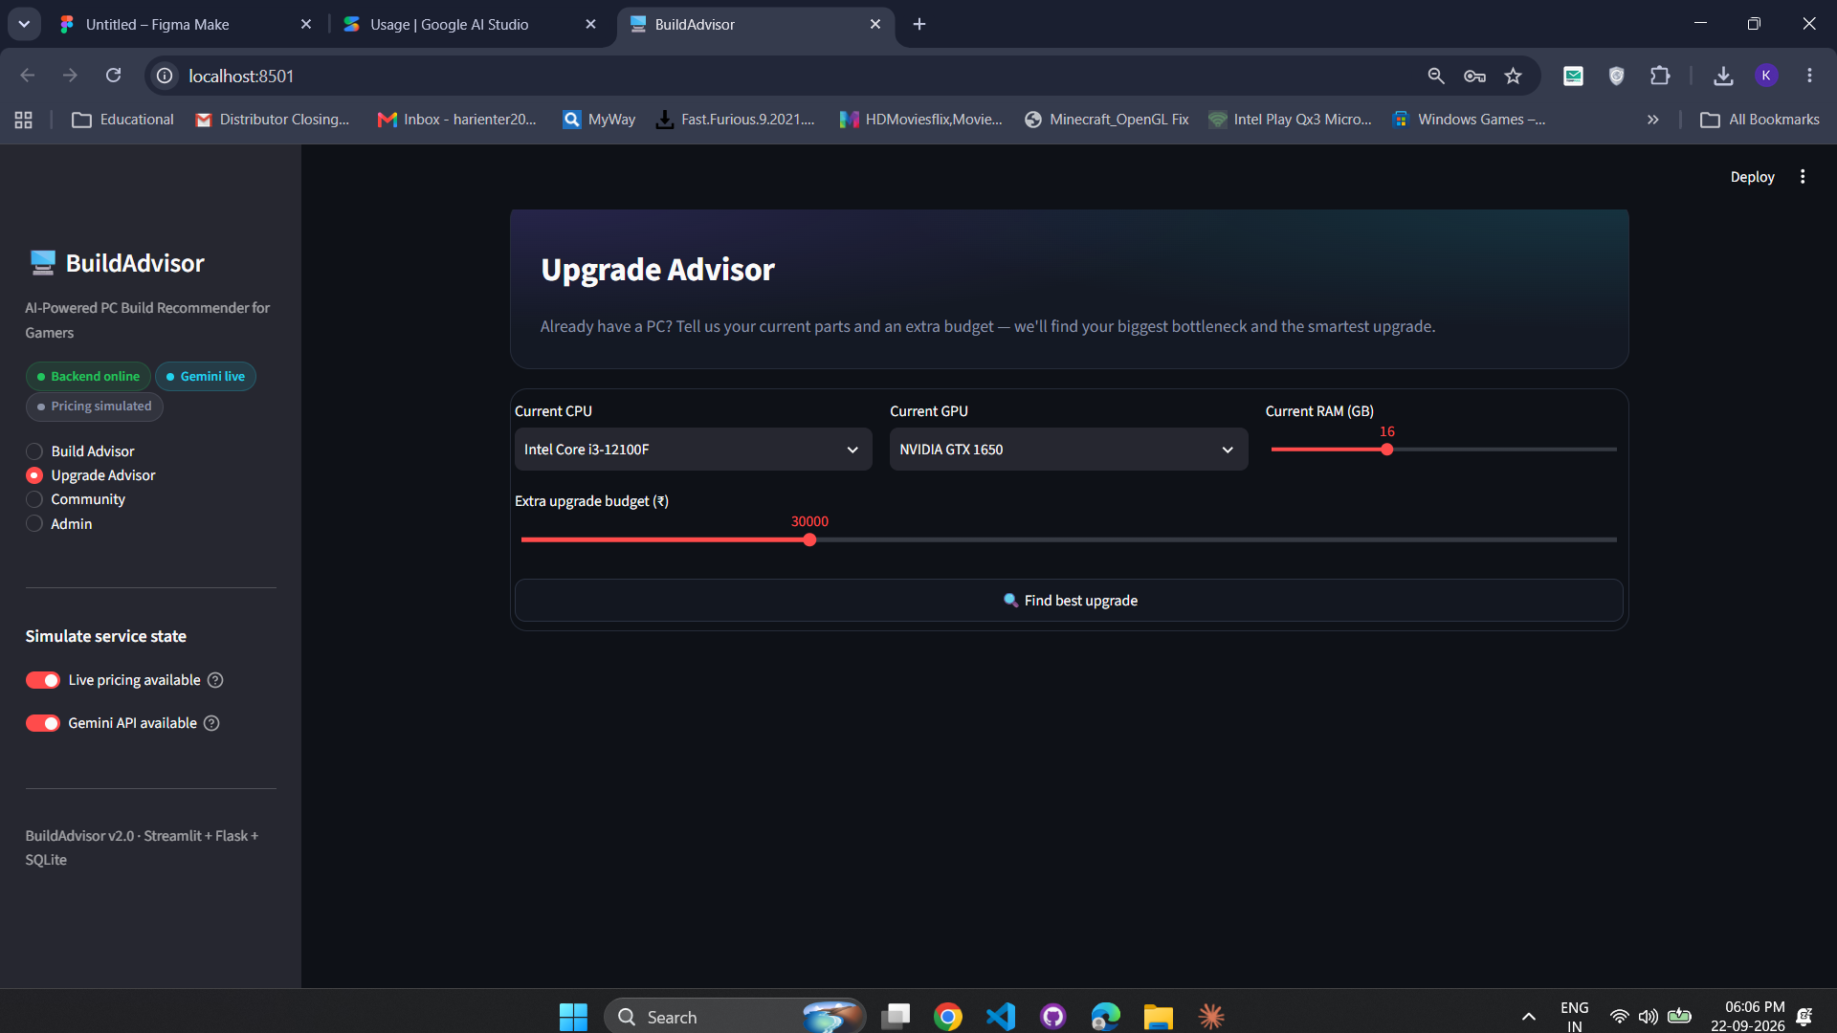
Figure 5.4: Upgrade Advisor
Community Builds
Description: The Community page lists saved builds. Each card shows the build name and target game, the share ID, the build cost (₹52,387) and the average rating (4.0 ★). Users can expand View components and submit their own rating with the slider.
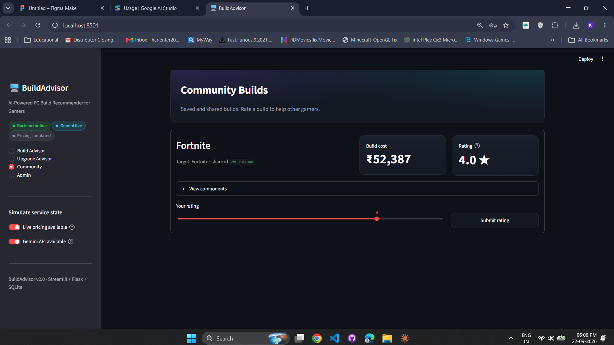
Figure 5.5: Community Builds
Admin Dashboard – component database
Description: After signing in, the administrator sees the Admin Dashboard with tabs for Component database, Add component, Add game, Bulk import (JSON) and Ratings moderation. The Current components table lists each part with its type, name, price and tier.
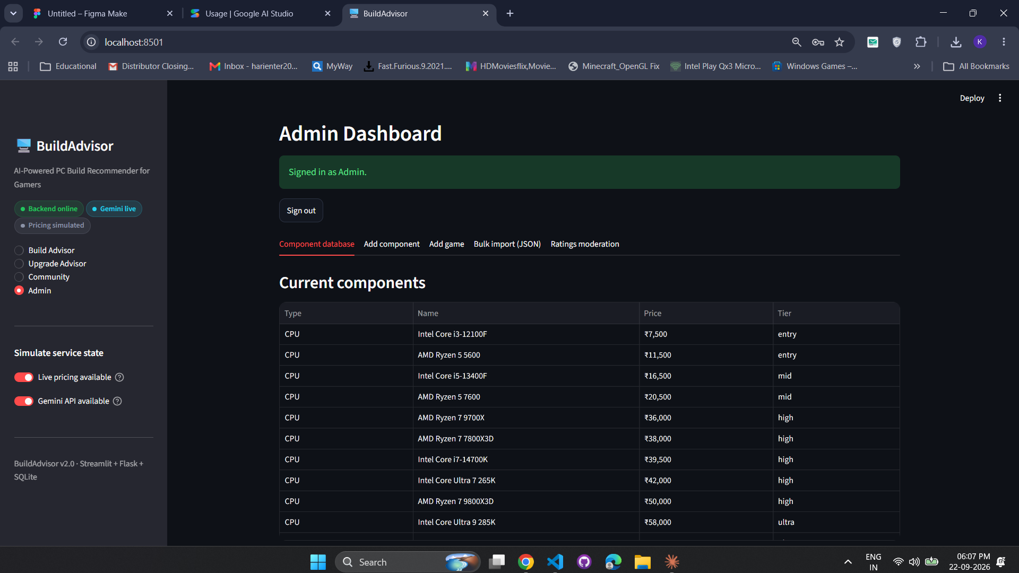
Figure 5.6: Admin Dashboard – component database
Build Advisor with status chips
Description: The polished Build Advisor page with the gradient hero header and the sidebar status chips added through ui.py. The two-column form keeps the budget, game and resolution inputs on one row.
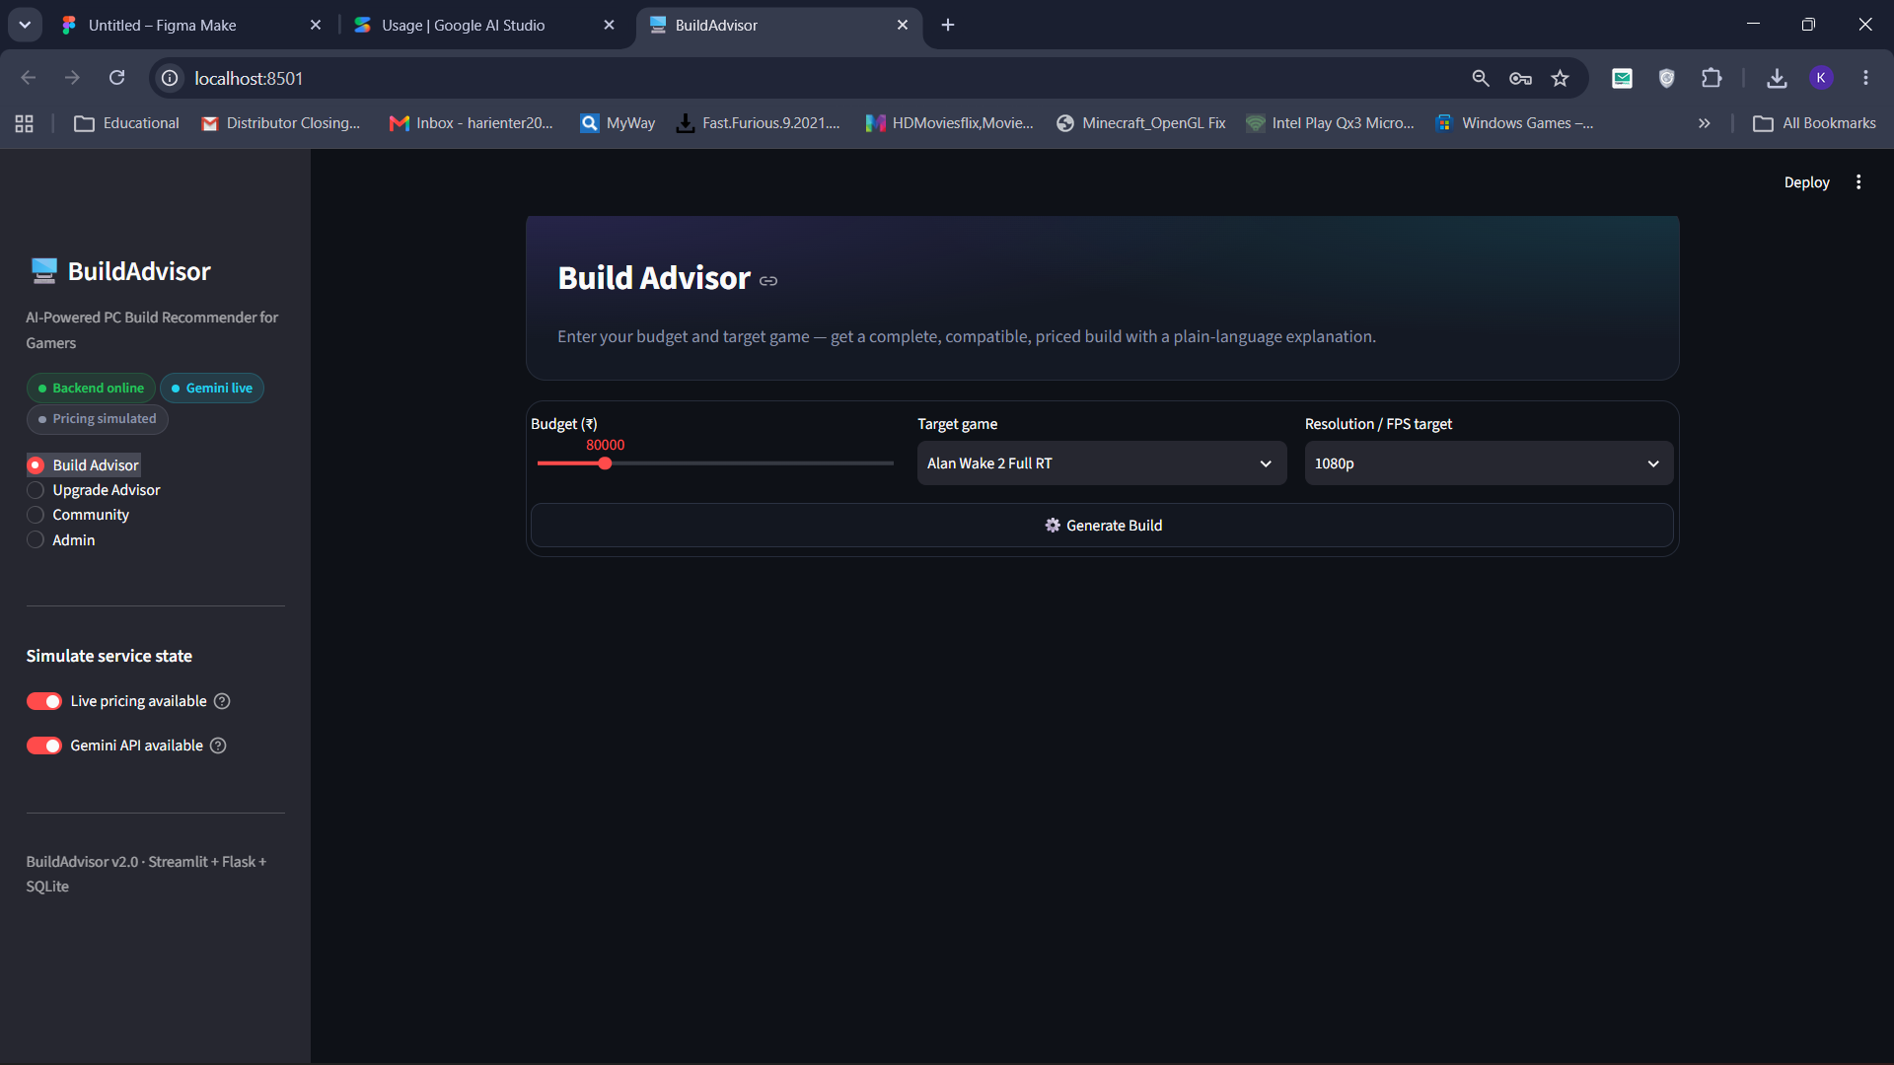
Figure 5.7: Build Advisor with status chips

CHAPTER 6
ADVANTAGES & LIMITATIONS
6.1. Advantages
• Turns a complex technical purchase into three simple inputs: budget, game and resolution.
• Every recommended build is checked for socket, RAM type, PSU headroom and case fit, so the user does not buy incompatible parts.
• AI-generated explanations make recommendations easy to understand for beginners.
• Graceful fallback: the system keeps working with local explanations and last known prices when the Gemini API or live pricing is not available.
• Multi-retailer price comparison helps the user save money.
• The Upgrade Advisor extends the life of existing PCs instead of recommending a full new build.
• Business rules are configured through environment variables, so tiers, budgets and retailers can be changed without editing code.
• Modular three-tier design (Streamlit, Flask, SQLite) is easy to maintain and extend.
• The admin dashboard and JSON bulk import make catalogue maintenance quick.
6.2. Limitations
• The catalogue currently has only 35 components and 13 games, so choices are limited.
• FPS values are approximate estimates from a weighted benchmark model, not measured results.
• Live price scraping is optional and disabled by default; prices are otherwise simulated or last known values.
• AI explanations need an internet connection and are subject to Gemini API rate limits.
• SQLite is suitable for a single server but not for very high numbers of concurrent users.
• There is no full user registration system yet; only the admin has a login.
• Peripherals such as monitors, keyboards and CPU coolers are not part of the recommendation.

CHAPTER 7
CONCLUSION
Build Adviser successfully meets its objective of helping gamers build a compatible, budget-friendly gaming PC without needing expert knowledge. The system combines rule-based compatibility checking, a substitution loop, multi-retailer pricing and FPS estimation with explanations from the Google Gemini API. The three-tier design using Streamlit, Flask and SQLite kept the code modular, and moving the business rules into environment variables made the system flexible. The polished dark violet interface, the Upgrade Advisor, the Community module and the protected Admin dashboard make the project a complete and practical application.
Working on this project gave the team hands-on experience with REST API design, relational database design, integrating a generative AI service, handling failures gracefully and testing a full-stack application.
7.1. Future Planning
• Expand the database with more components (CPU coolers, monitors, peripherals) and more games.
• Use real benchmark data from reviews to improve FPS accuracy.
• Enable reliable live price scraping and price-drop alerts for saved builds.
• Add user registration, login and personal build history.
• Support laptops and pre-built PCs, and workloads such as streaming and video editing.
• Move to PostgreSQL and deploy the application on the cloud for public use.
• Add a chat-style assistant powered by Gemini for follow-up questions about a build.
7.2. References
• Streamlit Documentation – https://docs.streamlit.io
• Flask Documentation – https://flask.palletsprojects.com
• SQLite Documentation – https://www.sqlite.org/docs.html
• Google Gemini API Documentation – https://ai.google.dev/gemini-api/docs
• Python Documentation – https://docs.python.org/3
• Requests Library – https://requests.readthedocs.io
• Beautiful Soup Documentation – https://www.crummy.com/software/BeautifulSoup/bs4/doc
• PCPartPicker (compatibility reference) – https://pcpartpicker.com
• BuildAdvisor Software Requirements Specification (SRS v2.0)

CHAPTER 8
BIBLIOGRAPHY
1. Roger S. Pressman, Software Engineering: A Practitioner's Approach, McGraw-Hill Education.
2. Ian Sommerville, Software Engineering, Pearson Education.
3. Mark Lutz, Learning Python, O'Reilly Media.
4. Miguel Grinberg, Flask Web Development, O'Reilly Media.
5. Elmasri and Navathe, Fundamentals of Database Systems, Pearson Education.
6. Stuart Russell and Peter Norvig, Artificial Intelligence: A Modern Approach, Pearson Education.
7. Official online documentation of Streamlit, Flask, SQLite and the Google Gemini API.

