Sarvajanik College of Commerce and Computer Application
Software Requirements Specification
BuildAdvisor – AI-Powered PC Build Recommender for Gamers
Version 3.0 (Updated after implementation)
Team Members
Sr. No. | Name | Roll No. | Division | Contact No. | Email
1
2
3
4

Revision History
Version | Date | Description
1.0 | — | Initial SRS draft: problem statement, features and requirements.
2.0 | — | Added use case, DFD, activity, sequence, architecture and ER diagrams, business rules, error handling and test cases.
3.0 | October 2026 | Updated to match the implemented system: actual SQLite schema and data dictionary, REST API endpoints, environment-based business rules, admin authentication and bulk import, graceful fallbacks, revised DFD (8 processes, 7 data stores), revised use case and sequence diagrams, and executed test cases.

Table of Contents
Right-click here and choose Update Field to build the table of contents.

1. Introduction

1.1 Purpose
This document specifies the software requirements for BuildAdvisor, an AI-powered web application that recommends a compatible PC build to gamers based on their budget, target game and resolution. Version 3.0 updates the earlier specification so that it matches the system that has actually been implemented and tested. It guides design, development and testing, and is a shared reference between the project team and evaluators.

1.2 Scope
BuildAdvisor lets a user enter a budget, a target game and a resolution (1080p, 1440p or 4K) and receive a complete seven-part build (CPU, GPU, motherboard, RAM, storage, PSU and case) that is checked for compatibility, priced across retailers, given an estimated FPS and explained in plain language by the Google Gemini API. Existing PC owners can enter their current CPU, GPU, RAM and an extra budget to receive the most cost-effective upgrade. Builds can be saved, shared through a short share code and rated by the community. An authenticated Admin maintains the component and game catalogue through an Admin Dashboard, a JSON bulk import or a command-line bootstrap script.

1.3 Definitions, Acronyms and Abbreviations
Term | Description
SRS | Software Requirements Specification
FPS | Frames Per Second, a measure of gaming performance
CPU / GPU | Central Processing Unit / Graphics Processing Unit
PSU | Power Supply Unit
TDP | Thermal Design Power, used to estimate power draw
API / REST | Application Programming Interface / Representational State Transfer
DFD | Data Flow Diagram
ER Diagram | Entity Relationship Diagram
Gemini API | Google generative AI API used to produce plain-language build explanations
.env | Local configuration file holding environment variables (business rules and API key)
TTL | Time To Live of a cached price

1.4 Overview
Section 2 describes the product context. Section 3 analyses the problem and system behaviour through use case, DFD, activity and sequence diagrams. Sections 4 and 5 list functional and non-functional requirements. Section 6 covers external interfaces including the REST API, Section 7 the architecture and Section 8 the database design. Sections 9 to 16 cover business rules, error handling, testing, security, limitations, future scope, traceability and the appendix.

1.5 SDLC Model
The project follows the Agile (Scrum-based) Software Development Life Cycle. The system was built as a set of largely independent features that suit short, testable iterations, and AI-integration work (prompt design and response handling) needed repeated refinement based on testing.
• Sprint 1: Requirement analysis, database design and UI wireframes
• Sprint 2: Budget-based build generator and compatibility checker
• Sprint 3: Price comparison with fallback, and the Upgrade Advisor
• Sprint 4: Gemini API integration with a local fallback explanation
• Sprint 5: Save/share/rating, Admin Dashboard and bulk import, UI polish, testing and deployment

2. Overall Description

2.1 Product Perspective
BuildAdvisor is a standalone web application built as a BCA capstone project. It follows a three-tier client-server model: a Streamlit frontend (app.py, ui.py) talks over HTTP (api.py) to a Flask REST backend (backend.py), which runs the business logic (logic.py) and stores data in an SQLite database (db.py). Optional external services are the Gemini API (ai.py) and retailer price scraping (pricing.py).

2.2 Product Features
• Budget-based build generator with configurable tiers (entry, mid, high)
• Game and resolution targeting with an estimated FPS for each build
• Automatic compatibility checking and part substitution (socket, RAM type, PSU headroom, case form factor)
• Price comparison across configured retailers, with optional live scraping, caching and last-known fallback
• Upgrade Advisor that finds the biggest bottleneck of an existing PC
• AI explanation through the Gemini API with a locally generated fallback
• Save and share builds with a share code, and community ratings
• Password-protected Admin Dashboard: add components and games, JSON bulk import and ratings moderation
• Sidebar status chips showing backend, Gemini and pricing status, plus outage simulation switches for demonstration

2.3 User Classes
User Class | Description
Gamers (Buyers) | New PC builders who enter a budget, target game and resolution to receive a complete build with estimated FPS, prices and an explanation.
Existing PC Owners | Users who enter their current CPU, GPU, RAM and an extra budget to receive the best upgrade.
Admin | Signs in with a password, maintains the component and game catalogue, bulk imports data and moderates community ratings.

2.4 Operating Environment
• Client: Any modern web browser (Chrome, Edge, Firefox) on desktop or mobile
• Server: Python 3.x with Flask (port 8000) and Streamlit (port 8501); started with run.sh or two terminals
• Database: SQLite file buildadvisor.db (schema portable to MySQL)
• External services (optional): Gemini API (default model gemini-2.5-flash) and retailer search pages via requests and BeautifulSoup

2.5 Constraints
• Backend must be implemented in Python (Flask) and frontend in Streamlit
• Business rules must not be hard-coded; they are read from BUILDADVISOR_* environment variables
• The database starts empty; catalogue data must be added by the Admin or the bootstrap script
• AI explanations depend on Gemini API availability, key validity and rate limits
• Live price accuracy depends on the structure of third-party retailer pages

2.6 Assumptions and Dependencies
• Users understand basic terms such as resolution and FPS
• An internet connection is available when live pricing or Gemini is enabled
• The Admin keeps component prices, scores and game weights reasonably up to date
• The .env file is configured before first use and is never committed to version control

3. System Analysis

3.1 Problem Statement
Gamers, especially first-time PC builders, often overspend or end up with mismatched or bottlenecked components because they lack the knowledge to judge CPU-GPU pairing, compatibility or realistic FPS for their games. This leads to buyer's remorse, wasted budget and reliance on scattered, outdated forum advice.

3.2 Existing System
Gamers currently rely on generic PC-build tools, YouTube guides or forum threads. These tools let users pick parts manually and check basic compatibility, but they do not tailor recommendations to a game and resolution target, do not explain choices in plain language and rarely reflect Indian retail prices.

3.3 Proposed System
BuildAdvisor combines a budget, game and resolution input with automatic build generation, compatibility repair, multi-retailer pricing, FPS estimation and an AI explanation. It also helps existing PC owners by recommending the most cost-effective upgrade instead of a full rebuild, and keeps working when external services fail.

3.4 Advantages of Proposed System
• Personalised recommendations based on budget, game and resolution
• Plain-language explanations instead of a bare parts list
• Every build is checked and repaired for compatibility automatically
• Price comparison across retailers helps avoid overpaying
• Graceful fallbacks keep the app usable when Gemini or pricing is unavailable
• Business rules can be changed through .env without editing code

3.5 Feasibility Study
Technical Feasibility
The stack (Python, Flask, Streamlit, SQLite, Gemini API) is well documented and free or open source, and the complete system has been implemented and tested, confirming technical feasibility.
Economic Feasibility
Only open-source frameworks and the free Gemini tier are used, so development cost is minimal. Public deployment would only need basic hosting.
Operational Feasibility
The interface needs only three inputs and shows results with metric cards, tables and explanations, so users need no training. Admins manage data through forms or a JSON import without developer help.

3.6 Use Case Diagram
The diagram shows the three actors — Gamer, Existing PC Owner and Admin — and the use cases inside the BuildAdvisor system boundary.
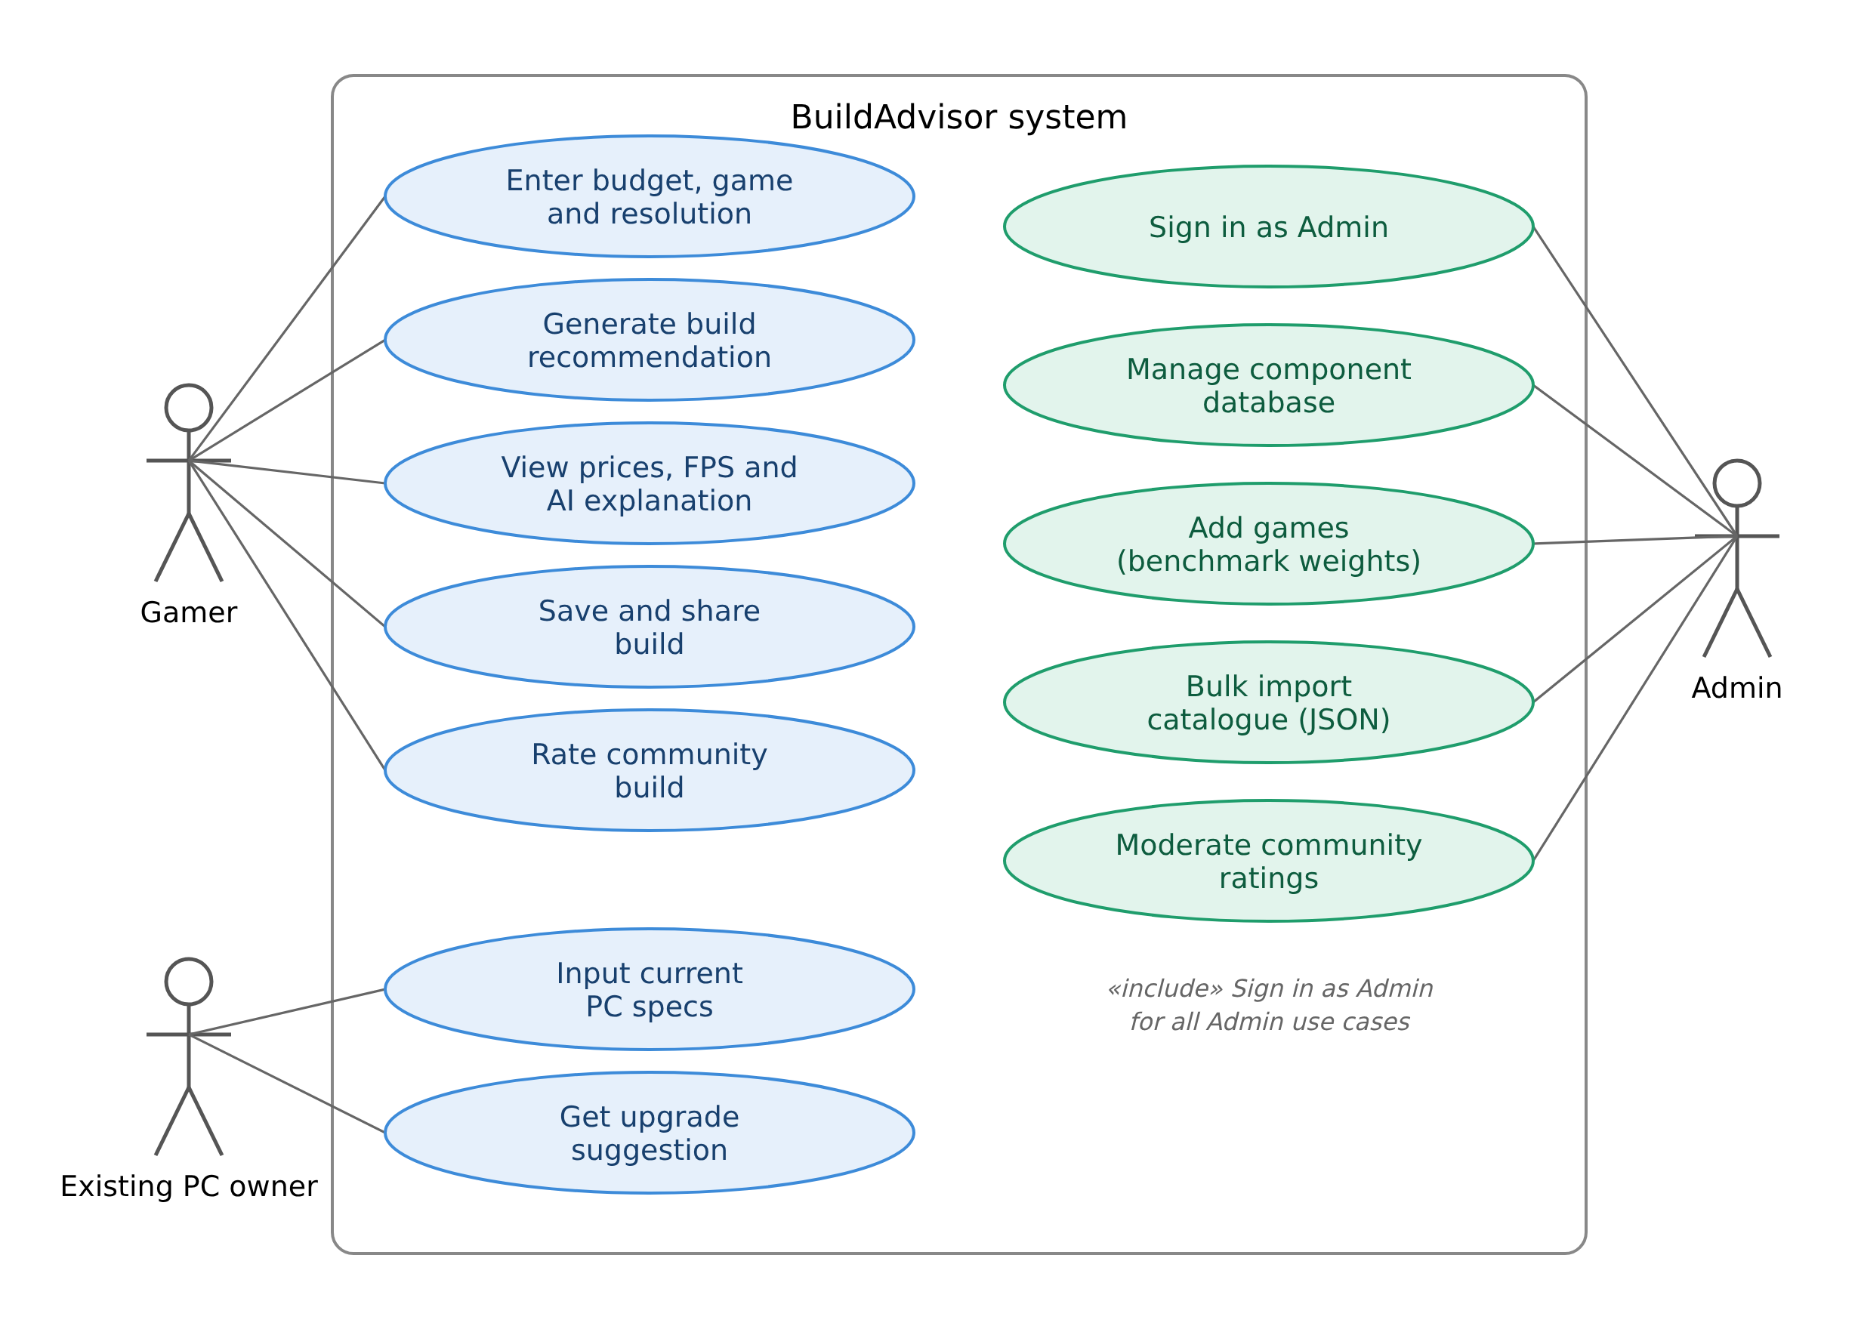
Figure 3.1: Use Case Diagram
Description: Gamers configure and generate builds, view prices, FPS and the AI explanation, save and share builds and rate community builds. Existing PC owners enter current specifications and get an upgrade suggestion. Every Admin use case (manage components, add games, bulk import and moderate ratings) includes signing in as Admin.

3.7 Detailed Use Cases
Field | Use Case: Generate Build Recommendation
Actor | Gamer
Precondition | Business rules are configured in .env and the catalogue contains all seven part types and at least one game
Main Flow | 1. User selects budget, game and resolution. 2. Backend validates the budget and rules. 3. Backend loads components and games from SQLite. 4. Generator allocates the budget across seven parts. 5. Compatibility is checked and incompatible parts are substituted. 6. FPS is estimated. 7. Prices are fetched for every part. 8. Gemini (or the local fallback) explains the build. 9. Results are displayed.
Alternate Flow | Budget below minimum, empty catalogue or missing rules: an explanatory message is shown and no build is generated.
Postcondition | A compatible, priced build with FPS and an explanation is shown and can be saved

Field | Use Case: Get Upgrade Suggestion
Actor | Existing PC Owner
Precondition | The catalogue contains CPUs, GPUs and RAM
Main Flow | 1. User selects current CPU and GPU, RAM size and extra budget. 2. System compares normalised CPU, GPU and RAM scores to find the bottleneck. 3. System lists better parts of that type within the extra budget and highlights the best one.
Postcondition | User sees the bottleneck, the best upgrade and other options in budget

Field | Use Case: Manage Catalogue (Admin)
Actor | Admin
Precondition | Admin has signed in with the admin password and holds a session token
Main Flow | 1. Admin views the component database. 2. Admin adds a component or game with its specifications. 3. Admin optionally bulk imports a JSON catalogue. 4. Admin removes inappropriate ratings of a build.
Postcondition | Catalogue and ratings are up to date and used in later recommendations

3.8 DFD Level 0 (Context Diagram)
The context diagram shows BuildAdvisor as a single process exchanging data with its three external entities.
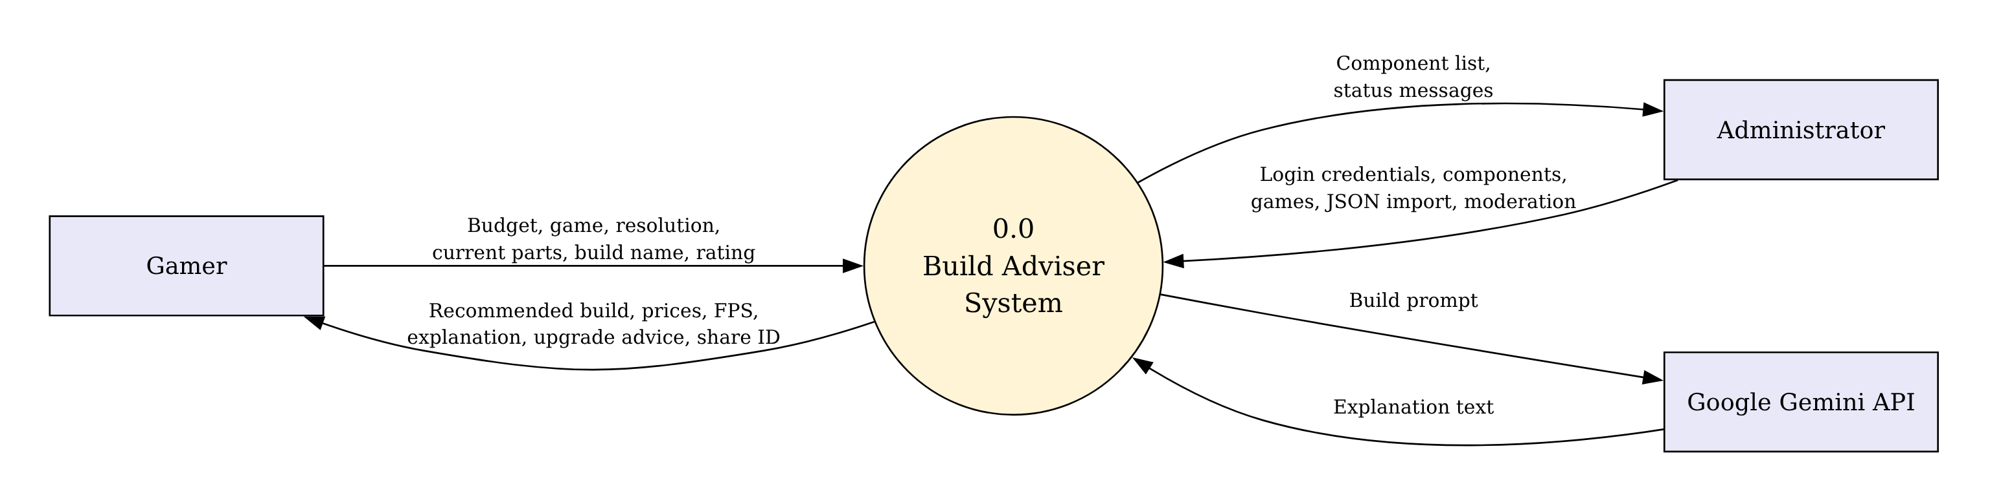
Figure 3.2: Level 0 DFD (Context Diagram)
Description: The Gamer sends budget, game, resolution and current specifications and receives builds, prices, FPS, explanations and upgrade advice. The Admin sends credentials and catalogue data and receives status and listings. The Gemini API receives a build prompt and returns explanation text.

3.9 DFD Level 1
The Level 1 diagram decomposes the system into eight processes and seven data stores that match the implemented modules and database tables.
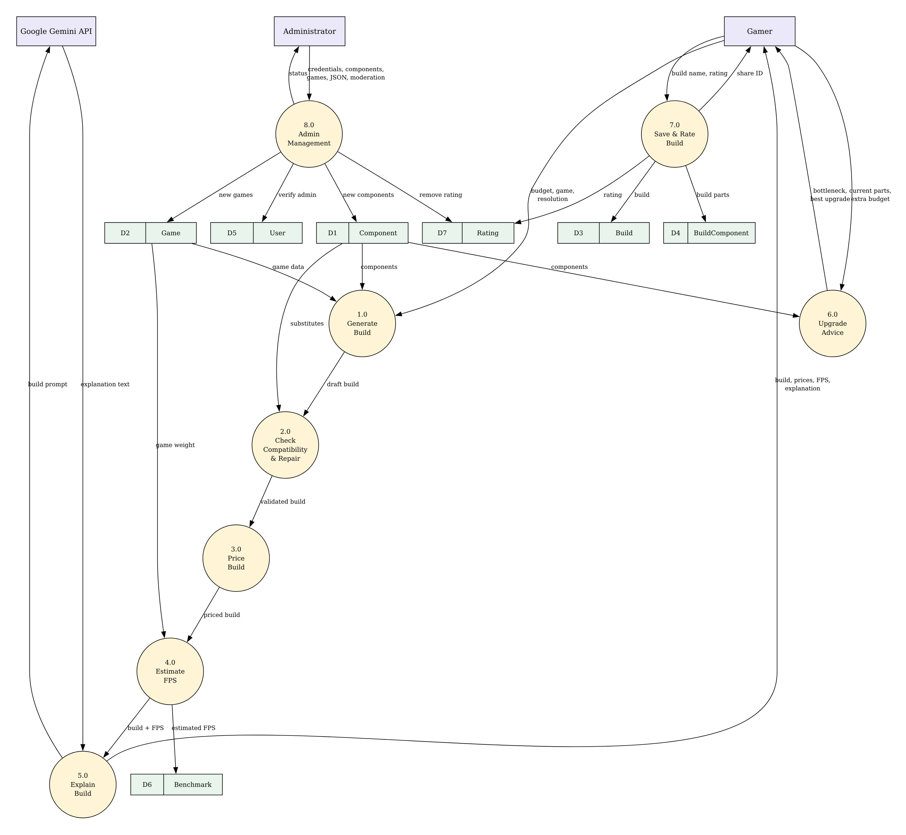
Figure 3.3: Level 1 DFD
Description: Processes cover input validation, build generation, compatibility checking, FPS estimation, pricing, explanation, save/share/rate and admin management. They read and write the data stores D1 to D7, which correspond to the User, Component, Game, Build, BuildComponent, Benchmark and Rating tables.

3.10 Activity Diagram
The activity diagram traces the build-generation flow from user input to the final recommendation, including the validation and compatibility/budget decision points.
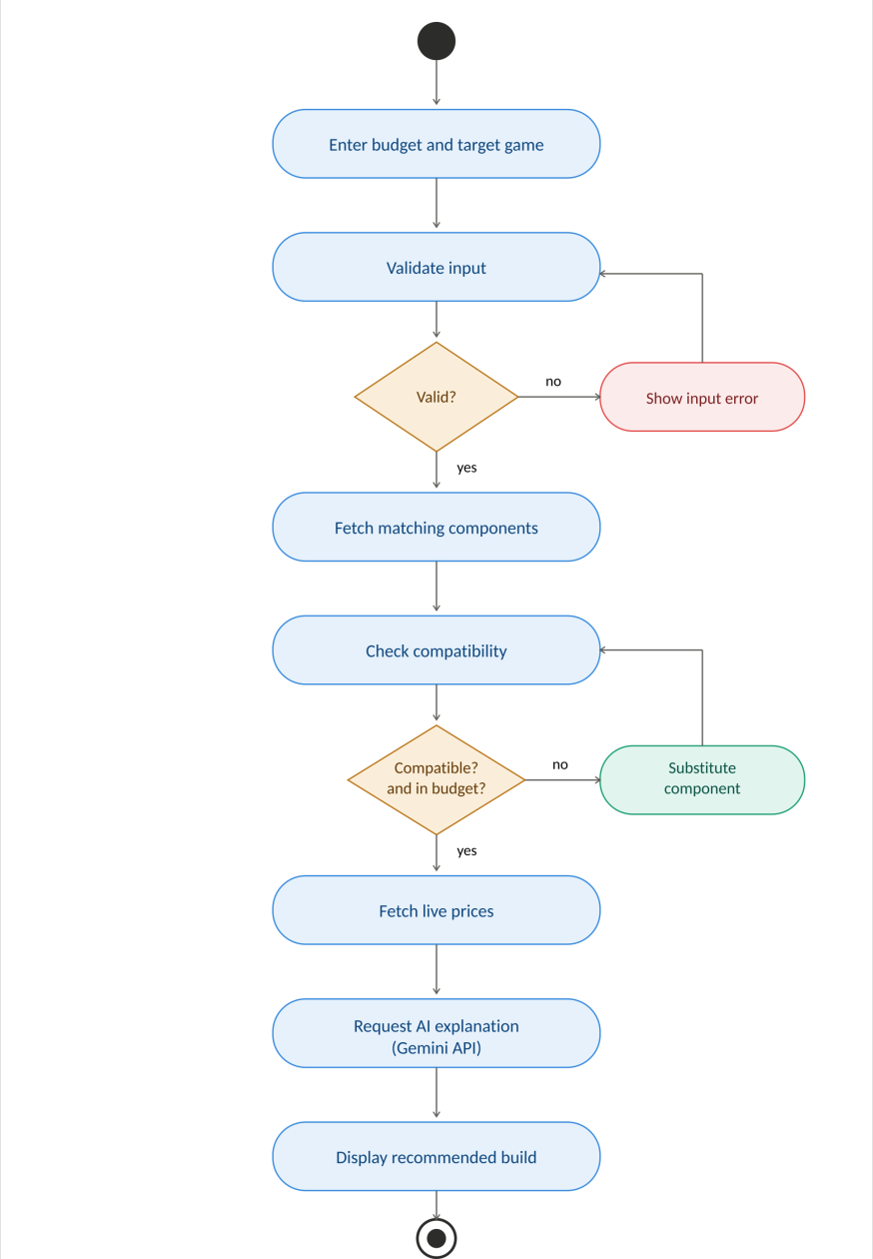
Figure 3.4: Activity Diagram – Generate Build
Description: Invalid input returns the user to correct it. After components are selected, the compatibility and budget check loops back through part substitution (logic._repair, up to eight attempts) until the build is valid. Prices are then fetched, an explanation is requested and the build is displayed.

3.11 Sequence Diagram
The sequence diagram shows the interaction between the Gamer, the Streamlit UI, the Flask backend, the SQLite database, the pricing module and the Gemini API.
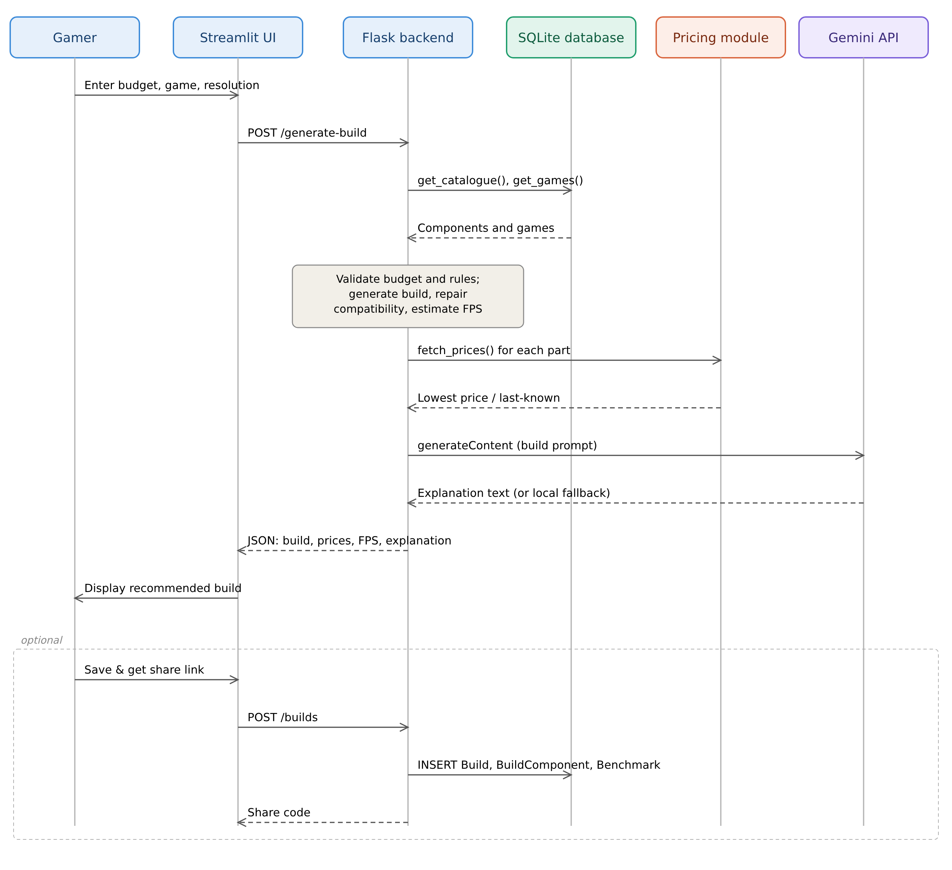
Figure 3.5: Sequence Diagram – Generate and Save Build
Description: Generating a build does not write to the database; it only reads the catalogue. The build is stored only when the user chooses Save and get share link, which calls POST /builds and inserts rows into Build, BuildComponent and Benchmark.

4. Functional Requirements

4.1 Build Generation (FR-1)
The system shall generate a complete seven-part build (CPU, GPU, motherboard, RAM, storage, PSU, case) within the user-specified budget.
1. The system shall accept a numeric budget from a slider and reject zero, negative or non-numeric values.
2. The system shall classify the budget into a tier using BUILDADVISOR_TIERS and prefer components of that tier.
3. The system shall allocate the budget across parts (GPU 32%, CPU 20%, motherboard 13%, RAM 10%, PSU 9%, storage 8%, case 8%) while reserving enough for the remaining parts.
4. The system shall ensure the total list price does not exceed the budget.
5. The system shall refuse to build when the budget is below BUILDADVISOR_MIN_BUDGET, the catalogue is empty or a part type is missing, and state the reason.

4.2 Game Performance (FR-2)
The system shall let the user choose a target game and resolution and show an estimated FPS.
1. The system shall list the games stored in the Game table and the resolutions from BUILDADVISOR_RESOLUTIONS.
2. The system shall estimate FPS from GPU and CPU scores, the game weight, whether the game is CPU-bound and the resolution multiplier.
3. The system shall mark the FPS value as approximate.

4.3 Compatibility (FR-3)
The system shall validate and repair compatibility before presenting a build.
1. The system shall verify that the CPU socket matches the motherboard socket.
2. The system shall verify that the RAM type (DDR4/DDR5) matches the motherboard.
3. The system shall verify that PSU wattage is at least 1.4 times the combined CPU and GPU TDP.
4. The system shall verify that the motherboard form factor is supported by the case.
5. The system shall substitute compatible parts automatically and report any remaining warnings.

4.4 Price Comparison (FR-4)
The system shall show the lowest price and retailer for every recommended part.
1. The system shall obtain quotes from the retailers listed in BUILDADVISOR_RETAILERS.
2. When ENABLE_SCRAPING=1, the system shall scrape retailer search pages and cache results for PRICE_CACHE_TTL seconds.
3. When scraping is disabled or fails, the system shall use estimated prices; when pricing is unavailable it shall show last-known prices with a date.
4. The system shall display both the list total and the best live total.

4.5 Upgrade Advisor (FR-5)
The system shall recommend the most cost-effective upgrade for an existing PC.
1. The system shall accept the current CPU, GPU, RAM size and an extra budget.
2. The system shall identify the bottleneck by comparing normalised GPU, CPU and RAM scores.
3. The system shall list better parts of the bottleneck type within the extra budget and highlight the best one.

4.6 AI Explanation (FR-6)
The system shall explain each build in plain language.
1. When GEMINI_API_KEY is set, the system shall send the build, budget, game, resolution and FPS to the Gemini generateContent endpoint with a 20-second timeout.
2. On any failure the system shall use a locally generated explanation, or show a notice when the AI service is marked unavailable.

4.7 Save, Share and Rate Builds (FR-7)
The system shall let users save, share and rate builds.
1. The system shall store a saved build in Build, BuildComponent and Benchmark.
2. The system shall generate a ten-character share code from the build components.
3. The system shall list saved builds on the Community page with their average rating.
4. The system shall accept a rating from 1 to 5 with an optional comment.

4.8 Admin Management (FR-8)
The system shall provide a password-protected Admin Dashboard.
1. The system shall issue a session token on correct password (POST /admin/login) and require it in the X-Admin-Token header.
2. The system shall allow the Admin to add or replace components and games.
3. The system shall allow bulk import of components and games from JSON (POST /admin/import or bootstrap.py).
4. The system shall allow the Admin to remove the ratings of a build.

5. Non-Functional Requirements

5.1 Performance
• A build recommendation shall be generated within 5 seconds under normal load, excluding external API latency.
• Scraped prices shall be cached for PRICE_CACHE_TTL seconds to avoid repeated calls.

5.2 Reliability
• Failure of Gemini or pricing shall never stop a build from being shown.
• If the backend is offline, the frontend shall show a clear message and a red status chip instead of crashing.
• The SQLite file shall be backed up periodically.

5.3 Usability
• The interface shall need only budget, game and resolution to produce a build.
• Results shall use metric cards, a price table and a plain-language explanation.
• The sidebar shall show backend, Gemini and pricing status.

5.4 Security
• Admin endpoints shall require a valid admin token.
• User text (build names, comments) shall be filtered to safe characters and length-limited before storage.
• All SQL shall use parameterised queries.
• The Gemini API key shall be kept only in .env and never committed.

5.5 Maintainability
The code is split into separate modules — app.py, ui.py, api.py, backend.py, logic.py, db.py, config.py, ai.py, pricing.py and bootstrap.py — so the UI, API, rules, data, AI and pricing can be changed independently.

5.6 Scalability
The backend is stateless apart from the database, so more components and games can be added without redesign. Component type is indexed, and the schema is portable to MySQL or PostgreSQL for larger deployments.

5.7 Availability
When a third-party dependency is unavailable, the system continues with last-known prices or a local explanation rather than becoming unavailable.

6. External Interface Requirements

6.1 User Interface
The Streamlit interface uses a custom dark violet theme and has four pages selected from the sidebar: Build Advisor (budget slider, game and resolution selectors, results with metric cards, price table, explanation and save/share), Upgrade Advisor, Community (saved builds and ratings) and Admin (sign-in, component database, add component, add game, bulk import and ratings moderation). The sidebar also shows status chips and outage simulation switches.

6.2 Hardware Interface
No special hardware is required; the system runs on standard client and server machines with internet access for optional services.

6.3 Software Interface
Interface | Purpose
Streamlit (app.py, ui.py) | Renders the user interface and captures input
Flask (backend.py) | REST API, request validation and orchestration
SQLite (db.py) | Stores users, components, games, builds, benchmarks and ratings
Gemini API (ai.py) | Generates plain-language build explanations
requests + BeautifulSoup (pricing.py) | Optional live retailer price scraping
python-dotenv / environment (config.py) | Loads business rules and keys from .env

6.4 REST API Interface
Method | Endpoint | Purpose
GET | /health, /config | Backend, Gemini and pricing status; business-rule configuration
GET | /games, /components | Reference data from the database
POST | /generate-build | Generate a priced, explained build (FR-1 to FR-4, FR-6)
POST | /upgrade | Upgrade advice (FR-5)
POST / GET | /builds | Save a build / list saved builds (FR-7)
POST | /builds/<id>/ratings | Rate a build (FR-7)
POST | /admin/login | Admin authentication, returns token
POST | /admin/components, /admin/games | Add component or game (FR-8)
POST | /admin/import | Bulk JSON import (FR-8)
DELETE | /admin/builds/<id>/ratings | Moderate ratings (FR-8)

6.5 Communication Interface
The frontend and backend communicate using JSON over HTTP (HTTPS when deployed). Calls to the Gemini API and retailer sites use HTTPS.

7. System Architecture

7.1 Architecture Diagram
The diagram shows the flow from user input through the frontend and backend to the component database, price fetcher and Gemini API, converging into the final recommendation.
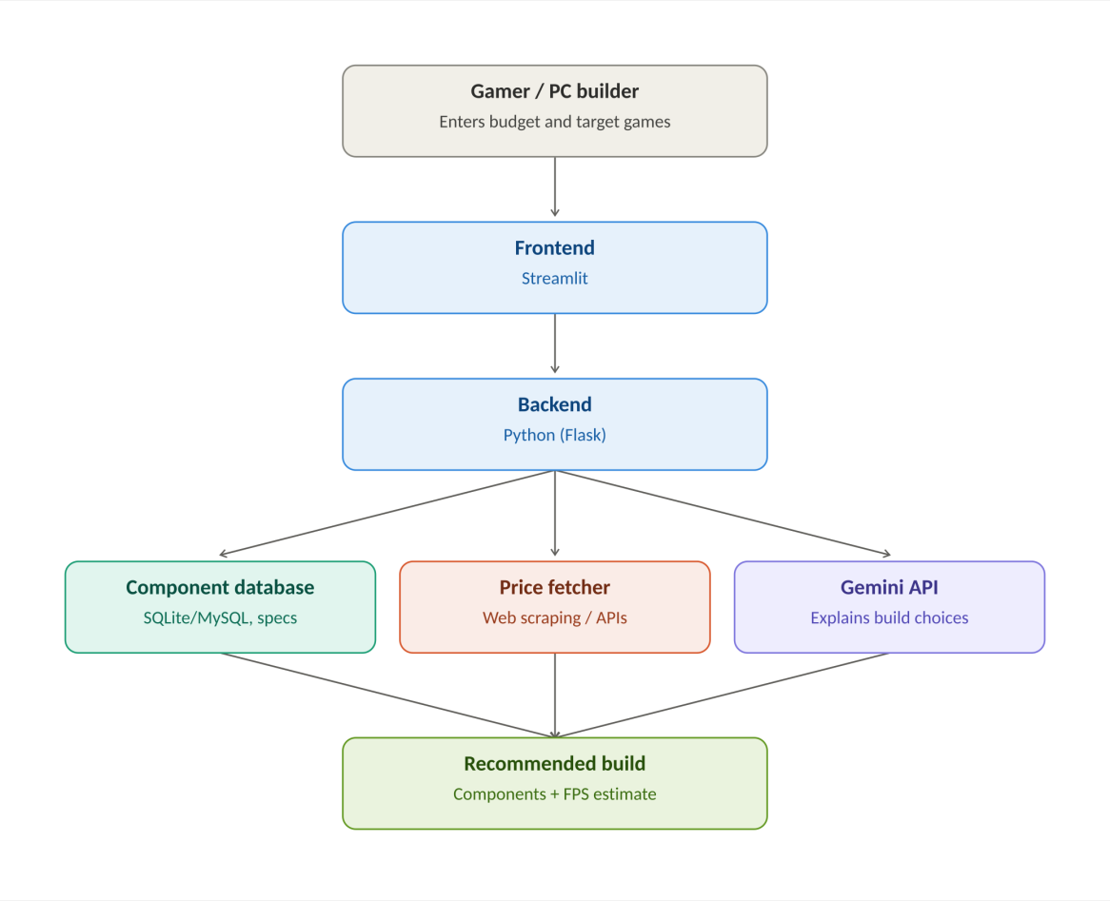
Figure 7.1: System Architecture
Description: The Streamlit frontend sends requests to the Flask backend, which reads the SQLite component database, obtains prices from the pricing module and requests an explanation from the Gemini API. The results are combined into the recommended build with an FPS estimate.

7.2 Frontend
Built with Streamlit (app.py) and a helper module ui.py for gradient headers, status chips, metric cards and bordered cards. The frontend is a thin client that calls the backend through api.py.

7.3 Backend
Built with Flask (backend.py). It validates requests, calls logic.py for build generation, compatibility, FPS, pricing, upgrade advice and explanations, and returns JSON. Admin routes are protected by a token check.

7.4 Database
SQLite (db.py) with foreign keys enabled. Tables are created empty on first run; there is no seed data. Component specifications are stored as JSON in Component.specs, which keeps the schema portable to MySQL.

7.5 Configuration
config.py reads BUILDADVISOR_MIN_BUDGET, BUILDADVISOR_TIERS, BUILDADVISOR_RESOLUTIONS and BUILDADVISOR_RETAILERS from the environment. If any are missing, the sidebar lists them and build generation explains what must be configured.

7.6 External APIs
ai.py calls the Gemini generateContent endpoint (default model gemini-2.5-flash, set by GEMINI_MODEL). pricing.py scrapes retailer search pages when ENABLE_SCRAPING=1. Both are optional and fall back gracefully.

8. Database Design

8.1 ER Diagram
The ER diagram shows the entities, keys and relationships implemented in db.py, including the associative entities BuildComponent and Benchmark that resolve the many-to-many relationships Build–Component and Build–Game.
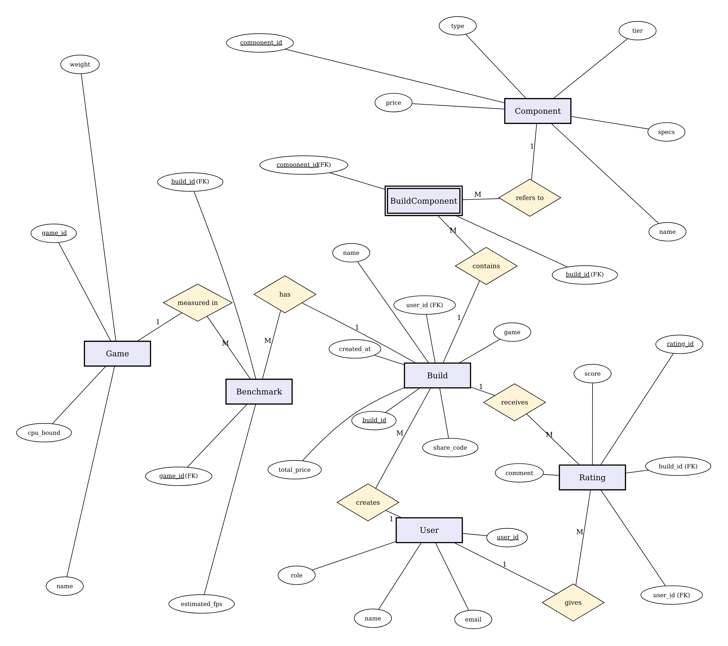
Figure 8.1: E-R Diagram
Description: Entities are shown as rectangles, relationships as diamonds and attributes as ellipses, with primary keys underlined. A User creates many Builds and writes many Ratings; a Build receives many Ratings; BuildComponent links Builds to Components and Benchmark stores the estimated FPS of a Build for a Game.

8.2 Data Dictionary
Entity | Attribute | Type | Description
User | user_id | INTEGER (PK, auto) | Unique user identifier
User | name | TEXT, not null | Display name
User | email | TEXT | Contact email
User | role | TEXT, default Gamer | Gamer, PC owner or Admin
Component | component_id | TEXT (PK) | Unique component code
Component | type | TEXT, not null, indexed | CPU, GPU, Motherboard, RAM, Storage, PSU or Case
Component | name | TEXT, not null | Product name
Component | price | INTEGER, not null | List price in ₹
Component | tier | TEXT | entry, mid or high
Component | specs | TEXT (JSON) | socket, tdp, ram_type, form_factor, wattage, supports, score
Game | game_id | TEXT (PK) | Unique game code
Game | name | TEXT, not null | Game title
Game | weight | REAL, not null | Relative difficulty used in FPS estimate
Game | cpu_bound | INTEGER (0/1) | Whether the game depends more on the CPU
Build | build_id | INTEGER (PK, auto) | Unique build identifier
Build | share_code | TEXT, unique | Ten-character share code
Build | user_id | INTEGER (FK → User) | Owner of the build (optional)
Build | name | TEXT | Build name given by the user
Build | game | TEXT | Target game name
Build | total_price | INTEGER, not null | Total price in ₹
Build | created_at | TEXT | Save timestamp
BuildComponent | build_id | INTEGER (PK, FK → Build) | Build reference
BuildComponent | component_id | TEXT (PK, FK → Component) | Component reference
Benchmark | build_id | INTEGER (PK, FK → Build) | Build reference
Benchmark | game_id | TEXT (PK) | Game reference
Benchmark | estimated_fps | INTEGER, not null | Estimated FPS for the build and game
Rating | rating_id | INTEGER (PK, auto) | Unique rating identifier
Rating | build_id | INTEGER (FK → Build) | Rated build
Rating | user_id | INTEGER | Rating author (optional)
Rating | score | INTEGER, not null | Rating value 1–5
Rating | comment | TEXT | Optional sanitised comment

8.3 Database Tables
Table | Purpose
User | Stores gamer, PC owner and Admin accounts
Component | Stores hardware parts available for recommendation
Game | Stores supported games with weight and CPU-bound flag
Build | Stores saved builds with share code and total price
BuildComponent | Associative table linking builds to components (cascade delete)
Benchmark | Associative table storing estimated FPS per build and game
Rating | Stores community ratings and comments (cascade delete)

8.4 Relationships
• One User creates many Builds (1:M)
• One User writes many Ratings (1:M)
• One Build receives many Ratings (1:M)
• Build and Component are M:N, resolved by BuildComponent
• Build and Game are M:N, resolved by Benchmark

9. Business Rules

9.1 Budget Rules
• The total list price of a recommended build must not exceed the budget.
• Budgets below BUILDADVISOR_MIN_BUDGET are rejected with the minimum shown to the user.
• Tiers are defined in BUILDADVISOR_TIERS (for example entry:0-55000, mid:55000-110000, high:110000-10000000); budgets above every range use the highest tier.

9.2 Compatibility Rules
• CPU socket must match the motherboard socket.
• RAM type must match the motherboard RAM type.
• PSU wattage must be at least 1.4 × (CPU TDP + GPU TDP).
• The motherboard form factor must be listed in the case "supports" field.

9.3 FPS Rules
• For CPU-bound games: base = 0.55 × GPU score + 0.45 × CPU score; otherwise base = 0.8 × GPU score + 0.2 × CPU score.
• FPS = (base × 3.2) ÷ (game weight × resolution multiplier), with a minimum of 15.
• Every estimate is marked approximate.

9.4 Pricing Rules
• The lowest quote across configured retailers is shown for each part.
• Scraped prices are cached for PRICE_CACHE_TTL seconds.
• If live pricing is unavailable, the last-known price is shown with the date it was recorded.

10. Error Handling
Scenario | System Response | User Impact
Invalid or non-numeric budget | HTTP 400 with "Please enter a valid budget." | User corrects the input
Budget below minimum | Message showing the minimum budget | User increases the budget
Business rules not configured | Sidebar lists missing BUILDADVISOR_* variables | Admin configures .env
Empty catalogue or missing part type | Message naming the missing part types | Admin adds components
Pricing unavailable | Last-known prices with a date and a notice | Build still shown
Gemini failure, timeout or no key | Local explanation, or a notice if AI is marked unavailable | Build still shown
Backend offline | Red "Backend offline" chip and a message to run backend.py | App does not crash
Wrong admin password or token | "Incorrect password." / HTTP 401 | Admin tabs stay hidden
Invalid JSON in bulk import | Error message; nothing imported | Admin fixes the file

11. Testing Requirements

11.1 Test Strategy
Testing combined unit testing of logic functions (tier selection, compatibility, FPS, upgrade advice), integration testing of the REST endpoints with SQLite and the Gemini API (test_gemini.py), system testing of the full Streamlit–Flask–SQLite flow including simulated outages, and informal user acceptance testing.

11.2 Test Cases
ID | Description | Input | Expected Output | Status
TC01 | Generate mid-range build | ₹80,000, Starfield, 1080p | Compatible 7-part build within budget with prices, FPS and explanation | Pass
TC02 | 4K resolution target | ₹90,000, Elden Ring, 4K | Stronger GPU and lower FPS due to 2.6 multiplier | Pass
TC03 | Invalid budget | Budget 0 or negative | Validation error, no build | Planned
TC04 | Budget below minimum | Budget below MIN_BUDGET | Minimum budget message | Planned
TC05 | Compatibility repair | Catalogue with mismatched sockets | Incompatible part substituted | Planned
TC06 | Rules not configured | Empty BUILDADVISOR_* variables | Missing variables listed | Planned
TC07 | Gemini unavailable | AI switch off, ₹90,000, Valorant | Build shown with AI-unavailable notice | Pass
TC08 | Pricing unavailable | Pricing switch off, ₹90,000, GTA V, 1440p | Last-known prices with note | Pass
TC09 | Upgrade Advisor | i3-12100F, GTX 1650, 16 GB, ₹30,000 | Bottleneck GPU, RTX 4060 suggested | Pass
TC10 | Save and share | Name "GTA V", save | Share link shown, build on Community page | Pass
TC11 | Rate a build | Score 4 on a saved build | Average rating updated | Planned
TC12 | Admin wrong password | Incorrect password | "Incorrect password.", tabs hidden | Pass
TC13 | Admin bulk import | Valid catalogue JSON | Components and games added | Planned
TC14 | Backend offline | Flask server stopped | Red status chip and clear message | Pass

Status Pass means the test was executed on the running application (screenshots are in the project report); Planned means the case is specified but has not yet been executed and recorded.

11.3 Acceptance Criteria
• A generated build never exceeds the budget.
• Every displayed build passes the rules in Section 9.2.
• A build is always shown even if Gemini or pricing fails.
• The Admin can add, import and moderate data without developer help.
• Admin features cannot be used without the correct password.

12. Security and Privacy
• Admin features require a password and a session token sent in the X-Admin-Token header.
• Build names (60 characters) and comments (200 characters) are sanitised to safe characters; all SQL uses parameters.
• Only minimal personal data (name, email, role) is stored; no payment data is collected.
• The Gemini API key is stored in .env, which is git-ignored, and must never be shown in screenshots or committed.
• The demo admin password (admin123) and fixed token must be replaced with a hashed password and random tokens before public deployment.
• HTTPS should be used for all traffic when deployed.

13. Limitations
• The demonstration catalogue has 35 components and 13 games, so choices are limited.
• FPS values come from a weighted score model, not measured benchmarks.
• Live scraping is off by default and retailer page changes can break it; otherwise prices are estimated or last-known.
• There is no user registration; only the Admin signs in.
• SQLite suits a single server, not heavy concurrent use.
• Peripherals such as monitors and CPU coolers are not recommended.
• The system recommends builds only; it does not process purchases.

14. Future Enhancements
• User registration with persistent build history
• Real benchmark data for more accurate FPS
• Reliable live pricing with price-drop alerts and affiliate links
• More components (coolers, monitors) and more games
• Hashed admin passwords and role-based access
• PostgreSQL and cloud deployment
• A Gemini-powered chat assistant for follow-up questions
• A mobile app version

15. Requirements Traceability Matrix
Req. ID | Description | Section | Module | Test Case
FR-1 | Budget-based build generation | 4.1 | logic.generate_build | TC01, TC03, TC04, TC06
FR-2 | Game and resolution FPS estimate | 4.2 | logic.estimate_fps | TC01, TC02
FR-3 | Compatibility checking and repair | 4.3 | logic.check_compatibility, _repair | TC05
FR-4 | Price comparison and fallback | 4.4 | logic.fetch_prices, pricing.py | TC08
FR-5 | Upgrade advice | 4.5 | logic.upgrade_advice | TC09
FR-6 | AI explanation with fallback | 4.6 | ai.py, logic.explain_build | TC07
FR-7 | Save, share and rate builds | 4.7 | db.save_build, /builds | TC10, TC11
FR-8 | Admin management | 4.8 | backend admin routes, bootstrap.py | TC12, TC13
NFR | Reliability (backend offline) | 5.2 | app.py, api.py | TC14

16. Appendix

16.1 Glossary
Term | Description
Bottleneck | The component limiting overall performance
Tier | Budget category: entry, mid or high
Game weight | Relative graphical demand of a game used in the FPS model
Resolution multiplier | Factor by which a higher resolution reduces FPS
Share code | Short identifier used to share a saved build
Associative entity | Entity that resolves a many-to-many relationship

16.2 Configuration Variables
Variable | Purpose
BUILDADVISOR_MIN_BUDGET | Minimum budget for a working build
BUILDADVISOR_TIERS | Budget tier ranges
BUILDADVISOR_RESOLUTIONS | Resolution multipliers, e.g. 1080p:1.0,1440p:1.5,4K:2.6
BUILDADVISOR_RETAILERS | Retailer names for price quotes
GEMINI_API_KEY / GEMINI_MODEL | Gemini key and model (optional)
ENABLE_SCRAPING / PRICE_CACHE_TTL | Live price scraping switch and cache time (optional)
BUILDADVISOR_DB | Path of the SQLite database file (optional)

16.3 References
• Google AI for Developers – Gemini API documentation (ai.google.dev)
• Flask documentation (flask.palletsprojects.com)
• Streamlit documentation (docs.streamlit.io)
• SQLite documentation (sqlite.org/docs.html)
• Beautiful Soup and Requests documentation
• Manufacturer specification sheets for CPU, GPU and motherboard compatibility data

