FestivalGen AI: Your Personal AI Festival Planner
Project Description:
FestivalGen AI harnesses Generative AI to turn festival preparation into a calm, guided experience. The platform's Plan Generator collects a festival, city, family size, budget, preferred language, and a short set of preferences, then produces one complete, structured festival plan covering a shopping list, a category-wise budget breakdown, festival-appropriate recipes, a step-by-step ritual and puja guide, invitation content, and a day-by-day preparation timeline.
Utilizing Groq's API with the LLaMA 3.3-70B Versatile model and a strict JSON Schema response format, FestivalGen AI guarantees a consistently structured plan on every generation. Built with a React 18 + TypeScript client (Vite), an Express + tRPC backend, and Drizzle ORM over MySQL for persistence, the platform pairs reliable AI output with a fast, type-safe full-stack architecture. A dashboard, shopping list, budget planner, recipe library, ritual guide, invitations, calendar, nearby-store finder, reports, and settings panel round out a complete personal festival-planning experience for Indian families.
Scenarios
Scenario 1: A user selects Krishna Janmashtami, sets their city to Hyderabad, Telangana, a family size of 4, and a budget of ₹15,000. The Plan Generator wizard walks them through Festival Details, Preferences, and Review, then calls the AI to produce 18 shopping items, 5 recipes, 5 ritual steps and a complete day-by-day plan in seconds.
Scenario 2: A family reviews their Budget Planner and sees a donut chart breaking their ₹16,000 plan into Food, Shopping, Decorations, Puja, and Other categories, with an AI Tip suggesting a way to trim the decorations budget by shopping locally.
Scenario 3: A user sets their Preferred Language to Hindi or Telugu while generating a plan. FestivalGen AI instructs the Groq model to return every user-facing text field — recipes, ritual descriptions, invitation copy — in the selected language, while the underlying JSON structure and field names stay identical.
Scenario 4: A returning user opens the Dashboard and immediately sees their upcoming festival countdown ("12 Days to go!"), a Festival Plan Overview with recipe, ritual, shopping, invitation, timeline and budget metrics, and one-click links into every planning page.
Technical Architecture:
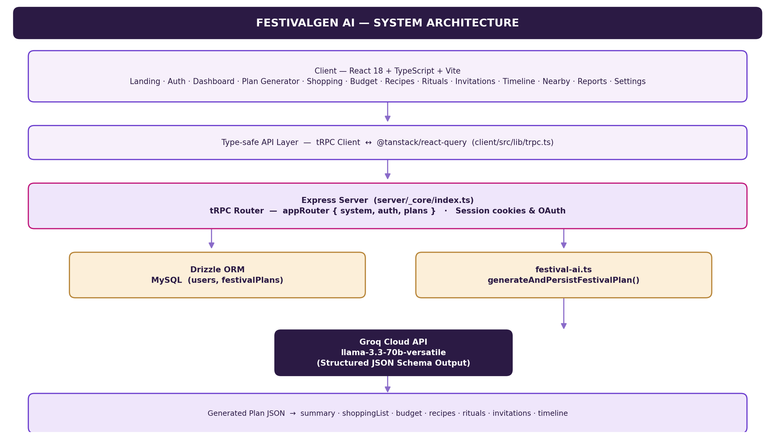
Pre-requisites:
React & TypeScript Knowledge: React Documentation
Node.js & Express Familiarity: Express Documentation
tRPC Familiarity: tRPC Documentation
Groq API Familiarity: Groq API Documentation
Drizzle ORM & MySQL: Drizzle ORM Documentation
Vite Build Tool: Vite Documentation
Version Control with Git: Git Documentation
Project Workflow:
Activity 1: Model Selection and Architecture
- Activity 1.1: Generate a Groq API key and configure it securely in the project environment.
- Activity 1.2: Research and select the appropriate generative AI model from Groq for structured festival-plan generation.
- Activity 1.3: Define the full-stack architecture, detailing interactions between the React client, the tRPC API layer, the Express server, and the Drizzle/MySQL data layer.
- Activity 1.4: Set up the development environment, installing Node.js, pnpm, and configuring environment variables.
Activity 2: Database & Schema Development
- Activity 2.1: Design the MySQL schema with Drizzle ORM covering users and festivalPlans.
- Activity 2.2: Implement the data-access layer (db.ts) for upserting users and creating/reading festival plans.
Activity 3: AI Plan Generation Engine
- Activity 3.1: Define a strict JSON Schema describing the shape of a complete festival plan.
- Activity 3.2: Implement generateAndPersistFestivalPlan() to call the Groq chat completions endpoint and persist the result.
- Activity 3.3: Expose plans.generate and plans.latest as type-safe tRPC procedures.
Activity 4: Frontend Development
- Activity 4.1: Build the landing page, navigation, and authentication (Sign In / Sign Up) screens.
- Activity 4.2: Build the four-step Plan Generator wizard: Festival Details, Preferences, Review, and Complete.
- Activity 4.3: Build the Dashboard, Shopping List, Budget Planner, Recipes, Rituals & Puja, Invitations, Festival Calendar, Nearby Stores, Reports, and Settings pages.
- Activity 4.4: Wire every page to the backend using tRPC client hooks and @tanstack/react-query.
Activity 5: Deployment
- Activity 5.1: Prepare the application for local development by installing dependencies and configuring the server environment.
- Activity 5.2: Run a type-check, build the production bundle, and start the compiled server.
- Activity 5.3: Conclusion
Milestone 1: Model Selection and Architecture
In this milestone, we focus on selecting the appropriate generative AI model from Groq for structured festival-plan generation, and on defining the full-stack architecture that connects the React client, the tRPC API layer, the Express server, and the Drizzle/MySQL data layer.
Activity 1.1: Generate a Groq API Key
Before the application can request completions from the Groq-hosted LLaMA model, you need a valid Groq API key. Follow the steps below to create one and connect it securely to the project.
- Step 1 — Create a Groq Account: Visit console.groq.com and sign up for a free account using your Google account or email address.
📷 Screenshot placeholder
Groq Console — Sign up / account creation screen
- Step 2 — Navigate to API Keys: After logging in, open the API Keys page from the console sidebar.
📷 Screenshot placeholder
Groq Console — API Keys page (list of existing keys)
- Step 3 — Create a New API Key: Click "Create API Key", give it a descriptive name (e.g., festivalgen-key), and submit.
📷 Screenshot placeholder
Groq Console — Create API Key dialog
- Step 4 — Copy and store the key: The key is only shown once — copy it immediately into a password manager or secrets vault.
- Step 5 — Add the key to your project: Create a .env file in the project root (never commit it) and add the key alongside the rest of the environment configuration:
GROQ_API_KEY=
DATABASE_URL=
JWT_SECRET=
VITE_APP_ID=
OAUTH_SERVER_URL=
VITE_OAUTH_PORTAL_URL=
VITE_ANALYTICS_ENDPOINT=
VITE_ANALYTICS_WEBSITE_ID=
VITE_APP_TITLE=FestivalGen AI
VITE_APP_LOGO=
- Step 6 — Verify the key is loaded: festival-ai.ts reads the key from process.env at request time and fails fast with a clear error if it is missing:
const apiKey = process.env.GROQ_API_KEY;
if (!apiKey) throw new Error("GROQ_API_KEY is not configured");
- Important — Never Commit Your API Key: keep real secrets out of .env.example, and add .env to .gitignore.
Activity 1.2: Research and Select the Appropriate Generative AI Model
- Understand the Project Requirements: Review what the plan generator must return — a shopping list, a budget breakdown, recipes, rituals, invitation copy, and a preparation timeline — in one consistent response.
- Explore Groq's Model Documentation: Review the available LLaMA models on Groq, including context window, throughput, and structured-output support.
- Evaluate Model Performance: Compare models on response quality, generation speed, and reliability when producing large nested JSON objects.
- Select the Optimal Model: Choose llama-3.3-70b-versatile with a temperature of 0.35 (favoring consistency over creativity) and max_tokens of 7000, combined with a strict json_schema response_format so every generation matches the same shape.
Activity 1.3: Define the Full-Stack Architecture
- Draft an Architectural Diagram: Map the layers — React client, tRPC API layer, Express server, Drizzle/MySQL, and the external Groq Cloud API (see the Technical Architecture diagram above).
- Detail Frontend Functionality: Outline how users interact with the application — browsing the landing page, signing in, stepping through the Plan Generator wizard, and navigating the dashboard pages.
- Outline Backend Responsibilities: Specify how the Express server mounts the tRPC router at /api/trpc, validates input with Zod, calls the Groq API, and persists the generated plan.
- Describe AI Integration Points: Define how festival-ai.ts constructs the request body, enforces the JSON schema, parses the model's response, and stores it via createFestivalPlan().
Activity 1.4: Set Up the Development Environment
- Install Node.js: Ensure Node.js 22 (or a compatible current release) is installed.
- Install Dependencies with pnpm:
pnpm install
- Configure the API Key and Secrets: Create a .env file in the project root using .env.example as a template, and add your Groq API key and database URL.
- Review the Project Structure: client/ (React + Vite UI), server/ (Express + tRPC + AI engine), drizzle/ (schema & migrations), and shared/ (types shared between client and server).
Milestone 2: Database & Schema Development
Milestone 2 covers the persistence layer: a MySQL schema defined with Drizzle ORM, and a small data-access module that upserts users and creates/reads festival plans.
Activity 2.1: Design the MySQL Schema with Drizzle ORM
The schema (drizzle/schema.ts) defines two tables: users, which backs the authentication flow, and festivalPlans, which stores every generated plan's inputs alongside the AI's structured JSON output.
import { int, mysqlEnum, mysqlTable, text, timestamp, varchar } from "drizzle-orm/mysql-core";

/**
* Core user table backing auth flow.
* Columns use camelCase to match both database fields and generated types.
*/
export const users = mysqlTable("users", {
id: int("id").autoincrement().primaryKey(),
openId: varchar("openId", { length: 64 }).notNull().unique(),
name: text("name"),
email: varchar("email", { length: 320 }),
loginMethod: varchar("loginMethod", { length: 64 }),
role: mysqlEnum("role", ["user", "admin"]).default("user").notNull(),
createdAt: timestamp("createdAt").defaultNow().notNull(),
updatedAt: timestamp("updatedAt").defaultNow().onUpdateNow().notNull(),
lastSignedIn: timestamp("lastSignedIn").defaultNow().notNull(),
});

export type User = typeof users.$inferSelect;
export type InsertUser = typeof users.$inferInsert;

/** Persisted inputs and the structured plan generated by Groq. */
export const festivalPlans = mysqlTable("festivalPlans", {
id: int("id").autoincrement().primaryKey(),
userId: int("userId"),
festival: varchar("festival", { length: 120 }).notNull(),
city: varchar("city", { length: 160 }).notNull(),
familySize: int("familySize").notNull(),
budget: int("budget").notNull(),
language: varchar("language", { length: 64 }).notNull(),
preferences: text("preferences"),
planJson: text("planJson").notNull(),
createdAt: timestamp("createdAt").defaultNow().notNull(),
});

export type FestivalPlan = typeof festivalPlans.$inferSelect;
export type InsertFestivalPlan = typeof festivalPlans.$inferInsert;

Activity 2.2: Implement the Data-Access Layer
db.ts lazily creates a single Drizzle connection, then exposes small, purpose-built functions for the rest of the app to call — upsertUser(), getUserByOpenId(), createFestivalPlan(), and getLatestFestivalPlan().
import { desc, eq } from "drizzle-orm";
import { drizzle } from "drizzle-orm/mysql2";
import { festivalPlans, InsertFestivalPlan, InsertUser, users } from "../drizzle/schema";
import { ENV } from "./_core/env";

let _db: ReturnType<typeof drizzle> | null = null;

// Lazily create the drizzle instance so local tooling can run without a DB.
export async function getDb() {
if (!_db && process.env.DATABASE_URL) {
try {
_db = drizzle(process.env.DATABASE_URL);
} catch (error) {
console.warn("[Database] Failed to connect:", error);
_db = null;
}
}
return _db;
}

export async function upsertUser(user: InsertUser): Promise<void> {
if (!user.openId) {
throw new Error("User openId is required for upsert");
}
// ... upsertUser continues, handling nullable fields and admin role assignment
console.warn("[Database] Cannot get user: database not available");
return undefined;
}

const result = await db.select().from(users).where(eq(users.openId, openId)).limit(1);
return result.length > 0 ? result[0] : undefined;
}

export async function createFestivalPlan(plan: InsertFestivalPlan) {
const db = await getDb();
if (!db) throw new Error("Database is not available");

const result = await db.insert(festivalPlans).values(plan);
const id = Number(result[0].insertId);
const created = await db.select().from(festivalPlans).where(eq(festivalPlans.id, id)).limit(1);
return created[0];
}

export async function getLatestFestivalPlan(userId: number) {
const db = await getDb();
if (!db) return undefined;

const result = await db
.select()
.from(festivalPlans)
.where(eq(festivalPlans.userId, userId))
.orderBy(desc(festivalPlans.createdAt))
.limit(1);
return result[0];
}
Milestone 3: AI Plan Generation Engine
Milestone 3 is the heart of FestivalGen AI: festival-ai.ts defines the JSON Schema that constrains the model's output, calls the Groq chat completions endpoint, and persists the resulting plan through the data-access layer.
Activity 3.1: Define the Structured JSON Schema
Every field the frontend expects — summary, shoppingList, budget, recipes, rituals, invitations, and timeline — is declared up front as a strict JSON Schema, so the model cannot return a differently-shaped object:
export type FestivalPlanInput = {
festival: string;
city: string;
familySize: number;
budget: number;
language: string;
preferences: string[];
};

export type GeneratedFestivalPlan = {
summary: string;
shoppingList: Array<{ item: string; category: string; quantity: string; estimatedPrice: number }>;
budget: Array<{ category: string; amount: number; percentage: number }>;
recipes: Array<{ name: string; category: string; cookTime: string; ingredients: string[]; steps: string[]; rating: number }>;
rituals: Array<{ stepNumber: number; title: string; description: string; duration: string }>;
invitations: Array<{ type: string; title: string; content: string }>;
timeline: Array<{ dayDate: string; title: string; description: string; status: "Completed" | "In Progress" | "Upcoming" }>;
};

const planSchema = {
name: "festival_plan",
strict: true,
schema: {
type: "object",
additionalProperties: false,
required: ["summary", "shoppingList", "budget", "recipes", "rituals", "invitations", "timeline"],
properties: {
summary: { type: "string" },
shoppingList: { type: "array", items: { type: "object", additionalProperties: false, required: ["item", "category", "quantity", "estimatedPrice"], properties: { item: { type: "string" }, category: { type: "string" }, quantity: { type: "string" }, estimatedPrice: { type: "number" } } } },
budget: { type: "array", items: { type: "object", additionalProperties: false, required: ["category", "amount", "percentage"], properties: { category: { type: "string" }, amount: { type: "number" }, percentage: { type: "number" } } } },
recipes: { type: "array", items: { type: "object", additionalProperties: false, required: ["name", "category", "cookTime", "ingredients", "steps", "rating"], properties: { name: { type: "string" }, category: { type: "string" }, cookTime: { type: "string" }, ingredients: { type: "array", items: { type: "string" } }, steps: { type: "array", items: { type: "string" } }, rating: { type: "number" } } } },
rituals: { type: "array", items: { type: "object", additionalProperties: false, required: ["stepNumber", "title", "description", "duration"], properties: { stepNumber: { type: "number" }, title: { type: "string" }, description: { type: "string" }, duration: { type: "string" } } } },
Activity 3.2: Implement generateAndPersistFestivalPlan()
The core function builds the Groq request — model, temperature, max_tokens, the JSON schema as response_format, a system instruction describing FestivalGen AI's persona, and the user's inputs as the user message — then parses and saves the response:
type GroqResponse = {
choices?: Array<{ message?: { content?: string | null } }>;
};

export async function generateAndPersistFestivalPlan(input: FestivalPlanInput, userId?: number) {
const apiKey = process.env.GROQ_API_KEY;
if (!apiKey) throw new Error("GROQ_API_KEY is not configured");

const response = await fetch("https://api.groq.com/openai/v1/chat/completions", {
method: "POST",
headers: {
Authorization: `Bearer ${apiKey}`,
"Content-Type": "application/json",
},
body: JSON.stringify({
model: "llama-3.3-70b-versatile",
temperature: 0.35,
max_tokens: 7000,
response_format: { type: "json_schema", json_schema: planSchema },
messages: [
{
role: "system",
content: "You are FestivalGen AI, an expert Indian festival planner. Return only valid JSON matching the provided schema. Make every recommendation practical, culturally respectful, family-friendly, and specific to the requested city, budget, family size, language, and festival. Use INR amounts and provide enough detail to be useful, but keep the plan concise.",
},
{
role: "user",
content: JSON.stringify({
task: "Create a complete festival plan",
...input,
preferences: input.preferences.join(", "),
}),
},
],
}),
signal: AbortSignal.timeout(30_000),
});

if (!response.ok) {
const errorText = await response.text();
throw new Error(`Groq request failed (${response.status}): ${errorText.slice(0, 240)}`);
}
Activity 3.3: Expose the tRPC Procedures
routers.ts validates the wizard's input with Zod and exposes two procedures: plans.generate (public, so a visitor can try the generator) and plans.latest (protected, returning the signed-in user's most recent plan):
import { COOKIE_NAME } from "@shared/const";
import { z } from "zod";
import { getSessionCookieOptions } from "./_core/cookies";
import { systemRouter } from "./_core/systemRouter";
import { protectedProcedure, publicProcedure, router } from "./_core/trpc";
import { generateAndPersistFestivalPlan } from "./festival-ai";
import { getLatestFestivalPlan } from "./db";

const generateInput = z.object({
festival: z.string().min(2).max(120),
city: z.string().min(2).max(160),
familySize: z.number().int().min(1).max(50),
budget: z.number().int().min(1).max(10_000_000),
language: z.string().min(2).max(64),
preferences: z.array(z.string().max(120)).max(20),
});

export const appRouter = router({
system: systemRouter,
auth: router({
me: publicProcedure.query(opts => opts.ctx.user),
logout: publicProcedure.mutation(({ ctx }) => {
const cookieOptions = getSessionCookieOptions(ctx.req);
ctx.res.clearCookie(COOKIE_NAME, { ...cookieOptions, maxAge: -1 });
return { success: true } as const;
}),
}),
plans: router({
generate: publicProcedure.input(generateInput).mutation(async ({ input, ctx }) => {
return generateAndPersistFestivalPlan(input, ctx.user?.id);
}),
latest: protectedProcedure.query(({ ctx }) => getLatestFestivalPlan(ctx.user.id)),
}),
});

export type AppRouter = typeof appRouter;

Milestone 4: Frontend Development
Milestone 4 covers the React + TypeScript client: the landing page, authentication screens, the four-step Plan Generator wizard, and the full set of dashboard pages, all built as typed function components and wired to the backend through tRPC.
Activity 4.1: Application Shell, Navigation & Type-Safe API Client
The client talks to the Express/tRPC backend through a single typed client instance, generated directly from the server's AppRouter type so every call is checked at compile time:
import { createTRPCReact } from "@trpc/react-query";
import type { AppRouter } from "../../../server/routers";

export const trpc = createTRPCReact<AppRouter>();

The sidebar navigation used across every authenticated page is declared once as a typed list of routes:
const navItems: { id: PageKey; label: string; icon: typeof HomeIcon }[] = [
{ id: "home", label: "Home", icon: HomeIcon },
{ id: "dashboard", label: "Dashboard", icon: LayoutDashboard },
{ id: "plan", label: "My Plan", icon: CalendarDays },
{ id: "shopping", label: "Shopping List", icon: ShoppingBasket },
{ id: "budget", label: "Budget Planner", icon: WalletCards },
{ id: "recipes", label: "Recipes", icon: Utensils },
{ id: "rituals", label: "Rituals & Puja", icon: Sparkles },
{ id: "invitations", label: "Invitations", icon: Mail },
{ id: "timeline", label: "Timeline", icon: Clock3 },
{ id: "nearby", label: "Nearby Stores", icon: MapPin },
{ id: "reports", label: "Reports", icon: Tags },
{ id: "settings", label: "Settings", icon: Settings },
];
Activity 4.2: Build the Four-Step Plan Generator Wizard
The PlanGenerator component tracks the current step in local state and renders Festival Details, Preferences, Review, and Complete panels from the same piece of state, calling the plans.generate tRPC mutation when the user reaches the final step:
function PlanGenerator({ onNavigate }: { onNavigate: (page: PageKey) => void }) {
const [step, setStep] = useState(1);
const [festival, setFestival] = useState("Diwali");
const [city, setCity] = useState("Hyderabad, Telangana");
const [familySize, setFamilySize] = useState("4");
const [budget, setBudget] = useState("15000");
const [language, setLanguage] = useState("English");
const [preferences, setPreferences] = useState<string[]>(
["Vegetarian", "Family-friendly", "Traditional rituals"]
);
const [generated, setGenerated] = useState<GeneratedPlanPreview | null>(null);
const generatePlan = trpc.plans.generate.useMutation();

const togglePreference = (preference: string) => {
setPreferences(current =>
current.includes(preference)
? current.filter(item => item !== preference)
: [...current, preference]
);
};
// nextStep() advances through Festival Details -> Preferences -> Review,
// then calls generatePlan.mutate({ festival, city, familySize, budget,
// language, preferences }) before showing the Complete step.
}
Activity 4.3: Build the Dashboard & Content Pages
- Dashboard: Welcome banner, upcoming-festival countdown card, and a Plan Overview metric grid (Shopping Items, Budget Planned, Recipes, Rituals, Invitations, Timeline) that deep-links into each page.
- Shopping List: A searchable, checkable list of items grouped by category, each with an estimated price and an inline edit action.
- Budget Planner: A donut chart breaking total budget into Food, Shopping, Decorations, Puja and Other, alongside an AI Tip suggestion card.
- Recipes: Filterable recipe cards (Main Course, Dessert, Sweet, Drink) with prep time, servings, and rating; selecting a card opens ingredient and step detail.
- Rituals & Puja: A numbered, festival-specific ritual guide with per-step duration and a "Personalize Guide" action.
- Invitations, Timeline, Nearby Stores, Reports & Settings: Round out the planning suite with shareable invitation content, a day-by-day preparation timeline, a store locator, a plan-health report, and a profile/preferences panel.
Activity 4.4: Wire Pages to the Backend
Every data-driven page consumes the appRouter through React Query hooks generated by createTRPCReact, giving automatic caching, loading states, and revalidation without any hand-written fetch logic:
// Fetching the signed-in user's most recent plan
const { data: latestPlan, isLoading } = trpc.plans.latest.useQuery();

// Generating a brand-new plan from the wizard
const generatePlan = trpc.plans.generate.useMutation({
onSuccess: (result) => setGenerated(result.plan),
});
Milestone 5: Deployment
In Milestone 5, the focus is on running FestivalGen AI locally for development and verification, and then producing a production build that can be started with a single Node.js process.
Activity 5.1: Local Development Setup
- Install dependencies:
pnpm install
- Configure environment variables:create a .env file from .env.example and add GROQ_API_KEY, DATABASE_URL and JWT_SECRET.
- Start the development server:
pnpm dev
This runs NODE_ENV=development tsx watch server/_core/index.ts, which starts the Express server, mounts the tRPC router at /api/trpc, and serves the Vite dev server for the React client on the same process. The app auto-selects the first free port starting at 3000.
Activity 5.2: Type-Check, Build & Start for Production
- Run a full type-check across client and server:
pnpm check
- Build the production bundle:
pnpm build
This runs vite build for the client bundle, then bundles the Express/tRPC server with esbuild into dist/index.js.
- Start the compiled server:
pnpm start
This runs NODE_ENV=production node dist/index.js, serving the built client as static files and the API from the same Express process.
Activity 5.3: Database Migrations
- Generate and apply Drizzle migrations against the configured MySQL database:
pnpm db:push
Important Notes
- GROQ_API_KEY is required — generateAndPersistFestivalPlan() throws immediately if the key is missing, so the Plan Generator will fail fast rather than silently returning empty data.
- DATABASE_URL is optional for local UI work — db.ts lazily skips connecting when it is unset, so the client can still be explored without a live MySQL instance, though saving and loading plans requires it.
- Never commit real secrets — keep GROQ_API_KEY, DATABASE_URL and JWT_SECRET only in your local .env file.
Exploring the Website's Web Pages:
Home / Landing Page:
The public landing page opens with a full-width hero: the FestivalGen AI wordmark, a top navigation bar (Home, Features, How It Works, About Us, FAQs, Contact), a language selector, and Sign In / Sign Up actions. The hero copy — "Plan Your Festival, The Smart Way with AI" — sits over a festive diya photograph, with three trust badges and a "Get Started Free" call to action.
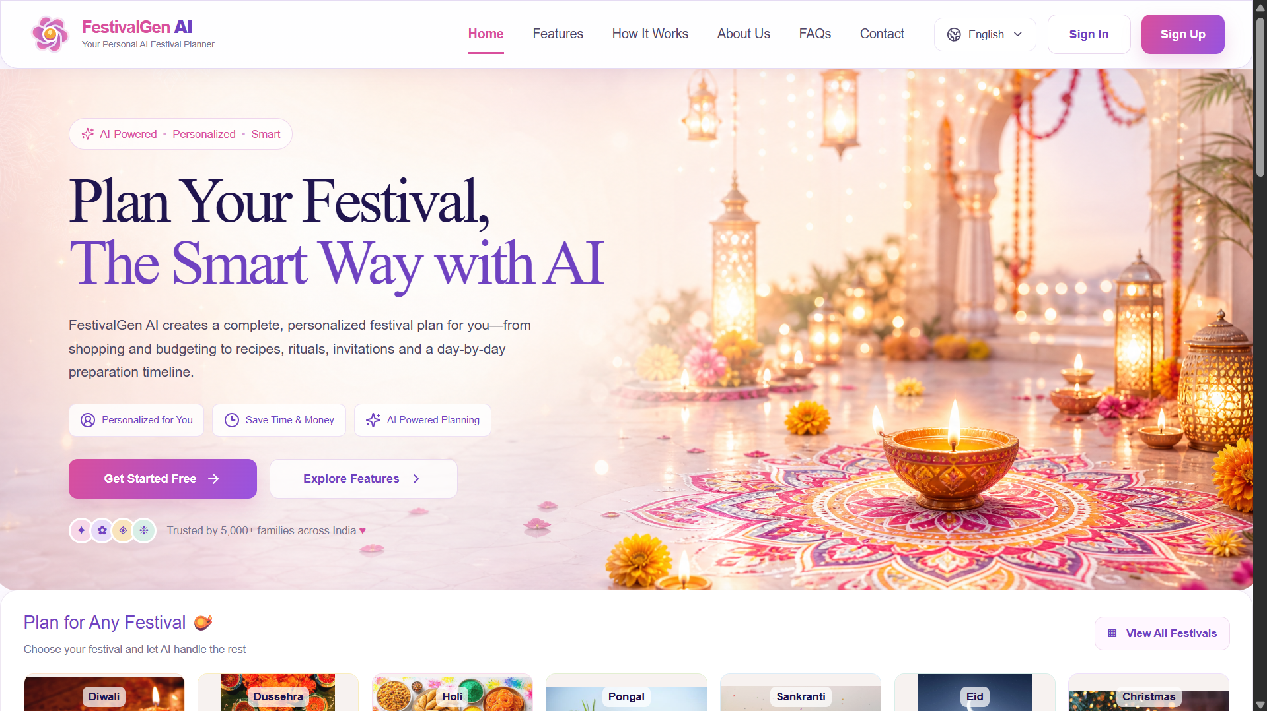
Home page hero section with navigation, headline and primary call-to-action.
Festival Selection & Feature Grid:
Beneath the hero, a horizontally-browsable strip lets visitors jump straight into planning for Diwali, Dussehra, Holi, Pongal, Sankranti, Eid, or Christmas. An eight-card feature grid then summarizes every planning capability — Festival Planning, Smart Shopping, Festival Recipes, Rituals & Puja, Budget Planning, Invitations, Festival Calendar, and Preparation Timeline.
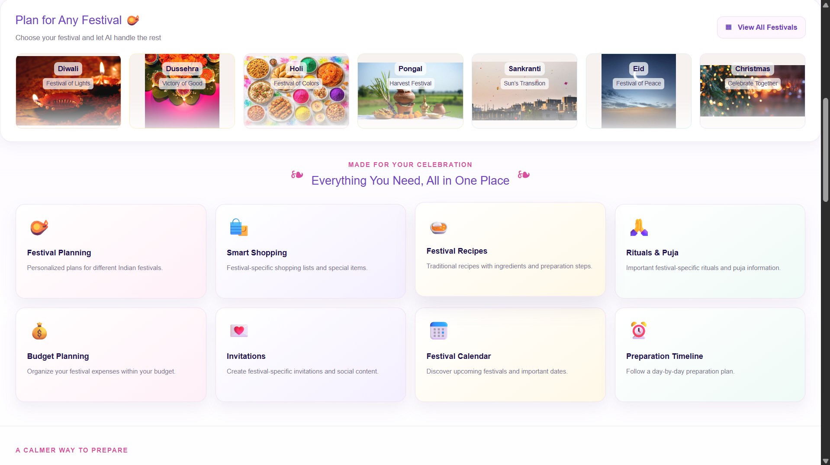
Festival selection strip and the "Everything You Need, All in One Place" feature grid.
How It Works & About:
A four-step explainer (Choose Your Festival, Tell Us Your Preferences, Let AI Plan Everything, Celebrate Stress-Free) walks new visitors through the product flow, followed by an About section reinforcing that FestivalGen AI organizes the practical details so families can spend more time together.
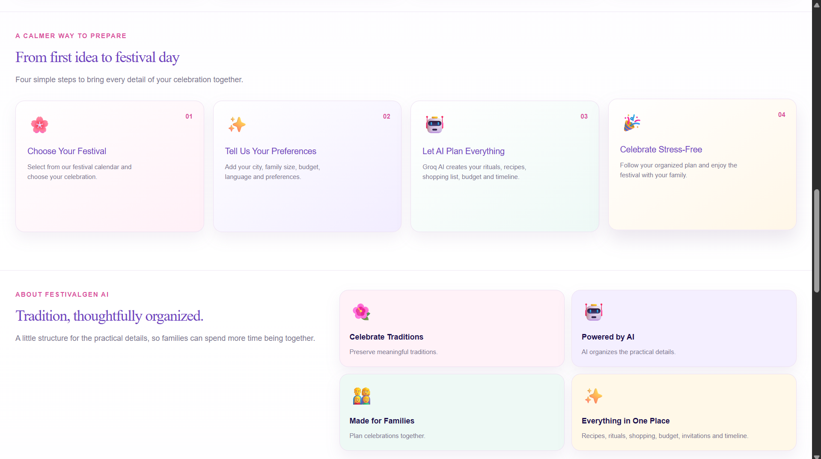
"From first idea to festival day" step explainer and About FestivalGen AI section.
FAQs, Contact & Footer:
An accordion-style FAQ answers common questions (how the AI generates a plan, data privacy), followed by a contact form and a closing statistics strip — 5,000+ happy families, 50+ festivals covered, 100+ cities supported, 10,000+ plans generated, and 100% secure & private.
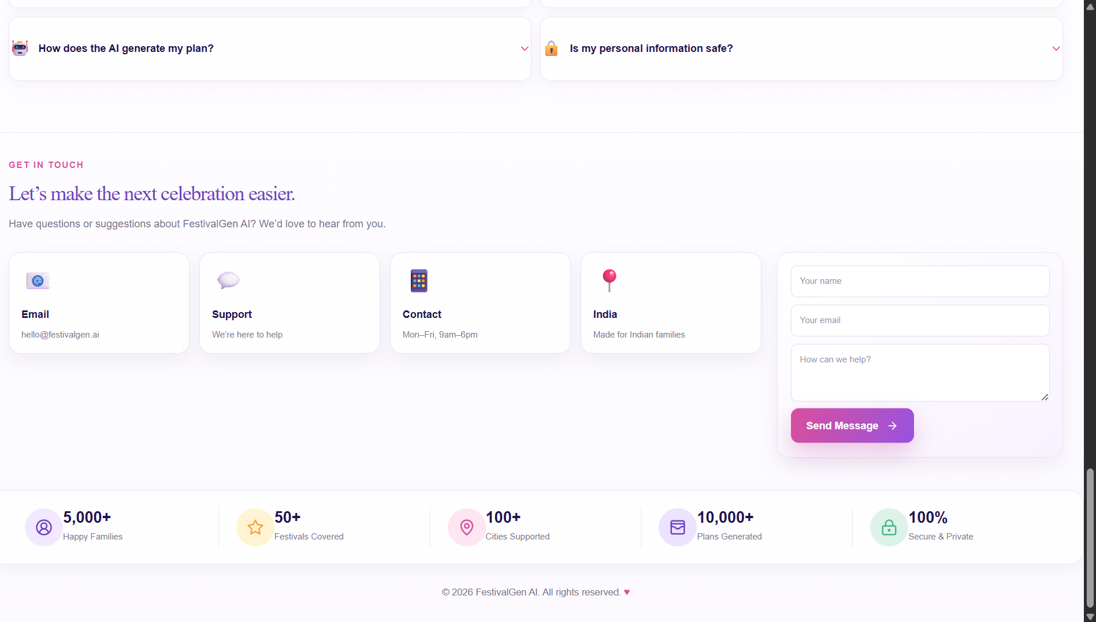
FAQ accordion, contact form and trust-statistics footer.
Sign In Page:
A split-screen layout pairs a festive rangoli photograph with a compact sign-in form (email, password, remember me, forgot password) and Google / Facebook social sign-in options.
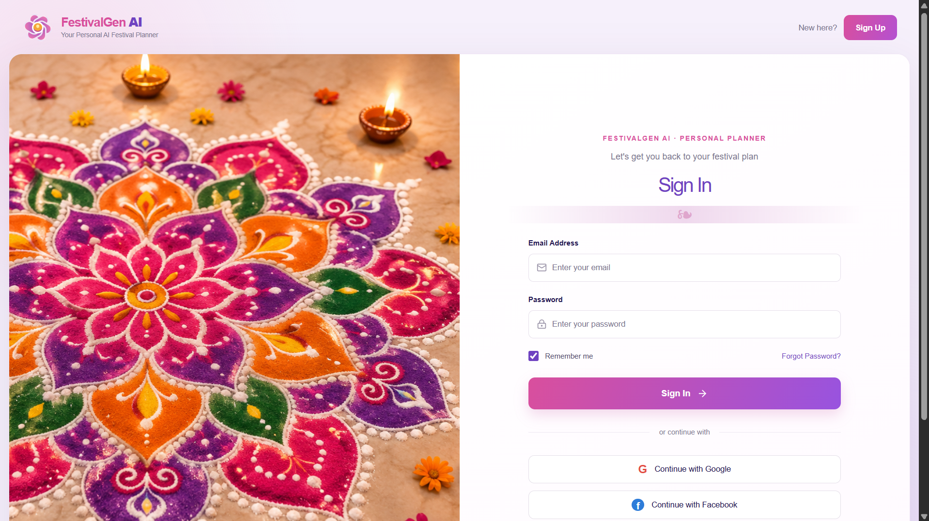
Sign In page with email/password form and social sign-in options.
Sign Up Page:
The registration form mirrors the sign-in layout, collecting full name, phone number, email, and password with confirmation, plus a Terms of Service / Privacy Policy acknowledgement before account creation.
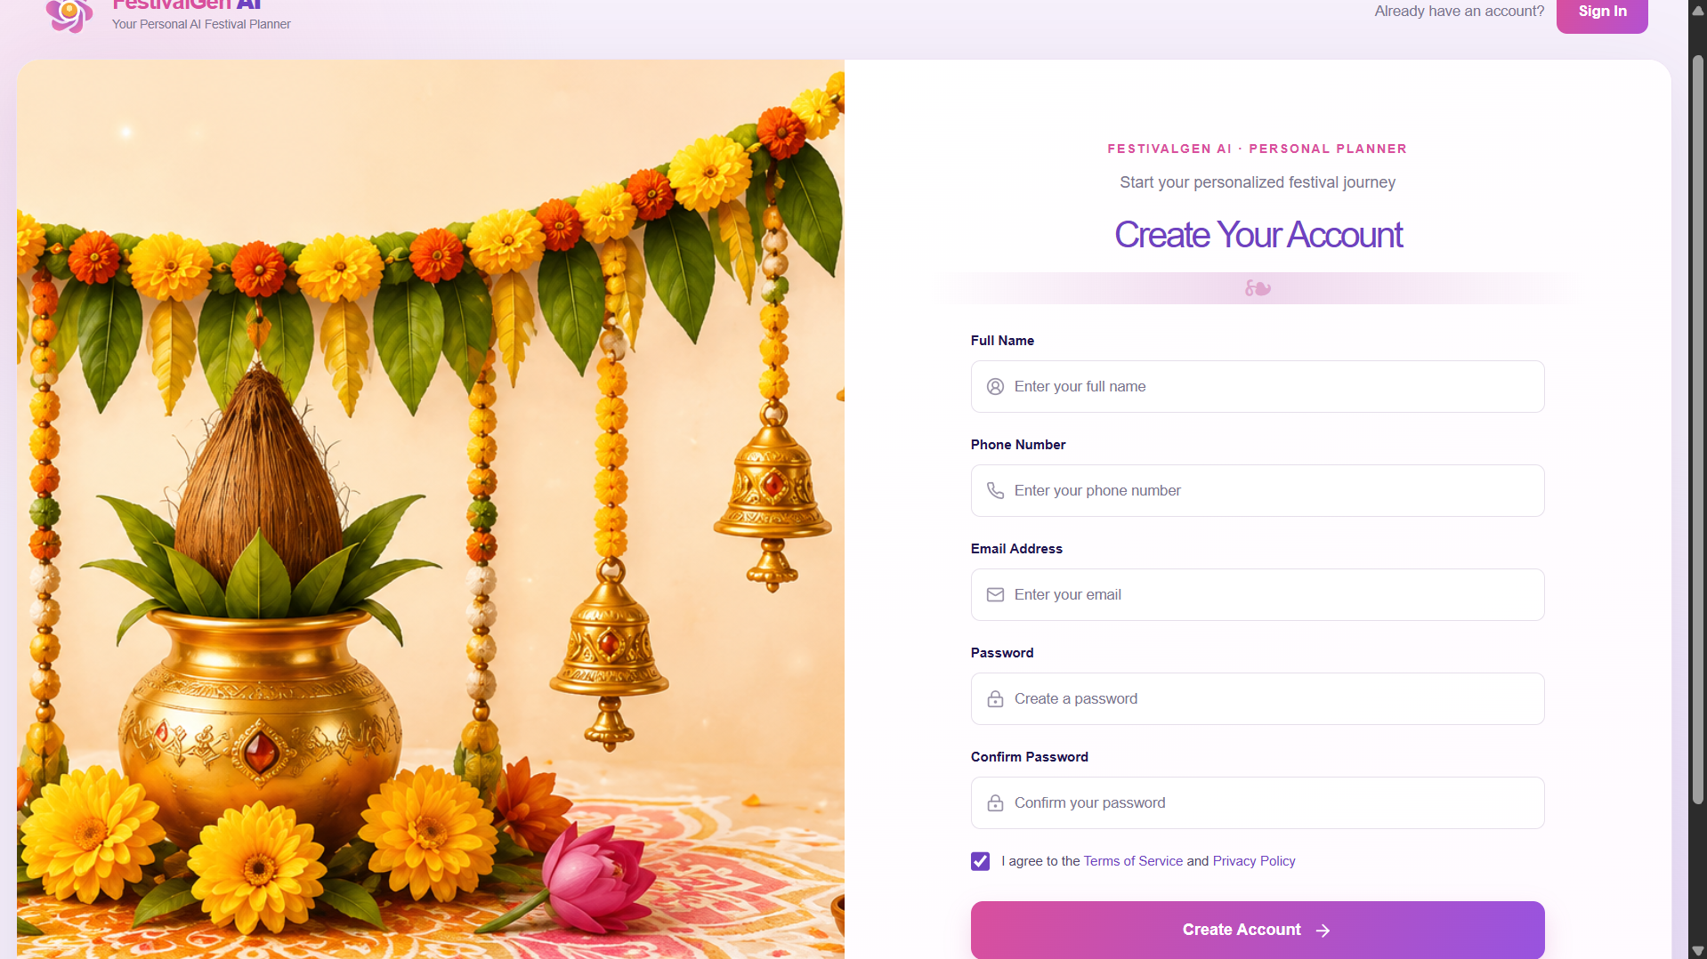
Sign Up page collecting name, phone, email and password.
Plan Generator — Step 1: Festival Details:
The first step of the four-step wizard collects the Festival, City, Family Size, Budget (₹), and Preferred Language, with a live step-progress indicator across the top of the card.
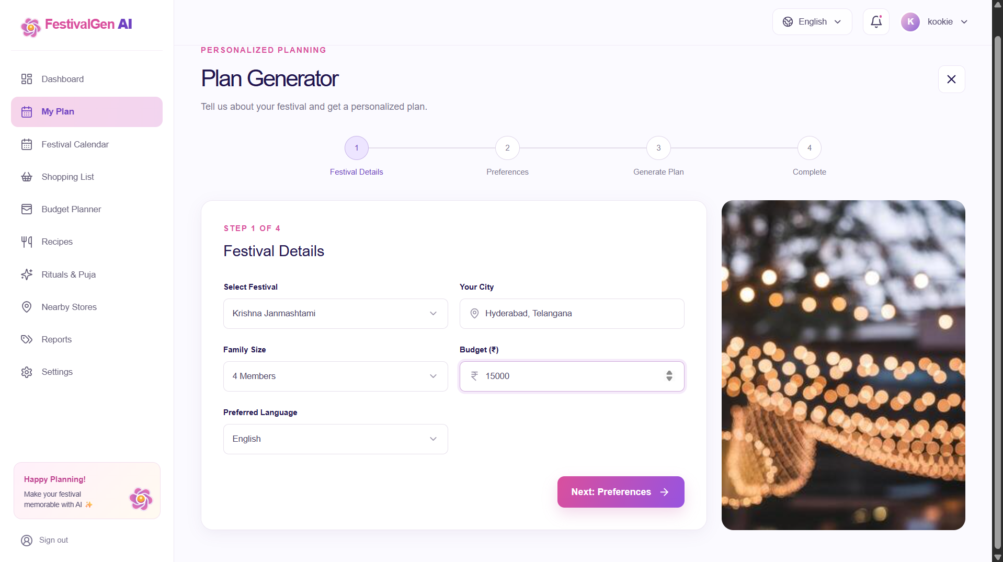
Plan Generator Step 1 — Festival Details form.
Plan Generator — Step 2: Preferences:
Step 2 presents togglable preference rows — Vegetarian, Local shopping, Traditional rituals, Social content — that are folded into the generation request sent to the AI engine.
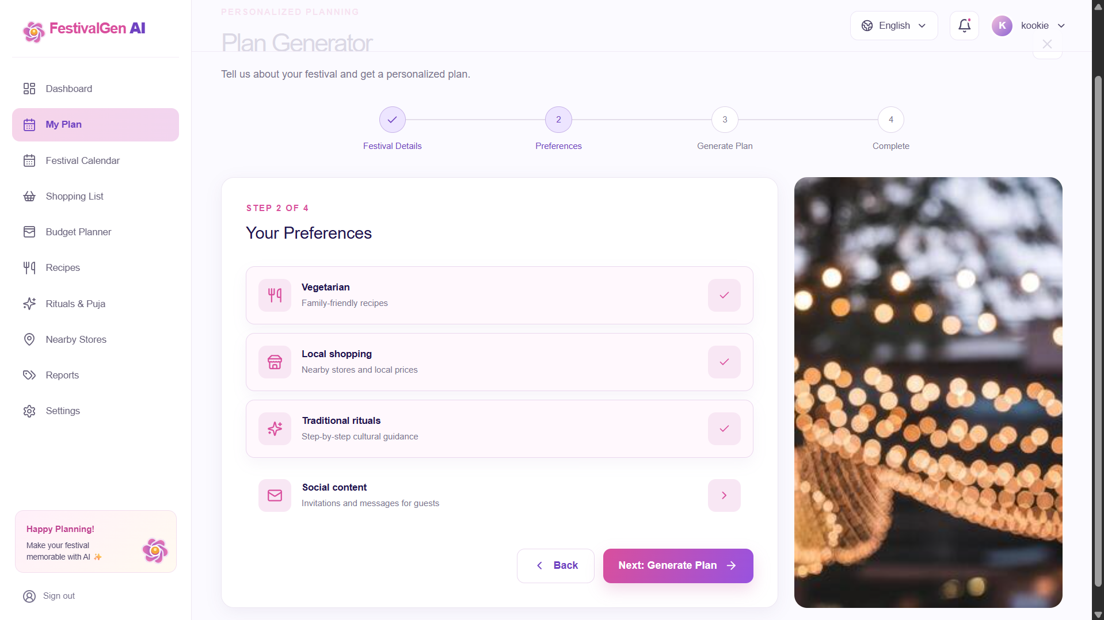
Plan Generator Step 2 — Your Preferences selection.
Plan Generator — Step 3: Review:
Before generating, the wizard summarizes every choice — festival, city, family size, budget, language, and the selected preferences — so the user can confirm everything is correct.
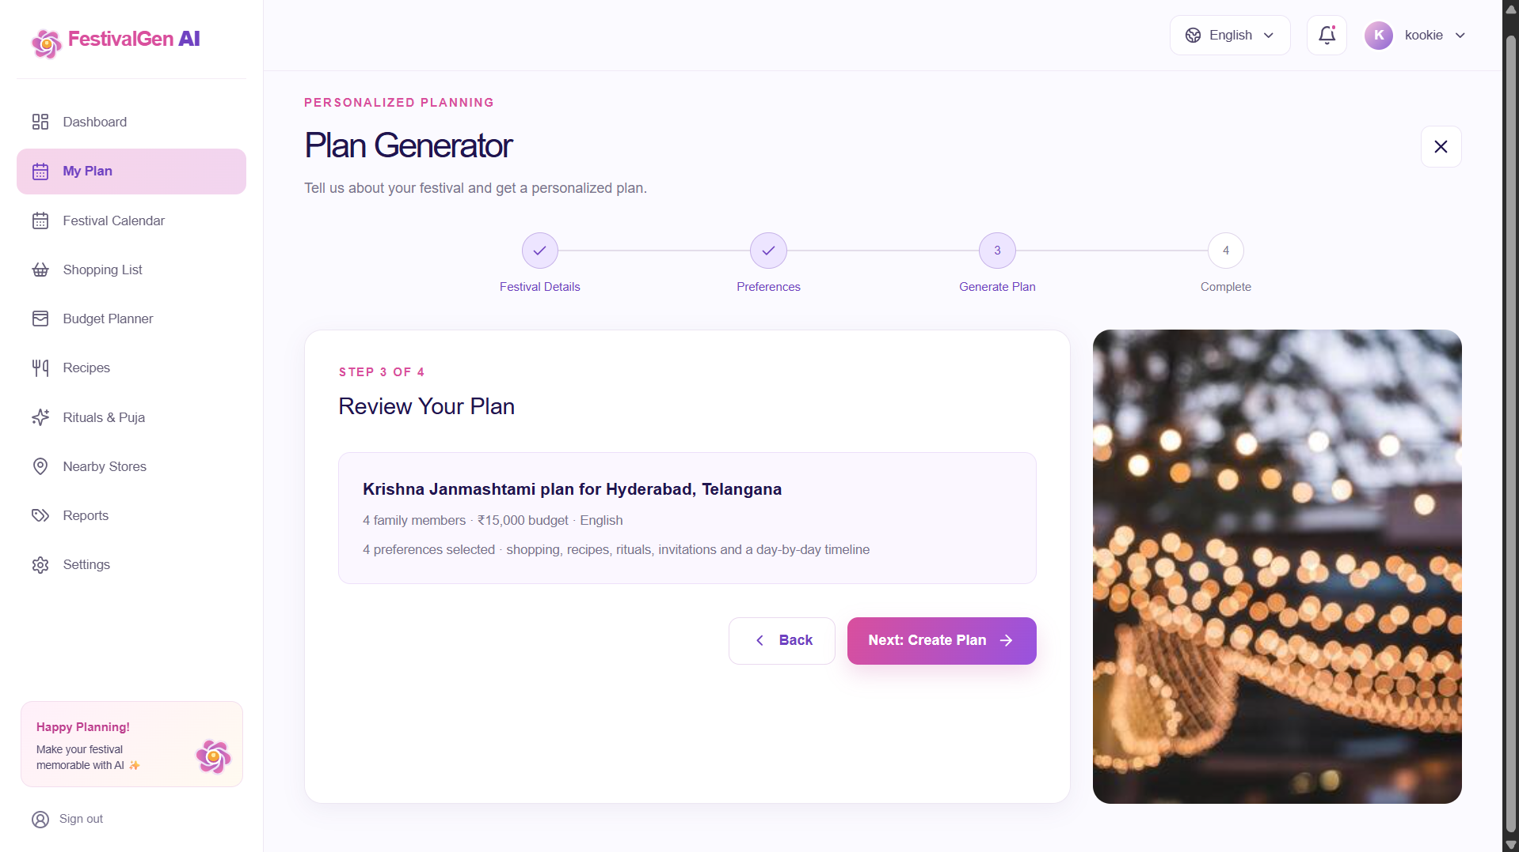
Plan Generator Step 3 — Review Your Plan summary.
Plan Generator — Step 4: Complete:
Once the Groq request resolves, the final step confirms the plan is ready with a success toast and a quick summary — item counts for shopping, recipes and timeline steps, plus highlighted special items and decorations — before routing the user to the Dashboard.
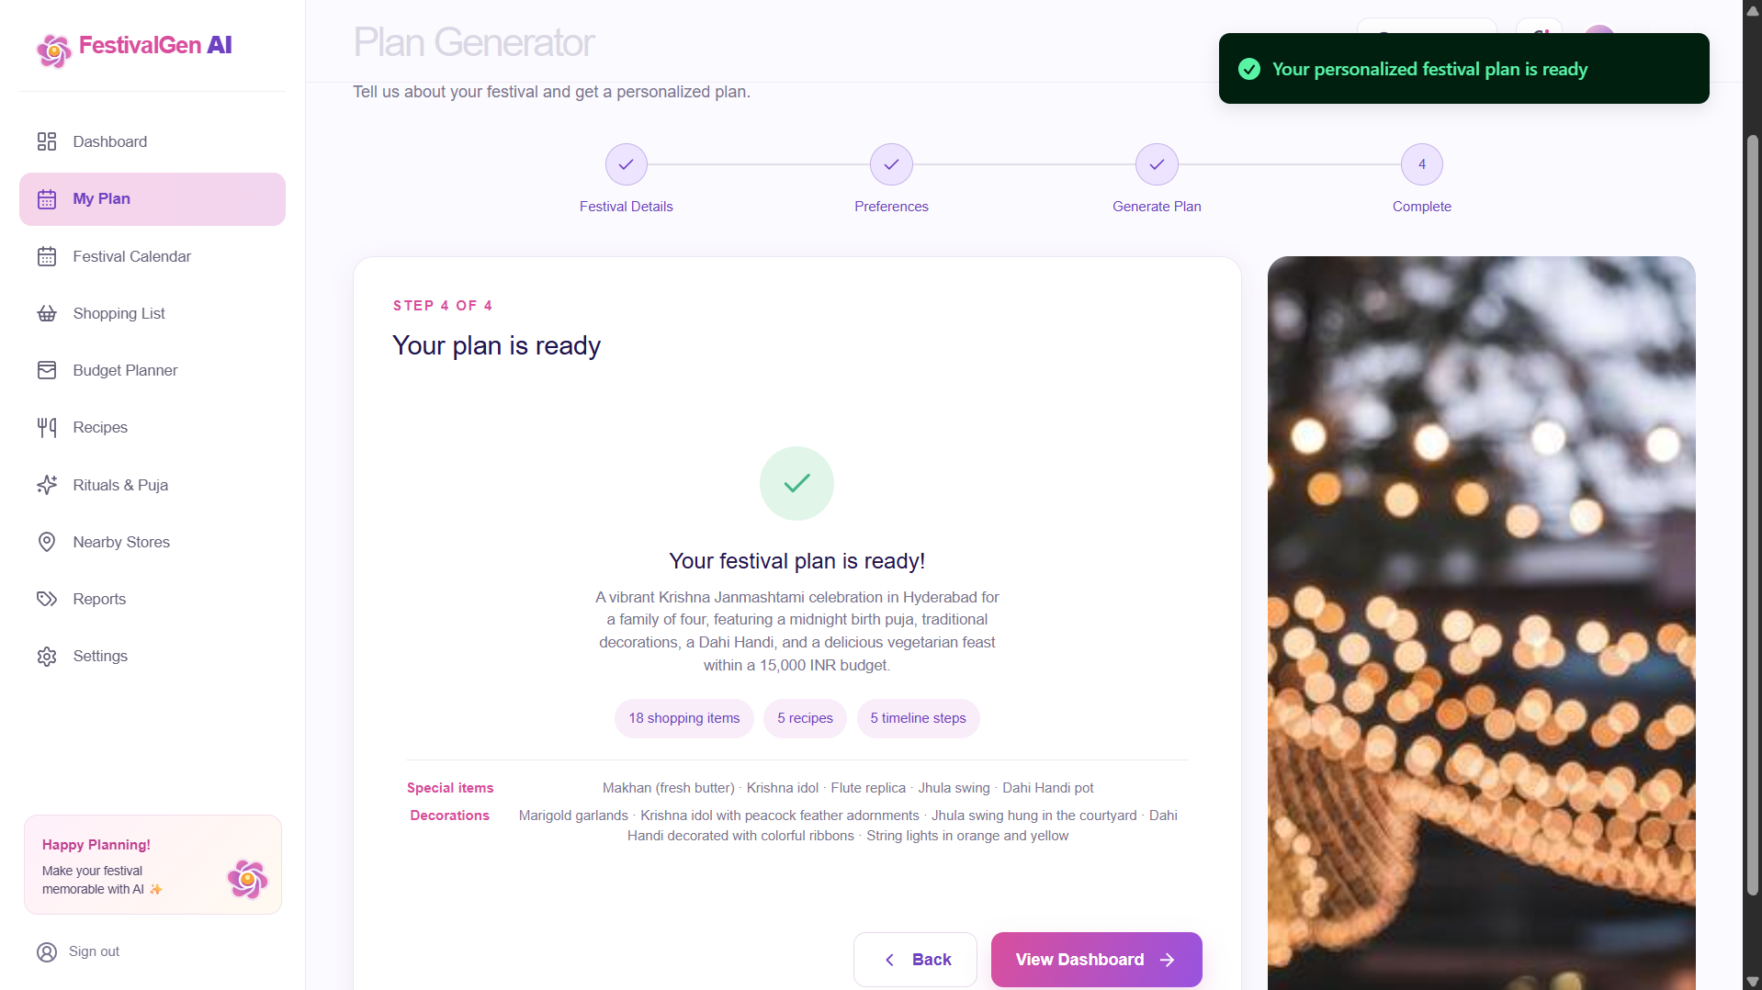
Plan Generator Step 4 — generated plan summary and confirmation toast.
Dashboard — Upcoming Festival:
The Dashboard greets the signed-in user by name and surfaces their upcoming festival as a countdown card with date, days-remaining, location, family size, budget and language, next to a full-width hero banner and a "Create New Festival Plan" call to action.
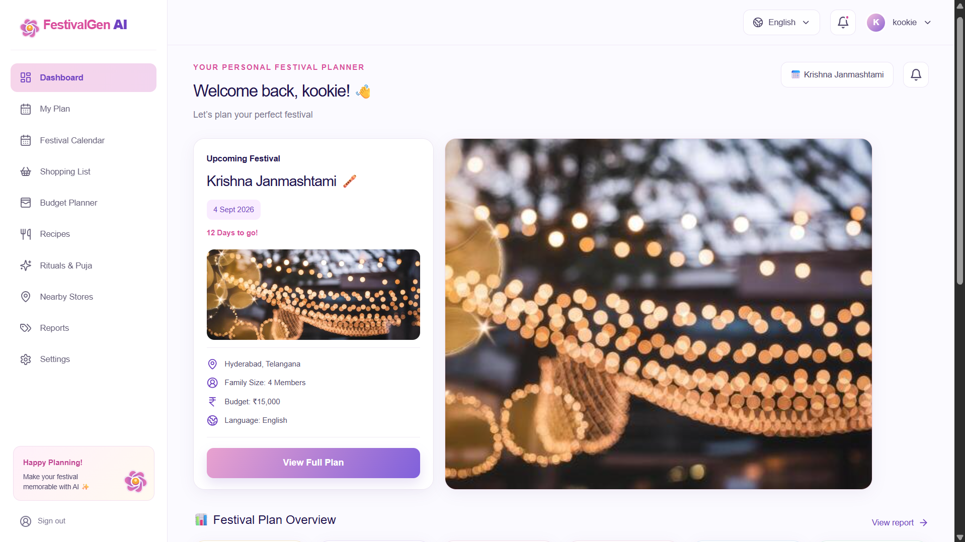
Dashboard welcome banner and upcoming-festival countdown card.
Dashboard — Plan Overview & Charts:
Scrolling down, the Festival Plan Overview presents six metric tiles (Recipes, Rituals & Puja, Shopping Items, Invitations, Timeline Tasks, Budget) each linking to its detail page, followed by a recipe-distribution donut chart, a shopping purchased-vs-pending bar comparison, a budget breakdown by category, and a preparation-timeline progress chart.
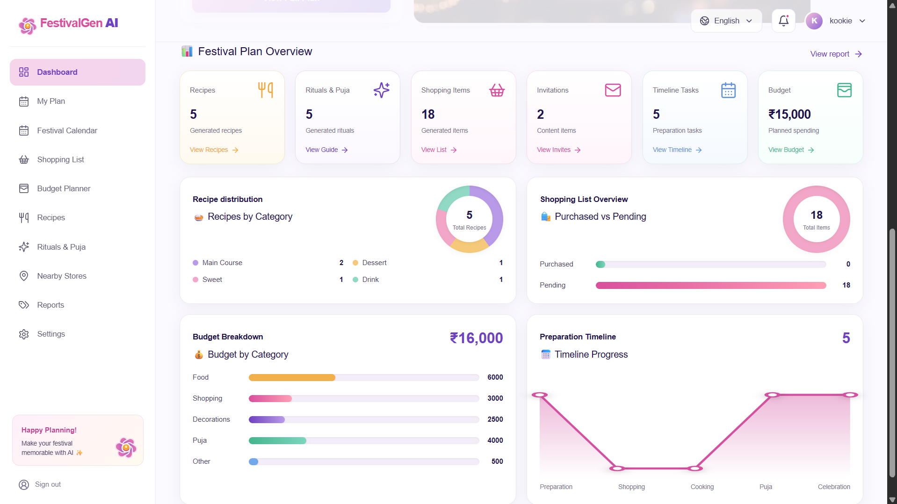
Dashboard plan-overview metric tiles and analytics charts.
Festival Calendar:
The calendar page lists India's major festivals month by month, filterable by year, category and region, with a search box and a "Create Festival Plan" shortcut for any upcoming date.
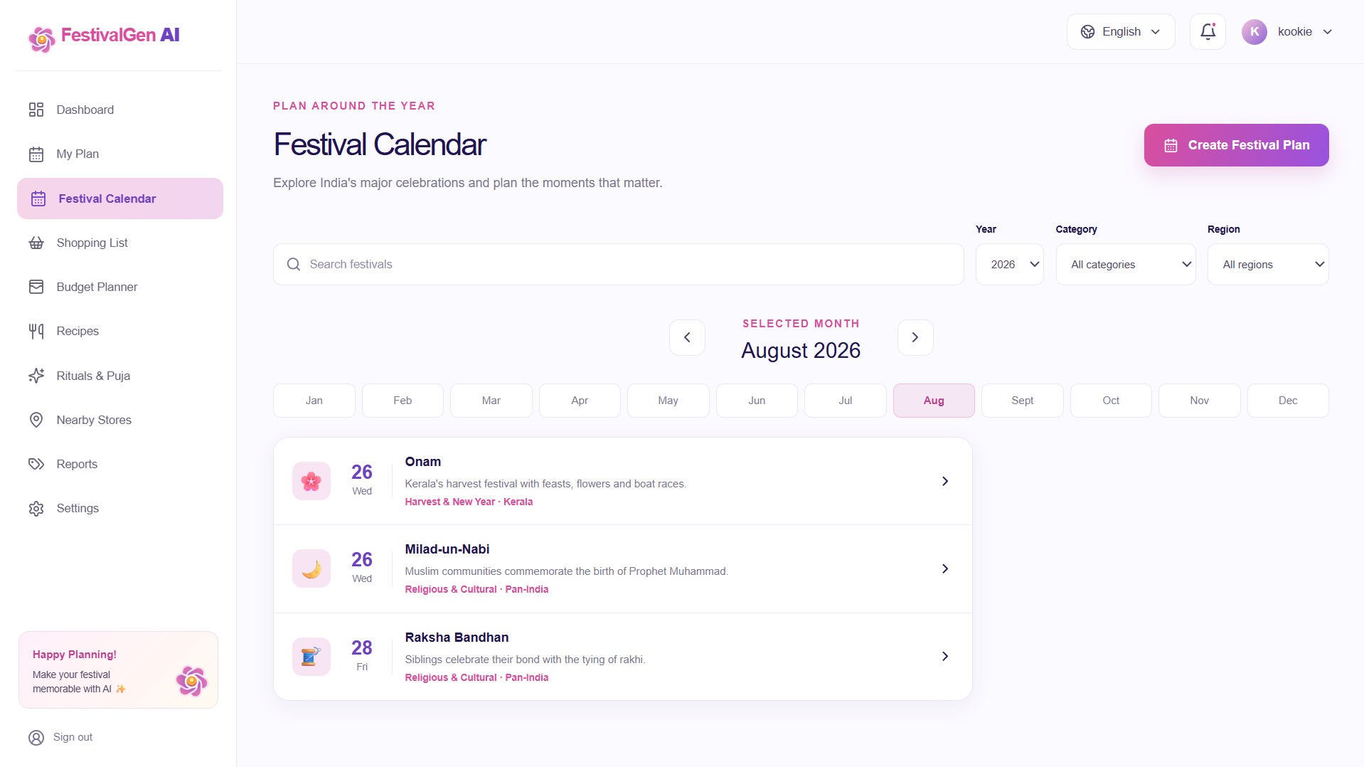
Festival Calendar page filtered to August 2026.
Shopping List:
Every AI-generated shopping item appears as a checkable row with its category and estimated price, with search, category filtering, and an "Add Item" action for anything the plan missed.
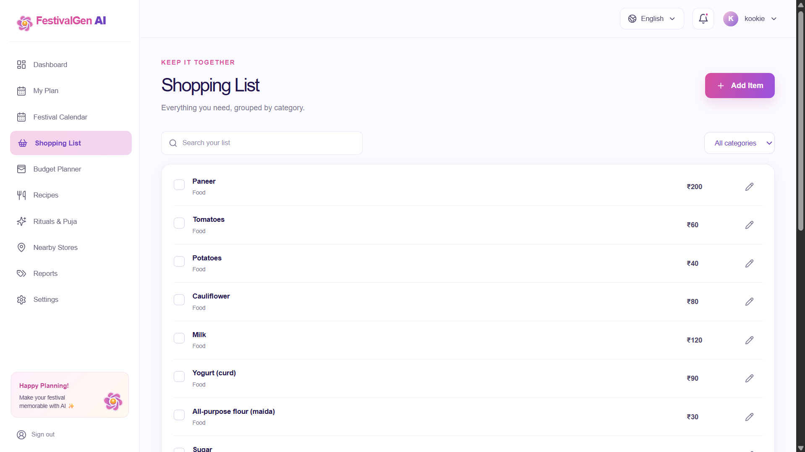
Shopping List page with checkable, priced items grouped by category.
Budget Planner:
A donut chart visualizes the total budget split across Food, Shopping, Decorations, Puja and Other, paired with an AI Tip card suggesting concrete ways to optimize spending.
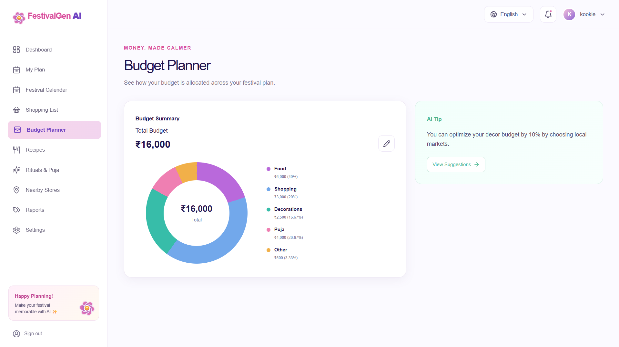
Budget Planner donut chart and AI savings tip.
Recipes:
Recipe cards are grouped by category (Main Course, Dessert, Sweet, Drink) and show prep time, servings, and rating; a "Refresh Recipes" action regenerates the set and "View All Recipes" expands the full library.
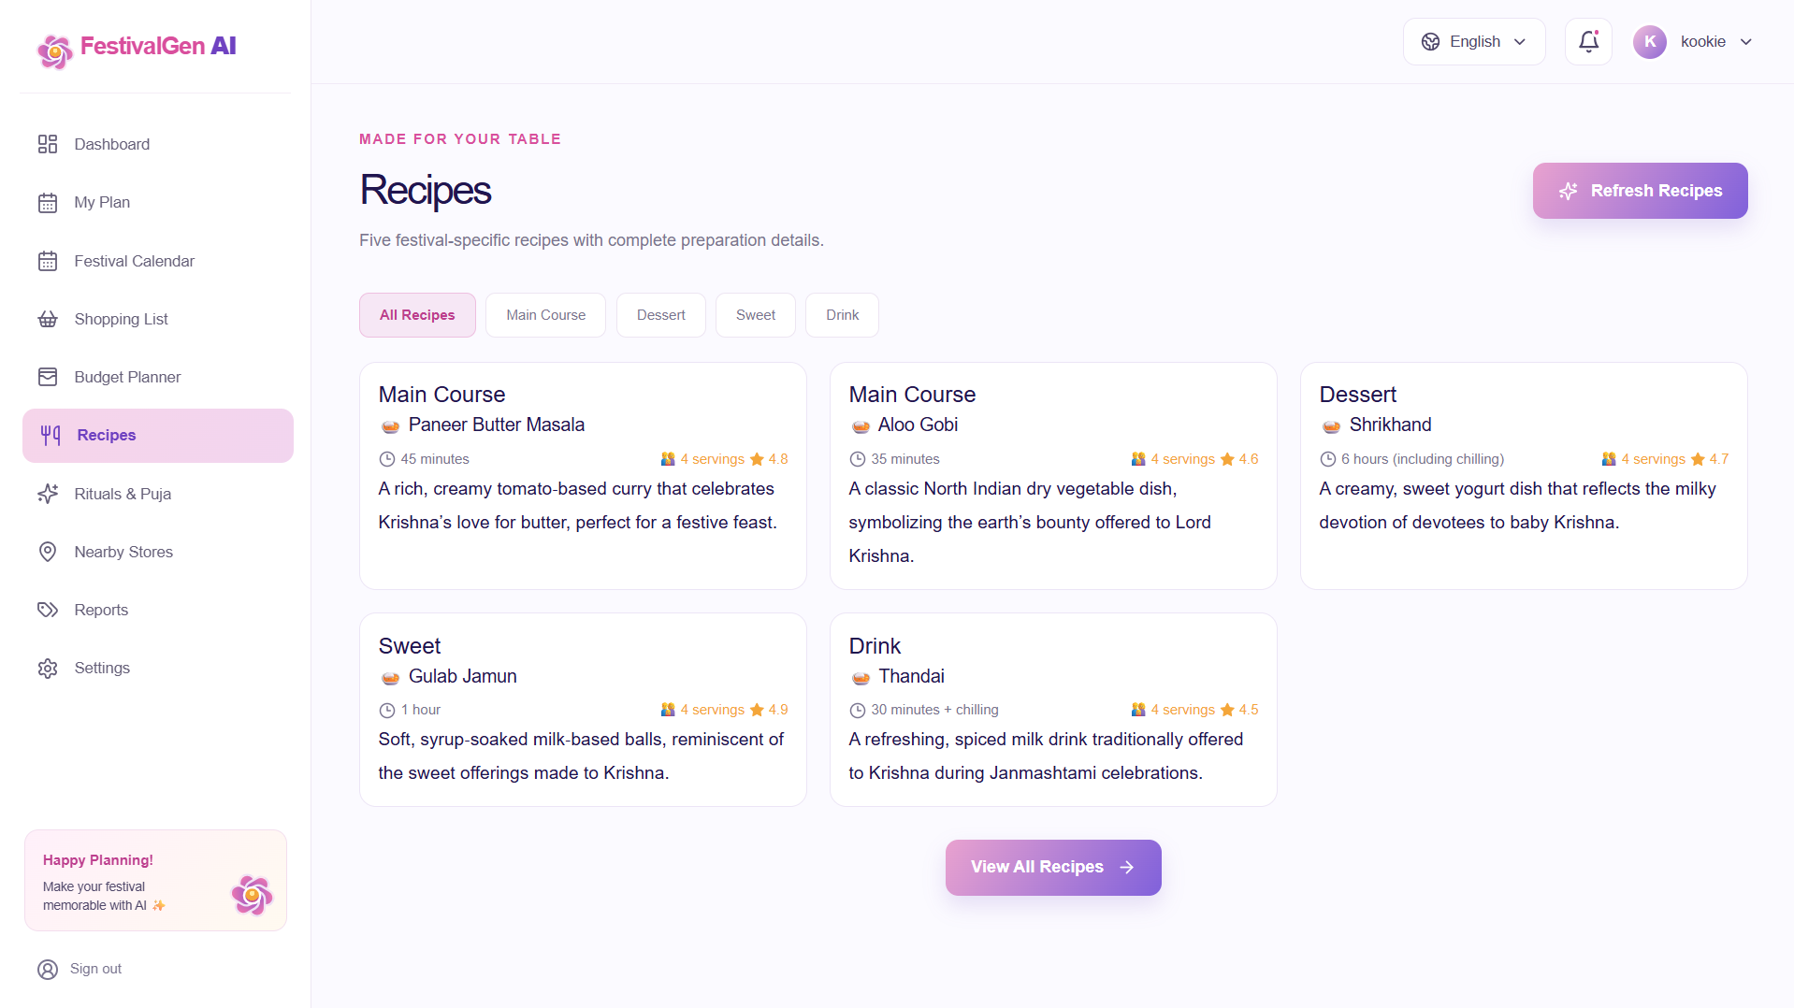
Recipes page with category-filtered recipe cards.
Rituals & Puja Guide:
A numbered ritual guide walks the family through each step of the festival — from purifying the puja space through the closing celebration — with a duration estimate per step and a "Personalize Guide" action.
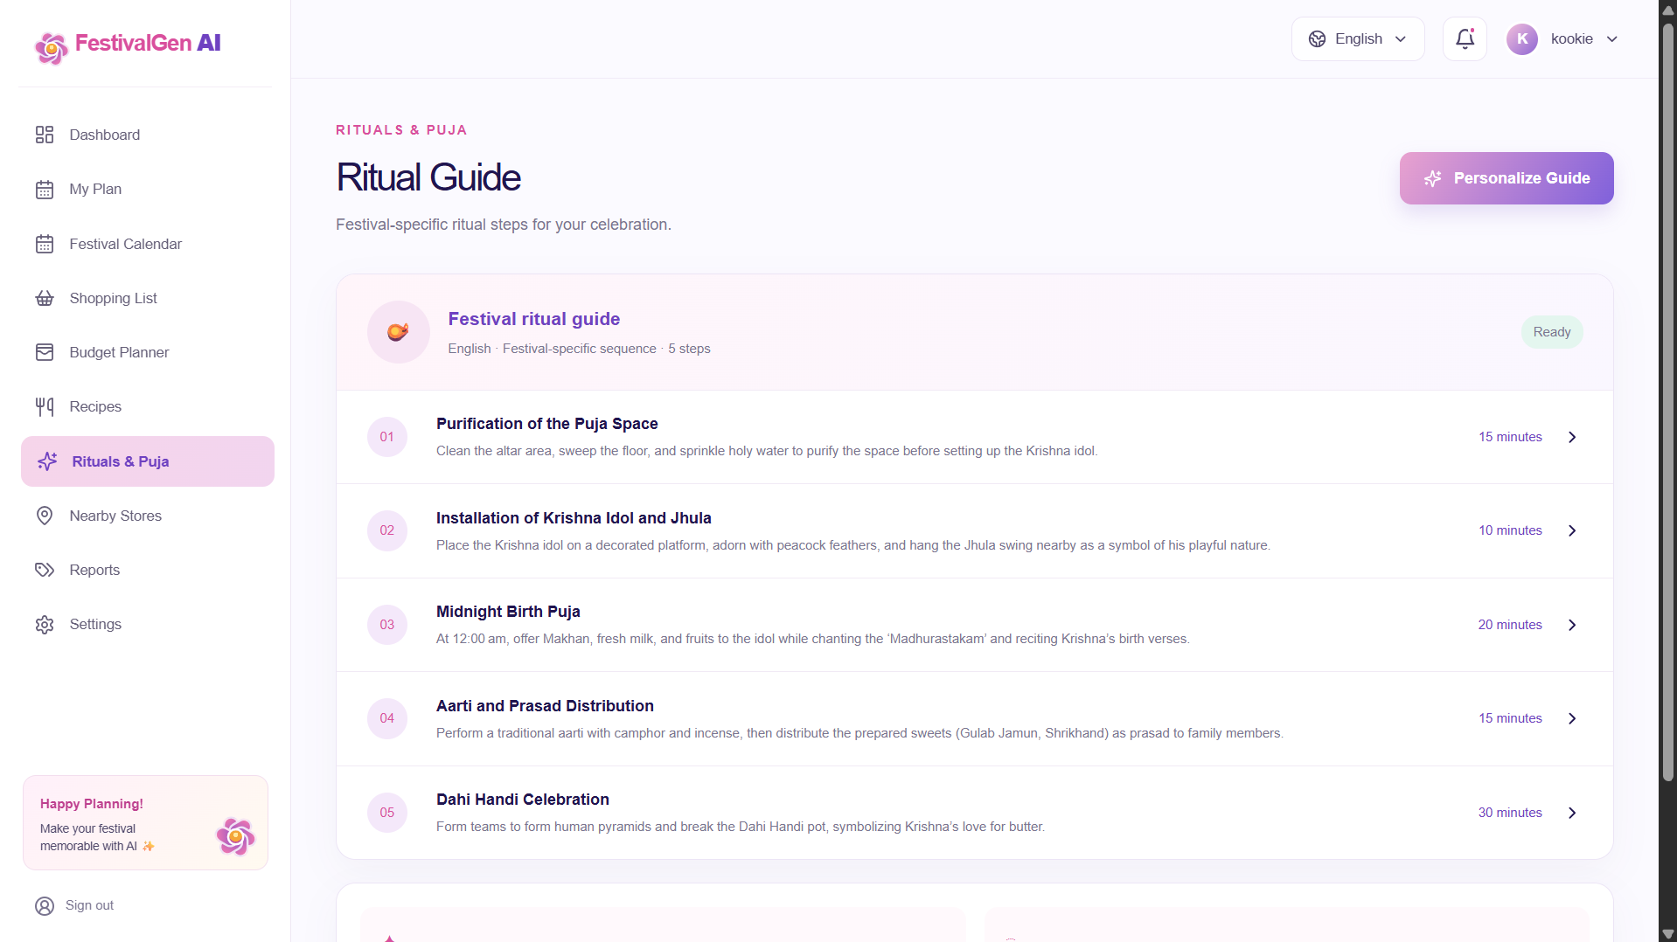
Rituals & Puja step-by-step guide.
Festival Reports:
The Reports page gives a calm, single-glance view of overall plan health as a percentage, alongside progress bars for shopping completion, budget allocation, and recipes saved, with a "Download Report" export action.
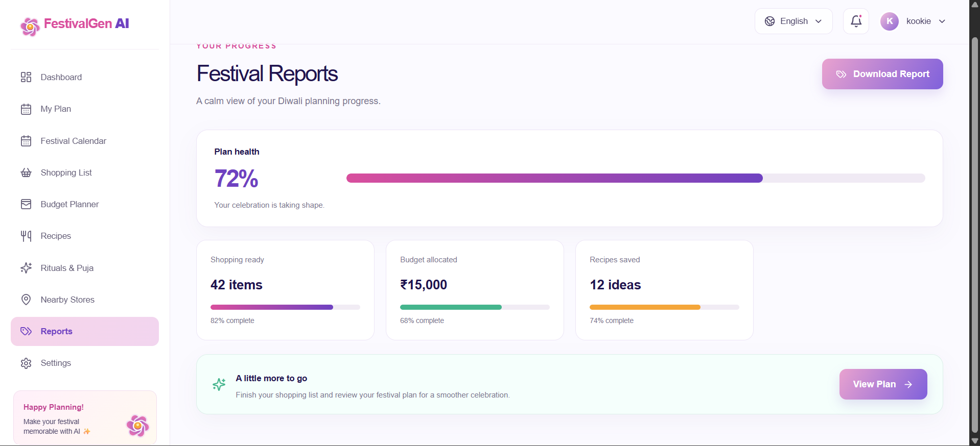
Festival Reports page showing overall plan-health progress.
Settings:
Users manage their profile details (name, city, preferred language) and planning preferences (local market suggestions, preparation reminders, personalized recipe ideas) from a single Settings screen.
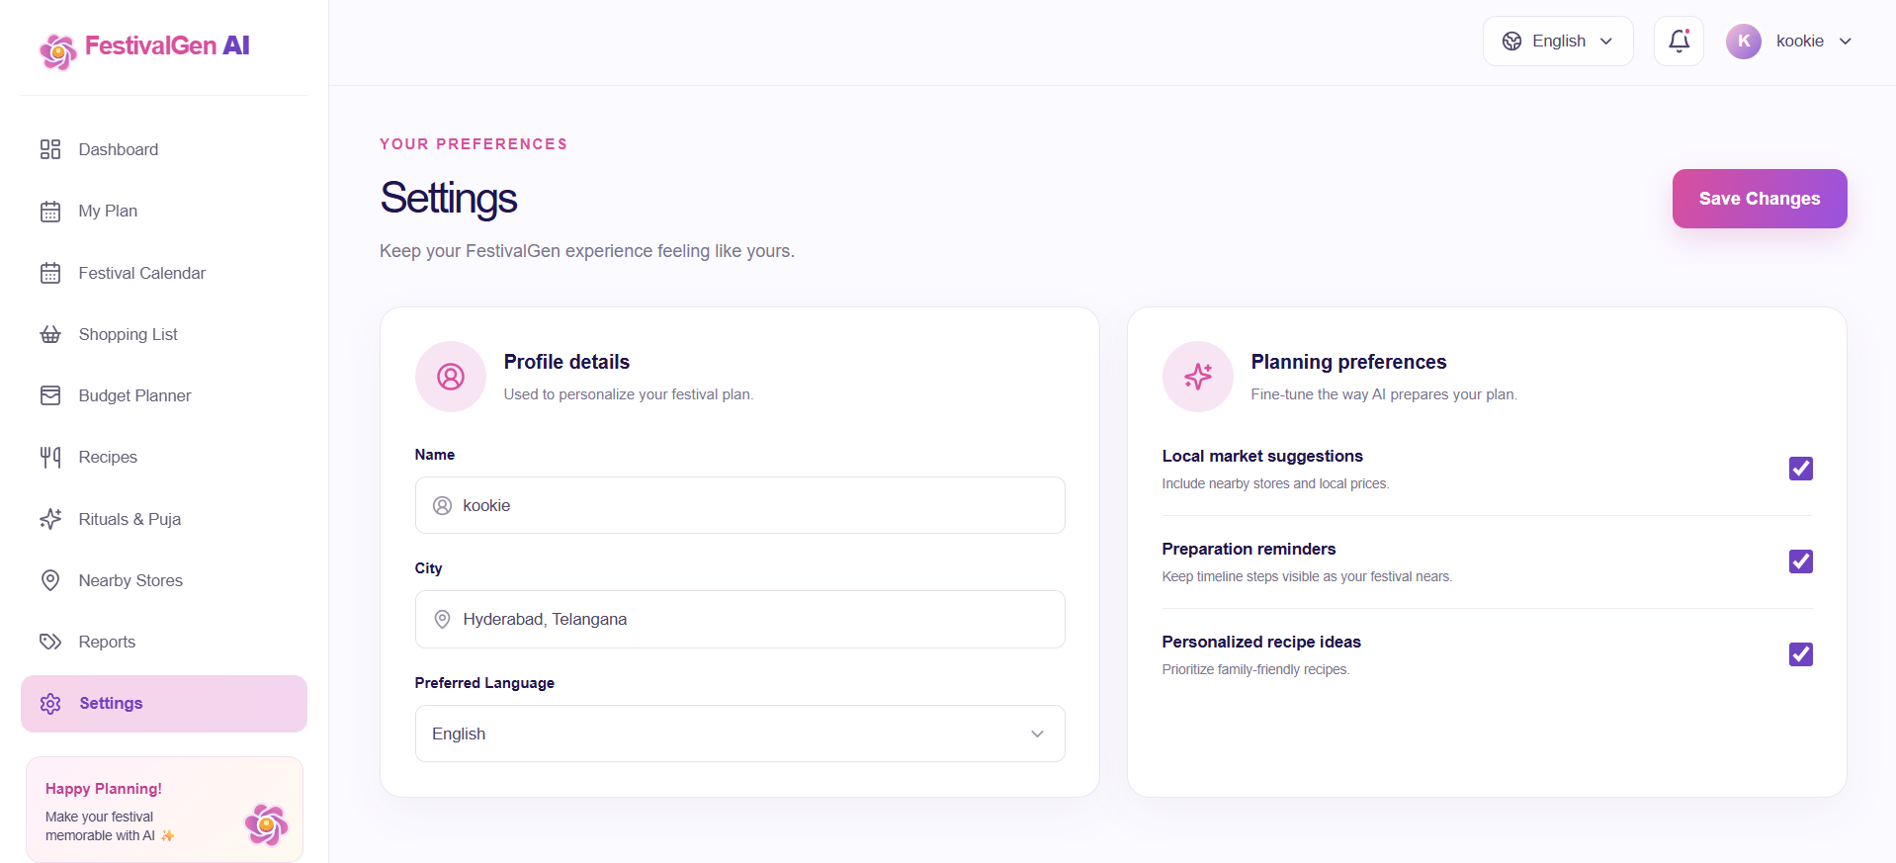
Settings page with profile details and planning preferences.
Conclusion:
FestivalGen AI is a generative-AI festival planning platform built with a React 18 + TypeScript client and an Express + tRPC backend, styled with a calm, editorial UI aimed at Indian families. It uses Groq's high-speed inference API with the LLaMA 3.3-70B Versatile model and a strict JSON Schema response format to instantly generate a complete, consistently structured festival plan — shopping list, budget, recipes, rituals, invitations and a preparation timeline — tailored to the user's festival, city, family size, budget and language. The project, which spanned schema design, AI engine development, a type-safe full-stack API, and a full dashboard experience, highlights how a constrained AI output format combined with a focused UI can turn a stressful, scattered planning process into one calm, guided flow, with clear room for future scalability across more festivals, languages, and regions.

