VideoScriptAI: AI-Powered Video Content Generator
Project Description:
VideoScriptAI harnesses Generative AI to provide intelligent promotional video content generation, offering users a fast and structured content-creation experience. The platform includes a Hook Generator module, which produces an attention-grabbing opening line to immediately capture viewer interest, a Script Generator, which writes a complete scene-by-scene video script calibrated to a specified duration, a Scene Suggester, which delivers three visually engaging shot descriptions to guide video production, and a Call-to-Action (CTA) Generator, which crafts a concise, action-oriented closing phrase tailored to the campaign goal and target audience.
Utilizing Groq's API with the LLaMA 3.3-70B Versatile model, VideoScriptAI processes user inputs to deliver fast, high-quality video content plans. Built with Flask and served with CORS support for seamless frontend integration, the platform ensures a smooth and user-friendly experience. With secure API key management via .env and responsible input handling, VideoScriptAI empowers marketers, creators, and businesses to plan compelling promotional videos with confidence.
Scenarios
Scenario 1: A user wants to promote the iPhone 14 Pro Max to tech enthusiasts. They input the product name, a detailed description, and their target audience. The system instantly generates a bold hook, a 30-second multi-scene script, three cinematic scene suggestions, and a punchy CTA — all ready to hand off to a video production team.
Scenario 2: A user running a B2B SaaS product launch selects a 60-second duration and sets the campaign goal to "drive demo sign-ups." VideoScriptAI generates a professional hook, a structured script with three scenes, visually descriptive shot suggestions, and a CTA designed to push professionals toward a free trial.
Scenario 3: A user promoting a weekend flash sale needs a short 15-second video. The AI generates an urgency-driven hook, a tight two-scene script with rapid pacing, scene suggestions focused on product close-ups and countdown visuals, and a CTA like "Shop now — offer ends Sunday!"
Scenario 4: A user generates individual components one at a time, first requesting only the hook to test messaging, then the full script after approving the hook, and finally the scenes and CTA — all via separate API calls without needing to regenerate everything from scratch.

Technical Architecture:
Pre-requisites:
Flask Framework Knowledge: Flask Documentation
Groq API Familiarity: Groq API Documentation
HTML, CSS, and JavaScript Skills: W3Schools HTML/CSS/JavaScript Tutorials
Python Programming Proficiency: Python Documentation
Version Control with Git: Git Documentation
Development Environment Setup: Flask Installation Guide
Project Workflow:
Activity 1: Model Selection and Architecture
- Activity 1.1: Generate a Groq API key and configure it securely in the project environment.
- Activity 1.2: Research and select the appropriate generative AI model from Groq for video content generation.
- Activity 1.3: Define the architecture of the application, detailing interactions between the frontend, backend, and AI integration.
- Activity 1.4: Set up the development environment, installing necessary libraries and dependencies for Flask and the Groq API.
Activity 2: Core Functionalities Development
- Activity 2.1: Develop the four core functionalities: Hook Generator, Script Generator, Scene Suggester, and Call-to-Action Generator.
- Activity 2.2: Implement the Flask backend to manage routing and user input processing, ensuring smooth API interactions.
Activity 3: App.py Development
- Activity 3.1: Write the main application logic in app.py, establishing routes for each feature and integrating AI responses.
Activity 4: Frontend Development
- Activity 4.1: Design and develop the user interface using HTML, CSS, and JavaScript, ensuring a responsive and intuitive layout.
- Activity 4.2: Create dynamic templates with Flask's render_template to display results based on user interactions.
Activity 5: Deployment
- Activity 5.1: Prepare the application for local deployment by configuring the server environment and ensuring all dependencies are correctly installed.
- Activity 5.2: Deploy and test the application locally, verifying all endpoints return correct AI-generated content.
Activity 6: Conclusion
Milestone 1: Model Selection and Architecture
In this milestone, we focus on selecting the appropriate generative AI model from Groq for our video content generation needs. This involves researching the capabilities and performance of various models that Groq offers, ensuring that the chosen model aligns well with the application's objectives of generating hooks, scripts, scene suggestions, and CTAs for promotional videos of varying durations.
Activity 1.1: Generate a Groq API Key
Before the application can communicate with the Groq LLM, you need a valid Groq API key. Follow the steps below to create one and connect it securely to the project.
• Step 1 — Create a Groq Account: Visit https://console.groq.com and sign up for a free account using your Google account or email address.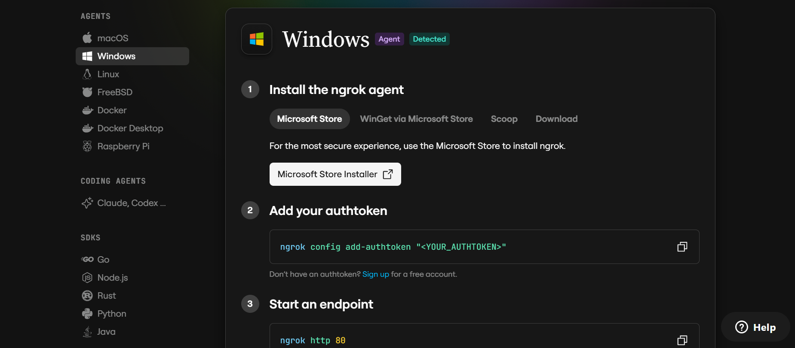
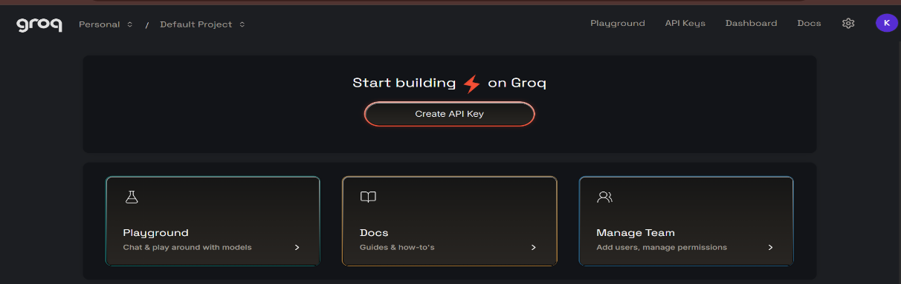
• Step 2 — Navigate to API Keys: After logging in, click on your profile icon in the top-right corner and select "API Keys" from the dropdown menu, or go directly to the API Keys page.
• Step 3 — Create a New API Key: Click the "Create API Key" button. Give your key a descriptive name (e.g., videoscriptai-key) so it is easy to identify later.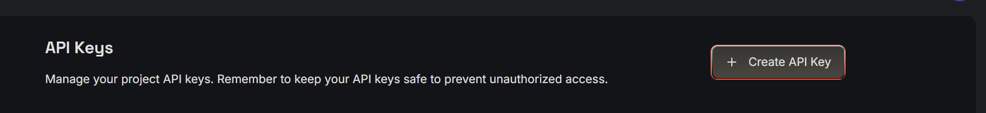
• Step 4 — Copy Your API Key: Provide a "Display Name," set an optional expiration, and click "Submit." Copy the key immediately and store it in a safe place — you will not be able to view it again after closing the dialog.
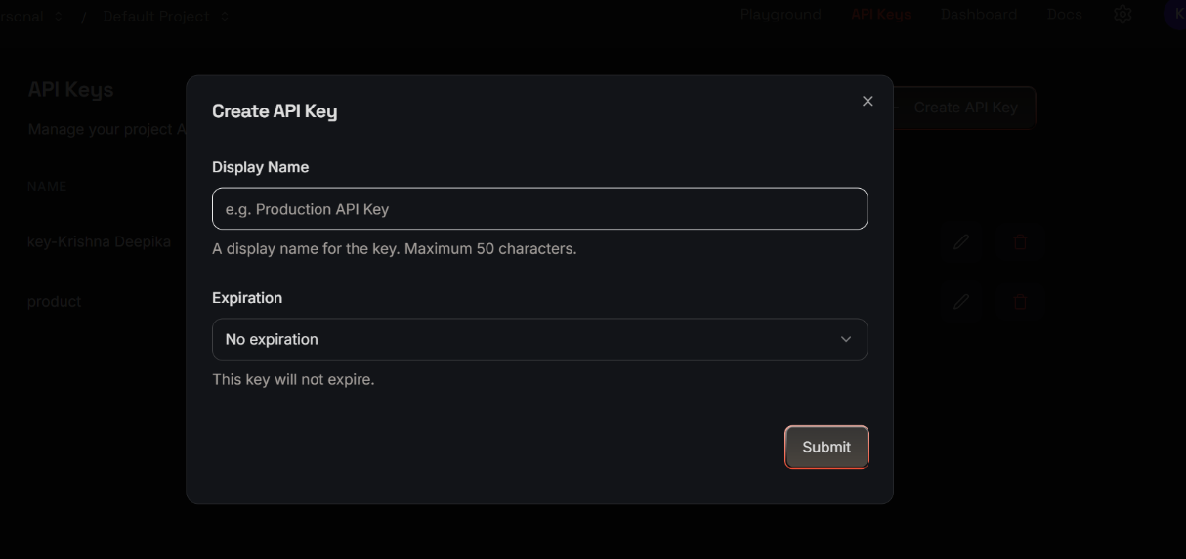
• Step 5 — Add the Key to Your Project: Create a .env file in the root of your project directory (if it does not already exist) and paste the key as shown below:
GROQ_API_KEY=your_copied_api_key_here
• Step 6 — Verify the Key is Loaded: The app.py file loads this key automatically at startup using python-dotenv:
from dotenv import load_dotenv
load_dotenv(dotenv_path='.env')
client = Groq(api_key=os.getenv("GROQ_API_KEY"))
• Important — Never Commit Your API Key: Add .env to your .gitignore file to prevent accidentally pushing the key to a public repository:
.env
Activity 1.2: Research and Select the Appropriate Generative AI Model
- Understand the Project Requirements: Review the specific needs of VideoScriptAI, focusing on the types of content it will generate — hooks, multi-scene scripts, visual scene descriptions, and CTAs for video campaigns of varying lengths.
- Explore Groq's Model Documentation: Visit the Groq documentation to examine the available LLM models, including their context windows, generation speed, and suitability for creative long-form output.
- Evaluate Model Performance: Compare models based on response quality for structured creative writing tasks, generation speed for real-time use, and ability to follow formatting instructions consistently.
- Select the Optimal Model: Choose llama-3.3-70b-versatile for its balance of creative output quality and generation speed, suitable for generating structured, multi-part video content across a wide range of products and audiences.
Activity 1.3: Define the Architecture of the Application
- Draft an Architectural Diagram: Create a visual representation of the application architecture, including components such as the frontend (HTML, CSS, JavaScript), the Flask backend, and the Groq API integration.
- Detail Frontend Functionality: Outline how users interact with the application — entering product name, description, target audience, campaign goal, and optional video duration, then triggering individual or combined content generation.
- Outline Backend Responsibilities: Specify how the Flask backend handles incoming POST requests to each of the five endpoints (/api/generate-hook, /api/generate-script, /api/generate-scenes, /api/generate-cta, /api/generate-all), validates required fields, and communicates with the Groq API.
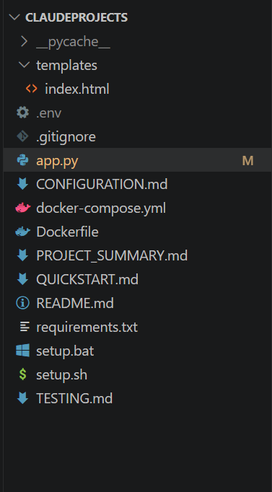
- Describe AI Integration Points: Define how the backend constructs individual prompts per feature using helper functions (generate_hook(), generate_script(), generate_scenes(), generate_cta()), calls the Groq API via call_ai(), and returns plain-text AI responses wrapped in JSON to the frontend.

Activity 1.4: Set Up the Development Environment
- Install Python and Pip: Ensure Python 3.8+ is installed on your machine along with pip for dependency management.
- Create a Virtual Environment: Set up a virtual environment using venv to isolate project dependencies:
python -m venv videoscriptai-env
videoscriptai-env\Scripts\activate # For Windows
source videoscriptai-env/bin/activate # For macOS/Linux
- Install Flask: Use pip to install Flask:
pip install Flask
- Install Groq SDK: Install the Groq Python library to interact with the Groq API:
pip install groq
- Install python-dotenv: Install dotenv support for secure API key management:
pip install python-dotenv
- Install Flask-CORS: Install CORS support to allow cross-origin requests from the frontend:
pip install flask-cors
- Configure the API Key: Create a .env file in the project root and add your Groq API key:
GROQ_API_KEY=your_groq_api_key_here
- Set Up Application Structure: Create the project directory structure including folders for templates, static files (CSS, JS), and the main application file (app.py).
Milestone 2: Core Functionalities Development
Activity 2.1: Develop Core Content Generation Features
Implement the four core generation features — Hook, Script, Scenes, and CTA — each as a standalone AI-powered function driven by a purpose-built prompt.
- Hook Generator: Produces a single attention-grabbing opening line (max 20 words) starting with a question, surprising fact, or bold statement, tailored to the product and target audience.
- Script Generator: Writes a complete scene-by-scene promotional video script formatted as [SCENE #] - SCENE DESCRIPTION followed by VOICEOVER/DIALOGUE, scaled to the specified duration in seconds (default: 30 seconds, approximately one sentence per three seconds), with 2–3 scenes maximum.
- Scene Suggester: Returns three numbered visual scene descriptions (2–3 sentences each) focusing on practical, visually engaging shots that align with the campaign goal.
- CTA Generator: Produces a concise, action-oriented closing phrase (max 25 words) calibrated to the product, campaign goal, and target audience, including a reference to where to find or purchase the product where applicable.
Activity 2.2: Implement the Flask Backend
Define Routes in Flask:
- Set up five routes in app.py: one home page route and four content generation endpoints, plus a combined /api/generate-all endpoint.
Process User Input:
- Create a form in index.html for users to submit product name, description, target audience, campaign goal, and optional duration.
- Use Flask's request.json to retrieve JSON data submitted from the frontend.
- Validate that all required fields are present before processing, returning a 400 error with a descriptive message if any are missing.
Integrate API Calls:
- Within each route handler, call the corresponding helper function (generate_hook(), generate_script(), generate_scenes(), or generate_cta()) which internally builds a structured prompt and calls call_ai().
- Submit each prompt to the Groq API using client.chat.completions.create() with the llama-3.3-70b-versatile model.
- Return the plain-text AI response wrapped in a JSON object alongside a UTC timestamp via datetime.now().isoformat().
Milestone 3: App.py Development
Milestone 3 focuses on creating and refining the core logic of the app.py file, which serves as the backbone of VideoScriptAI. In this milestone, you will set up each feature's functionality through Flask routes, establish reliable prompt construction and API interaction, and verify that each endpoint returns well-formed responses.
Activity 3.1: Writing the Main Application Logic in app.py
Define the Core Routes in app.py:
Establish routes for VideoScriptAI's six endpoints, each serving a distinct purpose:
- / — Home page route that renders the main index.html interface:
@app.route('/')
def home():
return render_template('index.html')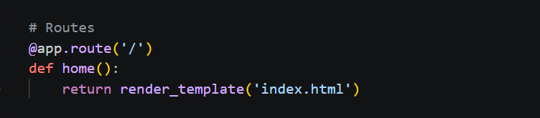
- /api/generate-hook — POST endpoint that accepts product name, description, and target audience, and returns a generated hook:
@app.route('/api/generate-hook', methods=['POST'])
def api_generate_hook():
data = request.json
if not all(k in data for k in ['productName', 'productDescription', 'targetAudience']):
return jsonify({'error': 'Missing required fields'}), 400
hook = generate_hook(data['productName'], data['productDescription'], data['targetAudience'])
return jsonify({'hook': hook, 'timestamp': datetime.now().isoformat()}), 200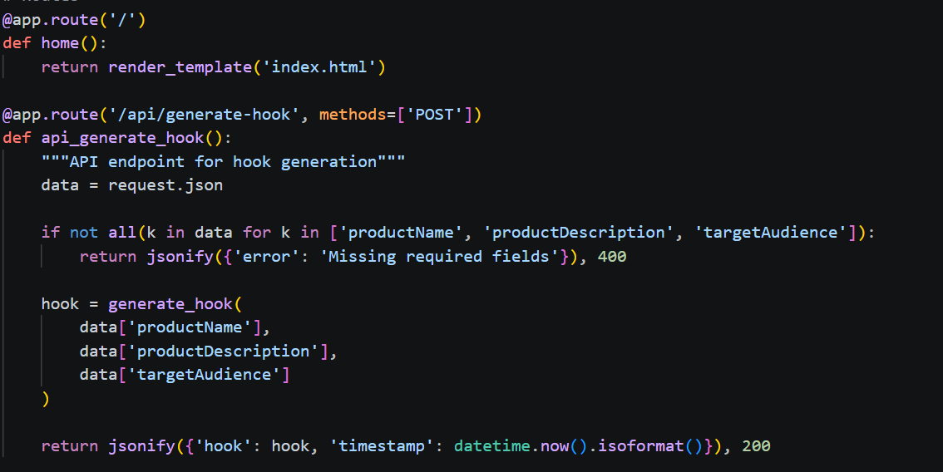
- /api/generate-script — POST endpoint that accepts product name, description, target audience, campaign goal, and optional duration, and returns a full video script.
- /api/generate-scenes — POST endpoint that accepts product name, description, and campaign goal, and returns three visual scene suggestions.
- /api/generate-cta — POST endpoint that accepts product name, campaign goal, and target audience, and returns a closing CTA.
- /api/generate-all — POST endpoint that accepts all required fields and returns all four components in a single response:
return jsonify({
'hook': hook,
'script': script,
'scenes': scenes,
'cta': cta,
'timestamp': datetime.now().isoformat()
}), 200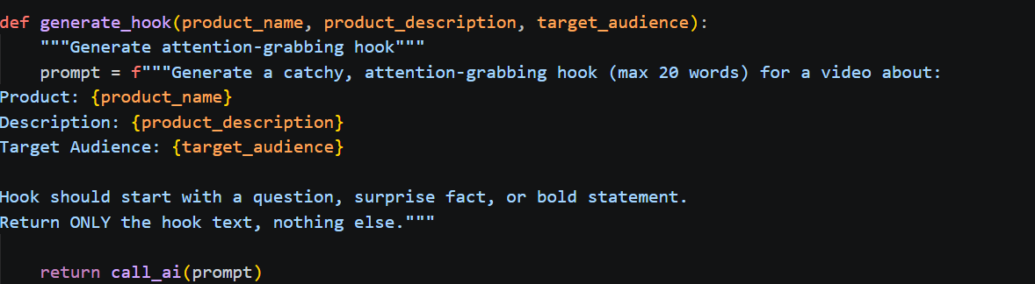
Set Up the Shared AI Caller:
- Implement a single call_ai(prompt) function that sends any prompt to the Groq API and returns the model's response text. This function is reused by all four generation helpers, keeping API interaction logic in one place:
def call_ai(prompt):
try:
chat_completion = client.chat.completions.create(
messages=[{"role": "user", "content": prompt}],
model="llama-3.3-70b-versatile"
)
return chat_completion.choices[0].message.content
except Exception as e:
return f"Error: {str(e)}"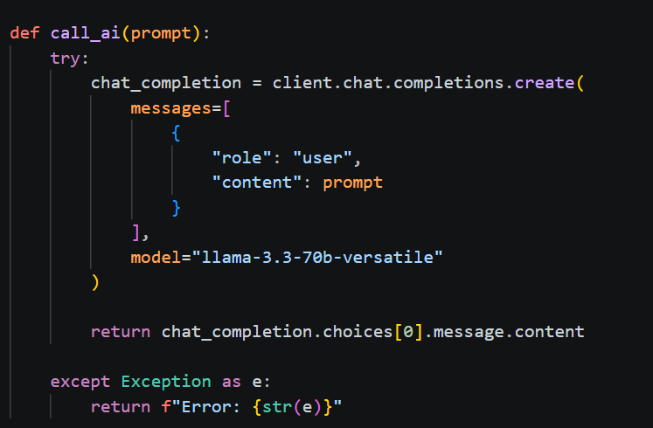
Define Prompt Engineering Helpers:
- generate_hook(product_name, product_description, target_audience) — builds a prompt instructing the model to produce a max-20-word hook starting with a question, surprise fact, or bold statement, and returns only the hook text with no additional commentary.
- generate_script(product_name, product_description, target_audience, campaign_goal, duration_seconds) — builds a prompt for a scene-by-scene script scaled to the given duration, formatted as [SCENE #] - DESCRIPTION followed by VOICEOVER/DIALOGUE, with 2–3 scenes maximum.
- generate_scenes(product_name, product_description, campaign_goal) — builds a prompt for three numbered visual scene descriptions of 2–3 sentences each, focused on practical and visually engaging shots.
- generate_cta(product_name, campaign_goal, target_audience) — builds a prompt for a max-25-word CTA that is clear, compelling, and action-oriented, including product discovery information where relevant.
Input Validation per Endpoint:
- Each route validates its own required fields using:
if not all(k in data for k in ['productName', 'productDescription', ...]):
return jsonify({'error': 'Missing required fields'}), 400
- The /api/generate-script endpoint reads an optional duration field from the request body, defaulting to 30 seconds if not provided.
Route Summary:
Route | Method | Required Fields | Returns
/ | GET | — | index.html
/api/generate-hook | POST | productName, productDescription, targetAudience | hook, timestamp
/api/generate-script | POST | productName, productDescription, targetAudience, campaignGoal | script, timestamp
/api/generate-scenes | POST | productName, productDescription, campaignGoal | scenes, timestamp
/api/generate-cta | POST | productName, campaignGoal, targetAudience | cta, timestamp
/api/generate-all | POST | productName, productDescription, targetAudience, campaignGoal | hook, script, scenes, cta, timestamp

Milestone 4: Frontend Development
Milestone 4 focuses on developing a user-friendly and visually appealing interface for VideoScriptAI. This involves designing a clean, responsive layout with HTML and CSS to enhance usability, and creating dynamic content rendering with JavaScript to display AI-generated hooks, scripts, scenes, and CTAs based on user interactions.
Activity 4.1: Designing and Developing the User Interface
Set Up the Base HTML Structure:
- Develop the main HTML file (index.html) as the single-page interface, including a header with the VideoScriptAI brand and tagline, an input section for product and campaign details, and a results section for displaying AI-generated content.
- Use semantic HTML elements to keep the structure organized and ensure the interface is accessible for all users.
- Integrate Google Fonts for clean typography and icon libraries for visual section headers and buttons.
Design a Responsive Layout Using CSS:
- Create a CSS stylesheet implementing a modern, dark-themed aesthetic suitable for a creative production tool.
- Use flexbox and grid layouts to organize results into clearly separated panels for hook, script, scenes, and CTA.
- Add media queries to ensure the layout adapts cleanly across desktop, tablet, and mobile screen sizes.
Create Separate UI Components for Each Output Type:
- Hook Card: displays the generated hook in a prominent card at the top of the results section, with a one-click copy button.
- Script Panel: renders the multi-scene script in a preformatted, readable block preserving scene labels and dialogue formatting.
- Scene Cards: displays three numbered scene description cards, each representing a visual shot suggestion.
- CTA Card: shows the closing call-to-action phrase in a highlighted card with a copy-to-clipboard button.
Activity 4.2: Creating Dynamic Content Rendering with JavaScript
Handle Form Submission Asynchronously:
- Attach a submit event listener to the generator form that prevents default form submission and sends the data as a JSON POST request to /api/generate-all (or individual endpoints) via the Fetch API.
- During loading, disable the submit button and display an animated spinner to indicate that the AI is processing the request.
Render Results Dynamically:
- Implement a renderResults(data) function that dynamically creates and injects DOM elements for the hook, script, scenes, and CTA into their respective containers based on the API response.
- After rendering, automatically smooth-scroll the viewport to the results section using scrollIntoView().
Restore UI State After Generation:
- In the finally block of the async handler, re-enable the submit button and restore the original button label regardless of success or failure, ensuring the interface remains responsive after every request.
Milestone 5: Deployment
In Milestone 5, the focus is on deploying the VideoScriptAI application locally to verify correct operation across all endpoints, then preparing it for public access. This involves configuring the server environment, managing dependencies, and launching the app for real-world use.
Activity 5.1: Preparing the Application for Local Deployment
Set Up a Virtual Environment:
- Create and activate a virtual environment, then install all required dependencies:
python -m venv env
source env/bin/activate # For macOS/Linux
env\Scripts\activate # For Windows
pip install -r requirements.txt
Configure Environment Variables:
- Create a .env file in the project root and add your Groq API key. The app loads this automatically using python-dotenv at startup:
GROQ_API_KEY=your_groq_api_key_here
Activity 5.2: Local Testing and Verification
Start the Flask Development Server:
- Run the application locally using:
python app.py
- Once running, open a browser and navigate to http://127.0.0.1:5000 to access the app.
- Test each endpoint individually using a tool like Postman or curl, verifying that:
  - /api/generate-hook returns a focused one-line hook.
  - /api/generate-script returns a structured multi-scene script.
  - /api/generate-scenes returns three numbered scene descriptions.
  - /api/generate-cta returns a concise closing phrase.
  - /api/generate-all returns all four components in a single response.
- Use the /test-ai route to run a quick end-to-end sanity check with a pre-filled iPhone 14 Pro Max example:
GET http://127.0.0.1:5000/test-ai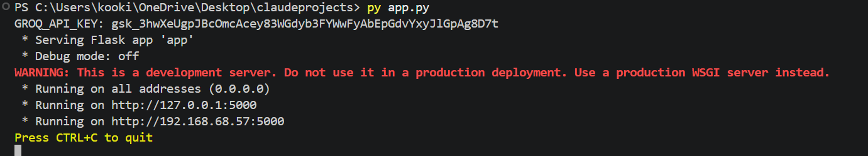
Verify the PORT Configuration:
- The app reads the PORT environment variable at startup and defaults to 5000 if not set:
port = int(os.getenv("PORT", 5000))
app.run(host='0.0.0.0', port=port)
- Set a custom port in the .env file if needed: PORT=8080
Exploring the Website's Web Pages:
Home / Generator Page:
Description: The single-page interface of VideoScriptAI serves as both the landing page and the generation tool. It features a header displaying the VideoScriptAI brand and a tagline. The main section contains the input form and the AI-generated results panel — all on one seamless page.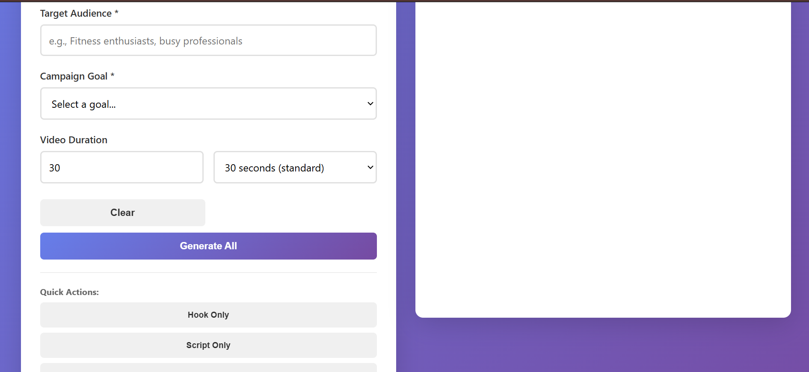
Input Section:
Description: A card containing the main generation form. Users enter their product name, product description, target audience, and campaign goal into text fields. An optional duration field (in seconds) controls the length of the generated script, defaulting to 30 seconds. Users click "Generate" to trigger all four content components at once, or individual buttons to generate each component separately. While the AI processes the request, the button transitions to an animated loading state.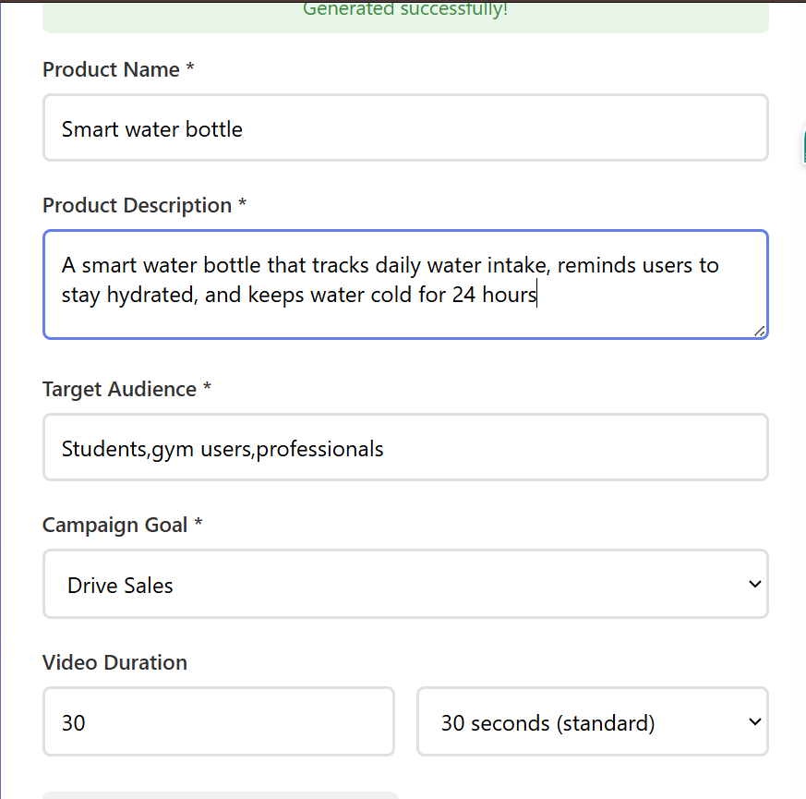
Results Section:
Description: Revealed dynamically after generation, this section displays the AI output in clearly labelled panels. The Hook panel shows the attention-grabbing opening line. The Script panel renders the full scene-by-scene script with formatted scene labels and dialogue. The Scenes panel displays three numbered visual shot suggestions. The CTA panel shows the closing call-to-action phrase. Each panel includes a copy-to-clipboard button. The viewport automatically smooth-scrolls to this section upon content generation.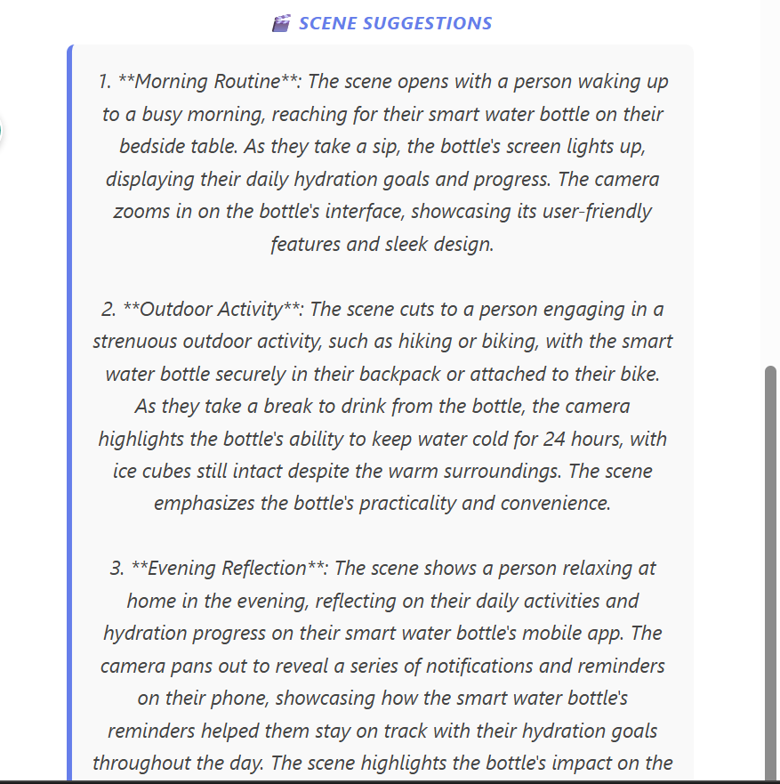
Conclusion:
VideoScriptAI is a generative AI platform built with Flask that streamlines promotional video content planning. It uses Groq's high-speed inference API with the LLaMA 3.3-70B Versatile model to instantly generate a complete content package — attention-grabbing hook, structured multi-scene script, visual shot suggestions, and a closing call-to-action — tailored to any product, audience, and campaign goal. The project, which included model selection, backend development across five REST endpoints, and local deployment, highlights how targeted AI and a structured framework can dramatically accelerate the video pre-production workflow for marketers and creators, with strong potential for future scalability including tone presets, platform-specific script styles, and multi-language support.

