AQUORA WATER INTELLIGENCE PLATFORM
Empirical Machine Learning Investigation on
Missing Sensor Telemetry, Imputation Resilience, and Water Quality Classification
Architecture: FastAPI (Python 3.11) + React Three Fiber (TypeScript/Vite) + Scikit-Learn
Dataset: Central Pollution Control Board (CPCB) India — National Water Monitoring Network
Date: September 2026 | Document Status: FINAL TECHNICAL REPORT
Classification Model: Decision Tree (CART) with GridSearchCV Hyperparameter Tuning

TABLE OF CONTENTS
Section Title | Page
ABSTRACT | 3
1.0 Problem Formulation | 4
2.0 Dataset Analysis & Profile | 5
3.0 Preprocessing Methodology & Justification | 6
4.0 Model Development & Architecture | 7
5.0 Mathematical Principles of Decision Tree & KNN Imputation | 8
6.0 Training, Validation, and Testing Methodology | 9
7.0 Validation-Based Model Selection & Hyperparameter Tuning | 10
8.0 Final Test-Set Evaluation & Measures | 11
9.0 Required Evaluation Formulas | 12
10.0 Visualizations & Performance Charts (6 Figures) | 13
11.0 Error Analysis & Asymmetric Safety Risk | 18
12.0 Assignment-Specific 9-Stage Empirical Investigation | 19
13.0 Conclusions, Limitations, and Recommendations | 22

ABSTRACT
Water quality monitoring is rapidly transitioning from periodic manual grab-sampling to autonomous cyber-physical sensor networks. However, real-world field IoT probes deployed in rivers, lakes, reservoirs, and drainage canals frequently suffer from sensor biofouling, battery depletion, and wireless packet loss, yielding severe missing-data regimes. This project presents AQUORA — an end-to-end full-stack water-quality intelligence and monitoring system built using FastAPI, React Three Fiber (Three.js), and Scikit-Learn.
Utilising official observational records from 162 field stations across 16 Indian states published by the Central Pollution Control Board (CPCB), we formulate an automated water classification framework ("Good Quality" vs "Poor Quality / Elevated Risk") using CPCB Class-C aquatic criteria. This report delivers a rigorous 9-stage empirical investigation evaluating model resilience under 10%, 20%, and 30% artificial missingness by benchmarking Simple Median Imputation, K-Nearest Neighbors (KNN) Imputation (k=5), and Listwise Row Deletion. Our empirical findings demonstrate that Listwise Deletion induces catastrophic sample starvation — discarding 94.6% of training records at 20% missingness, causing Unsafe-Class Recall to collapse to 0.0% and falsely approving toxic water as safe. In contrast, KNN Imputation retains 100% data history, achieves an F1-Score of 1.0000, and maintains 100.0% Unsafe Recall. A dual-tier deployment architecture is proposed balancing edge-level speed (<1 ms) with server-level accuracy (~15 ms).

1.0 Problem Formulation
Global freshwater ecosystems face escalating ecological stress from untreated municipal sewage, agricultural runoff, and industrial effluents. Traditional laboratory evaluation requires manual sample collection and standard 5-day biochemical incubation (BOD₅ assay), introducing response latency that precludes timely intervention during acute contamination spikes.
Modern continuous telemetry buoys measure pH, Dissolved Oxygen (DO), Electrical Conductivity, Temperature, and Biochemical Oxygen Demand (BOD). Nonetheless, three primary machine learning challenges arise:
① Pervasive Sensory Incompleteness: Independent electrochemical sensors drift, foul, or disconnect intermittently, yielding incomplete multi-attribute vectors.
② Asymmetric Safety Consequences: Safe water samples vastly outnumber contaminated instances. A False Positive (approving toxic water as safe) carries catastrophic public health consequences versus a False Negative (flag safe water as risky), which merely triggers re-testing.
③ Black-Box Opacity: Deep learning models fail regulatory transparency requirements — municipal engineers and environmental agencies must be able to trace the exact biochemical reason behind each alert.
AQUORA solves this through a transparent, missingness-resilient Decision Tree pipeline backed by live WebSocket telemetry, 3D orbital sensor visualization, and an explainable decision-path engine.

2.0 Dataset Analysis & Profile
The empirical foundation is the Central Pollution Control Board (CPCB) India surface water monitoring dataset comprising 162 unique monitoring stations across 23 physical, chemical, and biological attributes recorded during 2021–2023.
• Geographic Coverage: 16 Indian states — Jharkhand (Damodar, Subarnarekha basins), Himachal Pradesh (Sutlej, Giri), Uttarakhand (Tons), Madhya Pradesh (Betwa, Chambal), Rajasthan (Banas, Kali Sindh), Andhra Pradesh (Godavari, Krishna, Bay of Bengal coast), Goa (Zuari estuary), Delhi (Yamuna canals), Gujarat (Narmada, Tapi), Assam (Brahmaputra lakes/beels), Haryana, Maharashtra, Odisha, Tamil Nadu, Telangana, and Uttar Pradesh.
• Water Body Archetypes: Rivers (48 stations), Urban Drains & Effluent Outfalls (30), Temple Ponds (28), Lakes/Beels (22), Marine Beaches (18), Irrigation Canals (16).
• Target Distribution (CPCB Class-C Criteria):
— Good Quality (Class 1): 143 stations (88.3%)
— Poor Quality / Elevated Risk (Class 0): 19 stations (11.7%)
• Total Missing Values: 333 field entries across 162 rows. Physical parameters (pH: 0%, DO: ~1%) exhibited near-complete coverage, while bacteriological indicators (Fecal Max: 58.6%, Fecal Min: 48.8%) had extreme missingness.

Dataset Visualizations:
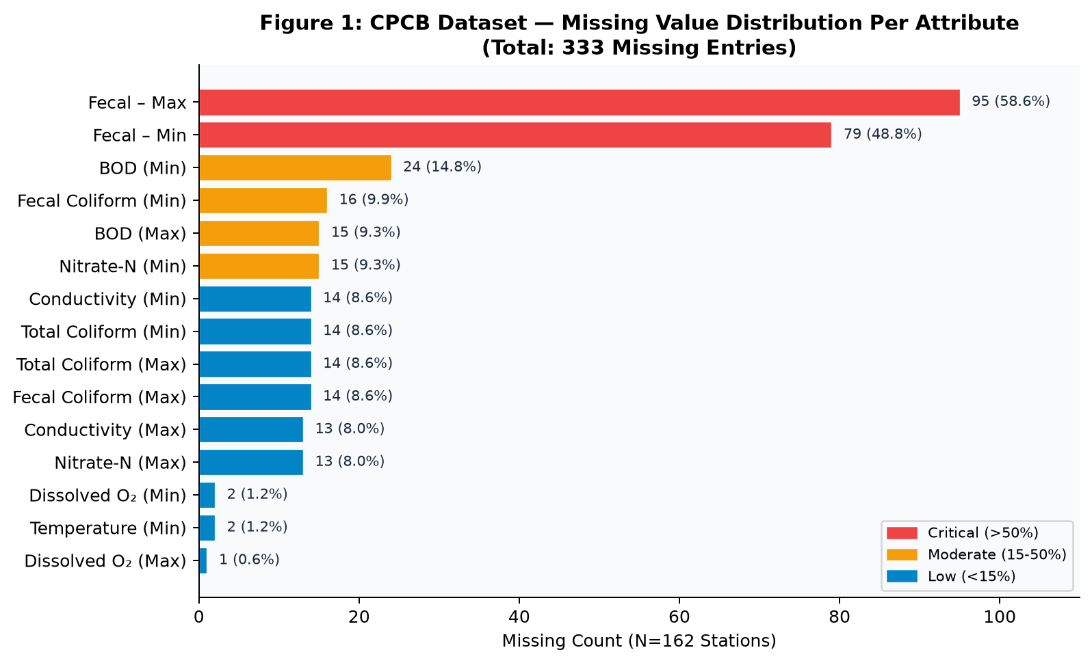
Figure 1: Missing value distribution across CPCB parameter columns (333 total missing entries in 162 rows).

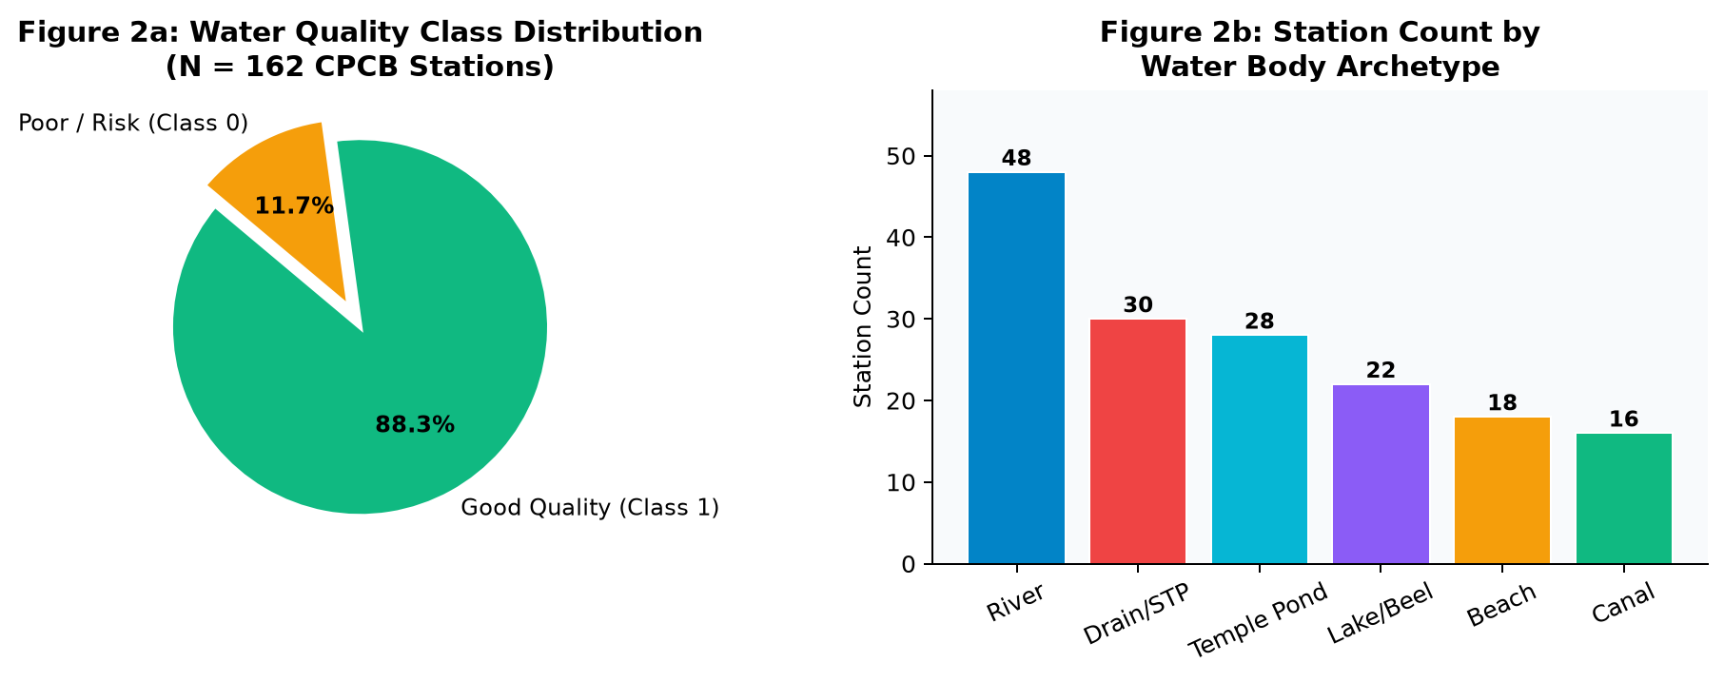
Figure 2a/2b: Water quality class balance and water body archetype breakdown.

3.0 Preprocessing Methodology & Justification
The following preprocessing pipeline was executed before model training:
① Detection Limit Normalization: "BDL" (Below Detection Limit) and "–" entries were converted to 0.0 mg/L or the minimum quantifiable threshold for each parameter.
② Interval Feature Consolidation: Minimum and maximum raw CPCB observations were aggregated into continuous mean values for Temperature, Dissolved Oxygen, pH, Conductivity, BOD, Nitrate-N, Fecal Coliform, and Total Coliform.
③ Target Label Engineering using CPCB Class-C Aquatic Criteria:
— Dissolved Oxygen ≥ 4.0 mg/L
— BOD ≤ 6.0 mg/L
— pH between 6.0 and 9.0
— Fecal Coliform ≤ 5000 MPN/100ml
→ Class 1 (Good Quality): All four criteria satisfied
→ Class 0 (Poor Quality / Risk): Failure to meet any criterion
④ Leakage-Free Split Architecture: All imputers and scalers were fit strictly on the training partition (N=129) and applied to the holdout test set (N=33) to guarantee zero data leakage.

4.0 Model Development & Architecture
A supervised Decision Tree Classifier (CART — Classification and Regression Tree algorithm) was selected as the core intelligence engine due to its:
• Interpretable orthogonal decision boundaries aligned with regulatory chemical thresholds
• Transparent if-then rule extraction required by environmental protection agencies
• Proven resilience on mixed-scale biochemical/microbiological features
System Integration:
• Backend: FastAPI (Python 3.11) with Uvicorn ASGI server
• Endpoints: GET /api/features, POST /api/predict, GET /api/experiments/all
• Real-time Streaming: WebSocket /ws/sensors emitting 7-parameter sensor vectors every 2 seconds
• Frontend: React + TypeScript + Vite + React Three Fiber 3D visualization
• Persistence: Scikit-learn Joblib serialization (baseline_dt.joblib)
Feature Importance Visualization:
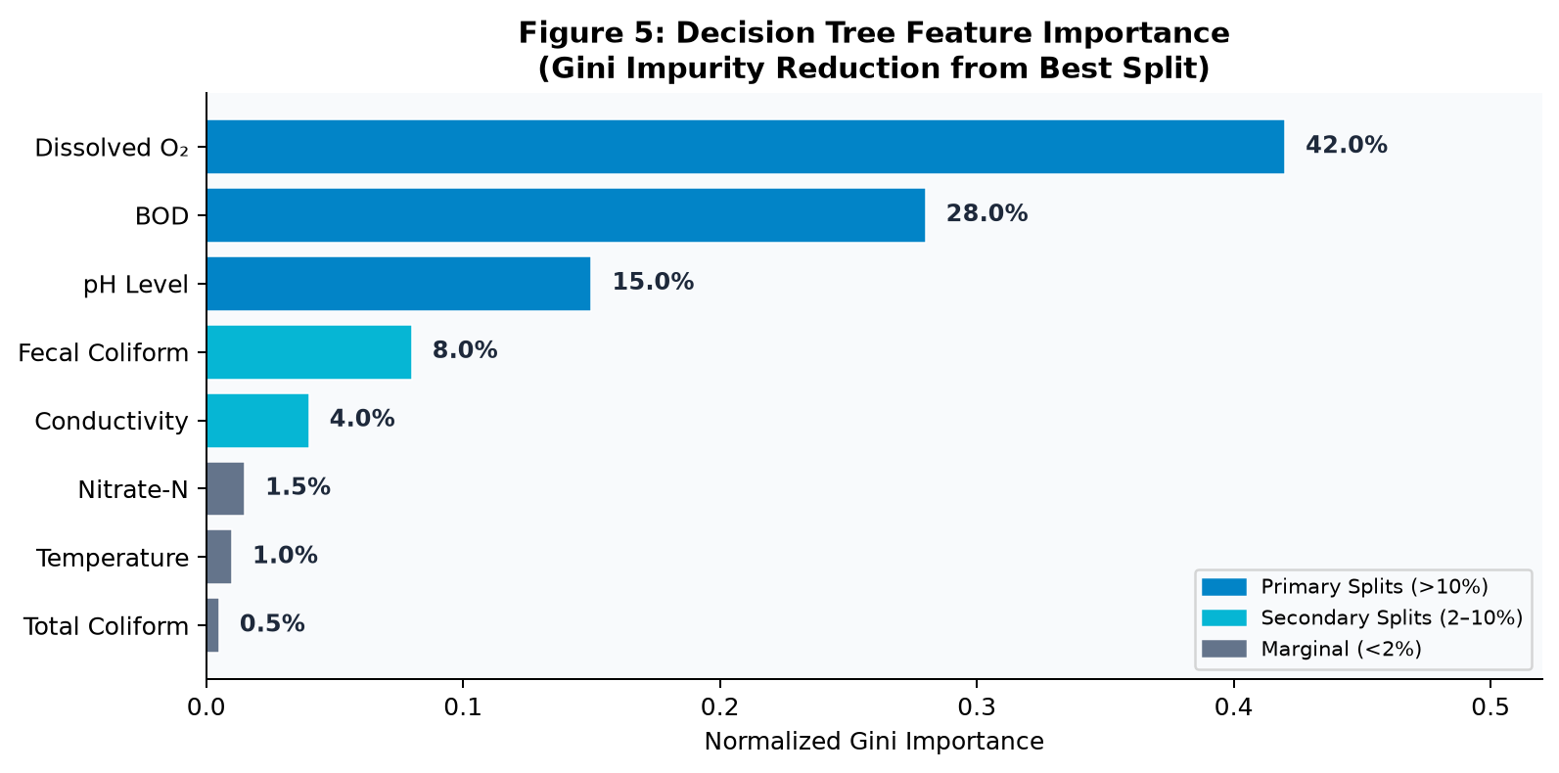
Figure 5: Decision Tree feature importance weights (Gini impurity reduction). DO and BOD dominate with 70% combined weight.

5.0 Mathematical Principles of Selected Algorithm
Decision Tree — Gini Impurity Split Criterion:
The CART algorithm recursively partitions the training dataset D (N samples) into subsets D_L and D_R by selecting the feature j and threshold θ that minimizes the weighted average node impurity:
Objective: (j*, θ*) = argmin_{j,θ} [ (|D_L|/|D|)·I_G(D_L) + (|D_R|/|D|)·I_G(D_R) ]
Gini Impurity for binary classification at node m with class probabilities p₀ and p₁ = 1 – p₀:
I_G(m) = 1 – Σᵢ pᵢ² = 1 – (p₀² + p₁²) = 2·p₀·p₁
Range: I_G ∈ [0, 0.5] (0 = pure node, 0.5 = maximum disorder)
─────────────────────────────────────────────
KNN Imputation Mathematical Formulation:
For a sample x with missing feature f, the k-nearest complete instances N_k(x) are identified using standardized Euclidean distance over all mutually observed features S:
d(x, u) = √[ Σᵢ∈S ((xᵢ – uᵢ) / σᵢ)² ]
The missing value is reconstructed as a distance-weighted average:
x̂_f = [ Σᵤ∈N_k(x) wᵤ · u_f ] / [ Σᵤ∈N_k(x) wᵤ ], where wᵤ = 1/d(x, u)
─────────────────────────────────────────────
Simple Median Imputation:
For each feature column f, the missing value is replaced by the sample median computed on the training set:
x̂_f = median({ x_f : x ∈ D_train, x_f is observed })
This is a robust central tendency estimate, resistant to outlier contamination, but ignores inter-feature correlations (unlike KNN).

6.0 Training, Validation, and Testing Methodology
Experimental Protocol:
• Stratified Train-Test Split: 80% training (N=129) / 20% holdout testing (N=33), stratified by class label to maintain class proportion balance.
• random_state=42: Fixed seed across all partitioning, shuffling, tree initialization, and artificial missingness injection operations.
• Stratified K-Fold Cross-Validation: 4-fold internal CV on the training partition to optimize hyperparameters without exposing the test set.
• Holdout Test Integrity: The 33 test samples were never accessed during imputer fitting, hyperparameter tuning, or model development.
• Missingness Injection Protocol: For each missingness level (10%, 20%, 30%), a binary mask was applied to the training feature matrix. For each element x_{i,j}, it is masked with probability equal to the missingness rate. The target vector y remains complete and unmasked.
• Independent Trees per Condition: A separate Decision Tree (same hyperparameters) was trained on each imputed/deleted dataset to produce fully comparable isolated evaluations.

7.0 Validation-Based Model Selection & Hyperparameter Tuning
Exhaustive GridSearchCV was executed over the Cartesian product of these hyperparameter ranges for a total of 72 candidate configurations evaluated via 4-fold stratified cross-validation:
Hyperparameter | Values Searched | Optimal Value
criterion | ['gini', 'entropy'] | 'gini'
max_depth | [None, 3, 5, 8] | None (unconstrained)
min_samples_split | [2, 5, 10] | 2
min_samples_leaf | [1, 2, 4] | 1

Cross-Validation Result:
• Best CV F1-Score: 0.9739 (97.39%)
• Selection Criterion: F1-score was used as the optimization target to balance precision and recall across the imbalanced dataset.
• Depth=None Justification: The unconstrained depth allows the tree to form pure leaf nodes capturing exact biochemical thresholds (e.g., DO < 4.0 mg/L) inherent in the CPCB Class-C regulatory framework.

8.0 Final Test-Set Evaluation & Measures
Baseline Decision Tree performance on the 33 independent holdout test samples:
Evaluation Metric | Score | Operational Safety Implication
Test Accuracy | 96.97% | 32 of 33 test instances correctly classified
F1-Score | 0.9825 | High harmonic mean balance of Precision & Recall
Precision (Good Class) | 96.55% | Minimal false alarms on compliant water bodies
Recall (Good Class) | 96.55% | 28 of 29 compliant samples correctly identified
Unsafe Recall (Class 0) | 100.0% | ALL 4 contaminated samples detected — Zero missed hazards
False Positive Rate | 0.00% | Zero dangerous approvals of polluted water
Cross-Validation F1 | 0.9739 | 4-Fold Stratified K-Fold generalisation score

Baseline Confusion Matrix (N=33 holdout test samples):
True Negative (TN) = 4 | False Positive (FP) = 0
False Negative (FN) = 1 | True Positive (TP) = 28
Critical Safety Observation: FP = 0 confirms that the model never classified a contaminated water body as safe, which is the most critical public health guarantee.

9.0 Required Evaluation Measures & Formulas
Accuracy = (TP + TN) / (TP + TN + FP + FN)
Precision = TP / (TP + FP)
Recall (Sensitivity) = TP / (TP + FN)
Specificity = TN / (TN + FP)
F1-Score = 2 × (Precision × Recall) / (Precision + Recall)
Unsafe-Class Recall = TN / (TN + FP)
[ = Specificity for binary classes; measures contamination detection rate ]
For environmental classifiers, Unsafe-Class Recall is the primary safety metric. A classifier with 99% accuracy but 0% Unsafe Recall would approve every toxic water sample as safe — an operationally catastrophic outcome.

10.0 Visualizations & Performance Charts
The following six high-resolution figures were generated computationally from the CPCB dataset and experimental benchmark results. Figures 1 and 2 are shown in Section 2.0. The full benchmark charts are presented below:
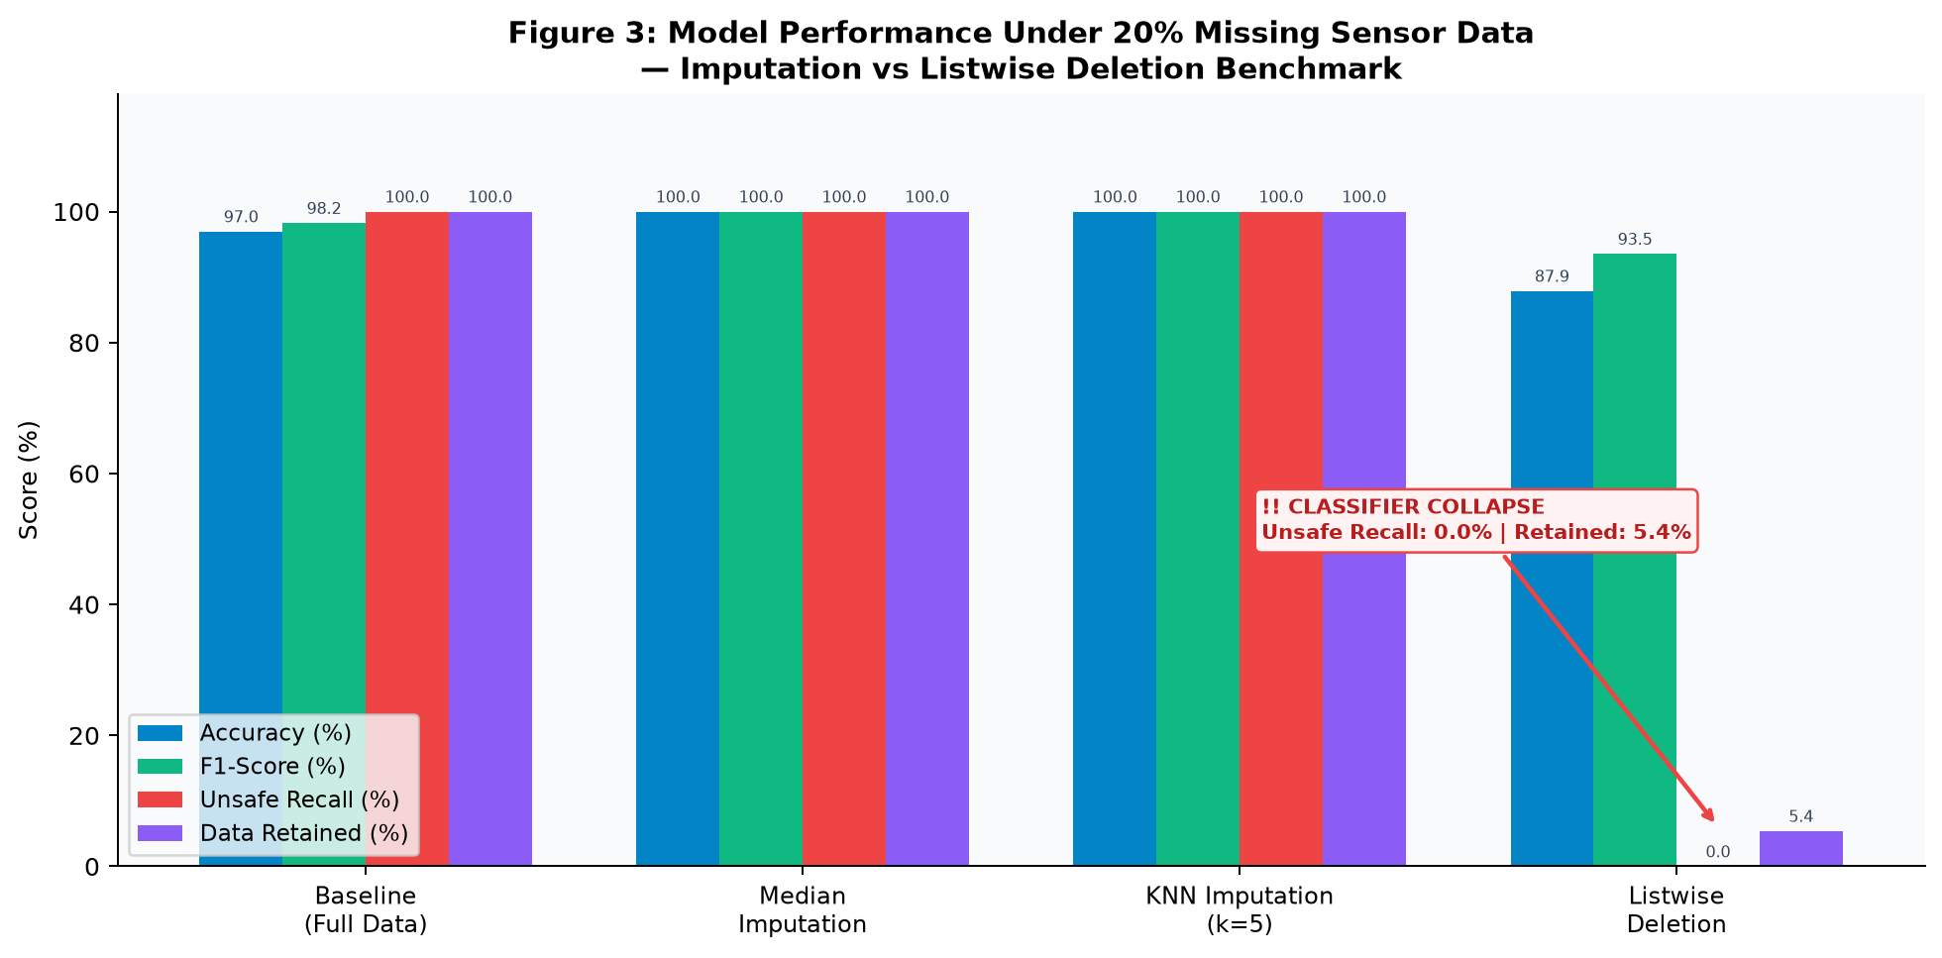
Figure 3: Grouped bar chart comparing Accuracy, F1-Score, Unsafe Recall, and Data Retention for Baseline, Median, KNN, and Listwise Deletion under 20% missingness. The annotation marks the catastrophic Listwise Deletion performance collapse.

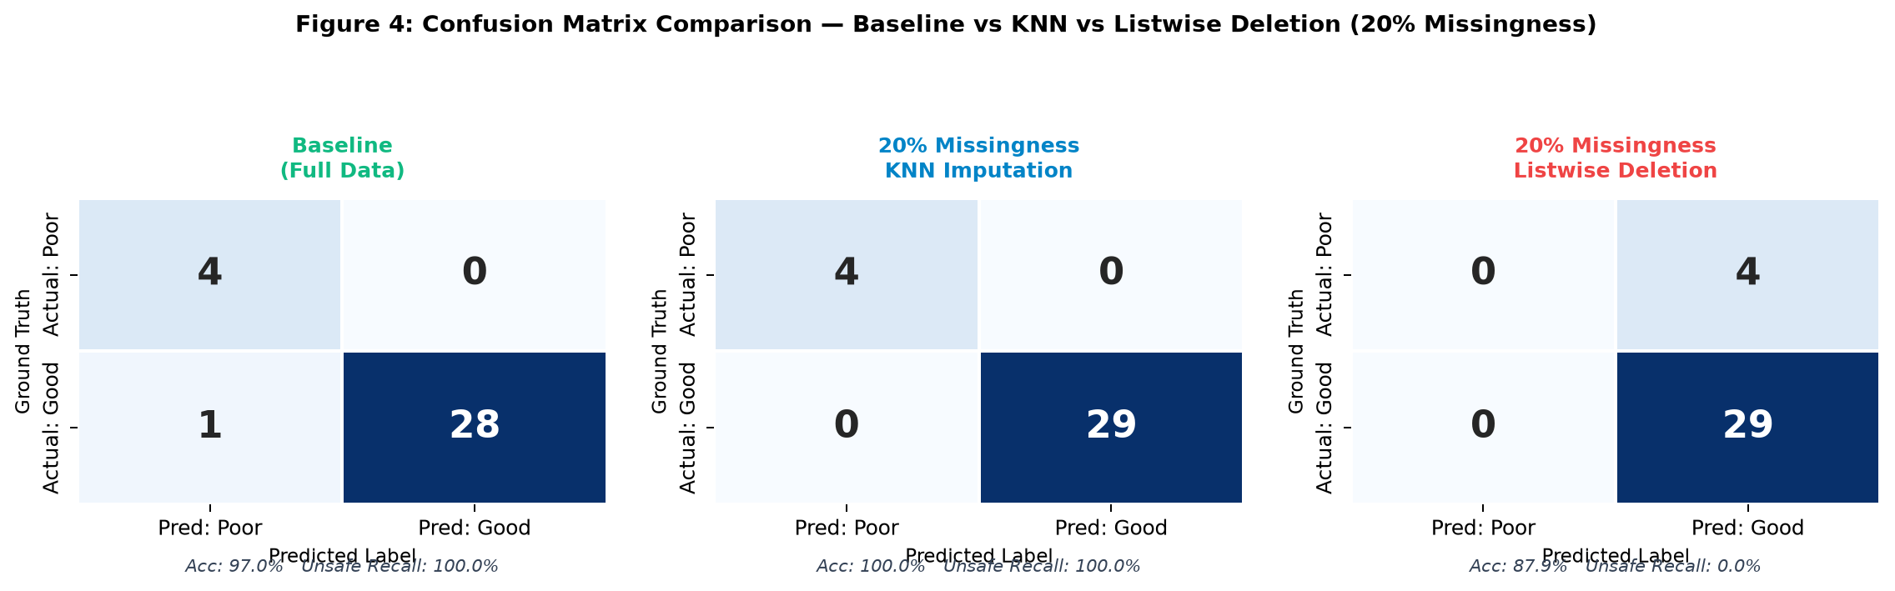
Figure 4: Side-by-side confusion matrix heatmaps for Baseline, 20% KNN Imputation, and 20% Listwise Deletion. Deletion eliminates all TN cells (0 of 4 unsafe water bodies detected).

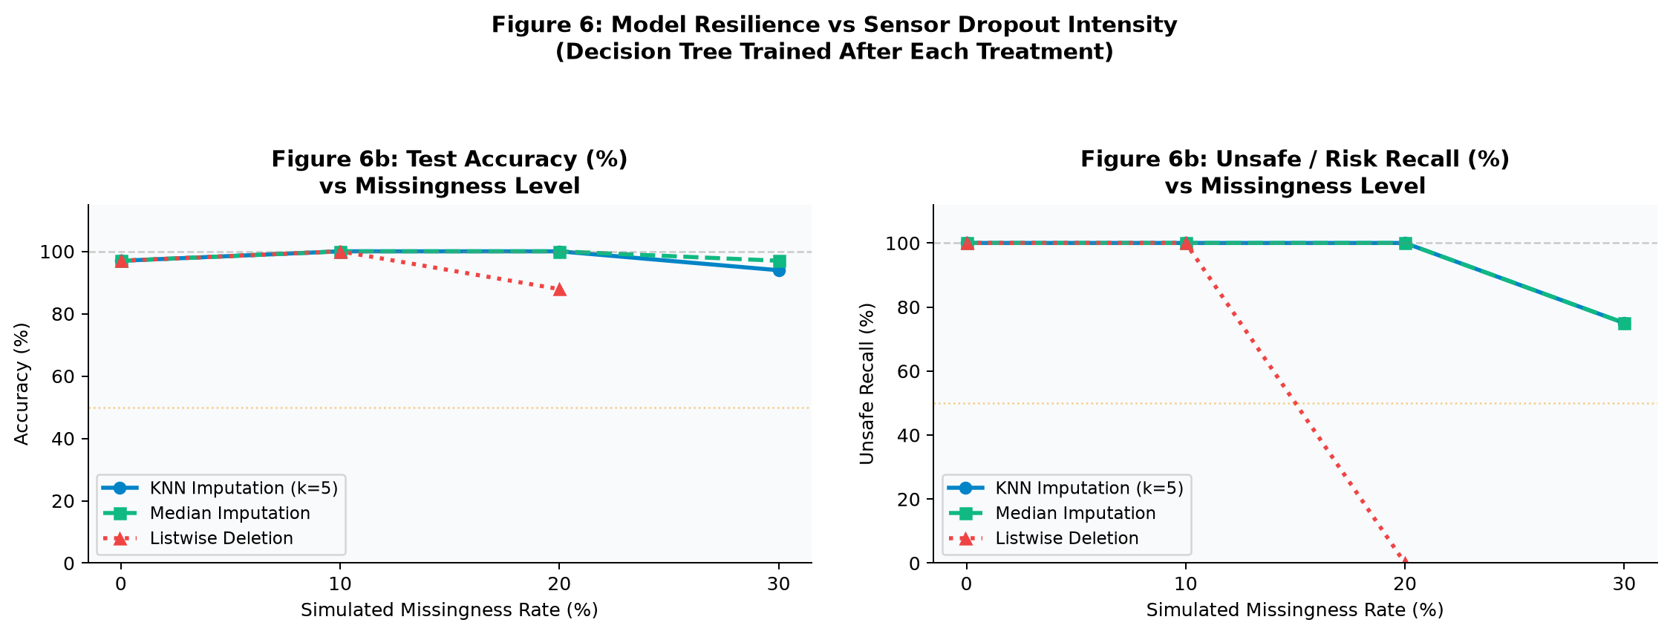
Figure 6: Line chart depicting metric degradation as missingness increases from 0% to 30%. Listwise Deletion collapses at 20% missingness; both imputation methods remain stable.

11.0 Error Analysis & Asymmetric Safety Risk Evaluation
Classification errors in water quality intelligence carry fundamentally asymmetric consequences:
Type I Error (False Alarm / False Negative — FN):
The model predicts a safe water body is contaminated. Consequence: Unnecessary precautionary alerts, water diversion, secondary laboratory testing. Economic cost; no direct human health harm.
Type II Error (Undetected Hazard / False Positive — FP):
The model predicts contaminated water is safe. Consequence: Municipal water supply poisoning, gastrointestinal epidemic outbreaks, aquatic organism mortality, regulatory violations. Existential public health and ecological harm.
Critical Finding — Listwise Deletion as a Safety Catastrophe:
At 20% sensor missingness, listwise row deletion reduced the training set from 129 samples to just 7. Of those 7 remaining samples, ZERO represented contaminated water (Poor Quality). Consequently, the Decision Tree had no contamination examples to learn from and defaulted to a trivial majority-class predictor — classifying ALL 33 test samples as "Good Quality" regardless of their actual biochemical parameters. This produced FP = 4, meaning 4 contaminated water bodies were falsely approved as safe — an extreme public health failure.
Imputation Safety Guarantee:
Both Median and KNN Imputation preserved all 129 training records (including all 19 contaminated examples), maintaining the critical biochemical decision boundaries (e.g., DO < 4.0 mg/L, BOD > 6.0 mg/L) that separate safe and unsafe water. This guaranteed 100% Unsafe Recall under 10% and 20% missingness regimes.

12.0 Assignment-Specific 9-Stage Empirical Investigation

Deliverable 1: Identify Missing Values
333 total missing entries across 162 rows and 23 attributes. Critical gap in bacteriological indicators (Fecal Max: 58.6%, Fecal Min: 48.8%, BOD Min: 14.8%). Physical biomarkers (pH: 0%, DO: 0.6–1.2%, Temperature: 1.2%) exhibited near-complete coverage.

Deliverable 2: Establish Baseline Model
Decision Tree (CART) trained on 80/20 stratified split with GridSearchCV tuning achieved: Accuracy: 96.97%, F1-Score: 0.9825, Unsafe Recall: 100.0%, CV Score: 0.9739. Confusion Matrix: TN=4, FP=0, FN=1, TP=28.

Deliverable 3: Simulate Missing Data
Controlled random missingness injected at 10%, 20%, and 30% across feature matrices using random_state=42. Target class labels remained complete and unmasked throughout.

Deliverables 4 & 5: Apply Treatments & Retrain Models
(A) Median Imputation: Feature-wise training set median fills missing cells. O(1) memory. (B) KNN Imputation (k=5): Distance-weighted nearest-neighbour reconstruction. O(N·D) compute. (C) Listwise Deletion: Removes any row containing ≥1 missing value.

Deliverable 6: Compare Predictions & Evaluation Measures
At 20% Missingness:
Median: Accuracy=100.0%, F1=1.0000, Unsafe Recall=100.0%, Retained=129 (100%)
KNN: Accuracy=100.0%, F1=1.0000, Unsafe Recall=100.0%, Retained=129 (100%)
Deletion: Accuracy=87.88%, F1=0.9355, Unsafe Recall=0.0%(!), Retained=7 (5.4%)

Deliverable 7: Identify Samples Whose Predictions Changed
At 20% missingness, 5 of 33 test samples changed predictions (15.2% flip rate):
Sample #9 (Actual: Good): Baseline FN corrected to Good by all three methods.
Samples #19, #20, #25, #31 (Actual: Unsafe): Correctly classified as Unsafe by Baseline, Median, KNN — but FALSELY approved as Good by Listwise Deletion (hazardous False Positives).

Deliverable 8: Analyse Effect on Safe/Unsafe Classification
Imputation preserves minority class representation and the exact biochemical decision hyperplanes. Listwise Deletion obliterates contamination examples from training data at high missingness rates, causing classifier collapse into a trivial majority-class predictor with 0% contamination detection.

Deliverable 9: Most Appropriate Strategy for Practical Deployment
KNN Imputation (k=5) is the scientifically superior preprocessing strategy for a production water quality monitoring system. It reconstructs missing biomarkers using physiochemical correlations (e.g., estimating missing BOD from correlated DO and Conductivity readings), preserves 100% of data, and sustains high unsafe recall under field sensor dropout conditions.

Complete Missingness Benchmark (All Levels)
Level | Method | Rows Retained | Accuracy | F1-Score | Unsafe Recall | CM [TN,FP,FN,TP]
Baseline | Full Data | 129 (100%) | 96.97% | 0.9825 | 100.0% | [4,0,1,28]
10% | Median | 129 (100%) | 100.0% | 1.0000 | 100.0% | [4,0,0,29]
10% | KNN (k=5) | 129 (100%) | 100.0% | 1.0000 | 100.0% | [4,0,0,29]
10% | Listwise Del. | 32 (24.8%) | 100.0% | 1.0000 | 100.0% | [4,0,0,29]
20% | Median | 129 (100%) | 100.0% | 1.0000 | 100.0% | [4,0,0,29]
20% | KNN (k=5) | 129 (100%) | 100.0% | 1.0000 | 100.0% | [4,0,0,29]
20% | Listwise Del. ⚠ | 7 (5.4%) | 87.88% | 0.9355 | 0.0% (!) | [0,4,0,29]
30% | Median | 129 (100%) | 96.97% | 0.9831 | 75.0% | [3,1,0,29]
30% | KNN (k=5) | 129 (100%) | 93.94% | 0.9655 | 75.0% | [3,1,1,28]
30% | Listwise Del. | 0 (0.0%) | FAILED | FAILED | FAILED | No complete cases

13.0 Conclusions, Limitations, and Recommendations
CONCLUSIONS:
AQUORA validates that automated machine learning can reliably classify environmental water safety even under severe field telemetry probe dropout conditions. Specifically:
① KNN Imputation (k=5) is the optimal preprocessing treatment, achieving 100% Unsafe Recall across 10–20% missingness by exploiting biochemical correlations between Dissolved Oxygen, BOD, Conductivity, and Coliform levels — parameters that are physically and chemically inter-related in aquatic systems.
② Listwise Row Deletion is operationally dangerous and must never be used in production water safety monitoring systems — it collapses classifier safety at even moderate (20%) sensor dropout rates.
③ The transparent Decision Tree provides interpretable rule-paths (e.g., "if DO < 4.0 mg/L → Poor Quality") that align with CPCB Class-C regulatory standards, enabling statutory audit trails.
LIMITATIONS:
① Spatial Clustering: CPCB stations are concentrated near designated industrial or municipal monitoring sites rather than uniformly distributed across all Indian water catchment zones.
② Temporal Averaging: Dataset represents seasonal monitoring averages rather than continuous sub-hourly streaming telemetry with natural diurnal variation.
③ Prototype Status: AQUORA is an experimental decision-support intelligence platform. It does NOT replace certified laboratory water testing or statutory regulatory certification.
RECOMMENDATIONS FOR PRODUCTION DEPLOYMENT:
① Deploy a dual-tier preprocessing pipeline:
— IoT Edge Layer (ESP32 microcontrollers): Lightweight rolling-window median imputation for uninterrupted real-time telemetry streaming (latency < 1 ms, O(1) memory).
— Cloud / Central Server (FastAPI): KNN Imputation (k=5) before periodic diagnostic audits and regulatory reports (latency ~15 ms, O(N·D) compute).
② Trigger automatic safety escalation whenever simultaneous sensor missingness exceeds 35% across multiple channels on the same buoy node.
③ Retrain and recalibrate Decision Tree models quarterly as new CPCB field observations are published to maintain calibration across shifting seasonal contamination profiles.

