PDO Entity Generator — Sequence Diagrams
Comprehensive sequence diagrams covering the primary user flows and key component interactions.

1. Composer Plugin — Auto-Configuration on Install
Trigger: composer install / composer update
This flow is triggered automatically when a user runs composer install or composer update in a project that includes kdevhubin/pdoentitygenerator. The PostInstallHandler Composer Plugin hooks into the POST_INSTALL_CMD and POST_UPDATE_CMD lifecycle events to auto-create the default configuration file.

- Flow Summary:
- Composer dispatches post-install/post-update event
- PostInstallHandler resolves the project root via vendor-dir config
- Checks if config/pdoentitygenerator.yaml already exists
- If missing: creates config/ directory (with chmod 0775 for Docker compatibility)
- Writes default YAML template via ConfigLoader::getDefaultConfigContent()
- Sets file permissions to 0666 (writable by any user in Docker)

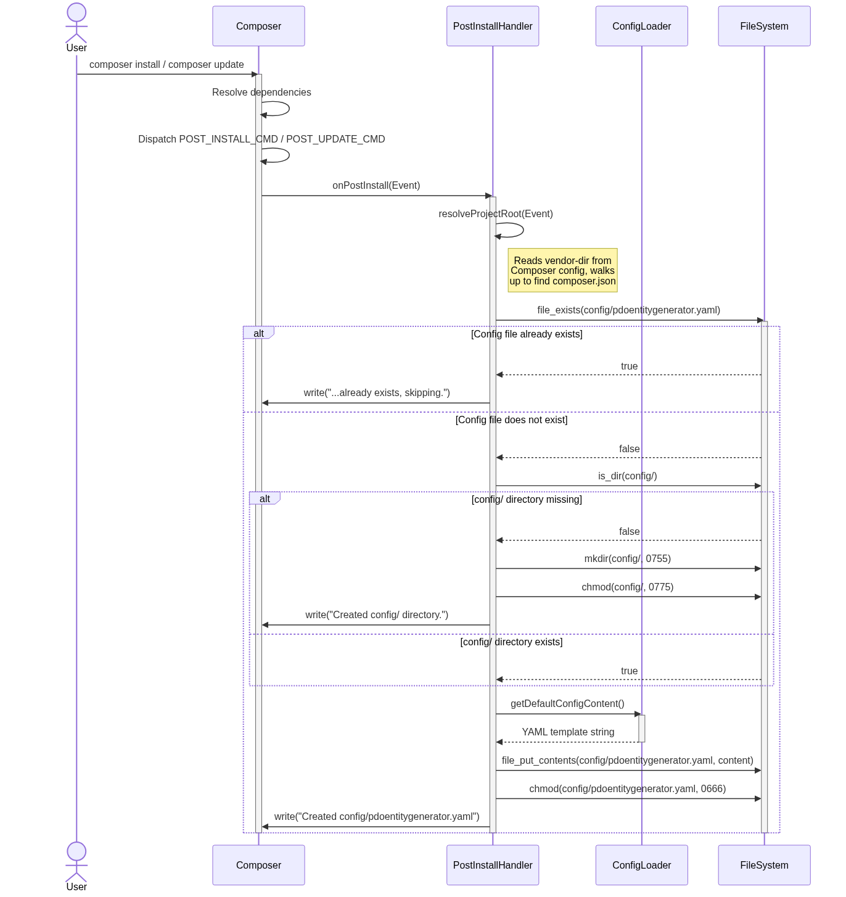

2. CLI Generation — Primary User Flow
Command: vendor/bin/pdoentitygenerator table <table_name>
This is the main user flow. The developer runs the CLI command to generate Entity and Repository classes from a database table. The command orchestrates a multi-step pipeline through six components.

- Pipeline Steps:
- CLI entry point resolves the Composer autoloader
- GenerateEntityCommand parses argv (validates command and table name)
- Resolves project root by walking up to find composer.json
- ConfigLoader reads and validates config/pdoentitygenerator.yaml via Symfony YAML
- Creates PDO connection with exception mode and native prepared statements
- TableInspector executes DESCRIBE query, maps SQL types to PHP types
- EntityGenerator builds a POPO class with typed properties, getters, and fluent setters
- RepositoryGenerator builds CRUD methods with bindValue() and PDO type constants
- Writes both files to disc with Docker-safe permissions (chmod 0775/0664)

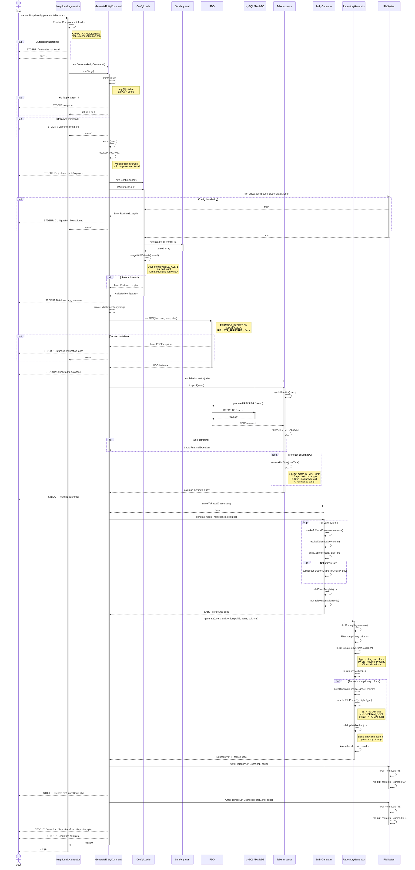

3. Generated Repository — Runtime CRUD Interactions
This diagram shows how the generated repository class interacts with the database at runtime, after the code has been generated. All five CRUD methods are covered: find, findAll, insert, update, and delete.

Method | SQL Operation | PDO Type Binding | Return
find($id) | SELECT ... WHERE pk = :id LIMIT 1 | bindValue(:id, $id, PARAM_INT) | ?Entity or null
findAll() | SELECT * FROM table | No parameters | Entity[]
insert($entity) | INSERT INTO table (...) VALUES (...) | bindValue per column with typed constant | Entity (with ID)
update($entity) | UPDATE table SET ... WHERE pk = :id | bindValue per column + PK binding | Entity
delete($id) | DELETE FROM table WHERE pk = :id | bindValue(:id, $id, PARAM_INT) | bool

- Key Characteristics:
- All parameters use bindValue() with explicit PDO::PARAM_* type constants
- Nullable columns use a local variable with ternary for PDO::PARAM_NULL
- DateTimeImmutable values are formatted as Y-m-d H:i:s before binding
- Primary keys are set via ReflectionProperty (bypassing the missing setter)
- Entity hydration uses type casting: (int), (float), (bool), (string), new DateTimeImmutable()

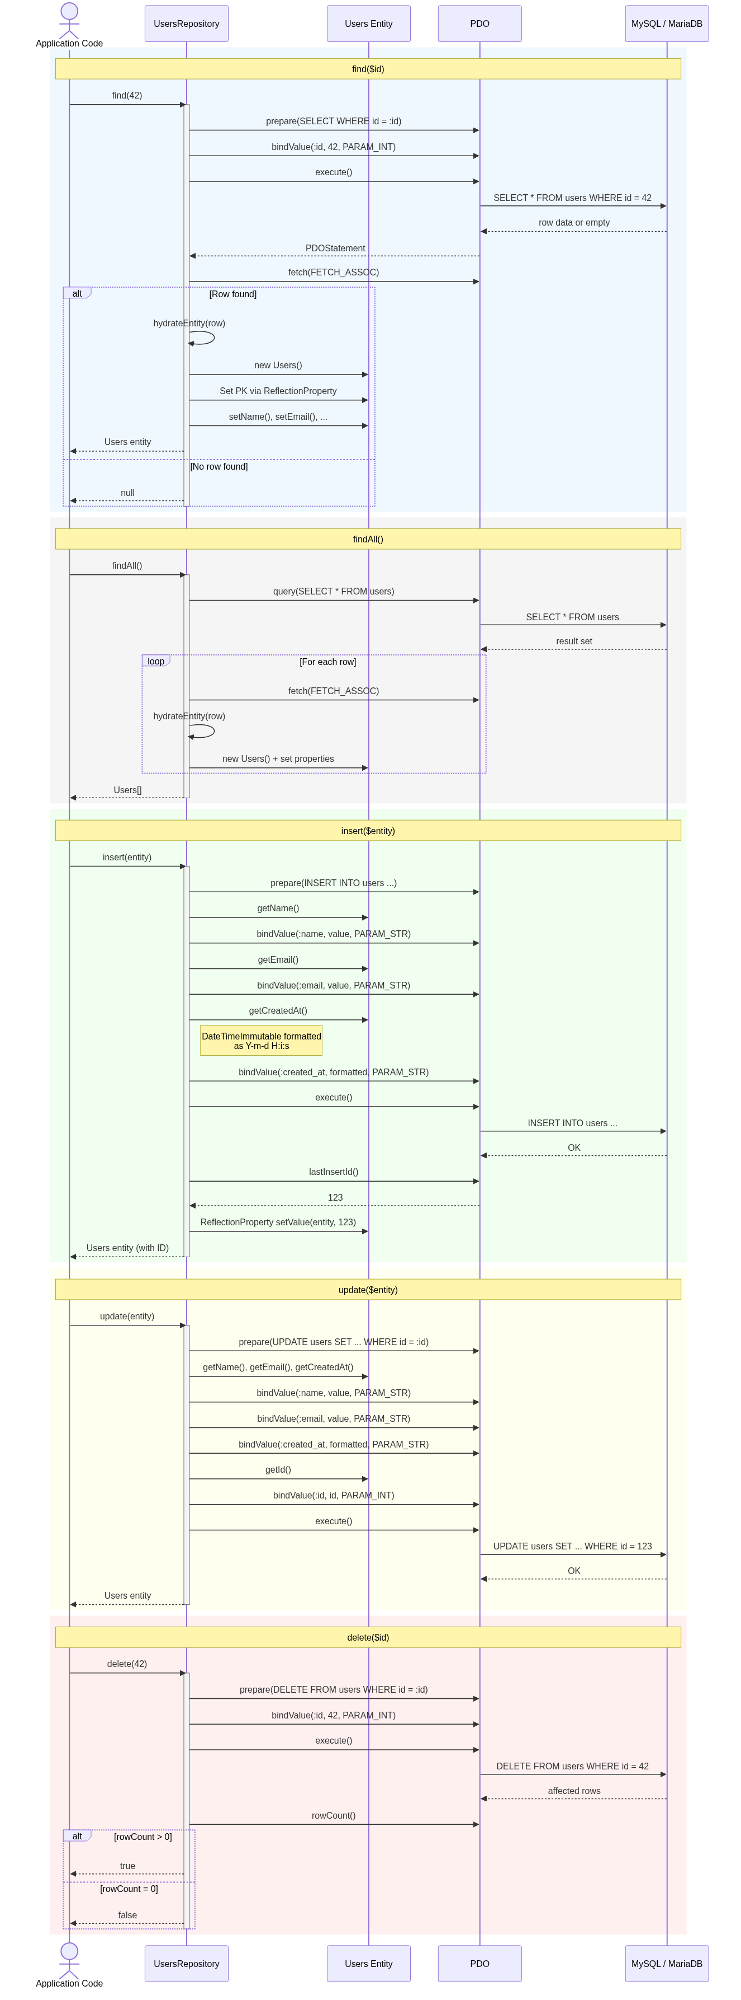

4. Participants Summary
Reference table mapping each diagram participant to its source class and role.

Participant | Class / Component | Role
User | Developer | Triggers Composer install or CLI command
Composer | Composer 2.x | Dispatches lifecycle events
CLI | bin/pdoentitygenerator | Entry point — resolves autoloader, delegates to command
Command | GenerateEntityCommand | Orchestrates the full generation pipeline
ConfigLoader | ConfigLoader | Reads and validates YAML configuration
YAML | Symfony\Component\Yaml\Yaml | Parses YAML files
PDO | \PDO | Database connection and prepared statements
Database | MySQL / MariaDB | Source of table schema and runtime data
TableInspector | TableInspector | Inspects table schema via DESCRIBE
EntityGen | EntityGenerator | Generates Entity class source code
RepoGen | RepositoryGenerator | Generates Repository class source code
PostInstallHandler | PostInstallHandler | Composer Plugin — auto-creates config file
FileSystem | PHP filesystem functions | Directory creation and file writing
Repo | Generated *Repository | Runtime CRUD operations (generated output)
Entity | Generated Entity class | Runtime data object (generated output)

5. PDO Type Mapping Reference
Mapping of PHP types to PDO parameter type constants used in generated bindValue() calls.

PHP Type | PDO Type Constant | Value Expression
int | PDO::PARAM_INT | $entity->getX()
bool | PDO::PARAM_BOOL | $entity->getX()
string | PDO::PARAM_STR | $entity->getX()
float | PDO::PARAM_STR | $entity->getX()
\DateTimeImmutable | PDO::PARAM_STR | $entity->getX()?->format('Y-m-d H:i:s')
Nullable (any) | Typed constant or PDO::PARAM_NULL | Local variable with ternary null check

