TEAM-7

BUILDING PIVOT TABLES USING STUDENT DATA FOR DECISION MAKING

1. Introduction to Student Data Analysis :-
Student Data includes marks, attendance, CGPA, technical skills, etc. Educational institutions collect student data for analysis and decision making. Data analysis helps to improve academic performance and decision making.
- There is an assumption that some pre-defined columns are present in the table (excel sheet)
- There should be a pre-check on the data set, that will confirm the presence or absence of expected list of columns
- attendance, CGPA, technical skills, etc
- The columns could be same or it could have something else other than expected
Ramani’s tasks/TLs:
- What is meant by classification?
- What are the methods in classification?
- How does it works→ understand the mathematical formulation
Creating Pivot table:
- A Pivot table is an Excel Tool used to summarize large amount of data.
- It helps to organize, Filter, and analyse information quickly.
- Pivot tables make reporting simple and effective.

2. Objectives of the project :-
- To Analyse Student data efficiently.
- ² To create reports using pivot tables.
- ² To support academic decision making.
- ² To visualize data using charts.
3. Student data Over view :-
- The dataset contains student names, groups, CGPA, GitHub account, ChatGPT account, and laptop access.
- The data is organized in rows and columns in Excel.
- Each column represents Specific student information.

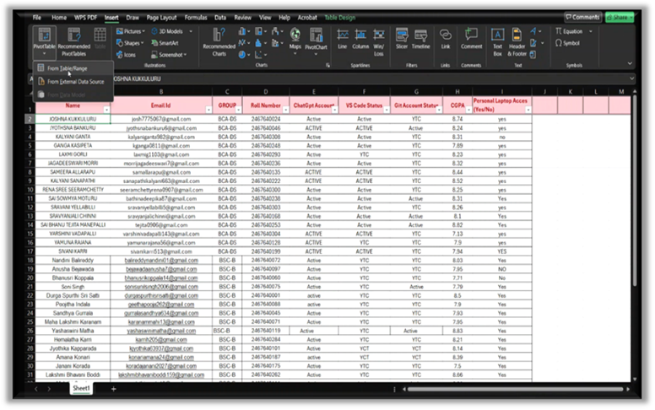
4. Data Organization in Excel :-
- The data was arranged with Proper headers.
- Blank rows and errors are removed.
- Data formatting was maintained for accurate analysis.
5. Pivot table creation (Steps) :-
i. Select the dataset.
ii. Click on Insert à Pivot table.
iii. Choose worksheet location.
iv. Drag fields into rows, columns, and values.
v. Generate analysis reports.
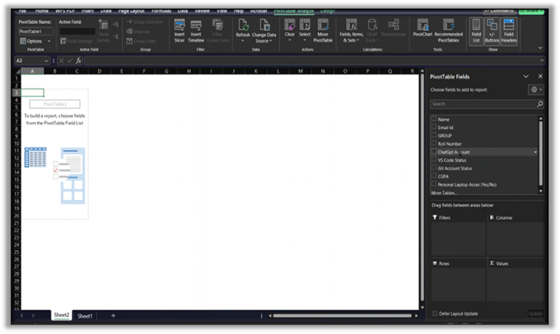
6. Analysis and Insights :-
How does previous academic performance can influence current CGPAs?
- 10th marks
- Intermediate (+2) marks
- CBSE/STATE - board name
- School name
  - Type of school (Private/govt)
- School location
  - City, Town, Village
- College name
  - Type of college
- College location
  - City/town/village
Task-1:
Data cleaning and data validation for all the above features
Task-2:
- Building pivot table in Python
  - Data checks
  - Column and respective properties
  - When all are present, all are absent and when new data comes

Task-3:How does 10th class features are influencing current performance
Task-4: How does intermediate class features influencing current performance
Task-5: how does both 10th and intermediate together are influencing current state of performance

Task-6: CGPA performance analysis :
When current CGPA alone is considered without all the features::
Average CGPA is calculated using Pivot tables
  - What are the data characteristics? [sample: understand distributions]
- mean /variance / percentiles
- Student performance is compared among groups which helps in identifying academic strength and weakness.

1.3 Technical Resource analysis:
Personal Laptop accessibility among students.GitHub and Vs code account usage were studied.

1.4 Insights:
- Pivot tables were used to analyse GitHub and ChatGPT account usage.
- This analysis shows interest in technology and AI tools.

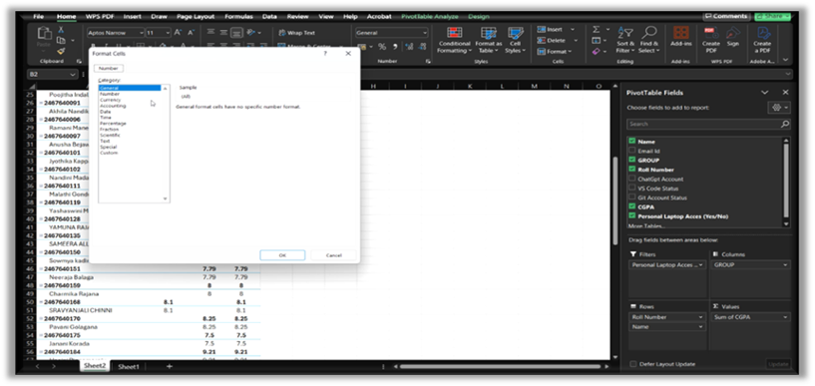
Problem Statement :
Educational institutions collect large amounts of student data such as CGPA, attendance, technical skills, software usage, and resource accessibility. Managing and analysing this data manually is difficult, time-consuming, and may lead to inaccurate decisions. There is a need for an efficient method to organize, summarize, and analyse student information for better academic and administrative decision making.This project focuses on using Pivot Tables in Microsoft Excel to transform raw student data into meaningful reports and insights. The project helps identify academic performance trends, technical readiness, and resource availability among students.
Real-Life Solution Scenarios
- Academic Performance Analysis
Problem:
Solution Using Pivot Table:
Create:
- Average CGPA by Group
Decision Making:
- Extra coaching can be provided to weaker groups.
- Faculty can improve teaching strategies.

2. Laptop Accessibility Analysis
Problem:
Some students may not have personal laptops for practical learning.
Solution Using Pivot Table:
Analyse:
- Students with and without laptop access
Decision Making:
- College can provide lab support or loan devices.
- Digital learning plans can be improved.

3. Technical Skill Readiness
Problem:
Institutions do not know how many students use platforms like GitHub or VS Code.
Solution Using Pivot Table:
Count:
- Students with GitHub accounts
- Students using VS Code
Decision Making:
- Organize coding workshops
- v Improve technical training programs

4. AI Tool Adoption Analysis
Problem:
Colleges need to understand student awareness of AI tools like ChatGPT.
Solution Using Pivot Table:
Analyse:
- Students having ChatGPT accounts
Decision Making:
- Conduct AI awareness sessions
- Introduce AI-based learning methods

5. Student Data Reporting
Problem:
Manual report preparation takes too much time.
Solution Using Pivot Table:
Generate:
- Automatic summaries
- Charts and reports
Decision Making:
- Faster report generation
- Better administrative planning

7. Decision Making Through Analysis :-

- Data Analysis supports academic planning.
- Decisions regarding digital resources and training become easier.
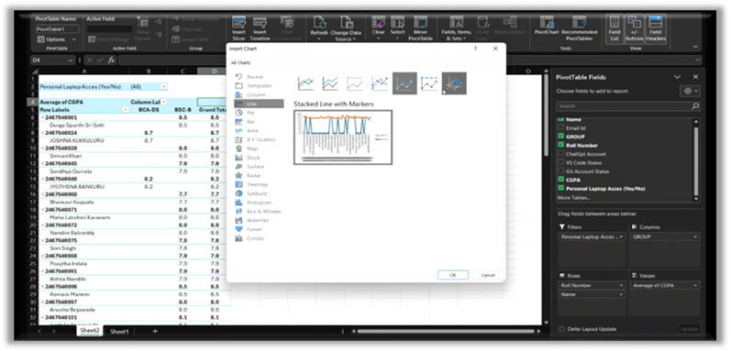

8. Project Outcomes :-
- Successfully created pivot table from Student Data.
- Generated meaningful Report and Graph.
- Improved understanding of Data analysis techinques and tools.

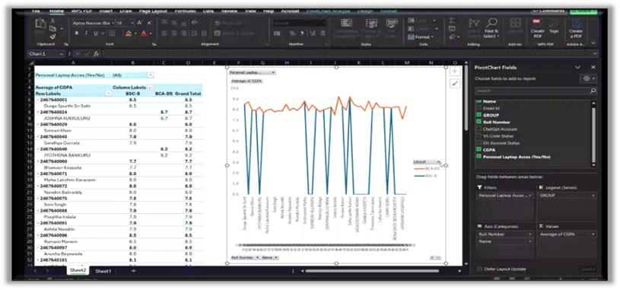
9. Advantages :-
- Saves time in analysis.
- Easy to Organise and understand.
- Helps in Accurate reporting and Visualization.

10. Applications & Websites used :-
1. Ms Word (Documentation)
2. Ms Excel (Data Analysis)

11. Future Improvements:
- More student Records can be analysed.
- Automatic and Real-Time reporting can be added.
12.Conclusion :-
- Pivot tables are powerful tools for student data analysis.
- They help to simplify complex and vast information.
- The project demonstrated effective decision making using excel.

…\…Thankyou…/…

