Week-1 Tic-tac-toe problem

# Tic-Tac-Toe Game

board = [' ' for _ in range(9)]

# Display the board
def print_board():
print()
print(board[0], "|", board[1], "|", board[2])
print("--+---+--")
print(board[3], "|", board[4], "|", board[5])
print("--+---+--")
print(board[6], "|", board[7], "|", board[8])
print()

# Check winner
def check_winner(player):
winning_positions = [
(0, 1, 2),
(3, 4, 5),
(6, 7, 8),
(0, 3, 6),
(1, 4, 7),
(2, 5, 8),
(0, 4, 8),
(2, 4, 6)
]

for a, b, c in winning_positions:
if board[a] == board[b] == board[c] == player:
return True

return False

def check_draw():
return ' ' not in board

# Main game
print("===== TIC-TAC-TOE =====")
print("Player 1: X")
print("Player 2: O")

player = 'X'

for turn in range(9):

print_board()

position = int(input("Player " + player + ", enter position (1-9): "))
position = position - 1

if position < 0 or position > 8 or board[position] != ' ':
print("Invalid move! Try again.")
continue

board[position] = player

# Check winner
if check_winner(player):
print_board()
print("Player", player, "wins!")
break

# Check draw
if check_draw():
print_board()
print("Game Draw!")
break

# Change playe
if player == 'X':
player = 'O'
else:
player = 'X'

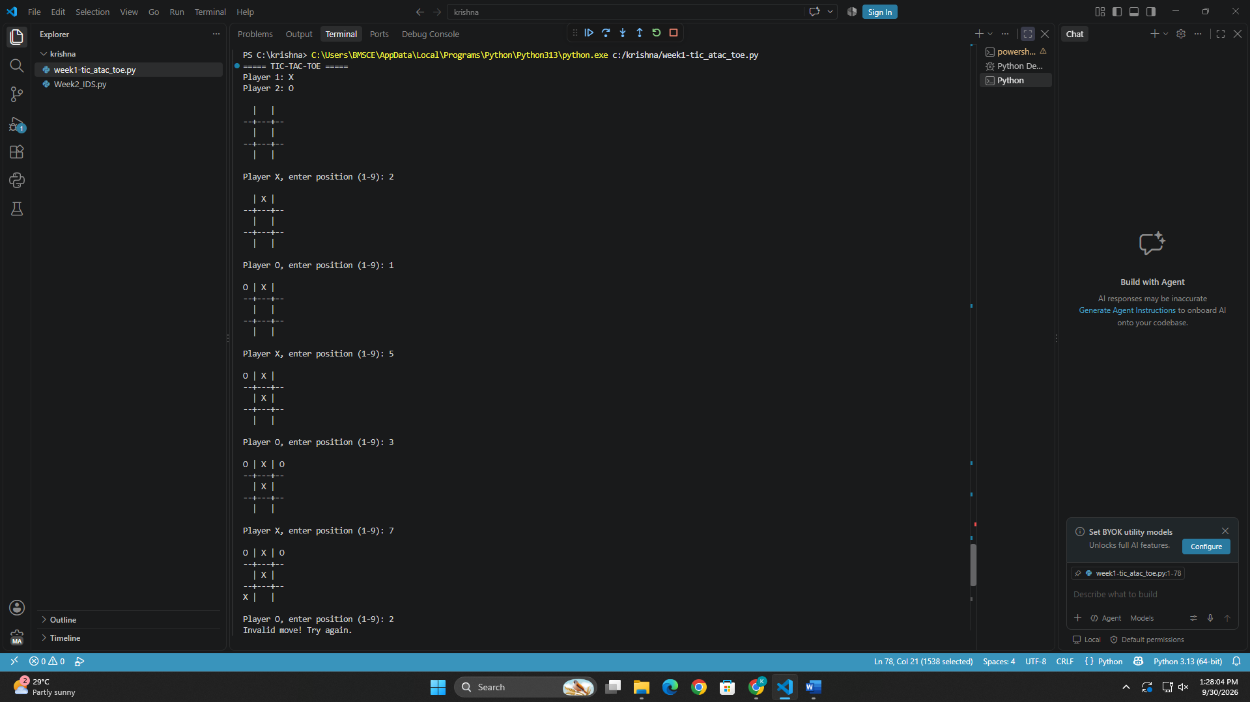
Week1-Vaccume cleaner agent

def vacuum_cleaner(location, room_A, room_B):

print("Initial State:")
print("Room A:", room_A)
print("Room B:", room_B)
print("Vacuum is in:", location)
print()

while room_A == "Dirty" or room_B == "Dirty":

if location == "A":
if room_A == "Dirty":
print("Vacuum is in A -> Suck")
room_A = "Clean"
else:
print("Room A is Clean -> Move to B")
location = "B"

elif location == "B":
if room_B == "Dirty":
print("Vacuum is in B -> Suck")
room_B = "Clean"
else:
print("Room B is Clean -> Move to A")
location = "A"

print("\nFinal State:")
print("Room A:", room_A)
print("Room B:", room_B)
print("Vacuum is in:", location)
print("All rooms are clean!")

location = input("Enter vacuum location (A/B): ").upper()
room_A = input("Enter status of Room A (Clean/Dirty): ").capitalize()
room_B = input("Enter status of Room B (Clean/Dirty): ").capitalize()

vacuum_cleaner(location, room_A, room_B)

