**PostgreSQL Training Day-1 Tasks**

**Name**: Pillalamarri Krishna Dheeraj

**Intern Id**: 2000147

**Email:** [saisuryadheeru@gmail.com](mailto:saisuryadheeru@gmail.com)

**PG Task-2**

Based On the below Table structure:

create table Employee

(

EmpId varchar(10) primary key pk1,

Name varchar(30) NOT NULL,

salary number(10),

location varchar(40),

Phone number(10),

Designation varchar(20)

)

Write the SQL Query For the Below Tasks using created table :

1. Show the EMP details with EMPID, PHONE and salary.

**Command:**

create table Employee

(empId varchar(10) primary key,

name varchar(30) nOT NULL,

salary integer,

location varchar(40),

phone integer,

designation varchar(20)

);

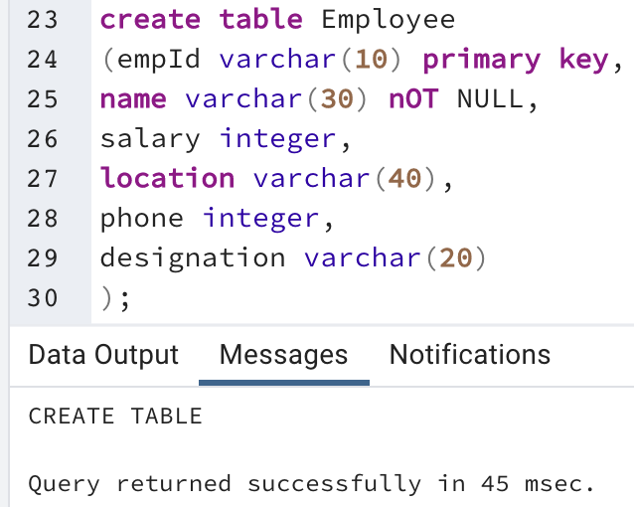

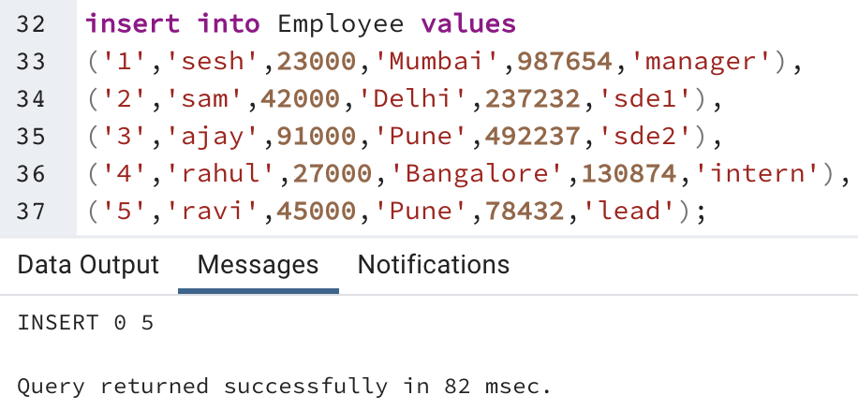

2. Show All employee have Location either Delhi or Mumbai.

**Command:**

select * from Employee where location in('Mumbai','Delhi');

3. Insert 2 more records without Salary and Location.

**Command:**

insert into Employee(empId,name,phone,designation)

values('6','pkd',987654,'manager'),

('7','sai',237232,'sde1');

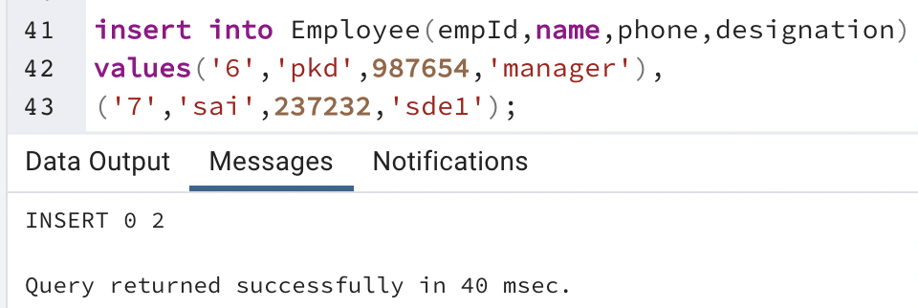

4. Show the Employee getting salary between 20000 and 40000.

**Command:**

select * from Employee where salary between 20000 and 40000;

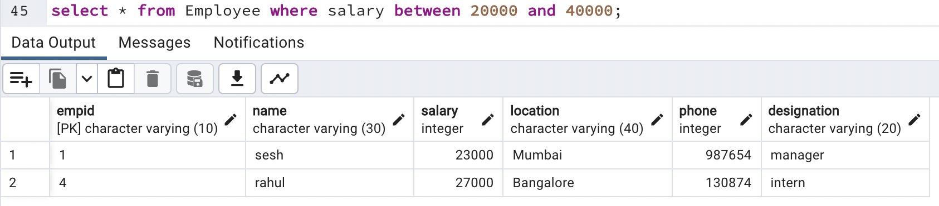

5. Show the Employee EMPID, Name and Salary getting the salary<40000.

**Command:**

select empId,name,salary from Employee where salary<40000;

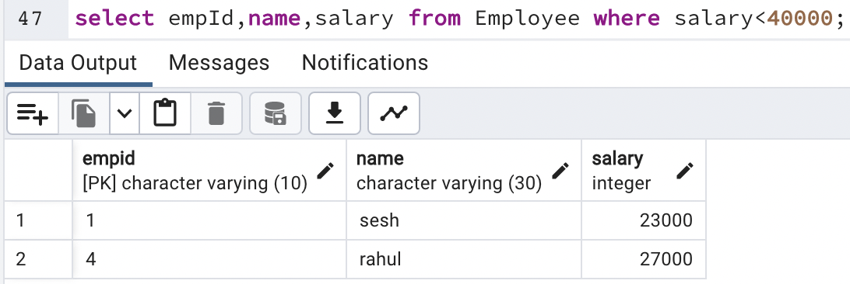

6. Show the list of employee Getting the salary>40000 and location is either from Mumbai or Delhi.

**Command:**

select * from Employee where salary>40000 and location in('Mumbai','Delhi');

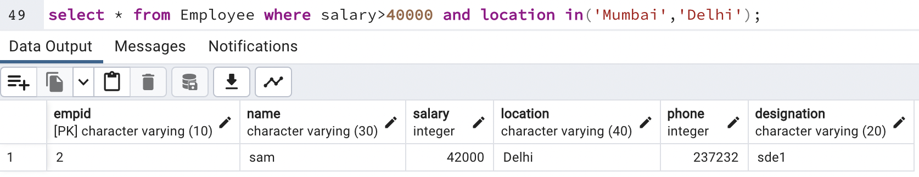

7. Show the List Of Employee name starts from S.

**Command:**

select name from Employee where name like 's%';

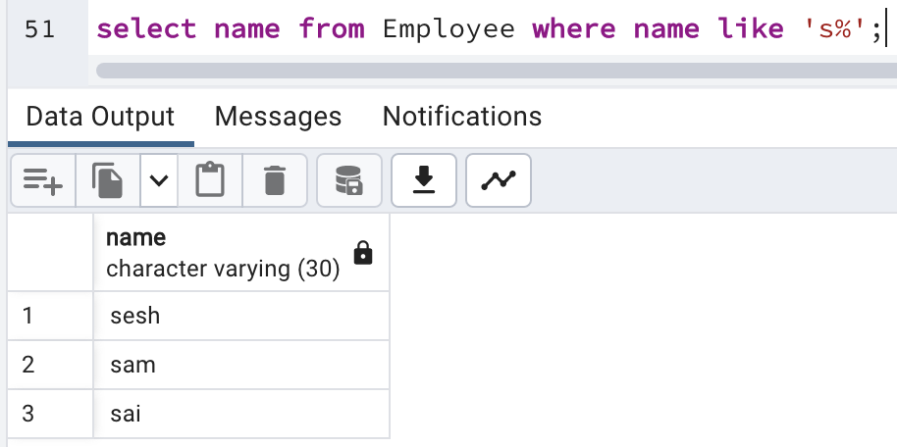

8. Show the Name and Phone Number of Employee not from Mumbai.

**Command:**

select name,phone from Employee where location not in('Mumbai');

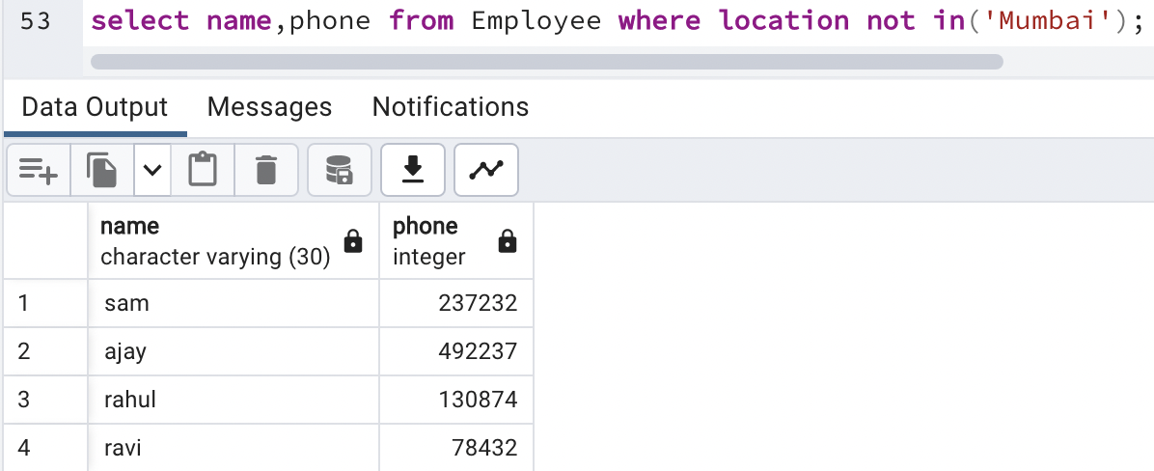

9. Show the Name of the Employee Name ending with 'SH'.

**Command:**

select name from Employee where name like '%sh';

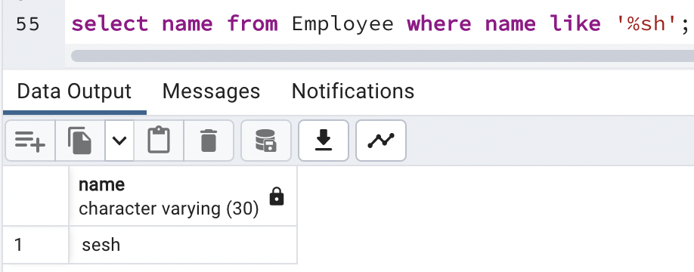

10. Show the Name, Designation & salary of the Employee getting salary>4000 and Name not starts from A.

**Command:**

select name,designation,salary from Employee where salary>4000 and name not like 'a%';

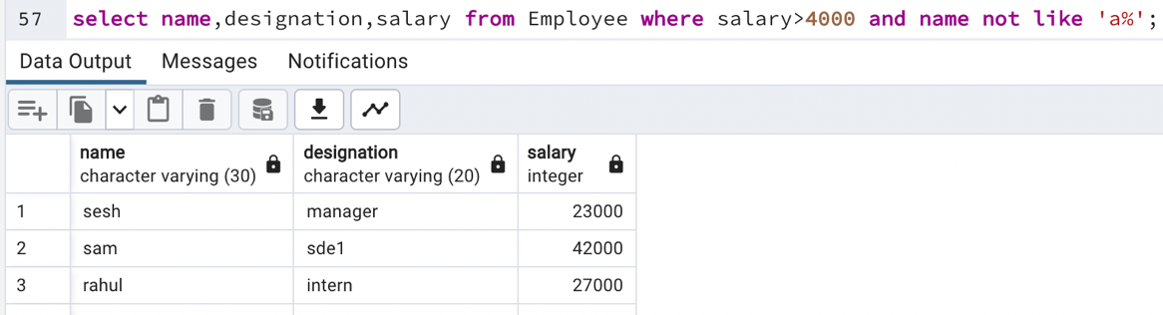

11. Update 10% of the salary who getting the salary>40000.

**Command:**

update Employee set salary=salary+salary*10/100 where salary>40000;

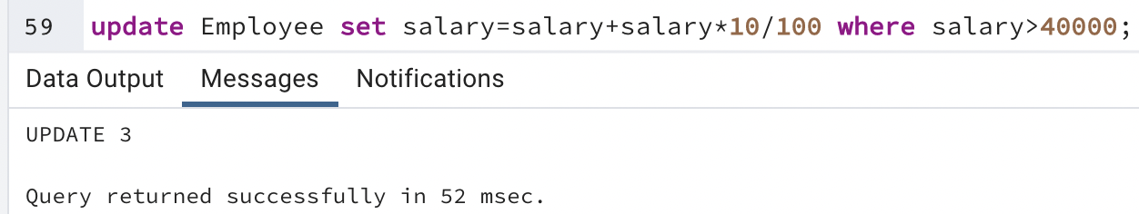

12. Delete all employee from the Employee table who getting the salary>90000.

**Command:**

delete from Employee where salary>90000;

