**PostgreSQL Training Day-1 Tasks**

**Name**: Pillalamarri Krishna Dheeraj

**Intern Id**: 2000147

**Email:** [saisuryadheeru@gmail.com](mailto:saisuryadheeru@gmail.com)

**PG Task-1**

1. Create the Below Table Structure with Conditions :

|  |  |  |  |  |  |
| --- | --- | --- | --- | --- | --- |
| EmpCode | Name | Designation | Age | Salary | Email |
|  |  |  |  |  |  |
|  |  |  |  |  |  |

1. Put Conditions on above table:
   * Empcode Should Not be Duplicate & Blank  - **Primary Key ( Key Field : No Blank, No Duplicate)**
   * Name Should not be blank – **Not Null**
   * By Default the Designation is STAFF – **Default**
   * //Age should be between 20 and 60 – **Check**
   * //Salary Should not be less than 5000 and salary should not be greater than 90000  **check**
   * Email should not be blank and Duplicate : **Unique**

**Command:**

create table emp_data

(empcode varchar(5)primary key not null unique,

name varchar(20) not null,

designation varchar(20) default 'Staff',

age integer check(age>20 and age<60),

salary integer check(salary>=5000 and salary<=90000),

email varchar(25) not null unique

);

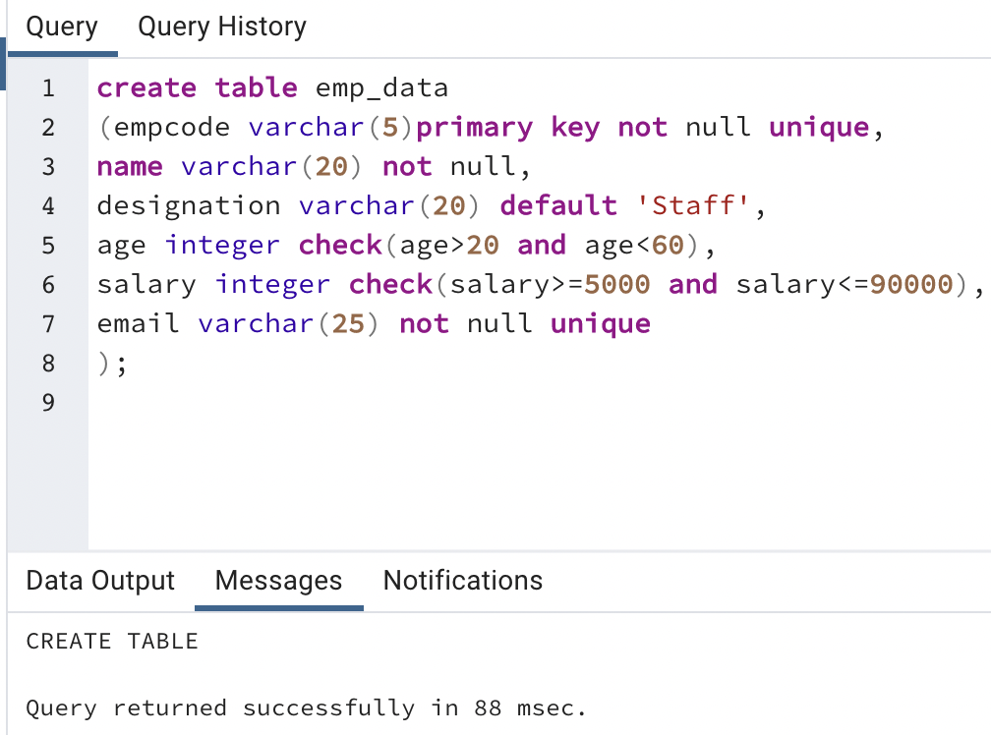

1. Insert 5 different records in the table.

**Command:**

insert into emp_data values (1,'raju','manager',26,67000,'rj@gmail.com'),

(2,'ram','sde1',22,47000,'rm@gmail.com'),

(3,'sam','sde2',34,53000,'sm@gmail.com'),

(4,'yash','lead',25,60000,'ys@gmail.com'),

(5,'jim','intern',21,30000,'jm@gmail.com');

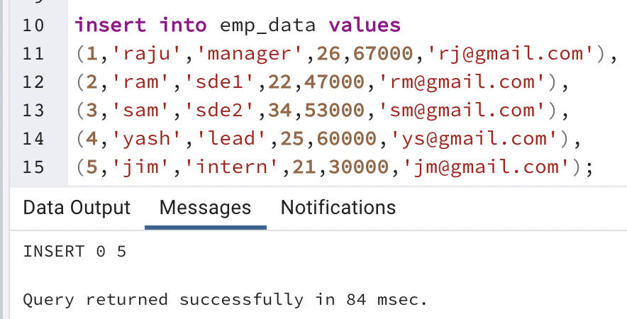

1. Create View for the employee getting salary more than 50000.

**Command:**

select * from emp_data where salary>50000;

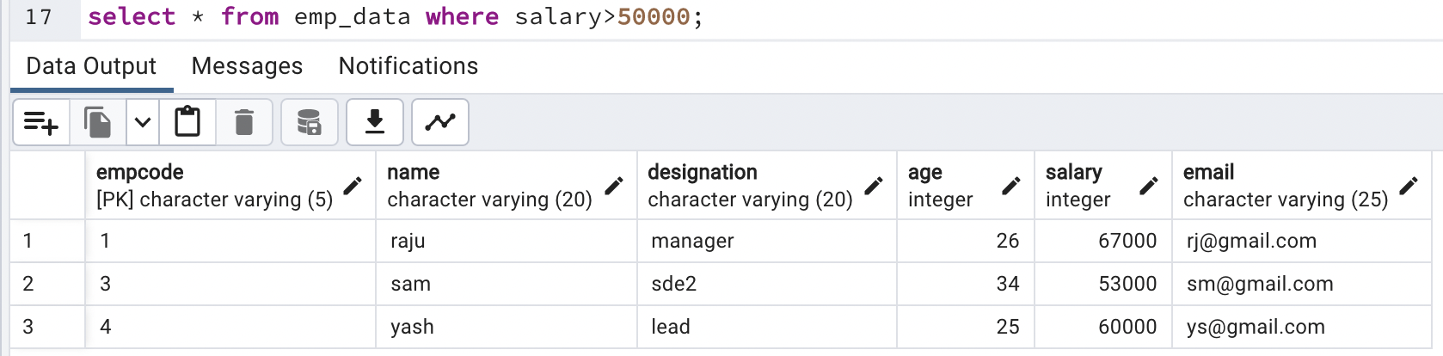

1. Create Procedure to  add location field in the given table.

**Command:**alter table emp_data add location varchar(25);

