**PostgreSQL Training Day-2 Tasks**

**Name**: Pillalamarri Krishna Dheeraj

**Intern Id**: 2000147

**Email:** [saisuryadheeru@gmail.com](mailto:saisuryadheeru@gmail.com)

**TASK 1:**

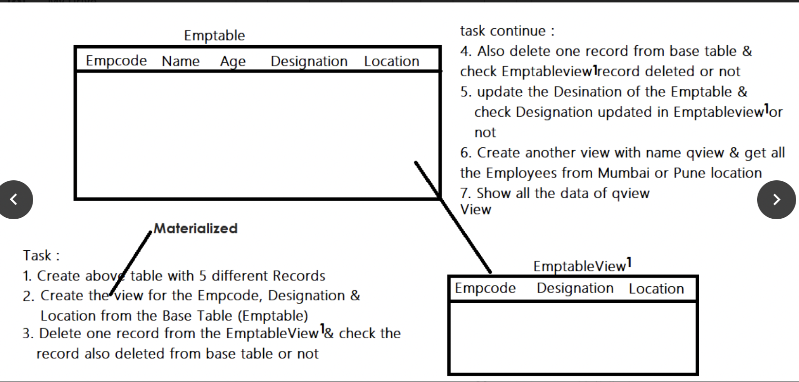

**2**.Create an employee table with 5 records.

**Commands:**

create table emp_details2 (empcode varchar(5),name varchar(20),age integer,designation varchar(25),location varchar(25));

insert into emp_details2 values (1,'Raj',20,'SDE2','Mumbai'), (2,'Ram',24,'SDE3','Pune'), (3,'PKD',21,'Intern','Pune'), (4,'Sam',26,'Manager','Bangalore'), (5,'greg',25,'SDE1','Bangalore');

select * from emp_details2;

**3**.Create a view for empcode,designation,location from base table.

**Command:**

create materialized view mymv1 as select Empcode,Designation,Location from emp_details2;

**4**.Delete one record from the view and check whether it is updated from base table.

**Commands:**

delete from mymv1 where empcode='2';

select * from emp_details2;

**5**.Delete one record from base table and check if view is updated.

**Commands:**

delete from emp_details2 where empcode='2';

select * from mymv1;

**6**.Update designation of emptable and check if it is updated in the view.

**Command:**

update emp_details2 set designation='SDE2' where empcode='4';

select * from mymv1;

**7**.Create another view qview with all employees from pune or Mumbai.

**Command:**

create materialized view qview1 as select * from emp_details2 where location='Mumbai' or location='Pune’;

**8**.Display view.

**Command:**

select * from qview1;