**Gujarat University**



**PROJECT REPORT ON:**

**INDIA TODAY**

**DEVELOPED BY:**

KARAN RATHOD (202126940103)

KRISHNA DHOLAKIYA (202126940021)

**MSc .IT Data Management & Visual Insight (sem-4)**

**(5 YEAR INTEGRATED)**

**Academic Year 2021-2026**

**INTERNAL GUIDE:**

MR. ROHIT SIR

**Acknowledgement**

It is our pleasure to acknowledgement the contribution and assistance of a few individuals to this efforts. We acknowledgment here our debt to those who have contributed significantly to this project.

We would like to thank Department of Animation for giving us a chance to gain the experience in project.

We would like to express our deep sence gratitude to our project internal guide Prof. Rohit Sir who provided him expert guidance and inspiration during all phases of this project. His guidance, suggestions and expertise have been a source of inspiration and helped in refining our thanking and approaches during the project tenure.

We would again to thank all who made it possible for us.

**Table of Content**

|  |  |  |
| --- | --- | --- |
| NUMBER | DESCRIPTION | PAGE NO |
| 1 | Introduction | 4 |
| 2 | Feasibility Study | 6 |
| 3 | Database Design | 7 |
| 4 | Screen Layout | 8 |
| 5 | References & Bibliography |  |
| 6 | Conclusion |  |

**Introduction**

* **What is India today?**
* India today is an article website.
* India today provides News, Articles, Magazines, Weather.
* India today provides National News, State Level News, International News.
* India today also provides top Headlines and Live TV.
* **Technology Used in this Project**
* **REACT JS**
* React JS is a free and open source front end java script library for building user interface based on component.
* Component: components are independent and reusable bits of code.
* Component used in this project: Header.jsx, : Signin.jsx, : Signup.jsx, : Subscribe.jsx
* CSS File used in this project: index.css

: login.css

: sub.css

* **NODE JS**
* Node JS is a cross platform, open source server environment that can be run on Windows, Linux, Unix, MacOS and more.
* Node JS is a back-end java script run time environment.
* We used Node JS in this project to connect MongoDB for data bases.
* Node JS and React JS are connected in this project.
* This project is based on Express JS.
* **MONGO DB**
* Mongo DB mongo is a source available cross platform document-oriented data base program.
* MongoDB is classified as a NoSQL data base program.
* MongoDB used JSON documents with optional schemas.
* MongoDB is faster and more scalable.
* Used of MongoDB in this project: Databases.
* **About**
  + We have so many Different News topic,
    - Like India-Today, E-Sports, Entertainment,
    - Travelling, Technical, Social Media, Share Market, Business, Login/Signin.
  + We will provide Images and Videos with news headline.
  + We used Advanced Technology to build this website like Node JS, React JS and Mongodb for Database.

**Feasibility Study**

**Database Design**

**Number of Tables**



**Sign up**

|  |  |  |  |  |  |
| --- | --- | --- | --- | --- | --- |
| **Serial No.** | **Field Name.** | **Data Type.** | **Size.** | **Constraints.** | **Description.** |
| 1 | Full name | Varchar | (30) | Not null | Store user name |
| 2 | Email.ID | Varchar | (30) | Not null,  unique,  Primary key | Store user  E-mail.ID |
| 3 | Password | Varchar | (30) | Not null | Store user Password |
| 4 | Contact | int | (12) | Not null | Store use contact no |

**Screen Layout**

Home page

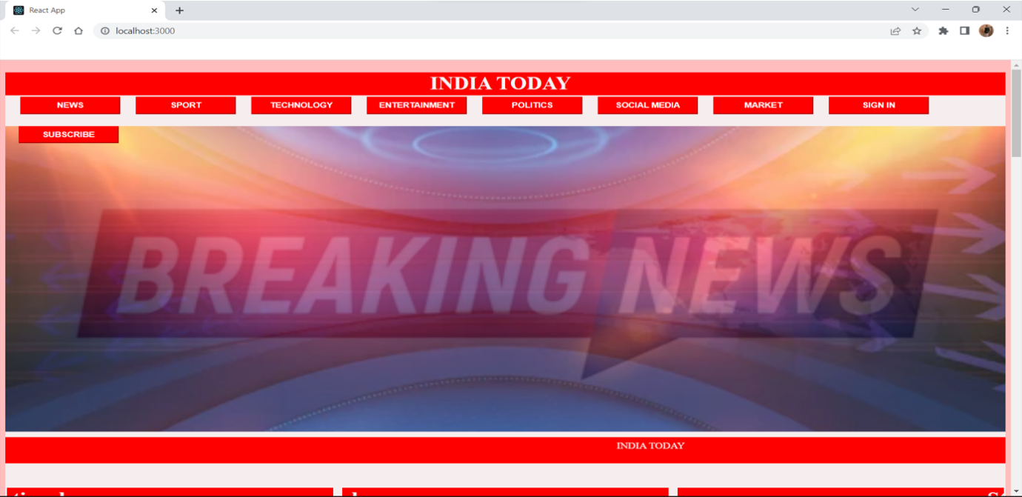

Content

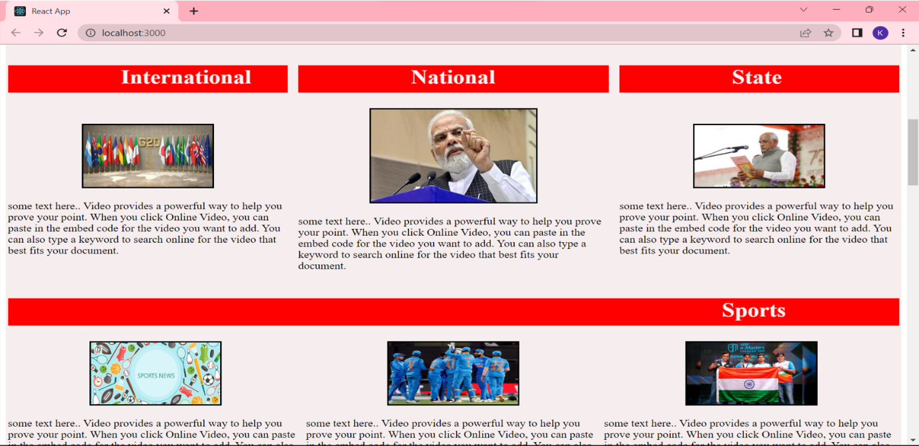

Footer

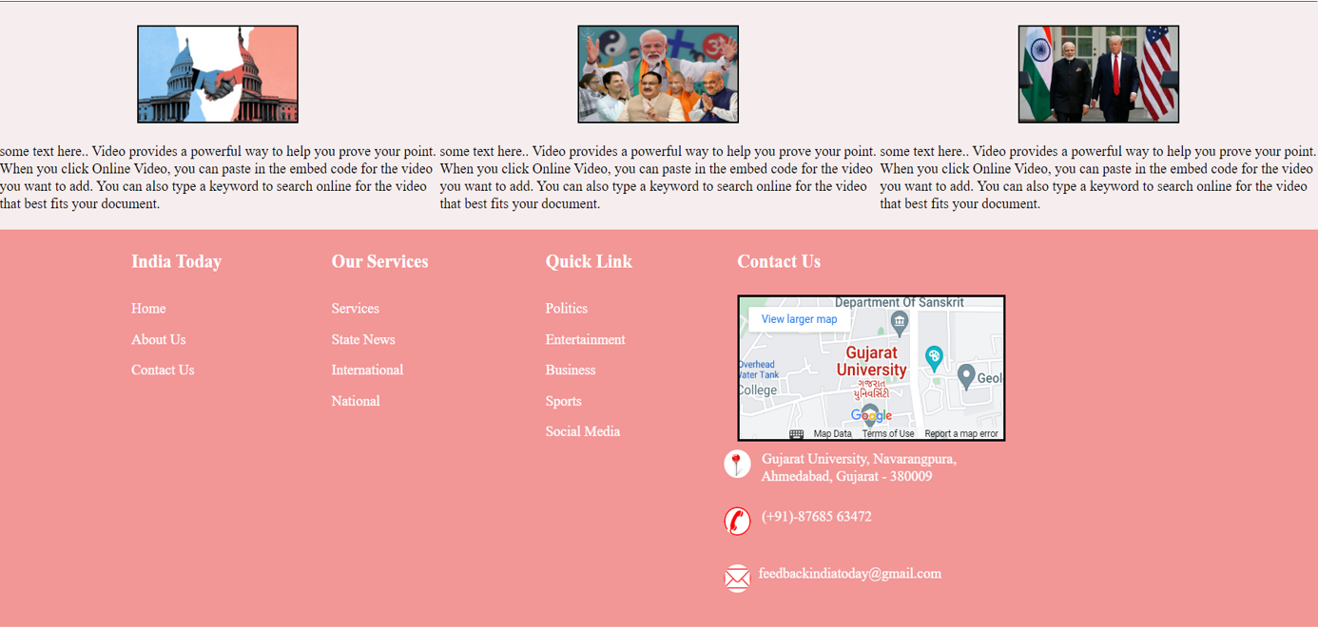

Sign in

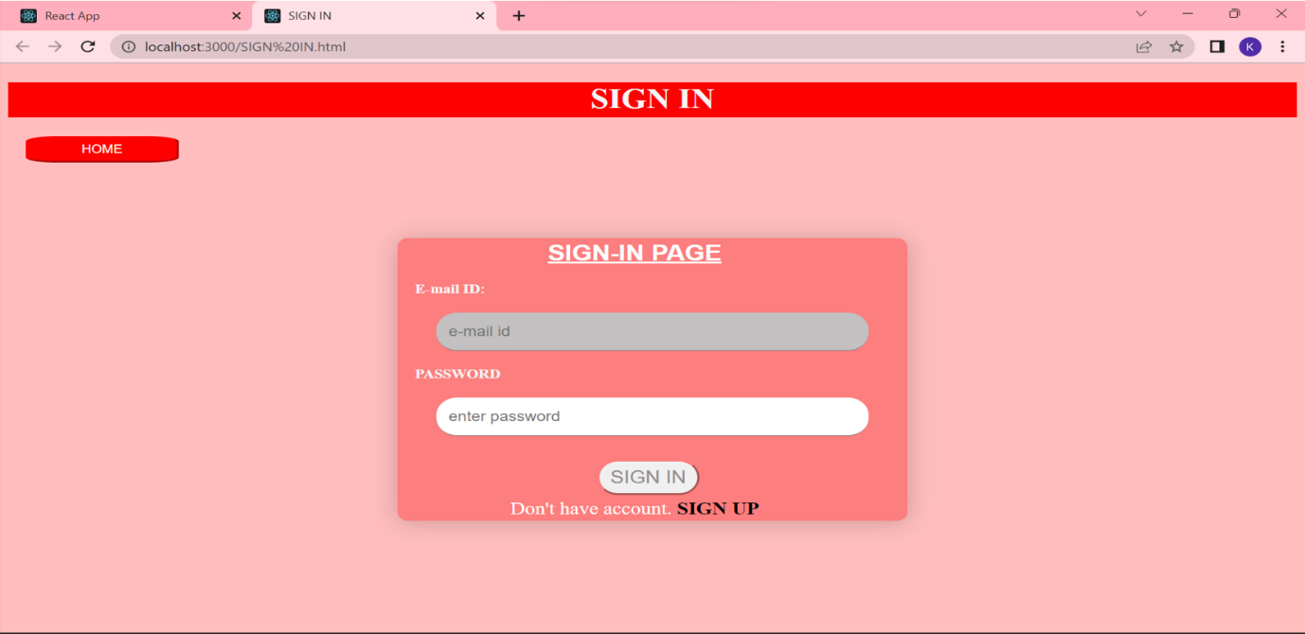

Sign up

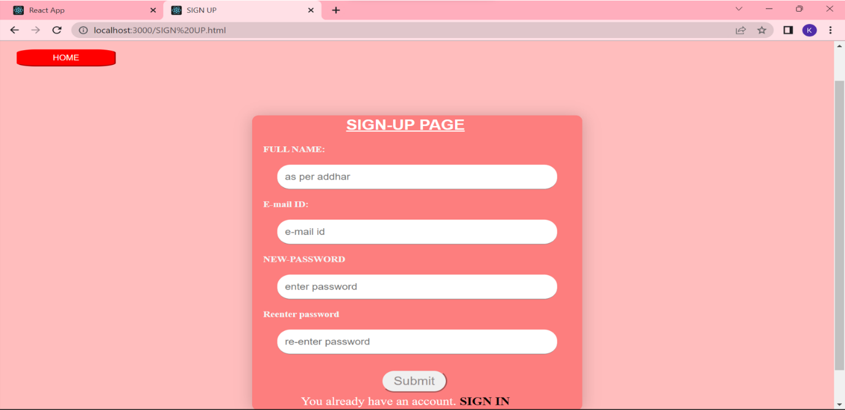

Subscription

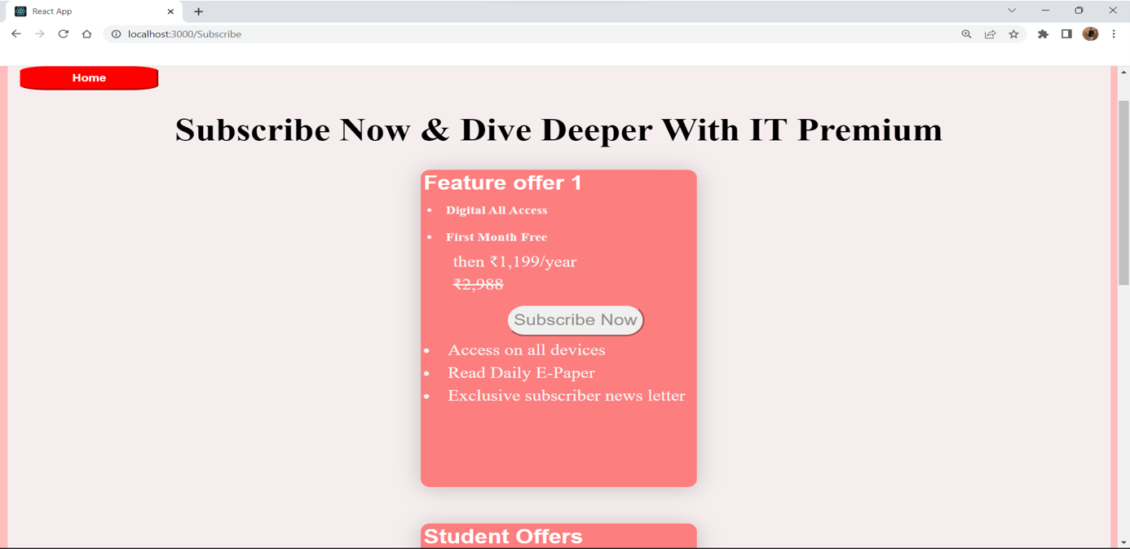

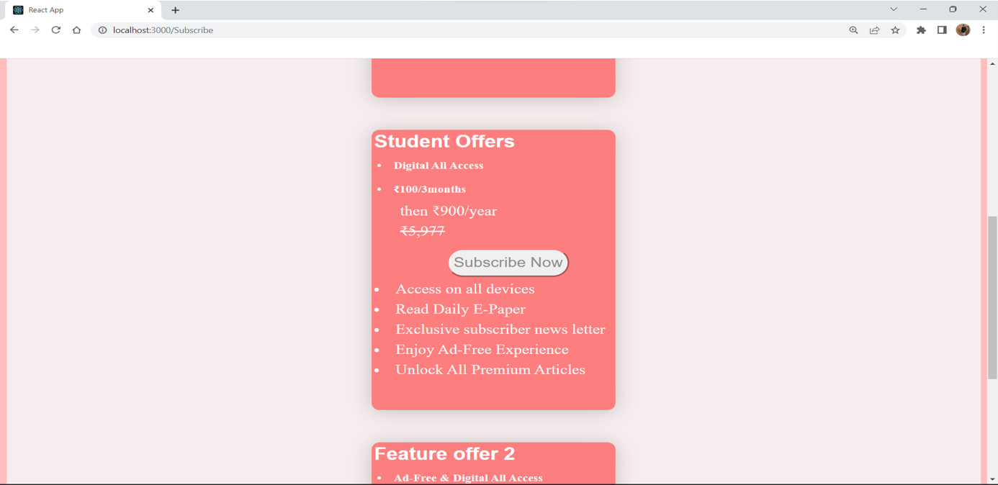

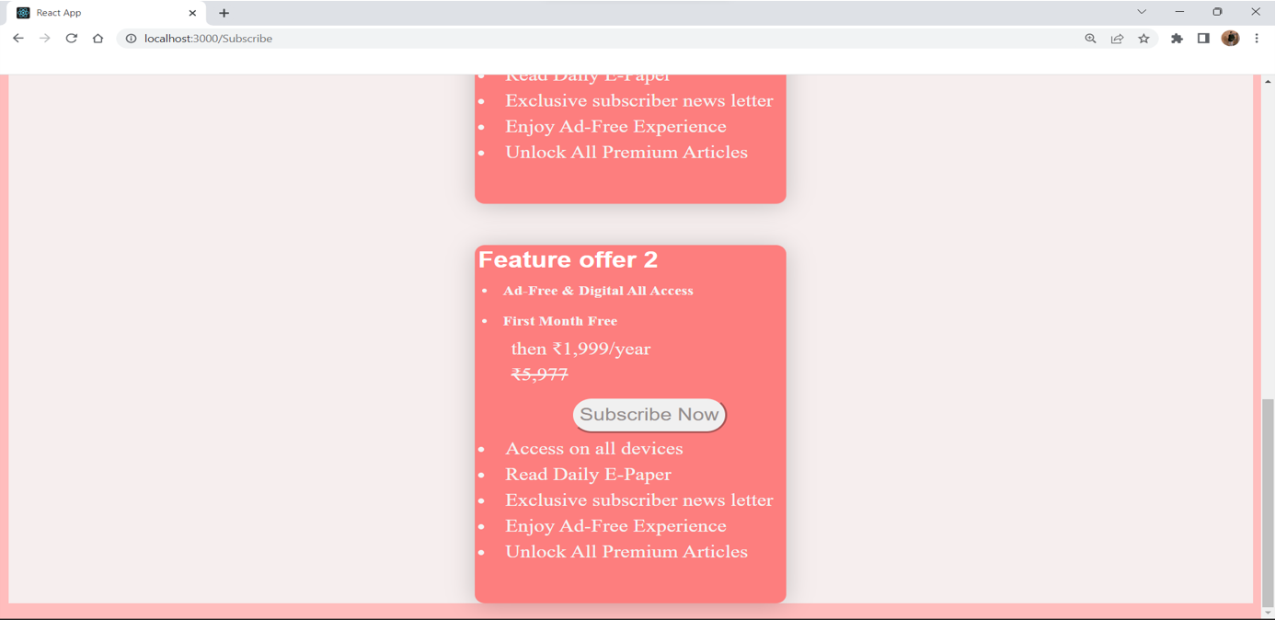

**References & Bibliography**

[www.usatoday.com](http://www.usatoday.com) (for front-end)

[www.indiatv.com](http://www.indiatv.com) (for front-end)

Apna college YouTube (for back-end)

**Conclusion**

* We have learned how to make proper website with frontend, backend, database connectivity.
* We learn how to work in group.
* Learned how to complete work in time limit.
* Get knowledge of software and packages like, visual studio codes, mongodb, mongosh, node packages.



Department of Animation, IT-IMS & Mobile Application, School of Science,

Gujarat University,

Navrangpura, Ahmedabad- 380009.

**CERTIFICATE**

This to certify that **Karan Rathod and krishna dholakiya** student of **MSc.IT in Data Management & Visual Insight(5 year integrated),** semester-4 , Enrollment No: **202126940103 and 202126940021** has satisfactorily completed his/her semester end project on **INDIA TODAY** by using React JS, Node JS and Mongodb.

Project internal guide:

MR. Rohit Sir