XAMPP Server

* Download and Extract
* setup_xampp.bat (Run)
* xampp-control.exe (Run)

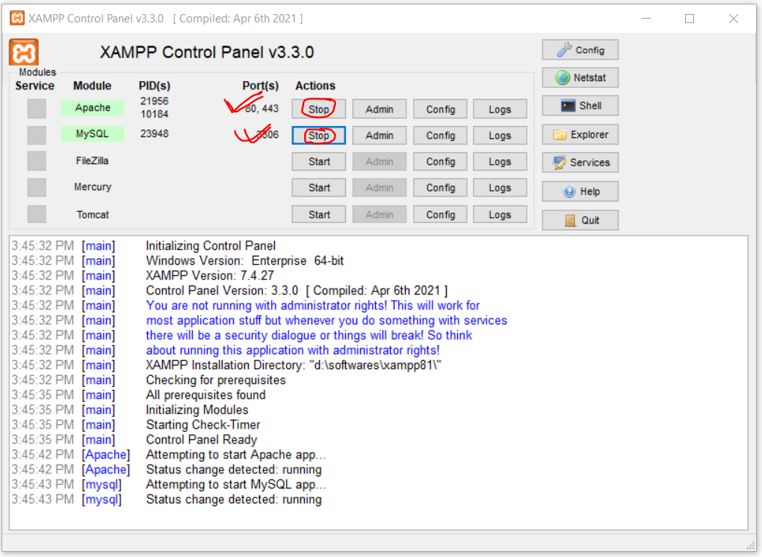

* Service start and Close (Apache/MySQL)
* Browse phpMyAdmin (http://localhost/phpmyadmin)
* Manage Database (Create, Select, Drop)
* Manage Table (Create, Alter, Drop)
* Record Manage (Insert, Update, Select, Delete)

**Database Connection (Python-> MySQL)**

**MySQL Info**

Server: localhost

Port: 3306

Database Name: ‘test’

Database User: ‘root’

Database User Password: ‘’

**Libraries (Core/Django)**

pip install mysql-connector

pip install mysql-connector-python

pip install mysql-client

**Connect with MySQL (Core Python)**