Home Work 1

Linear Systems

Sreedhar Sai Krishna Emani Venkata

UTA ID: 1001564303

EENG 5307 Homework 1

Assigned: September 12, 2017

Due Day: September 20, 2017

Problem 1: System Classification

1) Please prove that the following system is linear.

x˙(t) = A(t)x(t) + B(t)u(t)

y(t) = C(t)x(t) + D(t)u(t).

2) Please prove that the following system is time invariant.

x˙(t) = Ax(t) + Bu(t)

y(t) = Cx(t) + Du(t).

Problem 2: Modeling and the State Space Representation

Please study the circuit. The resistor, capacitor, and inductor values are marked on Figure 1.

Please construct a state-space continuous time model to describe the dynamics of the circuit.

Problem 3: Three Representations

Please derive the state space and Laplace transform models for the following two systems.

Problem 4: Linearizion and Computer Simulation

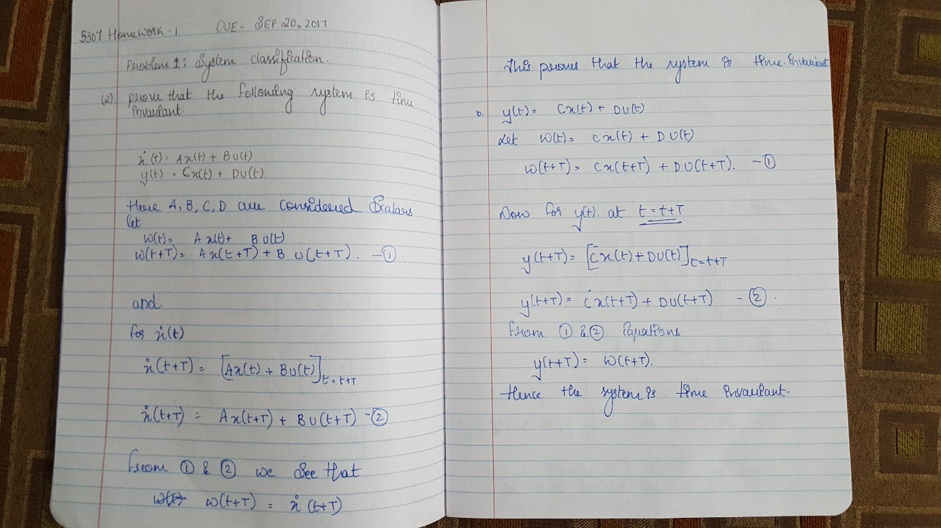

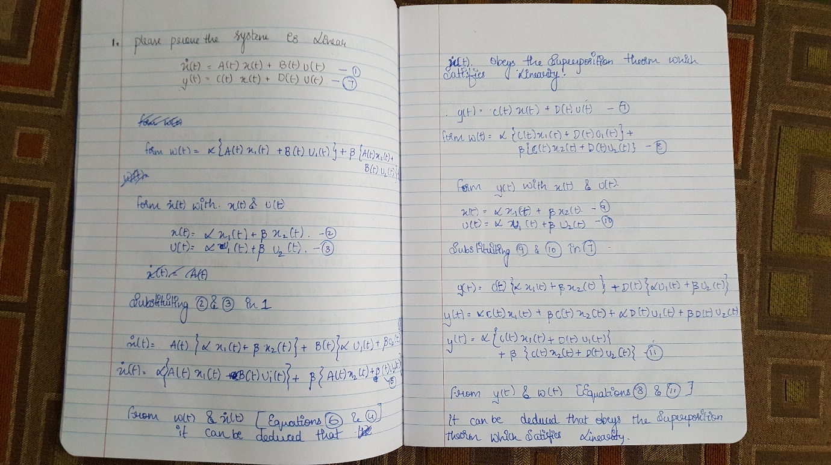

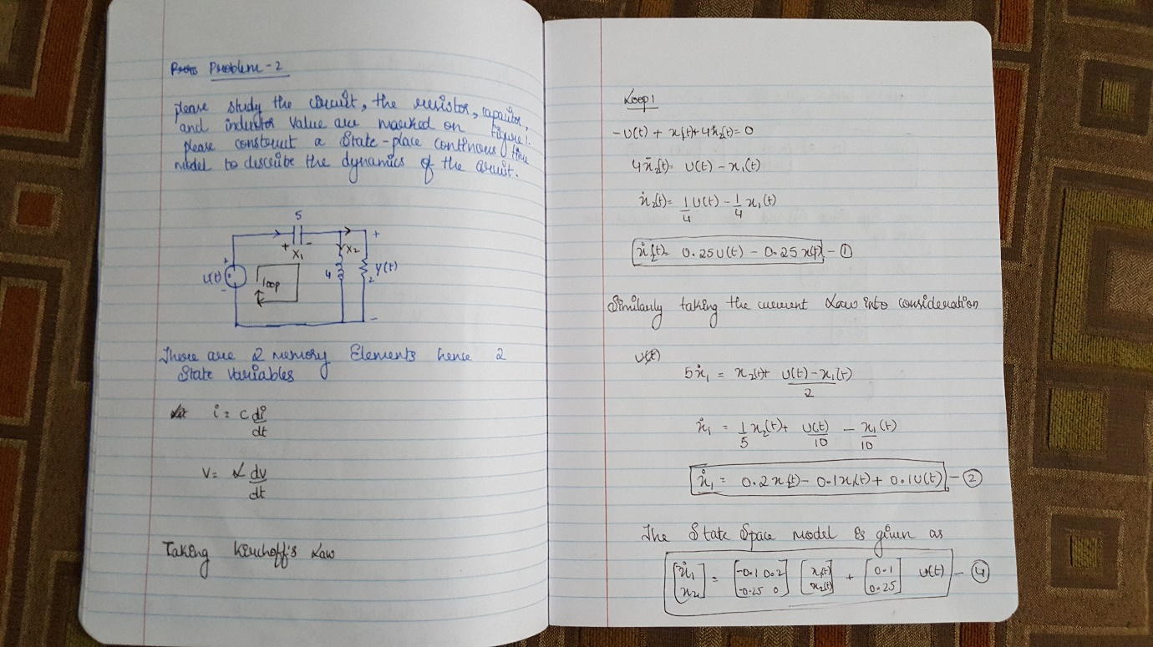

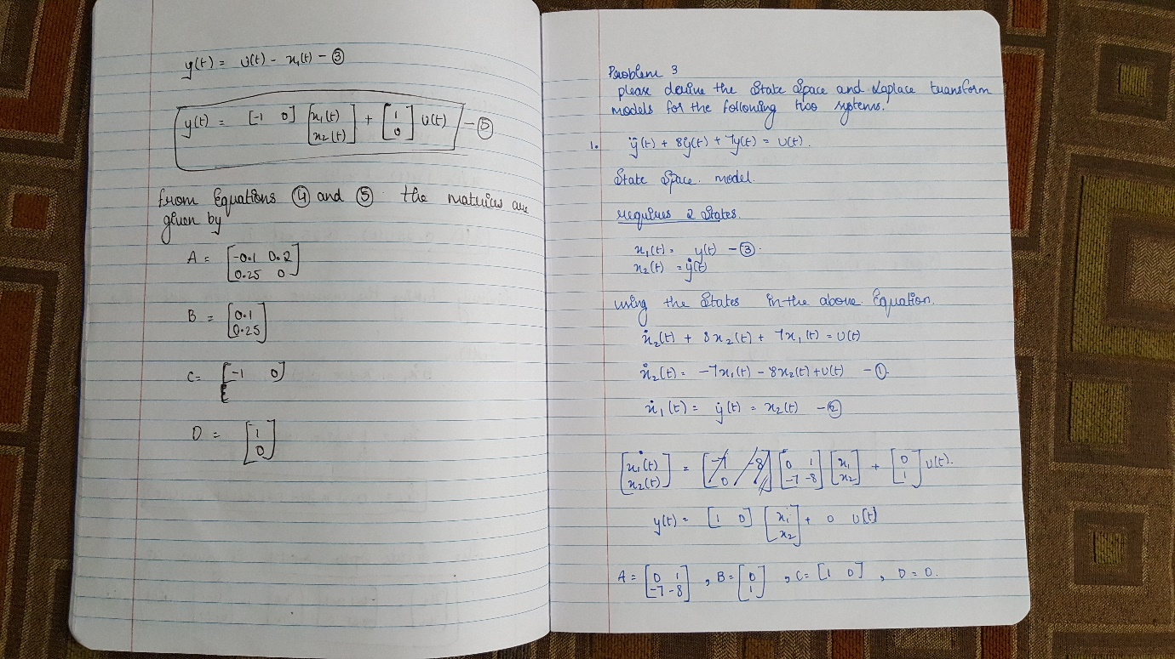

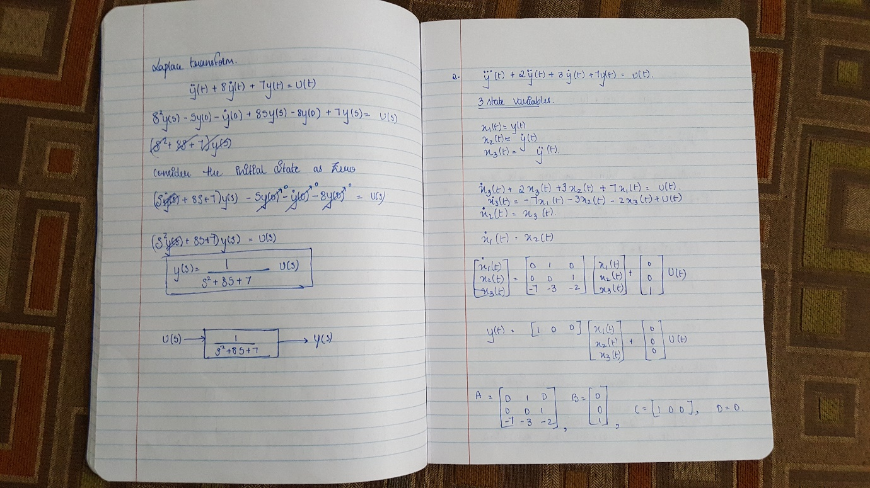

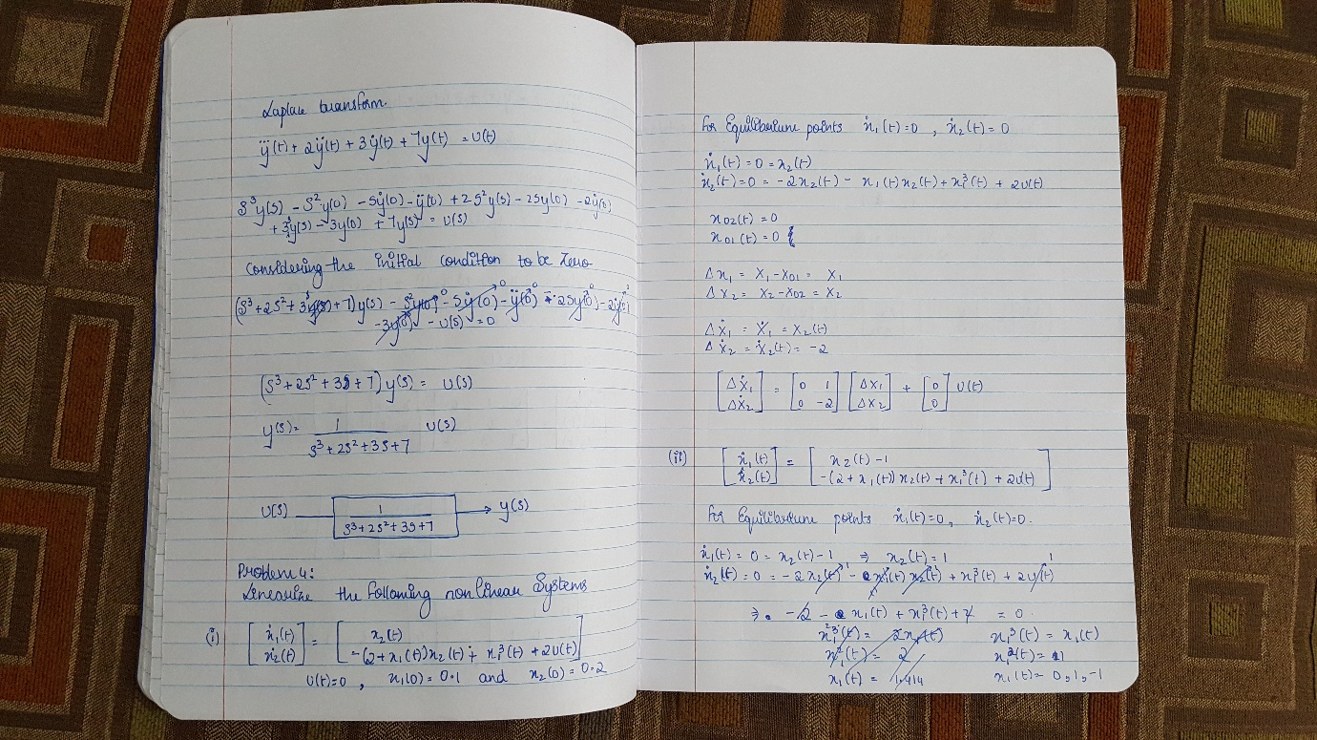

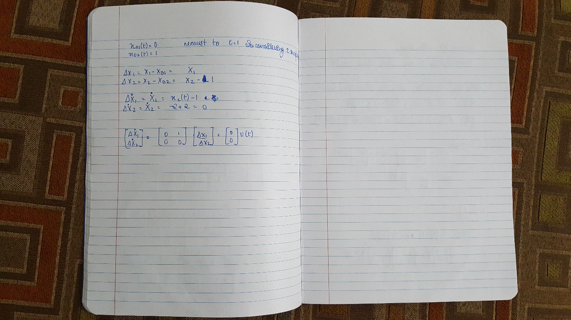

Program:

1.

**Function Program **

function [xdot] = equation(t,x);

xdot = [x(2); (-2*x(2))];

end

**Main Program**

clc;

clear all;

t_int = [0 20];

x_0 = [0.1 0.2]';

[t,x] = ode23('equation',t_int,x_0);

plot(t,x(:,2))

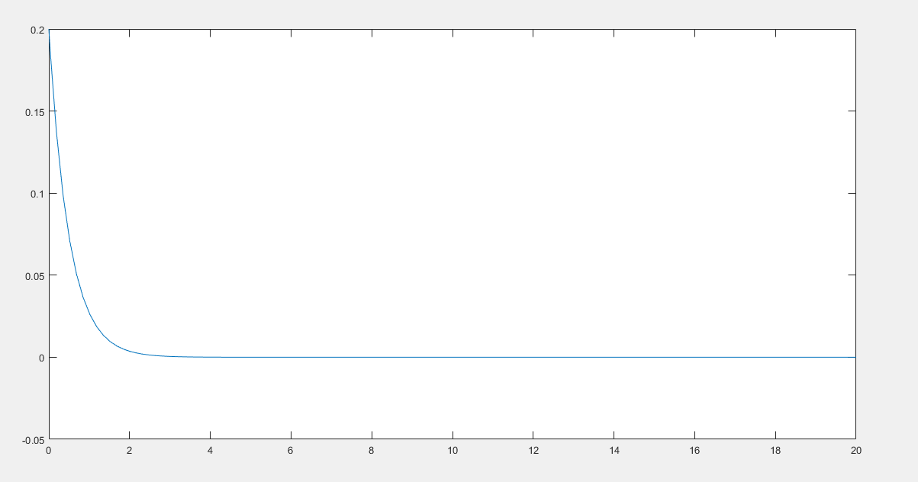

**Function program**

function [xdot] = nlequation_2(t,x)

xdot = [x(2)-1; -(x(1)+2*x(2)-2.2)];

end

**Main Program**

clc;

clear all;

t_int = [0 20];

x_0 = [0.1 1.1]';

[t,x] = ode23('nlequation_2',t_int,x_0);

figure(2);

plot(t,x(:,2))

