# Hospitality Dashboard - Analysis Of Hotel Booking Data

## Goal/Objective

Develop a Database to analyze & visualize hotel booking data using Power BI to provide the answers for the below questions to the stakeholders. – Is our hotel revenue growing by year? – What trends we see in the data?

## Steps Follow to get the Insights

1. Build a database
2. Develop the SQL query to join a tables
3. Exploratory data analysis using SQL
4. Connect Power BI to the database
5. Create a Dashboard
6. Summarize Findings

## Dashboard

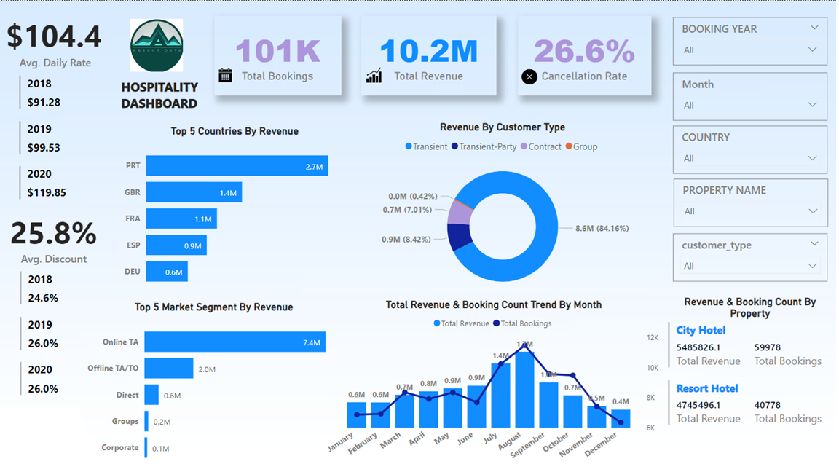

image

## Knowledge gain from this project

• Learnt how to create a database in SQL server using CSV files. • How to perform exploratory data analysis using SQL quires to get an overview of provided dataset. • Learnt how to connect the SQL server database with the Power BI. • Created a calculated columns & DAX measures. • How to add icons to enhance the visuals on the dashboards. • Used different charts along with key metrics, just to show the trend along with the metrics itself,