**Module 2: Java Script and SQL**

1. Write a guessing game where the user has to guess a secret number. After every guess the program tells the user whether their number was too large or too small. At the end the number of tries needed should be printed. It counts only as one try if they input the same number multiple times consecutively.
2. Write a Java Script to find the n prime number.
3. Write a function that rotates a list by k elements. For example [1,2,3,4,5,6] rotated by two becomes [3,4,5,6,1,2]. Try solving this without creating a copy of the list. How many swap or move operations do you need?
4. Write the queries Based on following Loan Schema:

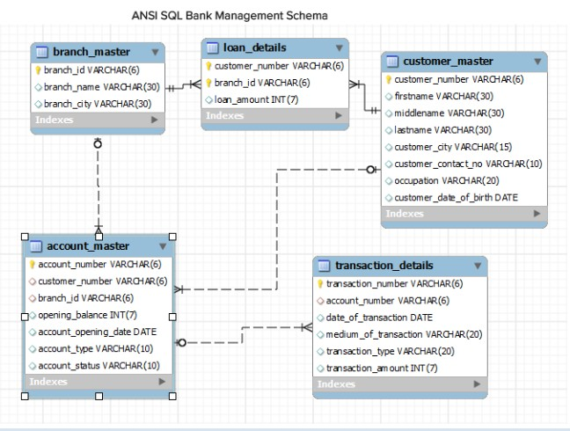

**Queries:**

1. Write a query to display customer number, customer’s firstname , account number where the account status is terminated. Display the records sorted in ascending order based on customer number and then by account number.
2. Write a query to display the number of accounts opened in each city. The query should display the Branch city and the number of No_of_Accounts for the branch city where we don’t have any accounts opened display 0. Display the records in the sorted order based on branch city.
3. Write a query to display the customer number, customer firstname, customer lastname who has taken loan from more than 1 branch. Display the records sorted in order based on customer number.
4. Write a query to display the number of clients who have asked for loan but they don’t have any account in the bank though they are registered customers. Give the count an alias name of Count.
5. Write a equerry to display customers firstname, city and account number whose occupation are not business , Services or Student. Display the records sorted in ascending order based on customer firstname and by account number.

**Module 1: Software Engineering, HTML and CSS**

1. (a) Create a html web page that contains a button with which it is possible to change the text that is shown on the screen. The file ButtonDemo.html has a JavaScript function named change_text() which is called after the button is pressed. When the button is pressed repeatedly the text changes Hello! ... Well done! ... Hello! ... Well done! ... Hello! ..

(b) Modify the program so that the initial text shown on the screen is "Monday", and it will change in the following way when the button is pressed repeatedly: Monday ... Tuesday ... Wednesday ... Thursday ... Friday ... Saturday ... Sunday ... Monday ... Tuesday ... etc. You should also change the button text so that there is written "Change day" on the button.

1. a. Create a newHTML-document with an unordered list element, a text-box,and a button that says “Add.”

b. Add JavaScript(and/or jQuery)that appendsa new <li> element to the unordered list when the button is clicked. The text of the new li-element should correspond to the text entered by the user in the text-box. Make sure thatthe content of the text-box is cleared when the button is clicked to be ready for new input from the user.

c. Add functionality to allow the user to delete a selected list item. When the“delete” button is clicked, the itemshould be removed from the list.

3. Using CSS properties create a calendar with following Calender Template:

