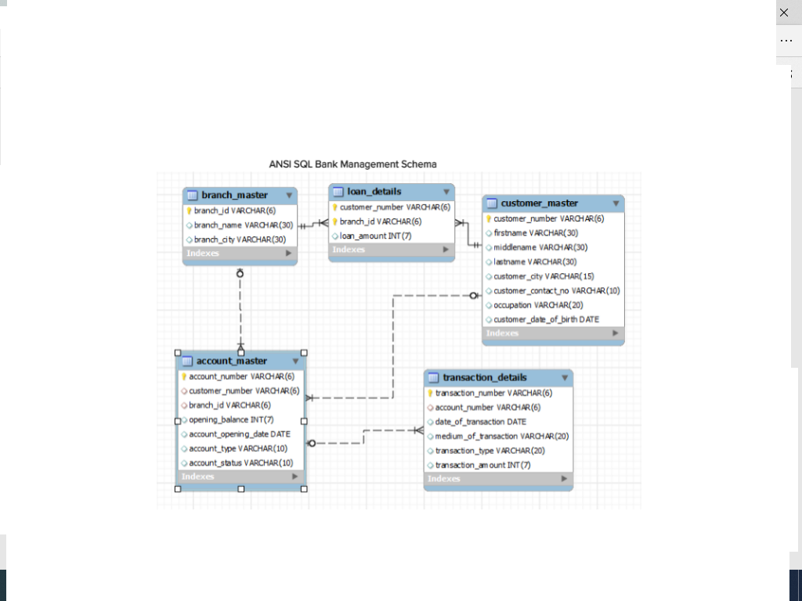

1. Create the tables based on above schema, and insert few records in the tables, and write the queries:
2. Write a query to display account number, customer’s number, customer’s firstname, lastname, account opening date. Display the records sorted in ascending order based on account number.
3. Write a query to display the number of customer’s from Delhi. Give the count an alias name of Cust_Count.
4. Write a query to display the customer number, customer firstname, account number for the customer’s whose accounts were created after 15th of any month. Display the records sorted in ascending order based on customer number and then by account number.
5. . Write a query to display customer number, customer's first name, account number where the account status is terminated. Display the records sorted in ascending order based on customer number and then by account number
6. Write a query to display the total number of withdrawals and total number of deposits being done by customer whose customer number ends with 001. The query should display transaction type and the number of transactions. Give an alias name as Trans_Count for number of transactions. Display the records sorted in ascending order based on transaction type
7. Write a query to display the number of customers who have registration but no account in the bank. Give the alias name as Count_Customer for number of customers
8. Write a query to display account number and total amount deposited by each account holder (Including the opening balance). Give the total amount deposited an alias name of Deposit_Amount. Display the records in sorted order based on account number.
9. Write a query to display the number of accounts opened in each city .The Query should display Branch City and number of accounts as No_of_Accounts.For the branch city where we don’t have any accounts opened display 0. Display the records in sorted order based on branch city.
10. Write a query to display the firstname of the customers who have more than 1 account. Display the records in sorted order based on firstname.
11. Write a query to display the customer’s number, customer’s firstname, customer’s city and branch city where the city of the customer and city of the branch is different. Display the records sorted in ascending order based on customer number.
12. Create a method that accepts a number and modifies it such that the each of the digit in the newly formed number is equal to the difference between two consecutive digits in the original number. The digit in the units place can be left as it is.
13. Write a java program to read student objects in a ArrayList and display the student result based on the condition that max&gt;=80, distinction, between 60 and 79 as First class, between 50 and 50 as Second class, else fail, and display only students who are passed

Note; Test the pass condition by using Java8 Predicate, find the class by using Function and display the results using Consumer predefined interfaces.

1. Write a program that performs the following actions:

1.     Read n strings as input and stores them as an arraylist. The string consists of student information like name and obtained marks of three subjects. Eg: name-mark1-mark2-mark3 [suresh-70-47-12] The mark would range between 0 – 100 (inclusive).

2.     Write a function highestScorer which accepts these the arraylist and returns the name of the student who has scored the max marks. Assume the result will have only one student with max mark.

Read the string in the same format as [Praveen-70-68-82]

1. Create an Employee Registration form. Create an user interface, which should accept Employee details like employee id, employee name, employee designation and employee department in a text boxes and when user clicks on submit button, it has to update in the employee table of Mysql, if the employee id is already exists it has to raise an exception.