Online Bank

Software Requirements Document

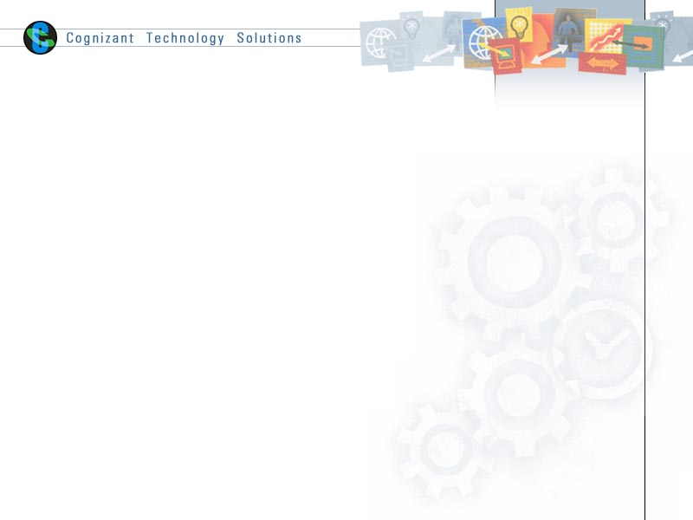

Table of Contents

1.0 Introduction 3

1.1 About this document 3

1.1.1 Purpose & Scope of the document 3

1.1.2 Intended Audience 3

1.2 About the Software System 3

1.2.1 Purpose 3

1.2.2 Scope of the system 3

1.2.3 System Perspective 5

1.2.4 System diagram 6

1.2.5 System Environment 6

1.2.6 User Characteristics 6

1.2.7 Impact of the System 7

1.2.8 Assumptions, Dependencies, Risks / Constraints 7

1.2.9 Software proposed 7

2.0 System Requirements 8

2.1 Functional Requirements 8

2.1.1 Login Module 8

2.1.2 Authentication 9

2.1.3 User module 10

2.1.3.1. New user Registration 10

2.1.3.2. User Account page 11

2.1.3.3. Insurance Claims page 12

2.1.3.4. Insurance Claims Report 13

2.1.4 Admin Module 14

2.1.4.1. Admin home page 14

2.1.4.2. Activate User Account 15

2.1.4.3. Disable User Account 15

2.1.4.4. Delete User Account 16

2.1.4.5. Review pending claims 17

2.2 Non functional Requirements 17

2.2.1 UI Requirements: Inn 17

2.2.2 Performance Requirements: Pnn 17

2.2.3 Installation, Deployment & Operational Requirements: Onn 17

2.2.4 Reliability 18

2.2.5 Maintainability & Portability Requirements: MPnn 18

2.2.6 Security Requirements Snn: 18

2.2.7 Online User Documentation and Help System Requirements (DOCnn) 18

2.2.8 Training Requirements (TRnn) 18

2.2.9 Training Requirements (TRnn) 18

3.0 Make /Buy analysis 19

3.1 Reusable components 19

4.0 Annexure 19

5.0 Change Log 19

# Introduction

## About this document

### Purpose & Scope of the document

The purpose of the software requirements document is to systematically capture requirements for the project and the system to be developed. Both functional and non-functional requirements are captured in this document. It also serves as the input for the project scoping

The scope of this document is limited to addressing the requirements from a user, quality, and non-functional perspective. It is recommended that design aspects are not added in this document.

### Intended Audience

* *Project Team*
* *Customer(to sign-off this document)*

## About the Software System

### Purpose

This product is developed for users can create account from online .User can also check the balance enquires, transfer funds, withdraw money and close the account by using this application.

Scope of the system

The proposed system consists of onemajor modules i.e.

* + - **USER**

1. The Scope of the **USER** module is to
2. **Create Account:** The user can able to create accounts.
3. **Balance Check:** The User can check the balance in his account
4. **Deposit:** The user can Deposit money in his account.
5. **Withdraw:** The user can with draw money from his account.
6. **Transfer:** The user can Transfer money from his account to another account.
7. **Close account:** User can close his account

**Use Case Diagram**

### System Perspective

This is an independent system.

### System diagram

Registered users

Register User

Store user Information in Database

Create /Update /Delete /Transfer amount

Store Account Information in Database

Login

### 

### System Environment

.When a user connects to theWeb Server, theWeb Server will interact with the Database after processing the business logic to transfer data to and from a database.

* Apache Tomcat Server for application deployment.
* My SQL database for data storage

### User Characteristics

The application should be user friendly; hence the user should not need any software and hardware knowledge. The user may be new to health insurance products having never used them before.

### Impact of the System

This is a new product which is developed for internal users. Expected impact of the product is to automate existing manual processes in order to make them more efficient and cost effective.

### Assumptions, Dependencies, Risks / Constraints

### Software proposed

* Tomcat 7.0
* J2EE 1.5
* MySQL5.5

# System Requirements

## Functional Requirements

|  |  |
| --- | --- |
| Online Bank-2.1.1 | HomePage |
| **Functional Requirements**  When the user enters Home page appears which will have a short welcome message, a brief introduction to the purpose of this site, the Input fields for User ID and Password, link. The input fields for User ID and Password are Text fields. The User ID must be a registered user ID only. The entered characters in the Password field must be masked with an * symbol. There should be a Submit command Button. User Id and password are mandatory. | |
| **User Interface Requirements**  1. The User ID and Password fields should be the text boxes.  2. The entered characters in the Password field must be masked with an * symbol.  3. There should be login button.  4. The page header should be “Apana Bank”. | |

### Login Module

### User module

### Create Account

|  |  |
| --- | --- |
| Pharma Assistant-2.1.3.1 | Create Account |
| **Functional Requirements**  When the user clicks onCreateAccountlink on the home page, Create account form is opened. The user needs to enter the following details   * First name * Last name * Gender * Address1 * Address 2 * Land Phone * Mobile * Email | |
| **User Interface Requirements**  1.All the fields should be text boxes and mandatory. | |

### 

### Balance Check

|  |  |
| --- | --- |
| Pharma Assistant-2.1.3.2 | Balance check |
| **Functional Requirements**  When the User click on Balance link. Balance check form will be displayed.  User needs to enter below details;  Account Number | |
| **User Interface Requirements**  All the fields should be text box. | |

### Deposit Form

|  |  |
| --- | --- |
| Online Bank-2.1.3.3 | Deposit Formpage |
| **Functional Requirements**  When the User clicks on Deposit button, Deposit form will be opened. The following fields should be displayed to user   * Account No * Username * Amount | |
| **User Interface Requirements**  All the fields should be text boxes. | |

### Withdraw form

|  |  |
| --- | --- |
| Online Bank-2.1.3.4 | With draw Page |
| **Functional Requirements**  When the User clicks on the Withdraw form linkthe Withdraw form screen will be displayed. The user need to enter the following details on this page:   * Account No * Username * Amount | |
| **User Interface Requirements**  All the fields should be text boxes. | |

### Transfer Form

|  |  |
| --- | --- |
| Online Bank -2.1.3.4 | Transfer form |
| **Functional Requirements**  When the User clicks on Transfer form button, Amount transfer form page will be opened. The following fields should be displayed to user   * Account No * Target Account No * Amount | |
| **User Interface Requirements**  All the fields should be text boxes. | |

### Close Account

|  |  |
| --- | --- |
| Online Bank -2.1.3.4 | Transfer form |
| **Functional Requirements**  When the User clicks on Close Account, account should be closed. The following fields should be displayed to user   * Account No * User Name * Password | |
| **User Interface Requirements**  All the fields should be text boxes.  UserName and Password should be the ones associated with the account. | |

### Logout

|  |  |
| --- | --- |
| Online Bank -2.1.3.4 | Logout |
| **Functional Requirements**  When the User clicks on Logout button, Login page will be opened. | |

## Non functional Requirements

### UI Requirements: Inn

1. The front end should be user-friendly and pleasant
2. Any error message or exception displayed to the user should be user-readable (and not technical)
3. All entered values should be validated

### Performance Requirements: Pnn

1. All front-end pages and reports should be served up in less than 5 seconds post click when up to 1000 users are on the application concurrently
2. Should be able to support 5000 simultaneous users with response time not degrading to below 10 seconds post click

### Installation, Deployment & Operational Requirements: Onn

1. Application needs IBM Websphere/ JBoss / Weblogic server for deploymentwith oracle 10i database for persistence
2. This system must be up 23X7

### Reliability

1. It should permit 1 hour per day for maintenance and backup activities with no access for users during this time – suitable message asking users to log back on later should be presented
2. Any server failure should cause no more than 10-minute downtime, with the average downtime not exceeding 2 minutes

### Maintainability & Portability Requirements: MPnn

1. If the allocated memory space for the existing website needs to be increased then it should be possible without any impact to performance

### Security Requirements Snn:

1. Security should be through a security table with encrypted passwords
2. All transactions (updating data or otherwise) in the application should be audit logged for future reference
3. No unauthorized users should be able to log on to the system
4. None of the pages are reachable without a log on id having been entered and authenticated
5. Passwords must be at least 8 characters and have a combination of letters, numbers and special characters (#,@,$,%,&)
6. 3 incorrect password entries must de-activate the user
7. There should be a forgotten password option which would allow the password to be sent to their registered email id based upon then user id and the date of birth

### Online User Documentation and Help System Requirements (DOCnn)

1. Online help engine accessible from every screen
2. Help provided on each screen of the application

### Training Requirements (TRnn)

1. Training for intended users on the operation of the new software is not within scope

### Training Requirements (TRnn)

1. Training for intended users on the operation of the new software is not within scope

# Annexure

# Change Log

Please note that this table needs to be maintained even if a Configuration Management tool is used.

|  |  |  |  |  |
| --- | --- | --- | --- | --- |
| **Version Number** | **Changes made** | | | |
| V1.0 | *<First version>* | | | |
| V1.1 | *<If the change details are not explicitly documented in the table below, reference should be provided here>* | | | |
| Page no | Changed by | Effective date | Changes effected |
|  |  |  |  |
|  |  |  |  |
|  |  |  |  |
|  |  |  |  |
| V1.2 | *<If the change details are not explicitly documented in the table below, reference should be provided here>* | | | |
| Page no | Changed by | Effective date | Changes effected |
|  |  |  |  |
|  |  |  |  |
|  |  |  |  |
|  |  |  |  |