***Module 3 (Testing on Live Application)***

1. What is RDBMS

A relational [database](https://www.techtarget.com/searchdatamanagement/definition/database) management system (RDBMS) is a collection of programs and capabilities that enable IT teams and others to create, update, administer and otherwise interact with a [relational database](https://www.techtarget.com/searchdatamanagement/definition/relational-database). RDBMSes store data in the form of tables, with most commercial relational database management systems using [Structured Query Language](https://searchsqlserver.techtarget.com/definition/SQL) (SQL) to access the database. However, since SQL was invented after the initial development of the relational model, it is not necessary for RDBMS use.

The RDBMS is the most popular database system among organizations across the world. It provides a dependable method of storing and retrieving large amounts of data while offering a combination of system performance and ease of implementation.

1. What is SQL

Structured Query Language is a computer language that we use to interact with a relational database. SQL is a tool for organizing, managing, and retrieving archived data from a computer database. The original name was given by IBM as Structured English Query Language, abbreviated by the acronym SEQUEL. When data needs to be retrieved from a database, SQL is used to make the request.

The DBMS processes the SQL query retrieves the requested data and returns it to us. Rather, SQL statements describe how a collection of data should be organized or what data should be extracted or added to the database. In common usage, SQL encompasses [DDL](https://www.geeksforgeeks.org/ddl-commands-syntax/) and [DML](https://www.geeksforgeeks.org/dml-full-form/) commands for create, updates, modified or other operations on database structure.

1. Write SQL Commands
2. DDL – Data Definition Language

[DDL](https://www.geeksforgeeks.org/features-of-structured-query-language-sql/) or Data Definition Language actually consists of the SQL commands that can be used to define the database schema. It simply deals with descriptions of the database schema and is used to create and modify the structure of database objects in the database. DDL is a set of SQL commands used to create, modify, and delete database structures but not data. These commands are normally not used by a general user, who should be accessing the database via an application.

List of DDL commands:

* [**CREATE**](https://www.geeksforgeeks.org/sql-create/): This command is used to create the database or its objects (like table, index, function, views, store procedure, and triggers).
* [**DROP**](https://www.geeksforgeeks.org/sql-drop-truncate/): This command is used to delete objects from the database.
* [**ALTER**](https://www.geeksforgeeks.org/sql-alter-add-drop-modify/)**:**This is used to alter the structure of the database.
* [**TRUNCATE**](https://www.geeksforgeeks.org/sql-drop-truncate/)**:**This is used to remove all records from a table, including all spaces allocated for the records are removed.
* [**COMMENT**](https://www.geeksforgeeks.org/sql-comments/): This is used to add comments to the data dictionary.
* [**RENAME**](https://www.geeksforgeeks.org/sql-alter-rename/)**:**This is used to rename an object existing in the database.

2. DML – Data Manipulation Language

The SQL commands that deals with the manipulation of data present in the database belong to DML or Data Manipulation Language and this includes most of the SQL statements. It is the component of the SQL statement that controls access to data and to the database. Basically, DCL statements are grouped with DML statements.

List of DML commands:

* [**INSERT**](https://www.geeksforgeeks.org/sql-insert-statement/) : It is used to insert data into a table.
* [**UPDATE**](https://www.geeksforgeeks.org/sql-update-statement/)**:** It is used to update existing data within a table.
* [**DELETE**](https://www.geeksforgeeks.org/sql-delete-statement/) : It is used to delete records from a database table.
* [**LOCK:**](https://www.geeksforgeeks.org/sql-lock-table/) Table control concurrency.
* **CALL:**Call a PL/SQL or JAVA subprogram.
* **EXPLAIN PLAN:** It describes the access path to data.

3. DCL – Data Control Language

DCL includes commands such as GRANT and REVOKE which mainly deal with the rights, permissions, and other controls of the database system.

List of DCL commands:

* [**GRANT:**](https://www.geeksforgeeks.org/mysql-grant-revoke-privileges/)This commandgives users access privileges to the database.
* [**REVOKE:**](https://www.geeksforgeeks.org/difference-between-grant-and-revoke/)This command withdraws the user’s access privileges given by using the GRANT command.

1. DQL – Data Query Language

**DQL**statements are used for performing queries on the data within schema objects. The purpose of the DQL Command is to get some schema relation based on the query passed to it. We can define DQL as follows it is a component of SQL statement that allows getting data from the database and imposing order upon it.

It includes the SELECT statement. This command allows getting the data out of the database to perform operations with it. When a SELECT is fired against a table or tables the result is compiled into a further temporary table, which is displayed or perhaps received by the program i.e. a front-end.

List of DQL:

* [**SELECT**](https://www.geeksforgeeks.org/sql-select-clause/)**:**It is used to retrieve data from the database.

4. What is join?

**Structured Query Language (SQL)** allows us to perform some sort of action on a single table in a relational database. These actions can update, create, delete or select a record in that table. What if we had two tables that had different information about the same person, and we wanted to use all of that information to display on that person’s invoice? We would need to use a **join clause** for that.

In this tutorial, we will define what a join clause is, talk about the types of join clauses, and give join examples for each.SQL join statements allow us to access information from two or more tables at once. They also keep our database normalized. Normalization allows us to keep data redundancy low so that we can decrease the amount of data anomalies in our application when we delete or update a record.

1. Write type of joins?

1. Inner Join

Syntax the most frequently used and important of the joins is the INNER JOIN. They are also referred to as an EQUIJOIN. The INNER JOIN creates a new result table by combining column values of two tables (table1 and table2) based upon the join-predicate. The query compares each row of table1 with each row of table2 to find all pairs of rows which satisfy the join-predicate. When the join-predicate is satisfied, column values for each matched pair of rows of A and B are combined into a result row.

SYNTAX: The basic syntax of INNER JOIN is as follows:

SELECT table

1. Column1, table2.column2...FROM table1INNER JOIN table2ON table1.common_filed = table2.common_field;

2. Left Join Syntax

The SQL LEFT JOIN returns all rows from the left table, even if there are no matches in the right table. This means that if the ON clause matches 0 (zero) records in right table, the join will still return a row in the result, but with NULL in each column from right table. This means that a left join returns all the values from the left table, plus matched values from the right table or NULL in case of no matching join predicate.

SYNTAX:

The basic syntax of LEFT JOIN is as follows:

SELECT table1.column1, table2.column2...FROM table1LEFT JOIN table2ON table1.common_filed = table2.common_field;

3. Right Join Syntax

The SQL RIGHT JOIN returns all rows from the right table, even if there are no matches in the left table. This means that if the ON clause matches 0 (zero) records in left table, the join will still return a row in the result, but with NULL in each column from left table. This means that a right join returns all the values from the right table, plus matched values from the left table or NULL in case of no matching join predicate.

SYNTAX:

The basic syntax of RIGHT JOIN is as follows:

SELECT table1.column1, table2.column2...FROM table1RIGHT JOIN table2ON table1.common_filed = table2.common_field;

4. Full Join Syntax

The SQL FULL JOIN combines the results of both left and right outer joins. The joined table will contain all records from both tables, and fill in NULLs for missing matches on either side.

SYNTAX:

The basic syntax of FULL JOIN is as follows:

SELECT table1.column1, table2.column2...FROM table1FULL JOIN table2ON table1.common_filed = table2.common_field;

1. How Many constraint and describes it self
2. SQL PRIMARY KEY Constraint

The PRIMARY KEY constraint uniquely identifies each record in a table.

Primary keys must contain UNIQUE values, and cannot contain NULL values.

A table can have only ONE primary key; and in the table, this primary key can consist of single or multiple columns (fields).

* The following SQL creates a PRIMARY KEY on the "ID" column when the "Persons" table is created:

CREATE TABLE Persons (  
    ID int NOT NULL,  
    LastName varchar(255) NOT NULL,  
    FirstName varchar(255),  
    Age int,  
    PRIMARY KEY (ID)  
);

2. SQL FOREIGN KEY Constraint

The FOREIGN KEY constraint is used to prevent actions that would destroy links between tables.

A FOREIGN KEY is a field (or collection of fields) in one table, that refers to the  [PRIMARY KEY](https://www.w3schools.com/sql/sql_primarykey.asp) in another table.

The table with the foreign key is called the child table, and the table with the primary key is called the referenced or parent table.

* The following SQL creates a FOREIGN KEY on the "PersonI D" column when the "Orders" table is created:

CREATE TABLE Orders (  
    OrderID int NOT NULL,  
    OrderNumber int NOT NULL,  
    PersonID int,  
    PRIMARY KEY (OrderID),  
    FOREIGN KEY (PersonID) REFERENCES Persons(PersonID)  
);

3. SQL Unique KEY Constraint

A unique key is a constraint in SQL which helps in uniquely identifying a record in the data table. It is can be considered somewhat similar to the Primary key as both of them guarantees the uniqueness of a record. But unlike primary key, a unique key can accept NULL values and it can be used on more than one column of the data table.

* This is the basic SQL syntax for creating a unique key constraint using the CREATE TABLE clause.

CREATE TABLE table_name

(

Column_name1 datatype [NULL | NOT NULL] UNIQUE,

Column_name2 datatype [NULL | NOT NULL],

Column_name3 datatype [NULL | NOT NULL]

);

1. Difference between RDBMS vs DBMS

|  |  |
| --- | --- |
| DBMS | RDBMS |
| [DBMS](https://www.geeksforgeeks.org/introduction-of-dbms-database-management-system-set-1/) stores data as file. | [RDBMS](https://www.geeksforgeeks.org/rdbms-architecture/) stores data in tabular form. |
| Data elements need to access individually. | Multiple data elements can be accessed at the same time. |
| No relationship between data. | Data is stored in the form of tables which are related to each other. |
| Normalization is not present. | Normalization is present. |
| DBMS does not support distributed database. | RDBMS supports distributed database. |
| It stores data in either a navigational or hierarchical form. | It uses a tabular structure where the headers are the column names, and the rows contain corresponding values. |
| It deals with small quantity of data. | It deals with large amount of data. |
| Data redundancy is common in this model. | Keys and indexes do not allow Data redundancy. |

**8.What is API Testing?**

Application Programming Interface (API) is a software interface that allows two applications to interact with each other without any user intervention another definition, API (Application Programming Interface) is a computing interface which enables communication and data exchange between two separate software systems.

The purpose of API Testing is to check the functionality, reliability, performance, and security of the programming interfaces. In API Testing, instead of using standard user inputs (keyboard) and outputs, you use software to send calls to the API, get output, and note down the system’s response. API tests are very different from GUI Tests and won’t concentrate on the look and feel of an application.

* 1. Types of API Testing?

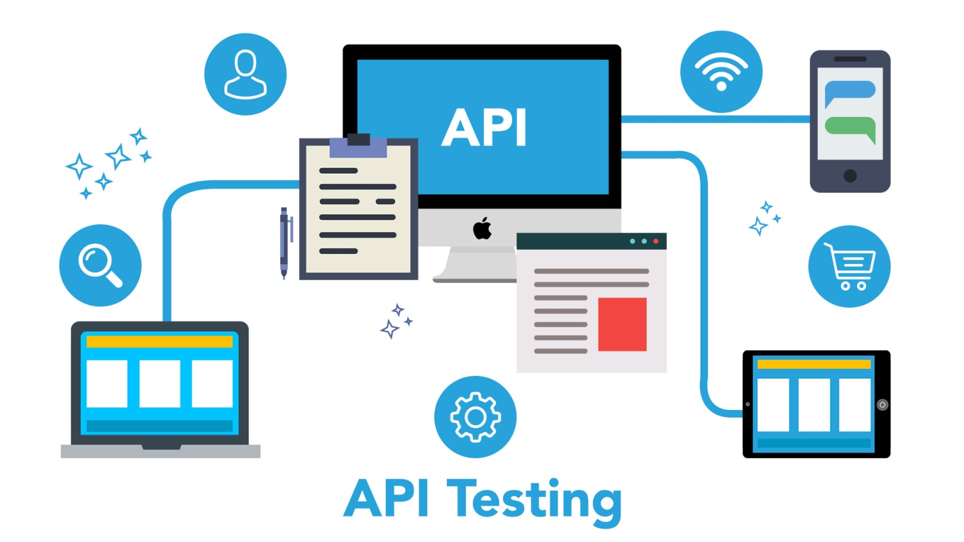

There are mainly 3 types of API Testing

Open APIs:

These types of APIs are publicly available to use like Oath APIs from Google. It has also not given any restriction to use them. So, they are also known as Public APIs.

Partner APIs:

Specific rights or licenses to access this type of API because they are not available to the public.

Internal APIs:

Internal or private. These APIs are developed by companies to use in their internal systems. It helps you to enhance the productivity of your teams.

10. What is Responsive Testing?

A responsive web design involves creating a flexible web page that is accessible from any device, starting from a mobile phone to a tablet. Furthermore, a responsive web design improves users’ browsing experience. Considering this from a quality assurance perspective, a responsive web design requires thorough evaluation using a variety of devices before it is ready to go live.

Software testers may find it challenging to perform responsive design testing as a variety of factors is to be looked into during the testing phase. Some points to be understand for Responsive Testing. The challenges involved in testing a responsive website how website testing differs from a mobile device to a computer Rules and guidelines to be followed during responsive design testing and Lastly, various tools available to perform responsive testing

11. Which types of tools are available for Responsive Testing?

* LT Browser
* Lambda Testing

This is a cross-browser testing tool which allows users to test more than 22,000 browsers, mobile, and OS combinations. You get a separate tab for Responsive testing under Visual UI Test, where you can see the responsiveness of your site on varied devices and screen sizes.

* Google Resister

Google provides one of the simplest ways to simulate mobile devices within Chrome. Using this tool, you can see how your device appears across various screen sizes.

* I am responsive

I feel this is a tool for quick screenshots rather than a tool for testing. It only supports viewport sizes for Apple devices. Enter the URL in the input field, click go, and see the responsiveness of your device.

* Pixel tuner

12. What is the full form of .ipa, .apk

 IPA Stands for **APP Store Package**

APK stands for**Android Application Package**

13. How to create step for to open the developer option mode ON?

1. On your device, find the **Build number** option. The following table shows the settings location of the **Build number** on various devices:

**Table 1.** Device settings location for the **Build number** option

|  |  |
| --- | --- |
| Device | Setting |
| Google Pixel | Settings > About phone > Build number |
| Samsung Galaxy S8 and later | Settings > About phone > Software information > Build number |
| LG G6 and later | Settings > About phone > Software info > Build number |
| HTC U11 and later | Settings > About > Software information > More > Build number *or* Settings > System > About phone > Software information > More > Build number |
| OnePlus 5T and later | Settings > About phone > Build number |

1. Tap the **Build Number** option seven times until you see the message You are now a developer! This enables developer options on your device.
2. Return to the previous screen to find **Developer options** at the bottom.

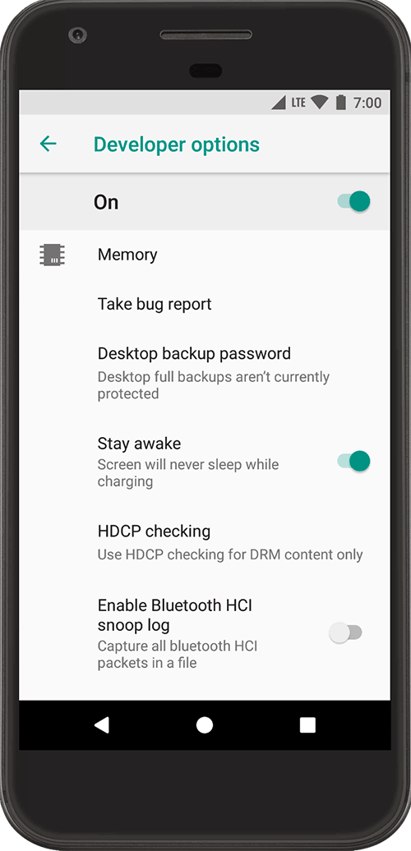

**Figure 1.** On-device developer options.

At the top of the **Developer options** screen, you can toggle the options on and off, as shown in figure 1. Keep this on. When off, most options are disabled except those that don't require communication between the device and your development computer.

### Enable USB debugging on your device

Before you can use the debugger and other tools, you need to enable USB debugging, which allows Android Studio and other SDK tools to recognize your device when connected via USB.

Enable **USB debugging** in the device system settings under **Developer options**. You can find this option in one of the following locations, depending on your Android version:

* Android 9 (API level 28) and higher: **Settings > System > Advanced > Developer Options > USB debugging**
* Android 8.0.0 (API level 26) and Android 8.1.0 (API level 27): **Settings > System > Developer Options > USB debugging**
* Android 7.1 (API level 25) and lower: **Settings > Developer Options > USB debugging**