

STUDENT Module Bank-1

Question-1
You are a senior faculty at a premier engineering institute of the city. The head of the department has asked you to take a look at the institute’s learning website and make a list of the unstructured data that gets generated on the website that can ten be stored and analyzed to improve the website to facilitate and enhance the student’s learning. You loged into the institute learning website and observe the following features on it: presentation decks(.pdf files) laboratory manual (.doc files) discussion forum, student’s blog, link to Wikipedia, A survey questionary for the students, students performance sheet downloadable into an .xls sheet and students performance sheet downloadable into a .txt file, Audio/video learning files(.wav files) , .xls sheet having a compiled list of FAQs.
- Identify which data is unstructured data, structured and semi structured data
Unstructured Data
- Presentation decks (.pdf files)
- Laboratory manuals (.doc files)
- Discussion forum posts
- Students’ blogs
- Wikipedia links
- Audio/Video learning files (.wav / video files)
- Students’ performance sheet (.txt file)

Structured Data
- Survey questionnaire responses (stored in tables)
- Students’ performance sheet (.xls file)
- Compiled list of FAQs (.xls sheet)

Semi-Structured Data
- Discussion forum data (tags, timestamps, user IDs)
- Blog data (metadata with content)

- Why is an email placed in the unstructured category?
- Email content has no fixed format
- Contains free-text, images, attachments, and links
- Difficult to store and analyze using traditional databases

- Describe the challenges associated with the working of various digital data?
• Unstructured data:
- No predefined format
- Difficult storage and analysis
- Time-consuming processing
• Semi-structured data:
- Dynamic schema
- Requires special parsing techniques
• Structured data:
- Limited flexibility
- Not suitable for multimedia or text-heavy data

- What category will you place a CCTV footage into?
Unstructured Data
(Video data without fixed schema)

- Which category would you place the consumer complaints and feedback?
Unstructured Data
(Free-text opinions, comments, reviews)

- State few examples of human generated and machine generated data.
Human-Generated Data
- Emails
- Blogs
- Social media posts
- Discussion forum messages
Machine-Generated Data
- CCTV footage
- Sensor data
- Server logs
- Transaction logs

Question-2

One promising survey conducted by Central Banking in association with BearingPoint during mid-2017. It proves that Big Data is an active area for new projects in central banks and key Big Data projects in central banks is reported development of credit registers, followed by administrative sources and consolidation of internal system. They decided to use Big Data and Data Science to drive change towards data and analytics to gain an overall competitive advantage.
- Identify the various categories of digital data available in the banking sector.
Structured Data
- Customer account details
- Transaction records
- Credit and loan databases
- Financial statements
Semi-Structured Data
- XML / JSON transaction logs
- Online banking logs
- ATM transaction data
Unstructured Data
- Emails and customer complaints
- Call center notes and voice recordings
- Social media posts and feedback
- Scanned documents and PDFs

- Describe the various categories of Analytics with sample outputs.
Descriptive Analytics
- Shows what happened
- Output: Monthly transaction reports, customer balance summaries
Diagnostic Analytics
- Explains why it happened
- Output: Reasons for increase in loan defaults
Predictive Analytics
- Predicts what will happen
- Output: Credit risk score, fraud probability
Prescriptive Analytics
- Suggests what should be done
- Output: Loan approval recommendation, fraud prevention actions

- Need of big data analytics and Challenges to big data analytics.
Need of Big Data Analytics
- Faster and accurate decision-making
- Fraud detection and prevention
- Improved customer experience
- Better risk management
- Competitive advantage

Challenges of Big Data Analytics
- Storage of huge volumes of data
- Data integration from multiple sources
- Security and privacy of financial data
- Data quality issues
- High processing requirements

- What are the five key characteristics of big data, and how does each characteristic influence data processing and analysis in the bank
• Volume – Massive transaction and customer data
• Velocity – Real-time transactions and fraud detection
• Variety – Structured, semi-structured, and unstructured data
• Veracity – Data inconsistency and noise
• Value – Useful insights such as fraud patterns and customer behavior

- Define big data and its need for the smooth progress of the bank.
Definition
Big Data refers to large, complex datasets that cannot be processed using traditional data processing systems and require advanced analytics techniques.
Need in Banking
- Enhances credit risk assessment
- Enables real-time fraud detection
- Improves customer personalization
- Supports regulatory compliance
- Strengthens strategic decision-making

- Compare existing Data Warehouse environment and Hadoop environment with neat sketch.
Data Warehouse | Hadoop
Stores structured data | Stores structured, semi-structured, unstructured data
Expensive proprietary hardware | Uses low-cost commodity hardware
Schema-on-write | Schema-on-read
Limited scalability | Highly scalable
Batch processing | Batch and near real-time processing

Neat Sketch (to draw in exam)
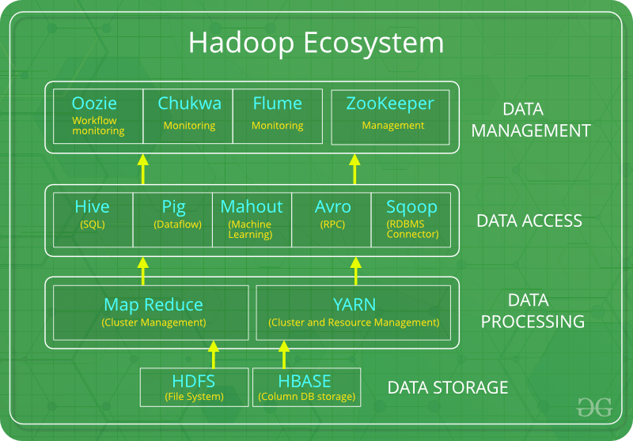

(OR)

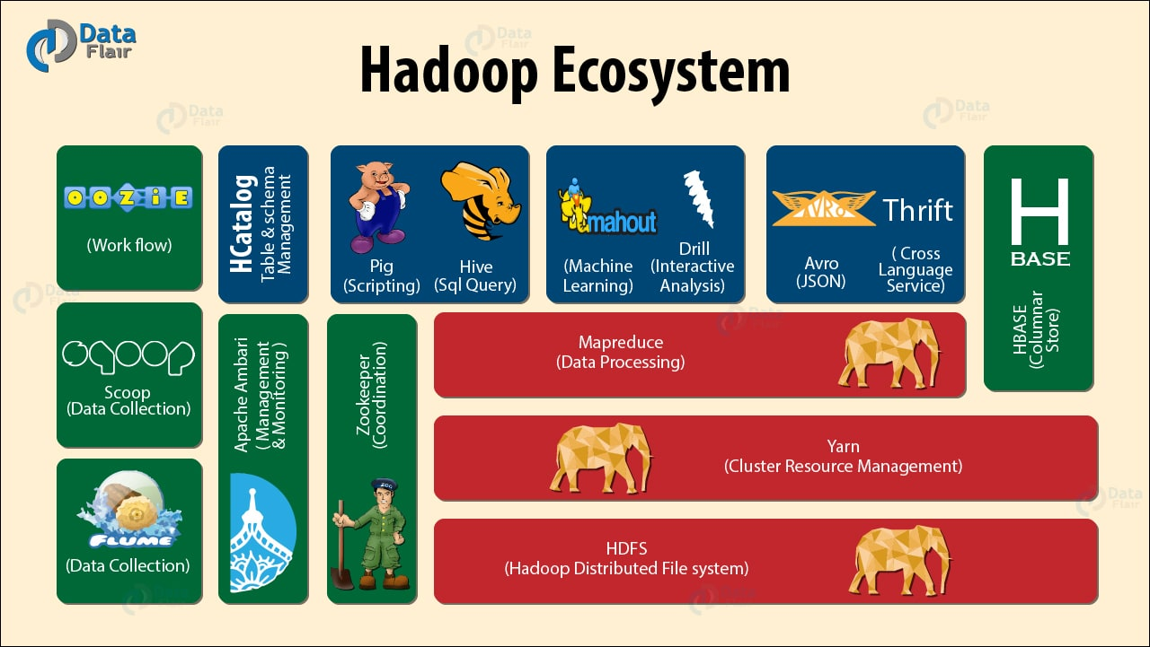

Question-3

A media company is setting up a Hadoop-based data infrastructure to handle extensive data processing tasks related to user activity logs, video streaming data, and content metadata. They must understand how to manage resources effectively with YARN and leverage the Hadoop ecosystem to ensure seamless data processing and analytics.
- What is the role of the ResourceManager and NodeManager in Hadoop YARN? How do these components manage resources and applications within a Hadoop cluster?
ResourceManager
- Master of YARN
- Manages CPU and memory of the whole cluster
- Decides which application gets how many resources
- Starts an ApplicationMaster for each job
NodeManager
- Runs on each worker node
- Gives resources to tasks using containers
- Monitors CPU and memory usage
- Reports status to ResourceManager
Together
- ResourceManager does global planning
- NodeManager does local execution
- Ensures fair and efficient use of resources

- Describe the Hadoop ecosystem's main components, including their interactions and purposes. How do components like HDFS, MapReduce, Hive, and Pig contribute to the overall data processing framework?
HDFS (Storage)
- Stores large data across many machines
- Splits data into blocks and keeps copies
MapReduce (Batch Processing)
- Processes big data in Map and Reduce steps
- Good for long, batch jobs
Hive (Query Tool)
- SQL-like tool (HiveQL)
- Used for easy querying of data in HDFS
Pig (Data Flow Tool)
- Uses Pig Latin language
- Used for data cleaning and transformation
Interaction
- Data is stored in HDFS
- MapReduce / Hive / Pig process the data
- YARN gives resources to run these tools

- Analyze the role of YARN in resource management for different types of data processing tasks (e.g., batch processing with MapReduce vs. interactive querying with Hive). How does YARN adapt to the varying resource demands of these tasks?
Batch Processing (MapReduce)
- Needs more CPU and memory
- Runs for a long time
- YARN gives large containers
Interactive Queries (Hive)
- Needs fast response
- Runs many small queries
- YARN gives smaller containers quickly
How YARN Adapts
- Allocates resources based on job need
- Runs multiple jobs at the same time
- Avoids waste and improves speed

Question-4
A software development company plans to integrate big data technologies into its infrastructure. The company must familiarize its development team with key terminologies used in big data environments to facilitate effective implementation and utilization of these technologies.
- Define in-memory analytics and explain its advantages in processing big data. How does it differ from traditional disk-based analytics?
In-memory analytics means processing data directly in RAM instead of reading from hard disks.
Advantages
- Very fast processing
- Low delay in getting results
- Good for real-time and near real-time analysis
- Better performance on big data
Difference from Disk-Based Analytics
- Disk-based analytics reads data from hard disk → slow
- In-memory analytics keeps data in RAM → fast
Example
- Apache Spark

- What is massive parallel processing (MPP), and how does it contribute to the scalability and performance of big data systems? Provide examples of industries or applications where MPP is particularly beneficial.
Massive Parallel Processing (MPP) means many processors work at the same time on different parts of the same data.
How it Helps
- Faster processing of large data
- Easy to scale by adding more processors
- Improves system performance
Examples / Applications
- Banking: fraud detection
- Retail: market basket analysis
- Telecom: call data analysis
- Healthcare: patient data analysis

- Discuss the implications of the CAP theorem in distributed systems design. How does it influence the trade-offs between consistency, availability, and partition tolerance in big data architectures?
The CAP Theorem says a distributed system cannot provide all three at the same time:
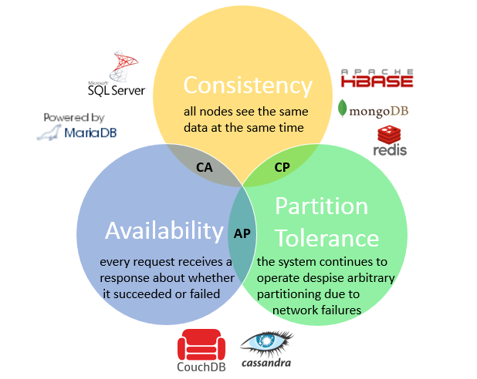
- Consistency (C) – All users see the same data
- Availability (A) – System always gives a response
- Partition Tolerance (P) – System works even if network fails
Impact on Big Data Systems
- Systems must choose any two out of three
- Example choices:
  - CP: Consistency + Partition Tolerance
  - AP: Availability + Partition Tolerance

- Illustrate the features of NoSQL databases.
- Handles big data easily
- Supports structured, semi-structured, and unstructured data
- Schema-less or flexible schema
- Highly scalable
- Works well with distributed systems
- Faster for large read/write operations
Examples
- MongoDB
- Cassandra
- HBase

Question-5
A data engineering team is tasked with setting up a Hadoop environment to handle largescale data processing for a financial analytics project. The team needs to understand Hadoop's architecture, the roles of its daemons, and how data processing is managed within the ecosystem. They must also evaluate the effectiveness of different Hadoop components in managing resources and applications.
- Describe the key daemons of Hadoop and their functions within the Hadoop architecture. How does each daemon contribute to the overall data processing and management? (Understanding)
- NameNode
  - Master of HDFS
  - Stores file information (metadata) like file name and block location
  - Controls DataNodes
- DataNode
  - Stores actual data blocks
  - Reads and writes data as told by NameNode
- Secondary NameNode
  - Takes backup of NameNode metadata
  - Helps in recovery
- ResourceManager
  - Master of YARN
  - Manages CPU and memory of the cluster
  - Schedules jobs
- NodeManager
  - Runs on each node
  - Manages containers and monitors resources
- ApplicationMaster
  - Manages one application
  - Requests resources and tracks task progress
Contribution:
These daemons together manage storage, resources, and job execution efficiently.

- Explain the architecture of Hadoop. What are the core components of Hadoop and their respective roles in processing and managing data? (Remembering)
Core Components
- HDFS
  - Distributed storage system
  - Stores data in blocks with replication
- YARN
  - Resource management layer
  - Allocates CPU and memory to jobs
- MapReduce
  - Batch processing framework
  - Processes data using Map and Reduce steps
Roles
- HDFS → Storage
- YARN → Resource management
- MapReduce → Data processing

- Analyze the data processing workflow in Hadoop. How do the core components of Hadoop interact to process large-scale data efficiently? Provide a detailed explanation of the data flow from ingestion to processing. (Analyzing)
Step 1: Data Ingestion
- Data is loaded into HDFS
- Files are split into blocks and stored in DataNodes
Step 2: Job Submission
- User submits a MapReduce job
- ResourceManager starts an ApplicationMaster
Step 3: Map Phase
- Data blocks are processed in parallel
- Mapper creates key–value pairs
Step 4: Shuffle and Sort
- Mapper output is grouped by key
- Data is sent to reducers
Step 5: Reduce Phase
- Reducer processes grouped data
- Final result is generated
Step 6: Output Storage
- Output is stored back in HDFS
Interaction
- HDFS stores data
- YARN allocates resources
- MapReduce processes data

Question-6

You are at the university library. You see few students browsing through the library catalog on a kiosk. You observe the librarians busy at work issuing and returning books. You see a few students fill up the feedback form on the services offered by the library. Quite a few students are learning using the e-learning content. Think for a while on the different types of data that are being generated in this scenario.
- Describe the categories of digital data.
Structured Data
- Fixed format (rows and columns)
- Examples:
  - Library catalog database
  - Book issue/return records
Unstructured Data
- No fixed format
- Examples:
  - Feedback forms (text)
  - E-learning videos, audio files
  - Blogs, discussion posts
Semi-Structured Data
- Partly structured with tags
- Examples:
  - Log files
  - XML / JSON data

- Describe the various categories of Analytics with sample outputs.
Descriptive Analytics (What happened?)
- Output:
  - Number of books issued per day
  - Website usage reports
Diagnostic Analytics (Why did it happen?)
- Output:
  - Reasons for low library usage
  - Causes of poor student feedback
Predictive Analytics (What will happen?)
- Output:
  - Expected demand for books
  - Student performance prediction
Prescriptive Analytics (What should be done?)
- Output:
  - Recommendation to add more e-learning content
  - Improve library services

- Design big data solution to store e-learning content in a Hadoop cluster.
- Store videos, PDFs, and audio files in HDFS
- Use replication to avoid data loss
- Use YARN to manage resources
- Use Hive for content metadata queries
- Use MapReduce or analytics tools to analyze usage
Benefits
- Large storage
- High fault tolerance
- Easy scalability

- Describe the anatomy of HDFS file write operation for a textbook of size 600 MB stored in HDFS using default block size configuration and default replication factor with neat sketch using Hadoop 2.x.
Default Values
- Block size = 128 MB
- Replication factor = 3
Block Calculation
- 600 MB ÷ 128 MB ≈ 5 blocks
Write Process
- Client requests NameNode
- NameNode gives DataNode locations
- File is split into 5 blocks
- Each block is stored in 3 DataNodes
- Metadata stored in NameNode
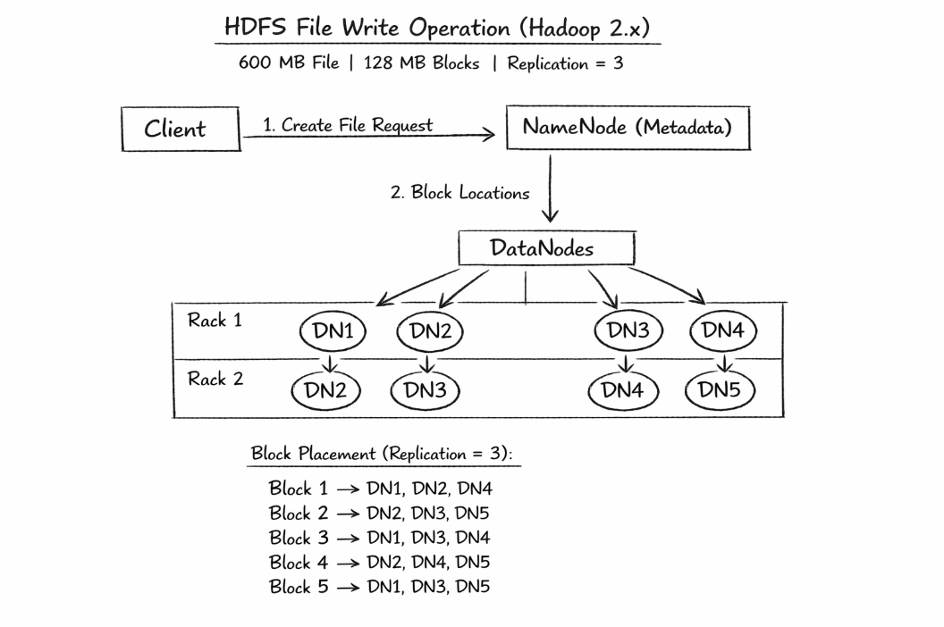

- Describe How Hadoop version 2 is supporting the following features
  - Improved Resource Management with YARN
• Separates resource management from processing
• Allows multiple applications to run together

  - High Availability (HA)
• Two NameNodes (Active and Standby)
• Prevents single point of failure

  - Enhanced Scalability via HDFS Federation
• Multiple NameNodes manage different namespaces
• Improves storage scalability

  - Co-location of Computation and Data
- Processing happens near stored data
- Reduces network usage and improves speed

Question-7

An application (e.g., a user clicking a link to view a log file) uses the HDFS client API
DistributedFileSystem
(like ) to request a file.
- Describe the anatomy of HDFS file read operation for there is file of size 594 MB stored in HDFS using default block size configuration and default replication factor with neat sketch using Hadoop 1.x.
Given
- File size = 594 MB
- Default block size = 128 MB
- Replication factor = 3
Number of blocks
- 594 ÷ 128 ≈ 5 blocks
File Read Steps
- Client sends a read request to the NameNode
- NameNode returns metadata (block locations)
- Client contacts the nearest DataNode
- DataNode sends block data to the client
- Steps repeat until all 5 blocks are read
- File is reassembled at the client side
Note
- Data is read directly from DataNodes
- NameNode is not involved in data transfer
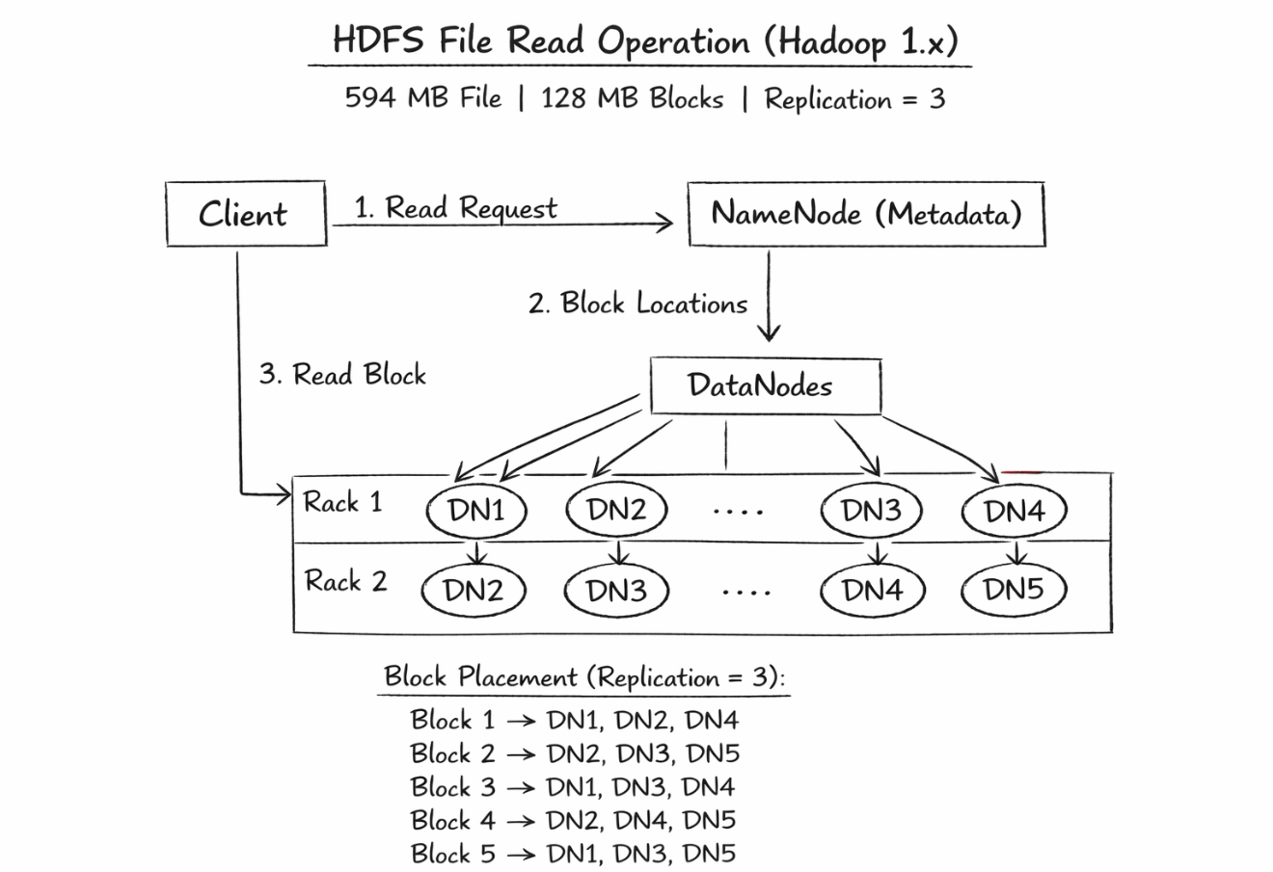

- Describe the functions of Namenode and Datanodes.
NameNode
- Master of HDFS
- Stores metadata (file name, block location)
- Controls DataNodes
- Does not store actual data
DataNode
- Stores actual data blocks
- Performs read and write operations
- Sends heartbeat to NameNode
- Reports block information

- Assume the nodes in the cluster are placed in two racks, Draw the replica placement strategy with neat sketch for the above file.
Default Replica Placement (Replication = 3)
For each block:
- 1st replica → DataNode in Rack 1
- 2nd replica → Another DataNode in Rack 1
- 3rd replica → DataNode in Rack 2
Advantages
- Fault tolerance if one rack fails
- Reduced network traffic
- High data availability
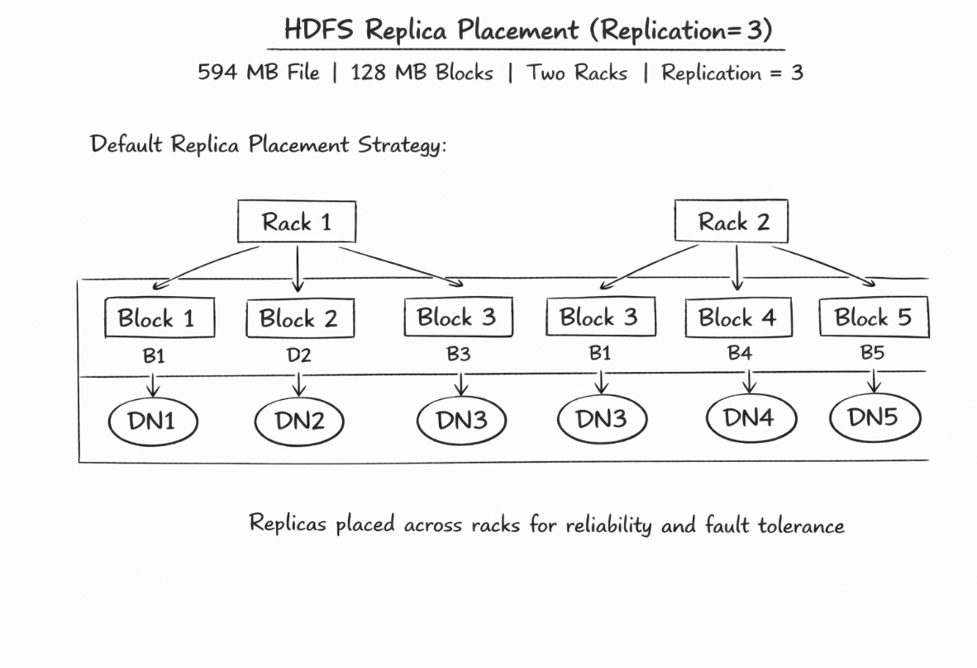

Question-8

The Yahoo NUTCH project refers to the period in the mid-2000s when Yahoo provided the critical resources and manpower to scale the Apache Nutch project, which ultimately led to the creation and popularization of Apache Hadoop.
- Describe the Hadooop Architecture with neat sketch.
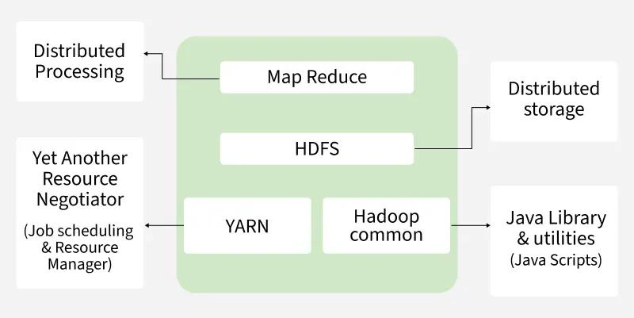

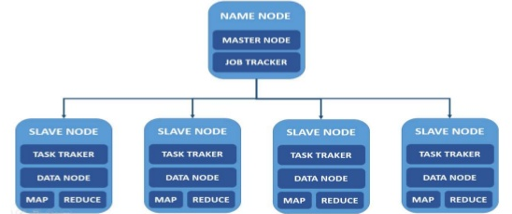

Hadoop follows a master–slave architecture and has three main layers:
- HDFS (Storage layer)
  - Stores large data in blocks
  - Uses replication for fault tolerance
  - NameNode manages metadata
  - DataNodes store actual data
- YARN (Resource management layer)
  - Manages CPU and memory
  - Schedules applications
  - Uses ResourceManager and NodeManagers
- MapReduce (Processing layer)
  - Processes data in parallel
  - Uses Map and Reduce phases

- Illustrate the big data processing using Hadoop Map Reduce with neat sketch.
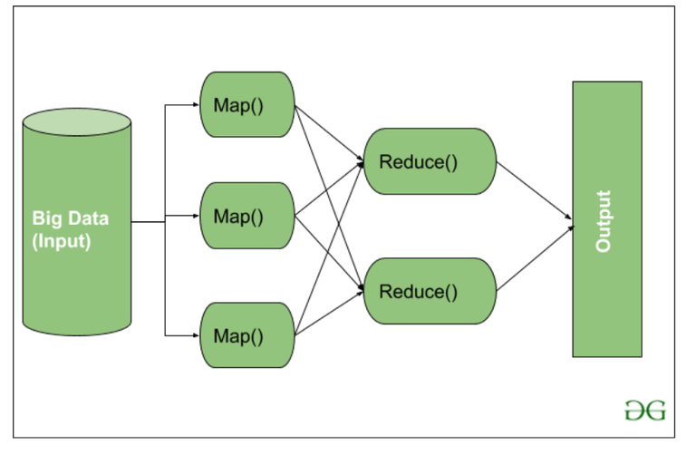
Processing Steps
- Data is stored in HDFS
- Input is split into blocks
- Map phase processes blocks and creates key–value pairs
- Shuffle and Sort groups same keys
- Reduce phase processes grouped data
- Final output is stored back in HDFS
Result
- Fast and parallel processing of big data

- Describe the key developments of Hadoop till now.
• Origin from Apache Nutch project
• Introduction of HDFS for distributed storage
• Introduction of MapReduce for batch processing
• Hadoop 2.x introduced YARN
• Added High Availability (HA) for NameNode
• Support for multiple processing frameworks
• Improved scalability and performance

- Discuss the various Distributors of Hadoop.
Major Hadoop distributions are:
- Apache Hadoop
  - Open-source Hadoop framework
- Cloudera
  - Enterprise Hadoop with tools and support
- Hortonworks
  - Focused on pure open-source Hadoop
(later merged with Cloudera)
- MapR
  - High-performance Hadoop distribution
- Amazon EMR
  - Cloud-based Hadoop service

Question-9

Web Click stream data analysis project objective is to collect Click Stream data of USA Government websites which is high in volume and velocity, and store it for analysis in a cost effective manner for enhanced insight and decision making. Design the following Big Data solutions to Click Stream analysis that allows
- To load the data into a Hadoop HDFS and analyze the data
• Collect click stream data from government websites
• Data is high volume and high speed
• Load data into HDFS using tools like data ingestion programs
• HDFS stores data in blocks with replication for safety
• Use MapReduce / Hive to analyze stored data
• Analysis helps understand user behavior and website usage

- Producing aggregates for reporting as well as session statistics like User_Agent, Country_Code, Know_User, Encoding_User_Login, Referring_URL, Timestamp, Geo_Region, Geo_city_name and Time Zone.
Required Aggregates and Statistics
- User_Agent
- Country_Code
- Known_User
- Encoding_User_Login
- Referring_URL
- Timestamp
- Geo_Region
- Geo_City_Name
- Time_Zone
How It Is Done
- Use Hive to create tables on click stream data
- Write Hive queries to:
  - Count page visits
  - Group users by country and city
  - Analyze session time using timestamps
- Use MapReduce for large batch aggregation jobs
Output
- Daily and monthly reports
- Session-based user activity reports
- Location-wise access statistics

- Describe how Hadoop Ecosystem is providing the solutions to this project.
HDFS
- Stores huge click stream data at low cost
- Provides fault tolerance
YARN
- Manages CPU and memory
- Allows multiple analysis jobs to run together
MapReduce
- Processes large log files in parallel
- Generates aggregated results
Hive
- Simple SQL-like queries for analysis and reporting
- Useful for business users
Pig
- Used for data cleaning and transformation

Question-10

You are appointed as data scientist for the vignan university describe the various data available and what descriptive analytics, diagnostic analytics and predictive analytics and prescriptive analytics will you suggest for the management for the better growth of the university. Generate the following
- Describe the various structured, semi structured and unstructured data available in the University
Structured Data
- Student admission records
- Marks, grades, attendance
- Fee payment details
- Staff and payroll data
Semi-Structured Data
- Online application forms (XML / JSON)
- Learning Management System (LMS) logs
- Website access logs
Unstructured Data
- Student feedback and complaints
- Emails
- E-learning videos and audio
- Social media posts
- Survey comments

- Describe three Descriptive analytics reports with sample data.
• Student Enrollment Report
- Year-wise number of students admitted
• Result Analysis Report
- Pass percentage of each department
• Attendance Report
- Average attendance of students per semester

- Describe three sample reports generated by Diagnostic Analytics.
- Low Pass Percentage Report
  - Reasons for poor results in a subject
- Dropout Analysis Report
  - Causes of student dropouts
- Low Attendance Report
  - Reasons for low attendance in certain courses

- Describe two sample reports generated by Predictive Analytics.
• Student Performance Prediction
- Predicts students who may fail or succeed
• Admission Forecast Report
- Predicts number of students for next academic year

- Describe one solution designed using Prescriptive Analytics.
Student Improvement Solution
- Identify weak students using predictive analytics
- Recommend extra classes, mentoring, and tutorials
- Suggest course content improvement

- Explain how the components of Hadoop Ecosystem are useful for data ingestion, data processing and data analysis.
Data Ingestion
- Load data from LMS, exams, and websites into HDFS
Data Processing
- Use MapReduce / Spark to process large student data
- Use Pig for data cleaning
Data Analysis
- Use Hive for reports and queries
- Use analytics tools for insights
Resource Management
- YARN manages CPU and memory

