DATABASE APPLICATION DESIGN DOCUMENT

by,
Harsh Parmar(130050017)
Shouvanik Chakrabarti(130050072)
Krishna Harsha(130050076)

Purpose of Application:
To build a project allocation system wherein professors can float projects with their requirements, projected timelines and application deadlines. Students will be able to view these projects and apply to them online. The professor will be able to view the applications for his projects and select students based on their qualifications. The applications will be presented in order of decreasing preference for the professor so that he can just select the top few if necessary.

Data Modelling:
The following are the main entities relevant to the model:
- Professors who float projects for perusal by the students. Associated with an ID, name, department and other attributes as necessary.
- Students who apply to the floated projects. Associated with an ID, name, department, total credits, department, courses done and other attributes as necessary.
- Courses offered by the university in question. These form the prerequisites for the projects and are completed by the students. Associated with an ID, name, department and credits.
- Projects floated by professors that the students apply to. Associated with an ID, description, maximum slots, vacancies, hard and soft prerequisites.
The following are the relevant relationships between these identities:
- A professors floats Projects for a particular interval and year.
- Courses are prerequisites for various Projects. They may be hard / soft prerequisites.
- A student takes courses in a particular semesters / years and obtains a grade for that attempt.
- A student applies for selection to a project.
- Students are finally allotted to projects based on their and the professors preference.

Given this basic model we construct the following ER diagram:-

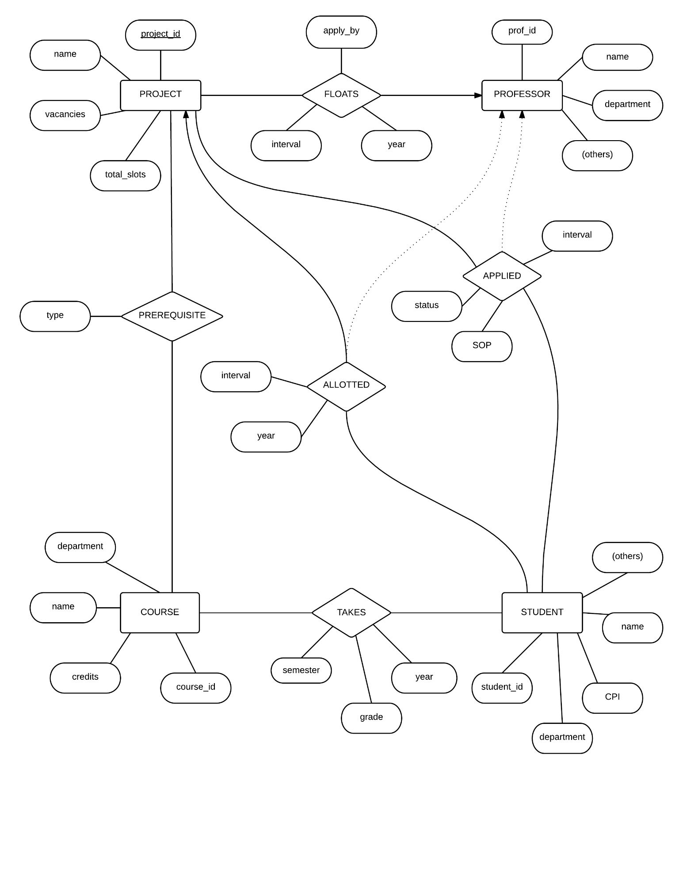
Normalizing the database design:
We use upto 3NF normalization to remove the transitive ternary relations between students, projects and professors. Instead we have two binary relations applied and allotted that are unlinked form professor.

We use integrity constraints as well as programmatic checks to ensure that the problem constraints are met. Eg: there cannot be more students allotted to a project than the total number of slots, a student who has not passed the hard prerequisite courses for a project cannot apply for it.

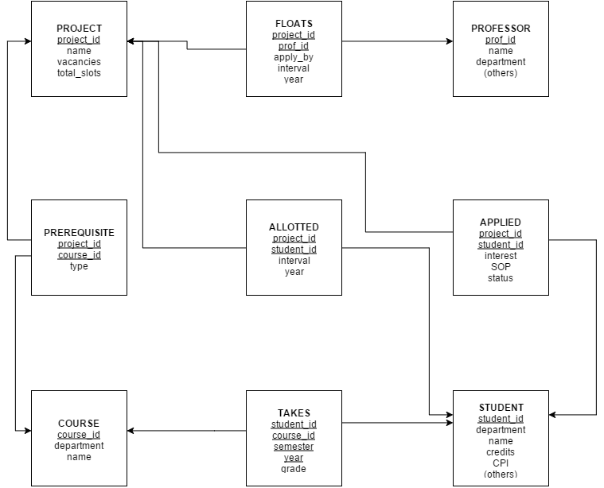
Finally we end up with the above database schema. We have a total of 9 tables. The underlined fields are the primary keys, whereas the arrows depict foreign keys referencing other tables.

Physical Database Design:
The largest tables we expect to find are the takes and applies tables as they depict many-many relationships.
However all the querying and updating required for our application can be done by using simple searches on the primary keys. Thus, the primary key indices are sufficient for our purpose. We need not create further indices.

Implementation Details:

The application is designed based on the Model-View-Controller Architecture. The various components in this architecture are described below.

Model
The model for the application is implemented in the form of constraint checking boolean functions and querying functions. We have included these functions in the JAVA classes, ViewProjectServlet and StudentStatusServlet.

ViewProjectServlet contains functions:
- getProjects() that returns a result set consisting of the projects floated by a professor.
- checkFinalized() that checks if aproject has been finalized yet.
- checkHard() / checkSoft() to check if a student has completed the prerequisites for a project.

StudentStatusServlet contains functions:
- allProjects() to get all the projects for which a student is yet to apply
- getStatus() to get the application status for each project to which the student has applied.

Controllers
The controllers are implemented as servlets which are clled into action through submitting forms using the HTTP post method to trigger the servlet. The response of each of these servlets is defined in their doPost methods.

-ProfLoginServlet : Authenticates the professor after he enters his username and password, and places a cookie indicating this fact.
-ProfLogoutServlet: Deletes the login cookie placed earlier.
-AddProjectServlet: Performs the necessary updates for the professor to float a new project after he submits the application form.
-FinalizeProjectServlet: Performs the necessary updates in order to finalize the selected allottment for a project.
-DeleteProjectServlet: Deletes a project and makes the necessary changes to the database.
-StudentLoginServlet : Authenticates the student after he enters his username and password, and places a cookie indicating this fact.
-StudentLogoutServlet: Deletes the login cookie placed earlier.
-ApplyToProject: Performs the updates necessary to register a student's application to a project.

Views:

-index.html: Welcome page. Can choose to login as a student or a professor.
-prof.html: Page for professor to login
-student.html: Page for student to login
-profafterlogin.jsp: Professor's dashboard to choose various actions
- prof_view.jsp: Dashboard to view floated projects and the applications to them. Allows prof to delete projects and finalize allotments
-prof_float.jsp: Form to float a new project
-prof_final.jsp: Finalized allocation list for professor
-studentafterlogin.jsp: Student's dashboard to choose various actions
-student_browse.jsp: Student's dashboard to browse projects and apply to them with an SOP
-student_status.jsp: Page where student can see the status of projects he has applied to

Interface Design:
We provide interfaces for:
Logging in:

- Student login

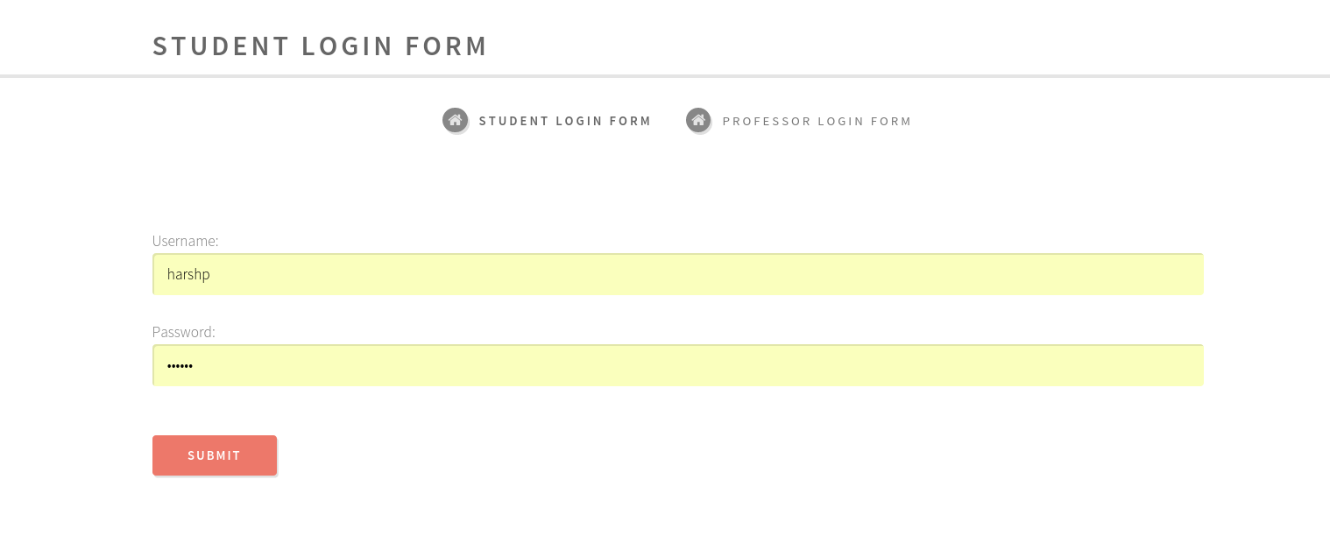

- Professor Login

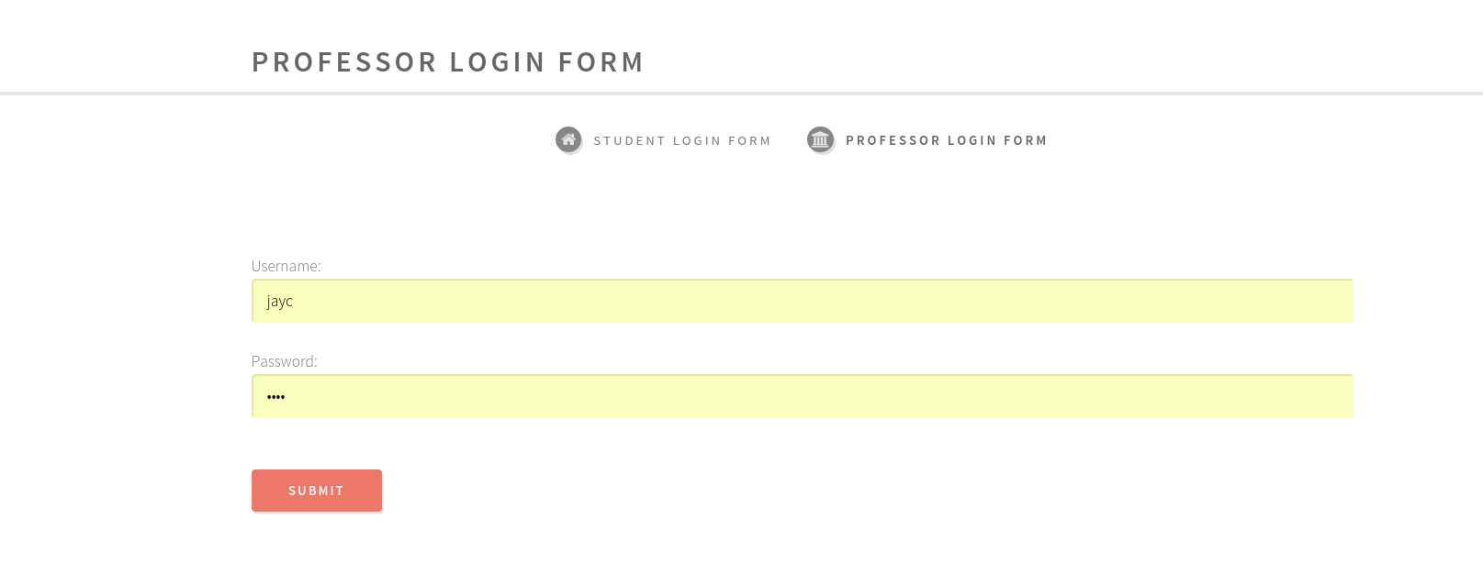

Both of these redirect back to the login page if a login fails.
We use cookies to maintain the state of who is logged in.

Professor Side:

-Float a Project

Here the professor can choose to float a new project.

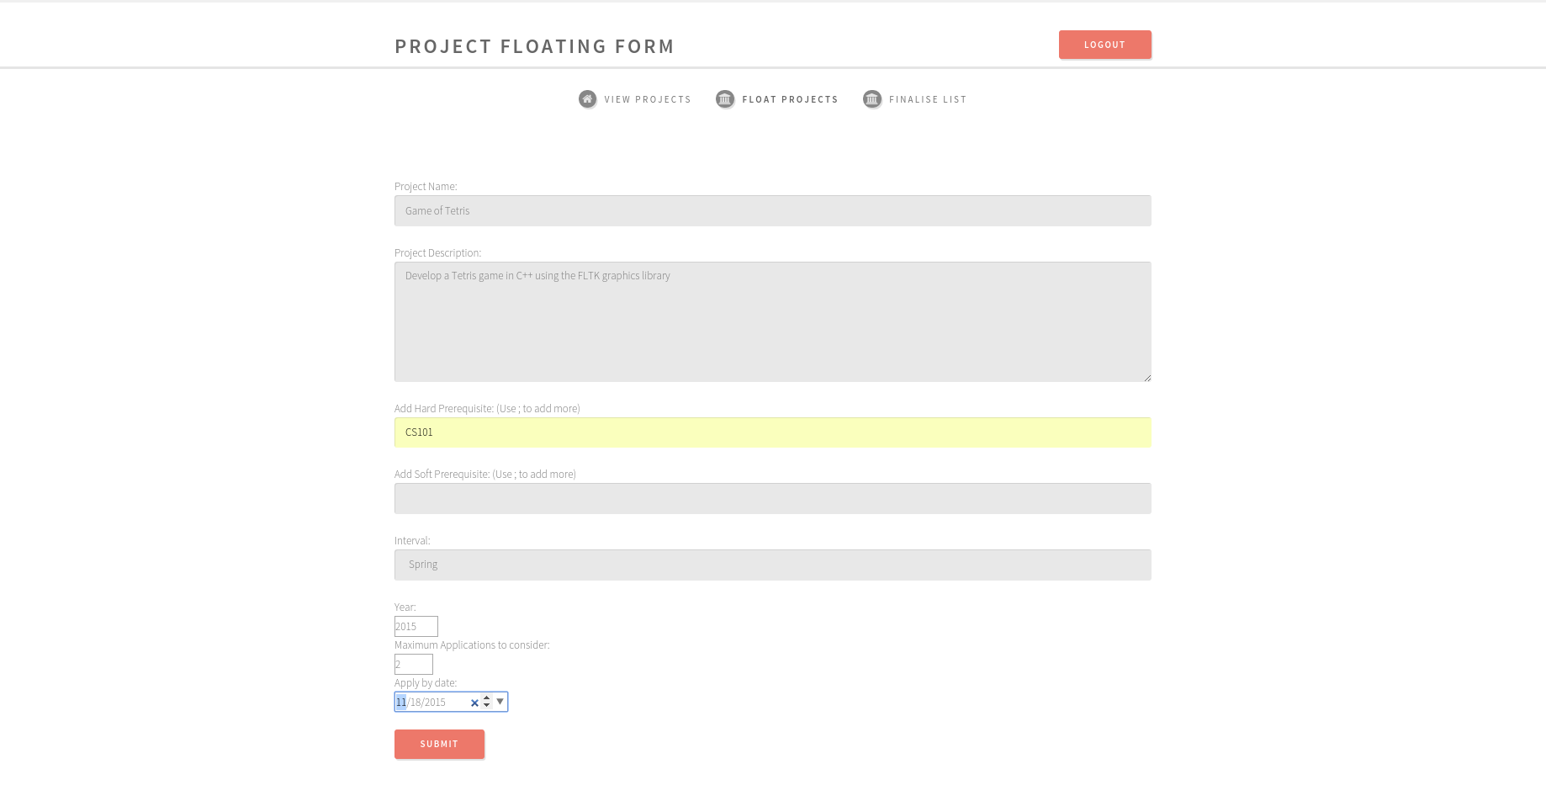

If everything goes well then we get a message saying it was successful. If anything goes wrong, or if the year specified is lesser than the last date we get an error. This is because the professor is allowed to finalize a project only after the last date.

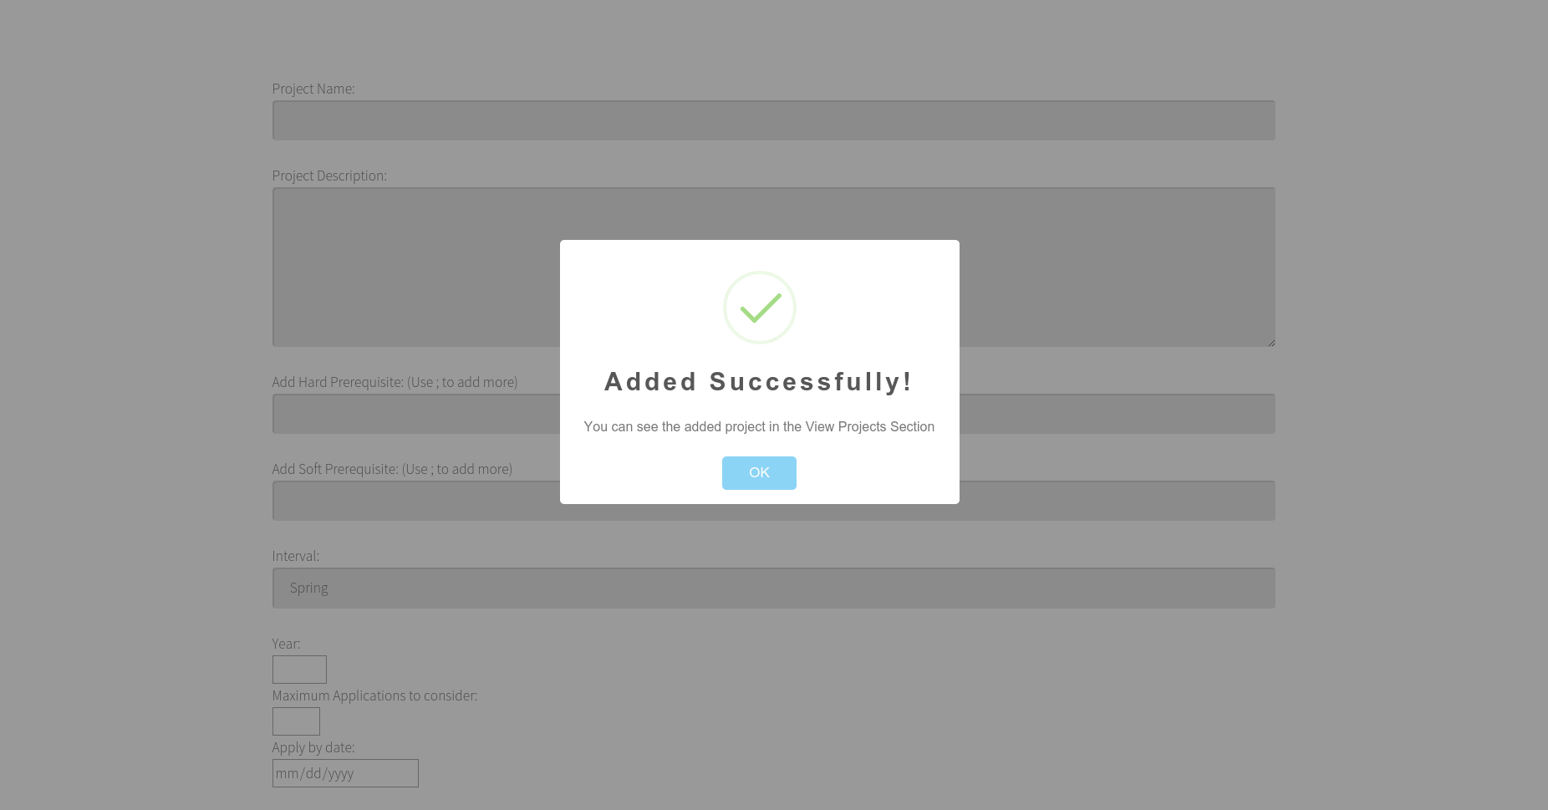
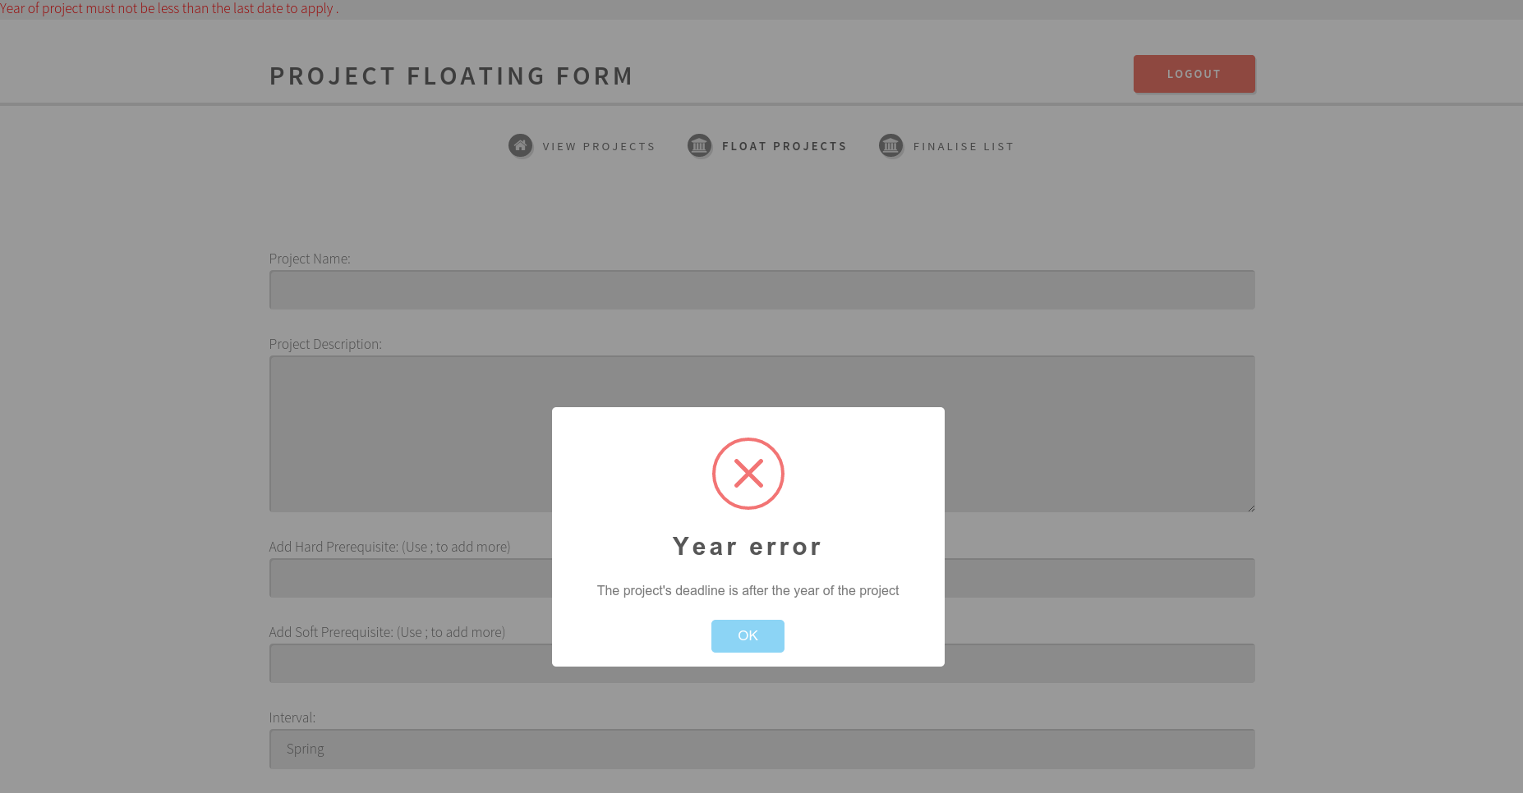
- Success Error
-Browse Projects

Here the professor can choose to see the SOP of students who applied to his project, choose whom he wants to select and Finalize the project. The finalize button will not appear before the deadline. He can also choose to delete the project in which case it will be removed from the database.

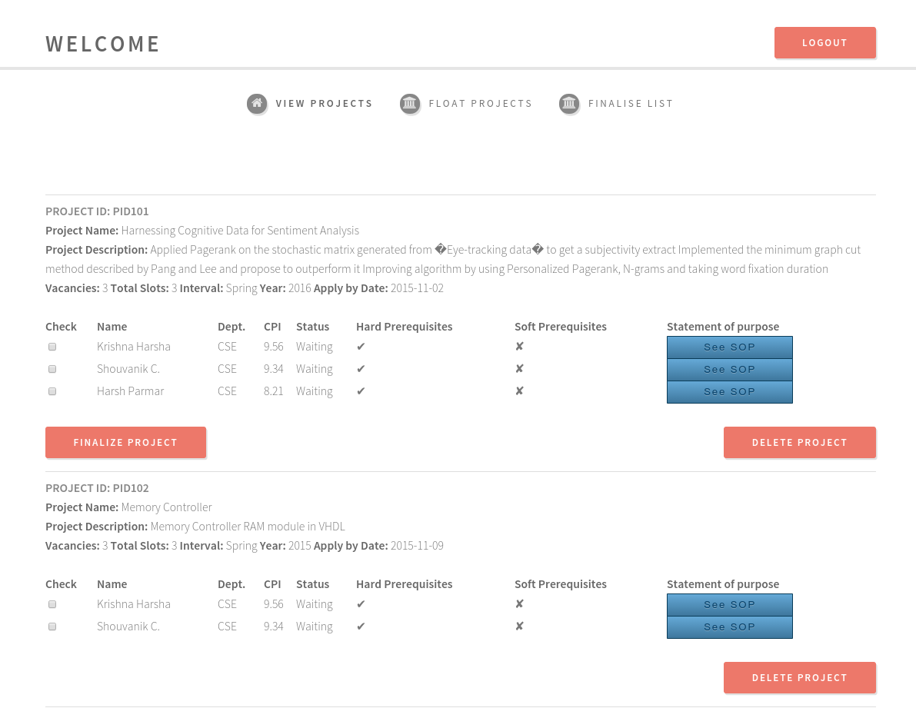

We sort the applications on CPI and show the professor. We show only as many applications as the professor wanted to see in the first place.

-SOP Pop-up

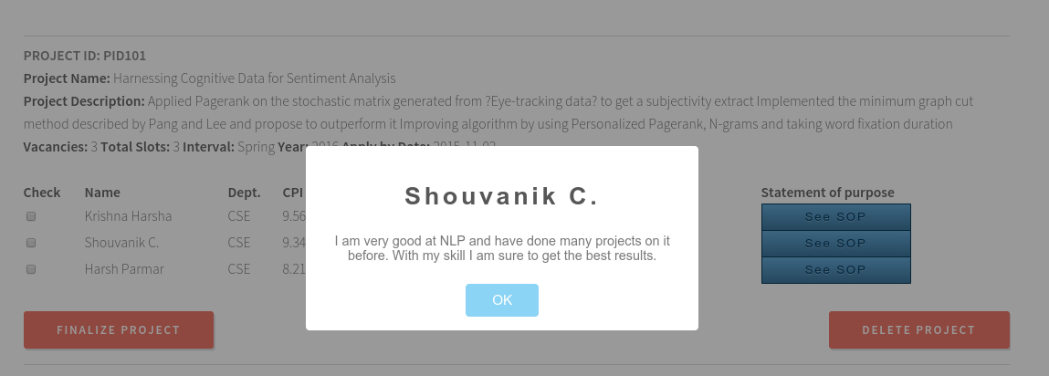

- Delete Project

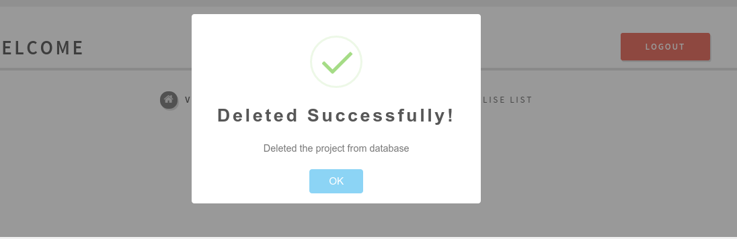

- Finalize Project will take you to the Finalize List pane

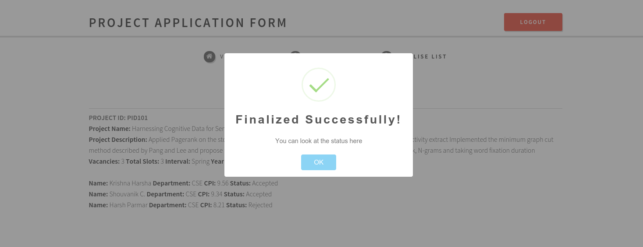

- Finalize List

Here the professor can see the applications and see who all applied and who were accepted and rejected. It’s just for a reference.

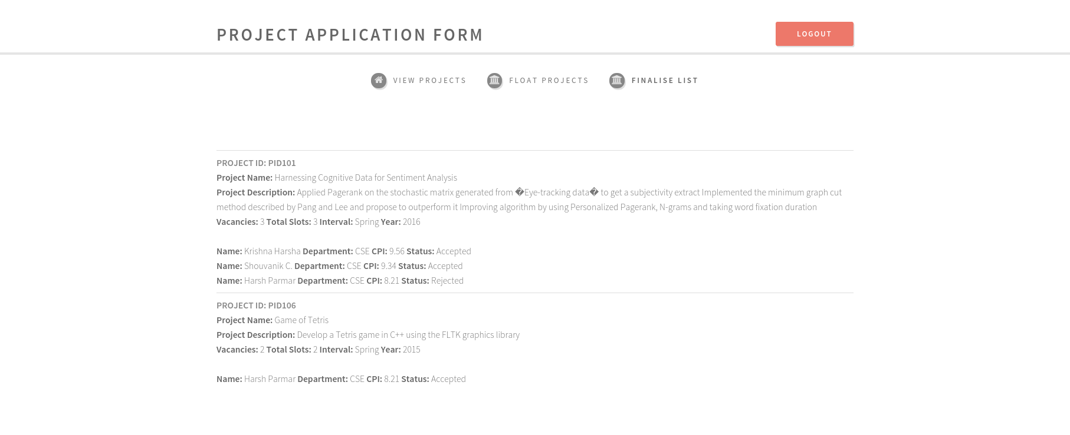

On selecting logout, the cookie is deleted and we go back to the login page.

Student Side:

- View Project

Here the student can see which all projects to apply for.
He can see if he meets the “Soft Prerequisites” and doesn’t get an option to choose the project if he doesn’t meet the “Hard Prerequisites” (Though it will still appear in his view)
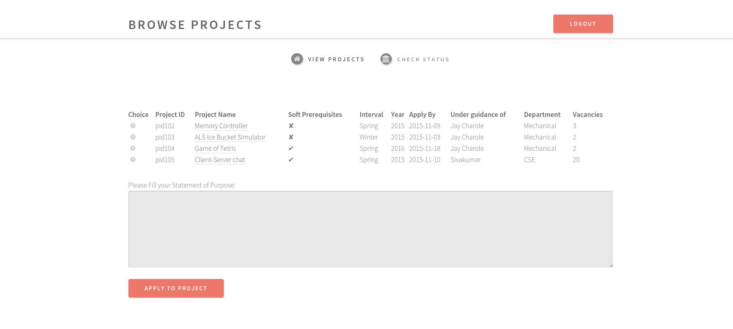
- Project Description

If the student clicks the project name, a pop-up will come showing the description for the project he chose.

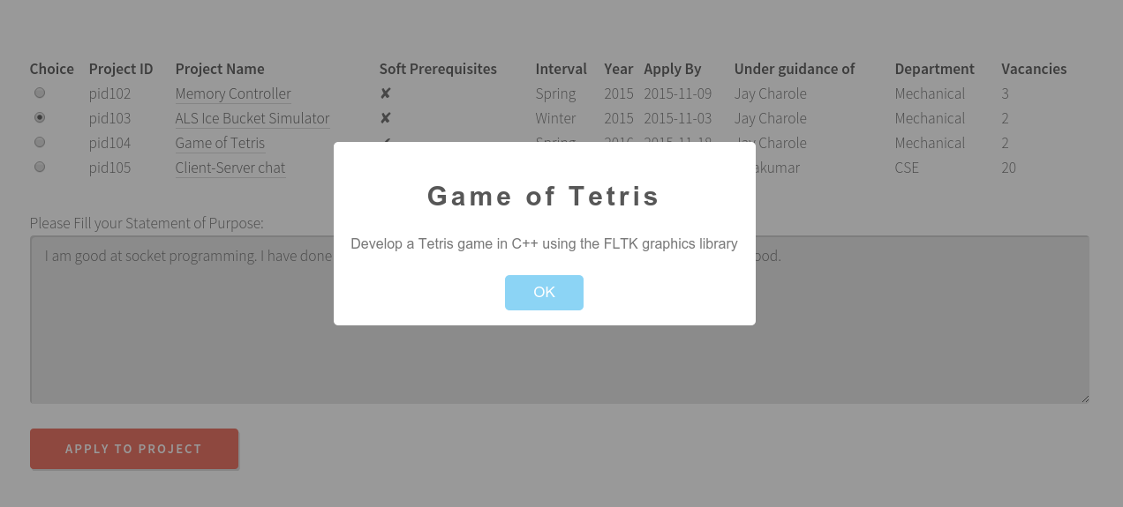
- Apply to the project

After filling your SOP in the text box below, on clicking apply to the project, if you chose a valid option you will get a success message and it will be updated in the database.

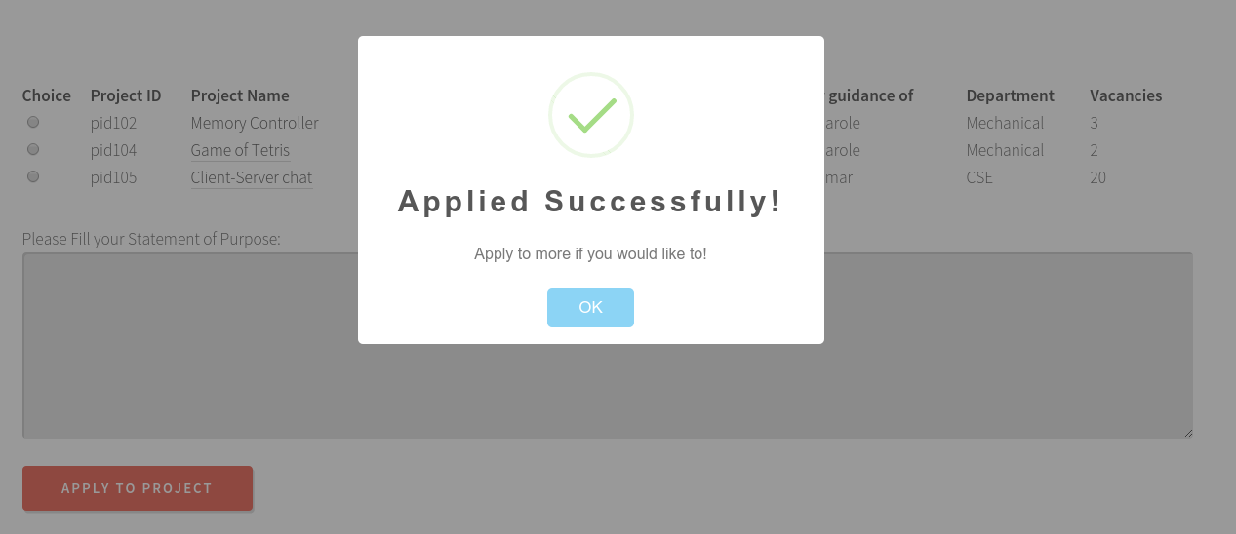

If no option was chosen you get an error.

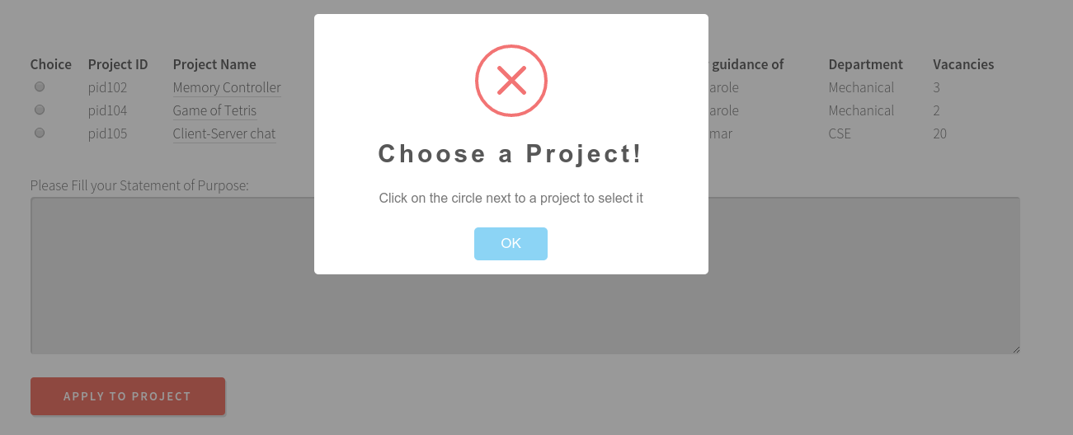

- Status of your applications

In this pane the status of your applications are present. If the professor accepts you get a status “Accepted” for the status and if you are ejected you get “Rejected” and if no decision has been taken you will get “Waiting.

