Cardiovascular Disease Prediction Model
Omkar Hepat¹, Krishna Heda¹, Harshwardhan Bhadke¹, Vishwaraj Ingawale¹, Subodh Humne¹
Project Guide: Prof. Rajesh Dhake¹

¹ Department of Multidisciplinary Engineering, Vishwakarma Institute of Technology, Pune-411037, Maharashtra, India

Abstract
The advent of artificial intelligence and machine learning has opened the gates to early prediction of deadly diseases that otherwise would go undetected through traditional methods. One such class of disease is cardiovascular disease, which is now commonly seen in the younger generation. The conglomeration of AI and healthcare is the future humanity looks upon. The aim of this research was to develop a model that can accurately identify patients with cardiovascular diseases based on their clinical parameters. The focus of this research was not only to improve the accuracy of the existing algorithms but also to work on the recall of the developed model so that the issue of false negatives, which is very crucial in disease prediction, can be handled in an efficient manner. This project also aims to provide insightful information from the data using the concept of data visualization. The results of the model look promising, and by harnessing the power of machine learning, we can create advanced and personalised healthcare systems.

Keywords — cardiovascular diseases, false negatives, k-fold cross validation, personalized healthcare systems.

INTRODUCTION
Disease prediction is an important area of healthcare study that aims to identify probable illnesses in individuals before they present clinically. Early disease identification and prediction are critical for improving patient outcomes, lowering healthcare costs, and optimising treatment choices. Disease prediction has traditionally depended on clinical skill and statistical analysis of population-based risk variables. However, as technology advanced and large amount of disease based was collected, medical research boosted and better computing techniques arose, machine learning algorithms have emerged as useful tools for cardiac disease prediction, with the promise to improve accuracy and efficiency.
A risky assumption made during traditional prediction methods is assuming linear relation between various clinical factors, but machine learning algorithms can automatically discover patterns and relationships from massive and complicated datasets, allowing predictive models to be developed. These models may efficiently examine numerous patient characteristics, such as medical records, genetic information, lifestyle factors, and environmental exposures, in order to detect trends and forecast disease incidence. Machine learning algorithms can identify hidden patterns and relationships that may evade human intuition by utilising the richness of available data.
Logistic regression, Random Forest Classifier, XGBoost, Naive Bayes Classifier, and K-Nearest Neighbours are among the machine learning techniques used in this work. These algorithms have had widespread application in the task of classification with promising results. The selection of these algorithms enables a thorough examination of their strengths and shortcomings in forecasting various types of diseases.
The dataset used is based on clinical parameters which include age, gender, resting blood pressure, cholesterol level, thallium stress level, etc. Apart from these traditional parameters the dataset also includes cp or chest pain type which may be of four types including typical angina (type 0), atypical angina (type 1), non-anginal pain (type 2) and asymptopmatic (type 3). There is also a term ca which is the number of major vessles (0-3) coloured by fluoroscopy, a term slope which is nothing but the slope of peak exercise ST segment derived from an ECG diagram and may more such terms.
The use of techniques like Voting Classifier for creating an ensemble model, k-fold cross validation for algorithm testing and finally the usage of flask for model deployment on a web app makes this model stand out.
This study is a stepping stone towards automation in healthcare so that every life can be saved within time and disease detections can be more efficient. Not only this but from the analysis from these clinical parameters authorities can make policies to promote a healthy lifestyle within their citizens.

Parameters

Age: This variable represents the age of an individual. It is typically measured in years and is used to indicate the age of a person in the dataset.

Sex: This variable represents the gender or sex of an individual. It is often coded as binary values, where 0 might represent female and 1 might represent male.

CP (Chest Pain Type): CP represents the type of chest pain that a person is experiencing. It is usually categorized into several classes (e.g., 0 for no chest pain, 1 for typical angina, 2 for atypical angina, 3 for non-anginal pain, etc.), with each class describing a different type of chest pain.

Trestbps (Resting Blood Pressure): Trestbps is the resting blood pressure of an individual, typically measured in millimeters of mercury (mm Hg). It provides information about an individual's blood pressure when they are at rest.

Chol (Serum Cholesterol): Chol represents the level of serum cholesterol in an individual's blood, typically measured in milligrams per deciliter (mg/dL). It is an important indicator of heart health and can be used to assess the risk of cardiovascular diseases.

FBS (Fasting Blood Sugar): FBS is a binary variable (often 1 for high blood sugar and 0 for normal blood sugar) that indicates whether an individual has high fasting blood sugar levels. High fasting blood sugar is often associated with diabetes or prediabetes.

Restecg (Resting Electrocardiographic Results): Restecg represents the results of a resting electrocardiogram (ECG or EKG). It can take on different values to indicate different ECG results, which can help diagnose heart conditions.

Thalach (Maximum Heart Rate Achieved): Thalach is the maximum heart rate achieved by an individual during a cardiac stress test or exercise. It is measured in beats per minute (bpm) and can provide information about an individual's cardiovascular fitness.

Exang (Exercise-Induced Angina): Exang is a binary variable (often 1 for yes and 0 for no) that indicates whether an individual experiences angina (chest pain) during exercise or physical exertion.

Oldpeak (ST Depression): Oldpeak measures the amount of ST segment depression on an ECG during exercise compared to rest. It is used as an indicator of how much the heart's electrical activity changes during exercise.

Slope: The slope typically represents the slope of the ST segment on the ECG during exercise. It can have different values to describe the upward or downward slope and can provide additional information about the ECG.

CA (Number of Major Vessels Colored by Fluoroscopy): CA represents the number of major blood vessels colored by a contrast agent during a fluoroscopy procedure. This can be an important indicator of potential blockages or stenosis in the coronary arteries.

Thal (Thalassemia): Thal is a variable related to thalassemia, a genetic blood disorder. It can have different values indicating different types and severities of thalassemia.

Target: Target is often a binary variable (1 or 0) and represents the presence or absence of a specific condition or outcome of interest. In the context of cardiovascular health, it might indicate whether an individual has heart disease (1 for yes, 0 for no).

methodology

Proposed Architecture

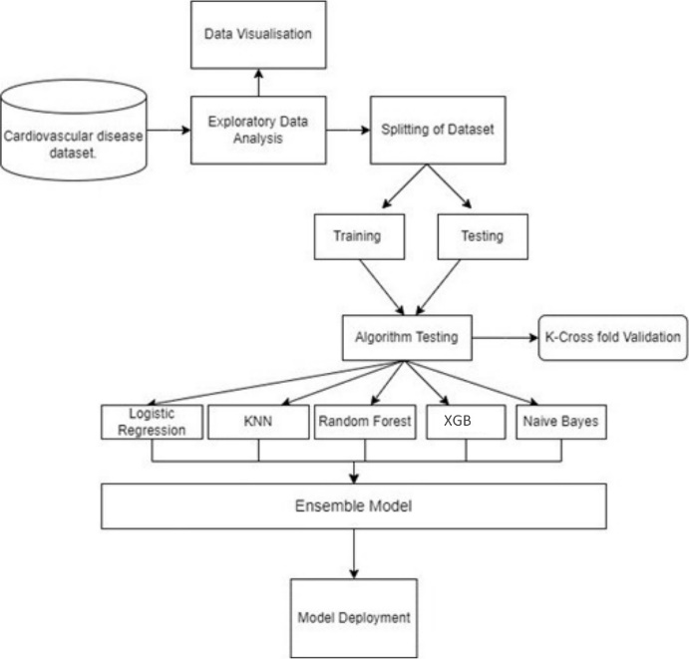
Fig. 1) Architecture of the model
Figure 1 shows the architecture of the proposed model. The details of the architecture have been explained below.

Steps Involved:
- Exploratory Data Analysis: The sample dataset was loaded from the repository and was carefully studied using various statistical techniques. The data was checked for null values and outliers were handled. Visualization was also an important part of this step where all the attributes, their frequency, their relation with target variable and their importance was studied. EDA can clearly be observed in figure 4, 5,7, 8 and 9.
- Algorithm selection: The data was individually trained on various algorithms to check the accuracy of each model and the best ones were chosen to be the part of final model. The algorithms with best accuracy were Random Forest Classifier, K- Nearest Neighbor Classifier, XGBoost, Naïve Bayes Classifier and Logistic Regression. To more comprehensively understand each algorithm and its performance, they were tested with k-cross fold validation (k=10 here).
- Ensemble model: An ensemble model is created using all the algorithms mentioned above. A Voting Classifier is used to create this ensemble model. This helps us get more accurate results compared to a model built only on a single algorithm.
- Model Deployment: Finally, this model is saved and a web app is designed using flask where data can be entered the web app returns the result, whether cardiovascular disease is detected or not.

Mathematical Algorithms
- Logistic Regression: It is a binary classification method which is suitable here as we are trying to classify patients who are either suffering from a cardiovascular disease and who are not based on the clinical parameters. It basically coverts the output of linear regression in the range of 0 to 1 and checks for the threshold. The mathematical equation (sigmoid function) can be represented as shown in equation (1):

P($y=1|x$) = $\frac{1}{1+e^{-\left(wx+b\right)}}$ (1)

where:
- P(y=1∣x) is the probability of the output being class 1 given the input x.
- w is the weight, and b is the bias term.
Graphically it can be visualised as shown in figure 2:
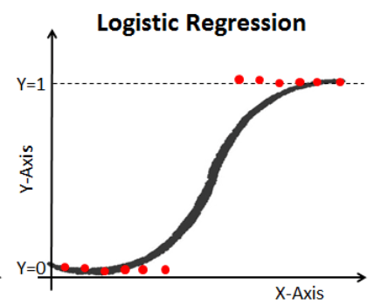
Fig. 2) Graphical representation of Logistic regression
Source: www.datacamp.com

- K- Nearest Neighbors: It is a supervised machine learning algorithm that classifies items based on its nearest neighbor. The neighbor can be calculated using various techniques, here in particular Euclidean distance has been used. KNN does not make presumptions about the data distribution, it is more practical rather than being statistical . It does not generalize the data. Choosing the optimum k value is also important, for the model accuracy of various values were compared and the best k (odd value) was chosen. Formula for distance is shown in equation (2):

$ⅆ\left(X,Y\right)=\sqrt{\sum_{i=1}^{n-1}{{\left(x_{i}-y_{i}\right)}^{2}}}$ (2)
where:
- X: is the new data point whose class needs to be determined
- Y: is the value of training data point
- $x_{i}$: is the features of i^{th} training data point
- $y_{i}$: is the class value of the i^{th} training data point.
- $n$: is the number of features in the dataset.
- XGBoost: XGBoost is an optimized distributed gradient boosting library designed for efficient and scalable training of machine learning models. It is an ensemble learning method that combines the predictions of multiple weak models to produce a stronger prediction. XGBoost stands for “Extreme Gradient Boosting” and it has become one of the most popular and widely used machine learning algorithms due to its ability to handle large datasets and its ability to achieve state-of-the-art performance in many machine learning tasks such as classification and regression.
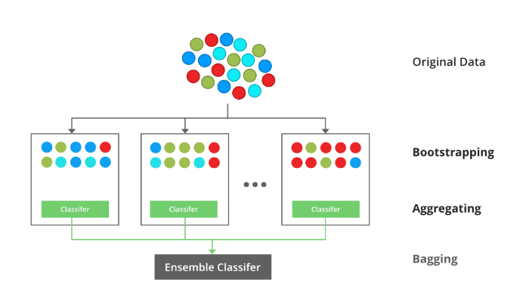
Fig 3) Visualization of XGBoost
Source:GeeksforGeeks

- Naïve Bayes Classifier: It is simple technique that uses the concept of probability named Bayes Theorem. It all attributes contribute equally to the probability of the outcome. The mathematical representation of this concept is shown in equation (3):

$P\left(\left.A\right|B\right)=\frac{P\left(\left.B\right|A\right)P\left(A\right)}{P\left(B\right)}$ (3)
Here, P(A|B) is the posterior probability, P(A) is class prior probability, P(B) is predictor prior probability and P(B|A) is the likelihood, probability of predictor. It can handle non-linear and complicated data. Bayesian models prove to be very useful even in real life complex situations.
- Random Forest Classifier: It is a popular algorithm which is essentially ensemble of multiple decision trees. Trees are basically dependent on the attributes, their entropy and information gain. It works with high dimensional data. Technique of voting classifier and regression is used to give the final prediction.

Testing
In the testing phase the above architecture has been programmed on Pycharm which has helped with computationally heavy calculations. The first few tests involve visualization of the data. Figure 4 shows the balanced nature of the dataset. Figure 5 shows a heat-map showing the importance and correlation of each independent variable (features) with the dependent variable. Figure 6 highlights the different accuracies of different algorithms that have been chosen which has been calculated by taking the k-fold cross validation on each algorithms (k=10 here).
Table 1 is the tabulation of all the test results. It shows the performance metrics of each algorithms. These results prove to be promising hence, they have been included in the ensemble model.

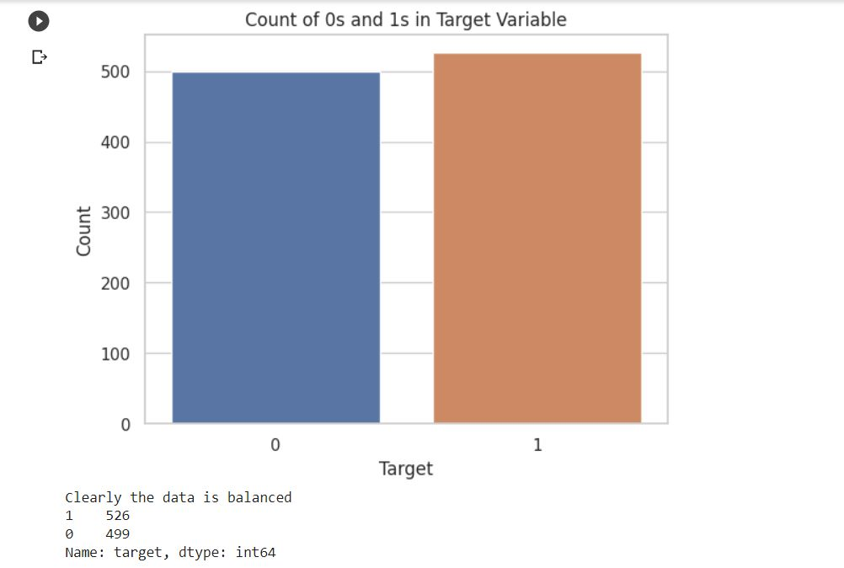
Fig. 4) Bar graph representing balanced data

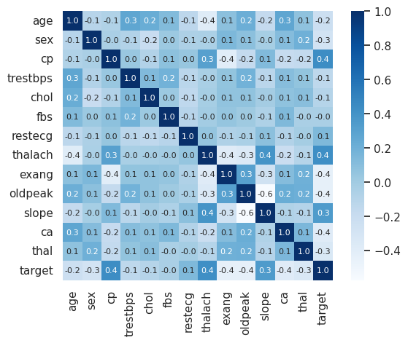
Fig. 5) Correlation matrix of various features using a heat map.
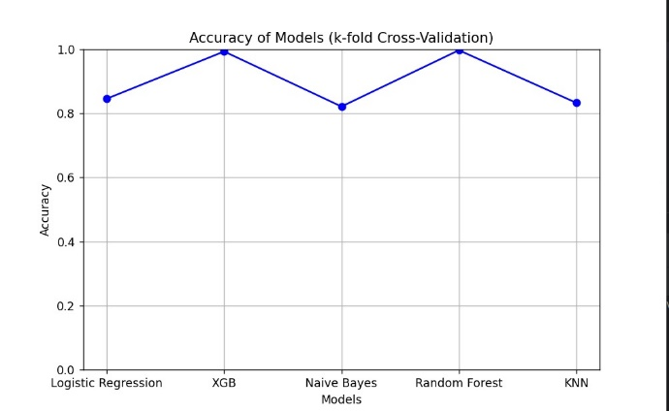
Fig. 6) Comparison of Algorithms based on k-fold Cross Validation

No. | Algorithm | Accuracy | Precision | Recall
1. | Random Forest | 1.00 | 1.00 | 1.00
2. | K-NN | 1.00 | 1.00 | 0.99
3. | X-GB | 1.00 | 1.00 | 1.00
4. | Naïve Bayes | 0.83 | 0.85 | 0.87
5. | Logistic Regression | 0.86 | 0.90 | 0.91
6. | Ensemble Model | 0.95 | 0.94 | 0.94
Table 1) Comparative Analysis of Algorithms

Results And Discussions
The results include both results from data analysis and the developed model, which makes this research novel.
- The frequency distribution of cp from figure 7 and the bar plot of cp against target from figure 8 show that people with a cp value of 0 are high in number but have less relationship with the target value. On the other hand, cp with 1, 2, or 3, irrespective of their frequency, has a relationship with the target value, or, in other words, they have high chances of having a cardiovascular disease.
- Patients with a slope value of 2 have high chances of having a heart disease, which is both appreciably related in the bar graph from Figure 9 and the heat map. So, this becomes an important factor.
- The model was trained on the available dataset, and an ensemble model of the five best algorithms was taken, which gave an accuracy of almost 95%. The most accurate was the Random Forest Algorithm.
- Not only were the accuracies very high, precision and recall were also very good. This is important for specifically disease-related models, where the rate of false negatives creates a huge difference. The high recall shows the versatility of the developed model.

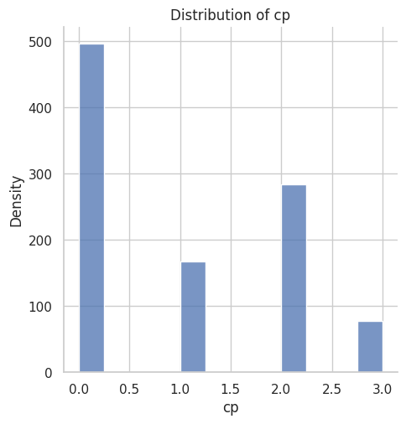
Fig. 7) Frequency distribution of cp

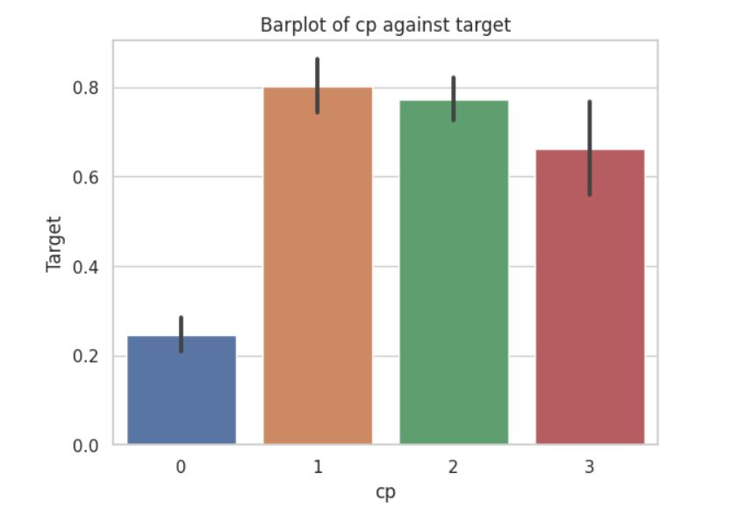
Fig. 8) Bar plot of cp against target

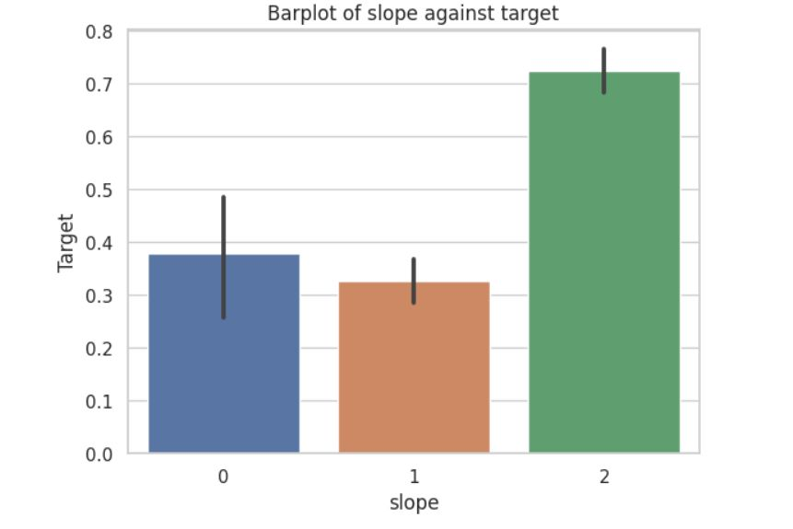
Fig. 9) Bar plot of slope against target

A culmination of all these concepts is the web app where the machine learning model has been deployed. It has a simple interface and is easy to use. Users can enter the values and check whether a patient has cardiovascular issue or not. Figure 10 is the sample of the web application.
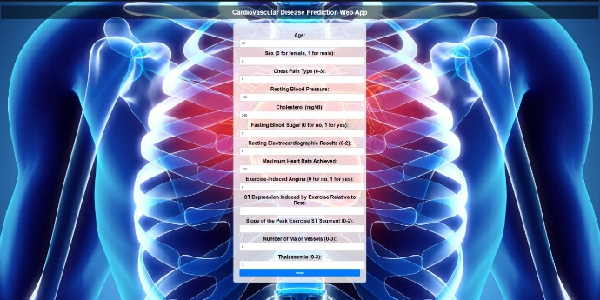{
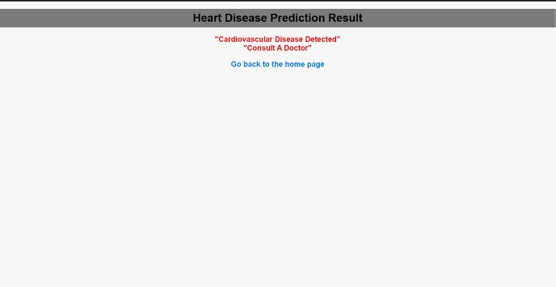
Fig. 10) Output of the provided data on Web App

Future Scope
The future scope of this project encompasses several potential avenues for further enhancement and expansion.
- While this project utilizes some algorithms there are numerous other machine learning algorithms available that could be explored, such as neural networks could be incorporated to compare their performance and potentially improve disease detection accuracy.
- As healthcare data continues to grow exponentially, leveraging big data technologies and cloud computing can provide scalable and efficient solutions for disease detection.
- Implementing distributed computing frameworks and cloud-based storage can enable processing and analysis of large-scale datasets, leading to more accurate and reliable disease predictions.
- We can use more optimal methods for data preprocessing and perform grid search on the algorithms that we have used to optimize the hyper-parameters. This would in turn increase the overall accuracy of the model.

Conclusion
In conclusion, this research aims to contribute to the growing body of knowledge on heart disease prediction using machine learning algorithms. By harnessing the power of advanced computing techniques, we can potentially transform healthcare practices and improve patient outcomes. The results of this study will shed light on the efficacy of machine learning algorithms in disease prediction and provide valuable insights for future research and practical implementations.

References
- Kourou, K., Exarchos, T.P., Exarchos, K.P., Karamouzis, M.V. and Fotiadis, D.I., 2015. Machine learning applications in cancer prognosis and prediction. Computational and structural biotechnology journal, 13, pp.8-17.
- Ensemble Methods in Python (https://www.geeksforgeeks.org/ensemble-methods-in-python/?ref=lbp)
- K-Nearest Neighbor(KNN) Algorithm (https://www.geeksforgeeks.org/k-nearest-neighbours/?ref=lbp)
- Pouriyeh, S., Vahid, S., Sannino, G., De Pietro, G., Arabnia, H. and Gutierrez, J., 2017, July. A comprehensive investigation and comparison of machine learning techniques in the domain of heart disease. In 2017 IEEE symposium on computers and communications (ISCC) (pp. 204-207). IEEE.
- Ramalingam, V.V., Dandapath, A. and Raja, M.K., 2018. Heart disease prediction using machine learning techniques: a survey. International Journal of Engineering & Technology, 7(2.8), pp.684-687.
- Kohli, P.S. and Arora, S., 2018, December. Application of machine learning in disease prediction. In 2018 4th International conference on computing communication and automation (ICCCA) (pp. 1-4). IEEE.
- XGBoost (https://www.geeksforgeeks.org/xgboost/)
- sklearn.ensemble.RandomForestClassifier (https://scikit-learn.org/stable/modules/generated/sklearn.ensemble.RandomForestClassifier.html)
- Logistic Regression (https://web.stanford.edu/~jurafsky/slp3/5.pdf)

