ETL Processing Solution
Who: Krishna Kancharla
What: Final ETL Processing documentation

The ETL process consist of four Milestones:

1: File Imports
Automate ETL from clinic CSV files to Patients database

2: Data Warehouse ETL
Automate ETL from Patients and DoctorSchedules databases to the DWClinicReportsData database

3: Non-SQL ETL
Upload ETL report data from DWClinicReportData to a MongoDB Atlas database

4: Automation, Reports, and Documentation
Automate, Report, and Document your ETL process

Overview
A consultant is hired to perform an ETL solution for a small medical clinic. Currently, the business has individual clinics send data to a corporate office by uploading CSV files each day. Those files are then added to one of the two databases. The current ETL process is entirely manual.

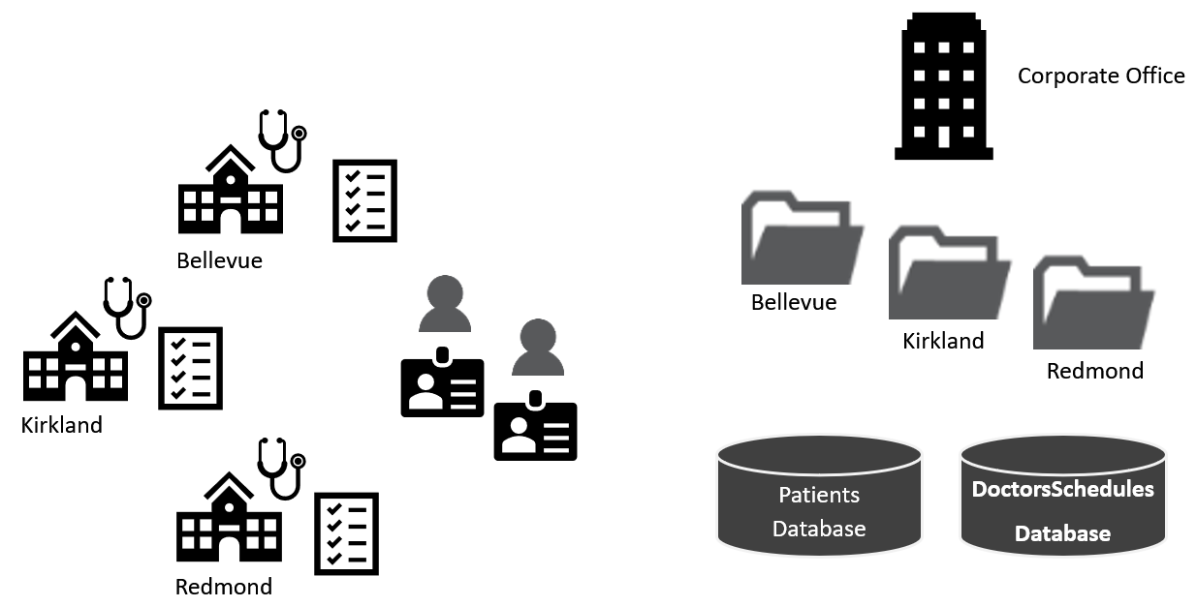
Figure 1. Topology of the current design.

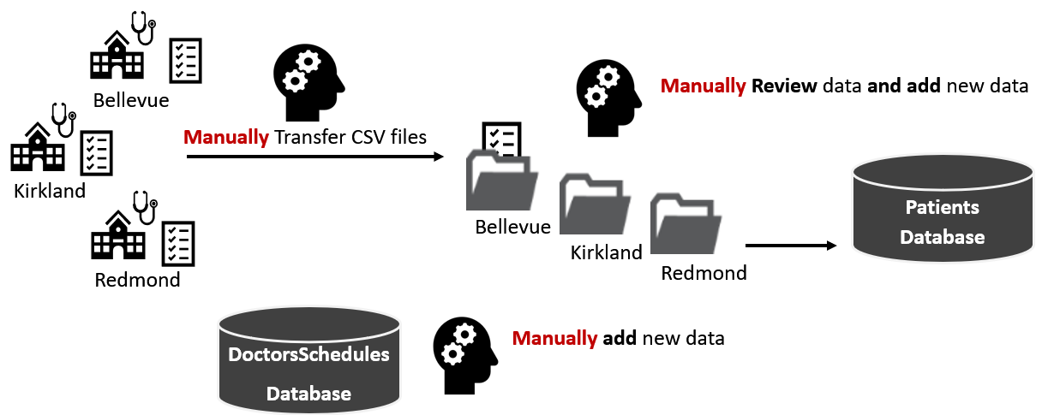
Figure 2. Visualization of the manual ETL file process

The new ETL process will include some automation. If all goes well, they may fully automate in the future.
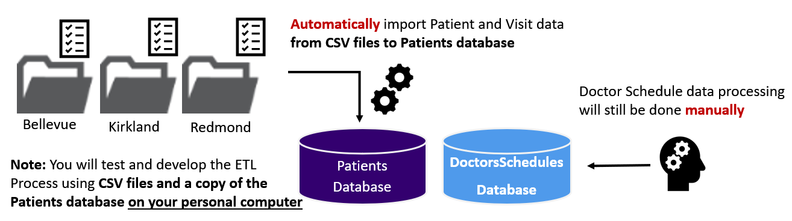
Figure 3. Visualization of the manual ETL file process

1: File-Based ETL
The goal of milestone 1 is to automate the import of data from the CSV files into the "Patients" database. There are two sets of files in each folder, with new patient data and new visits data.

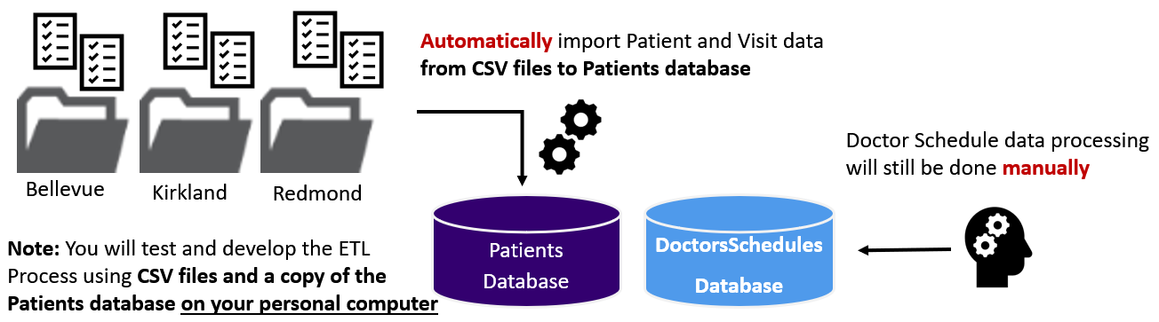
Figure 4. Visualization of the file import process

Step 1 - Review the data
There are two sets of CSV files to process. These files represent data added daily to the source databases. Review each file, watching for any issues in their design and data! Then, review the data in each of the databases, noticing the table, columns, data types, and any issues in the data.

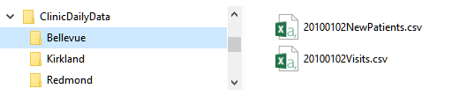
Figure 5. Examples of the daily data CSV files

Note: There are several typical issues to address:
- Column Names
- Column Order
- Bad Data
- Concatenations
- Dates and times

Step 2 - Create a Dev copy of the OLTP Databases
The two source databases called DoctorsSchedules and Patients on my personal computer and are my developer copies of the databases. The .BAK files for each database are backup files.

ALTER DATABASE [Patients] SET SINGLE_USER WITH ROLLBACK IMMEDIATE;
RESTORE DATABASE [Patients]
FROM DISK = N'C:/_BISolutions/Databases/Patients.bak'
WITH RECOVERY, REPLACE;
ALTER DATABASE [Patients] SET MULTI_USER;
go
ALTER DATABASE [DoctorsSchedules] SET SINGLE_USER WITH ROLLBACK IMMEDIATE;
RESTORE DATABASE [DoctorsSchedules]
FROM DISK = N'C:/_BISolutions/Databases/DoctorsSchedules.bak'
WITH RECOVERY, REPLACE;
ALTER DATABASE [Patients] SET MULTI_USER;

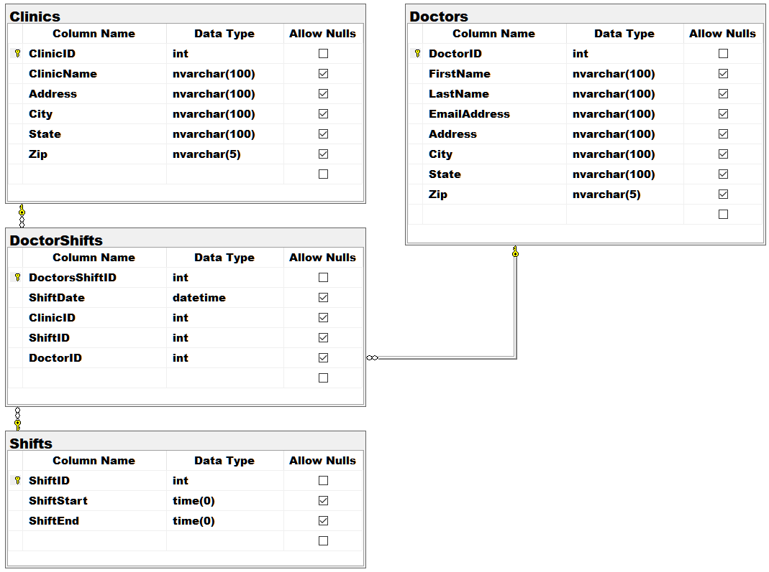
Figure 9. The DoctorsSchedules Database

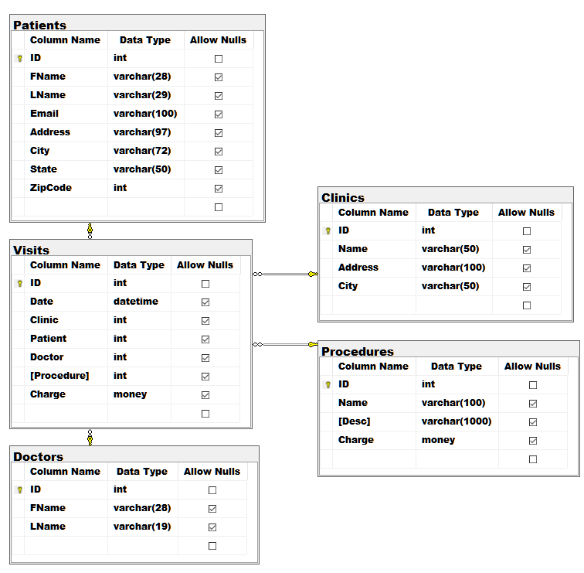
Figure 6. The Patients Database

Step 3 - Document the tables and transformations
Review the local dev copies of the source databases and note any issues you find in their designs. Look for things like inconsistent or ambiguous names and data types. Document your source, destination, and transformations in the ETL Transformation metadata worksheet (.\Document\BISolutionWorksheets.xlsx).

Step 4 - Create an SSIS Package
Add an SSIS project ETLFinalSSISPackages to your Visual Studio. Create a package called ETLFilesToDatabases that imports data from the files into your local dev version of the "Patients" database

Notes:
- Incrementally load the source databases with CSV data (This is supposed to happen daily).
- Convert schedule time data to a 24-hour format
- Use Views and Stored Procedures when working with SQL code
- Update your Excel worksheet with any objects or changes you made while developing your ETL process (.\Document\BISolutionWorksheets.xlsx.)

2: Data Warehouse ETL
The goal of Milestone 02 is to create an ETL process from the "DoctorsSchedules" and "Patients" OLTP databases and to "DWClinicReportData" OLAP database. The two OLTP databases are on different servers, one hosted on Azure and the other on the UW network. These are the production version of the two databases you restored in Milestone 1 with only read access.

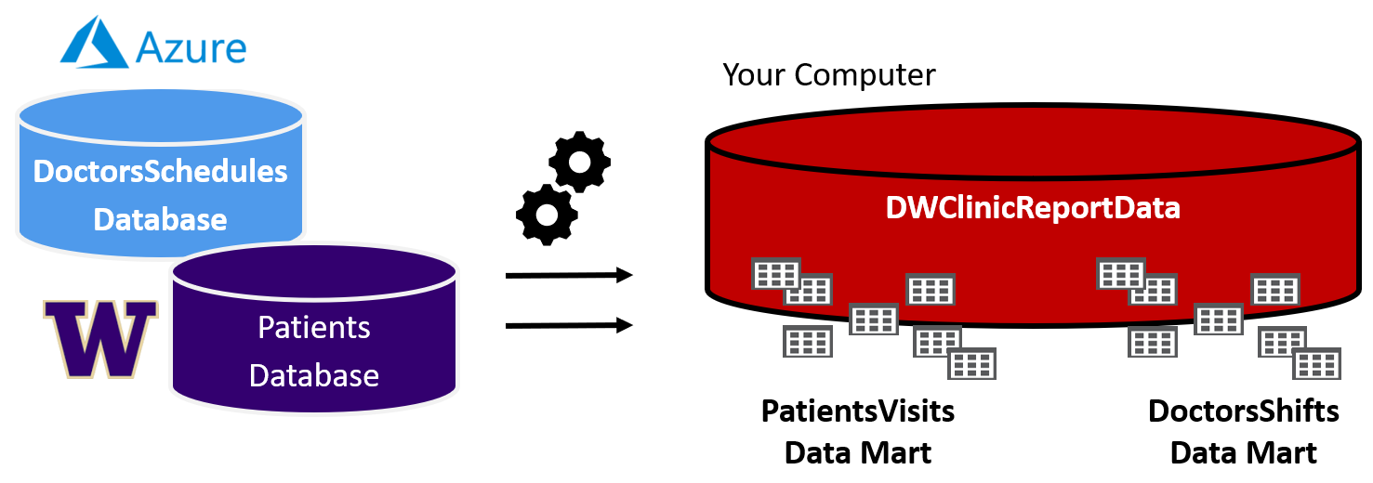
Figure 7. The databases used in the Milestone 2

Step 1. Create a Data Warehouse
Use the data warehouse database script (\Scripts\CreateDWClinicReportData.sql) to create data warehouse destination database.

Step 2. Review the database design
There are two data marts (A and B) in this data warehouse. Note that DimPatients is a Type-2 SCD design, but all other tables are a Type-1 SCD design.

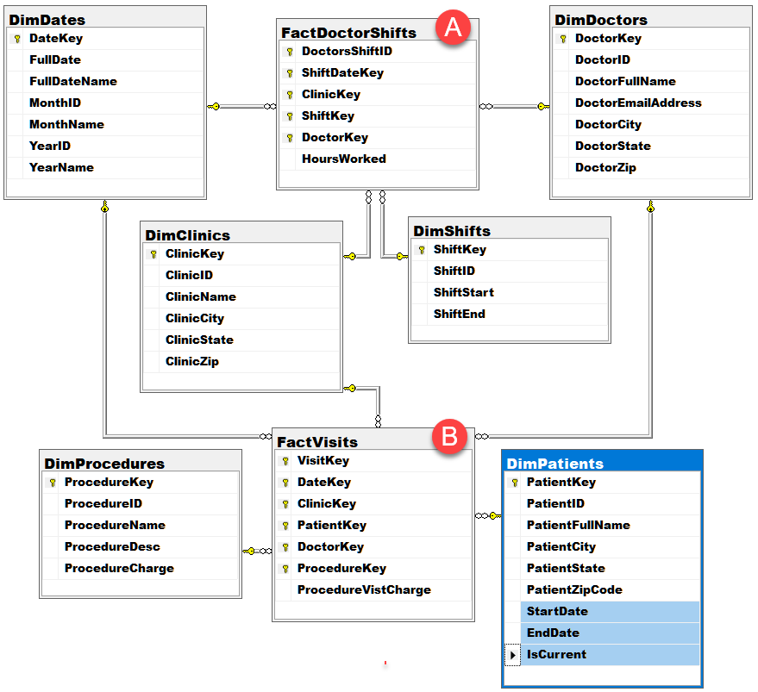
Figure 8. The CreateDWClinicReportData database tables

Step 3. Update your ETL process design in Excel
Updated the metadata spreadsheet with the source, destination, and transformation metadata as needed to describe the ETL process.

Step 4. Create a SQL ETL process and SSIS Package
Created an ETL processing scripts using SQL views and stored procedures. Then create an SSIS ETL package called "DWClinicReportDataETL.dtsx" to run the stored procedures.

3: Non-SQL ETL
The goal of Milestone 03 is to create an ETL process between the "DWClinicReportData" database and MongoDB database hosted on Atlas.

Step 1. Create a MongoDB Database
MongoDB database on Atlas to host the new report documents called ClinicReportsData (figure 13).
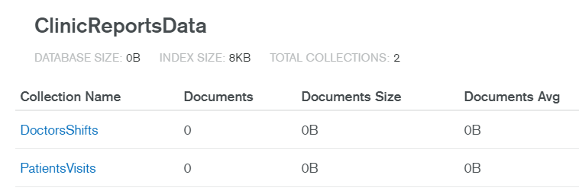
Figure 9. The MongoDB database and collections need for the solution

Step 2. Create Views
Two views in the data warehouse to shape export data to be used in the ETL process like the one in figure 14. Have one view pull data about doctor shifts and the other data about patient visits.

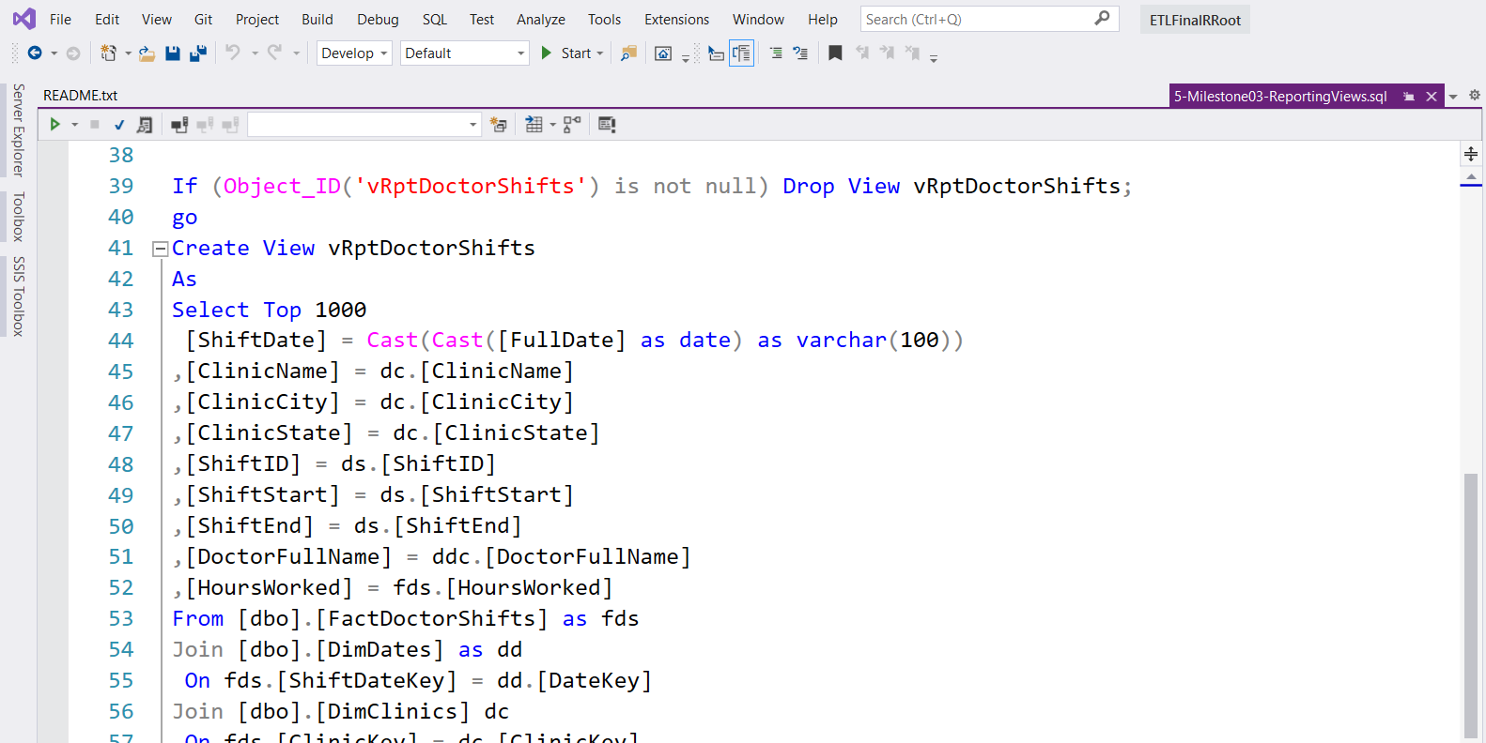
Figure 10. An example view for shaping export data

Step 3. Extract, Transform, and Load data
Python scripts to Extract, Transform, and Load data from a SQL Server relational data warehouse to MongoDB Atlas document database, different collections for each datamart Visits and Dr. Shifts (Figure 15).

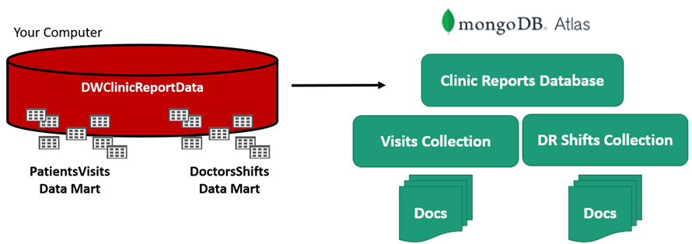
Figure 11. Exporting data to the MongoDB Atlas database.

Step 4. Create an SSIS Package
SSIS package called, ETLClincReportsDocumentData.dtsx, that executes Python scripts.

Step 5. Update ETL process design in Excel
Update the metadata spreadsheet with the source, destination, and transformation metadata as needed to describe ETL process (See figure 11).

4: Automation, Reporting, and Documentation
The goal of Milestone 04 is to complete the BI solution by adding automation, reporting, and documenting your solution. Perform the following steps to complete Milestone 04.

Step 1. Create a new SQL Agent Job to automate ETL process.
- Create a SQL Agent Job called ETLDWClinicReportData to run SSIS package.
- Set the Job Owner as SA and configure it to run each night at 1 AM.
- Generate a SQL Script for the Job and add structured error handling to the script.
- Add the script file to VSS.
Step 2. Create SQL Reporting Views
- Create ETL report views that pull data ETL log and the MSDB jobs tables.
Step 3. Create ETL Dashboard Reports with SSRS.
- Add an SSRS project called ETLDashboardReports to VSS.

